Wear Lifetime and Elongation Analysis of Undercarriage Components in the D375-6 Dozer: An Integrated FMEA and Economic Order Quantity Approach
Sudarman^{a)}, Eko Hermawan Susanto^{b)}, Faiqsyah Iqbal Nugraha^{c)}, Roro Heni Hendaryati^{d)}, Herry Suprianto^{e)}, and Yepy Komaril Sofii^{f)}
Department of Mechanical Engineering, University of Muhammadiyah Malang, Malang, Indonesia
^{f)} Corresponding author: yepykomarils@umm.ac.id
^{a)} sudarman@umm.ac.id
^{b)} hermako15@gmail.com
^{c)} faiqiqbal373@gmail.com
^{d)} heni@umm.ac.id
^{e)} hery@umm.ac.id
Abstract. The undercarriage is a critical support system beneath various vehicles, including excavators, cars, and tractor-trailers. Wheels or tracks are attached to the undercarriage to facilitate the movement of heavy machinery. Besides collisions, undercarriage damage can result from exposure to salt, mud, and potholes. Additionally, outdated shock absorbers can cause excessive vibrations, leading to further damage. Symptoms of undercarriage failure may include handling issues, fluid leaks, oil odors, and visible damage. This study focuses on undercarriage components, particularly wear and service life, using a Failure Mode and Effects Analysis (FMEA) approach to identify maintenance needs and applying the Economic Order Quantity (EOQ) model to manage component procurement for the following year. The results indicate the following maintenance and procurement schedules: Carrier Roller: 2 times/year with a procurement rate of 95.09%, Idler: 1 time/year with a procurement rate of 43.04%, Segment Sprocket: 1 time/year with a procurement rate of 87.67%, Track Link: 1 time/year with a procurement rate of 65.41%, Grouser Shoe: 1 time/year with a procurement rate of 88.70%, Track Roller: 1 time/year with a procurement rate of 85.68%. These findings provide a strategic approach to undercarriage maintenance, potentially extending the lifespan of components and reducing operational costs.
Keywords: FMEA, EOQ, Wear, Undercarriage Lifetime.

INTRODUCTION
Heavy machinery, particularly bulldozers, relies heavily on a crucial component known as the undercarriage, which is responsible for direct contact with the ground or road surface [1, 2]. The undercarriage immediately engages with the terrain, facing significant resistance from the ground [3, 4]. This interaction enhances the operational efficiency of the machinery, ensuring firm traction on the surface. However, it also introduces challenges related to wear and tear [5, 6]. Components such as track shoes, track links, carrier rollers, track rollers, idlers, and sprockets, which rotate and touch the ground, are subjected to friction and tension. The resulting friction generates heat and leads to wear, while tension causes strain on the track links [7]. These factors contribute to the deterioration of the undercarriage, necessitating periodic component replacement to maintain operational integrity [8].
Component wear is a primary cause of machine operational failure, and the physical and chemical properties of these components significantly impact their functionality. It is crucial to adhere to manufacturer recommendations and standards to prevent equipment or component failure. To optimize machine performance and minimize excessive operational costs due to frequent component replacements, undercarriage parts should be replaced at least once a year, with an estimated annual expenditure of around $500,000 [9].
Under normal operating conditions, the track shoes, track links, carrier rollers, track rollers, idlers, and sprockets of a bulldozer are expected to have a long service life. However, in practice, many undercarriage parts fail to reach their expected lifespan, leading to unplanned downtime and increased maintenance costs [10]. This study investigates the failure of undercarriage components on the Komatsu D375-6 bulldozer to enhance understanding and optimize the use and functionality of these parts, thereby reducing or minimizing unexpected undercarriage failures that do not align with the expected service life.
A specific issue of concern is chain elongation, which can significantly hinder the performance of track links. When the maximum allowable elongation is reached, the chain is considered worn and must be replaced. If the chain’s length reaches or exceeds this threshold, it will fail to seat properly in the sprocket’s base, instead riding on the sprocket teeth. Continued operation under these conditions accelerates sprocket wear, leading to excessive tooth wear, pitting, and deformation [11]. Therefore, replacing a chain on a sprocket that has worn beyond the standard is not recommended.
Despite the critical importance of undercarriage components, there is a limited amount of research on the application of Failure Mode and Effects Analysis (FMEA) in the systematic maintenance of these parts. Existing studies have primarily focused on general maintenance practices and economic models, without integrating a structured approach to risk assessment specific to bulldozer undercarriages [12]. This study aims to fill this gap by integrating FMEA with the Economic Order Quantity (EOQ) model to develop a comprehensive maintenance and procurement strategy for the Komatsu D375-6 dozer. By systematically identifying and addressing potential failure modes, this research seeks to extend the service life of undercarriage components, reduce maintenance costs, and improve overall machine reliability.

METHODS

RESEARCH DESIGN
This study using the Failure Mode and Effect Analysis (FMEA) Method, began by collecting literature on the Komatsu D375A-6 dozer, undercarriage components, and the FMEA method. A thorough review of the literature led to the selection of specific undercarriage components for detailed analysis: track shoe (grouser height), idler, track link (link height), carrier roller, track roller, sprocket, track link (link pitch), and track link (chain). Data collection involved a literature review, selecting test objects, and interviewing employees to measure the selected components. Subsequently, wear lifetime and elongation were calculated using predefined equations. These calculations are intended to inform maintenance decisions and establish tolerance limits for component replacement.

TOOLS
Ultrasonic Thickness Gauge: The ultrasonic thickness gauge is designed to measure the thickness of metals (cast iron, steel, and aluminum) non-metals (ceramics, plastics, and glass) and other ultrasonic wave conductors. The tool offers quick inspections of large metal structures with small measurement intervals, providing high-detail thickness maps with an accuracy of 0.01mm. It is particularly efficient for monitoring erosion or corrosion effects, playing a critical role in quality assurance and control.
Tape Measure: Also known as a measuring tape or roll meter, this tool is used to measure length or distance, useful for measuring angles, creating right angles, and drawing circles. Tape measures typically range from 3m to 100m in length, with a precision of 0.5mm, as shown in FIGURE 1.

Materials
Komatsu D375 Track Shoe (Grouser Height)
Komatsu D375 Track Link (Link Height, Link Pitch, and Chain)
Komatsu D375 Carrier Roller
Komatsu D375 Track Roller
Komatsu D375 Idler
Komatsu D375 Sprocket

Wear and lifetime check procedure
To begin, the soil attached to the components to be measured is removed, followed by wiping any remaining soil to ensure the components are clean. A gel is then applied to the ultrasonic thickness gauge, which is subsequently attached to the component for measurement. The results are recorded on an assessment sheet, and the wear rate and lifetime are calculated by equation 1 and 2. These calculated values are then compared with factory standards to determine the necessary maintenance actions
$Wr=\frac{Sv-Mw}{Sv-Wl}$ (1)
Information:
Wr : Worn/ Wear Rate
Sv : Standard Value
Mw: Meassured Wear Rate
Wl: Wear Limit

$Wr=α.Xᴷ$ or $X=\sqrt[K]{\frac{Wr}{α}}$ (2)
Information:
Wr : Worn/ Wear Rate
α : Konstanta
X : Operating Hours
K : Component Factor

Elongation check procedure
First, the soil attached to the link to be measured is removed, and any remaining soil is wiped off to ensure the link is clean. The pitch distance on the track link is then measured, and the results are recorded on an assessment sheet. The elongation is calculated by equation 3, and these values are compared with the established maintenance or replacement standards.
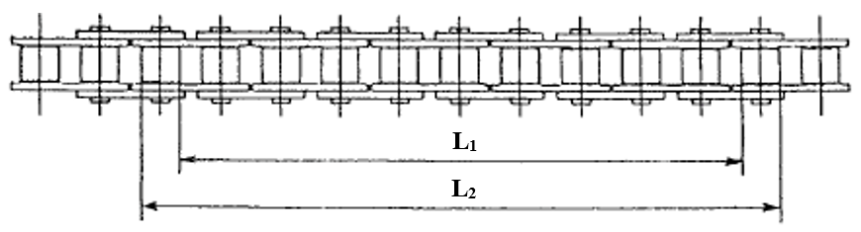
FIGURE 1. Roller Chain

$$Measured length= \frac{L_{1}+L_{2}}{2}$$

$$Original length-Chain pitch x Number of links$$

$$Chain elongation \left(\%\right)= \frac{Measure length-Original length}{Original length}×100 (3)$$

FMEA APPLICATION METHOD
To address wear or damage issues on undercarriage components, the Failure Mode and Effect Analysis (FMEA) method was employed to identify the root causes of potential problems and perform a detailed analysis. The FMEA technique was selected due to its simplicity and widespread use in the industry, though its application in undercarriage component replacement is still underexplored. This study aims to further investigate the FMEA method's application in this context.
The FMEA procedure began by selecting a high-risk process, which was reviewed by a carefully chosen team comprising individuals with diverse job responsibilities and experience levels, ensuring a range of perspectives. The team conducted a brainstorming session to identify potential failure modes and their root causes. For each identified failure mode, the team listed potential effects and assigned severity, occurrence, and detection levels based on the following criteria:
- Severity (S): The impact of the failure mode on the system, with levels ranging from 1 (no impact) to 10 (catastrophic impact).
- Occurrence (O): The likelihood of the failure mode occurring, with levels ranging from 1 (extremely unlikely) to 10 (almost certain).
- Detection (D): The probability of detecting the failure before it occurs, with levels ranging from 1 (very high chance of detection) to 10 (almost impossible to detect).
The Risk Priority Number (RPN) for each failure mode was calculated using the equation 4.
$Risk Priority Number (RPN)=Severity \left(S\right)×Occurrence \left(O\right)×Detection \left(D\right)$ (4)
Failure modes were prioritized for action based on their RPN. Actions were taken to eliminate or reduce high-risk failure modes, after which the RPN was recalculated to monitor the effectiveness of the interventions. The FMEA process in this study was instrumental in identifying critical areas for improvement and guiding the redesign of maintenance practices for the Komatsu D375A-6 dozer.

RESULTS AND DISCUSSION

RESULTS
The research focused on the wear lifetime and elongation analysis of various undercarriage components of the Komatsu Dozer D375A-6. The components analyzed include track shoe (grouser height), idler, track link (link height), carrier roller, track roller, sprocket, and track link (chain). The study aimed to determine the wear rates and elongation to assess the damage levels and inform necessary repairs. The data collected was processed and analyzed to determine the components' lifetimes and wear rates (see TABLE 1).

TABLE 1. Undercarriage components analysis.
Component | Standard Value (Sv) | Measured Wear Rate (Mw) | Wear Limit (Wl) | Wear Rate (%) | Time Reached (Hours)
Grouser Height | 188 | 147,7 | 128 | 48,21 | 9000
Idler | 210 | 190,68 | 185 | 65,87 | 4000
Link Height | 93 | 87,96 | 30 | 53,45 | 9000
Carrier Roller | 880 | 879,32 | 855 | 75,54 | 4000
Track Roller | 181 | 180,88 | 163 | 52,66 | 9000
Sprocket | 140 | 137,66 | 127 | 78,32 | 4000
Track Link (Pitch) | 270 | 265,42 | 210 | 94,29 | 4000

The wear rate (%) represents the degree of wear experienced by each component within the undercarriage system (see FIGURE 2). According to the provided data, components such as the Carrier Roller and Idler exhibit the highest wear rates, indicating that they deteriorate more rapidly compared to other components. In contrast, components like the Grouser Height, Link Height, and Track Roller display lower wear rates, suggesting that they are more resistant to wear. High wear rates are typically associated with factors such as greater load, higher usage frequency, or more extreme operating conditions.

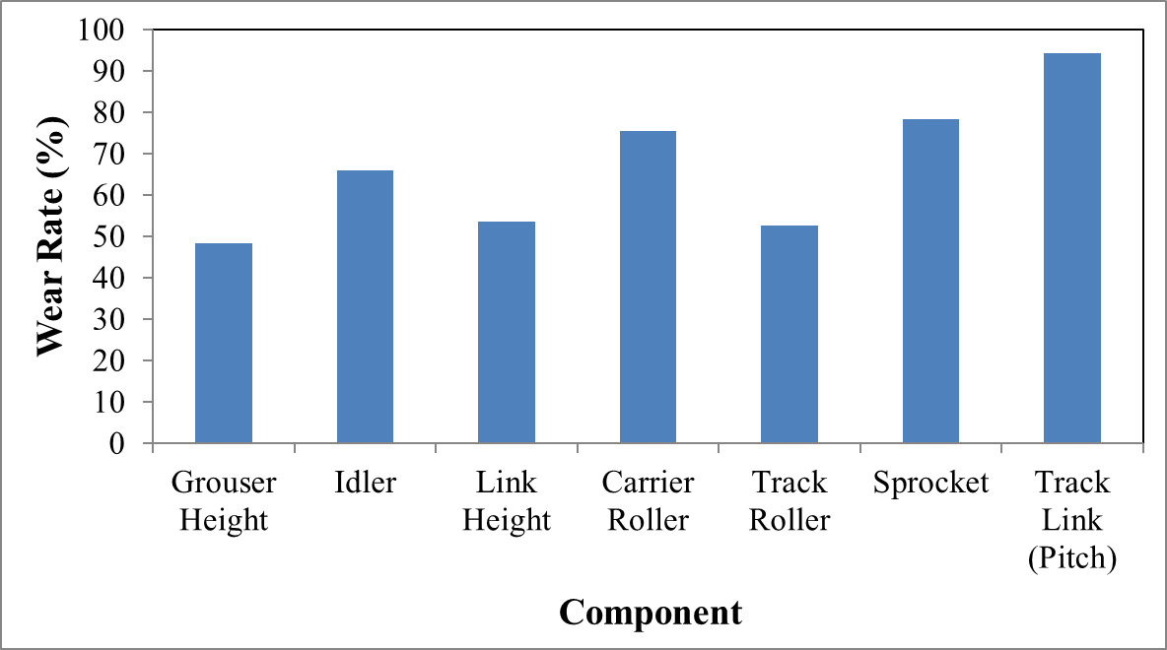
FIGURE 2. Wear rate at undercarriage components.

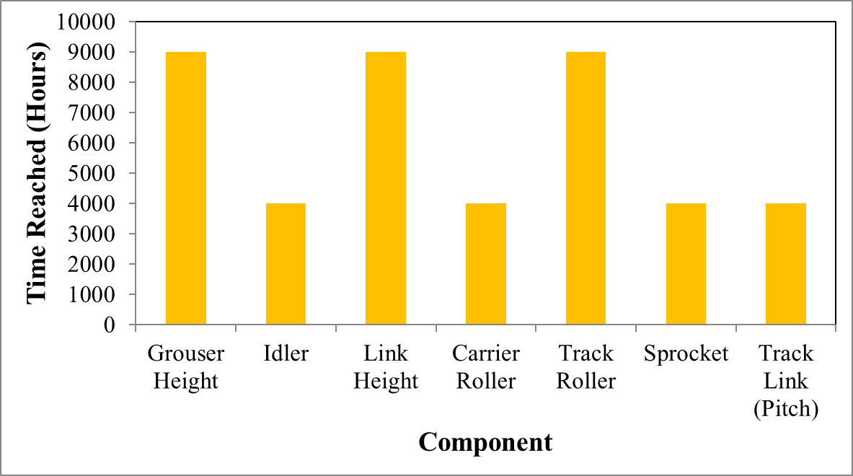
FIGURE 3. Time Reached at undercarriage components.

As shown in FIGURE 3, the relationship between components and Time Reached (Hours) reveals that components with higher wear rates tend to have shorter service lives, as observed in the Carrier Roller and Idler, which have a time reached of 4000 hours. Conversely, components with lower wear rates, such as Grouser Height, Link Height, and Track Roller, can last up to 9000 hours before reaching significant levels of wear. This underscores the importance of regular maintenance and timely replacement of components to ensure optimal performance and prevent system failures during operation.

DISCUSSION
In the wear and lifetime analysis, it was observed that the actual wear rate of the grouser height increased over time, yet remained lower than the standard, indicating superior performance. The possibility of regrousing was also considered, given that the wear plate met the criteria for regrousing. Similarly, the idler’s actual wear rate showed an increase over time, with performance exceeding the standard. It was recommended to utilize the idler until it reached 100% wear, or even beyond, depending on operational requirements. The link height demonstrated a rising wear rate over time, although the actual wear rate was smaller than the standard. Recommendations were made to replace the link height following operational conditions. The carrier roller was found to have a lower actual wear rate than the standard, with suggestions to use it until 100% wear was reached. The track roller exhibited a similar trend, with the actual wear rate surpassing the standard, thus advising its use until 100% wear. The sprocket’s wear rate was also found to be lower than the standard, with the study suggesting that it could be used until or even beyond 100% wear. The pitch analysis of the track link indicated better actual wear rates compared to the standard, with recommendations for continued use until maximum wear was reached.
In the elongation analysis, it was found that the elongation of the track link did not exceed 3-5%, with some instances reaching approximately 10%. The elongation data, derived from 13 track link samples, was utilized to guide the timing of replacement.

TABLE 2. FMEA of Undercarriage components
Component | Severity (S) | Occurrence (O) | Detection (D) | RPN | Priority Level
Grouser Height | 7 | 4 | 5 | 140 | Medium
Idler | 8 | 6 | 4 | 192 | High
Link Height | 6 | 3 | 7 | 126 | Low
Carrier Roller | 9 | 5 | 3 | 135 | High
Track Roller | 7 | 4 | 6 | 168 | Medium
Sprocket | 8 | 3 | 5 | 120 | Low
Track Link (Pitch) | 6 | 5 | 4 | 120 | Low

The Failure Mode and Effect Analysis (FMEA) identified the components with the highest Risk Priority Number (RPN), highlighting the components that should be prioritized during maintenance to prevent failures.
Based on the wear data and FMEA analysis presented in TABLE 2, specific recommendations were made for the replacement of undercarriage components. It is suggested that the carrier roller be replaced biannually, while the idler, sprocket, track link, grouser shoe, and track roller should be replaced annually. Additionally, it is recommended to enhance the securing of the carrier roller to prevent the loss of components during operation. Economic Order Quantity (EOQ) calculations were utilized to optimize procurement planning, thereby reducing costs and ensuring component availability without incurring excessive expenses. These calculations indicate a potential cost savings of 228%, or approximately $470,485.53, compared to conventional procurement methods.
The proposed replacement schedule is as follows:
- Carrier Roller: Twice per year
- Idler, Segment Sprocket, Track Link, Grouser Shoe, Track Roller: Once per year
Component procurement should be guided by EOQ calculations to maximize cost efficiency and avoid overstocking. The findings of this study provide a more accurate and efficient framework for managing undercarriage components. Furthermore, the consideration of failure risks identified through FMEA offers a strategic approach that can be implemented to enhance the operational performance of the Komatsu Dozer D375A-6.
While the study's findings offer valuable insights, certain limitations should be acknowledged. The FMEA process, although effective in identifying critical components, may be subject to biases. These biases could arise from subjective judgments during the assessment of failure modes and their associated risks. Future studies could mitigate this by incorporating a broader range of expert opinions or utilizing more quantitative approaches to enhance the objectivity of RPN values.
Similarly, while the EOQ model has proven useful in optimizing procurement, it operates under the assumption of constant demand and lead times, which may not hold true in dynamic operational environments. Fluctuations in operational conditions, such as unexpected increases in wear rates or supply chain disruptions, could affect the accuracy of EOQ calculations. Future research should explore adaptive or robust inventory management models that account for such variability to ensure more accurate and flexible procurement strategies.
Further research should focus on the development of procurement models tailored to dynamic operational environments. The integration of real-time data analytics with EOQ models could provide enhanced decision-making capabilities, allowing for more responsive and cost-effective procurement planning.
Additionally, the study of advanced wear prediction models, incorporating a wider range of variables, such as environmental factors, machine usage patterns, and material properties, could significantly improve the predictive accuracy of component wear and lifetime. Machine learning algorithms offer a promising avenue for this exploration.
Finally, future research could benefit from a more comprehensive approach to FMEA, integrating quantitative data with expert opinions to improve the reliability of RPN assessments. Investigating the impact of different maintenance strategies on FMEA outcomes could also provide deeper insights into optimizing maintenance schedules and enhancing overall operational efficiency.

CONCLUSIONS
Recommendations for component procurement, based on Economic Order Quantity (EOQ) calculations derived from FMEA, suggest a targeted approach to purchasing. For instance, it is advised to purchase 95.09% of the total planner for Carrier Rollers, and similar calculated percentages for other key components such as Idler, Segment Sprocket, Track Link, Grouser Shoe, and Track Roller. This strategic procurement plan not only aligns with the anticipated needs but also optimizes cost efficiency while ensuring that essential components are readily available to maintain the undercarriage's performance. Future studies should explore the application of FMEA in other critical components of heavy machinery to develop a more comprehensive maintenance framework. Additionally, further research into the economic impact of the proposed EOQ model on long-term operational costs would provide valuable insights for industry stakeholders

Acknowledgments
The authors gratefully acknowledge the University of Muhammadiyah Malang for the financial support of this research.

References
1. Jankovic, I., et al., Multi-criteria approach for selecting optimal dozer type in open-cast coal mining. Energies, 2019. 12(12): p. 2245.
2. Basri, H., E. Diniardi, and A.I. Ramadhan, Troubleshooting Blow by Pressure High on the Komatsu Bulldozer Unit D375A-6R. Journal of Applied Sciences and Advanced Technology, 2019. 2(1): p. 17-20.
3. Nadykto, V., M. Arak, and J. Olt, Theoretical research into the frictional slipping of wheel-type undercarriage taking into account the limitation of their impact on the soil. 2015.
4. Perillo, M., et al. Structural dynamic response of a track chain complete undercarriage system using a virtual proving ground approach.
5. Antoni, R., Studi Cara Kerja Komponen Undercarriage Excavator. 2019.
6. Parkhomenko, G.G., et al. Reducing the negative impact of undercarriage systems and agricultural machinery parts on soils. IOP Publishing.
7. Pradhana, Y.H., Analisa Keausan Dan Kerusakan Komponen Undercarriage Pada Unit Bulldozer SD22E. 2020.
8. Priyana, D.A., Perbaikan Track Roller Pada Bulldozer Komatsu D31E. 2020.
9. Spirito, C.M., et al., Chain elongation in anaerobic reactor microbiomes to recover resources from waste. Current opinion in biotechnology, 2014. 27: p. 115-122.
10. Angenent, L.T., et al., Chain elongation with reactor microbiomes: open-culture biotechnology to produce biochemicals. Environmental science & technology, 2016. 50(6): p. 2796-2810.
11. Grevtseva, A.S., V.V. Davydov, and V.Y. Rud. Development of neural network for automatic calibration of ultrasonic thickness gauge. IOP Publishing.
12. Das, A. and G. Agarwal, Compression, tension & lifting stability on a meter gauge flat Wagon: An experimental approach. Australian Journal of Mechanical Engineering, 2022. 20(4): p. 1113-1125.

