Design and Analysis of Shell Eco Marathon Body Prototype by Using CFD
Farrelian Izzata Anantara^{a)}, Achmad Fauzan Hery Soegiharto^{b)}, Yepy Komaril Sofi'i^{c)}, and Garibaldi Sadam Setyawan^{d)}
Department of Engineering, University of Muhammadiyah Malang, Malang, Indonesia

^{b)} Corresponding author: achmadfauzan@umm.ac.id
^{a)} tarafarrelian309@gmail.com
^{c)} yepykomaril@umm.ac.id
^{d)} saddamsatu9@gmail.com
Abstract: The Shell Eco Marathon is a global program that challenges students to design, build, and drive energy-efficient vehicles. This research focuses on the development of a prototype car body design for the Shell Eco Marathon competition. Students compete to create energy-efficient and environmentally friendly vehicles. This study produces a car body design that is lightweight, aerodynamic, and compliant with competition regulations. Airflow simulations were conducted using Computational Fluid Dynamics (CFD) software to analyze the performance of the design. The analysis results showed a drag force of 1.8674797 N. The pressure contours at the front and rear areas of the vehicle need improvement to reduce pressure in those areas. The airflow contours suggest that the rear design of the car should be optimized to reduce air resistance caused by flow separation, and the underside of the vehicle should be optimized to maximize the Venturi effect, thereby increasing downforce and fuel efficiency.
Keywords: Body design, Aerodinamic, fuel eficiency, Shell Eco Marathon

Introduction
Shell Eco Marathon is a global competition that challenges students to design, build, and drive energy-efficient vehicles [1]. After creating their vehicles, participants compete in specific categories [2]. The winner is determined by the vehicle that is most efficient in energy usage [3]. This competition emphasizes not only energy efficiency but also the use of environmentally friendly materials [4]. Additional awards are given to vehicles made from recycled or eco-friendly materials [5]. The competition demands creativity in designing energy-efficient vehicles and is divided into two main groups: Prototype and Urban Concept[6]. The Prototype category features futuristic vehicles with three wheels, elongated designs, and a driving position that is typically reclined, all aimed at maximizing fuel efficiency[7]. The Urban Concept category involves energy-efficient vehicles with four wheels, though smaller than standard vehicles[8]. hell Eco Marathon includes three energy categories: Internal Combustion Engine (ICE), Hydrogen Fuel Cell, and Battery-Electric[9]. ICE is further divided into gasoline, diesel, and ethanol, where fuel is combusted to generate power[7]. n the Hydrogen Fuel Cell category, hydrogen reacts with oxygen to produce electricity that powers an electric motor[8]. In the Battery-Electric category, electricity from a battery is used directly to drive an electric motor[2]. The winner is determined by the vehicle that travels the farthest with the least energy consumption[1]. The fuel used is Shell Petrol/Gasoline 95 for the ICE class[10]. For Hydrogen Fuel Cell and Battery-Electric, liquid hydrogen consumption and KWH used are measured[11]. his paper will design and analyze the body of the most efficient prototype vehicle using Computational Fluid Dynamics (CFD)[12]. focusing on parameters such as drag force[13], air pressure contour[14], and wind flow contour[15].

METHODS
The simulation-based research was conducted following the sequence of steps outlined in the flowchart presented in FIGURE 1.
The 3D body prototype model was designed using Autodesk Fusion, ensuring meticulous attention to detail. An extract flow surface was prepared, facilitating a 3D flow analysis on the vehicle body without ground clearance. Six boundaries were utilized (inlet, outlet, and four walls). At this stage, careful attention was also given to ensuring detailed meshing in critical areas within the simulation domain.
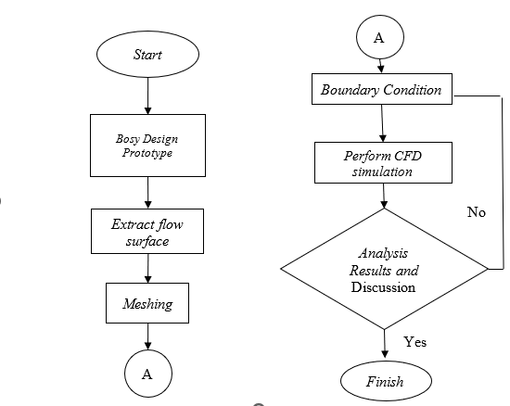
FIGURE 1. Block Simulation Diagram with CFD

The fluid-filled volume was divided into small meshes to apply boundary conditions and parameters. The testing yielded 9,404,425 cell elements, 37,204,573 faces, and 19,268,514 nodes, with a minimum orthogonal quality of 19,268,514.
The numerical modeling was conducted using a 3D space model, a time-steady model, and a viscous SST k-omega turbulent model. The material properties used were as follows: density of 1.225 kg/m³, specific heat capacity (cp) of 1006.43 J/(kg·K), thermal conductivity of 0.0242 W/(m·K), viscosity of 1.7894e-05 kg/(m·s), molecular weight of 28.966 kg/kmol, thermal expansion coefficient of 0, and speed of sound was not considered.
For the inlet boundary condition, the velocity specification method was defined as "Magnitude, Normal to Boundary," with an absolute reference frame. The velocity magnitude was set at 8.333 m/s, and the initial/supersonic gauge pressure was 0 Pa. The turbulent specification method was based on intensity and viscosity ratio, with a turbulence intensity of 5% and a turbulent viscosity ratio of 10. At the outlet, the backflow reference frame was absolute, with a gauge pressure of 0 Pa and a pressure profile multiplier of 1. The backflow direction specification method was "Normal to Boundary." The turbulent specification method for backflow was also based on intensity and viscosity ratio, with a backflow turbulence intensity of 5% and a backflow turbulent viscosity ratio of 10. The backflow pressure specification was set to total pressure. No artificial walls were used to prevent backflow, and radial equilibrium pressure distribution was not considered. Average pressure specifications and targeted mass flow rate were also not specified.
The right wall was set to "symmetry." The top wall was stationary with a no-slip shear boundary condition, zero wall surface roughness, and a wall roughness height of 0 m. The wall roughness constant was 0.5. The left wall and the body also had stationary walls with no-slip shear boundary conditions, zero wall surface roughness, and a wall roughness height of 0 m. Both had a wall roughness constant of 0.5. Finally, the bottom wall had the same stationary wall and no-slip shear boundary conditions, with zero wall surface roughness, a wall roughness height of 0 m, and a wall roughness constant of 0.5.
The following are the reference values for the prototype used in the simulation: Area of $0.24233 m²,$ density of $1.225 kg/m³,$ enthalpy of $0 J/kg$, length of 1 meter, pressure of $0 Pa$, temperature of $288.16 K$, velocity of $8.333 m/s$, viscosity of $1.7894×{10}^{-5} kg.m/s ,$ ratio of specific heats of 1.4, and a Yplus for the heat transfer coefficient of 300. The reference zone is the solid simulation domain.
The solver settings were configured as follows: Under-Relaxation Factors: Pressure 0.3, Density 1, Body Forces 1, Momentum 0.7, Turbulent Kinetic Energy 0.8, Specific Dissipation Rate 0.8, and Turbulent Viscosity 1. For Solution Limits: Minimum Absolute Pressure (Pa) 1, Maximum Absolute Pressure (Pa) 5.00E+10, Minimum Temperature (K) 1, Maximum Temperature (K) 5000, Minimum Turbulent Kinetic Energy (m²/s²) 1.00E-14, Minimum Specific Dissipation Rate (s⁻¹) 1.00E-20, and Maximum Turbulent Viscosity Ratio 100000.
The analysis of the prototype body was conducted in three dimensions using Computational Fluid Dynamics (CFD) to obtain pressure contours, velocity contours, and drag coefficient (Cd). From these results, speed distribution analysis, drag force analysis, and force analysis can be performed

RESULTS AND DISCUSSION
The vehicle body shape was analyzed using Computational Fluid Dynamics (CFD) to obtain pressure contours, velocity contours, and drag coefficients. This analysis helps in assessing speed distribution and drag forces.
FIGURES 2 and 3 show the pressure contours. The flow characteristics around the midspan affected by the side body effects can be observed through the pressure contour visualization on the body. This visualization is useful for understanding the distribution of static pressure across the entire body.
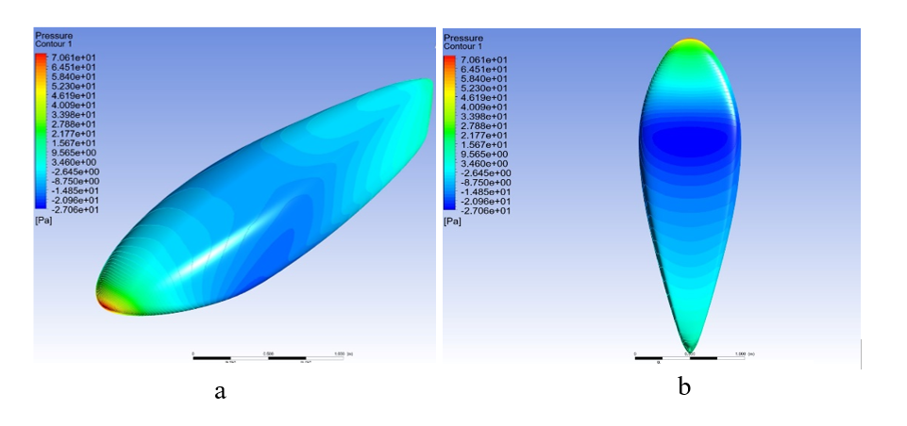
FIGURE 2. (a). Contours of Visible Static Pressure Isometric, (b). Contours of Visible Static Pressure Lower
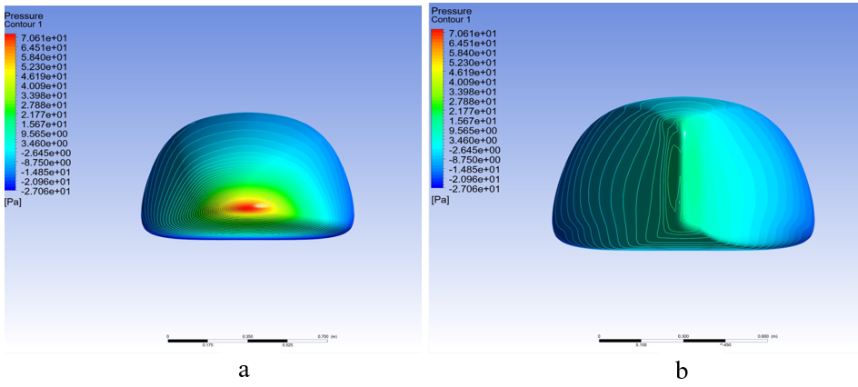
FIGURE 3. (a). Static Pressure Contour Front viev, (b). back Static Pressure Contour View

FIGURE 2(a) shows an isometric and top view of the front area of the vehicle, highlighting high-pressure regions (red and yellow) due to air impact. FIGURE 2(b) illustrates the underside of the vehicle, which experiences lower pressure (blue and green) due to accelerated airflow. FIGURES 3(a) and 3(b) present front and side views of the vehicle, showing areas with lower pressure (blue to green), indicating more laminar airflow. The rear of the vehicle exhibits low pressure (blue), possibly due to vacuum effects or turbulence.
FIGURE 4 shows the velocity vectors and contours.

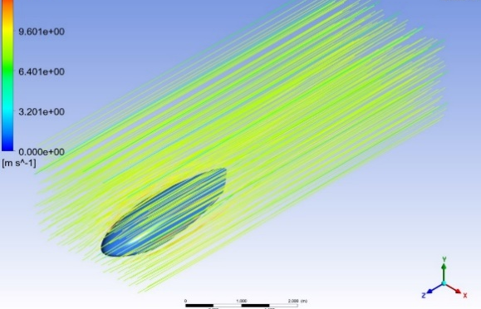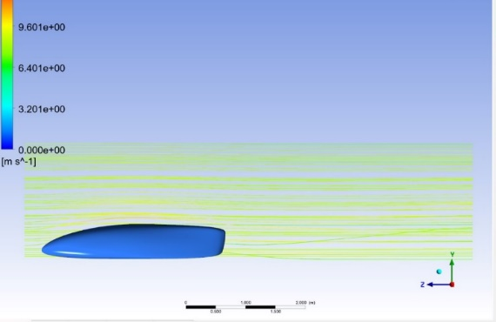
a b
FIGURE 4. a). Prototype Velocity Contour Visualization isometric view, b). Prototype Velocity Contour Visualization side view

FIGURES 4(a) and 4(b) present velocity contours from isometric and side views, respectively. The velocity contours provide an analysis of airflow around the vehicle body. The streamlines adhere to the front of the vehicle but separate at the rear, creating aerodynamic drag that increases fuel consumption. The Venturi effect at the underside of the vehicle accelerates the airflow, enhancing downforce, especially at high speeds.
CFD analysis produces visual data such as pressure contours and streamlines, as well as quantitative data such as drag coefficient and drag force (N). This data aids in understanding the aerodynamic performance of the analyzed object.
The drag force is obtained from the analysis of the pressure difference between the inlet and outlet, as well as the friction caused by the viscous fluid. In this experiment, the drag coefficient was found to be 0.18059997, and the drag force was 1.8674797 N.
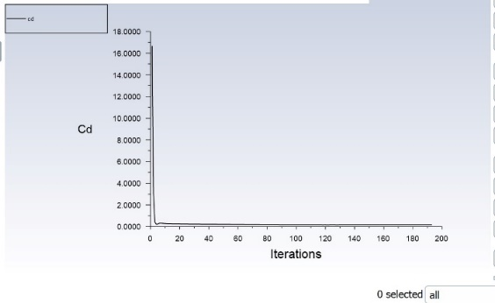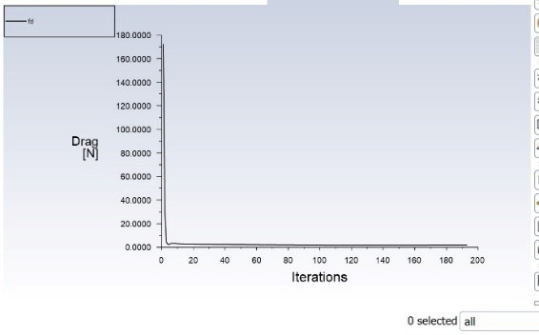
a b
FIGURE 5. a). Plots CD, b). Plots FD

FIGURE 5(a) shows the drag coefficient (Cd) graph, and FIGURE 5(b) shows the drag force (Fd) graph. Both graphs converge, indicating a successful analysis. The drag force is influenced by air density, velocity, frontal area, and drag coefficient, according to the applicable equation:
$F_{D}=C_{D}×ρ×V^{2}×A$ (1)
$C_{D}=\frac{F_{D}}{\frac{1}{2}×ρ×V^{2}×A}$ (2)
Information : $C_{D }=$ Coefficient drag
$F_{D} =$ Drag force (N)
$ρ$ = Density 1.2250 ($kg / m^{3}$)
𝑉 = Free stream velocity ($m/s$)
𝐴 = Area ($m^{2}$)
so that,
$$F_{D}=0.1059997×\frac{1}{2}×1.2250 \frac{kg}{m^{3}}×{(8.333\frac{m}{s})}^{2}×0.2433 m^{2}=1.8674797 N$$
$C_{D}=\frac{1.8674797}{\frac{1}{2} × 1.2250 \frac{kg}{m^{3}} × {\left(8.333\frac{m}{s}\right)}^{2} ×0.2433 m^{2}}=0.18059997$

Each vehicle is expected to have a low drag coefficient, as it affects the magnitude of the drag force experienced by the vehicle.

CONCLUSIONS
Based on the analysis data, the front area experiences high pressure, while the top and side areas have lower pressure. The rear area exhibits low pressure, which can lead to turbulence. The airflow around the vehicle body experiences separation at the rear, causing drag and low pressure that increases fuel consumption. The Venturi effect at the underside of the vehicle enhances airflow speed and downforce at high speeds. The drag force calculated from the analysis data yields satisfactory results.

Acknowledgments
The ideas and concepts presented in this paper originate from the Mechatronics Team of the Faculty of Engineering, Department of Mechanical Engineering, during their preparation for the Shell Eco-marathon competition. The team had several designs to analyze and select for submission.

ReferencE
1. Fabian, M., et al., Design of experimental vehicle specified for competition Shell Eco-marathon 2017 according to principles of car body digitisation based on views in 2D using the intuitive tool Imagine&Shape CATIA V5. Advances in Engineering Software, 2018. 115: p. 413-428.
2. Kozák, E., et al. Eco-marathon racing car casing and frame structure design. in IOP Conf. Ser. Mater. Sci. Eng. 2022. IOP Publishing.
3. Abo-Serie, E., Aerodynamics assessment using CFD for a low drag Shell Eco-Marathon car. Journal of Thermal Engineering, 2017. 3(6): p. 1527-1536.
4. Howlader, A.H., et al. Development of energy efficient battery electric car for Shell Eco-Marathon competition-Qatar University experience. in 2014 9th Int. Conf. Ecol. Veh. Renew. Energies, EVER. 2014. IEEE.
5. Donateo, T., et al., An Inter-disciplinary Approach to the Development of a Low-consumption Prototype for the European Shell Eco-marathon. Advanced Materials Research, 2014. 875: p. 977-982.
6. Mitev, E., S. Iliev, and D. Gunev. Developing of automatic lap counting system for electric vehicle at Shell Eco-marathon competition. in IOP Conf. Ser. Mater. Sci. Eng. 2020. IOP Publishing.
7. Tiew, H.S.K., et al., Fluid-structure interaction on the design of fully assembled Shell Eco-Marathon (SEM) Prototype Car. CFD Letters, 2020. 12(12): p. 115-136.
8. Messana, A., et al., From design to manufacture of a carbon fiber monocoque for a three-wheeler vehicle prototype. Materials, 2019. 12(3): p. 332.
9. Butyrkin, A., et al. Flexible Pricing System Implementation in International Passenger Traffic. in AISC. 2020. Springer.
10. Kamal, M.N.F., et al., A review of aerodynamics influence on various car model geometry through CFD techniques. Journal of Advanced Research in Fluid Mechanics and Thermal Sciences, 2021. 88(1): p. 109-125.
11. Rao, S., Comparision of Aerodynamic Drag and Lift Forces of a Car. International Journal for Research in Applied Science and Engineering Technology, 2018. 6: p. 2061-2069.
12. Zhou, J., Q. Han, and Y. Chen. Design and analysis of the formula student car body based on CFD. in Proc. - Int. Conf. Artif. Intell. Electromechanical Autom. AIEA 2020. 2020. IEEE.
13. Grabowski, L., et al. Application of CAD/CAE class systems to aerodynamic analysis of electric race cars. in IOP Conf. Ser. Mater. Sci. Eng. 2015. IOP Publishing.
14. Thabet, S. and T.H. Thabit, CFD simulation of the air flow around a car model (Ahmed body). International Journal of Scientific and Research Publications, 2018. 8(7): p. 517-525.
15. Brandt, A., B. Jacobson, and S. Sebben, High speed driving stability of road vehicles under crosswinds: an aerodynamic and vehicle dynamic parametric sensitivity analysis. Vehicle system dynamics, 2022. 60(7): p. 2334-2357.

