Analysis and Handling of Hull Area Damage (Waterline) on KM. XYZ
Alfan Satria Anggayudha^{a)}, Nur Subeki^{b)}, Ali Mokhtar^{c)}, Achmad Fauzan Hery Soegiharto^{d)}, and Satriyo Arif Wicaksono^{e)}
Department of Mechanical Engineering, Universitas Muhammadiyah Malang, Malang, Indonesia

^{b)} Corresponding author: nursubeki@gmail.com
^{a)} yudha.alfan99@gmail.com
^{c)} mokhtar@umm.ac.id
^{d)} achmadfauzan@umm.ac.id
^{e)} iosatriyo21@gmail.com
Abstract. The important role of the shipping industry cannot be separated from Indonesia, as it relies heavily on ships as a means of transportation. However, ships face various issues, particularly in the hull area near the Waterline. Corrosion is a common problem that occurs in the hull area at the Waterline. The independent variable used in this discussion focuses on addressing hull damage. The dependent variable in this discussion is the Waterline area. In this case, the control variable is Motor Vessel (MV) XYZ, which serves as the main object of study. The problem encountered in the field is that some ship plates are damaged due to corrosion, hindering the ship's operations. The handling of corrosion on the plates requires a replating process. It's not just the process that matters but also the steps to minimize the recurrence of such damage. The objective of this study is to understand the replating process of ships, specifically due to severe corrosion in the hull area near the Waterline. Corrosion on ships is often caused by seawater pressure and high salt content in seawater, as well as the poor quality of the ship's coating paint. Replating is a necessary step when the plates are severely damaged. The quality of the plate's coating paint serves as the primary defense to minimize corrosion caused by strong currents and high salt content in seawater.
Keywords: Ship, Corrosion, Replating, SMAW

INTRODUCTION
In the past, Indonesia was referred to as Nusantara due to its dominant influence in Asia, thanks to its strategic position as an archipelagic country and its maritime strength [1]. With 17,504 islands, Indonesia has significant potential to boost its economy. Marine resources, such as oil, natural gas, and fisheries, offer unique benefits. Approximately 26.03% of the GDP (Gross Domestic Product) is derived from the maritime sector [2]. Given this advantage, the strength of logistics transportation must be considered. The economic stability of a country is influenced by how easily its marine diversity is distributed. Not only marine products, but the vast number of islands also requires safe and efficient sea transportation for its people.
The maritime world is heavily dependent on archipelagic countries like Indonesia [3]. Countries around the globe rely on ships as a means to reach places that cannot be accessed by land. Merchant ships and warships are two categories within the shipping industry [4]. The Indonesian Navy (TNI AL) uses warships for patrols and military operations [5]. Growing industries, construction, automotive, and other sectors extensively use steel [6]. As an archipelagic country, the demand for merchant and warships will inevitably increase. Adequate and proper maintenance services must be accompanied by quality improvements to meet this demand. However, ships face many issues, particularly in the hull area along the Waterline Area (WLA). Corrosion is one of the most common problems in the WLA. Corrosion is the deterioration of material caused by factors in the environment or its surroundings.
Low-quality metal is due to chemical reactions between it and its environment [7]. The event where metal electrons are released into the electrolyte solution is called corrosion. Many factors are considered in influencing the rusting process of iron. Some measures that can be taken to prevent iron rusting include avoiding contact with oxygen gas, water, and electrolytes, as well as making the surface smoother. Corrosion occurs when metal deteriorates or loses its quality due to electrochemical reactions happening around it [8]. The metal surface usually corrodes before the internal part is damaged. The physical characteristics of corrosion products are comparable to porous, brittle, reddish-brown solids [9].
Therefore, to prevent damage to the ship's structure caused by corrosion, an annual maintenance process, also known as an annual survey, is conducted. The annual survey is carried out to ensure the condition of the ship and to record any damage that has occurred. The safety of passengers and crew requires regular maintenance [10] [11]. In addition, the vessel class must be able to provide a sailing recommendation letter at a specific time, indicating that the vessel is ready to operate [12]. Since this is a serious issue that requires attention, it must be discussed and investigated.
Corrosion is a type of ship failure that can have severe consequences if not addressed promptly with the proper treatment [13]. Corrosion can occur because iron or steel, which are still the primary materials used in shipbuilding, are relatively prone to corrosion from seawater [14]. However, if the corrosion becomes too severe, it can affect the structure and reduce the safety of the ship. The process of ship replating is not explained in the two cited issues [15].
The process of replacing ship plates with new ones is carried out to maintain the ship’s structure and replace old plates that are damaged due to sea water corrosion [16]. The purpose of this discussion is to identify the elements causing corrosion, the ship replating procedure, and strategies for reducing corrosion. It is hoped that the results of this discussion will provide a reference on several processes, especially the replating process.
In the issues encountered in the field, there is a condition where the ship's plates are experiencing corrosion damage, which certainly hinders the operational performance of the ship . Handling corrosion on the plates requires a replating process [17]. It involves not only the process itself but also steps to prevent recurrence. The results of this discussion are crucial, as corrosion is not a trivial issue and must be addressed immediately with concrete measures.
The goal of this issue is to understand the process of ship replating, which is caused by severe corrosion in the BGA (boundary waterline) area. The ship's readiness for seaworthiness has a focus on the safety, security, and comfort of both passengers and the ship's crew.
This has benefits as additional reference material for understanding the world of ship maintenance and repair. For shipbuilding companies, it serves as a reference for the replating process and subsequent procedures. For academic institutions, it acts as a factual reference for writing about ship maintenance and repair processes.
This discussion focuses on the corrosion process in the BGA area, the ship replating process, and steps to minimize corrosion. It does not account for the costs incurred or the rate of corrosion.

METHODS
In this discussion, the focus will be on the ship hull affected by corrosion. The location is PT ABC, with a timeframe from October 2023 to January 2024.
The design of this discussion involves a real-world case study. Independent variables, dependent variables, and control variables are some of the supporting variables used in this discussion. The plate thickness is the independent variable used in this discussion to standardize perceptions. The hardness test results of the welds are the dependent variable used in this discussion. However, the control variable is used to manage the influence of independent and dependent variables, ensuring they are not affected by other variables unrelated to the research topic. In this case, welding parameters are used as a reference object and are considered the control variable.
In this research method, using the Causal Comparative type, or known as ex-post facto. This is a methodology of quantitative research, which identifies the causal relationship between independent and dependent variables. The tools and materials used are tape recorders and stationery to conduct interviews and record all activities. Then the laptop is used to copy and process data collected during the field. The stationery used to record all data from the interview results, 150 mm Mitotoyo calipers, and grade A steel plates with thicknesses of 12mm, 14mm, 19mm.
Two types of data are needed: primary and secondary [17]. Documentation, observation (direct observation), and interviews are examples of primary data [18]. Conversely, observation (direct observation) is an example of secondary data, which includes previous research and relevant journals [19]. The first step is to determine what will be created. Second, they conduct observations using the five senses to collect data and identify problems. Third, they conduct interviews with the ship's captain, crew, dock workers, and the company's quality inspectors. This aims to gather data or information not obtained during the observation process. Fourth, conclusions are drawn about the problems identified in the field. After the entire series of testing processes are completed and the data has been obtained, then analyze it. The data analysis used is descriptive, where in this method it will be described comprehensively from the cause of the damage, the testing process, to the steps to minimize the damage, as seen in FIGURE 1.
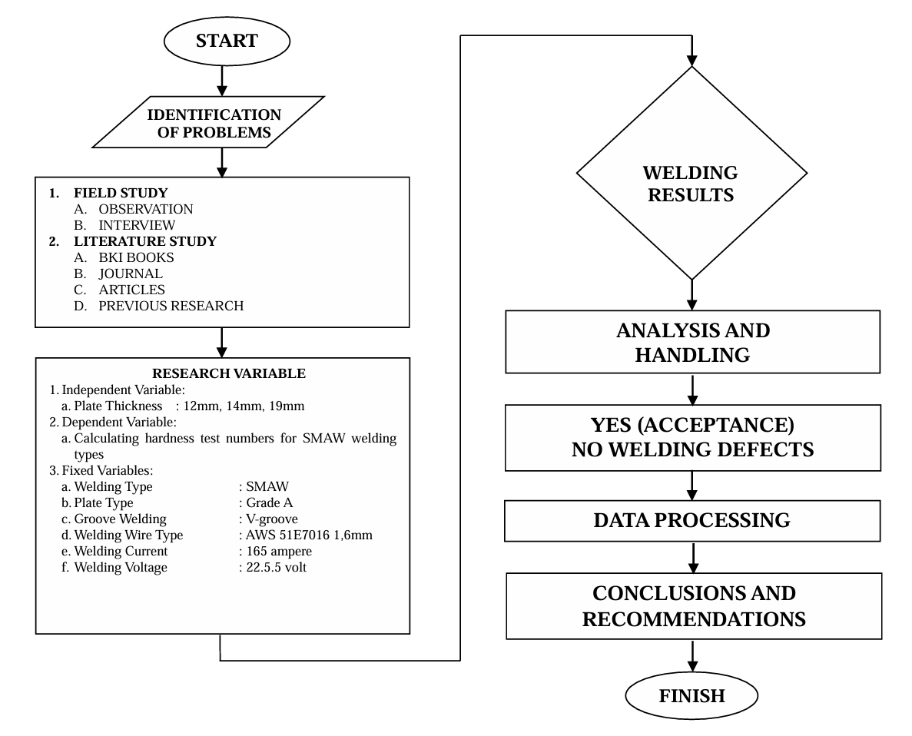
FIGURE 1 Research Flowchart

RESULTS AND DISCUSSION
The results of this discussion show how corrosion occurs and how to address it, specifically through the replating process. During the docking process, the author interviewed the crew of KM XYZ, who reported that the ship had not undergone annual docking for over two years and five months. This neglect led to corrosion of the hull in the BGA area. After analysis, it was found that stationary ships experience faster corrosion for several reasons:
- Stagnant Water: When the XYZ vessel is stationary or not sailing for 2.5 years, the water around its surface tends to become stagnant, particularly in the submerged areas of the ship. This leads to the accumulation of dissolved oxygen, salts, and other substances that accelerate the corrosion process.
- Humidity: Ships in open waters usually have lower humidity levels on their surfaces compared to ships docked at a pier. High humidity can accelerate ship corrosion, especially if the surface is not protected from wind and sunlight, as is the case with the XYZ vessel.
- Exposure to Chemicals: During the corrosion process, electrochemical reactions occur between the metal and its environment.
- Iron Oxidation :
Fe + ½ O₂ + H₂O = Fe(OH)₂
The iron in the ship's steel plates will react with oxygen (O₂) from the air and water (H₂O) to form iron (II) hydroxide
- Further Oxidation :
Iron(II) hydroxide can be further oxidized to iron(III) oxide, which is the main ingredient of rust. :
4Fe(OH)₂ + O₂ = 2Fe₂O₃ + 4H₂O

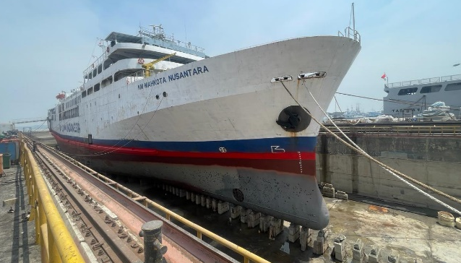
FIGURE 2. Ship XYZ

The XYZ ship is a ro-ro passenger vessel with a route from Surabaya to Ende, as displayed in FIGURE 2. The ship recently experienced a jam in the engine, causing it to be inoperable. Due to the strong pressure of seawater and high salt content, the ship's hull sustained damage. Below are the steps for handling this issue:

Ship Data
This data contains the ship specifications (TABLE 1), which include several pieces of information obtained from interviews with the crew
TABLE 1. Ship Date XYZ
No | General Data | Note
1 | IMO | 7819XXX
2 | SHIP NAME | KM XYZ
3 | TYPE | Ro-Ro/ Passanger Ship
4 | FLAG | Indonesia [ID]
5 | CALL SIGN | PMXXX
6 | GROSS TONNAGE | 7570 Ton
7 | LENGTH OVERALL | 123 M
8 | BREADTH | 18.03 M
9 | YEAR BUILT | 1979
10 | HOME PORT | Pontianak
11 | BUILDER | Jepang
12 | CLASS SOCIETY | Biro Klasifikasi Indonesia (BKI)
13 | MAIN ENGINE | Mitsui 9000HP
14 | AUXILARY ENGINE | Yanmar & Mitsubishi

The replating process carried out in the dock area of PT ABC on the hull of the KM XYZ vessel has the following Welding Procedure Specification (WPS) or welding parameters:
- Material : Grade-A
- Welding Type : SMAW
- Join : Butt Joint Single V– Groove
- Plate Thickness : 19mm, 14mm, 12mm
- Welding Current : DC
- Types of Welding Wire : AWS 51E7016 1,6mm (SMAW)
- Welder : N/A
TABLE 2. Testing Data for Hardness of SMAW Welding Results

No | Dimension Plate (P X L X T) | Ampere (A) | Voltage (V) | Plate Thickness  (mm) | Rockwell Hardness Testing Facility
 |  |  |  |  | Base Metal  Kgf/mm² | HAZ  Kgf/mm² | Weld Metal  Kgf/mm²
No | 1 | 2 | 3 | 7 | 9 | 10 | 11
1 | 1900 x 700 x 12 | 165 | 22.5 | 12 mm | 38,5 | 53 | 58.5
2 | 7000 x 1840 x 14 | 165 | 22.5 | 14 mm | 32.5 | 48 | 54
3 | 1330 x 1110 x 19 | 165 | 22.5 | 19 mm | 24 | 41 | 48

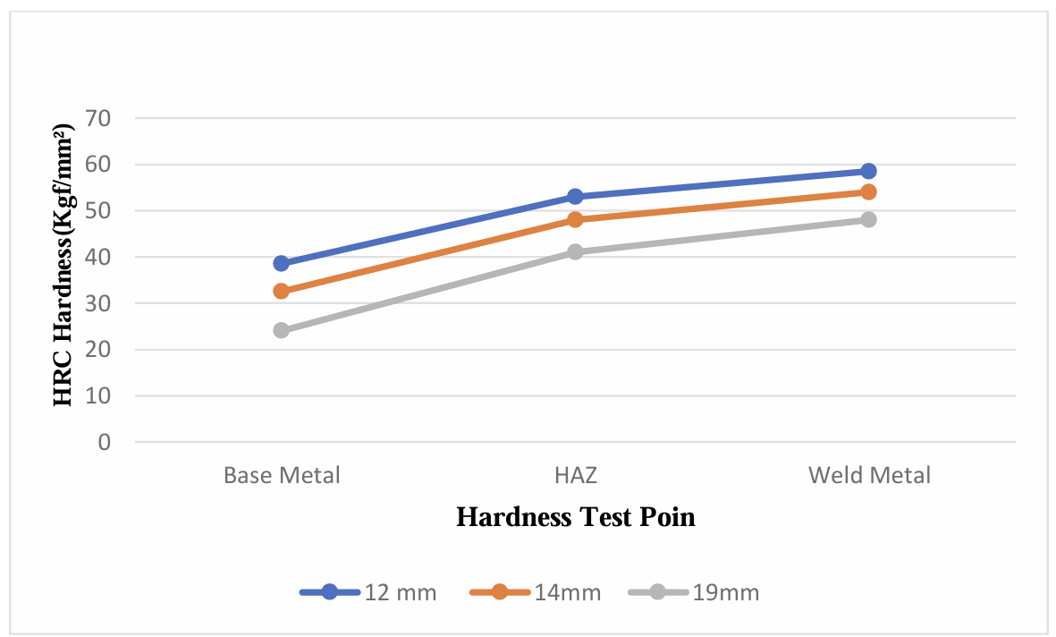
FIGURE 3. Graph of the Influence of Welding Position on Hardness with Different Plate Thicknesses in SMAW Welding
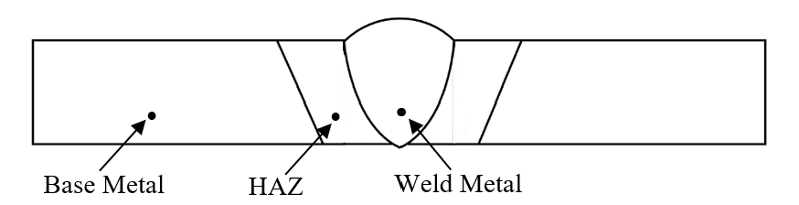
FIGURE 4. SMAW Hardness Testing Area

If you look at the results in the TABLE 2 and FIGURE 3 above, it can be concluded that the base metal area, the HAZ (Heat-Affected Zone) area, and the hard metal area each show decreasing hardness values with increasing plate thickness. The graph indicates that the hard metal area has the highest hardness value, the HAZ area has the second highest hardness value, and the base metal area has the lowest hardness value. We can see that the hardness testing of the welds is affected by the plate thickness, as shown in FIGURE 4.
Minimizing the occurrence of corrosion is crucial, especially in the hull areas above the waterline. This is not only a concern for PT. XXX, a shipyard company that handles ship repairs, but also needs to be addressed by the management of XYZ Shipping Company. The steps to be taken are as follows:
- To protect the ship's hull from corrosion, use a special protective coating that is resistant to seawater.
- Conduct regular inspections and maintenance on the ship's hull to identify and repair areas vulnerable to corrosion.
- Ensure that the ship's cathodic protection system is functioning properly. One example is the correct use and placement of sacrificial anodes.
- Ensure the ship's hull is always clean and free from corrosive deposits.
- Remember that the condition of the seawater where the ship is moored or sailing can affect the rate of corrosion.
- Reduce the ship's hull exposure to conditions that accelerate corrosion, such as avoiding contact with corrosive chemicals.

CONCLUSIONS
Based on the research findings discussed, the following conclusions can be drawn :
- There are several contributing factors that lead to corrosion on KM. XYZ, particularly on ships that have been left idle and floating for a long period. These factors include water stagnation, environmental humidity, and exposure to chemicals.
- The process of replating the plate is the right choice to address the damage in the hull area at the waterline on KM. XYZ. This is because the condition of the plate was severely compromised due to corrosion, with more than a 20% reduction in plate thickness. Replacing the old damaged plate with a new one that has the appropriate specifications, type, quality, and thickness is the most suitable solution to handle severe hull damage.
- The thickness of the plate affects the hardness test results of the welding process. This, in turn, will impact the overall quality of the welding.

Acknowledgments
Research and publication are facilitated by Muhammadiyah University of Malang and partners.

References
1. Rochwulaningsih, Y., et al., Marine policy basis of Indonesia as a maritime state: The importance of integrated economy. Marine Policy, 2019. 108: p. 103602.
2. Amin, C., et al., Impact of maritime logistics on archipelagic economic development in eastern Indonesia. The Asian Journal of Shipping and Logistics, 2021. 37(2): p. 157-164.
3. Nugroho, A., O.S. Suharyo, and A. Rahman. The development of Indonesian maritime potential and prospects towards a world maritime axis. in Int. Conf. Marit. Sci. Technol. 2020.
4. Xing, W. and L. Zhu, A functional approach to reassessing the legal status and navigational rights of ships and ship-shaped structures. Transport Policy, 2021. 106: p. 120-130.
5. Richard, M., et al., A REVIEW OF MARITIME PATROL AIRCRAFT ROLE IN SUPPORTING INDONESIAN MARITIME SECURITY OPERATIONS. Russian Journal of Agricultural and Socio-Economic Sciences, 2021. 114(6): p. 17-23.
6. Jufri, M., et al., The Effect of Electroplating Hard Chrome with Different Dissolvent Compositions to the Mechanical Properties of ST-37. Journal of Energy, Mechanical, Material, and Manufacturing Engineering, 2021. 6(3): p. 221-226.
7. Alamri, A.H., Localized corrosion and mitigation approach of steel materials used in oil and gas pipelines–An overview. Engineering failure analysis, 2020. 116: p. 104735.
8. Harsimran, S., K. Santosh, and K. Rakesh, Overview of corrosion and its control: A critical review. Proc. Eng. Sci, 2021. 3(1): p. 13-24.
9. Nejneru, C., et al., Corrosion Behaviour of Nodular Cast Iron Used for Rotor Manufacturing in Different Wastewaters. Coatings, 2022. 12(7): p. 911.
10. Sánchez-Beaskoetxea, J., et al., Human error in marine accidents: Is the crew normally to blame? Maritime Transport Research, 2021. 2: p. 100016.
11. Svilicic, B., et al., Maritime cyber risk management: An experimental ship assessment. The Journal of Navigation, 2019. 72(5): p. 1108-1120.
12. Sheng, K., et al., Research on ship classification based on trajectory features. The Journal of Navigation, 2018. 71(1): p. 100-116.
13. Gong, C., D.M. Frangopol, and M. Cheng, Risk-based decision-making on corrosion delay for ship hull tankers. Engineering Structures, 2020. 212: p. 110455.
14. Ojaniittu, L., Corrosion of cruise vessel outfitting parts. 2019.
15. Feng, L., et al., A study on the ultimate strength of ship plate with coupled corrosion and crack damage. Ocean engineering, 2020. 200: p. 106950.
16. Djumiati, A., et al. The effect of ship replating welding process on floating conditions against strength value. 2021. IOP Publishing.
17. Faes, W., et al., Corrosion and corrosion prevention in heat exchangers. Corrosion reviews, 2019. 37(2): p. 131-155.
18. Ajayi, V.O., Primary sources of data and secondary sources of data. Benue State University, 2017. 1(1): p. 1-6.
19. Morgan, S.J., et al., Case study observational research: A framework for conducting case study research where observation data are the focus. Qualitative health research, 2017. 27(7): p. 1060-1068.

