The Effect of Current Variations on Aluminium Welding Process in Tensile, Hardness and Distortion
Nur Subeki^{a)} and Mohamad Irkham Mamungkas^{b)}
Department of Engineering, Universitas Muhammadiyah Malang, Malang, Indonesia

^{a)} Corresponding author: nursubeki@umm.ac.id
^{b)} irkham@umm.ac.id
Abstract. Welding is the process of joining materials using heat or pressure to create a strong and permanent joint. This study discusses the effect of welding aluminum 5083 using ER 5356 electrode and current strength variations on distortion, hardness, and tensile strength. The main focus is on the complex interaction between these variables in the welding process to improve welding techniques, reduce distortion, and ensure the quality of aluminum joints in industrial applications. The lowest distortion on the aluminum plate with a current of 130 A is 0.36 mm and the highest is 0.89 mm. At a current of 150 A, the lowest distortion was 0.53 mm and the highest was 1.36 mm, while at a current of 170 A, the lowest distortion was 0.55 mm and the highest was 1.55 mm. The highest hardness in the Weld Metal was obtained with a current of 130 A, while the lowest hardness with a current of 170 A. The highest modulus of elasticity was at a current of 130 A, while the greatest strength value was found at a current of 130 A and the greatest ductility at a current of 170 A. Similarly, the toughness value was highest at a current of 150 A.
Keywords: Welding, Aluminum 5083, Distortion Test, Hardness Test, Tensile Test

INTRODUCTION
Welding is the process of melting two or more parts using heat, pressure, or both [1]. GTAW welding is often performed on metals, thermoplastics, and aluminum [2]. The resulting joint is called a weld, and the parts joined together are called the parent material [3]. Aluminum 5083 is one of the aluminum alloys that is popular in maritime applications and the aviation industry because of its high strength, corrosion resistance, and good weldability [4]. However, the welding process of aluminum 5083 requires special attention because it is sensitive to inertia and structural changes during the welding process [5]. ER 5356 electrode is a welding electrode commonly used to weld 5xxx series aluminum [6]. This electrode is suitable for welding aluminum-magnesium (often called Al-Mg alloy), such as 5083. This electrode provides good mechanical and corrosion properties after welding [7]. The strength of the welding current has a direct influence on the quality of aluminum welding [8]. A current strength that is too low can result in a weld that is not strong enough or does not melt properly, while a current strength that is too high can cause significant distortion, decreased mechanical properties, or even weld failure.
Welding aluminum 5083 with ER 5356 electrodes and variations in current strength can affect the level of distortion in the workpiece [9]. Distortion is a change in dimensions or shape that occurs during or after the welding process [10]. Variations in welding settings such as temperature, welding speed, and current strength can affect the level of distortion produced, causing permanent shape changes [11]. The hardness of 5083 aluminum welded joints is also influenced by the welding process used to determine the resistance of a material to permanent or plastic deformation [12]. Vickers hardness testing is used to determine material hardness by pressing the core of the test object using a Vickers test tool [13]. ER 5356 electrodes usually produce joints with a hardness suitable for general applications, but variations in current strength can affect the thermal and structural zones in the weld area which in turn affects the joint hardness [14]. The tensile test is used to evaluate the strength of welded joints [15]. Tensile testing is widely used as product performance testing, product warranty, and research activities which are very important for manufacturers and research and development institutions [16]. Variations in welding processes such as the electrode used and the current strength can affect the tensile strength of the 5083 aluminum joint [17]. Factors such as the distribution of the base metal, the thermally affected zone, and the fineness of the metal grains also play a role in determining the tensile strength of the joint [18].
The study of the effect of welding aluminum 5083 with changing ER 5356 electrodes and variations in current strength on distortion, hardness and tensile tests is important to understand how these variables interact with each other in the complex aluminum welding process. This research can provide valuable insights to improve welding techniques, minimize distortion, and ensure optimal aluminum weld joint quality in a variety of industrial applications.

METHODS
This research uses quantitative experimental methods. This approach was chosen to investigate the influence of independent variables, namely the type of electrode (ER 5356) and welding current strength on the dependent variables which include tensile strength, hardness and distortion in welding Aluminum 5083. The experimental method allows researchers to manipulate the independent variables in a controlled manner and observe their effects. on the dependent variable, so that the causal relationship between welding parameters and the quality of the weld results can be determined systematically and measurably.
The variables for this research are as follows:
- Independent variables: Independent variables are variables in a study that can be changed by the researcher. This variable is the factor that causes changes in other variables in a study. The independent variable in this research is the variation in welding current strength. The variations in current strength used are 130 A, 150 A and 170 A.
- Dependent Variable: The dependent variable is the variable that is measured or tested in a study. The dependent variable is the variable that is measured in response to manipulation of the independent variable. The dependent variables in this research are Tensile Test, Distortion Test and Hardness Test.
- Control Variables: Control variables are variables that are maintained so that they do not change during the course of the research. The role of control variables is to ensure that changes observed in the dependent variable can be distributed exactly to changes that occur in the independent variable. The control variable in this study is Aluminum 5083, ER5356 Electrodes.
Tools and materials
The tools and materials used in this research are GTAW Welding Machine, ER5356 electrode, Welding Equipment, Ruler, Steel Brush, Pliers, Gloves, Sandpaper, Tensile Testing Machine, Hardness Testing Machine, and Dial Indicator Distortion Test.
Specimen Making
- Prepare the test material, namely aluminum 5083 with a thickness of 5mm as in the picture below
- Measure the aluminum plate to see if it matches the size to be used before welding
- Make a corner of the weld seam using a hand grinder of 70° on the edge of the aluminum to be welded
- Prepare the gtaw welding machine and set it to 3 predetermined current strength variables
- Carrying out the aluminum welding process
- 5083 aluminum welding results using a GTAW welding machine
NDT testing on aluminum welding
- NDT or Non-Destructive Testing is carried out to test whether there are cracks or defects on the aluminum surface that has been welded
- Prepare 3 sprays that will be used for the NDT test
- Clean the aluminum surface using a rag
- Spray NDT test spray on the aluminum surface
- After spraying the aluminum 3x, you can see that white spots on the aluminum indicate that there are no defects or cracks in the welding process
Distorsion Test
- Prepare the dial indicator and aluminum plate to be tested
- Make a grid line of 1cm x 1cm on the entire surface of the plate aluminum
- Adjust the dial indicator so that the indicator used is functional shows valid numbers.
- Carry out the distortion test process.
- Note the results shown on the dial indicator and carry it out until finished.
Tensile Test
- Prepare the aluminum plate that will be used in the tensile test.
- Cutting aluminum plates according to ASTM E8 standards.
- Cut the plate using a grinder.
- Adjust the cutting results to ASTM E8 standards.
- Record the results of the cutting using the current strength of the aluminum to be tested.
- Bring the specimens that are ready for the tensile test to the lab.
- Prepare the computer that will be used to record the tensile test results.
- Tie the specimen to the clamp on the tensile testing tool and start the aluminum tensile testing process.
- The fracture results of the specimens that have undergone the tensile test process.
Hardness Test
- Prepare the specimen to be used for the hardness test.
- Sand the top surface of the specimen until it is flat and shiny so that the hardness test results can be optimal.
- After sanding until the surface is flat and shiny, the next step is to apply resin to the entire surface of the aluminum so that the specimen is not shaken during the hardness test.
- After applying resin to the aluminum surface, the specimen is ready to be tested for hardness.
- Following are the results of the hardness test that has been carried out.

RESULTS AND DISCUSSION

Distorsion test
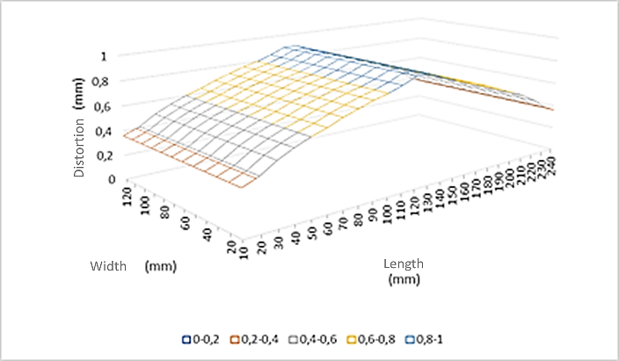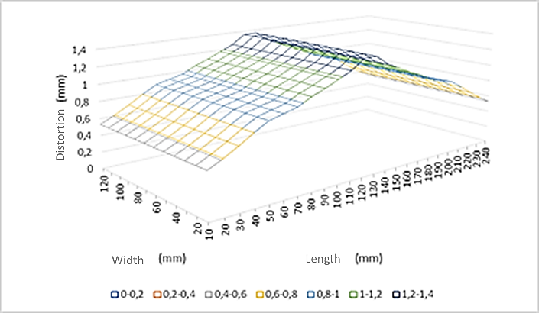
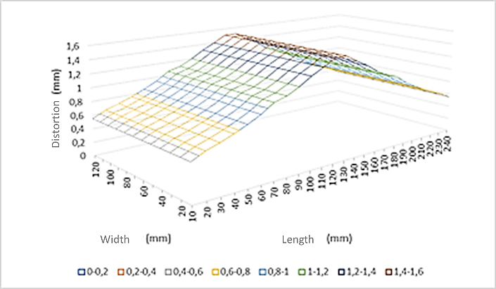
FIGURE 1. 5083 Aluminum Distortion Graph with Variations in Current Strength

From FIGURE 1 it can be seen that the results of the distortion test on 5083 aluminum plate which has been welded using GTAW welding which uses various variations of current, namely 130 A, 150 A and 170 A. The distortion test is carried out to check and measure the level of change or deformation that occurs in aluminum. during the welding process. On aluminum plates with a current variation of 130 A, the lowest distortion value was 0.36 mm and the highest value was 0.89 mm. On an aluminum plate with a current variation of 150 A, the lowest distortion value was 0.53 mm and the highest value was 1.36 mm. On an aluminum plate with a current variation of 170 A, the lowest distortion value is 0.55mm and the highest distortion value is 1.55 mm. The distortion test results for the 3 variables experienced a constant increase due to high currents and low welding speeds resulting in excessive heat buildup.

Hardness Test
Research data from aluminum 5083. The aluminum tested is expressed on the appropriate Vickers scale, followed by a number indicating the hardness value (VHN). The higher the hardness number (Vickers), the harder the test object. From the research carried out, the following results were obtained in TABLE 1
TABLE 1. Vickers Hardness Test Results Data
Variations |  | VHN | VHN rata²
Specimen 130 A | Weld Metal | 9,78 | 10,67
Specimen 130 A | Weld Metal | 8,46 | 10,67
Specimen 130 A | Weld Metal | 13,77 | 10,67
Specimen 130 A | HAZ | 3,35 | 3,30
Specimen 130 A | HAZ | 3,91 | 3,30
Specimen 130 A | HAZ | 2,65 | 3,30
Specimen 130 A | Base Metal | 2,50 | 2,93
Specimen 130 A | Base Metal | 3,55 | 2,93
Specimen 130 A | Base Metal | 2,74 | 2,93
Specimen 150 A | Weld Metal | 6,30 | 6,22
Specimen 150 A | Weld Metal | 7,03 | 6,22
Specimen 150 A | Weld Metal | 5,33 | 6,22
Specimen 150 A | HAZ | 3,59 | 3,27
Specimen 150 A | HAZ | 2,47 | 3,27
Specimen 150 A | HAZ | 3,76 | 3,27
Specimen 150 A | Base Metal | 2.28 | 2.38
Specimen 150 A | Base Metal | 2,69 | 2.38
Specimen 150 A | Base Metal | 2,18 | 2.38
Specimen 170 A | Weld Metal | 2,85 | 3,82
Specimen 170 A | Weld Metal | 4,69 | 3,82
Specimen 170 A | Weld Metal | 3,93 | 3,82
Specimen 170 A | HAZ | 4,63 | 4,14
Specimen 170 A | HAZ | 3,84 | 4,14
Specimen 170 A | HAZ | 3,95 | 4,14
Specimen 170 A | Base Metal | 5,56 | 5,87
Specimen 170 A | Base Metal | 5,69 | 5,87
Specimen 170 A | Base Metal | 6,36 | 5,87

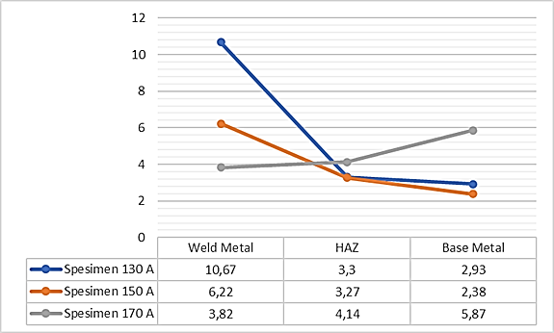
FIGURE 2. Graph of Hardness Values ​​with Current Variations

From FIGURE 2 above, it can be seen that for Weld Metal, the 130 A specimen variation is the highest hardness value, and the 170 A specimen variation is the lowest hardness value in the Vickers test. In the HAZ, the 170 A specimen variation is the highest hardness value, the 150 A specimen variation is the lowest hardness value in the Vickers test. In Base Metal, the 170 A specimen variation is the highest hardness value, the 150 A specimen variation is the lowest hardness value in the Vickers test.

Tensile Test
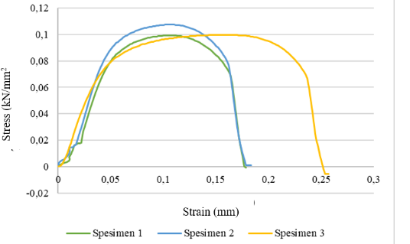
FIGURE 3. Stress Strain Graph for Current Variations of 130A, 150A, 170A

After calculating using the equation above which is entered into the calculation table, it produces a graph from testing specimen 1, varying the current strength of 130 A with a maximum tensile stress value of 0.0786 kN/mm2 and an average tensile stress value of 0.2482 kN/mm2 , in specimen 2 the current strength variation is 150 A with a maximum tensile stress value of 0.1135 kN/mm2 and the average tensile stress value is 0.0747 kN/mm2, in specimen 3 the current strength variation is 170 A with a maximum tensile stress value of 0.1006 kN/mm2 and the average value of tensile stress is 0.0674 kN/mm2.
From the FIGURE 3, it shown that the stiffness value refers to the elastic modulus value. To determine the largest stiffness value obtained from the elastic modulus value, the largest value was obtained for the current variation of 130 A with a value of 5,589 N/m² and for The smallest value is at a current variation of 170 A with a value of 1,659 N/m². The strength value refers to the maximum stress value that can be withstood before aluminum fractures. The greatest strength value is found at a current variation of 130 A with a value of 0.113 kN/mm2 and the smallest value is at a current variation of 150 A with a value of 0.997 kN/mm2. Ductility value refers to the maximum strain value that occurs before aluminum fractures. The greatest ductility value is found at a current variation of 170 A with a value of 0.256 mm and the smallest value is at a current variation of 130 A with a value of 0.168 mm. The toughness value refers to the area under the strain-stress curve. From the UT calculation [=] F/A × ΔL/L = (N·m−2) we get the maximum value for a current variation of 150 A with a value of 0.185 J/m³ and the smallest value for a current variation of 130 A with a value of 0.016 J/m³.

CONCLUSIONS
- On an aluminum plate with a current variation of 130 A, the lowest distortion value was 0.36 mm and the highest value was 0.89 mm. On an aluminum plate with a current variation of 150 A, the lowest distortion value was 0.53 mm and the highest value was 1.36 mm. On an aluminum plate with a current variation of 170 A, the lowest distortion value is 0.55mm and the highest distortion value is 1.55 mm. The distortion test results for the 3 variables experienced a constant increase due to the high current and low welding speed resulting in excessive heat buildup.
- In Weld Metal, the 130 A specimen variation is the highest hardness value, and the 170 A specimen variation is the lowest hardness value in the Vickers test. In the HAZ, the 170 A specimen variation is the highest hardness value, the 150 A specimen variation is the lowest hardness value in the Vickers test. In Base Metal, the 170 A specimen variation is the highest hardness value, the 150 A specimen variation is the lowest hardness value in the Vickers test.
- Determining the largest stiffness value is obtained from the modulus of elasticity value. The largest value is obtained for a current variation of 130 A with a value of 5,589 N/m² and for the smallest value for a current variation of 170 A with a value of 1,659 N/m². The strength value refers to the maximum stress value that can be withstood before aluminum fractures. The greatest strength value is found at a current variation of 130 A with a value of 0.113 kN/mm2 and the smallest value is at a current variation of 150 A with a value of 0.997 kN/mm2. Ductility value refers to the maximum strain value that occurs before aluminum fractures. The greatest ductility value is found at a current variation of 170 A with a value of 0.256 mm and the smallest value is at a current variation of 130 A with a value of 0.168 mm. The toughness value refers to the area under the strain-stress curve. From the UT calculation [=] F/A × ΔL/L = (N·m−2) we get the maximum value for a current variation of 150 A with a value of 0.185 J/m³ and the smallest value for a current variation of 130 A with a value of 0.016 J/m³.

Acknowledgments
This research was supported by Universitas Muhammadiyah Malang. The authors are grateful to all parties for their guidance and support. We also thank laboratory staff, technicians, and other contributors for their valuable contributions.

References
- A. Nugroho, "Pengaruh variasi kuat arus pengelasan terhadap kekuatan tarik dan kekerasan sambungan las plate carbon steel ASTM 36," Jurnal Rekayasa Sistem Industri, vol. 3, no. 2, pp. 134-142, 2018.
- M. K. Abbass, A. Ul-Qader, and G. Jihad, "Effect of Filler Metals on Microstructure and Mechanical Properties of GTAW Welded Joints of Aluminum Alloy (AA2024-T3)," Engineering and Technology Journal, vol. 38, no. 8A, pp. 1236-1245, 2020.
- Z. A. Mutair and H. M. Mohammad, "Prediction of Residual Stresses in 316 Stainless Steel Pipes Welded Joint," Basrah Journal for Engineering Sciences, vol. 23, no. 2, pp. 20-25, 2023.
- G. Yi, B. Sun, J. D. Poplawsky, Y. Zhu, and M. L. Free, "Investigation of pre-existing particles in Al 5083 alloys," Journal of Alloys and Compounds, vol. 740, pp. 461-469, 2018.
- V. Pasalbessy, S. Jokosisworo, and S. Samuel, "Pengaruh Besar Arus Listrik Dan Kecepatan Las Terhadap Kekuatan Tarik Aluminium 5083 Pengelasan TIG (Tungsten Inert Gas)," Jurnal Teknik Perkapalan, vol. 3, no. 4, pp. 336-345, 2015.
- R. P. Verma, K. N. Pandey, and Y. Sharma, "Effect of ER4043 and ER5356 filler wire on mechanical properties and microstructure of dissimilar aluminium alloys, 5083-O and 6061-T6 joint, welded by the metal inert gas welding," Proceedings of the Institution of Mechanical Engineers, Part B: Journal of Engineering Manufacture, vol. 229, no. 6, pp. 1021-1028, 2015.
- S. Balamurugan et al., "Microstructure and mechanical properties of cold metal transfer welding AA6082-T4 alloys," Indian J. Sci. Technol., vol. 12, no. 42, pp. 1-8, 2019.
- M. Khusaini, F. Fadelan, and Y. Winardi, "Pengaruh Kuat Arus Terhadap Kekuatan Tarik Dan Struktur Mikro Pada Pengelasan Mig (Metal Inert Gas) Aluminium 6061," AutoMech: Jurnal Teknik Mesin, vol. 1, no. 01, pp. 25-29, 2021.
- B. Çevik, "Gas tungsten arc welding of 7075 aluminum alloy: microstructure properties, impact strength, and weld defects," Materials Research Express, vol. 5, no. 6, p. 066540, 2018.
- H. Arora, P. Ramesh, K. V. Kumar, G. S. N. Rao, M. Pavan, and S. J. Sai, "Three dimensional finite element analysis to predict the effects of structural boundary conditions on temperature Distortion, angular distortion in single pass butt joint," Materials Today: Proceedings, vol. 50, pp. 962-968, 2022.
- V. D. Kalyankar and P. Shah, "A review on methodologies to reduce welding distortion," Materials Today: Proceedings, vol. 5, no. 11, pp. 24741-24749, 2018.
- B. Wang, H. Lan, and B. Lei, "Effect of Welding Method on Microstructure and Mechanical Properties of L360QS/N08825 Composite Pipe Welded Joint," Transactions of the Indian Institute of Metals, vol. 73, pp. 629-643, 2020.
- M. Tiryakioğlu and J. S. Robinson, "On the representative strain in Vickers hardness testing of 7010 aluminum alloy," Materials Science and Engineering: A, vol. 641, pp. 231-236, 2015.
- W. D. Callister Jr and D. G. Rethwisch, Fundamentals of materials science and engineering: an integrated approach. John Wiley & Sons, 2020.
- R. D. Salindeho, J. Soukotta, and R. Poeng, "Pemodelan pengujian tarik untuk menganalisis sifat mekanik material," Jurnal Poros Teknik Mesin Unsrat, vol. 2, no. 2, pp. 1-11, 2013.
- B. Aydemir and B. Cal, "Quality of material tensile test," in International Quality Conference, 2011, pp. 331-336.
- M. Rohman, A. Saepuddin, and M. A. Fardana, "ST41 tensile strength analysis of spiral groove welding with three current variations," Jurnal Pendidikan Teknik Mesin Undiksha, vol. 8, no. 2, pp. 62-68, 2020.
- V. Sharma and A. S. Shahi, "Effect of groove design on mechanical and metallurgical properties of quenched and tempered low alloy abrasion resistant steel welded joints," Materials & Design, vol. 53, pp. 727-736, 2014.

