Design and Fabrication of Stationary Bed Reactor with 500mL Capacity
Rizki Setiadi^{1,a)}, Catur Rini Widyastuti^{2,b)}, Rahmat Doni Widodo^{1,c)}, Habib Al Wahid^{1,d)}, and Iqbal Rasendriya Arafah^{1,e)}
¹Department of Mechanical Engineering, Universitas Negeri Semarang, Semarang, Indonesia
²Department of Chemical Engineering, Universitas Negeri Semarang, Semarang, Indonesia

^{a)} Corresponding author: rizkisetiadi@mail.unnes.ac.id
^{b)} catur.rini@mail.unnes.ac.id
^{c)} rahmatdoniwidodo@mail.unnes.ac.id
^{d)} habibalwahid1@students.unnes.ac.id
^{e)} Iqbala428@students.unnes.ac.id
Abstract. The use of reactors for chemical reactions using solid-state immobilized enzymes requires effective mass and heat transfer. The common reactor used is a rotating bed reactor that allows simultaneous mixing and filtration through a heterogeneous catalyst bed placed in a cylindrical basket. The use of heterogeneous catalysts in the chemical industry is known to be more profitable because apart from having high activity, it also has advantages including ease of separation from the reaction mixture and can be used repeatedly. The purpose of this study was to development a 500 mL Stationary Bed Reactor for laboratory scale. The method used in this study uses research and development (R&D) with a 3D approach (Define, Design, and Development). The results of the study showed that a Stationary Bed Reactor with an iron and stainless-steel frame, a capacity of 500 mL with a maximum rotation stirring of 466 RPM, a maximum temperature control of 100º Celsius, and using on-off control on the reactor heater.
Keywords: Design, Reactor, Stationary Bed Reactor, Slurry

INTRODUCTION
Catalysts play a very important role in chemical reactions, both in the chemical industry and in renewable energy production [1]. Catalysts can lower the activation energy by avoiding the slow rate-determining step of a reaction that cannot be catalyzed [2]. Solid catalysts are frequently employed to speed up chemical reactions, including esterification, transesterification, alkylation, and other processes. Among these is the Matter Car Composition (MCM-48) catalyst, which is employed as a heterogeneous catalyst in the esterification of glycerol with oleic acid to yield glycerol oleate [3]. Strontium oxide (SrO) has shown promise as a heterogeneous catalyst for the biodiesel industry, according to studies on heterogeneous catalysts based on metal oxides used in biodiesel manufacturing [4]. Apart from its application in the chemical industry, solid catalysts are also being developed as heterogeneous biocatalysts as a substitute for chemical reactions that are more ecologically friendly. One of them involves the use of biocatalysts produced from the manufacture of isoamyl acetate esters (banana odor) utilizing palm tree fronds as precursors, and an investigation into the impact of activated carbon on lipase immobilization.
Because of its high activity, ease of separating mixtures, and repeatable reactions, research on heterogeneous catalysts is thought to be more beneficial for the chemical industry. Generally speaking, the catalysts that are created are made of powder and are intended to improve the mass transfer efficiency and catalytic activity of molecules. However, the type of reactor frequently places restrictions on the catalyst mixing procedure when using powder form. The method of combining catalysts involves the use of many reactors. A slurry reactor is the type of reactor utilized in liquid phase reactors that contain catalysts. Stirring is used in the slurry reactor to combine the liquid phase reactant and powdered catalyst. The drawback of using granular or powdered catalysts in stirred reactors is the need for a filtration step to extract the catalyst from the reaction mixture. Furthermore, because the powdered solid catalyst follows the direction of fluid flow during stirring, it is recognized that there are significant mass transfer limits between the liquid and solid phases.
The rotating bed reactor is the most often used type of reactor, as shown in FIGURE 1. This kind of reactor is an adaptation of a stirred tank (STR) and fixed bed reactor (FBR). Centrifugal force powers the reactants in the revolving cell. The catalyst can now be recycled inside the tank or vessel thanks to this change. The catalyst separation and reaction occur concurrently in the rotating bed reactor; however, because the catalyst mixing process is conducted at a slow stirrer rotation speed, mass and heat transfer are still considered to be limited. This means that a fixed bed reactor—which can overcome the drawbacks of both slurry reactors and rotating bed reactors-is required [5].
.
Mixed product
Feed
Agitator
Cooling Jacket
Buflle
Motor


Catalyst particles

FIGURE 1. Slurry Reactor

For reactor tanks with volumes between 100 and 500 mL, the rotating bed reactor type with rotating catalyst bed can operate in a low stirrer rotation speed range of typically not more than 1000 rpm. Larger tanks have the capacity to run at a lower range of stirring speeds. Limited mass and heat transmission efficiency result from this. The adoption of a stationary bed reactor [6] is one possible technical solution. This kind of reactor is made up of a stationary catalytic bed, a circular catalyst basket or bed, and a stirrer.
By using vacuum filtration, catalysts that are in the form of solids smaller than 500 μm can be separated. Relatively significant energy and high catalyst recycling complexity are needed for this separation. As a result, a more effective technique for its separation is required, one of which involves building a reactor that enables the reaction and filtration to occur simultaneously. A rotating bed reactor is the type of reactor that can be employed. The reactor is a catalyst or stirred tank with a basket attached. The catalyst is positioned within a compartment and rotates in the opposite direction of the liquid fluid, following the direction of stirring. By doing this, the external mass transfer limit between the liquid fluid and the catalyst surface can be reduced. Furthermore, the catalyst can be kept inside the compartment and apart from the flowing fluid thanks to this design. This architecture permits an ongoing procedure. One drawback of a rotating bed reactor is its maximum stirring speed restriction. This kind of reactor has a low speed stirring mechanism.
Less effective heat and mass transport occurs in the reactor as a result of this. Using a stationary bed reactor with a fixed bed that holds a hollow catalyst basket is the suggested approach. This makes it possible to stir quickly, minimizing the limits imposed by interphase mass transfer. The efficiency of the catalyst and, thus, the yield of the reaction products can both be increased by using an appropriate reactor for this heterogeneous process.
In order to achieve high catalytic activity and selectivity, heterogeneous catalysts can be solid materials that are either pure metals or solids that are created by mixing metals and non-metals with supporting components. It is possible to create solid catalysts by adding chemicals or heating an activation stage. There are a number of different kinds of catalysts, which are catalysts that have been created in a lab setting and are recognized for their high activity and reaction-specific selectivity. As shown in Table 1, a variety of reactor types are used to test these catalysts. Slurry reactors are used for the majority of laboratory testing. Catalyst powder is added directly to the liquid phase reaction mixture in this sort of reactor.
The goal of using catalysts in chemical reactions is to speed up the reaction in order to improve the process's efficiency. A good catalyst is one that minimizes the generation of byproducts by having a high activity and being selective towards a certain reaction. Heterogeneous catalysts with high activity and selectivity towards a variety of chemical processes, including esterification, transesterification, hydrolysis, alkylation, etc., have been created extensively from solid materials, including metals and non-metals, supported by zeolites and carbon. The complexity of the reactor needed for solid-liquid phase reactions in industrial settings is a drawback of employing these catalysts. To improve the catalytic reaction system's efficiency, the reactor design must be suitable. In this investigation, an examination. The aim of this research is to development a 500 mL stationary reactor with temperature and rotation control for laboratory scale.

METHODS
This research method used research and development (R&D) with a 3D approach (define, design, and development). The first stage is define, which is defining the function of the reactor and the needs of the reactor components needed. The next stage is design. The design stage is designing the reactor using CAD software to obtain working drawings before the reactor fabrication process. The last stage is development. The fabrication process of creating a stationary bed reactor. The research flow is shown in FIGURE 2.

Fabrication, specification, and testing of rotation & temperature control performance
Working principle of reactor
main component: motor, motor controller, agitator, reactor glass, and temperature controller

3D modelling and detail drawing using CAD software

FIGURE 2. Research flowchart

RESULTS AND DISCUSSION
Design stationary bed reactor one kind of reactor that is frequently used in the chemical industry for catalytic reactions is the stationary bed reactor. The architecture of this reactor is straightforward but effective in promoting chemical reactions, particularly when heterogeneous catalysts are used. In the petrochemical, pharmaceutical, and waste treatment industries, where steady and regulated chemical reactions are crucial, stationary bed reactors are frequently utilized. A solid catalyst is kept stationary inside a reactor known as a stationary bed reactor, often called a fixed bed reactor, while a reactant fluid passes across it. Inside the reactor, the catalyst is firmly packed in the form of tiny beads or particles. Reactants are transformed into the intended products on the catalyst surface by chemical reactions that take place while the reactant fluid passes through it. Using the contact between the fluid and the solid catalyst to initiate the chemical reaction is the reactor's basic operating concept. This arrangement is called a "fixed bed" since the catalyst is immobile. In order to maximize the reaction and guarantee reliable results, the reactor's temperature and fluid flow rate are carefully controlled. 3D model images are used to illustrate the working principle of a stationary bed reactor. 3D design and bill of materials are shown in FIGURE 3 and FIGURE 4.

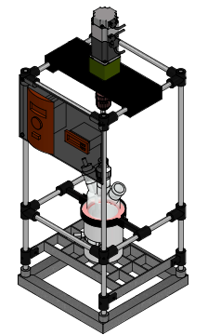
Glass Reactor
Electric Motor
Frame
Temperature
controller
Motor Controller
FIGURE 3. 3D Model Stationary Bed Reactor

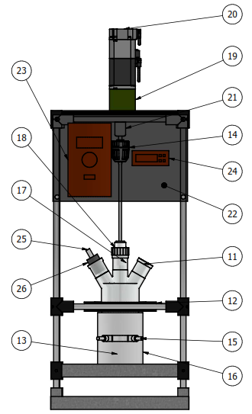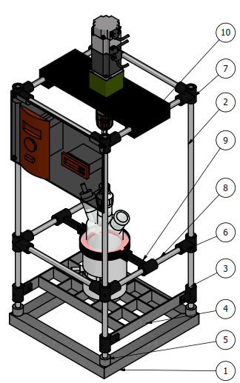
Bills of Materials :

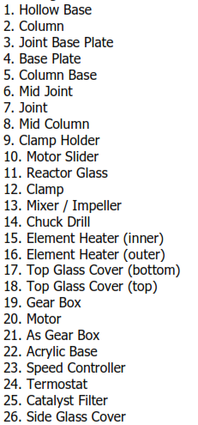

25. Catalyst Bed
26. Side Glass Cover

FIGURE 4. Component Details Stationary Bed Reactor

Based on Figure 4, the stationary bed reactor design used a bottom frame using iron, and a side frame using stainless steel. The reactor stand is made of iron and is hollow so that the heat spread from the heater to the reactor frame can be minimized, so that the heat spread is centered on the reactor. The use of a heater with a diameter of 90 mm and a height of 90 mm is adjusted to the height of the reactor glass so that the heat generated and transferred to the reactor glass can be comprehensive.
From the 3D model design that has been created, the fabrication process is carried out by making a reactor frame with iron and stainless-steel materials. The connection process is carried out by welding and assembling the frame using bolts. The reactor that has been produced is shown in FIGURE 5. The specifications of the reactor that has been created are shown in TABLE 1.

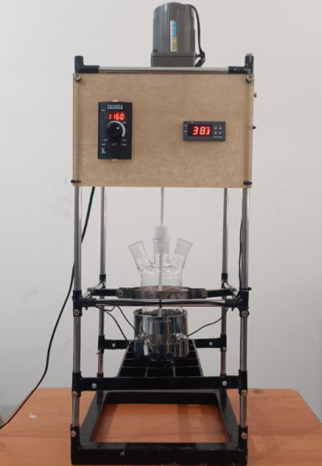
FIGURE 5. Stationary Bed Reactor 500 mL

TABLE 1. Reactor Specifications
Spesification | Details
Reactor capacity (Max.) | 500 mL
Frame Materials | Bottom frame: iron  Side frame: stainless steel
Dimensions  (length x width x height) | (320x320x730) mm
Motor Voltage | AC 220V
Motor Controller Model | FX1000A
Gearbox motor/Speed ratio | 1:3
Motor Power | 40 Watt
Heating Control | STC-1000 (0-100ºC)
Temperature Controller | On-Off
Heater voltage and dimensions | 220V, ∅ 90mmx90mm
Max. RPM | 466 RPM

Based on the research, the specifications of the stationary bed reactor are shown in table 1. The specifications of this reactor are the type of frame material used, the dimensions of the reactor, the motor power used, the operational temperature range and the rotation of the stationary bed reactor. This reactor can be used with several variations with an operational temperature of 0-100 degrees and a maximum stirring rotation of 466 RPM and a maximum capacity of 500 mL.

FIGURE 6. Heater temperature increase using on/off control

Based on FIGURE 6, the reactor temperature control test requires a temperature increase time from room temperature to the reaction setting temperature for 180 seconds. Using the on-off control temperature setting, the control temperature can be set at a temperature of 70 degrees with a heater maximum peak temperature at 77.5 at 220 seconds, and steady state at 260 seconds. Performance testing has been carried out to determine the comparison of the increase in heater temperature and temperature inside the reactor. Based on the results of the trial using water in the reactor glass and operated with a stirring rotation of 330 RPM with a heater control temperature of 70 degrees, it takes 21 minutes for the temperature inside the reactor glass to reach 70 degrees Celsius. The comparison graph of the heater temperature and inside the reactor glass is shown in FIGURE 7.

FIGURE 7. Comparison of heater temperature and inside the reactor

The design and fabrication of the catalyst bed in the reactor are shown in FIGURE 8. Catalysts play a very important role in chemical reactions, both in the chemical industry and renewable energy production. The mechanism of catalysis involves the interaction between the catalyst and the reactants which can increase the efficiency of the reaction, reduce the energy required, or allow reaction pathways that are not possible spontaneously.

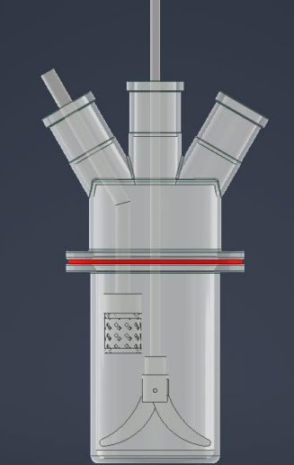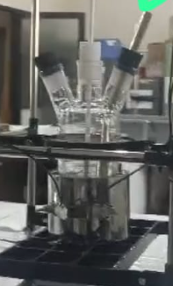
FIGURE 8. Design and fabrication of the catalyst bed

CONCLUSIONS
A stationary bed reactor with a maximum speed of 466 RPM and a maximum operating temperature of 100 degrees Celsius with on-off control on the reactor heater has been created. This reactor can be used to react several materials that meet specifications at an affordable price. It is necessary to test the reaction by setting the temperature and rotation as needed with the addition of catalysts and condensers. In the catalyst bed reactor that has been created, it is necessary to test the chemical reaction with variations in the stirring speed and temperature according to needs.

Acknowledgments
This article is funded by the research of lecturers of DPA FT UNNES, Budget Implementation List (DPA) FT Semarang State University Number: 023.17.2.690645/2024.05/2024, dated December 21, 2023 in accordance with the Letter of Agreement for the Implementation of Research by Lecturers (Faculty) DPA Fund FT UNNES Year 2024 Number 106.22.3/UN37/PPK.05/2024.

References
- Y. Ramadhanti, "Peran Katalis Dalam Reaksi Kimia: Mekanisme Dan Aplikasi," Hexatech: Jurnal Ilmiah Teknik, vol. 2, no. 2, pp. 74-78, 2023.
- Y. Susanto, S. B. Lestari, and E. Purwati, "POLA PERESEPAN OBAT ANTIDIABETIK PADA PASIEN DIABETES MELITUS TIPE 2 DI POLI PENYAKIT DALAM RS “X” SIDOARJO PERIODE OKTOBER-DESEMBER 2019," AFAMEDIS, vol. 1, no. 2, pp. 21-30, 2020.
- B. M. Kurji and A. S. Abbas, "MCM-48 from rice husk ash as a novel heterogeneous catalyst for esterification of glycerol with oleic acid: Catalyst preparation, characterization, and activity," Case Studies in Chemical and Environmental Engineering, vol. 8, p. 100382, 2023.
- V. Gadore, S. R. Mishra, N. Yadav, G. Yadav, and M. Ahmaruzzaman, "Metal oxide-based heterogeneous catalysts for biodiesel production," Next Sustainability, vol. 2, p. 100012, 2023.
- D. Kowalczykiewicz, K. Szymańska, D. Gillner, and A. B. Jarzębski, "Rotating bed reactor packed with heterofunctional structured silica-supported lipase. Developing an effective system for the organic solvent and aqueous phase reactions," Microporous and Mesoporous Materials, vol. 312, p. 110789, 2021.
- D. Stradomska, D. Świętochowska, R. Kubica, U. Hanefeld, and K. Szymańska, "New type of basket stationary bed reactor for heterogeneous biocatalysis," Chemical Engineering and Processing-Process Intensification, vol. 194, p. 109590, 2023.

