The Effect of Temperature Solution Heat Treatment Variation on Mechanical Properties in 2024 Aluminium
Dini Kurniawati^{a)}, Iis Siti Aisyah^{b)}, Nur Hasanah^{c)}, Rizqi Aufa Muzakki Pratama^{d)}, Suwarsono^{e)}, and Muhammad Zahmil^{f)}
Department of Mechanical Engineering, University of Muhammadiyah Malang, Malang, Indonesia

^{b)} Corresponding author: siti@umm.ac.id
^{a)} dini@umm.ac.id
^{c)} nur_hasanah@umm.ac.id
^{d)} rizqiaufa98@gmail.com
^{e)} suwarsono@umm.ac.id
^{f)} muhammadzahmil24@gmail.com
Abstract. Aluminum is one of the most widely used in the industrial world and in everyday life, it is because Aluminum has light and strong properties. In addition, the increasing use of aluminum is due to its advantages over other metals, including a good conductor of electricity. However, aluminum also has its disadvantages in its poor mechanical properties. In order to improve its mechanical properties, aluminum is combined with Cu, Si, Mg, Zn, Mn, Ni and other element, and also the way to improve its mechanical properties, aluminum is subjected to the heat-treatment process. This study looks for the effect of temperature variations at 493,495, 505, 520 and 525 on some properties such are hardness, tensile strength, conductivity, and microstructure. The results concluded that the ratio of the temperature variation of 525 °c indicate the higher and better strength values. While other temperature test results show lower results.
Keywords: Heat Treatment, Temperature, Variations

INTRODUCTION
The development of industrial technology in the current era will always be followed by a demand for products of better quality. Various ways are taken to create products that are better than before, one of which is by modifying the properties of the material by manipulating the heat treatment temperatures of various materials that are widely used in various aspects of human life.
Aluminum and aluminum alloys are metals that are widely used in the automotive, shipping, airplane industry and so on. Products made of aluminum are one of the most widely used in the industrial world and in everyday life. Aluminum is widely used because it has light and strong properties. In addition, the increasing use of aluminum is due to its advantages over other metals, including a good conductor of electricity. However, aluminum also has its disadvantages in its poor mechanical properties. In order to improve its mechanical properties, aluminum is combined with Cu, Si, Mg, Zn, Mn, Ni and other elements.
Aluminum is classified into 2 parts that can be heat treated (heat treatable) and can not be heat treated (non heat treatable). Aluminum Series 2xxx, 4xxx, 6xxx, 7xxx series can be heat treatable and non heat treatable series 1xxx, 3xxx, 4xxx, 5xxx for series 4 can be heat treated or not if the Si content is less than 1.6 as it reaches single phase if heated above the solvus line. Heat treatment is a combination of heating, temperature heating and cooling with the aim of increasing mechanical properties such as hardness, strength, ductility, toughness [1]. Hardening is often used to increase strength alloys and is the primary strengthening mechanism of high strength 2xxx aluminum alloys. Al alloys have a wide application range from the automotive industry to the aerospace industry. Research on solution heat treatment in aluminum generally varies temperatures from 350 to 450-550 carried out on material 6061, the final project of (Munir Misbahul, 2019) [2] "the effect of temperature variations of solution heat treatment on the mechanical properties of aluminum guide series 6061 with T4 heat treatment". Therefore, there has not been much research in the area of ​​temperature variations with the aluminum series 2024 with a thickness of 1.6 mm. For this reason, this study looks for the effect of temperature variations at 493-495-505-520-525 on mechanical and microstructure properties.

METHODS
The research was conducted in June 2019 until completion. Specimen testing is carried out at Aircraft manufacture in Bandung, Indonesia. In this research, 2024 aluminum used as material specimen with the thickness 1.6 mm. Conductivity test using the Sigmatest 2069 conductivity tool and the hardness test using Compressive force with 100 kg load-cell. Tensile test equipment using the Instron 5980/600kn, and Nikon LV150 as a micro test tool.
Heat treatment machine using kraft furnace, which the aluminum was heat treated with temperature variations. Before 2024 aluminum material was carried out heat treatment it is treated by cleaning and pickling. After the material goes through the heat treatment process for 30 minutes holding time, then tested. It can be seen through the process flow diagram of the 2024 aluminum heat treatment process, all requirements according to industry SOP/standard operating procedure. The complete procedure is in the diagram below in FIGURE 1.

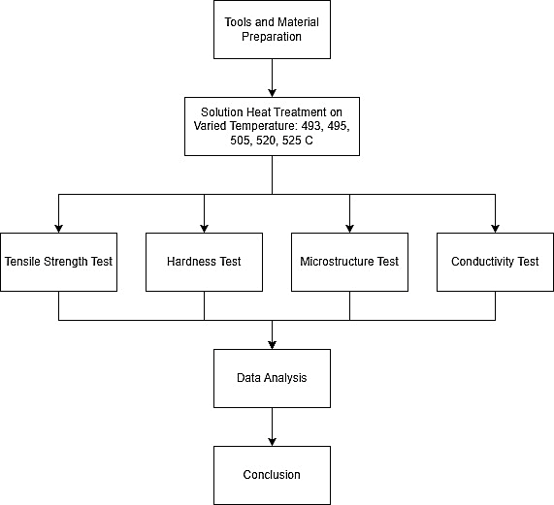
FIGURE 1. The Flowchart of Heat Treatmen Process

RESULT AND DISCUSSION

Results of Hardness Testing Data
Tests were carried out on each of 2 specimens, The hardness test results data can be seen in the temperature variation hardness test, can be seen at TABLE 1.
TABLE 1. Result of Hardness Test
Temperature | Number of Test | Speciment A | Speciment B | Mean
T0 | 1 | 52.1 HR | 39. 2 HR | 43 HR
T0 | 2 | 52 HR | 38.2 HR | 43 HR
T0 | 3 | 53.1 HR | 23.9 HR | 43 HR
493 | 1 | 66 HR | 68.5 HR | 67.5 HR
493 | 2 | 69 HR | 71 HR | 67.5 HR
493 | 3 | 67 HR | 66.8 HR | 67.5 HR
495 | 1 | 68.2 HR | 70 HR | 68.3 HR
495 | 2 | 69.1 HR | 68.2 HR | 68.3 HR
495 | 3 | 67.2 HR | 67.2 HR | 68.3 HR
505 | 1 | 69 HR | 69.8 HR | 68.3 HR
505 | 2 | 68.3 HR | 69.8 HR | 68.3 HR
505 | 3 | 68.3 HR | 65 HR | 68.3 HR
520 | 1 | 68 HR | 68 HR | 68.3 HR
520 | 2 | 67 HR | 68.2 HR | 68.3 HR
520 | 3 | 69.5 HR | 69.1 HR | 68.3 HR
525 | 1 | 68.2 HR | 70.2 HR | 69 HR
525 | 2 | 68.1 HR | 70 HR | 69 HR
525 | 3 | 68.1 HR | 70 HR | 69 HR

The results of hardness testing on each heat treatment specimen with temperature variations of 493 °, 495 °, 505 °, 520 °, and 525 ° are then used as a comparison chart which can be seen in the FIGURE 2. The visualization of hardness specimen is displayed in FIGURE 3.

FIGURE 2. Hardness test Results

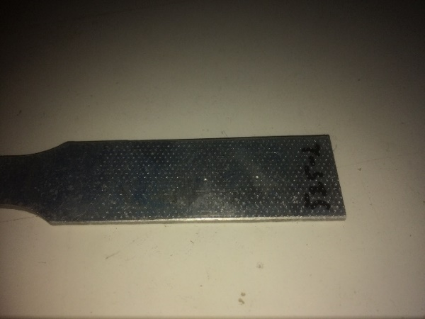
FIGURE 3. Hardness Speciment

Tensile Test Result Data
Tensile Testing to determine the maximum stress in 2024 Al material with temperature variations. From the results of the Pull test can be seen in the table as follows TABLE 2.

TABLE 2. Result Of Tensile test
Temperature | Spesimen | Max Load  (kg) | Tensile Strength  (kg/mm2) | Yield Strength  (kg/mm2) | Elongation  (%)
T0 | 1 | 3463.92 | 164.55 | 76.93 | 18.96
 | 2 | 3144.92 | 156.37 | 58.17 | 19.60
Mean |  | 3304.42 | 160.46 | 67.55 | 19.28
493 | 1 | 8981.97 | 437.18 | 269.29 | 22.84
 | 2 | 9458.51 | 456.85 | 279.31 | 17.12
Average |  | 9220.24 | 447.015 | 274.3‬ | 19.98
495 | 1 | 9105.10 | 443.99 | 271.21 | 17.36
 | 2 | 9284.39 | 444.77 | 274.54 | 13.88
Average |  | 9194.74 | 444.38 | 272.87 | 15.62
505 | 1 | 9296.41 | 439.13 | 270.65 | 18.76
 | 2 | 9377.91 | 448.21 | 211.68 | 24.36
Average |  | 9337.16 | 443.72 | 241.16 | 21.56
520 | 1 | 9192.18 | 436.28 | 269.24 | 24.76
 | 2 | 8844.78 | 433.05 | 267.84 | 20.44
Average |  | 9018.48 | 434.66 | 268.54 | 22.60
525 | 1 | 9440.90 | 462.11 | 287.78 | 21.60
 | 2 | 9516.90 | 457.98 | 281.69 | 20.00
Average |  | 9478.90 | 460.04 | 284.73 | 20.80

The results of tensile strength testing on each heat treatment specimen with temperature variations of 493 °, 495 °, 505 °, 520 °, and 525 ° are then used as a comparison chart which can be seen in the FIGURE 4-7 of Tensile Strength and Elongation. While its visualizations are shown in FIGURE 8.

FIGURE 4. Graph of Tensile Strength Results

FIGURE 5. Graph Results

FIGURE 6. Graph of Tensile Strength

FIGURE 7. Graph of Yield Strength

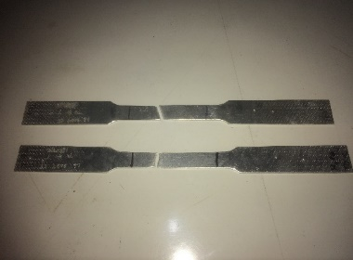 | 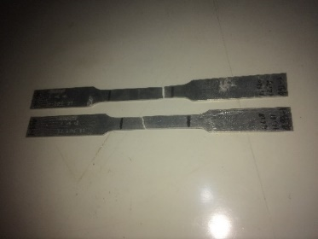 | 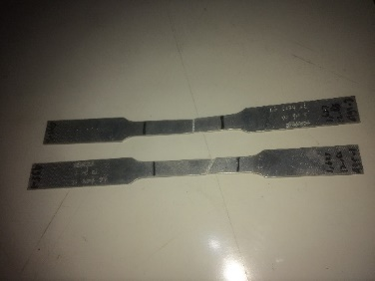
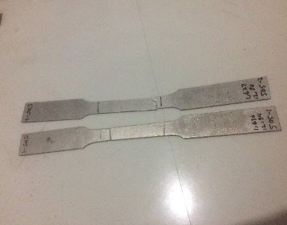 | 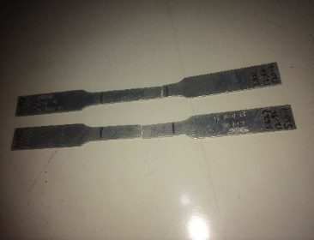 | 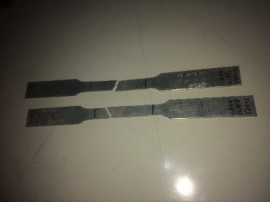
FIGURE 8. Tensile Test Specimens

Conductivity Test Results Data
Conductivity testing to determine the value of electrical conductivity in 2024 Al material with temperature variations. From the results of the Conduvtivity test, it can be seen in the TABLE 3 and FIGURE 9 as follows.
TABLE 3. Result of Conductivity Test
Temperature | Specimen Number | Conductivity
T0 | 1 | 49.35 %IACS
T0 |  | 49.62 %IACS
T0 | 2 | 48.59 %IACS
T0 |  | 48.72 %IACS
Mean |  | 49.07 %IACS
493 | 1 | 30.8 %IACS
493 |  | 30.12 %IACS
493 | 2 | 30.13 %IACS
493 |  | 30.21 %IACS
Mean |  | 30.31 %IACS
495 | 1 | 29.88 %IACS
495 |  | 29.94 %IACS
495 | 2 | 30.09 %IACS
495 |  | 30.17 %IACS
Mean |  | 30.02 %IACS
505 | 1 | 29.35 %IACS
505 |  | 29.51 %IACS
505 | 2 | 29.57 %IACS
505 |  | 29.73 %IACS
Mean |  | 29.54 %IACS
520 | 1 | 28.88 %IACS
520 |  | 29.90 %IACS
520 | 2 | 29.20 %IACS
520 |  | 29.21 %IACS
Mean |  | 29.29 %IACS
525 | 1 | 28.16 %IACS
525 |  | 28.35 %IACS
525 | 2 | 27.86 %IACS
525 |  | 28.27 %IACS
Mean |  | 28.16 %IACS

FIGURE 9. Graph of conductivity results

Microstructure Testing Result Data
Microstructural test results to see the results of the granules of aluminum material 2024 to determine the hardness of 2024 aluminum. The test result can be seen in FIGURE 10-15.

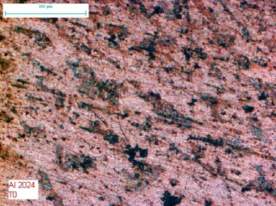  FIGURE 10. T0 Microstructure | 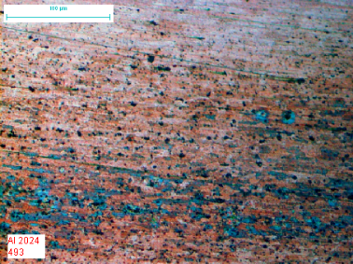  FIGURE 11. 493° Microstructure
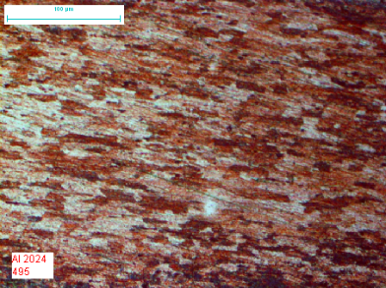  FIGURE 12. 495° Microstructure | 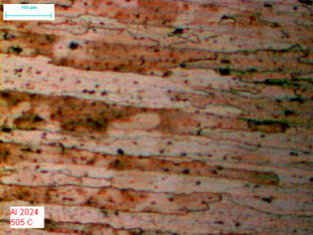  FIGURE 13. 505° Microstructure
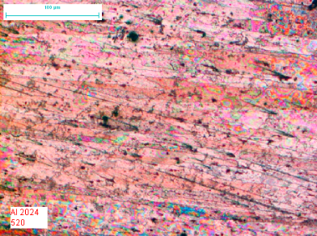  FIGURE 14. 520° Microstructure | 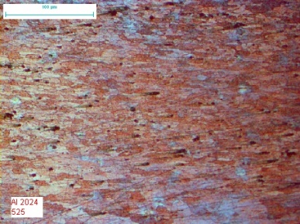  FIGURE 15. 525° Microstructure

DISCUSSION RESULTS

Discussion of Hardness Testing Results
The hardness test results from the results of the raw material hardness test and after being given the solution heat treatment process, the hardness value of the heat treatment temperature variations has increased from the hardness test results. This is because the higher the temperature given to the material, the value of the mechanical properties of a material will increase. This is in accordance with research [3] Hardness will increase with length, holding time and increasing process temperature.
After the heat treatment process at temperature variations the hardness value increases at temperature variations 493 to 495 increases around 1.2 HR and at a temperature of 520 to 525 increases around 0.7 HR, for temperatures in heat treatment 495.505, and 520 from the test results the average value is the same there is no change. And for the highest hardness value in the heat treatment process at a temperature of 525 ° C. According to research [4], materials that are subjected to heat treatment with a long holding time are materials with the highest hardness value.
The hardness value at the temperature variation of 525 ° C is higher, this is because the granules in the material begin to stretch according to the microstructure results showing that there has been a hardening process in the material precipitates which results in an increase in the hardness of the material. But the results of other temperature variations are compared to the highest temperature because the temperature used is not high enough for a material which results in the atomic granules not being stretched so that the hardness value decreases, but from other temperatures it meets the ASTM E8 standard but the hardness results are higher with temperature. 525 ° C. According to research [5] the variation of material hardness from the test can be seen through its microstructure, caused by the tendency of material sediment grains. The coarser the sediment grains, the hardness will decrease, while the finer the sediment grains the harder the material will be.

Discussion of tensile test results
In the table and graph above it can be concluded that the results of the tensile test that have been carried out, it can be concluded that the tensile value of Aliminium 2024 after the heat treatment process, the tensile value of 2024 aluminum tends to increase with higher temperature, the highest tensile value lies in aluminum with a temperature of 525 ° amounting to 9478.90 N and the lowest tensile value at 520 ° of 9018.48 N. From the graph above, it can be concluded that the higher the temperature, the value of the 2024 aluminum tensile test is getting higher. It can be seen from research [6] that it can be concluded that the higher the temperature, the lower the maximum tensile stress (UTS).

Discussion of the results of the Conductivity test
In the table and graph above, it can be concluded that the results of the 2024 aluminum conductivity test are the highest value of the test results at a temperature of 493 ° and the lowest value of the test results at a temperature of 525 °. It can be concluded that the higher the temperature, the lower the conductivity and the higher the low temperature conductivity. So the electric current at high temperatures is easy and free electrons in aluminum, this can be seen from the grains contained in aluminum, where the grains in aluminum are getting smaller which makes the electric current move freely.
This can be seen in research [7] The more free and easy electrons move, the higher the value of their electrical conductivity. Conversely, if when moving the electrons encounter many obstacles, their electrical conductivity will decrease. Many things can cause electrons to experience resistance when moving, one of which is the dislocation. The more dislocation density that accumulates, especially at the grain boundaries, the more difficult it is for electrons to move, so that the electrical conductivity will decrease.

Discussion of Microstructure results
From the results of the above microstructure it can be concluded that aluminum 2024 has changed the number of grains on the surface of aluminum 2024. In this study, the results of microstructure testing which have temperature variations are T0 (PreHeatreatment), 493 °, 495 °, 505 °, 520 °, and 525 °. The different metallographic results at T0 which are the source of the structure proposal are the grains that make up the structure which are much denser. the microstructure image shows dark areas, black dots and bright areas. According to [8], light colored areas are α phase areas, dark areas are phase regions, while dark colored areas are 'precipitates. According to [9] In micro structures that are not heat treated, the α phase spreads more evenly. The higher the heat treatment temperature and the longer the heat treatment holding time causes the microstructure to produce more precipitates θ '.
So seeing from the results of the T0 microstructure reference it is stated that the increasing the temperature given to the heatreatment process, the number of grains or grain density decreases. Observation of the results of the microstructure of T0 has dense grains, while at the highest temperature, small grains are seen and are far apart. This results in the material at a temperature of 525 ° having the highest hardness value among others. While the smallest temperature variation value of 493 ° has a hardness value below.

CONCLUSION
In the hardness testing process, the highest value was 69 HR with a temperature variation of 525 °, and for the lowest temperature variation was 493 ° with 67.5 HR. in the testing process the tensile strength with the highest value is 9478.90 N with a temperature variation of 525 °, and for the lowest at a temperature variation of 520 ° with 9018.48 N. 525 ° with 28.16% IACS. In the microstructure testing process of grain size and density, the largest grain size lies in aluminum with a temperature variation of 493 ° and the smallest grain size is a temperature variation of 525°.

AKNOWLEDMENT
The Authors thanks to the Puskareka Bloggrant of Faculty Engineering - UMM for financial support under grant Penelitian Internal for the year of 2024 with the grant number 1/P2M-HDL/FT-UMM/VI/2024

REFERENCES
- W. D. Callister Jr and D. G. Rethwisch, Materials science and engineering: an introduction. John wiley & sons, 2020.
- M. Munir, "PENGARUH VARIASI TEMPERATUR SOLUTION HEAT TREATMENT TERHADAP SIFAT MEKANIS ALUMINIUM PADUAN SERI 6061 DENGAN PERLAKUAN PANAS T4," 2019.
- A. Zulfia and M. Ariati, "Pengaruh suhu pemanasan dan waktu tahan terhadap karakterisasi material komposit logam AL/SiC hasil infiltrasi tanpa tekanan," Makara Journal of Technology, vol. 10, no. 1, p. 148294, 2006.
- T. A. Saputro, "Analisa Heat Treatment Pada Aluminium Magnesium Silikon (Al–Mg–Si) Dengan Silikon (Si)(1%, 3%, 5%) Terhadap Sifat Fisis Dan Mekanis," 2014.
- N. S. Wibowo and N. Nurato, "Analisis Pengaruh Ketidakstabilan Temperatur Terhadap Hasil Kekerasan Meterial dari Proses Heat Treatment Piston," Jurnal Teknik Mesin Mercu Buana, vol. 7, no. 3, pp. 138-148, 2018.
- D. Priadi, I. Setyadi, and E. S. Siradj, "Pengaruh Kecepatan Dan Temperatur Uji Tarik Terhadap Sifat Mekanik Baja S48C," Makara Journal of Technology, vol. 7, no. 1, p. 147186, 2003.
- R. Rusnaldy, N. Iskandar, M. K. Rais, and W. T. Erlangga, "PERUBAHAN NILAI KEKERASAN DAN KONDUKTIVITAS LISTRIK ALUMINIUM AKIBAT PROSES EQUAL CHANNEL ANGULAR PRESSING (ECAP)," ROTASI, vol. 16, no. 4, pp. 41-47, 2014.
- Z. Huda, N. I. Taib, and T. Zaharinie, "Characterization of 2024-T3: An aerospace aluminum alloy," Materials Chemistry and Physics, vol. 113, no. 2-3, pp. 515-517, 2009.
- L. H. Al Baihaqy and L. Winiasri, "Pengaruh Heat Treatment Dan Quenching Terhadap Sifat Fisis Dan Mekanis Aluminum Alloy 2024-t3," Jurnal Penelitian, vol. 5, no. 1, pp. 1-10, 2020.

