The Performance Analysis Vertical Propeller Turbine with 4 Model Guide Vane Dan Blade by Using CFD
Ali Mokhtar^{a)}, Achmad Fauzan Hery Soegiharto^{b)}, Bayu Riki Duwi Cahyo^{c)}, Andinusa Rahmandika^{d)}, and Muhammad Steven Hiu^{e)}
Department of Mechanical Engineering, University of Muhammadiyah Malang, Malang, Indonesia

^{a)} Corresponding author: alimokhtar@umm.ac.id
^{b)} achmadfauzan@umm.ac.id
^{c)} bayuriki@gmail.com
^{d)} andinusa@mm.ac.id
^{e)} stevenhiu68@gmail.com
Abstract. To optimize the performance of the Boonpring Mini-Hydro Power Plant, an experimental approach using CFD simulation methods is necessary. This approach aims to evaluate the performance of the vertical axis propeller turbine by altering the guide vane and fixed blade models. The modifications include varying the number of guide vanes and vertical blades across four different models. CFD results with the same water flow rate and head show that changes in the number of guide vanes and vertical blades have a significant impact on the turbine's output power. The analysis results indicate that the torque and power output of the turbines are not constant and vary depending on the number of blades used. Generally, turbines with 5 blades produce greater torque and power compared to turbines with 3 blades. For example, the torque for Type-1 and Type-2 turbines is 3023.21 Nm and 2707.86 Nm, respectively, whereas the torque for Type-3 and Type-4 turbines is 1967.37 Nm and 2014.4 Nm. These findings suggest that a higher number of blades on a water turbine contributes to an increased cross-sectional area exposed to the fluid, which in turn enhances the shaft rotation. Consequently, turbines with more blades produce higher torque and power. Therefore, increasing the number of blades can be an effective strategy for improving the performance of water turbines.
Keywords: guide vane, blade turbin, ansys fluent cfd.

INTRODUCTION
One of the most crucial needs today is the need for electrical energy. Experts are currently studying more practical and efficient ways to utilize fluid flow. In this study, experts are exploring the use of water flow as a renewable energy source by employing water turbines [1]. The application of water turbines for electricity generation is known as micro-hydro power plants (MHPP). MHPPs are small-scale power generation systems that use water power as the driving force. The water sources used include irrigation channels, rivers, or natural waterfalls that have specific head and flow rates [2].
The irrigation channel in Boon Pring Village, Malang Regency, has characteristics that make it suitable for use in an MHPP. The Boon Pring MHPP is located in Sanankerto Village, Turen District. The Boon Pring MHPP utilizes a vertical axis propeller turbine with a water flow rate of 0.50 m³/s, a head of 3.5 meters, and generates a power output of 13.734 kW. This MHPP in the Boon Pring area is used to provide lighting for the surrounding area of the eco-tourism site [3].
Water flow is a critical factor in MHPPs, as it is the main element in the operation of a turbine. Specifically, if there are flow losses, it can reduce the performance of the turbine [4]. Based on the information and data from the MHPP area's potential, it can be input into a CFD (Computational Fluid Dynamics) simulation program. The calculations include losses, speed, flow rate, pressure drop, and efficiency. Factors causing reduced turbine performance are simulated using CFD applications. The goal of the CFD simulation is to determine the fluid pressure on the turbine, inlet pressure, outlet pressure, and pressure on the turbine blades. This information is essential to obtain a clear picture of the operating conditions and the pressure exerted on the turbine [5].

METHODS
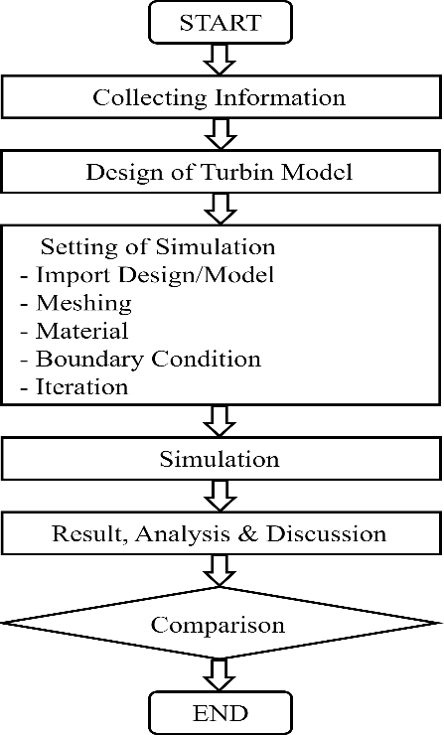
The research methodology involves in FIGURE 1 includes field research, literature review, and interviews conducted in Sanankerto Village, Turen District, Malang Regency, East Java. After gathering these data, simulations are performed using Ansys Fluent software.
FIGURE 1. Method

The turbine and guide vane simulation models are created according to the physical models, using SpaceClaim application. Turbine and guide vane Type 1 are shown in FIGURE 2, while Turbine and guide vane Type 2 are shown in FIGURE 3.
Simulations are conducted using CFD Ansys Fluent with designs created using Autodesk Inventor. The simulation employs the K-epsilon turbulence model. Prior to running the simulation, the models are first developed according to the data obtained using Autodesk Inventor, then imported into Ansys Fluent. The process involves defining fluid properties, meshing, and setting boundary conditions.
The geometry imports and meshing use default settings, and the results are presented in TABLE 1.

TABLE 1. Number of nodes and mesh elements
Turbine and Guide Vane Model | Nodes | Elements
Type 1 (5.10) | 457,438 | 2,531,447
Type 1 (5.5) | 408,455 | 2,273,008
Type 1 (3.5) | 471,504 | 2,624,464
Type 1 (3.10) | 407,253 | 2,273,342

The turbulence model used is k-epsilon. The selected fluid is water (H2O). The boundary conditions are set with a Mass Flow Rate of 579 kg/s at the Inlet and a Pressure of 0 Pa at the Outlet.
The solving phase involves computational calculations based on the relevant equations. These calculations are performed according to the steps outlined previously.
The final stage of the simulation produces results that can be visualized in graphs, images, contours, and specific color patterns. These results are used for analysis and discussion. The equations used are listed in Equations 1-3:
Reynold number = $\frac{V. DH}{µ}$ (1)
Intensitas Turbulent = $0,16 x (Re) (8) x 100\%$ (2)
Angular velocity = $2\frac{µ . n}{60}$ (3)

RESULTS AND DISCUSSION
The simulation parameters used are as follows: The fluid type selected is water (H₂O) with a density of 998 kg/m³ and a viscosity of 0.001003 Pa·s. The gravitational force is set to -9.81 m/s² along the y-axis. The turbulence model employed is the K-Epsilon model. The blade speed is 904 rpm, which is equivalent to 94.66 rad/s. The flow rate is 579 kg/s, and the flow velocity is 4.61001 m/s. The Reynolds number calculated is 1,835,179.255, and the turbulence intensity is set at 2.63%. Described in TABLE 2 and 3.

TABLE 2. Boundary condition
Boundary Condition | Input Type | Value
Inlet | Mass flow rate | 579 kg/s
Outlet | Pressure | 0 Pa
Intensitas turbulensi | Inlet dan Outlet | 2,63 %

TABLE 3. Simulation results
Turbine Type | No. of Blades | No. of Guide Vanes | Torque (Nm) | Power (Watts)
Type 1 | 5 | 10 | 3023.21 | 29929.77
Type 2 | 5 | 5 | 2707.86 | 26807.81
Type 3 | 3 | 5 | 1967.37 | 19476.96
Type 4 | 3 | 10 | 2014.4 | 19942.56

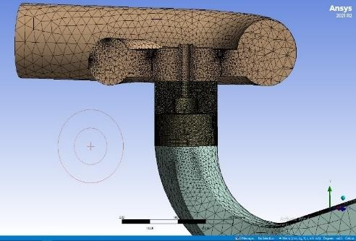
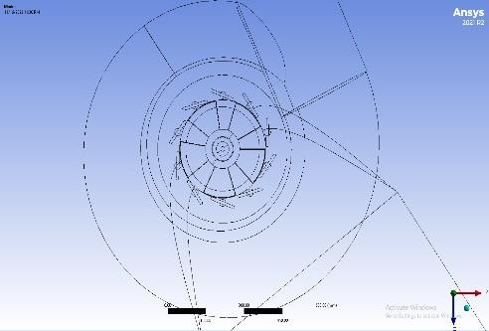
Analysis results of turbine type -1, in FIGURE 2 and 3.
(a) (b)
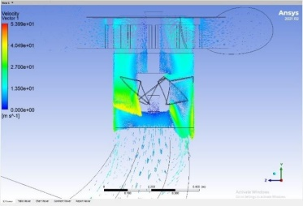
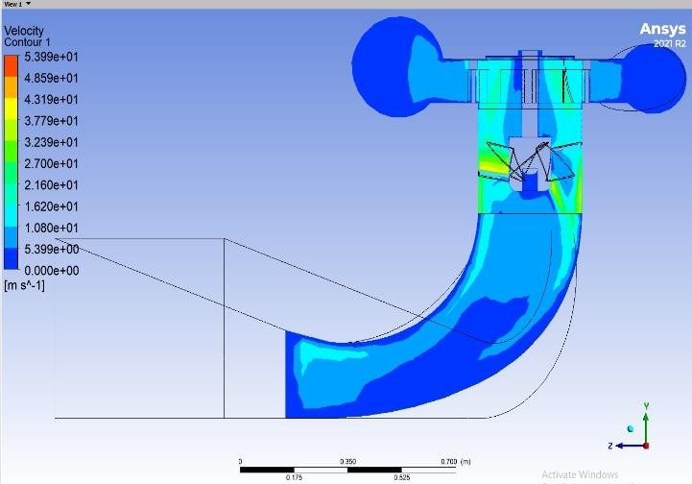
FIGURE 2. Turbin type 1: (a) design , (b) meshing
(a) (b)
FIGURE 3. Turbin type 1: (a) Kontur velicty, (b) Vektor velocity
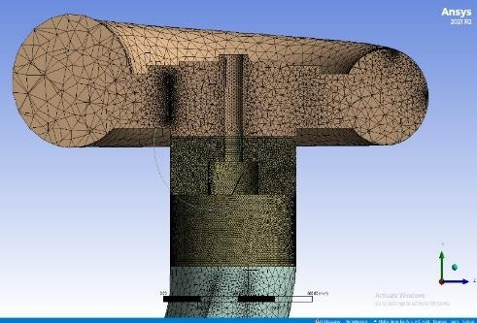
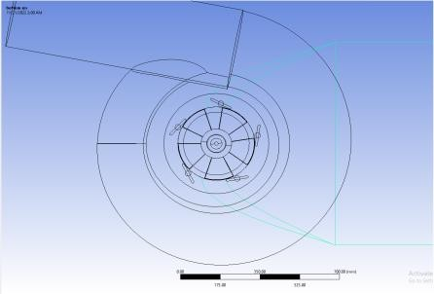
Analysis results of turbine type -2, in FIGURE 4 and 5.
(a) (b)
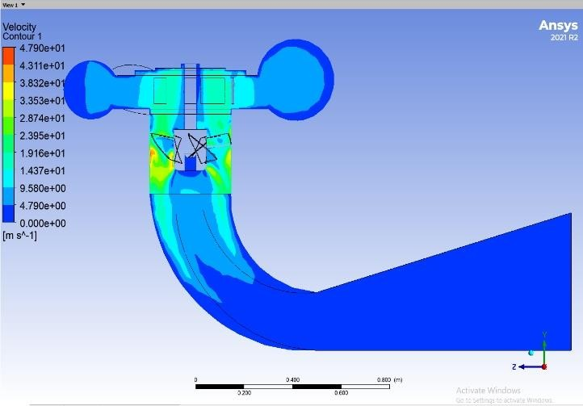
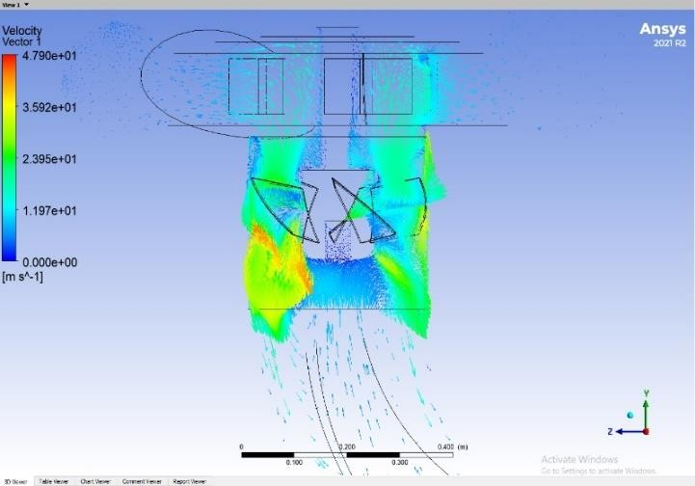
FIGURE 4. Turbin type 2: (a) design , (b) meshing
(a) (b)
FIGURE 5. Turbin type 2: (a) Kontur velicty, (b) Vektor velocity

Analysis results of turbine type -3, in FIGURE 6 and 7.
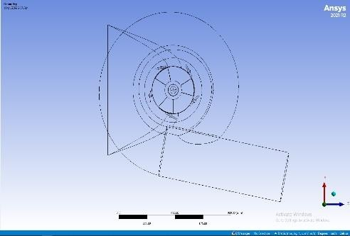
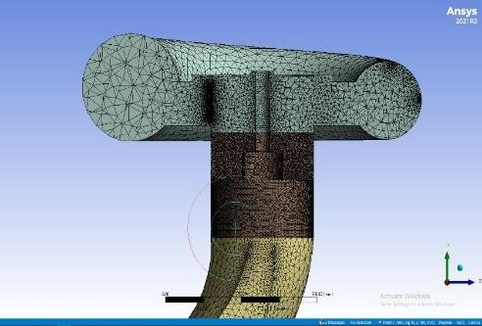
(a) (b)
FIGURE 6. Turbin type 3: (a) design , (b) meshing
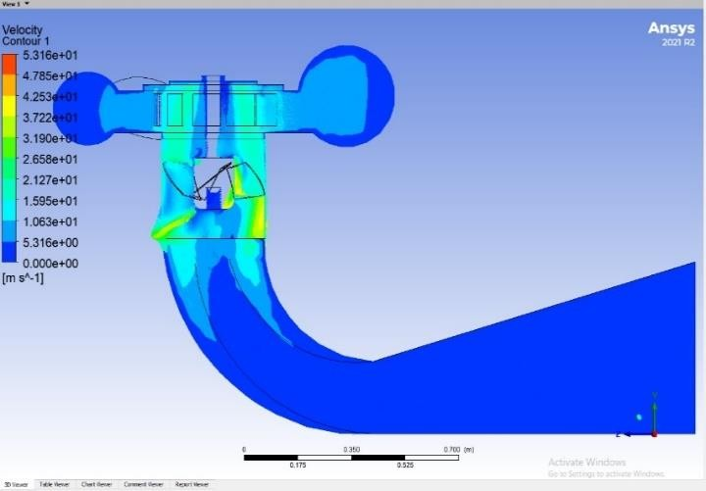
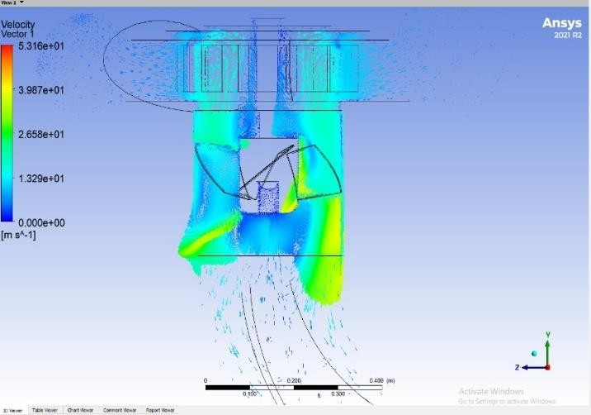
(a) (b)
FIGURE 7. Turbin type 3: (a) Kontur velicty, (b) Vektor velocity

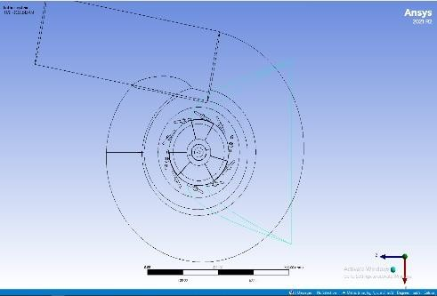
Analysis results of turbine type -4, in FIGURE 8 and 9.
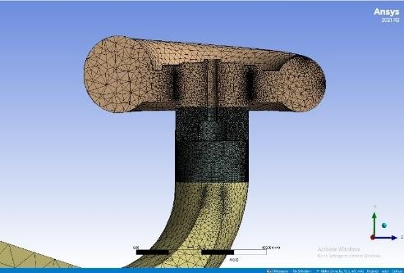
(a) (b)
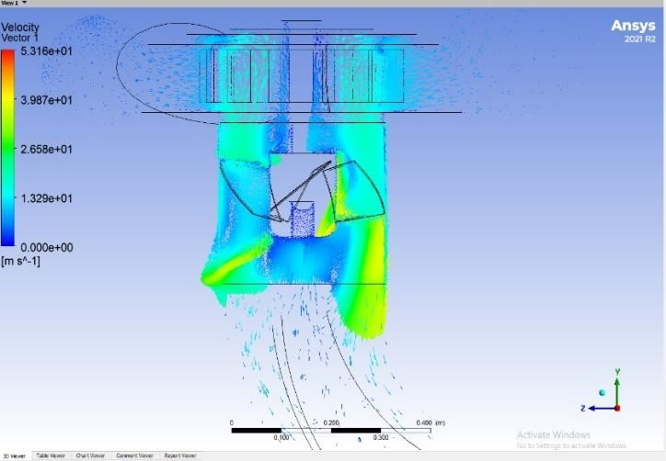
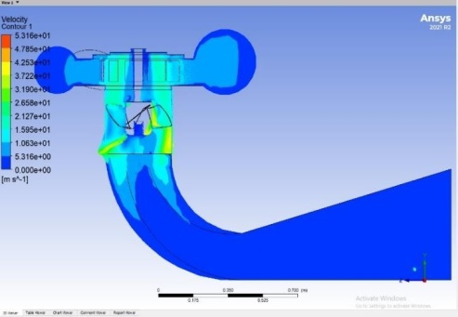
FIGURE 8. Turbin type 2: (a) design , (b) meshing
(a) (b)
FIGURE 9. Turbin type 4: (a) Kontur velicty, (b) Vektor velocity

The simulation results can be viewed in FIGURE 4 through FIGURE 9, which include velocity contours, velocity vectors, and meshing for all turbine designs, particularly in the guide vane and blade areas. The colors in Ansys Fluent represent the flow velocity levels, with red indicating the highest velocity, followed by yellow, green, light blue, and blue, which correspond to progressively lower flow velocities.

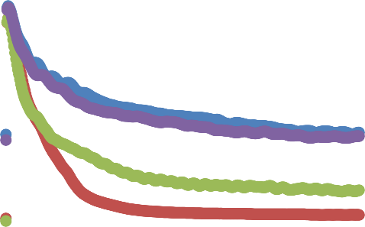
FIGURE 10. Torsion
0
-500
-1000
-1500
-2000
-2500
-3000
-3500
0
0.1
0.2
0.3
0.4
0.5
3.5
5.10
5.5
3.10
Moment

The test results reveal variations in torque and power output across the different turbine types tested. Generally, the torque produced by each turbine type shows significant differences, although the available data is somewhat limited.
For Turbine Type 1, as listed in TABLE 2, the torque achieved is 3023.21 Nm with a power output of 29,929.77 Watts. This indicates the highest performance compared to the other turbine types in terms of both torque and power. This turbine likely features a more efficient design or configuration for capturing and converting fluid energy into torque and power.
In contrast, Turbine Type 2 produces a lower torque of 2707.86 Nm and a power output of 26,807.81 Watts. While still relatively high, these values indicate a performance drop compared to Turbine Type 1, possibly due to differences in the design or configuration of the blades and guide vanes.
Turbine Type 3 shows a torque of 1967.37 Nm and a power output of 19,476.96 Watts. The torque and power for this turbine are lower compared to Turbine Types 1 and 2. This may suggest that the blade and guide vane design for Turbine Type 3 is less optimal in utilizing fluid flow compared to the other turbine types.
Finally, Turbine Type 4 produces a torque of 2014.4 Nm and a power output of 19,942.56 Watts. Although the torque for Turbine Type 4 is slightly higher than that of Turbine Type 3, the power output is almost the same as Turbine Type 3. This minor difference in output may be attributed to slight variations in design or operational conditions.
Overall, the data indicates that Turbine Type 1 exhibits the best performance in terms of torque and power. The observed differences among these turbine types may be related to variations in blade and guide vane designs, which affect the efficiency of converting fluid energy into torque and power. Despite the limited data, this analysis provides initial insights into how design changes in turbines can impact performance and underscores the need for further studies to optimize turbine design for better results.
Based on the analysis, it can be concluded that variations in the number of blades and guide vanes on the turbine have a significant impact on its performance, particularly in terms of torque and power output. Increasing the number of blades enhances the surface area interacting with the fluid, resulting in higher shaft rotation and greater torque. Additionally, increasing the number of guide vanes also contributes to improved fluid flow efficiency, which ultimately boosts the turbine's power output. These findings indicate that optimizing the number of blades and guide vanes can be an effective strategy for enhancing turbine performance. By understanding this relationship, designers and engineers can make better decisions in designing turbines to achieve maximum efficiency and power.

CONCLUSIONS
The analysis results indicate that the torque and power output of the turbine are not constant and vary depending on the number of blades used. Generally, turbines with 5 blades produce higher torque and power compared to turbines with 3 blades. For instance, the torque for Type 1 and Type 2 turbines reaches 3023.21 Nm and 2707.86 Nm, respectively, while the torque for Type 3 and Type 4 turbines is 1967.37 Nm and 2014.4 Nm, respectively. These findings suggest that a higher number of blades on a water turbine contributes to an increased cross-sectional area exposed to the fluid, which in turn enhances shaft rotation. Consequently, turbines with more blades produce higher torque and power. Therefore, increasing the number of blades can be an effective strategy for improving the performance of water turbines.

Acknowledgments
This research was funded by an internal institutional grant from Universitas Muhammadiyah Malang and through self-financing.

References
1. Abeykoon, C., Modelling and Optimisation of a Kaplan Turbine - a Comprehensive Theoretical and CFD Study. Cleaner Energy Systems, 2022. 3: p. 31.
2. Hariyadi, D., Perancangan Turbin Propeller Di Desa Sanankerto. Journal of Chemical Information and Modeling, 2017. 4: p. 4-24.
3. Sanusi, A., Simulasi Aliran Fluida pada Blade Rotor Turbin Angin Savonius dengan Computation Fluid Dynamics (CFD). LONTAR Jurnal Teknik Mesin Undana, 2017. 4(1): p. 11-15.
4. Rahmandhika, A., et al., Analisis Variasi Pipa Penstock Terhadap Kecepatan Inlet Turbin pada PLTMH Boonpring Menggunakan CFD. ARMATUR: Artikel Teknik Mesin & Manufaktur, 2024. 5(1): p. 115-121.
5. Sayoga, I.M.A., et al., Pengaruh Variasi Jumlah Blade Terhadap Aerodinamik Performan Pada Rancangan Kincir Angin 300 watt. Dinamika Teknik Mesin, 2014. 4(2): p. 103-109.

