Analysis of Drag Force on Prototype Ship for Fast Boat Contest Using Maxsurf Resistance Simulation
Abi Mufid Octavio^{1,a)}, Reza Aulia Rahman^{1,2,b)}, Mohamad Irkham Mamungkas^{1,c)}, and Achmad Fauzan Hery Soegiharto^{1,d)}
¹Mechanical Engineering, University of Muhammadiyah Malang, Malang, Indonesia
²Department of Mechanical Engineering, Osaka University, Osaka, Japan

^{b)} Corresponding author: rezarahman@umm.ac.id
^{a)} abimufid@webmail.umm.ac.id
^{c)} irkham@umm.ac.id
^{d)} achmadfauzan@umm.ac.id
Abstract. National Unmanned Fast Boat Contest is a forum for developing talents in the field of shipping, especially the design and performance of unmanned fast ships. In addition, National Unmanned Fast Boat Contest activities encourage the nation's young generation, in this case students, to be able to take part in thinking about the independence of Indonesia's defense and marine security. In this competition, students are required to create innovations in the field of shipping, especially in ship hulls. In this research, researchers used the V-Hull type. Shaped hull is a hull shape that resembles the letter V used in ships that have high speed. In conducting this research, the authors used Maxsurf Resistance software to solve the problem of research objectives. Maxsurf Resistance is software that allows predicting resistance and power requirements for lambug design. Based on the results of simulations conducted using Maxsurf Resistance software, it is found that the higher the speed, the higher the total resistance value.
Keywords: Resistance; V-Hull; Maxsurf.

INTRODUCTION
National Unmanned Fast Boat Contest is a contest organized National Achievement Center under the auspices of the Ministry of Education, Culture, Research and Technology. National Achievement Center pays attention to the development of talents, interests and potential of Indonesia's golden generation, especially academics. National Unmanned Fast Boat Contest is a popular competition in the maritime world where various teams and individuals compete to design, build and operate innovative high-speed vessels. Such competitions give participants the opportunity to prove their expertise in the design, construction and operation of fast vessels. In addition, these competitions encourage the development of new technologies and the improvement of the performance of high-speed vessels.
National Unmanned Fast Boat Contest requires students to innovate in the maritime world. In National Unmanned Fast Boat Contest 2023 there are 6 categories that are contested, of which the 6 categories are divided into 2 divisions, namely the tourism ship design division and protoype manufacturing and performance. At National Unmanned Fast Boat Contest 2023, researchers participated in the division of protoype manufacturing and performance in the Leisure Boat Fuel Engine Remote Control (LBFERC) category by carrying a mono hull type.
The first step is to create a 3D prototype design of a fast boat using maxsurf software [1]. This software has become a popular choice in the manufacturing and engineering industries for designing and developing complex products [2]. This is followed by the analysis stage of Maxsurf Resistance software [3]. Maxsurf allows detailed analysis of aspects that affect the performance of a vessel, such as hydrodynamic resistance [4], and wave effects [5].
The main reason for choosing a monohull model [6] is to refer to the regulations of National Unmanned Fast Boat Contest 2023 and because of its high speed performance and good maneuverability [7]. However, it is necessary to conduct a comprehensive resistance analysis of this prototype to achieve optimal performance [8]. To find out how much resistance is encountered on the Sangkaling EVO 5 Fast Boat Prototype, it is necessary to analyze the resistance in maxsurf software. Therefore, to find out the amount of resistance at a certain speed, the author created a scientific work with the title “Analysis of Drag Force on Prototype Ship for Fast Boat Contest Using Maxsurf Resistance Simulation”.

METHODS
Research on this simulation is carried out in accordance with the flowchart in FIGURE 1. The hull of the Sangkaling EVO 5 ship is a type or type of mono hull. In addition, this hull has dimensions with a length of 115 cm, width of 32 cm, height of 12 cm and DWL of 7.5 cm.
Before the analysis is carried out, unit settings are also carried out in maxsurf with the aim of getting the results as desired [9]. After that, the ship hull will be given a load at the CG (Center of Gravity) point and several speed variables to get the drag results.
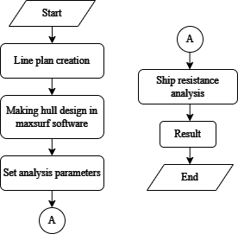
FIGURE 1. Flowchart

The ship's lines plan plays a very important role in the ship design and construction process [10]. The main purpose of making a lines plan is to determine the shape of the hull, especially below the waterline, so that ship characteristics such as stability, resistance, and cargo space can be determined [11]. Lines plan can also be used to create other ship structure drawings, such as general layout, profile construction, midship section, and hull stability (stability calculation), as seen in FIGURE 2, 3, and 4 [12].

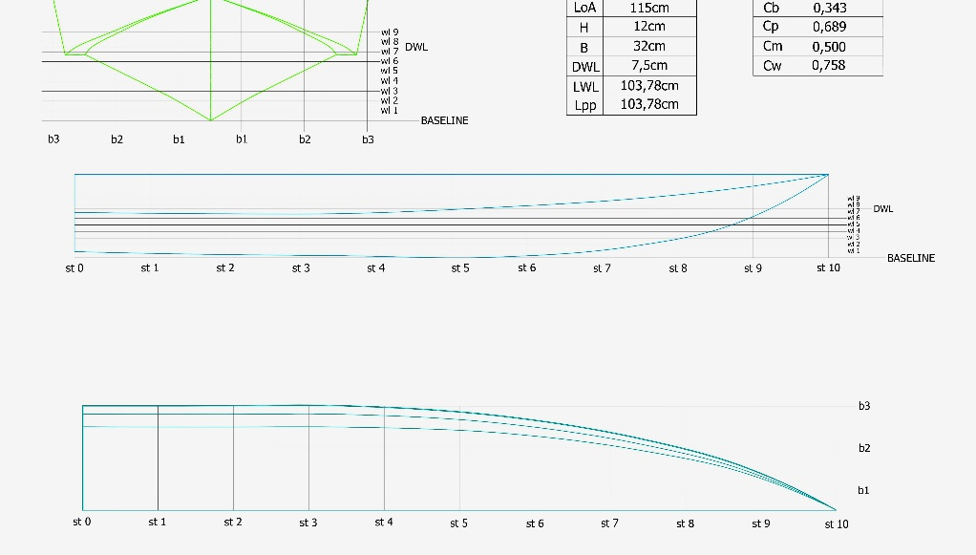
FIGURE 2. Lines plan

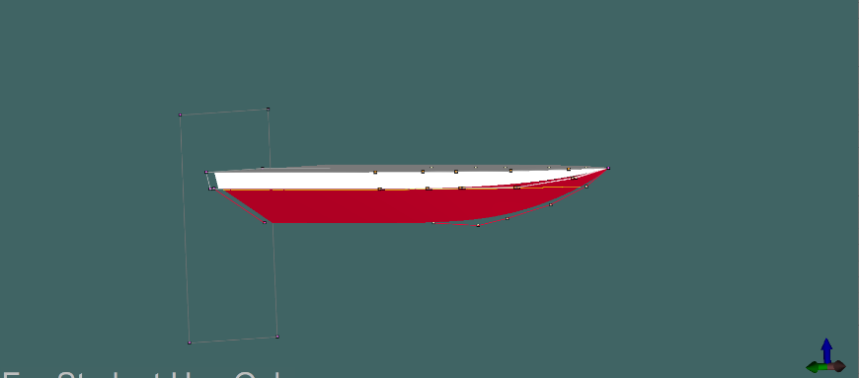
FIGURE 3. 3D view of ship body

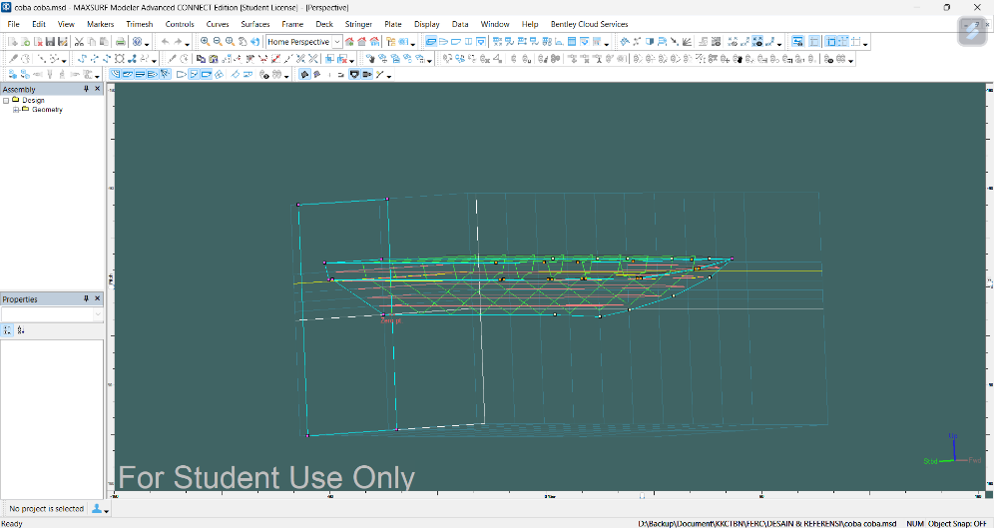
FIGURE 4. 2D view of ship body

RESULTS AND DISCUSSION

ANALYSIS RESULTS
Drag force analysis shown in FIGURE 5, FIGURE 6 and FIGURE 7 focuses on identifying and evaluating the various obstacles that affect the speed of the vessel. By examining the details shown in the figures we can understand the root cause of the failure and its impact.

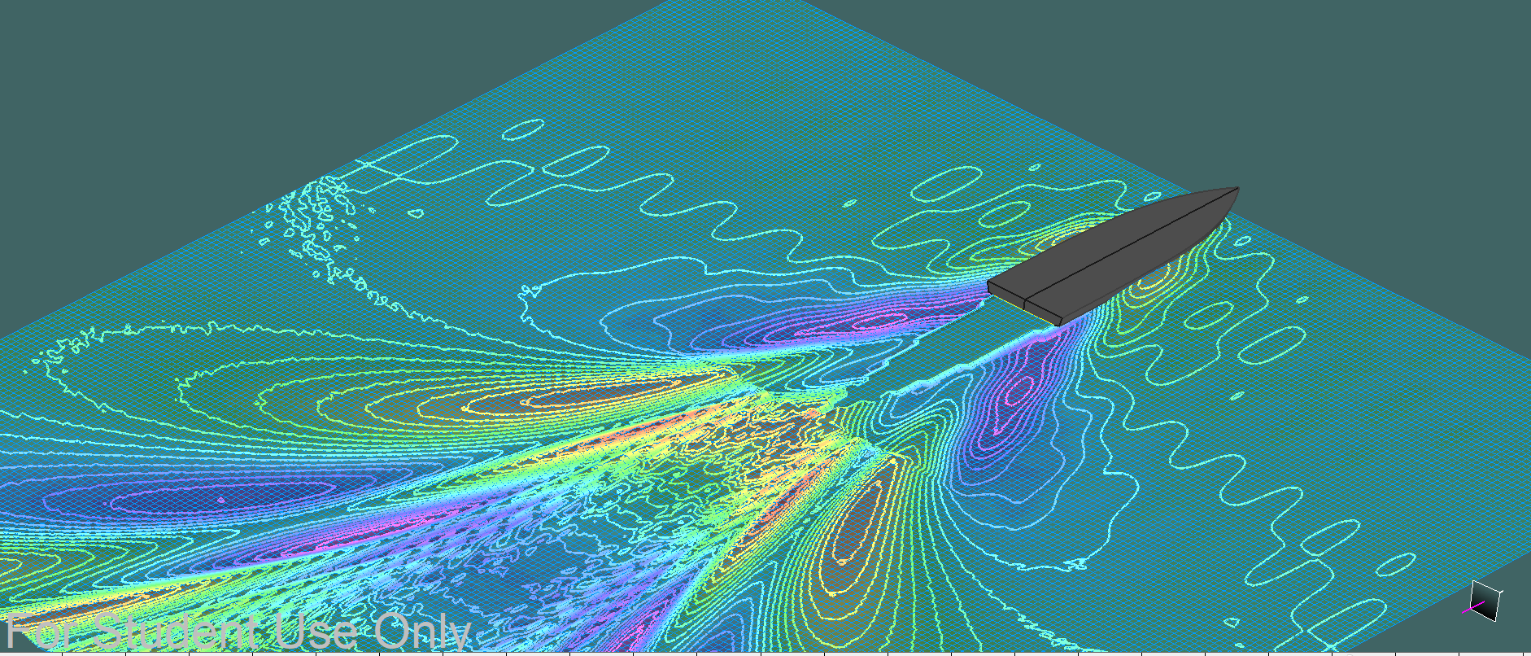
FIGURE 5. Isometric view resistance analysis results
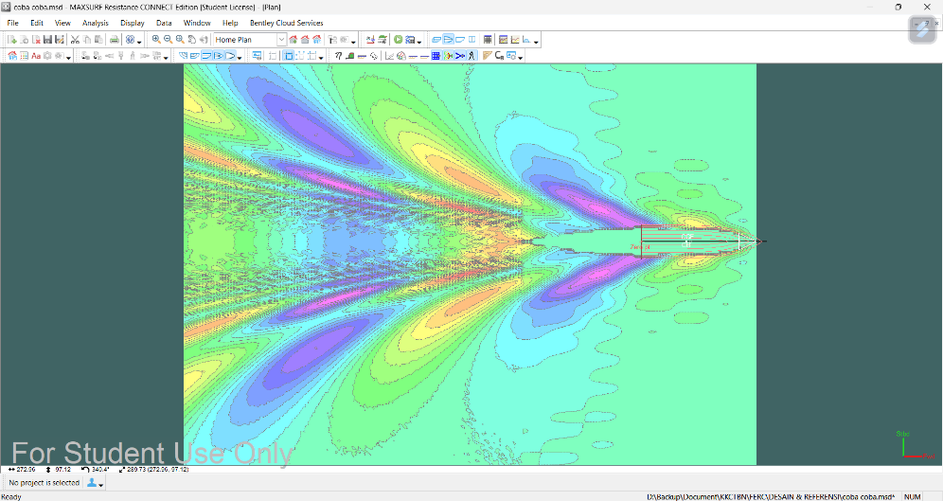
FIGURE 6. Top view resistance analysis results

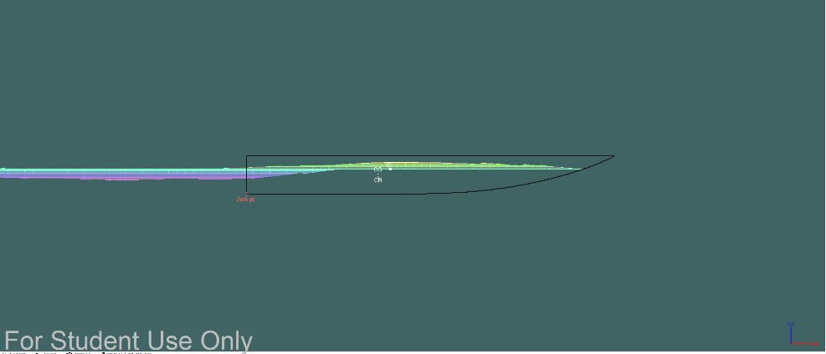
FIGURE 7. Bottom view resistance analysis results

ANALYSIS RESULTS
After successfully analyzing the resistance of the ship's hull, maxsurf will provide a graph of the resistance value along with the graph displayed in TABLE 1 and FIGURE 7.

TABLE 1. Speed to resistance
Speed (m/s) | Resistance (N)
0 | 0
1,25 | 2,36
2,5 | 6,62
3,75 | 10,68
5 | 17,89
6,25 | 26,72
7,5 | 37,12
8,75 | 49,04
10 | 62,46
11,25 | 77,37
12,5 | 93,75
13,75 | 111,57
15 | 130,84
16,25 | 151,53
17,5 | 173,64
18,75 | 197,15

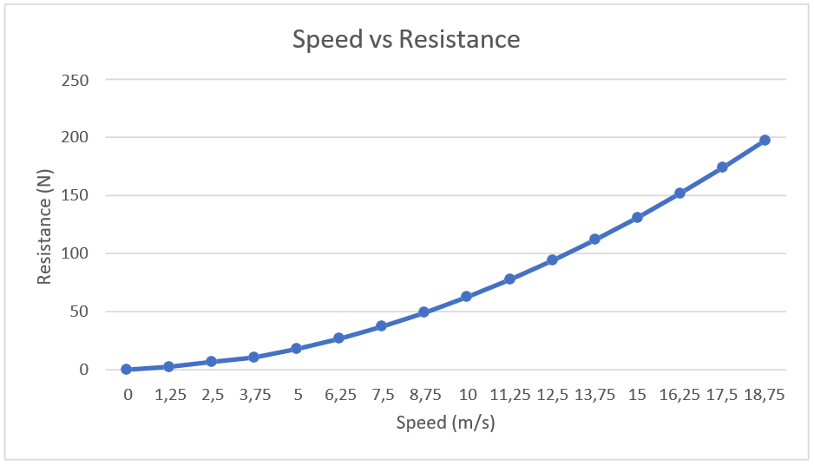
FIGURE 7. Correlation graph of resistance with speed

Effective power is the amount of power needed to overcome the hull resistance of the ship at a certain speed. This effective power is a function of the total drag and ship speed. Effective power calculation as follows the speed (Vs) is taken at the maximum speed of 8.75 m/s so that the total resistance (R total) is obtained at 49.04 N.
Unknown:
EHP = Effective Horse Power
EHP = Total resistance (R total) × Speed (Vs) (1)
EHP = 49,02 N × 8,75
EHP = 429,1 𝑊𝑎𝑡𝑡

Wake friction (𝜔) the change of the flow velocity resulting from the front of the ship is:
ω = 0.5 (𝐶𝑏) − 0.05
Cb (block coefficient on length displacement) Cb value of 0.343 from hydrostatic data on the SANGKALING EVO 5 ship.
ω = 0,5 (0,343) − 0,05 = 0,1215
From these calculations it can be concluded that the higher the speed, the greater the friction or drag. In addition, it also affects the Cb value.

CONCLUSIONS
From the analysis of the ship's hull in maxsurf software, it is found that the relationship between speed and resistance is proportional, meaning that if the speed is increased, the resistance experienced by the ship also increases. From the above analysis if the ship's speed is 8.75 m / s, the resulting resistance is 49.04 N. In addition, the shape of the hull also affects the performance of the ship. Later in further research the author will conduct research on several types of the same hull but with different dimensions.

Acknowledgments
The ideas and ideas of this paper were raised from the Mekatronic team of the Faculty of Engineering, Department of Mechanical Engineering, when preparing to take part in the National Unmanned Fast Boat Contest competition. Where the team has many designs to be analyzed and selected to be submitted.

References
1. Aung, M.Z., et al., Establishment of a design study for comprehensive hydrodynamic optimisation in the preliminary stage of the ship design. Ships and Offshore Structures, 2024. 19(6): p. 793-806.
2. Alkhaledi, A.N., S. Sampath, and P. Pilidis, A hydrogen fuelled LH2 tanker ship design. Ships and Offshore Structures, 2022. 17(7): p. 1555-1564.
3. Zhang, J., et al., A comparative analysis of numerically simulated and experimentally measured static responses of a floating dock. Ships and Offshore Structures, 2024: p. 1-18.
4. Iqbal, M., et al., Operability analysis of traditional small fishing boats in Indonesia with different loading conditions. Ships and Offshore Structures, 2023. 18(7): p. 1060-1079.
5. Hamisi, T.S., et al., Analysis of the ships’s bow to minimise air pollution–case study of the X-bow ship. Journal of International Maritime Safety, Environmental Affairs, and Shipping, 2023. 7(4): p. 2276989.
6. Adietya, B.A. and E.D. Gustiarini, Studi Perbandingan Performa Kapal Trimaran, Katamaran, dan Monohull Sebagai Kapal Penyeberangan di Kepulauan Karimunjawa. Kapal: Jurnal Ilmu Pengetahuan dan Teknologi Kelautan, 2018. 15(1): p. 18-23.
7. Priyono, H., S. Aritonang, and M. Akbar, Desaign Ulang Lambung Kapal Unmanned Surface Vessel dengan Senjata pada Kapal Nirawak Dinas Penelitian dan Pengembangan TNI Angkatan Laut Menggunakan Program Komputasional untuk Meningkatkan Performa Guna Mendukung Operasi TNI Angkatan Laut. Jurnal Teknologi Daya Gerak, 2021. 4(1): p. 10-20.
8. Adnyani, L.P. and R.F. Arrachman, Redesain Kapal Rede Untuk Analisa Hambatan. Inovtek Polbeng, 2019. 9(1): p. 72-78.
9. Asral, A. and S. Adis, Perancangan dan pengujian prototipe kapal ambulance Covid-19 tipe monohull elektrik untuk Kompetisi Kapal Cepat Tak Berawak Nasional. Jurnal Teknik Mesin Indonesia, 2022. 17(1): p. 113-117.
10. Prabowo, A.R., et al., Performance evaluation on the designed v-shaped monohull ship models. Journal of Applied Engineering Science, 2022. 20(2): p. 610-624.
11. Ma’ruf, B., et al., Technology capability of Indonesian medium-sized shipyards for ship production using Product-oriented Work Breakdown Structure method (case study on shipbuilding of Mini LNG vessel). Cogent Engineering, 2024. 11(1): p. 2284534.
12. Lee, Y.G., S. Ju, and J.H. Woo, Simulation-based planning system for shipbuilding. International Journal of Computer Integrated Manufacturing, 2020. 33(6): p. 626-641.

