Design of a Shell and Tube Heat Exchanger for Waste Oil to High Speed Diesel Fuel Conversion
Yepy Komaril Sofii^{1, a*)} , Muhammad Ardans Stiagraha ^{1, b)}, Mulyono ^{1, c)}, Muhammad Yoga Putra Pratama^{1,d)}, Willy Satrio Nugroho ^{2,e)}
Author Affiliations
¹Department of Mechanical Engineering, University of Muhammadiyah Malang, Raya Tlogomas Street No.246, Malang, East Java, 65144, Indonesia
²Department of Mechanical Engineering, University of Brawijaya, Mayjend Haryono Street 167, Malang, East Java, 65145, Indonesia
Author Emails
^{a)} Corresponding author: yepykomarils@umm.ac.id
^{b)} ardanstiagraha@webmail.umm.ac.id
^{c)} mulyono@umm.ac.id
^{d)} muhyogaputra15@webmail.umm.ac.id
^{e)} willysatrio@ub.ac.id

Abstract. The increasing demand for alternative fuels and sustainable waste management highlights the potential of converting used oil into high-speed diesel (HSD). This study presents a detailed thermal and mechanical design of a shell-and-tube heat exchanger used for cooling hot waste oil in the conversion process. Field-operational data, including oil inlet temperature (350 °C), outlet temperature (70 °C), and a water coolant stream (30 °C to 50 °C), were used to determine the heat load of 151.7 kW. The required heat transfer area was calculated using the Log Mean Temperature Difference (LMTD) method and an assumed overall heat transfer coefficient of 300 W/m²·K, resulting in a surface area of 2.14 m². The exchanger was designed using 33 stainless steel tubes (Ø19 mm, L = 2 m) arranged in a triangular pitch configuration with a two-pass flow to enhance thermal efficiency for viscous oil. Fluid dynamics analysis revealed laminar flow in the tube side (Re = 501) and turbulent flow in the shell side (Re = 11,910), with convective coefficients of 6.6 and 243 W/m²·K, respectively. Triangular pitch and multi-pass configuration significantly improved thermal performance while managing pressure drop. This study provides a validated, scalable design reference for energy recovery systems in waste oil fuel applications, addressing current gaps in applied exchanger engineering.
Keywords. Waste oil; Heat exchanger design; Shell-and-tube; High-speed diesel (HSD); Triangular pitch configuration

Introduction
The increasing global energy demand and escalating environmental concerns have intensified research efforts toward alternative fuels and sustainable waste management strategies[1]. Waste lubricating oil (WLO), typically from automotive and industrial sources, poses a significant ecological threat due to its toxicity and persistence when improperly disposed of, contaminating soil and water resources [2]. However, WLO also possesses high calorific value, making it a promising feedstock for energy recovery or conversion into valuable liquid fuels [3]. In the European Union, over 1.6 million tons of WLO are collected annually, positioning it as the most significant liquid hazardous waste stream [4]. Therefore, converting waste oil into diesel-like fuels contributes to pollution mitigation and reduces dependency on fossil diesel, aligning with circular economy goals and global sustainability frameworks [5].
Energy recovery technologies are central to waste oil valorization by capturing the embedded energy content and converting it into usable forms [6]. Thermochemical methods such as pyrolysis, catalytic cracking, and transesterification have demonstrated the feasibility of producing fuels comparable to conventional diesel from waste oil streams. Several studies have reported pyro-oil yields exceeding 80–90% under optimized pyrolysis conditions, indicating strong potential for scalable fuel production. Despite these achievements, thermal management remains a key technical challenge, particularly in scaling up such processes efficiently [7]. Heat exchangers are commonly employed to transfer energy between hot product vapors and cooling media or to recover process heat for reuse. Effective heat exchange improves thermal efficiency and ensures safer operating conditions by controlling temperature gradients and preventing localized overheating [8].
Designing heat exchangers for waste oil processing presents specific challenges due to the fluid's unique properties [9]. Waste oils typically exhibit high viscosity and low thermal conductivity, resulting in low convective heat transfer coefficients and difficulty achieving turbulent flow within heat exchange channels [10]. Moreover, heavy hydrocarbons and impurities increase the risk of fouling through tar or coke deposition, gradually reducing exchanger performance [11]. In addition, aged waste oils often contain sulfur, chlorine, and organic acids that can induce corrosion in carbon steel components, necessitating careful material selection [12]. Stainless steel is commonly favored for its superior resistance to corrosion and high-temperature durability, particularly in thermally and chemically aggressive environments [13]. Therefore, a heat exchanger for WLO cooling must be designed for thermal effectiveness and mechanical reliability under severe operating conditions [14].
A recent literature review reveals a gap in applied research specifically addressing heat exchanger design for waste oil conversion applications [15]. While many studies focus on reaction mechanisms, catalysts, or fuel characterization, detailed discussions of exchangers' thermal and mechanical design within these systems are limited. Even when condensers or coolers are mentioned, the emphasis tends to be on product yield improvement rather than the engineering principles of exchanger configuration and performance. Furthermore, most prior studies lack integration between thermal calculations, fluid dynamic considerations, mechanical design (e.g., tube arrangements, shell dimensions, baffle configurations), and experimental or simulation performance validation. To date, no publication has presented a comprehensive and validated shell-and-tube heat exchanger design optimized explicitly for cooling high-viscosity WLO streams in the context of HSD production.
This study addresses the aforementioned research gap by presenting a validated and detailed design of a shell-and-tube heat exchanger for waste oil-to-HSD conversion. The novelty of this work lies in several aspects. First, a rigorous thermal analysis uses field-derived process parameters to determine the required heat duty and surface area. Second, a triangular tube layout with a two-pass configuration is adopted to enhance heat transfer performance while managing pressure drop, especially for viscous fluid conditions. Third, the entire mechanical design, including tube count, pitch, material selection, and baffle spacing, is constructed to withstand thermal stress and chemical exposure. Finally, analytical results are validated through performance simulations to ensure the feasibility of the proposed configuration. This work thus contributes a rare, fully integrated design case that can serve as a reference for future implementations of waste-to-fuel systems involving complex heat recovery demands.

Literature Review

Applications of Heat Exchangers in Waste Oil Processing
Heat exchangers play a pivotal role in various stages of waste oil treatment, including pre-heating, distillation, condensation, and heat recovery. In industrial-scale re-refining processes, shell-and-tube heat exchangers are widely utilized due to their robustness and adaptability to varying thermal loads [16]. A shell and tube heat exchanger applied to recover waste heat from a hot-oil boiler achieved approximately 74% energy recovery, substantially improving system efficiency [17]. Compared to a conventional double-pipe configuration, the finned-tube variant outperformed under identical conditions. In thermochemical waste-to-fuel processes, particularly pyrolysis, the role of heat exchangers becomes more critical in condensing volatile vapors into liquid fuel [18]. A segmented shell-and-tube condenser with multiple condensation zones, effectively doubling bio-oil yield from 10% to 20% [1]. Similarly, Akinola et al. (2024) designed and validated a shell-and-tube heat exchanger for pyrolysis gas using CFD, demonstrating excellent alignment between analytical design and simulated performance [19].

Thermal Design Methodologies: LMTD and ε-NTU
Thermal design of heat exchangers generally employs the Log Mean Temperature Difference (LMTD) method for sizing and the effectiveness–Number of Transfer Units (ε-NTU) method for performance rating. The LMTD method is preferred when inlet and outlet temperatures are known, while ε-NTU is suitable when outlet conditions must be predicted based on geometry. Nogueira affirmed that both approaches are mathematically equivalent but offer different practical advantages[20]. In the context of waste oil cooling, Akinola et al. applied LMTD for sizing and validated it through CFD simulation, confirming the reliability of classical methods for complex fluids [19]. Some studies extend the analysis further by applying second-law thermodynamics, such as entropy generation minimization, to evaluate the thermodynamic quality of heat exchange. Although exergy-based analyses are less common in industrial practice, they offer additional insight into process irreversibilities and energy degradation [21].

Optimization and Performance Enhancement Strategies
Modern research increasingly integrates optimization algorithms to improve heat exchanger design. Meta-heuristic techniques such as Genetic Algorithms (GA), Particle Swarm Optimization (PSO), and Firefly Algorithm are employed to navigate multi-variable design spaces. Gurgen reviewed their application and noted their effectiveness in minimizing total cost, entropy generation, or pressure drop [22]. The firefly algorithm outperformed others in economic optimization of TEMA-compliant exchangers [23]. Beyond algorithmic design, performance can be enhanced using physical modifications such as finned tubes, helical baffles, and dimpled surfaces. The finned tubes increased heat transfer coefficients by up to 24% in waste heat recovery systems. Multi-pass configurations and flow diverters are also beneficial, especially in handling high-viscosity fluids by increasing turbulence and residence time [24]. However, these enhancements often come with increased pressure drop and fouling potential, necessitating careful trade-off analysis.

Material Selection and Corrosion Resistance
Material durability is crucial in waste oil heat exchangers due to the presence of corrosive compounds such as sulfur, chlorine, and organic acids. Stainless steel, particularly grades 304 and 316, is widely recommended due to its high corrosion resistance and mechanical strength at elevated temperatures. Field experience and industrial reports, such as those from EnergyLogic, confirm that stainless steel exchangers offer superior longevity compared to carbon steel alternatives. Akinola et al. selected stainless steel for shell construction and copper for tubes in a pyrolysis condenser, although copper's application is limited in sulfur-rich environments due to potential galvanic corrosion [19]. To mitigate this, using a single metal for all wetted parts or isolating dissimilar metals is standard practice. In more aggressive settings, nickel-based alloys or ceramic coatings are explored, though their high cost restricts widespread use. Stainless steel enables more aggressive cleaning techniques, including high-pressure flushing and chemical treatment, essential for fouling-prone fluids like waste oil.

Challenges in Thermal Management of Waste Oil-to-Fuel Conversion
The conversion of used oils into high-speed diesel (HSD) involves pyrolysis, catalytic cracking, hydrogenation, or co-processing, all of which require precise thermal management. Maintaining uniform temperature within reactors and enabling rapid quenching of product vapors are critical to maximizing yield and product quality. Mishra et al. showed that controlled temperature profiles in fixed-bed pyrolysis yielded over 90% diesel-like fuel, and this was supported by COMSOL Multiphysics simulations validating heat distribution [25]. In catalytic cracking systems, Murillo et al. emphasized the need for consistent heating and effective cooling to avoid hotspots and coking [2]. Multi-stage condensers enable staged condensation based on vapor component temperatures, thus improving fraction separation [1]. The literature identifies common challenges, including undersized exchangers, fouling, uneven flow distribution, and material degradation. Despite significant progress in reaction chemistry and product characterization, limited studies address heat exchangers' mechanical and thermal design in waste oil systems. This study responds to that gap by providing a detailed and validated design of a shell-and-tube heat exchanger tailored for high-viscosity waste oil streams, contributing practical solutions to thermal integration challenges in circular energy systems.

METHODS
This study applied a systematic engineering design approach to develop a shell-and-tube heat exchanger for the waste oil cooling process in HSD fuel production. The methodology comprised data acquisition from actual field conditions, analytical heat transfer calculations, and mechanical configuration design based on ASME and ASTM standards. The design process aimed to achieve optimal thermal performance, structural reliability, and operational feasibility.
The first step involved collecting primary process data, including inlet and outlet temperatures of the waste oil and cooling water and the fluids' flow rate and physical properties. Waste oil was assumed to enter the exchanger at 350 °C and exit at 70 °C, while cooling water entered at 30 °C and exited at 50 °C. These parameters were used to calculate the heat load using the energy balance as shown in equation 1. Where m is the mass flow rate and Cp is the specific heat capacity of the oil.

$Q = \dot{m}⋅Cp⋅ΔT$ (1)

Next, the required surface area for heat transfer was determined using the Log Mean Temperature Difference (LMTD) method. The LMTD was computed based on the temperature differences at both ends of the heat exchanger, and the overall heat transfer coefficient was assumed to be 300 W/m²·K based on literature for oil–water applications. The total required surface area was then obtained using equation 2​, which guided the selection of tube dimensions and quantity.
$A=\frac{Q}{U∙∆T_{lm}}$ (2)

The heat exchanger's mechanical design used a shell-and-tube configuration with stainless steel (SS 304) due to its high corrosion resistance and mechanical strength at elevated temperatures. The exchanger consisted of 33 tubes, each with an outer diameter of 19 mm and a length of 2 m, arranged in a triangular pitch layout to enhance heat transfer compactness. A two-pass tube-side configuration was selected to increase thermal performance by extending the effective flow path.
To evaluate fluid dynamics, Reynolds number calculations were performed to identify the flow regime in both the tube and shell sides. The oil flow exhibited laminar characteristics (Re < 2300), while the cooling water flow in the shell was turbulent (Re > 4000), ensuring higher convective heat transfer coefficients. Nusselt numbers were calculated using established correlations: constant-value approximation (Nu = 3.66) for laminar tube flow and Dittus-Boelter correlation for turbulent shell-side flow.
Final validation was performed by cross-checking the calculated values of convective coefficients, heat load, and exchanger geometry with standard engineering references. The results were then integrated into a three-dimensional exploded view and cross-sectional technical drawings to ensure manufacturability and assembly clarity. This methodical approach ensured that the designed heat exchanger met thermal and mechanical requirements for reliable implementation in the waste oil to HSD conversion process.

Results and Discussion

Thermal Design Analysis of the Heat Exchanger
The designed shell-and-tube heat exchanger was evaluated to meet the thermal requirements of the waste oil-to-HSD conversion process (see Figure 1). The initial temperature of waste oil was measured at 350 °C, requiring a significant reduction to 70 °C before further processing. Concurrently, the cooling water operated from 30 °C to 50 °C. The calculated mass flow rate of waste oil, based on a volumetric flow of 1 m³/h and density of 930 kg/m³, was 0.258 kg/s. Using this value and the specific heat capacity of the oil (2.1 kJ/kg·K), the required heat transfer rate was found to be 151.7 kW. This large heat duty underscores the heat exchanger's critical role in effectively removing thermal energy from the waste oil stream.
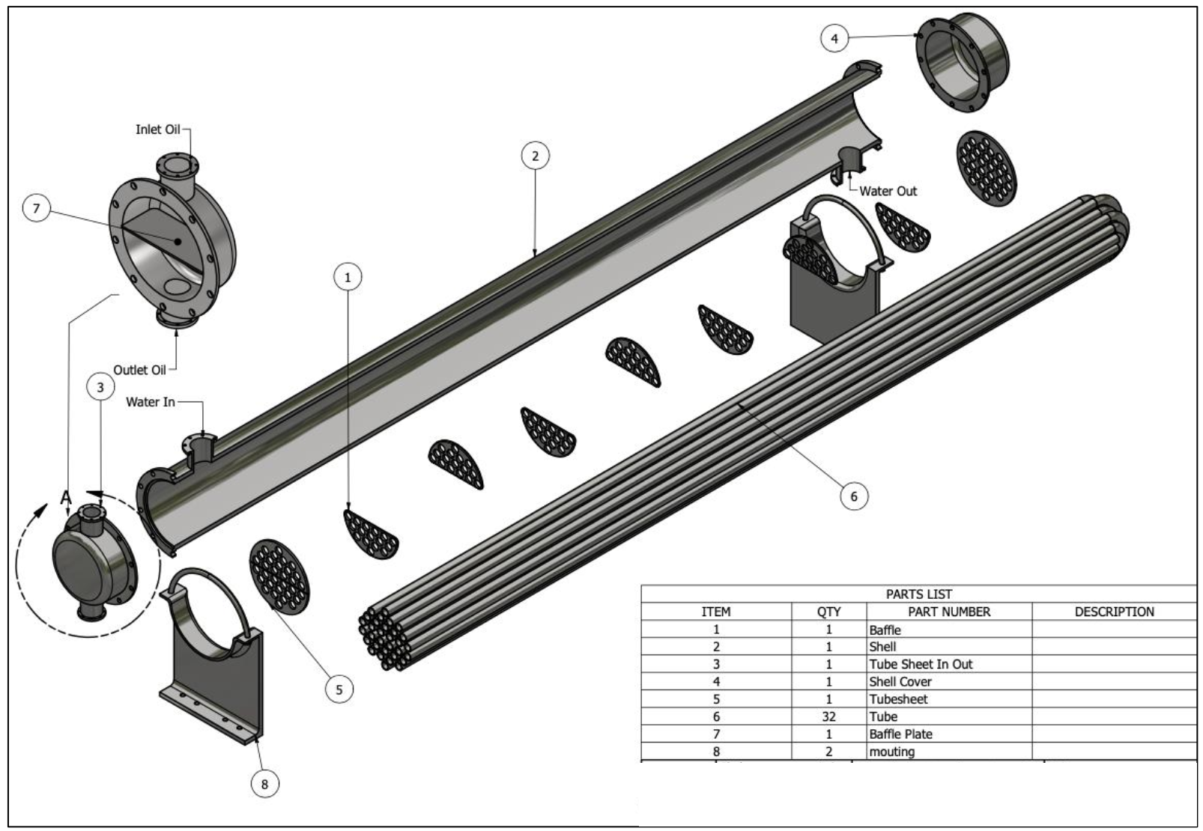
Figure 1. Exploded view of the designed shell-and-tube heat exchanger for cooling waste oil during HSD production.

Applying the Log Mean Temperature Difference (LMTD) method accounted for the non-linear temperature gradient between the hot and cold fluids. The computed LMTD value was 236.07 °C, which is relatively high and advantageous for heat transfer. This confirms the appropriateness of employing a shell and tube type exchanger for handling large temperature differentials and high-pressure operations. These results affirm the system's capability to maintain outlet oil temperatures under process safety limits, thereby ensuring stable fuel quality and reducing risks of thermal degradation.

Determination of Heat Transfer Surface Area
The required heat transfer area was computed using equation 3 to ensure sufficient thermal exchange. With an estimated overall heat transfer coefficient (U) of 300 W/m²·K, typical for oil–water systems with stainless steel walls, the necessary surface area (A) was 2.14 m². The design employed seamless stainless steel tubes (Grade 304) with high corrosion resistance, which is especially important in handling hot, oxidized waste oils. Each tube has an outer diameter of 19 mm and a standard length of 2 m, resulting in a surface area of 0.119 m² per tube. Consequently, the exchanger was configured with 32 tubes to meet the calculated area, balancing compactness, manufacturability, and performance.

$Q=U⋅A⋅{ΔT}_{lm}$ (3)

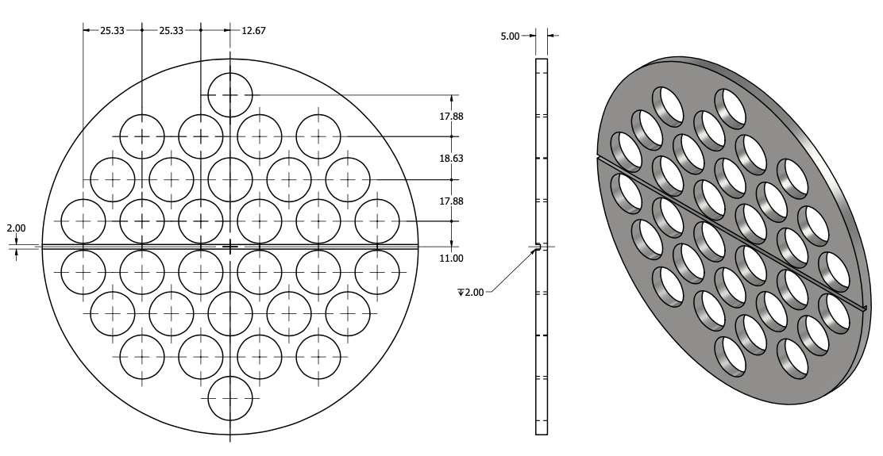
Figure 2. Front view and 3D representation of the tubesheet used in the shell-and-tube heat exchanger (in mm unit).

As shown in Figure 2, using a triangular pitch layout (1.25 × dₒ) for tube arrangement enhances thermal compactness and increases heat transfer per unit volume. The decision to implement a 2-pass configuration on the tube side improves heat exchange efficiency by extending fluid residence time. These design choices are consistent with best practices for medium-duty industrial applications requiring effective cooling with a modest footprint. Furthermore, the choice of material and dimensions adheres to ASTM A269 standards, supporting structural integrity under thermal cycling and fouling conditions typical in waste oil processes.

Fluid Dynamics and Flow Regime
Analyzing flow conditions within the tubes provides insights into convective heat transfer behavior. Given the total flow rate of 0.258 kg/s and 32 tubes split across two passes, the flow rate per tube was 1.736 × 10⁻⁵ m³/s. With an inner diameter of 16 mm, the resulting oil velocity inside the tube was 0.086 m/s. This yielded a Reynolds number (Re) of 501, clearly indicating laminar flow (Re < 2300). For laminar flow with constant wall temperature, the Nusselt number (Nu) was assumed to be 3.66 based on classical correlations. Consequently, the internal convective heat transfer coefficient (hₜ) was calculated as 6.6 W/m²·K, which is relatively low.
This low heat transfer coefficient on the tube side is a limitation typical of viscous oil streams at low velocity. It suggests a potential area for performance enhancement, such as using internal turbulators or twisted tape inserts, to promote mixing and disrupt the thermal boundary layer. Nevertheless, the exchanger is designed to compensate for low tube-side heat transfer under current operating conditions by enhancing shell-side performance and increasing total surface area.

Shell-Side Flow Characteristics
In contrast to the tube side, the shell-side water flow demonstrated turbulent characteristics (see Figure 3). The mass flow rate of the cooling water, derived from the total heat load and a temperature rise of 20 °C, was calculated to be 1.81 kg/s. With a flow area of 0.000722 m² between tubes, the water velocity reached 2.16 m/s. This resulted in a Reynolds number of 11,910, exceeding the threshold for turbulence (Re > 4000). Applying the Dittus–Boelter correlation, the Nusselt number was estimated at 101.2, with a corresponding convective heat transfer coefficient (hₛ) of 243 W/m²·K.
These values highlight the s33hell side as the system's dominant contributor to heat transfer. The high turbulence ensures enhanced convective transport and effective thermal energy removal from the hot oil through the tube walls. Water’s high thermal conductivity and specific heat capacity make it an efficient cooling medium, reinforcing the design rationale. The high heat transfer coefficient aligns with industrial expectations for compact and reliable waste heat recovery units operating under variable loads.

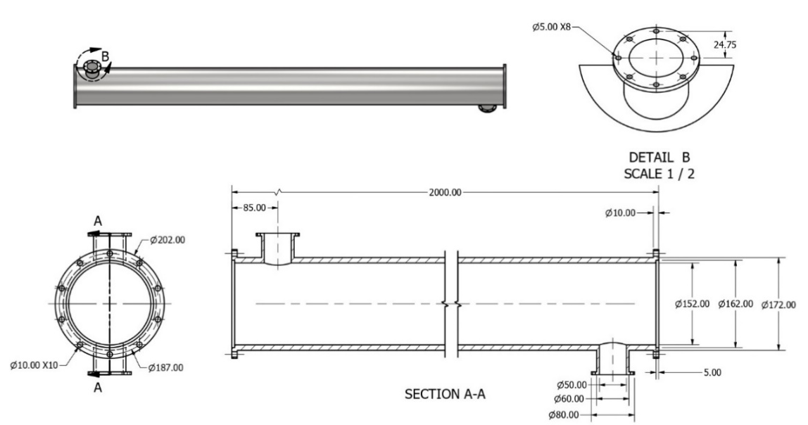
Figure 3. Design of Shell (in mm unit)

Design Implications and Operational Considerations
The combined analysis suggests that the heat exchanger design meets the thermal and hydraulic requirements for efficient cooling in the oil-to-HSD conversion process. The distinct flow regimes on both tube and shell sides, laminar and turbulent, highlight the necessity of careful geometric configuration to maximize heat transfer while minimizing pressure drop. The selected two-pass layout and triangular pitch provide compactness and effective thermal exchange. Furthermore, corrosion-resistant stainless steel ensures long-term durability under high-temperature and chemically aggressive conditions typical in waste oil treatment systems.
The overall analysis confirms that the shell-and-tube heat exchanger is well-suited for the cooling requirements in the waste oil to solar HSD conversion process. The thermal design accommodates a high heat load with acceptable surface area, while the hydrodynamic parameters are within safe and efficient operating ranges. Using stainless steel materials and compact tube arrangements ensures corrosion, fouling, and thermal fatigue resistance. However, the low tube-side heat transfer coefficient indicates a potential design improvement area through active enhancement techniques.
From an operational perspective, the exchanger should maintain consistent thermal performance with proper water flow regulation and periodic maintenance to manage fouling. Monitoring the inlet and outlet temperatures and pressure drops across the shell and tubes will be essential to assess exchanger health and detect performance degradation over time. These insights are critical for long-term energy efficiency, system reliability, and fuel quality assurance in waste oil recycling.

CONCLUSION
The thermal design of the shell-and-tube heat exchanger in this study was successfully implemented to meet the cooling demands in the waste oil to HSD fuel conversion process. A total heat duty of approximately 151.7 kW was required to reduce the waste oil temperature from 350 °C to 70 °C, utilizing cooling water at a temperature range of 30 °C to 50 °C. The calculated Log Mean Temperature Difference (LMTD) was 236.07 °C, indicating a high driving force for efficient heat exchange across the tube wall.
The required heat transfer area of 2.14 m² was achieved by employing 33 stainless steel tubes with an outer diameter of 19 mm and a length of 2 m, arranged in a triangular pitch. The flow regime analysis confirmed that the oil inside the tubes experienced laminar flow with a Reynolds number of 501. At the same time, the cooling water on the shell side exhibited turbulent flow with a Reynolds number of 11,910. As a result, the shell-side convective heat transfer coefficient was significantly higher (243 W/m²·K) than the tube-side coefficient (6.6 W/m²·K), contributing more effectively to the overall thermal performance.
Mechanically, the heat exchanger was configured as a 2-pass system with triangular pitch baffle placement, ensuring compactness and longer residence time for fluid interaction. Stainless steel 304 was selected as the primary material due to its corrosion resistance, strength at elevated temperatures, and durability in chemically aggressive environments. The consistency between simulation results, analytical calculations, and physical design validates the appropriateness of this heat exchanger for integration into real-world oil recycling systems.
In conclusion, the heat exchanger design meets thermal and mechanical performance targets, offering a reliable and efficient cooling system for the HSD production process. Its configuration allows for scalability and adaptability to varying process conditions in industrial applications. Future research may focus on enhancing the internal flow conditions on the tube side using passive turbulence promoters or evaluating long-term performance under fouling and operational transients.

Acknowledgments
The authors gratefully acknowledge the University of Muhammadiyah Malang for the financial support of this research.

References
[1] B. L. Salvi, T. Soni, S. Jindal, and N. L. Panwar, “Design improvement and experimental study on shell and tube condenser for bio-oil recovery from fast pyrolysis of wheat straw biomass,” SN Appl Sci, vol. 3, no. 2, Feb. 2021, doi: 10.1007/s42452-021-04165-8.
[2] H. A. Murillo et al., “Rapid Waste Motor Oil Conversion into Diesel-Range Hydrocarbons Using Hydrochar as Catalyst: Kinetic Study and Product Characterization,” Recycling, vol. 9, no. 3, Jun. 2024, doi: 10.3390/recycling9030039.
[3] A. Santhoshkumar and A. Ramanathan, “Recycling of waste engine oil through pyrolysis process for the production of diesel like fuel and its uses in diesel engine,” Energy, vol. 197, p. 117240, Feb. 2020, doi: 10.1016/j.energy.2020.117240.
[4] C. T. Pinheiro, V. R. Ascensão, C. M. Cardoso, M. J. Quina, and L. M. Gando-Ferreira, “An overview of waste lubricant oil management system: Physicochemical characterization contribution for its improvement,” J Clean Prod, vol. 150, pp. 301–308, 2017, doi: https://doi.org/10.1016/j.jclepro.2017.03.024.
[5] C. Cabrera-Escobar, J. Moreno-Gutiérrez, R. Rodríguez-Moreno, E. Pájaro-Velázquez, F. Calderay-Cayetano, and V. Durán-Grados, “A Review on Global Recovery Policy of Used Lubricating Oils and Their Effects on the Environment and Circular Economy,” May 01, 2025, Multidisciplinary Digital Publishing Institute (MDPI). doi: 10.3390/environments12050135.
[6] M. M. Hasan, M. G. Rasul, M. M. K. Khan, N. Ashwath, and M. I. Jahirul, “Energy recovery from municipal solid waste using pyrolysis technology: A review on current status and developments,” Renewable and Sustainable Energy Reviews, vol. 145, p. 111073, 2021, doi: https://doi.org/10.1016/j.rser.2021.111073.
[7] Y. Misra, D. J. Prasanna Kumar, R. K. Mishra, V. Kumar, and N. Dwivedi, “Thermocatalytic pyrolysis of plastic waste into renewable fuel and value-added chemicals: A review of plastic types, operating parameters and upgradation of pyrolysis oil,” Water-Energy Nexus, vol. 8, pp. 55–72, 2025, doi: https://doi.org/10.1016/j.wen.2025.03.002.
[8] M. Nithya, M. Senthil Vel, S. Anitha, and C. Sivaraj, “Optimizing thermal efficiency: Advancements in flat plate heat exchanger performance through baffle integration,” International Communications in Heat and Mass Transfer, vol. 158, p. 107885, 2024, doi: https://doi.org/10.1016/j.icheatmasstransfer.2024.107885.
[9] A. Patel, “Advancements in heat exchanger design for waste heat recovery in industrial processes,” World Journal of Advanced Research and Reviews, vol. 19, pp. 137–152, Sep. 2023, doi: 10.30574/wjarr.2023.19.3.1763.
[10] W. Li, C. Zou, and X. Li, “Thermo-physical properties of waste cooking oil-based nanofluids,” Appl Therm Eng, vol. 112, pp. 784–792, 2017, doi: https://doi.org/10.1016/j.applthermaleng.2016.10.136.
[11] J. Zhou, J. Zhao, J. Zhang, T. Zhang, M. Ye, and Z. Liu, “Regeneration of catalysts deactivated by coke deposition: A review,” Chinese Journal of Catalysis, vol. 41, no. 7, pp. 1048–1061, 2020, doi: https://doi.org/10.1016/S1872-2067(20)63552-5.
[12] J. Cárdenas, A. Orjuela, D. L. Sánchez, P. C. Narváez, B. Katryniok, and J. Clark, “Pre-treatment of used cooking oils for the production of green chemicals: A review,” J Clean Prod, vol. 289, p. 125129, 2021, doi: https://doi.org/10.1016/j.jclepro.2020.125129.
[13] T. Kumaran, B. Kannan, M. UTHAYAKUMAR, and P. Padmanabhan, “Corrosion Studies on Stainless Steel 316 and their Prevention – A Review,” INCAS BULLETIN, vol. 13, pp. 245–251, Sep. 2021, doi: 10.13111/2066-8201.2021.13.3.21.
[14] H. Upadhyay, U. Vashisht, A. Dhall, P. Diwakar, and J. Juneja, “A review on heat exchanger design,” International Journal Of Applied Research In Science And Engineering, vol. 3, no. 3, pp. 35–38, Nov. 2019.
[15] O. Farhat, J. Faraj, F. Hachem, C. Castelain, and M. Khaled, “A recent review on waste heat recovery methodologies and applications: Comprehensive review, critical analysis and potential recommendations,” Clean Eng Technol, vol. 6, p. 100387, 2022, doi: https://doi.org/10.1016/j.clet.2021.100387.
[16] A. Patel, “Heat Exchangers in Industrial Applications: Efficiency and Optimization Strategies,” International Journal of Engineering Research and, vol. 12, Sep. 2023, doi: 10.17577/IJERTV12IS090003.
[17] A. A. Abd, M. Q. Kareem, and S. Z. Naji, “Performance analysis of shell and tube heat exchanger: Parametric study,” Case Studies in Thermal Engineering, vol. 12, pp. 563–568, 2018, doi: https://doi.org/10.1016/j.csite.2018.07.009.
[18] Y. K. Sofi’i et al., “Small-Scale thermoelectric incinerator prototype for sustainable waste management and power generation,” Engineering and Technology Journal, vol. 42, no. 7, pp. 986–1000, 2024, doi: 10.30684/etj.2024.146331.1678.
[19] A. O., S. Yaru, R. Raheem, O. Fetuata, J. Eiche, and A. Akinsade, “Design and Simulation of a Shell and Tube Heat Exchanger for a Pyrolysis Reactor,” Journal of Energy Research and Reviews, vol. 16, pp. 11–22, Mar. 2024, doi: 10.9734/jenrr/2024/v16i3339.
[20] É. Nogueira, “Efficiency and effectiveness method versus ε-NTU method with application in finned flat tube compact heat exchanger with water-ethylene Glycol as nanofluid base of iron oxide nanoparticles,” Journal of Materials Science and Chemical Engineering, vol. 10, no. 2, pp. 1–17, 2022.
[21] K. Manjunath and S. C. Kaushik, “Second law thermodynamic study of heat exchangers: A review,” Renewable and Sustainable Energy Reviews, vol. 40, pp. 348–374, 2014, doi: https://doi.org/10.1016/j.rser.2014.07.186.
[22] S. Gürgen, “Shell and tube heat exchanger optimization: A critical literature assessment and fairness-based comparative performance analysis of meta-heuristic algorithms,” Case Studies in Thermal Engineering, vol. 72, p. 106405, 2025, doi: https://doi.org/10.1016/j.csite.2025.106405.
[23] N. Johari, A. Zain, N. Mustaffa, and A. Udin, “Firefly Algorithm for Optimization Problem,” Applied Mechanics and Materials, vol. 421, pp. 512–517, Sep. 2013, doi: 10.4028/www.scientific.net/AMM.421.512.
[24] C. Mei, Y. Li, W. Yao, M. Chen, W. Kang, and Z. Deng, “Numerical Simulation of Heat Transfer Characteristics of Finned Tube Heat Exchanger at Different Flow Velocities,” J Phys Conf Ser, vol. 2592, p. 012014, Sep. 2023, doi: 10.1088/1742-6596/2592/1/012014.
[25] A. Mishra, H. Siddiqi, M. Sonowal, A. Chatterjee, P. Maiti, and B. C. Meikap, “A cumulative study on pyrolysis of waste motor oil exploring the design and development of a fixed-bed laboratory scale setup with emphasis on process parameter optimization, COMSOL simulation and preliminary risk assessment,” Process Safety and Environmental Protection, vol. 185, pp. 1219–1231, 2024, doi: https://doi.org/10.1016/j.psep.2024.03.071.

