Vibration Analysis on The Structural Integrity of Pipelines Using Numerical Methods
Alvian Iqbal Hanif Nasrullah^{1,a)}, Shandi Restu Wahyudhi^{1,b)}, Daryono^{1,c)}, Bayu Kusuma Wardhana^{1,d)}, Yudi Primantoko^{1,e)}, Prasetya Adi Nugraha^{2,f)}
¹Departemen of Mechanical Engineering, University of Muhammadiyah Malang, Indonesia
²PT Mass Rapid Transit Jakarta, Jakarta, Indonesia

^{a)}Corresponding author: alvianiq@umm.ac.id
^{b)}shandirestu23@gmail.com
^{c)}daryono@umm.ac.id
^{d)}bayukusumawardhana@umm.ac.id
^{e)}yudipriman023@gmail.com
^{f)}nprasetya@jakartamrt.co.id

Abstract. Pump-induced vibrations can have a critical impact on the structural integrity of pipelines, requiring a comprehensive assessment to ensure operational safety and durability. This study investigates the effect of vibrations generated by pump G-9451 B using numerical simulations conducted in Ansys Workbench. The research focuses on evaluating the equivalent stress and deformation experienced by the pipeline under real-world conditions. The Finite Element Method (FEM) is applied to analyze how factors like meshing quality and pipeline support influence vibration loads, stress distribution, and the overall stability of the structure. Results indicate that the equivalent stress values produced by the pump vibrations exceed the safe operational limits, potentially leading to pipeline damage, failure, and reduced service life. Additionally, the study highlights the necessity of routine maintenance, regular inspections, and properly designed support systems to mitigate these stresses and improve vibration resistance. These findings contribute to advancements in pipeline design, promoting increased reliability, safety, and efficiency in various operational environments.
Keywords: FEM; Numerical analysis;pipeline; structural integrity; Vibration

INTRODUCTION
Indonesia is country rich in natural resources, particularly oil and natural gas. These resources are crucial to the country's economy, contributing significantly to the State Budget [1]. Oil and natural gas are valuable resources, playing an essential role in supporting human life and driving the growth and development of nations [2]. The technologies employed in natural gas liquefaction include various industrial equipment such as gas compressors, turbines, heat exchangers, pumps, and boilers [3]. In the upstream oil and gas industry, pipelines and pumping units are critical for transporting oil, gas, and water to processing facilities or other necessary infrastructure. The interconnection between subsystems within the industry is vital, as any changes in one subsystem can affect others, potentially causing operational issues. One of the key subsystems is the pipeline network [4]. A pump is a mechanical device used to increase work efficiency, primarily employed to transfer fluids or gases from one location to another [5]. Pump performance directly influences the operational costs and the consistency of production levels. The use of corrosion-resistant materials and advanced technology in modern pumps enhances their durability and performance [6]. These pumps not only ensure a continuous flow of oil and gas but also help to minimize the risk of leaks and environmental damage.
One critical component of the pump is the pipeline, which is responsible for transporting liquids or gases [7]. The safe operation of these pipelines depends on maintaining the structural integrity of the system. Any leaks in natural gas pipelines can result in significant harm to people, property, and the environment [8]. Pipelines are susceptible to mechanical damage when exposed to external disturbances. Common mechanical issues such as dents, cracks, gouges, and scratches often occur due to these external forces, which include vibrations [9], [10], [11].
Pump vibrations can be caused by various factors, such as coupling rubber failures, imbalances, or pump bearing issues, as well as installation or operational errors. Other contributing factors include connections between the pump and motor, pump base geometry, and material usage, in addition to pressure line adjustments to control vibrations and cavitation [12]. Furthermore, sudden pump shutdowns can generate severe vibrations, particularly when the pump operates with a closed valve. These vibrations subsequently affect the connected piping system [13].
External disturbances like vibrations can shorten the lifespan of pipelines, making routine maintenance and inspections critical. Regular inspections aim to detect any signs of damage early on [14]. Pump vibrations are often complex due to structural characteristics, rotor imbalances, and unstable fluid forces, which increase the likelihood of nonlinear gyroscopic effects [15], [16], [17].
Based on the issues discussed, this research focuses on the stress analysis of the G-9451 B pump pipeline using vibration data to assess the impact of vibrations on the pipeline and determine whether proper pipe supports can reduce the vibration load generated by the pump.

METHODOLOGY
Numerical analysis using Ansys Workbench software was employed to investigate the effects of pump-induced vibrations on the structural integrity of pipelines. The process began with the collection of initial data, focusing on the technical specifications of the G-9451 B pump and the characteristics of the pipeline under study. A detailed geometry model of the pipeline was created within Ansys Workbench, incorporating key parameters such as dimensions, material properties, and boundary conditions. Once the model was constructed, meshing was performed to break down the geometry into smaller elements, enabling a more precise analysis of vibration distribution. The quality of meshing is crucial for accuracy, so multiple mesh types were evaluated to determine the optimal configuration.
Dynamic analysis followed the meshing process, applying the vibration load produced by the pump to the pipeline model. The Finite Element Method (FEM) was used to calculate equivalent stress and deformation caused by these vibrations. Results were evaluated to determine if the stress and deformation values fell within the safe limits set by industry standards. Sensitivity analysis was also performed to assess the impact of various design parameters and the role of meshing quality on the accuracy of the simulation results.
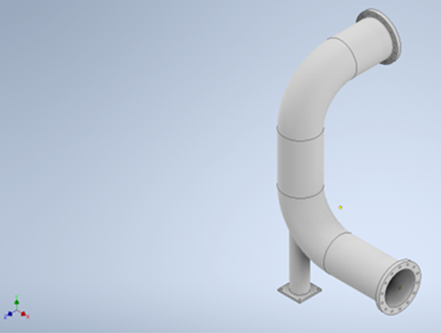
Engineering data for the simulation included material properties, with Gray cast iron chosen for the pipeline material. Autodesk Inventor software was used to create the geometry of the pipeline, with data obtained, as shown in Figure 1.
FIGURE 1. Geometry of pipeline

Finite Element Analysis was carried out using Ansys Workbench software to assess the vibrational impact on pipeline structural integrity. The study focused on determining the natural frequency of the pipeline through modal analysis [18], with fixed supports placed at both ends of the pipeline. The modal analysis identified the natural frequencies at which the pipeline is most susceptible to vibrational resonance.
After completing the modal analysis, the response spectrum was applied to further evaluate the vibrational effects. The response spectrum, which is derived from the velocity and frequency graph shown in Figure 2, was used to compute the vibrational impact on the pipeline in the x, y, and z directions. The Square Root of the Sum of the Squares (SRSS) method [19] was employed to combine the response spectrum velocities from each direction, allowing for an accurate representation of the overall vibrational impact on the pipeline structure.

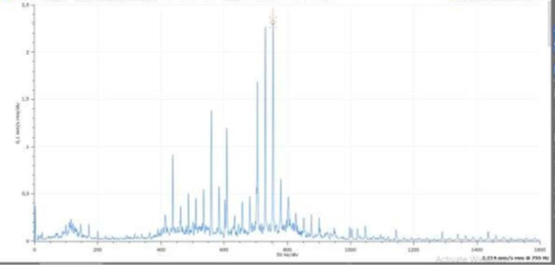
FIGURE 2. Spectrum Graph Data

Following the application of the response spectrum, the next step involved calculating the deformation and equivalent stress experienced by the pipeline. These values were obtained through finite element analysis (FEM), which simulated the structural behavior of the pipeline under vibrational loads. The analysis focused on determining whether the resulting stresses and deformations remained within safe operational limits, ensuring that the pipeline maintains its integrity under these conditions.
The results of the analysis were visually presented, with color-coded graphs highlighting areas of deformation and equivalent stress. These insights provided a clear understanding of how the pipeline responds to pump-induced vibrations, ultimately offering valuable recommendations for enhancing pipeline design and improving the durability and safety of the system.

RESULT AND DISCUSSION
Simulations using the Finite Element Method were conducted to analyze the effect of vibrations on the pipeline structure. The first stage of the modeling involved determining the natural frequencies of the pipeline. As shown in Figure 3, the analysis identified a total of 49 significant natural frequencies ranging from 240 Hz to 1500 Hz. These frequencies were found to be the most influential in determining the vibrational response of the pipeline and were selected for further analysis.
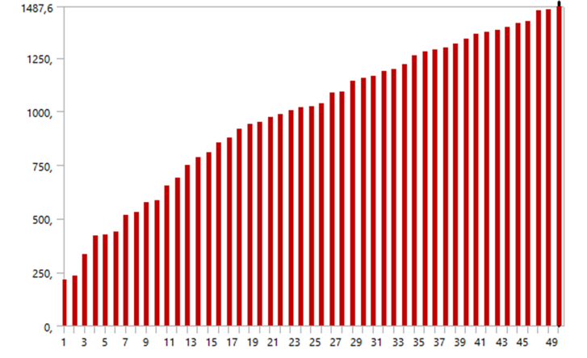
FIGURE 3. Natural Frequency of pipeline

The distribution of natural frequencies provides insight into the pipeline’s susceptibility to resonant vibrations. Frequencies within this range may coincide with external vibrational sources, such as the operational frequency of connected pumps or other mechanical systems, increasing the risk of resonance. Resonance occurs when an external vibrational frequency matches one of the pipeline’s natural frequencies, leading to amplified vibrations, which can cause excessive stress and deformation within the structure.
The Response Spectrum Analysis [20] was performed to evaluate the dynamic response of the pipeline structure to vibrations, focusing on total deformation and stress across the x, y, and z axes.
In Figure 4, the total deformation results for the x-axis show a maximum value of 3.93x10⁻⁶ mm. Figure 5 illustrates the total deformation along the y-axis, with a a maximum value of 2.27x10⁻⁶ mm. And in Figure 6, the total deformation along the z-axis reveals a maximum value of 4.38x10⁻⁶ mm. The red areas on the graph represent zones of maximum deformation, while the blue areas indicate zones with minimal deformation. The analysis shows that the pipeline experiences little to no deformation at the minimum point, and even at its maximum, the deformation remains extremely small. This indicates that the pipeline structure remains within the tolerance limits for deformation, suggesting that vibrational stress along this axis is minimal and unlikely to compromise structural integrity.

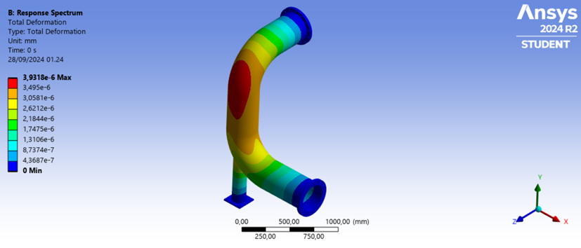
FIGURE 4. Total deformation for x-axis vibration

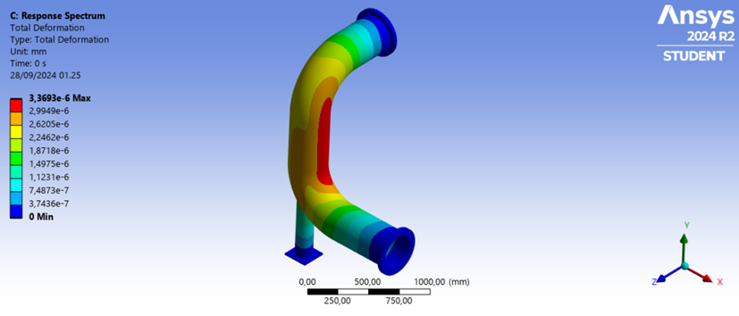
FIGURE 5. Total deformation for y-axis vibration

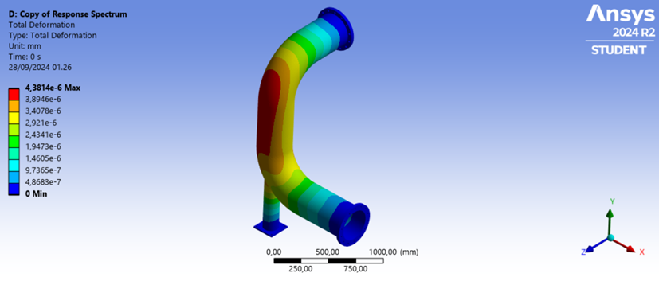
FIGURE 6. Total deformation for z-axis vibration

Overall, the total deformation across all three axes demonstrates that the pipeline structure experiences very minimal deformation due to the applied vibrational loads. The values remain within the tolerance limits, indicating that the pipeline is capable of withstanding the dynamic forces without significant risk of structural failure or compromise. These findings highlight the resilience of the pipeline design under vibrational stress and provide confidence in its operational stability.
In Figure 7, the simulation of the equivalent stress along the x-axis reveals a maximum value of 3.70x10-4 MPa. The red areas indicate zones of maximum stress, concentrated near the fixed support, while the blue areas show regions of minimal stress. The difference between the minimum and maximum values is relatively small, indicating that the stress distribution along the x-axis is fairly stable. This suggests that the structure is not under significant stress in this direction and is operating within safe limits, with no immediate risk of failure due to vibrational effects.

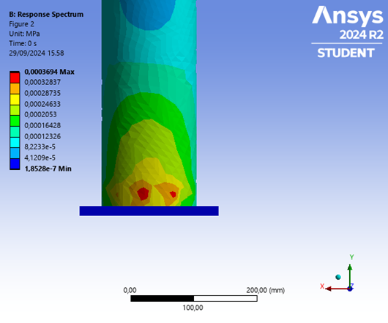
FIGURE 7. Equivalent stress for z-axis vibration

In Figure 8, the equivalent stress results along the y-axis show a maximum value of 6.98x10⁻⁴ MPa. The red areas, representing the highest stress values, are concentrated around the welded joint between the pipe and the fixed support. Although the maximum stress value in the y-axis is higher than that of the x-axis, the range remains small and within acceptable limits. This indicates that while the structure experiences slightly more stress in the y-direction, it is still well within the material's capacity and shows no signs of impending failure.

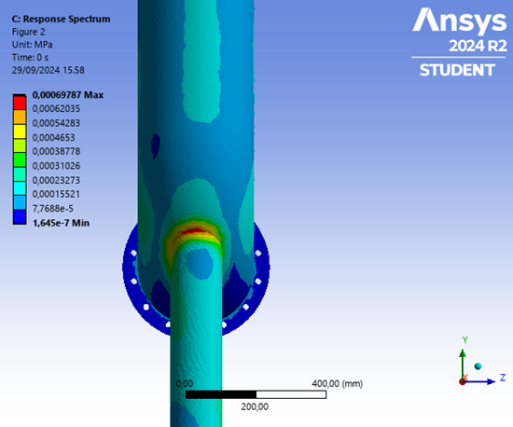
FIGURE 8. Equivalent stress for y-axis vibration

In Figure 9, the equivalent stress for z-axis vibration has a maximum value of 4.64x10-4 MPa. Similar to the x-axis, the stress concentrations are found near the fixed support. The stress range in the z-direction is slightly higher than in the x-axis but lower than in the y-axis. Despite this variation, the stress remains within safe operational limits, indicating that the structure remains stable under the vibrational loads applied in the z direction.

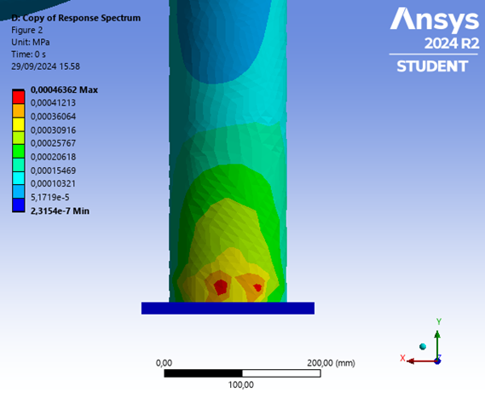
FIGURE 9. Equivalent stress for z-axis vibration

Overall, the equivalent stress simulations across all three axes demonstrate that the pipeline structure experiences minimal stress under the given vibrational conditions. The maximum stress values are well below the material's failure threshold, suggesting that the pipeline is structurally sound and can withstand the applied vibrations without compromising its integrity. These findings highlight the importance of proper support placement, particularly near welded joints and fixed supports, to mitigate the localized increase in stress and prolong the pipeline’s operational life.

CONCLUSION
The research successfully analyzed the impact of pump-induced vibrations on the structural integrity of the pipeline using numerical simulations via the Finite Element Method in Ansys Workbench. The modal analysis revealed that the pipeline's natural frequencies range from 240 Hz to 1500 Hz, with several frequencies potentially coinciding with operational conditions, indicating a risk of resonance. The response spectrum analysis demonstrated minimal deformation across the x, y, and z axes, confirming that the pipeline structure remains within safe deformation limits under vibrational stress.
Additionally, the equivalent stress analysis showed that the pipeline experienced low stress values across all directions, with the maximum stress concentrations located near fixed supports and welded joints. Despite these localized stress points, the overall stress levels were well below the material's failure threshold, suggesting that the pipeline structure remains stable and capable of handling the vibrational loads without compromising its integrity.
These findings affirm that proper support placement and regular maintenance are essential for mitigating the impact of vibrations on the pipeline. The results provide valuable insights for improving pipeline design and ensuring long-term structural stability in dynamic operating environments.

ACKNOWLEDGMENT
The authors would like to express their sincere gratitude to Universitas Muhammadiyah Malang for providing financial support for this research. We would like to thank Ansys for providing the student license, which was essential for the computational simulations carried out in this study. Their support has been instrumental in the successful completion of this study

references
[1] N. A. Pambudi et al., “Renewable Energy in Indonesia: Current Status, Potential, and Future Development,” Sustainability 2023, Vol. 15, Page 2342, vol. 15, no. 3, p. 2342, Jan. 2023, doi: 10.3390/SU15032342.
[2] E. Dogan, M. Madaleno, and B. Altinoz, “Revisiting the nexus of financialization and natural resource abundance in resource-rich countries: New empirical evidence from nine indices of financial development,” Resources Policy, vol. 69, Dec. 2020, doi: 10.1016/j.resourpol.2020.101839.
[3] W. Lim, K. Choi, and I. Moon, “Current Status and Perspectives of Liquefied Natural Gas (LNG) Plant Design,” Ind Eng Chem Res, vol. 52, no. 9, pp. 3065–3088, Mar. 2013, doi: 10.1021/IE302877G.
[4] A. Husen and A. Jamaludin, “ANALISIS TEGANGAN SISTEM PERPIPAAN PADA SISI TEKAN POMPA P-003E MENGGUNAKAN PROGRAM CAESAR II DAN PERHITUNGAN MANUAL,” Presisi, vol. 21, no. 2, pp. 8–28, Jul. 2019, Accessed: Oct. 15, 2024. [Online]. Available: https://ejournal.istn.ac.id/index.php/presisi/article/view/729
[5] K. J. Chua, S. K. Chou, and W. M. Yang, “Advances in heat pump systems: A review,” Appl Energy, vol. 87, no. 12, pp. 3611–3624, Dec. 2010, doi: 10.1016/J.APENERGY.2010.06.014.
[6] D. K. Peacock, “Effective design of high performance corrosion resistant systems for oceanic environments using titanium,” Corrosion Reviews, vol. 18, no. 4–5, pp. 295–330, Oct. 2000, doi: 10.1515/CORRREV.2000.18.4-5.295/MACHINEREADABLECITATION/RIS.
[7] K. Patchigolla and J. E. Oakey, “Design Overview of High Pressure Dense Phase CO2 Pipeline Transport in Flow Mode,” Energy Procedia, vol. 37, pp. 3123–3130, Jan. 2013, doi: 10.1016/J.EGYPRO.2013.06.198.
[8] D. A. Anderson, “Natural Gas Transmission Pipelines: Risks and Remedies for Host Communities,” Energies 2020, Vol. 13, Page 1873, vol. 13, no. 8, p. 1873, Apr. 2020, doi: 10.3390/EN13081873.
[9] S. Vishnuvardhan, A. R. Murthy, and A. Choudhary, “A review on pipeline failures, defects in pipelines and their assessment and fatigue life prediction methods,” International Journal of Pressure Vessels and Piping, vol. 201, p. 104853, Feb. 2023, doi: 10.1016/J.IJPVP.2022.104853.
[10] M. Hagarová, G. Baranová, P. Peterka, B. Buľko, M. Hrubovčáková, and V. Girman, “Failure analysis of a gas pipeline at the kinked dent location with crack indications,” Eng Fail Anal, vol. 153, p. 107579, Nov. 2023, doi: 10.1016/J.ENGFAILANAL.2023.107579.
[11] P. Prevéy and D. Hornbach, “Residual Stress in Pipelines,” Oil and Gas Pipelines: Integrity and Safety Handbook, pp. 73–98, Apr. 2015, doi: 10.1002/9781119019213.CH07.
[12] K. Kan et al., “Pump as turbine cavitation performance for both conventional and reverse operating modes: A review,” Renewable and Sustainable Energy Reviews, vol. 168, p. 112786, Oct. 2022, doi: 10.1016/J.RSER.2022.112786.
[13] F. Akbar et al., “Analisis Dinamik Sistem Perpipaan pada Aromatic Plant akibat Getaran Pompa,” Proceedings of National Conference on Piping Engineering and Its Application, vol. 8, no. 1, pp. 133–137, Nov. 2023, Accessed: Oct. 15, 2024. [Online]. Available: http://journal.ppns.ac.id/index.php/CPEAA/article/view/2525
[14] M. T. F. Azhari, D. M. Kamal, and V. Nanda, “Analisis Penyebab Penurunan Kinerja High Pressure Pump pada Sistem Reverse Osmosis,” Dec. 01, 2023. Accessed: Oct. 15, 2024. [Online]. Available: https://prosiding.pnj.ac.id/sntm/article/view/1559
[15] L. Bai, L. Zhou, X. Jiang, Q. Pang, and D. Ye, “Vibration in a Multistage Centrifugal Pump under Varied Conditions,” Shock and Vibration, vol. 2019, no. 1, p. 2057031, Jan. 2019, doi: 10.1155/2019/2057031.
[16] H. Zhang, H. You, H. Lu, K. Li, Z. Zhang, and L. Jiang, “CFD-Rotordynamics Sequential Coupling Simulation Approach for the Flow-Induced Vibration of Rotor System in Centrifugal Pump,” Applied Sciences 2020, Vol. 10, Page 1186, vol. 10, no. 3, p. 1186, Feb. 2020, doi: 10.3390/APP10031186.
[17] X. Zheng, Y. Zhang, J. Li, and Y. Zhang, “Influences of rotational speed variations on the flow-induced vibrational performance of a prototype reversible pump turbine in spin-no-load mode,” Journal of Fluids Engineering, Transactions of the ASME, vol. 142, no. 1, Jan. 2020, doi: 10.1115/1.4045159/1065464.
[18] J. O. Carneiro, F. J. Q. de Melo, J. F. D. Rodrigues, H. Lopes, and V. Teixeira, “The modal analysis of a pipe elbow with realistic boundary conditions,” International Journal of Pressure Vessels and Piping, vol. 82, no. 8, pp. 593–601, Aug. 2005, doi: 10.1016/J.IJPVP.2005.04.001.
[19] M. P. Singh, “SEISMIC RESPONSE BY SRSS FOR NONPROPORTIONAL DAMPING,” ASCE J Eng Mech Div, vol. 106, no. 6, pp. 1405–1419, Dec. 1980, doi: 10.1061/JMCEA3.0002672;WEBSITE:WEBSITE:ASCE-SITE.
[20] Y. Yang, G. Sui, and Y. Zhang, “Response spectrum method for fatigue damage assessment of aero-hydraulic pipeline systems,” Comput Struct, vol. 287, p. 107119, Oct. 2023, doi: 10.1016/J.COMPSTRUC.2023.107119.

