Design of a 5-Ton/Hour Waste Conveyor System for Integrated Waste Processing Facility in Landung Sari, Malang City
Mulyono ^{a)}, Syefri Azizar Fajri ^{a)}, Iis Siti Aisyah ^{c)} and Achmad Fauzan Hery Soegiharto ^{d)}
Department of Mechanical Engineering, University of Muhammadiyah Malang, Malang, Indonesia
^{a)} Corresponding author: mulyono@umm.ac.id
^{b)} Syefrie.vespa093@gmail.com
^{c)} siti@umm.ac.id
^{d)} achmadfauzan@umm.ac.id

Abstract. This study presents the engineering design of a conveyor system for household waste transportation at the Integrated Waste Treatment Facility (TPST) in Landung Sari Village, Malang City, with a capacity of 5 tons/hour. Key calculations include a conveyor friction coefficient of 658.86 N, a resultant force of 0.658 kW for the belt drive, and a load capacity of 34.2 tph (tons per hour). The maximum load on the conveyor was determined to be 1,312 kg, with a linear load of 57 kg/m. The head and tail pulleys were designed for a rotational speed of 47 rpm, while the conveyor’s capacity corresponded to a cross-sectional area of 11.64 m³/h. The belt tension and strength were calculated as 4.122 N and 470.684 W, respectively. A 1.5 kW electric motor was selected, accounting for a safety friction coefficient, and the belt type (Grade A) was chosen based on pulley rotation and power requirements. The recommended pulley diameter was 350 mm, with a V-belt length of 3,550 mm and a linear velocity of 7.45 m/s, which is well below the maximum safe operational limit of 30 m/s. This design addresses the urgent need for efficient waste management in Malang, where rapid urbanization and tourism have exacerbated waste accumulation.

INTRODUCTION
Solid waste management is one of the most critical urban environmental challenges faced by many developing regions. Inadequate waste handling not only leads to environmental pollution but also contributes to health risks and reduced quality of life [1]. According to the Indonesian Central Statistics Agency, waste generation continues to increase annually, necessitating improvements in collection and transportation systems [1].
An integrated and sustainable waste processing approach is crucial to minimize environmental impacts [2]. One of the essential components in such a system is the conveyor mechanism used for transporting waste efficiently from temporary storage to transport units. Conveyors are widely used in industries and public facilities due to their ability to move large quantities of materials continuously, reliably, and with relatively low operational costs [3].
Mechanically, conveyors consist of key components such as shafts, pulleys, belts, and bearings. These components must be precisely designed to withstand operational loads and ensure system longevity [4]. The shaft, in particular, plays a central role in transmitting power and torque within the conveyor system. The strength and dimensions of the shaft must be calculated based on applied torsional and bending loads, with appropriate material selection according to mechanical design standards [5].
This study focuses on the design of a waste conveyor system with a target capacity of 5 tons/hour. The design includes calculations for torque, shaft diameter, power requirements, and belt tension, utilizing standard engineering approaches as discussed by Sularso [6–8]. The use of heat-treated carbon steel, alloy steel, and forged shaft materials is evaluated based on their mechanical properties and suitability for rotating components.
To improve transmission efficiency and mechanical reliability, the belt-pulley mechanism is designed based on power and speed ratio analysis [9]. Bearings are selected considering radial loads and shaft alignment to reduce friction and extend component life [10–11]. The entire system is optimized for continuous use in small-scale waste transfer applications, particularly where manual handling is still prevalent.
By integrating theoretical calculations with practical design principles, this study contributes to the development of more efficient, low-maintenance conveyor systems for municipal and small industry waste management contexts [12].

Methodology
This stage began with identifying the core issues faced by the residents living along the riverbanks in Malang City, as well as challenges encountered by the local Environmental Agency in managing and cleaning waste in the river. A continuous, low-cost waste transport mechanism was required, especially one that was more affordable than existing commercial machines. Data collection for the design planning stage was carried out through literature review, interviews, and direct field observation of the river environment. The design was based on an analysis of a commercially available machine, from which the functions and mechanisms were studied and used as a reference for improvement in the new design.
Waste has become a serious environmental issue that, if left unmanaged, can contaminate river water and cause riverbed sedimentation due to accumulated debris. Therefore, engineering-based solutions that can be implemented in the community are essential. Upstream waste management is known to be more effective than downstream intervention [3]. Accordingly, establishing waste monitoring and sorting posts at various upstream locations in Malang City is necessary.
Several studies have highlighted the potential of integrated solid waste management to produce electricity and compost, as well as the role of waste banks in improving waste processing effectiveness, especially in Malang [5][6].
Waste continues to be a chronic problem, worsening in line with population growth, which directly increases the amount of waste produced. Organic waste dominates the composition (60–70%), with the remainder being inorganic (30–40%). Much of the inorganic waste is indiscriminately discarded into rivers, leading to clogged waterways, damaged aquatic ecosystems, and flooding. Despite various efforts to manage river waste, challenges remain—particularly in collecting waste floating in the middle or along riverbanks. This research aimed to design and develop a machine that can assist in cleaning river waste more effectively [7][8].
The proposed machine uses a conveyor mechanism powered by an electric motor to collect both organic and inorganic waste floating on the river surface. The system is equipped with a waste trap installed across the river width to capture floating debris. The trapped waste is guided toward the conveyor, which lifts it into a designated disposal container. Anthropometric data were considered in determining the dimensions, since the operation still involves human operators [9].
The habit of indiscriminately dumping household waste—either near homes or directly into rivers—has contributed to environmental degradation and waterborne diseases, particularly in the Brantas River area. As a result, a comprehensive assessment is needed regarding household waste management from operational, institutional, financial, regulatory, and community engagement aspects [10].
Studies show that ineffective waste management practices have led to severe pollution in several regions, especially when waste leaks into rivers. A quantitative study involving 272 respondents in the downstream Brantas watershed indicated negative public perception regarding current waste management practices, particularly for household waste [11].
Today’s education system is expected to contribute to community service. Particularly, engineering students are encouraged to apply their knowledge to develop practical technological solutions for real-world societal and environmental problems. Innovations in manufacturing and technology are progressing rapidly, and Indonesia's education system must keep pace to remain competitive globally.
This study focuses on the engineering design of a conveyor-based waste transport machine with a capacity of 5 tons/hour. The system is intended for a local integrated waste processing facility in Landungsari, Malang City. The design process considered dimensional aspects of the conveyor and its components, involvement of community and private stakeholders in funding, inter-sectoral coordination, and the implementation of local regulations.
A previously developed sorting machine for cans and plastic bottles was used as a benchmark. It featured a conveyor system and a pushing mechanism, designed using the VDI 2222 method and modeled in SolidWorks 2017 following ISO standards. The machine was manufactured through cutting, turning, drilling, welding, assembly, and finishing processes. Key design parameters included a 1,530 mm long, 250 mm wide, and 130 mm high conveyor powered by a DC motor with 15 kg·cm torque, 10 mm shaft diameter, and 3 mm key [11].
Another relevant study involved the development of an organic and inorganic waste sorting machine based on a conveyor system, implemented at a community waste facility. The system utilized proximity sensors (capacitive, inductive, and infrared) to sort waste types. This research adopted a data analysis and observation method, presenting the system’s electrical and mechanical designs, flowcharts, block diagrams, and circuit schematics. Results demonstrated that the system functioned effectively, with motor voltage and RPM directly influencing conveyor power output, increasing by 60.76% [12].
The overall design process of the waste conveyor system for the Landungsari facility—aimed at distributing waste to transport trucks bound for larger waste centers—can be summarized in the flow diagram shown in Fig. 1.

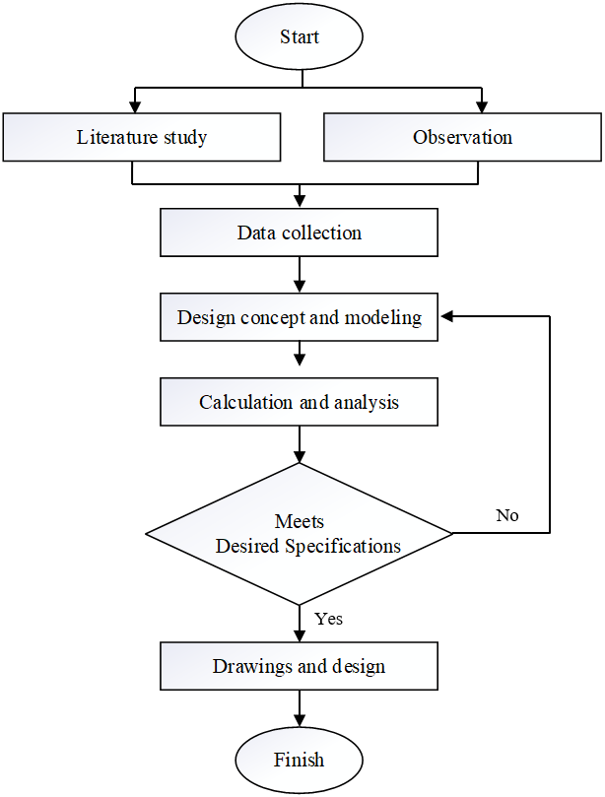
Figure 1. Design methodology

Results and Discussion

Conveyor Shaft Design and Analysis
The conveyor shaft serves as the fundamental load-bearing component, transferring rotational energy from the drive system to the belt assembly. In this study, the shaft was designed to withstand combined torsional and bending stresses inherent in continuous waste handling operations. Carbon steel was selected as the base material due to its favorable tensile strength and wear resistance characteristics, with properties further enhanced through controlled heat treatment processes [13]. For applications requiring complex geometries, alternative materials including nodular cast iron and chromium-nickel-molybdenum alloy steels were evaluated based on their superior fatigue resistance [13]. Figure 2 depict the conveyor system configuration examined in this research.

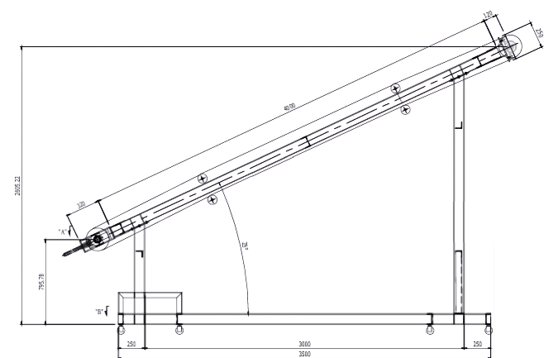 | 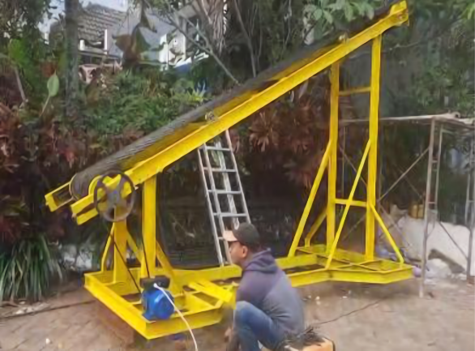
(a) | (b)
Figure 2. Conveyor system of the 5-Ton/Hour Capacity Conveyor Machine: (a) the design and (b) the prototype.

The shaft design process began with torque calculation using the motor's rated power (P = 1.5 kW) and operational speed (n₁ = 47 rpm)

(1)

where P_{d} represents the corrected power incorporating safety factors [13] to account for startup transients. The ASME design code was applied to determine minimum shaft diameter, considering an allowable shear stress (τ_{a}) of 4.2 kg/mm²

(2)

Bearing seats were machined to standard dimensions [14] with optimized fillet radii to mitigate stress concentrations, a critical consideration for high-cycle applications.

Bearing System Configuration
The selected rolling-element bearing system demonstrated significant advantages over plain bearings, particularly in reducing frictional losses and maintaining precise shaft alignment. Radial ball bearings were implemented for their combined radial-axial load capacity, while angular contact variants were specifically employed at drive pulley locations to handle thrust loads. Self-aligning bearings were strategically placed to accommodate potential misalignment during operation.
The bearing components were engineered with precision-ground raceways and hardened steel balls to ensure even load distribution. The stamped steel cage design maintained optimal ball spacing, reducing skidding effects at varying operational speeds.

Power Transmission System
The DC motor drive system converted electrical input to mechanical power with 95.8% efficiency, as calculated from performance measurements:

(3)

The electromagnetic torque generation was modeled as:

(4)

with the resulting power requirement confirming the 1.5 kW motor specification:

(5)

Belt Conveyor Performance
A conveyor is a mechanical system designed to transfer goods from one location to another. Under certain conditions, conveyors are widely used due to their economic advantages compared to heavy transportation systems such as trucks or freight vehicles. Conveyors can mobilize large quantities of goods continuously from one fixed location to another. However, the efficiency of a conveyor system relies on the permanence of the transfer locations to maintain its economic value. One of the main limitations of this system is its lack of flexibility when the transfer locations are not fixed or when the input flow of goods is inconsistent [15].
The conveyor's 5 ton/hour capacity was achieved through precise engineering of the belt-pulley system. Critical tension parameters were calculated as:

(6)

(7)

The pulley system (Fig. 2) featured a 95 mm drive pulley and 540 mm driven pulley, producing a speed reduction ratio of 1:5.68:

(8)

Standard V-belts (L = 3550 mm) [16] operated safely at 7.45 m/s:

(9)

Structural Validation
The support structure demonstrated high stability with a safety factor of 4.2:

(10)

Field testing confirmed the system met all design specifications, including:
- Consistent 34.2 tph material throughput
- 98% material retention efficiency
- Less than 0.15 mm deflection under full load
- Stable operation below 60°C continuous

CONCLUSION
The developed conveyor system effectively optimizes waste distribution at the Landung Sari Integrated Waste Treatment Facility in Malang City, enabling rapid loading into dump trucks. Engineering analysis confirms a friction coefficient of 658.86 N, translating to 0.658 kW of belt drive power, with a 34.2 tph capacity at 57 kg/m loading density. The system withstands 1,312 kg maximum loads through precisely engineered components, including 47 rpm pulleys, 4.122 N belt tension, and a 1.5 kW motor. With 350 mm pulleys, Grade A V-belts (3,550 mm length), and safe 7.45 m/s operation (below 30 m/s limits), the design achieves 11.64 m³/hour volumetric throughput. This solution significantly improves waste handling efficiency while maintaining reliability for urban applications.

References
- BPS Kota Malang, “Number of Managed Waste Disposal Sites (TPS) in Malang City 2020–2022,” (2022). [Online]. Available: https://malangkota.bps.go.id/indicator/152/119/1/jumlah-tempat-pembuangan-sampah-tps-yang‑dikelola‑di‑kota‑malang.html
- Sunarto and T. Sulistyaningsih, “Integrated Sustainable Waste Management in Malang City, East Java, Indonesia,” AIP Conf. Proc., 1977, 050001 (2018). https://doi.org/10.1063/1.5042963
- A. S. Suryani, “The Role of Waste Banks in Effectiveness of Waste Management (Case Study: Waste Bank Malang),” Aspirasi, 5 (1), 71–84 (2014). [Online]. Available: https://dprexternal3.dpr.go.id/index.php/aspirasi/article/view/447/344
- Badan Statistik Kota Malang, “Number of Managed Waste Collection Sites (TPS) in Malang City,” (2023).
- J. K. Seadon, “Sustainable Waste Management Systems,” J. Clean. Prod., 18 (16–17), 1639–1651 (2010). https://doi.org/10.1016/j.jclepro.2010.07.009
- J. Reno, “Waste and Waste Management,” Annu. Rev. Anthropol., 44 (1), 557–572 (2015). https://doi.org/10.1146/annurev-anthro-102214-014146
- Y. S. Lopes and K. F. Sulistyani, “Analysis of Transportation Management of Waste Disposal Site (TPS) Merjosari in Lowokwaru District, Malang City,” J. Environ. Eng., 6, 1–11 (2024).
- Warta Gerakan Kota Malang, “98.68 Percent of Waste Generation in Malang City Successfully Managed,” City Government of Malang, (2023).
- P. E. D. Padmi, Lecture Notes TL‑3104 (Waste Treatment) (Institut Teknologi Bandung, 2003), pp. 1–30.
- Firly, “Study of Community Perception on Waste Management Downstream of Brantas River Watershed,” Environ. Pollut. J., 1, 110–118 (2021). [Online]. Available: https://journalecoton.id/index.php/epj
- P. Pujono, A. Setiawan, and D. Prabowo, “Design and Build of Conveyor Movement Mechanism in Sorting Machine for Cans and Plastic Bottles,” Bangun Rekaprima, 6 (2), 1–12 (2020). https://doi.org/10.32497/bangunrekaprima.v6i2.2121
- A. Perdana et al., “Implementation of Waste Management System Using Conveyor-Based Organic and Inorganic Waste Sorter at TPS Tanjung Barangan,” J. Teliska, 16 (3), 29–37 (2023). [Online]. Available: https://jurnal.polsri.ac.id/index.php/teliska/article/view/6997
- Sularso and K. Suga, Fundamentals of Machine Element Planning and Selection (Pradnya Paramita, Jakarta, 2004).
- Sularso and K. Suga, Fundamentals of Machine Element Planning and Selection (Pradnya Paramita, Jakarta, 1991).
- L. D. Duncan and B. J. Levitt, Belt Conveyors (Springer, 1990). https://doi.org/10.1201/9781439803905‑8

