Optimization of Turbulent Flow in Pipe Bends Using Artificial Neural Network
Muhammad Mawlana Handyhasyim^{a)}, Daryono^{b)} and Murjito^{c)}
Department of Mechanical Engineering, University of Muhammadiyah Malang
Jl. Raya Tlogomas No. 246, Malang 65144, Indonesia.

^{a)}handy.hasym@gmail.com
^{b)}Corresponding author: daryono@umm.ac.id
^{c)}murjito@umm.ac.id

Abstract. Turbulence is a common phenomenon in fluid flow systems, particularly in pipe bends. This study aims to enhance the accuracy of Computational Fluid Dynamics (CFD) simulations performed using ANSYS Fluent by applying an Artificial Neural Network (ANN) optimization approach. The optimization process employs two key parameters: normalized streamwise velocity (W*) and normalized radial coordinate (r*). The pipe configuration consists of a straight pipe with a length of 70D and a bend radius of 7D, where D is the pipe diameter of 43 mm. Three discretization schemes—First-Order Upwind (FOU), Second-Order Upwind (2OU), and QUICK—were evaluated for turbulence models at bend angles of 45 degrees and 75 degrees. The simulation results indicate that ANN optimization improves the predictive accuracy of selected turbulence models, particularly at a 45 degrees bend. However, at a 75 degrees bend, the accuracy decreases across most models. This study demonstrates the potential of ANN to enhance CFD predictions in complex flow conditions.

INTRODUCTION
Pipes are commonly used to transport or transfer fluids, gases, steam, and chemicals from one location to another [1]. Pipe bends or elbows are widely utilized in engineering systems such as water distribution networks, oil and gas pipelines, automotive systems, power plants, turbomachinery, and heat exchangers. The flow within these systems is typically complex and turbulent [2]. In recent years, Computational Fluid Dynamics (CFD) has emerged as a powerful tool capable of modeling flow characteristics in detail [3]. CFD can be defined as a collection of numerical techniques that enable computers to simulate fluid flow phenomena [4]. Accurate fluid flow simulations are essential for solving various scientific and engineering problems, but they often require substantial computational resources [5]. Despite its advantages, CFD still faces limitations, including high computational costs and potential accuracy issues [6].
Machine Learning (ML), a subset of Artificial Intelligence (AI), has been increasingly applied to address challenges in prediction and automation [7]. Recently, ML has shown great potential in enhancing turbulence modeling. Although these models may provide improved accuracy compared to traditional turbulence models, they still face challenges in reducing computational costs [5]. Machine Learning builds models based on data and prior experiences [8]. ML approaches can be categorized into supervised, unsupervised, and reinforcement learning [9]. In supervised learning, input data are presented along with corresponding output labels. In contrast, unsupervised learning involves data without explicit output values [10]. Reinforcement Learning (RL) enables an AI agent to interact with its environment using trial-and-error and learn optimal strategies based on rewards received [11].
Artificial Neural Networks (ANNs) are one of the most widely used frameworks in ML, especially in control systems and modeling of complex or unknown structures [12][13]. ANNs mimic the function of biological neurons and apply learning processes inspired by the human brain to solve various problems [14]. A typical ANN consists of input, hidden, and output layers [15]. Recent ANN variants such as deep learning, recurrent neural networks, and genetic algorithms play significant roles in AI, robotics, image processing, and other cutting-edge technologies [16].
A study by Rilwan Kayode Apalowo (Federal University of Technology, Akure, Nigeria) in 2022 compared experimental results from W. N. Al-Rafai, Y. D. Tridimas, and N. H. Woolley [17] with CFD simulations using ANSYS software in a study titled "Numerical Study of Different Models for Turbulent Flow in 90° Pipe Bend". The reported errors were 3.83% for the k-epsilon model and 3.27% for the Spalart–Allmaras model [18]. Building upon the accuracy analysis in prior studies, the present research aims to optimize CFD simulation results using the Artificial Neural Network (ANN) method.

Methodology
This section describes the process of optimizing turbulent flow in pipe bends using the Artificial Neural Network (ANN) method. The goal of this optimization is to predict normalized streamwise velocity (W*) and normalized radial coordinate (r*) at bend angles of 45° and 75°. The optimization results are validated using standard percentage error formulas.

Data Collection
Data were obtained from previous research conducted by Rilwan Kayode Apalowo, which includes flow parameters and pipe geometry specifications. The flow characteristics used in the simulation are summarized in Table 1, while the pipe geometry is presented in Table 2.

TABLE 1. Flow Parameters.
Parameter | Value | Unit
Reynolds Number | 31132 | -
Bulk Velocity (U) | 11.595 | m/s
Turbulent Intensity | 5 | %
Hydraulic Diameter | 10.75 | mm
Backflow Intensity | 5 | %
Pressure | 0 | Pa
Roughness | 0 | m
Roughness Constant | 0.5 | -
No-Slip Condition | - | -

TABLE 2. Pipe Geometry Specifications.
Parameter | Value | Unit
Inner Diameter | 43 | mm
Curvature Radius | 301 | mm
Straight Length | 3010 | mm
Inner Radius | 22.5 | mm

Design and Simulation Process
The CFD simulations were carried out using ANSYS Fluent 2024 R1, which involved three main stages: pre-processing, solving, and post-processing. The pre-processing stage included the creation of a 3D geometry using Design Modeler and mesh generation with appropriate boundary conditions, as illustrated in Fig. 1 and Fig. 2, respectively.
In the solving stage, turbulence models including k-epsilon, k-omega, and Spalart–Allmaras were applied. The inlet boundary was assigned a velocity of 11.595 m/s, with 5% turbulence intensity and a hydraulic diameter of 10.75 mm. The outlet was set to zero pressure, with similar turbulence parameters. No-slip boundary conditions were applied to all walls. The solver method used was SIMPLE, with a residual convergence criterion of 0.0001 and 500 iterations.
Post-processing involved extracting numerical results from the simulation, particularly velocity data at different radial and axial positions. These outputs were then used as input for the ANN optimization phase.

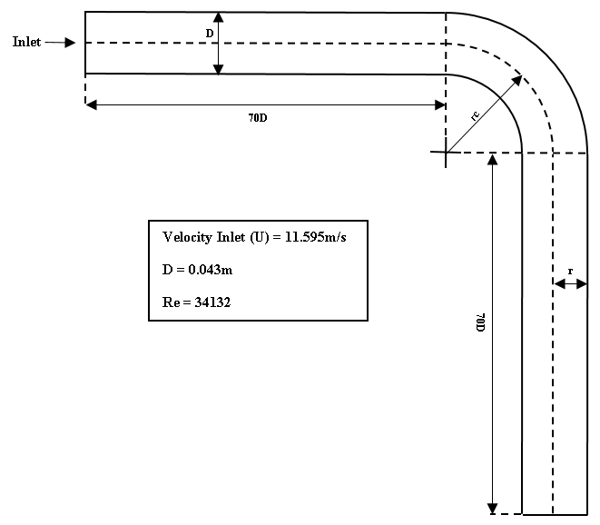
Figure 1. Pipe Geometry Model.

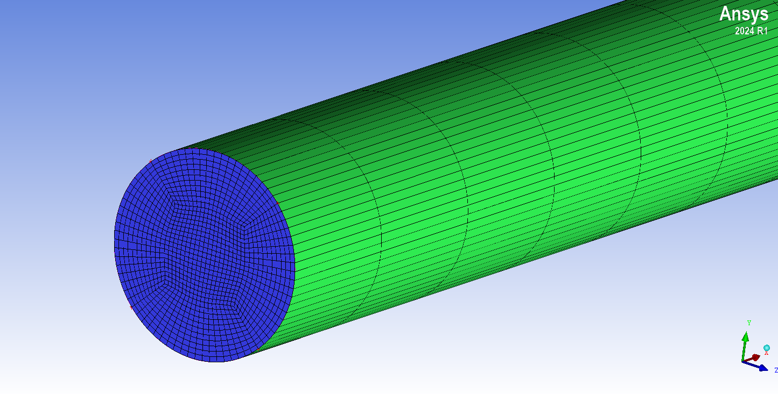
Figure 2. Computational Mesh of the Pipe Bend.

ANN-Based Optimization
The ANN optimization was implemented using Python libraries Keras and Scikit-learn. The dataset derived from ANSYS Fluent simulations was split into training and testing sets using train_test_split with a test size of 0.35, meaning 65% of the data were used for training and 35% for testing.
A Tensor Basis Neural Network was built with one input layer, three hidden layers, and one output layer. The architecture used the LeCun normal initializer and SELU (Scaled Exponential Linear Unit) activation functions. The Nadam optimizer was applied with a learning rate of 0.0005 and clipnorm of 1000. The loss function was Mean Squared Error (MSE), and evaluation metrics included MSE and Mean Absolute Error (MAE). The training process was run for 1000 epochs with a batch size of 1000.

Model Validation
Model validation was conducted by comparing the optimized values of normalized streamwise velocity (W*O,k) with numerical CFD values (W*N,k) using the standard percentage error formula, as given in Eq. (1):

(1)
Where W*O,k is the optimized value, W*N,k is the numerical CFD result, and N is the total number of nodal points.

Results and Discussion
This section presents the results of CFD simulations and ANN optimization for turbulent flow in pipe bends at 45° and 75° angles. Simulations were conducted using three turbulence models: k-epsilon, k-omega, and Spalart–Allmaras, combined with three discretization schemes: First-Order Upwind (FOU), Second-Order Upwind (2OU), and QUICK. The numerical results were validated using Eq. (1) and subsequently optimized using a Tensor Basis Neural Network.

Flow Pattern Visualization
Figure 3 illustrates the secondary flow pattern in the pipe bend, showing velocity differences between the inner and outer walls due to curvature-induced turbulence. The velocity magnitude reached up to 13.984 m/s at the outer wall along the curve, while lower velocities were observed near the inner wall due to flow deceleration.

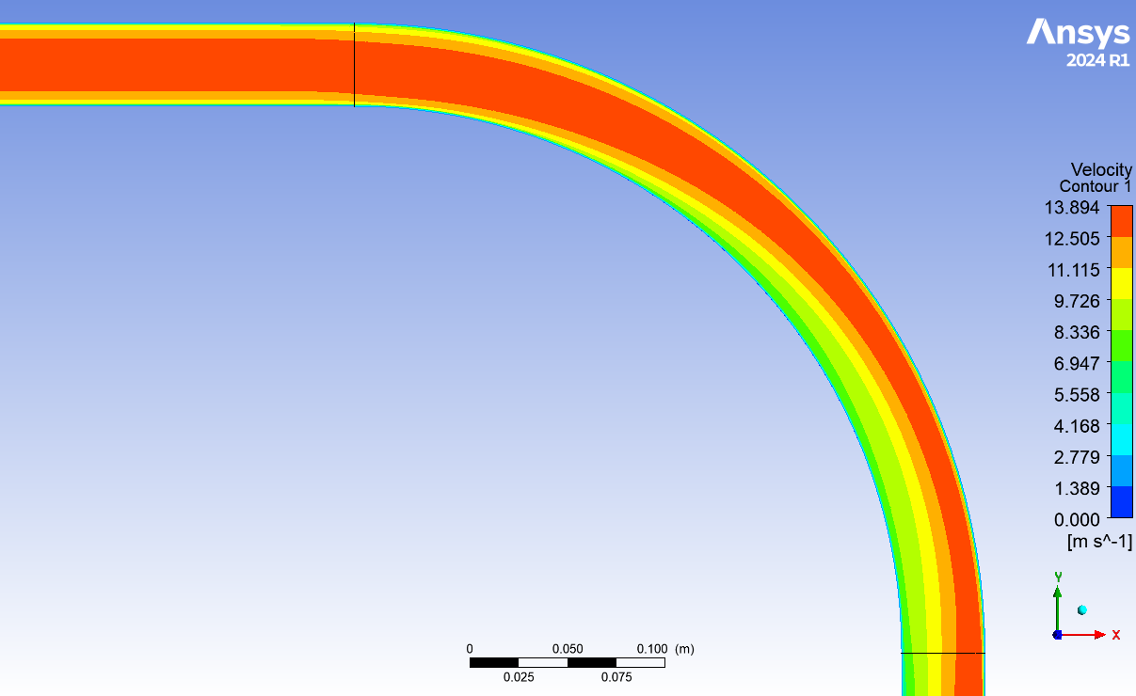
Figure 3. Flow Pattern in Pipe Bend.

k-Epsilon Turbulence Model
Simulation results using the Standard k-epsilon model are presented in Fig. 4 and Fig. 5 for 45° and 75° bends, respectively. All three discretization schemes were tested. Validation calculations show that at 45°, the FOU scheme yielded the lowest error (3.69%), followed by 2OU (4.61%) and QUICK (4.71%). However, at 75°, the error increased across all schemes, reaching values above 11%.

Figure 4. ANN-Optimized k-Epsilon Model at 45°.

Figure 5. ANN-Optimized k-Epsilon Model at 75°.

k-Omega Turbulence Model
The Standard k-omega model was evaluated with FOU and 2OU schemes. As shown in Fig. 6 and Fig. 7, the lowest error at 45° was obtained using FOU (4.88%), while 2OU resulted in 6.46%. At 75°, both schemes produced higher errors: 13.90% for FOU and 14.23% for 2OU.

Figure 6. ANN-Optimized k-Omega Model at 45°.

Figure 7. ANN-Optimized k-Omega Model at 75°.

Spalart–Allmaras Turbulence Model
Figures 8 and 9 show the results for the Spalart–Allmaras model. At 45°, the FOU scheme achieved the highest accuracy with an error of only 2.67%, followed by 2OU (4.37%) and QUICK (4.45%). At 75°, all three schemes exhibited significantly higher errors, ranging from 13.31% to 14.35%.

Figure 8. ANN-Optimized Spalart–Allmaras Model at 45°.

Figure 9. ANN-Optimized Spalart–Allmaras Model at 45°.

Error Evaluation and Comparison
All validation errors are summarized in Table 3, providing a comparative view of all turbulence models and discretization schemes at both angles. The lowest overall error was observed with the Spalart–Allmaras model using FOU at 45° (2.67%).
These results are compared to previous findings by Apalowo et al. [7], where the lowest error for the Spalart–Allmaras model using FOU was 3.27%. In contrast, this study achieved a slightly better performance of 2.67%. Similarly, improvements were observed in the k-epsilon model with FOU, but a decrease in accuracy was noted in other configurations and at 75°.
Overall, the ANN model improved prediction accuracy at 45° for certain turbulence models and schemes, but accuracy tends to degrade significantly at higher curvature (75°). The results highlight the importance of selecting the right combination of turbulence model, discretization scheme, and machine learning strategy depending on the flow conditions.

TABLE 3. Validation Error (%) for Each Turbulence Model and Discretization Scheme.
Turbulence Model | Discretization Scheme | 45° Error (%) | 75° Error (%)
k-Epsilon | FOU | 3.69 | 11.50
 | 2OU | 4.61 | 11.84
 | QUICK | 4.71 | 11.68
k-Omega | FOU | 4.88 | 13.90
 | 2OU | 6.46 | 14.23
Spalart–Allmaras | FOU | 2.67 | 13.31
 | 2OU | 4.37 | 14.31
 | QUICK | 4.45 | 14.35

CONCLUSION
Based on the conducted study, it can be concluded that the application of a Tensor Basis Neural Network to turbulent flow in pipe bends demonstrates varied levels of accuracy depending on the turbulence model, discretization scheme, and bend angle. In general, a decrease in prediction accuracy was observed across all discretization schemes—First-Order Upwind (FOU), Second-Order Upwind (2OU), and QUICK—particularly at a bend angle of 75°. However, for the Spalart–Allmaras turbulence model with the FOU scheme, a notable improvement in accuracy was achieved at a 45° bend, indicating that this configuration is more effective under moderate curvature conditions.

References
- R. A. Parisher, Pipe Drafting and Design, 4th ed. (Gulf Professional Publishing, 2022).
- P. B. G. N., P. Jain, A. Choudhury, P. Dutta, and K. Kalita, “Random forest regression-based machine learning model for accurate estimation of fluid flow in curved pipes,” Processes 9(11), 2095 (2021). doi: 10.3390/pr9112095.
- P. A. Mirzaei, “CFD modeling of micro and urban climates: Problems to be solved in the new decade,” Sustain. Cities Soc. 69, 102839 (2021). doi: 10.1016/j.scs.2021.102839.
- M. M. Bhatti, M. Marin, A. Zeeshan, and S. I. Abdelsalam, “Editorial: Recent trends in computational fluid dynamics,” Front. Phys. 8, 593111 (2020). doi: 10.3389/fphy.2020.593111.
- D. Kochkov et al., “Machine learning accelerated computational fluid dynamics,” Proc. Natl. Acad. Sci. U.S.A. 118(21), e2101784118 (2021). doi: 10.1073/pnas.2101784118.
- G. Calzolari and W. Liu, “Deep learning to replace, improve, or aid CFD analysis in built environment applications: A review,” Build. Environ. 206, 108315 (2021). doi: 10.1016/j.buildenv.2021.108315.
- B. Mahesh, “Machine learning algorithms—A review,” Int. J. Sci. Res. (IJSR) 9(1), 381–386 (2020). doi: 10.21275/ART20203995.
- Y. Yan, “Machine learning in chemical safety and health: Fundamentals with applications,” in Sustainability (Springer, 2022), Vol. 11, pp. 19–46. doi: 10.1002/9781119817512.ch2.
- A. Burkov, The Hundred-Page Machine Learning Book (Andriy Burkov, 2019).
- J. E. van Engelen and H. H. Hoos, “A survey on semi-supervised learning,” Mach. Learn. 109(2), 373–440 (2020). doi: 10.1007/s10994-019-05855-6.
- S. C. Ashish Kumar Shakya and G. Pillai, “Reinforcement learning algorithms: A brief survey,” Expert Syst. Appl. 231, 120495 (2023). doi: 10.1016/j.eswa.2023.120495.
- G. R. Yang and X. J. Wang, “Artificial neural networks for neuroscientists: A primer,” Neuron 107(6), 1048–1070 (2020). doi: 10.1016/j.neuron.2020.09.005.
- R. Dastres and M. Soori, “Artificial neural network systems,” Int. J. Imaging Robot. 21(2), 13–25 (2021). doi: 10.46538/ijir.21.2.2.
- J. Jawad, A. H. Hawari, and S. Javaid Zaidi, “Artificial neural network modeling of wastewater treatment and desalination using membrane processes: A review,” Chem. Eng. J. 419, 129540 (2021). doi: 10.1016/j.cej.2021.129540.
- Y. Chen et al., “A review of the artificial neural network models for water quality prediction,” Appl. Sci. 10(17), 5776 (2020). doi: 10.3390/app10175776.
- M. M. Bukhari et al., “An improved artificial neural network model for effective diabetes prediction,” Complexity 2021, 5525271 (2021). doi: 10.1155/2021/5525271.
- N. H. W. Al-Rafai and Y. D. Tridimas, “A study of turbulent flows in pipe bends,” J. Mech. Eng. Sci. 204(6), 399–408 (1995). doi: 10.1243/PIME_PROC_1995_209_154_02.
- R. K. Apalowo, “Numerical study of different models for turbulent flow in 90° pipe bend,” U.Porto J. Eng. 8(2), 121–134 (2022). doi: 10.24840/2183-6493_008.002_0010.

