Effect of Thickness Variation on Tensile Strength and Macrographic Characteristics in Resistance Spot Welding of Aluminum 2024-T42
Angga Dwi Aprilio^{a)}, Moh. Jufri^{b)} and Iis Siti Aisyah^{c)}
Department of Mechanical Engineering, University of Muhammadiyah Malang
Jl. Raya Tlogomas No. 246, Malang 65144, Indonesia.

^{a)}anggadwiaprilio4@gmail.com
^{b)}Corresponding author: jufri@umm.ac.id
^{c)}siti@umm.ac.id
^{d)}zmusyaffa77@gmail.com
Abstract. Resistance Spot Welding (RSW) is widely used in various manufacturing sectors, including the automotive and aerospace industries, due to its efficiency and reliability. However, welding failures often occur, and one significant contributing factor is the variation in sheet thickness. This study investigates the influence of different sheet thickness combinations, namely 0.6 mm with 0.8 mm, 0.8 mm with 0.6 mm and 1.0 mm, and 0.8 mm with 1.6 mm, on the tensile strength and macrographic characteristics of RSW joints using Aluminum 2024-T42 material. All welding was performed using consistent process parameters. Tensile strength was evaluated through destructive testing, while macrographic analysis was conducted to observe weld nugget geometry and penetration quality. The tensile test results showed that all three thickness combinations exceeded the minimum required standard values, with the highest average tensile strength observed in the 0.8 mm with 1.6 mm configuration. Macrographic observations confirmed acceptable nugget sizes and penetration depths across all specimens, indicating that the welding parameters used in this study are adequate for producing high-quality RSW joints.

INTRODUCTION
Welding is a process of joining two or more metal parts through the application of heat. According to the Deutsches Institut für Normung (DIN), welding is defined as a metallurgical bond formed at the joint between metals or alloys during the molten or liquid state [1]. Welding technology is widely utilized in the construction of ships, aircraft, and buildings [2]. Welding methods can be classified based on operational mechanisms and heat generation [3].
Resistance Spot Welding (RSW) is a complex joining method that involves interactions between electrical, thermal, mechanical, and metallurgical factors [4]. This method is particularly suitable for joining thin metal sheets in various structural manufacturing applications [5]. In large-scale structural assembly, such as in the production of vehicles, aircraft, and railway cars, approximately 4,000 weld points may be required per unit [6].
The use of RSW offers advantages including reduced structural weight, improved safety, and lower manufacturing costs [7][8]. This process utilizes a lap joint configuration where two or more metal sheets are overlapped and clamped between a pair of electrodes while a high electric current is applied. This generates resistance heat at the contact points, resulting in localized melting and the formation of a weld nugget [9][10].
When joining sheets of dissimilar thickness, the resulting microstructure and mechanical properties can be significantly more complex, potentially influencing the quality of the weld nugget [11]. RSW, also referred to as opposition spot welding, joins metal sheets by applying high electric current to the overlapped surfaces, causing localized heating and melting due to electrical resistance [12][13].
This welding technique offers several advantages, including fast and functional joining cycles, low production costs, consistent weld quality, and adaptability to automated manufacturing environments [14][15]. These characteristics make RSW widely used in the aerospace and automotive industries, where up to 90% of body components may be assembled using this method [16].
In RSW, three primary parameters influence weld quality: welding current, welding force, and weld time. These parameters vary according to the thickness and mechanical properties of the materials being joined. To evaluate weld quality, destructive testing methods such as tensile-shear testing can be employed [17].

Methodology
This research employed an experimental approach supported by literature review. The base material used was Aluminum 2024-T42 with three different sheet thickness combinations: 0.6 + 0.8 mm, 0.8 + 0.6 + 1.0 mm, and 0.8 + 1.6 mm. All specimens were welded using identical process parameters to ensure consistency across tests. The overall research procedure is illustrated in the process flow diagram shown in Fig. 1.

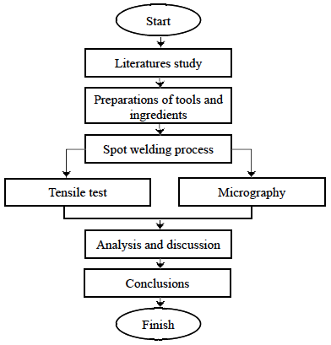
Figure 1. Research Process Flow Diagram.

The welding process was conducted using a Resistance Spot Welding machine of the SCIAKY PMCO.3STM-150 type. The technical specifications of the machine, including primary and auxiliary voltage ratings, peak secondary current, duty cycle, throat dimensions, and required water conditions, are listed in Table 1.

TABLE 1. Technical Specifications of SCIAKY PMCO.3STM-150.
Welding Circuit | Auxiliary Circuit
Voltage: 380 V | Voltage: 380 V
Frequency: 50 Hz | Frequency: 50 Hz
Phase: 3 | Phase: 3
Thermal Rating (50% Duty): 150 kVA | Description: 831
Peak Secondary Amps: 75,000 | Pressure Ratio: 85/1
No Load Voltage: 6.3–11.9 V | Water Temp Input: 10°C–40°C
Throat Dimension: 48 inches | Water Pressure Required: 35 lbs

Welding parameters for each thickness combination were carefully selected to ensure comparable weld quality and repeatability. These parameters are summarized in Table 2. Common settings across all combinations included the use of CuAg electrodes with a diameter of 16 mm, variable pressure programs, and consistent impulse sequences. Differences were present in the pressure settings and the number of cycles for pre-compression, squeeze, quenching, and holding, tailored to each thickness configuration.

TABLE 2. Welding Parameters for Aluminum 2024-T42 Sheet Thickness Combinations.
Welding Parameters | 0.6 + 0.8 mm | 0.8 + 0.6 + 1.0 mm | 0.8 + 1.6 mm
Electrode | CuAg / 16 mm | CuAg / 16 mm | CuAg / 16 mm
Radius Contact (Upper) | 100 mm | 100 mm | 150 mm
Radius Contact (Lower) | 100 mm | 100 mm | 150 mm
Contact Resistance | 75 µOhm | 75 µOhm | 75 µOhm
Weld Class | B | B | B
Upper Pressure | 23 psi | 23 psi | 21 psi
Lower Pressure | 12 psi | 12 psi | 11 psi
Contact Gauge | 20 psi | — | 18 psi
Pressure Program | Variable | Variable | Variable
Power | Low | Low | Low
Phase | 3 | 3 | 3
Pre-Compression | 10 cycles | 12 cycles | 12 cycles
Squeeze | 10 cycles | 10 cycles | 17 cycles
Quench | 5 cycles | 10 cycles | 10 cycles
Hold | 15 cycles | 20 cycles | 20 cycles
Welding | 2 impulses | 2 impulses | 2 impulses
Impulse CO | 2 cycles | 2 cycles | 2 cycles
Off | — | 2 cycles | 5 cycles
HT (Max Current %) | 50% | 57% | 65%
CD (Max Current %) | 30% | 30% | 30%

Tensile testing was performed using a universal testing machine, and the results were processed using Bluehill 3 software. Specimens were prepared in a lap joint configuration with dimensions of 100 mm × 20 mm, as illustrated in Fig. 2.

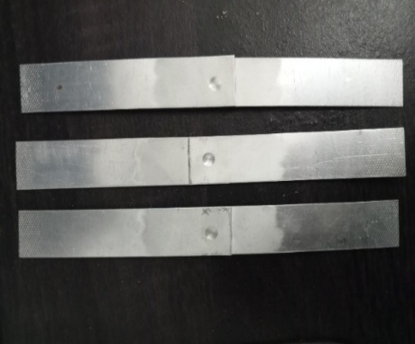
Figure 2. Lap Joint Tensile Test Specimen

Macrographic analysis was conducted using a stereomicroscope. Specimens were sectioned both longitudinally and transversely to observe the nugget shape and penetration depth. Measurements of nugget diameter and weld penetration were obtained and evaluated against applicable welding standards. Representative macrographic results are shown in Fig. 3.

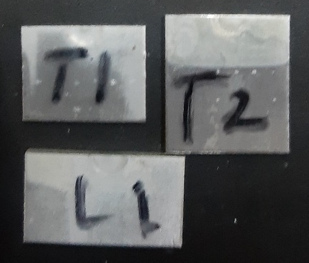
Figure 3. Macrographic Specimens of Weld Nugget Cross-Sections

Results and Discussion

Tensile Strength Test Results
The tensile strength test was conducted to assess the mechanical integrity of spot weld joints formed using three different plate thickness combinations: 0.6 + 0.8 mm, 0.8 + 0.6 + 1.0 mm, and 0.8 + 1.6 mm. The results, summarized in Table 3, show that the combination of 0.8 + 1.6 mm yielded the highest average tensile strength, reaching 822.69 lbf, followed by 0.8 + 0.6 + 1.0 mm (466.22 lbf), and 0.6 + 0.8 mm (347.55 lbf).

TABLE 3. Tensile Test Results.
Combination | Load Max (lbf) | Average (lbf) | Deviation
0.6 + 0.8 mm | 340.78 – 350.99 | 347.55 | 0.0293
0.8 + 0.6 + 1.0 mm | 463.16 – 471.24 | 466.22 | 0.0173
0.8 + 1.6 mm | 778.00 – 849.52 | 822.69 | 0.0869

The load–displacement curves for each specimen are shown in Fig. 4. All specimens exhibited a relatively linear increase in load with displacement up to fracture, indicating ductile behavior in the weld zone.
To evaluate compliance with applicable standards, the measured tensile strengths were compared to the minimum requirements for a 0.6 mm plate with a tensile strength of 57.0 ksi (57,000 psi). Referring to AWS D8.9 standard for spot welding, the minimum and average required ultimate loads for 0.6 mm plates are 160 lbf and 200 lbf, respectively. As shown in Table 4, all specimens significantly exceeded both thresholds.

TABLE 4. Comparison with Standard Shear Strength Requirements.
Combination | Average Load (lbf) | Meets Standard (200 lbf)?
0.6 + 0.8 mm | 347.55 | Yes
0.8 + 0.6 + 1.0 mm | 466.22 | Yes
0.8 + 1.6 mm | 822.69 | Yes

These findings confirm that the spot welding parameters applied in this study are adequate to produce mechanically sound joints that meet or exceed industrial requirements.

(a) | 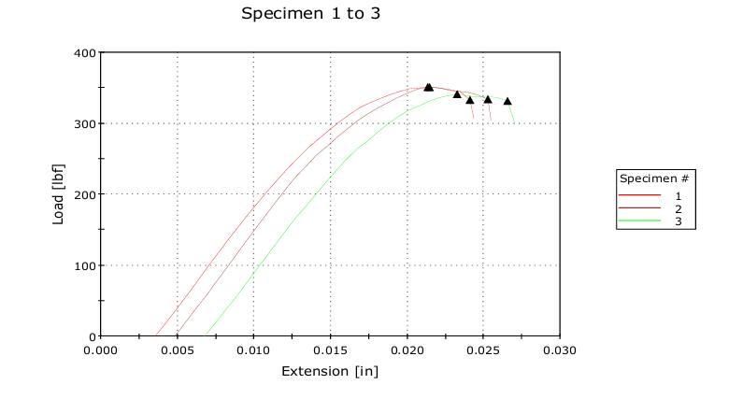
(b) | 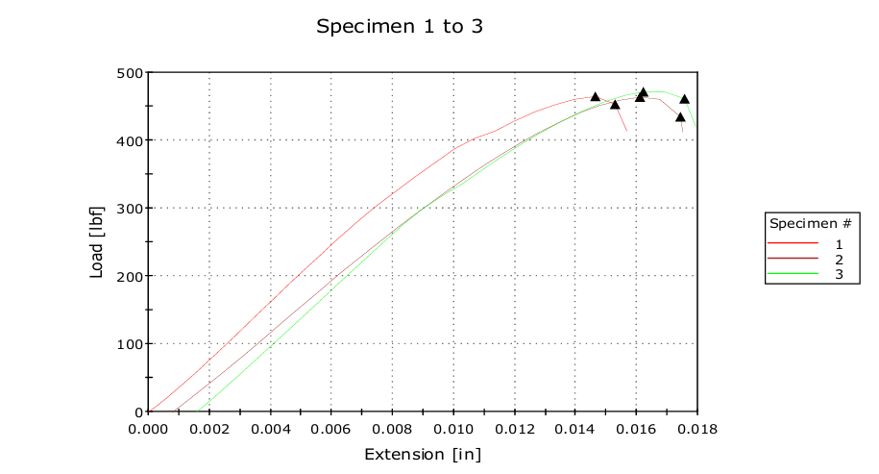
(c) | 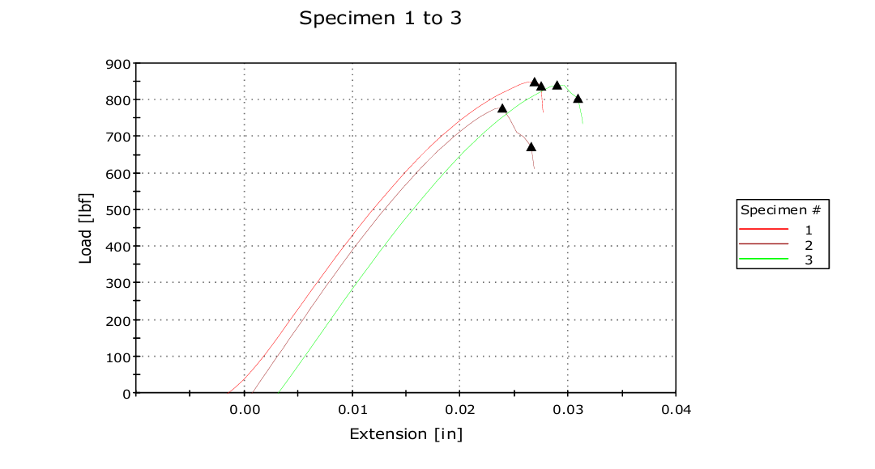
Figure 4. Load–Displacement Curves for Tensile Test (A) 0.6 + 0.8 mm, (B) 0.8 + 0.6 + 1.0 mm, (C) 0.8 + 1.6 mm

Macrographic Evaluation
Macrographic examination was conducted to observe the morphology of the weld nugget, determine nugget diameter (ØSPOT), and evaluate penetration percentage. The macrographs of the three thickness combinations are shown in Fig. 5.

(a) | 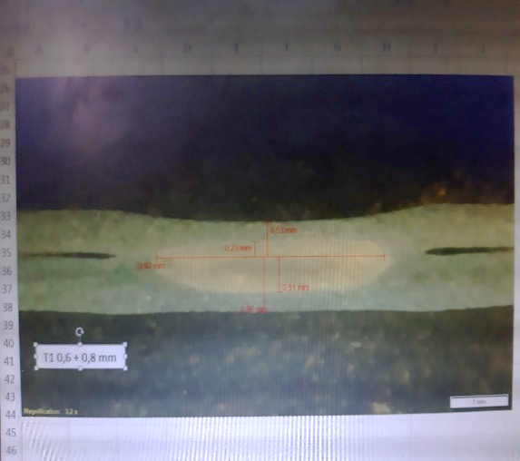
(b) | 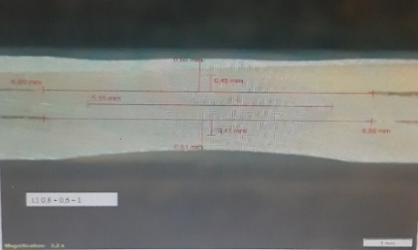
(c) | 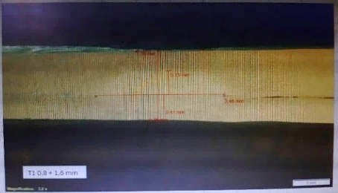
Figure 4. Macrographic Observation of Weld Nuggets (A) 0.6 + 0.8 mm, (B) 0.8 + 0.6 + 1.0 mm, (C) 0.8 + 1.6 mm.

As detailed in Table 5, all specimens achieved nugget diameters exceeding the minimum required value of 2.54 mm. In addition, the penetration depth for all welds ranged between 35.06% and 85.40%, which is within the acceptable standard range of 20–80%, with some slight over-penetration observed.

TABLE 5. Macrography Test Results.
Combination | Ø SPOT (mm) | Penetration (%) | Defects
0.6 + 0.8 mm | 3.40 – 4.26 | 43.39 – 71.25 | None
0.8 + 0.6 + 1.0 mm | 5.07 – 5.15 | 46.15 – 65.00 | None
0.8 + 1.6 mm | 3.06 – 4.37 | 35.06 – 85.40 | None

All nugget shapes were circular and symmetrical, and no internal cracks or voids were identified. This suggests consistent heat input and appropriate electrode pressure during welding. The largest nugget diameter and relatively uniform penetration were observed in the 0.8 + 0.6 + 1.0 mm specimen, which also corresponds to the second-highest tensile strength. Meanwhile, the 0.8 + 1.6 mm specimen showed the highest tensile strength despite some irregularities in penetration, likely due to improved heat absorption in thicker base metals.
Overall, both the mechanical and macrostructural results demonstrate that the spot welding parameters used in this study produce high-quality welds across various plate thickness combinations.

CONCLUSION
This study evaluated the tensile strength and macrographic characteristics of spot weld joints formed using three variations of plate thickness: 0.6 + 0.8 mm, 0.8 + 0.6 + 1.0 mm, and 0.8 + 1.6 mm. The results showed that all specimens exceeded the minimum tensile strength required by the AWS D8.9 standard, with the 0.8 + 1.6 mm combination achieving the highest average tensile load of 822.69 lbf. In terms of weld morphology, macrographic analysis confirmed that all nugget diameters were above the minimum standard of 2.54 mm, and the penetration rates ranged between 35.06% and 85.40%, indicating good fusion across all samples. No significant weld defects such as cracks or voids were observed, confirming the suitability of the applied welding parameters. Overall, the experimental findings demonstrate that plate thickness variation significantly influences the mechanical properties and quality of spot weld joints. The welding parameters used in this study produced joints that are mechanically reliable and visually defect-free, indicating their potential applicability in structural or industrial contexts requiring efficient and robust joining of thin steel plates.

References
- R. Siswanto, Welding Technology (Mechanical Engineering Department, Lambung Mangkurat University, 2018), pp. 1-20. [In Indonesian]
- H. Arora, R. Singh, and G. S. Brar, "Thermal and structural modelling of arc welding processes: A literature review," Meas. Control 52(7-8), 955-969 (2019).
- M. Pouranvari and S. P. H. Marashi, "Critical review of automotive steels spot welding: Process, structure and properties," Sci. Technol. Weld. Join. 18(5), 361-403 (2013).
- N. Haghshenas and H. Moshayedi, "Monitoring of resistance spot welding process," Exp. Tech. 44(1), 99-112 (2020).
- S. M. Hassoni et al., "Effect of welding parameters of resistance spot welding on mechanical properties and corrosion resistance of 316L," Mater. Res. 25, e20210117 (2022).
- S. H. Mousavi Anijdan et al., "Optimization of spot welding process parameters in dissimilar joint of dual phase steel DP600 and AISI 304 stainless steel to achieve the highest level of shear-tensile strength," Mater. Sci. Eng.
- A. Ghatei-Kalashami et al., "Failure behavior of resistance spot welded advanced high strength steel: The role of surface condition and initial microstructure," J. Mater. Process. Technol. 299, 117370 (2022).
- L. Chen et al., "Investigation on shearing strength of resistance spot-welded joints of dissimilar steel plates with varying welding current and time," J. Mater. Res. Technol. 16, 1021-1028 (2022).
- B. Zhou et al., "Machine learning with domain knowledge for predictive quality monitoring in resistance spot welding," J. Intell. Manuf. 33(4), 1139-1163 (2022).
- O. Martin et al., "Comparative study of classification algorithms for quality assessment of resistance spot welding joints from pre- and post-welding inputs," IEEE Access 10, 6518-6527 (2022).
- H. Zhang et al., "Failure analysis of dissimilar thickness resistance spot welded joints in dual-phase steels during tensile shear test," Mater. Des. 55, 366-372 (2014).
- C. Summerville, P. Compston, and M. Doolan, "A comparison of resistance spot weld quality assessment techniques," Procedia Manuf. 29, 305-312 (2019).
- M. Salem, Control and Power Supply for Resistance Spot Welding (RSW) (Master's Thesis, University of Western Ontario, 2011). [Online]. Available: http://ir.lib.uwo.ca/etd/130.
- J. Tomków et al., "Advantages of the application of the temper bead welding technique during wet welding," Materials 12(6), 915 (2019).
- V. P. Singh et al., "Recent research progress in solid state friction-stir welding of aluminium-magnesium alloys: A critical review," J. Mater. Res. Technol. 9(3), 6217-6256 (2020).
- G. Liedl et al., "Joining of aluminum and steel in car body manufacturing," Phys. Procedia 12(1), 150-156 (2011).
- B. Wang et al., "Non-destructive testing and evaluation of composite materials/structures: A state-of-the-art review," Adv. Mech. Eng. 12(4), 1-28 (2020).

