Mechanical Characterization of Aluminum 6061 Welded by GTAW with Varying Welding Currents
Devfan Hidarki Santana Caetano^{a)}, Sandy Azis Saputra^{b)}, Herry Suprianto^{c)},
Nur Hasanah^{1, d)} and Frizka Vietanti^{2, e)}
¹Department of Mechanical Engineering, University of Muhammadiyah Malang.
²Department of Mechanical Engineering, National Taiwan University of Science and Technology, Taipei, Taiwan.

^{a)} devfancaetano2@gmail.com
^{b)}sandyazis2004@gmail.com
^{c)} herry@umm.ac.id
^{d)} Corresponding author: nurhasanah02@umm.ac.id
^{e)} frizkavietanti3@gmail.com

Abstract. Welding is a widely used technique for joining metals through the application of heat to form metallurgical bonds, often involving melting of the base material to produce strong and durable joints. This study investigates the effect of welding current on the mechanical properties of Aluminum 6061 welded using ER5356 filler metal. Tensile and Vickers hardness tests were conducted to evaluate specimens welded at currents of 150 A, 165 A, and 180 A. The results showed that the highest hardness values in the Base Metal, Heat-Affected Zone (HAZ), and Weld Metal were consistently obtained at 180 A. In contrast, tensile testing revealed that the highest values of stress, strain, ultimate tensile strength, and elongation occurred at 150 A, whereas the maximum elastic modulus was recorded at 165 A. These findings indicate that while higher welding currents enhance hardness, lower currents favor tensile performance. The results provide insights for optimizing GTAW parameters to achieve balanced mechanical properties in Aluminum 6061 welds for industrial applications.

INTRODUCTION
Welding is one of the most widely used methods for joining metals in industry[1], [2], owing to its process simplicity and controllability, enabling effective joining of a variety of parts[3]. Metal is melted at specific areas to be joined using either heat or electricity. Several parameters significantly influence weld quality, such as electrode type, welding current, welding speed, suitability of the welding method, material dimensions, as well as pre- and post-welding treatments[4]. The welding current and arc voltage determine the heat input and arc stability, while welding speed affects the mechanical properties of the joint.
Currently, GTAW is extensively used due to its advantages. Gas Tungsten Arc Welding (GTAW), also known as Tungsten Inert Gas (TIG) welding, is an electric arc welding process that uses a non-consumable tungsten electrode and an inert shielding gas to protect the welding area from atmospheric contamination[5], [6]. GTAW produces a stable, high-precision arc, making it suitable for welding thin materials and applications requiring high weld quality.
Aluminum is the third most abundant element in the Earth's crust, following oxygen and silicon[7]. One of its most notable characteristics is its lightweight nature combined with strength that can be enhanced through alloying, making it widely used across various industrial applications [8]. To improve its mechanical properties, aluminum is commonly alloyed with elements such as copper (Cu), magnesium (Mg), silicon (Si), manganese (Mn), and zinc (Zn)[9]. In the marine industry, aluminum 6061 is widely employed in the construction of ship hulls, fittings and brackets, offshore platform structures, diving equipment, and dock components[10]. In the transportation sector, this material is utilized in bicycle frames, vehicle chassis components, trailer bodies, aircraft structures, and a variety of automotive parts[11].
Welding current is one of the most important process parameters in various metal joining techniques. It significantly influences the quality and strength of the resulting weld [12]. Selecting the correct welding current is crucial for achieving optimal results. Too low a current can cause inadequate penetration and weak joints, whereas too high a current can led to distortion, material burn-through, and other weld defects[13], [14].
In addition to welding current, the choice of electrode also plays a vital role in determining weld quality. The ER 5356 electrode is a widely used option for welding aluminum alloys. It contains magnesium as the primary alloying element, which enhances tensile strength and provides excellent corrosion resistance in the weld[15].

METHODOLOGY
This study investigates the effect of welding current variation in Gas Tungsten Arc Welding (GTAW) using Aluminum 6061 material with dimensions of 120 × 120 × 5 mm. The welding parameters employed include an ER 5356 electrode with a diameter of 2.4 mm, a 60° bevel angle, and welding currents of 150 A, 165 A, and 180 A. This study investigates the effect of welding current variation in Gas Tungsten Arc Welding (GTAW) using Aluminum 6061 material with dimensions of 120 × 120 × 5 mm. The welding parameters employed include an ER 5356 electrode with a diameter of 2.4 mm, a 60° bevel angle, and welding currents of 150 A, 165 A, and 180 A. The prepared specimens for the tensile and hardness tests are shown in Fig. 1 and Fig. 2, respectively.

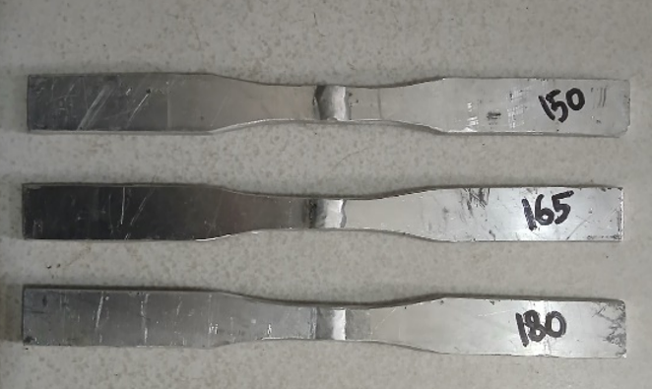
Figure 1. Tensile test specimens

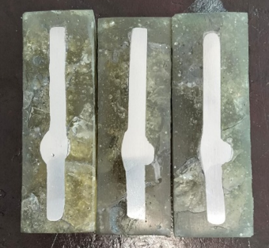
Figure 2. Hardness test specimens

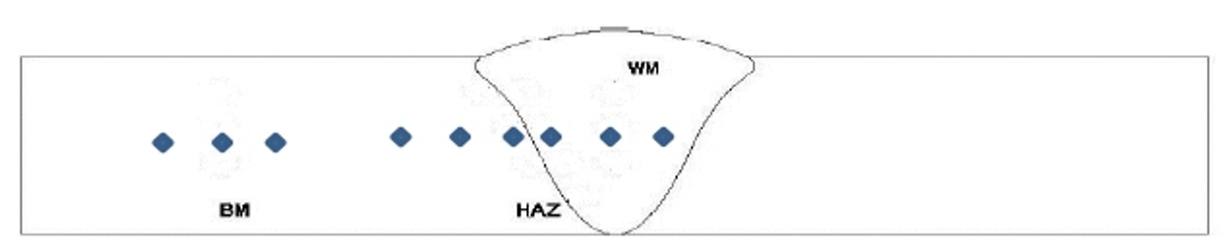
Figure 3. Indentation position of hardness test

Welded specimens that passed visual inspection were subjected to tensile testing in accordance with ASTM E8, as well as hardness testing. The tensile test provided data on tensile strength, elastic modulus, and elongation of the welded joints. The hardness test measured the hardness values at the weld metal, heat-affected zone (HAZ), and base metal. The position of indentation shown in Fig. 3.

RESULTS AND DISCUSSION

Tensile Properties
The tensile test results of the Al 6061 specimens provided data on the maximum tensile load and elongation. Table 1 presents the tensile test results of the GTAW-welded Al 6061 specimens.

Table 1. Tensile properties of welded Al 6061
Current (A) | Spesimen | Max Force (N) | A (mm²) | UTS (MPa) | Average UTS (MPa) | Lo (mm) | ΔL (mm) | ε (%) | Average ε (%)
150 | 1 | 7535.98 | 62.5 | 120.576 | 121.420 | 500 | 90.383 | 18% | 20.42%
150 | 2 | 7788.28 | 63 | 123.623 | 121.420 | 500 | 107.226 | 21% | 20.42%
150 | 3 | 7443.67 | 62 | 120.060 | 121.420 | 500 | 108.749 | 22% | 20.42%
165 | 1 | 7182.6 | 62 | 115.850 | 114.968 | 500 | 98.683 | 20% | 18.29%
165 | 2 | 7147.36 | 62 | 115.280 | 114.968 | 500 | 92.133 | 18% | 18.29%
165 | 3 | 7167.72 | 63 | 113.773 | 114.968 | 500 | 83.601 | 17% | 18.29%
180 | 1 | 7174.68 | 63 | 113.884 | 110.670 | 500 | 103.766 | 21% | 17.65%
180 | 2 | 6846.43 | 62 | 110.426 | 110.670 | 500 | 77.076 | 15% | 17.65%
180 | 3 | 6731.32 | 62.5 | 107.701 | 110.670 | 500 | 83.881 | 17% | 17.65%

Based on Fig. 4, it is observed that an increase in welding current leads to a decrease in the maximum tensile strength of Al 6061, with the lowest tensile strength of 110.670 MPa obtained at a welding current of 180 A.

Figure 4. Ultimate tensile strength and elongation of welded Al 6061

Meanwhile, the elongation values vary; however, a slight decrease in elongation was observed at 165 A and 180 A, the elongations of 18.29% and 17.65% respectively.

Hardness Properties
The hardness properties of the weld metal, heat-affected zone, and base metal for specimens welded at currents of 150 A, 165 A, and 180 A are presented in Table 2.

Table 2. Hardness properties of welded Al 6061
Current (A) | Weld Part | Hardness (VHN) | Average Hardness (VHN)
150 | Weld Metal | 745.4 | 744.800
150 | Weld Metal | 711 | 744.800
150 | Weld Metal | 778 | 744.800
150 | HAZ | 734.2 | 729.133
150 | HAZ | 709.1 | 729.133
150 | HAZ | 744.1 | 729.133
150 | Base Metal | 702.8 | 713.100
150 | Base Metal | 734.3 | 713.100
150 | Base Metal | 702.2 | 713.100
165 | Weld Metal | 709.7 | 732.833
165 | Weld Metal | 736.1 | 732.833
165 | Weld Metal | 752.7 | 732.833
165 | HAZ | 707 | 718.267
165 | HAZ | 706.1 | 718.267
165 | HAZ | 741.7 | 718.267
165 | Base Metal | 700.6 | 706.133
165 | Base Metal | 706.1 | 706.133
165 | Base Metal | 711.7 | 706.133
180 | Weld Metal | 753.1 | 755.100
180 | Weld Metal | 706.1 | 755.100
180 | Weld Metal | 806.1 | 755.100
180 | HAZ | 800.6 | 786.467
180 | HAZ | 786.1 | 786.467
180 | HAZ | 772.7 | 786.467
180 | Base Metal | 830 | 813.333
180 | Base Metal | 743.3 | 813.333
180 | Base Metal | 866.7 | 813.333

The results of Vickers hardness testing on welded specimens show variations in values depending on the welding current and material zone. In the Weld Metal zone, specimens welded at 180 A achieved the highest average hardness of 755.1 VHN, while those welded at 165 A had the lowest average hardness of 732.6 VHN. In the HAZ zone, the highest average hardness (786.4 VHN) was also obtained at 180 A, and the lowest (718.3 VHN) at 165 A. In the Base Metal zone, the highest average hardness of 810.3 VHN was recorded at 180 A, while the lowest value of 704.5 VHN occurred at 150 A.
Specimens welded at 180 A consistently exhibited the highest hardness across all three zones—786.4 VHN in the HAZ, 810.3 VHN in the Base Metal, and 755.1 VHN in the Weld Metal. Conversely, specimens welded at 165 A consistently showed the lowest hardness in the HAZ (718.3 VHN) and Weld Metal (732.6 VHN) zones.
Variations in welding current affect material hardness through changes in heat input, cooling rate, and the resulting microstructure formed during welding. According to M. Asif et al. [15], increasing heat input leads to a decrease in tensile strength and an increase in hardness in the HAZ and Base Metal zones, while hardness decreases in the Weld Metal zone. The findings of this study are generally consistent with those observations, except for the 165 A specimens, which showed deviations in the HAZ and Weld Metal zones.

CONCLUSION
The tensile test results for 6061 aluminum welding with current variations showed that a current of 150 A produced an ultimate tensile strength of 121.4193 MPa, a current of 165 A resulted in 114.967 MPa, and a current of 180 A yielded 110.6703 MPa. The hardness test results indicated that at 150 A, the weld metal, heat-affected zone (HAZ), and base metal had hardness values of 744.83 VHN, 729.1 VHN, and 704.5 VHN, respectively. At 165 A, the corresponding values were 732.6 VHN for the weld metal, 718.3 VHN for the HAZ, and 706.2 VHN for the base metal. At 180 A, the weld metal exhibited a hardness of 755.1 VHN, the HAZ reached 786.4 VHN, and the base metal recorded 810.33 VHN.

References
- N. Hasanah, R. R. Hendaryatu, Budiono, and B. S. A. Pradana, "The effect of cooling media on mechanical properties of welded ST37 steel," AIP Conf. Proc. 2453(1), 020018 (2022).
- D. K. Dwivedi, "Arc welding processes: Shielded metal arc welding—principle, electrode and parameters," in Fundamentals of Metal Joining: Processes, Mechanism and Performance, D. K. Dwivedi, Ed. (Springer Singapore, 2022), pp. 143–152.
- S. Chidambaresh, N. Radhika, D. Kumar N. H., and S. Bal, "A review on welding techniques: properties, characterisations and engineering applications," Adv. Mater. Process. Technol. 10, 1–56 (2023).
- F. Khoshnaw, "An introduction to welding of metallic materials," in Welding of Metallic Materials, F. Khoshnaw, Ed. (Elsevier, 2023), pp. 1–35.
- M. Tanaka, "Gas tungsten arc welding," in Novel Structured Metallic and Inorganic Materials, Y. Setsuhara, T. Kamiya, and S. Yamaura, Eds. (Springer Singapore, 2019), pp. 147–159.
- Q. Malik, "Gas tungsten arc welding (GTAW) or (TIG) welding" (2021).
- E. Skibniewska and M. Skibniewski, "Aluminum, Al," in Mammals and Birds as Bioindicators of Trace Element Contaminations in Terrestrial Environments: An Ecotoxicological Assessment of the Northern Hemisphere, E. Kalisińska, Ed. (Springer International Publishing, 2019), pp. 413–462.
- K. Sathyanarayana, S. M. Rangappa, S. M. Doddamani, S. Siengchin, and M. Doddamani, "Metallic lightweight materials: properties and their applications," in Lightweight and Sustainable Composite Materials (Woodhead Publishing, 2023), pp. 47–67.
- M. S. Ahmed, M. S. Anwar, M. S. Islam, and M. Arifuzzaman, "Experimental study on the effects of three alloying elements on the mechanical, corrosion and microstructural properties of aluminum alloys," Results Mater. 20, 100485 (2023).
- M. A. Wahid, A. N. Siddiquee, and Z. A. Khan, "Aluminum alloys in marine construction: characteristics, application, and problems from a fabrication viewpoint," Mar. Syst. Ocean Technol. 15(1), 70–80 (2020).
- J. Fan and J. Njuguna, "An introduction to lightweight composite materials and their use in transport structures," in Lightweight Composite Structures in Transport, J. Njuguna, Ed. (Woodhead Publishing, 2016), pp. 3–34.
- B. Kutelu, S. Seidu, G. Eghabor, and A. Ibitoye, "Review of GTAW welding parameters," J. Miner. Mater. Charact. Eng. 6, 541–554 (2018).
- A. Ikpe, K. Idiong, and M. Bassey, "A comprehensive overview of welding defects and associated failure mechanisms in metal joining process" (2023).
- A. Hasan, O. Ali, and A. Alsaffawi, "Effect of welding current on weldments properties in MIG and TIG welding," Int. J. Eng. Technol. (UAE) 7, 192–197 (2018).
- R. A. Fouad, A. A. Al-Badour, A. M. Alghamdi, S. A. Ahmed, M. T. Hayajneh, and M. M. Alqahtani, "The influence of various welding wires on microstructure and mechanical characteristics of AA7075 Al-alloy welded by TIG process," Sci. Rep. 14(1), 19023 (2024).

