Frame Design and Structural Analysis of a Single-Seater Electric Prototype Vehicle
Alvian Iqbal Hanif Nasrullah^{1, a)}, Ilham Al Basri Mohammad ^{1, b)}, Ali Saifullah^{1, c)}, Fauzan Ammar Putra^{1, d)}, Ahmad Khaidir Ali^{1, e)}, Yogi Adi Wijaya^{2, f)}
Author Affiliations
¹Department of Mechanical Engineering, University of Muhammadiyah Malang, Indonesia
²PT Pindad (Persero), Bandung, Indonesia
Author Emails
^{a)} Corresponding author: alvianiq@umm.ac.id
^{b)} ilhamalbasrimuhammad05@gmail.com
^{c)} ali_s@umm.ac.id
^{d)} fauzanammarputra@umm.ac.id
^{e)} ahmadka210622@gmail.com
^{f)} ywijaya@pindad.com

Abstract. The design of a vehicle frame is one of the crucial aspects of the student-level electric vehicle competition, which requires a lightweight, aerodynamic, and sturdy design. This study aims to design a frame that complies with the established regulations and analyze the structure of an electric vehicle frame using the Finite Element Analysis (FEA) method. The methods used include a literature review, modeling using Computer-Aided Design (CAD) software, and finite element analysis to evaluate structural strength, including stress, deformation, and safety factors, using Computer-Aided Engineering (CAE) software, the analysis results show that the designed frame can withstand the applied static and dynamic loads according to competition standards. Additionally, optimization in material selection results in a frame structure that is both lightweight and strong. Thus, this design is expected to serve as a reference for future research in the development of electric vehicle frames.

INTRODUCTION
Electric vehicles (EVs) are increasingly favored in the global transition toward cleaner transportation systems due to their potential to significantly reduce emissions from fossil-fueled vehicles [1]. As a result, academic and industrial sectors alike are actively driving research and innovation in EV design and performance [2][3]. Among the most critical components in an EV is the chassis or frame, which not only supports all subsystems and the driver [4][5], but also plays a key role in crash energy management, structural stiffness, and weight distribution.
The frame must be lightweight yet structurally sound, withstanding both static and dynamic loads while conforming to design envelope limitations, such as maximum dimensions and mass. To meet these requirements, modern engineering workflows increasingly leverage Computer-Aided Design (CAD) for 3D modeling and Computer-Aided Engineering (CAE) tools such as Finite Element Analysis (FEA) for evaluating stress, deformation, and crashworthiness [6–9]. Simulations conducted in CAE platforms like ANSYS [10] provide critical insight into performance and safety without the need for early-stage physical prototyping, reducing development cost and time.
A common and efficient solution for prototype electric vehicles is the use of tubular space frame structures, which provide high strength-to-weight ratios and excellent load distribution in multi-directional scenarios [11]. Previous studies have shown that using materials such as 6061-T6 aluminum for such frames can yield favorable results in terms of stiffness, strength, and safety factor while keeping the total mass low [12][13].
This study presents a structural design and analysis of a single-seater electric vehicle frame, with an emphasis on optimizing geometry and material selection to balance structural integrity and overall weight [14]. The frame design process involves iterative modeling, material property evaluation, and topological optimization. The outcome of this research aims to contribute to future developments in lightweight, safe, and efficient electric vehicle frame architectures—particularly in academic or early-stage innovation settings.

Methodology
This study follows a systematic, simulation-based design approach to develop a structurally safe single-seater electric vehicle frame. The process is outlined in the flowchart Fig.1 and involves iterative cycles of modeling and evaluation to ensure the frame meets performance, weight, and dimensional requirements.
The methodology begins with a literature study, which provides foundational knowledge on electric vehicle frame design, safety standards, material properties, and previous research. This is followed by problem identification and formulation of design criteria, including dimensional constraints, mechanical load expectations, and frame weight targets.
A conceptual frame design is then created using Computer-Aided Design (CAD) tools. After this, material selection is conducted by evaluating candidate materials based on parameters such as density, yield strength, and stiffness-to-weight ratio. Aluminum 6061-T6 is selected due to its proven performance in lightweight structural applications.
Next, the frame undergoes structural analysis using Finite Element Analysis (FEA) to assess stress distribution, deformation, and safety factor under static loading conditions. If the simulation results indicate that the frame does not meet the design criteria, the process loops back to the design stage for further refinement.
Once a satisfactory design is achieved, the final stage involves compiling the results and discussion, which includes interpreting FEA outcomes, assessing the safety factor, and evaluating the structural efficiency of the proposed design.

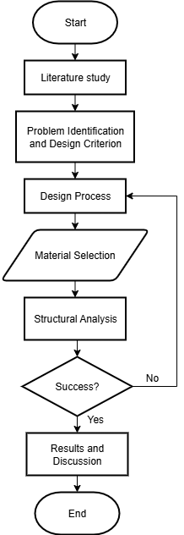

FIGURE 1. Flowchart of the design methodology

Wheelbase Calculation
Wheelbase refers to the distance between the front and rear wheel centers. It plays a significant role in vehicle maneuverability and stability. A short wheelbase enhances the vehicle’s ability to make sharp turns, making it ideal for urban driving and navigating narrow paths. In contrast, a longer wheelbase improves stability, particularly for high-speed applications such as race cars or vehicles designed for straight-line performance.
The ideal wheelbase-to-track width ratio typically ranges from 1.2 to 1.6, which helps ensure a balance between directional stability and maneuverability. For energy-efficient vehicle designs, the optimal wheelbase generally falls between 1.2 m and 1.5 m.
To determine the optimal wheelbase position for achieving maximum acceleration, the following equation can be used:

$\frac{a_{fwd}}{g}=\frac{μ_{x}}{1+μ_{x}\frac{h}{l} }\left(1-\frac{a_{1}}{l}\right)$ (1)

$\frac{a_{rwd}}{g}=\frac{μ_{x}}{1-μ_{x}\frac{h}{l}}\frac{a_{1}}{l}$ (2)

and for maximum braking:

$\frac{a_{fwb}}{g}=-\frac{μ_{x}}{1-μ_{x}\frac{h}{l} }\left(1-\frac{a_{1}}{l}\right)$ (3)

$\frac{a_{rwb}}{g}=-\frac{μ_{x}}{1+μ_{x}\frac{h}{l}}\frac{a_{1}}{l}$ (4)
Where:
$a_{fwd}$ : front wheel drive acceleration
$a_{rwd}$ : rear wheel drive acceleration
$a_{fwb}$ : front wheel brake acceleration
$a_{rwb}$ : rear wheel brake acceleration
g : gravitational acceleration
$a_{1}$ : distance between center of gravity and front wheel
h : center of gravity height
l : wheelbase length
$μ_{x}$ : coefficient of friction

Track Width Calculation
Track width is defined as the distance between the centers of the left and right wheels on the same axle. It significantly influences lateral stability [15]. A wider track width enhances resistance to centrifugal forces during cornering, thereby improving stability. Conversely, a narrower track width results in a more responsive vehicle but increases the risk of rollover.
The appropriate track width can be determined using the following equation:

$SSF=\frac{t}{2h}$ (5)

Where:
$SSF$ : Stability Safety Factor (1.2 for common electric vehicle competition)
$t$ : track width
$h$ : center of gravity height

Results and discussion

Wheelbase Position and Track Width
The results of acceleration for each wheelbase position are shown in Fig. 2. Based on these calculations, the ratio $\frac{a_{1}}{l}$​​ was selected as 0.6, resulting in $a_{1}=l$×0.6=0.9. With this configuration and assuming a rear-wheel-drive (RWD) layout, the front wheel is located 0.9 meters ahead of the center of gravity (CoG), while the rear wheel is positioned 0.6 meters behind the CG, yielding a total wheelbase length of 1.5 meters.
FIGURE 2. Relationship Between Wheelbase Ratio and Normalized Acceleration

In rear-wheel-drive (RWD) vehicles, the ability of the rear wheels to provide effective braking plays a crucial role in overall control, particularly during high-speed deceleration. Efficient braking at the rear axle enhances stability and reduces the risk of directional instability during hard braking. Based on the calculation results, the breaking point is located at the rear wheelbase, which coincides with the position of the rear wheels, situated 0.6 meters behind the center of gravity (CG). The relationship between the wheelbase ratio and the deceleration experienced by the front and rear wheels is illustrated in Fig. 3.
FIGURE 3. Relationship Between Wheelbase Ratio and Normalized Deceleration on Front and Rear Wheels

The track width can be calculated using the equation previously described, with the Static Stability Factor (SSF) value referenced from the Tarsius X3 electric vehicle, which is 1.4. Based on this calculation, the required track widthis determined to be 1.115 meters.

Frame Design Geometry and Specification
The electric vehicle frame was designed using SolidWorks 2020, a 3D Computer-Aided Design (CAD) software. The completed frame model was then prepared for simulation using Aluminum 6061-T6 as the structural material. Static structural analysis were conducted to evaluate the minimum and maximum values of stress, displacement, and strain. The resulting frame design are shown in Fig. 4, and the geometry in Table 1.

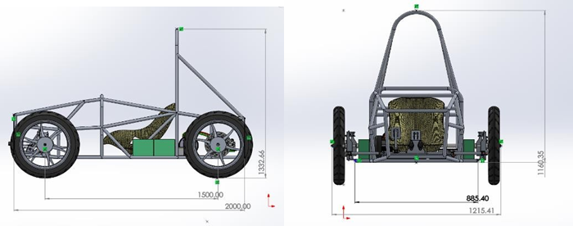
FIGURE 4. Frame design with key dimensions

TABLE 1. Frame geometry and material specification
Parameter | Value | Unit
Wheelbase length | 1500 | mm
Frame width | 885.40 | mm
Vehicle width | 1215.4 | mm
Frame length | 2000 | mm
Frame height | 1160.3 | mm
Frame mass | 21.2 | kg
Track width | 1115 | mm
Material | Aluminum 6061-T6 | —

Mesh Type and Size
Prior to conducting static analysis, the chassis model was discretized using the Static Structural module in ANSYS. This meshing process converts the continuous 3D geometry into a finite number of smaller elements, enabling numerical simulation through the finite element method (FEM) [16]. Each element contains a set number of nodes; in this case, tetrahedral elements were used, each comprising 4 nodes with 3 degrees of freedom per node. These elements are associated with mathematical models that govern their behavior under loading conditions.
In this analysis, a mesh size of 50 mm was selected, resulting in 77,197 nodes and 32,995 elements. This meshing configuration balances computational efficiency with sufficient resolution for evaluating structural response.

Total Deformation
Based on theoretical calculations, the allowable deformation is determined to be 4.68 mm, derived from the product of the track width (1115 mm) and the chassis deflection index (0.0042). As shown in Fig. 5, the simulation under vertical loading conditions on a 3 mm thick chassis yields a total deformation of 0.56255 mm. Additionally, directional deformation is observed along three axes, with values of 0.089225 mm (X-axis), 0.05364 mm (Y-axis), and 0.20688 mm (Z-axis), respectively. Since all deformation values remain well below the allowable limit, the chassis is considered structurally safe under the applied vertical load.

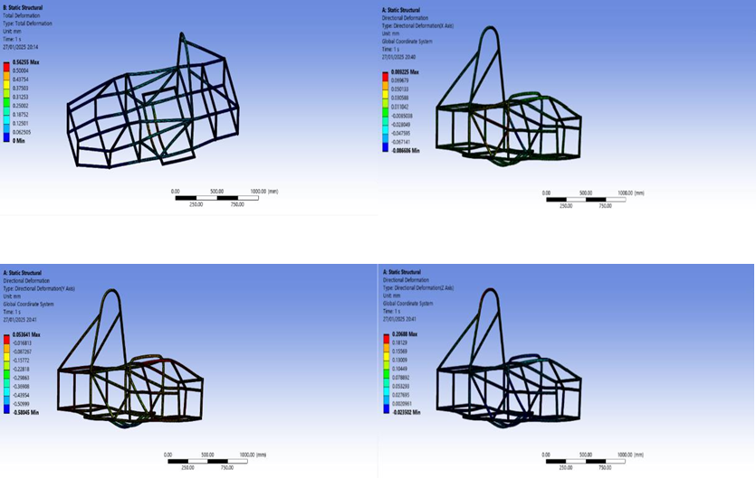
FIGURE 5. Results for deformation of the frame

Strain and Stress Distribution
Figures below present the results of the static analysis performed on the electric vehicle frame, focusing on strain distribution and stress analysis using Von Mises criterion. In Fig. 6, the strain distribution reveals a maximum strain of 0.003306 mm/mm and a minimum of 1.25 × 10⁻¹¹ mm/mm, with the highest strain occurring near the driver’s area,
where the structural load is most concentrated. Fig. 7 shows the Von Mises stress analysis, indicating a maximum stress of 225.91 MPa, also located in the driver compartment. This value remains below the material's yield strength of 276 MPa for Aluminum 6061-T6, ensuring the frame operates within safe stress limits [17].

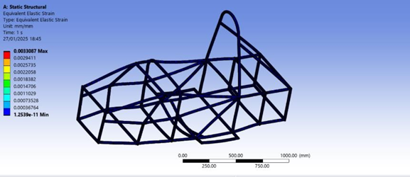
FIGURE 6. Equivalent (von Mises) strain of the frame

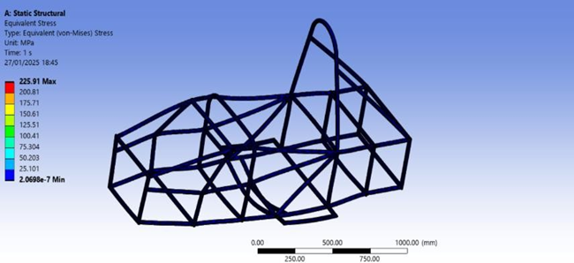
FIGURE 7. von Mises stress of the frame

Factor of Safety
Fig. 8 presents the Factor of Safety (FOS) analysis of the vehicle frame constructed from Aluminum 6061-T6. In this evaluation, the FOS is used as a key parameter to assess the structural integrity under load conditions, indicating the margin between the applied stress and the material’s yield strength [17]. The simulation yielded a minimum safety factor of 1.195, which remains within acceptable limits. For reference, the maximum allowable safety factor is 1.22, calculated by dividing the yield strength of Aluminum 6061-T6 (276 MPa) by the maximum simulated stress (225.9 MPa).

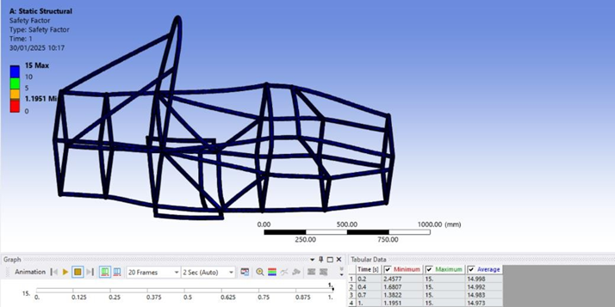
FIGURE 8. Factor of Safety across the frame

CONCLUSION
The design and analysis of the single-seater electric vehicle frame yielded a structurally efficient and lightweight solution using Aluminum 6061-T6 pipes with a diameter of 1 inch and a 3 mm wall thickness. The resulting frame dimensions include a wheelbase of 1500 mm, frame width of 885.4 mm, total length of 2000 mm, height of 1160.3 mm, and track width of 924 mm, with an overall mass of 21.2 kg. Specific design components such as the driver compartment, battery holder, roll bar, and motor mount were dimensioned to ensure compatibility and balance. Static structural analysis confirmed the mechanical reliability of the frame, with a maximum stress of 225.91 MPa remaining below the material yield strength of 276 MPa, and a total deformation of 0.56255 mm, which is significantly lower than the allowable deformation of 4.68 mm. The frame also demonstrated an acceptable factor of safety of 1.195, confirming its capacity to withstand operational loads. From the wheelbase analysis resulting in the front wheels positioned 0.9 m ahead and rear wheels 0.6 m behind the center of gravity, offering a balanced configuration for acceleration performance. Additionally, braking analysis for the rear-wheel-drive layout revealed that braking force is concentrated on the rear axle, with the effective braking point located 0.6 m behind the center of gravity, supporting improved control during deceleration. These results demonstrate that the proposed frame design meets structural and performance requirements and can serve as a foundation for further development of lightweight electric vehicle platforms.

References
- A. Mofolasayo, “Assessing and Managing the Direct and Indirect Emissions from Electric and Fossil-Powered Vehicles,” Sustainability 15(2), 1138 (2023).M. P. Brown and K. Austin, Appl. Phys. Letters 85, 2503–2504 (2004).
- M.A. Delucchi, C. Yang, A.F. Burke, J.M. Ogden, K. Kurani, J. Kessler, and D. Sperling, “An assessment of electric vehicles: technology, infrastructure requirements, greenhouse-gas emissions, petroleum use, material use, lifetime cost, consumer acceptance and policy initiatives,” Philos. Trans. R. Soc. A Math. Phys. Eng. Sci. 372(2006), 20120325 (2014).
- J. Köhler, W. Schade, G. Leduc, T. Wiesenthal, B. Schade, and L. Tercero Espinoza, “Leaving fossil fuels behind? An innovation system analysis of low carbon cars,” J. Clean. Prod. 48, 176–186 (2013)
- A.M. Faris, M. Marsono, and M.A. Mahardhika, “Kaji Eksperimental Kekakuan Sasis Mobil Listrik KMLI Jenis Tubular Space Frame,” J. Rekayasa Energi Dan Mek. 3(1), 45 (2023).
- A.K. Ary, A.R. Prabowo, and F. Imaduddin, “Structural Assessment of an Energy-Efficient Urban Vehicle Chassis using Finite Element Analysis – A Case Study,” Procedia Struct. Integr. 27, 69–76 (2020).
- M.D. Stroia, D.E. Moşteanu, I. Virca, E. Răduca, C. Popescu, and C. Haţiegan, “Case studies for automotive components using CAD and CAE techniques,” J. Phys. Conf. Ser. 1426(1), 012047 (2020).
- P. Kumar M.P., “Design and Analysis of a Tubular Space Frame Chassis of a High Performance Race Car,” Int. J. Res. Eng. Technol. 03(02), 497–501 (2014).
- N. Qiu, Y. Gao, J. Fang, Z. Feng, G. Sun, and Q. Li, “Crashworthiness analysis and design of multi-cell hexagonal columns under multiple loading cases,” Finite Elem. Anal. Des. 104, 89–101 (2015).
- D.M.V. T. Ananda Babu , D. Vijay Praveen, “Crash Analysis Of Car Chassis Frame Using Finite Element Method,” Int. J. Eng. Res. Technol. 01(08), (2012).
- A. Mayyas, A. Qattawi, M. Omar, and D. Shan, “Design for sustainability in automotive industry: A comprehensive review,” Renew. Sustain. Energy Rev. 16(4), 1845–1862 (2012).
- A. Toteles, “Analisis Material Kontruksi Chasis Mobil Listrik Laksamana V2 Menggunakan Software Autodesk Inventor,” Mach. J. Tek. Mesin 7(1), 30–37 (2021).
- M.W. Kahfi, N.A. Mufarida, and K. Kosjoko, “Desain dan analisis chassis tipe tubular space frame,” ARMATUR Artik. Tek. Mesin Manufaktur 4(1), 18–30 (2023).
- P. Castaldo, D. Gino, and G. Mancini, “Safety formats for non-linear finite element analysis of reinforced concrete structures: discussion, comparison and proposals,” Eng. Struct. 193, 136–153 (2019).
- S. Tebby, A. Barari, and E. Esmailzadeh, “Optimization of Vehicle Structure Considering Torsion Stiffness Using Simple Structural Beam Frame-Approach,” Comput. Aided. Des. Appl. 10(3), 413–426 (2013).
- A. Haigermoser, B. Luber, J. Rauh, and G. Gräfe, “Road and track irregularities: measurement, assessment and simulation,” Veh. Syst. Dyn. 53(7), 878–957 (2015).
- E. Madenci, and I. Guven, The Finite Element Method and Applications in Engineering Using ANSYS® (Springer US, Boston, MA, 2015).
- E. Bramanti, G. Cervino, F. Lauritano, L. Fiorillo, C. D’Amico, S. Sambataro, D. Denaro, F. Famà, G. Ierardo, A. Polimeni, and M. Cicciù, “FEM and Von Mises Analysis on Prosthetic Crowns Structural Elements: Evaluation of Different Applied Materials,” Sci. World J. 2017, 1–7 (2017).

