Effect of Quenching on the Hardness of ST 60 Steel Using Saltwater Cooling Media Variations
Huzaifah Farisul Mukhtar^{a)}, Sudarman^{b)}, Brigas Cahyono^{c)} and
Rafael Wahyu Verdiansyah^{d)}
Department of Mechanical Engineering, University of Muhammadiyah Malang
Jl. Raya Tlogomas No. 246, Malang 65144, Indonesia.

^{a)}huzaifahmukhtar98@gmail.com
^{b)}Corresponding author: sudarman@umm.ac.id
^{c)}brigascy@umm.ac.id
^{d)}wahyuverdiansyahr@gmail.com

Abstract. ST 60 steel is classified as a medium-carbon steel with a carbon content of approximately 0.44%, offering excellent mechanical properties including strength and impact resistance. This study investigates the effect of quenching on the hardness of ST 60 steel using different cooling media: water, 3.5% saltwater solution, and 34% saltwater solution. The specimens were heated to 850°C with a holding time of 60 minutes and then rapidly cooled in the respective media. Hardness tests were performed using the Rockwell hardness method. The results showed that the raw material had a hardness of 14.91 HRC. After quenching, the hardness increased significantly to 48.02 HRC with water, 43.12 HRC with 3.5% saltwater, and 48.84 HRC with 34% saltwater. These findings confirm that higher salt concentration in the cooling medium accelerates the cooling rate, leading to an increase in steel hardness. Overall, quenching proved to be an effective method to improve the mechanical properties of ST 60 steel for industrial applications.

INTRODUCTION
In industrial applications, steel is a material that can be easily formed into various shapes and dimensions. Medium-carbon steel, in particular, possesses desirable properties such as high strength, weldability, and impact resistance, making it suitable for manufacturing components like cutters and shears. These characteristics are attributed to its carbon content, which typically ranges from 0.3% to 0.6% [1].
Carbon steel is widely used and contains several alloying elements in controlled amounts, including phosphorus (P), silicon (Si), sulfur (S), and manganese (Mn) [2]. A carbon content between 0.25% and 0.55% results in higher mechanical strength than low-carbon steel, but it also makes the material more difficult to bend, weld, or cut. This type of steel is often used in structural machine components such as shafts, gears, and chains [3].
ST 60 steel is categorized as a medium-carbon steel, with a boiling point of approximately 1550°C and a melting point close to 2900°C [4]. It contains around 0.697% manganese, which enhances its hardness and wear resistance [5]. The chemical composition used in this study is based on material certification from a local supplier [6].
The carbon content in steel significantly influences its mechanical behavior. Carbon acts as a strengthening agent, and steels containing between 0.2% and 2.14% carbon can be hardened by heat treatment [7]. Heat treatment aims to improve specific mechanical properties by carefully managing the heating and cooling rates [8]. Proper control over these parameters is essential to obtain the desired material characteristics [9].
Among several heat treatment methods, quenching is one of the most commonly used techniques to increase hardness by rapidly cooling the heated steel in a suitable medium [10]. According to B.H. Amstead, heat treatment involves heating and cooling metals under controlled conditions to modify and improve their physical and mechanical properties, including hardness, corrosion resistance, thermal resistance, magnetic behavior, and machinability [11].
Despite its advantages, quenching also has limitations. Repeated use of cooling media can cause temperature buildup, leading to inconsistent cooling. Additionally, large or long components may not be uniformly cooled, making the process less effective [12]. Rapid immersion cooling is often difficult to apply to bulky steel parts, and water temperature tends to rise during repeated use [13].
The quenching outcome is influenced by multiple factors such as the type and condition of the cooling medium, the chemical composition of the material, and its hardenability, which depends on grain size and alloy content. The size of the steel workpiece also affects the final results [14]. Common cooling media include air, water, oil, and salt solutions, each offering different cooling rates due to variations in temperature, viscosity, and chemical composition. Faster cooling usually leads to increased hardness. Rapid cooling traps carbon atoms within the crystal structure, resulting in a tetragonal phase with less interatomic spacing, which contributes to higher hardness [15,16].
In this study, water and saltwater solutions at concentrations of 3.5% and 34% were selected as quenching media to evaluate their effect on the hardness of ST 60 steel. The hardness was assessed using the Rockwell hardness test, which, similar to the Brinell method, determines hardness based on the depth of indentation. However, Rockwell testing uses smaller loads and indenters, making the test faster and more practical for industrial settings [17].
A previous study conducted by Anton Tri Wibowo and Achmad Kusairi Samlawi investigated the effect of quenching temperature and cooling media on the hardness and microstructure of S45C steel. Their findings revealed that both factors significantly influenced the hardness values. At 800°C, water and oil quenching increased hardness, though oil resulted in slightly lower values. At 850°C, hardness decreased, especially with oil. However, at 900°C, hardness increased again, with oil producing slightly higher results than water. The study confirmed that the type of cooling medium and quenching temperature are critical in determining the mechanical properties of heat-treated steel [18].
Building upon these findings, this study aims to further improve the hardness and wear resistance of ST 60 steel. The primary objective is to analyze the effect of different cooling media (water, 3.5% saltwater, and 34% saltwater) on the hardness of ST 60 steel after quenching, and to compare the results with untreated specimens. The quenching process was carried out at 850°C with a holding time of 60 minutes.

Methodology
This study utilized an experimental approach to investigate the effect of saltwater-based quenching media on the hardness of ST 60 steel. The primary goal was to determine the improvement in hardness resulting from different quenching media using the Rockwell hardness test. The experimental workflow was designed and structured as shown in Fig. 1, which outlines the overall research flowchart.

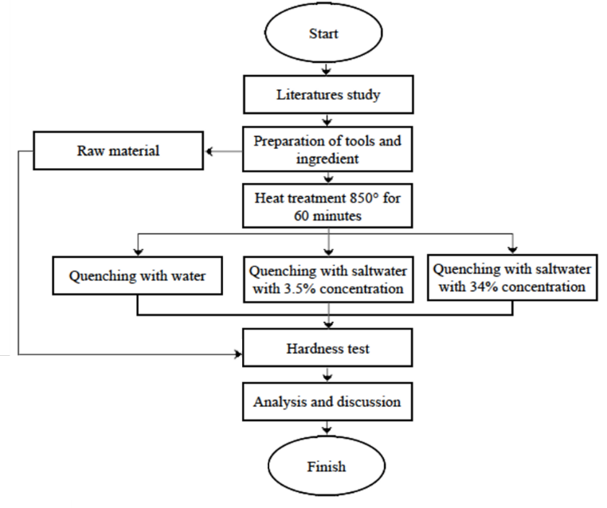
Figure 1. Research flowchart of the experimental procedure.

Research Site and Schedule
The experimental work was conducted in the Mechanical Engineering Laboratory of the State Polytechnic of Malang. The research activities commenced on November 12, 2024, and continued until the completion of all test procedures.

Specimen Preparation
To ensure compatibility with Rockwell hardness testing procedures, specimens were prepared according to the guidelines set in ASTM E18 (Standard Test Method for Rockwell Hardness of Metallic Materials) and ISO 6508 [19]. These standards specify the following requirements:
- Minimum specimen thickness of 8 mm.
- The test surface must be large enough to avoid edge effects, generally requiring a diameter exceeding 12.7 mm (½ inch).
- Acceptable specimen geometries include cylindrical, rectangular, or any shape with compliant test surfaces.
- The test surface must be flat, smooth, and free from irregularities, typically achieved through polishing [20].
The specimens were prepared with a diameter of 30 mm and a thickness of 10 mm, as shown in Fig. 2. The preparation process involved several steps. First, the specimens were cut using a DOALL C-916 cutting saw to obtain a total of 12 specimens. After cutting, sharp edges were removed by filing to ensure safe handling and accurate testing.

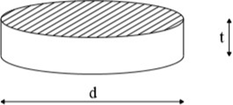
Figure 2. Geometry and dimensions of the hardness test specimens.

Heat Treatment Process
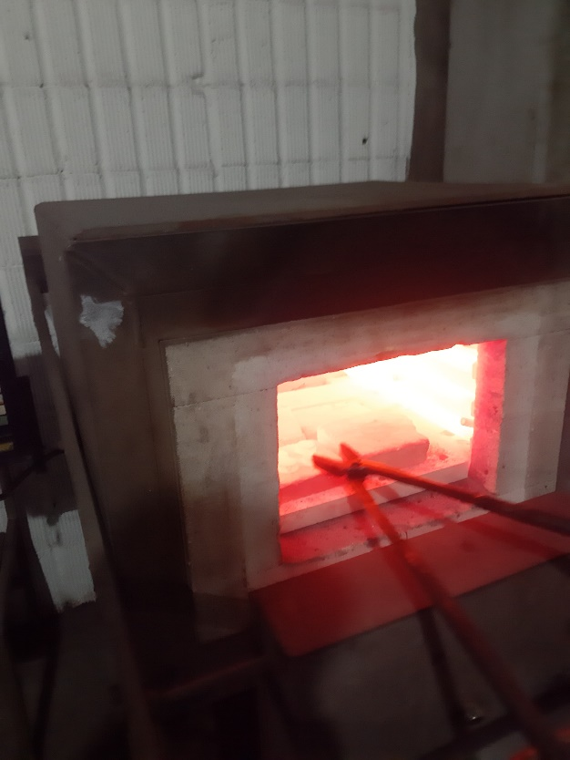
Figure 3. Furnace used for the heat treatment process at 850°C.

The heat treatment procedure consisted of several key stages. Initially, three cooling media were prepared using identical cylindrical metal containers to hold fresh water, 3.5% saltwater solution, and 34% saltwater solution, respectively. The heating process was carried out in a high-temperature furnace. Each specimen was placed inside the furnace and heated to a temperature of 850°C, with a soaking time of 60 minutes to ensure uniform heat distribution (Fig. 3).
Following the heat soaking process, each specimen was rapidly quenched by immersion into one of the prepared cooling media. This quenching stage was performed immediately upon removal from the furnace. The quenching process was intended to transform the microstructure of the steel, thus affecting its mechanical properties.
Once cooled to room temperature, the specimens were dried and cleaned using abrasive paper to remove oxidation and prepare the surface for hardness testing.

Hardness Testing
The hardness of ST 60 steel was evaluated using the Rockwell hardness testing method in accordance with the standard procedures [21]. The test involved several steps. First, both untreated (as-received) and heat-treated specimens were prepared for testing. The Rockwell hardness testing machine was configured with a 150-kgf load, and a diamond cone indenter (C-scale) was installed. Each specimen was tested individually, with the indenter applied to the flat center of the specimen surface to ensure consistent results.

Results and Discussion

Hardness Test Results
The hardness test results of the raw material can be seen in Table 1. Based on the data, it was found that the average Rockwell hardness value of ST 60 steel in its raw condition is 14.91 HRC.

TABLE 1. Rockwell Hardness Result without Cooling Treatment.
Specimen | Rockwell Hardness Value (HRC) |  |  | Average
Specimen | Point 1 | Point 2 | Point 3 | Average
R1 | 14.7 | 15.3 | 15.1 | 14.91
R2 | 14.4 | 15.0 | 14.9 | 14.91
R3 | 14.1 | 15.4 | 15.3 | 14.91

The hardness values of ST 60 steel after undergoing quenching with water as the cooling medium are presented in Table 2. From this table, it is evident that quenching in water results in a significantly increased average hardness of 48.02 HRC.

TABLE 2. Rockwell Hardness Result with Water Quenching.
Specimen | Rockwell Hardness Value (HRC) |  |  | Average
Specimen | Point 1 | Point 2 | Point 3 | Average
R1 | 48.3 | 47.7 | 48.1 | 48.02
R2 | 48.1 | 48 | 48.1 | 48.02
R3 | 47.7 | 48.3 | 47.9 | 48.02

Table 3 displays the results of the hardness test after quenching with a 3.5% saltwater solution. The average Rockwell hardness achieved through this medium is 43.12 HRC.
Furthermore, the hardness values following quenching in a 34% saltwater solution are shown in Table 4. The average hardness obtained in this case reaches 48.84 HRC.

TABLE 3. Rockwell Hardness Result with 3.5% Salt Solution Quenching.
Specimen | Rockwell Hardness Value (HRC) |  |  | Average
Specimen | Point 1 | Point 2 | Point 3 | Average
R1 | 42.8 | 43.0 | 43.5 | 43.12
R2 | 42.9 | 42.9 | 43.3 | 43.12
R3 | 43.1 | 43.1 | 43.5 | 43.12

TABLE 4. Rockwell Hardness Result with 34% Salt Solution Quenching.
Specimen | Rockwell Hardness Value (HRC) |  |  | Average
Specimen | Point 1 | Point 2 | Point 3 | Average
R1 | 49.4 | 48.5 | 48.6 | 48.84
R2 | 48.3 | 48.4 | 49.6 | 48.84
R3 | 48.9 | 49.1 | 48.8 | 48.84

Hardness Comparison
This study reveals that the hardness of ST 60 steel increases substantially after undergoing the quenching process, regardless of the cooling medium used. The untreated (raw) steel had a relatively low hardness of 14.91 HRC, indicating that it was still in a soft and easily machinable state. In contrast, all quenching treatments led to significantly higher hardness values.
A graphical representation of the Rockwell hardness values (Fig. 4) shows the comparison between the raw material and the quenched specimens using different cooling media.

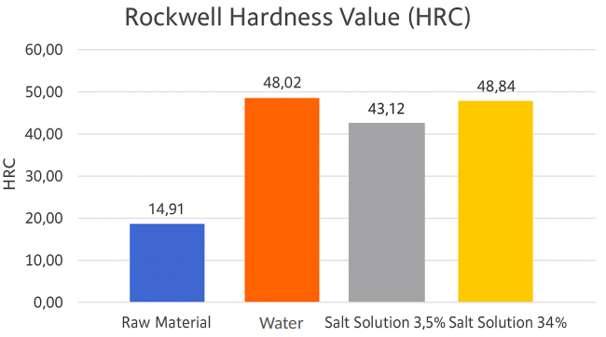
Figure 4. Comparison of Rockwell hardness (HRC) values of ST 60 steel before and after quenching using different cooling media (raw material, water, 3.5% saltwater, and 34% saltwater).

Based on the data, it can be concluded that the quenching process significantly enhances the hardness of ST 60 steel. Quenching in fresh water increased the hardness to 48.02 HRC, representing a 222.42% increase compared to the raw material. Meanwhile, quenching in a 3.5% saltwater solution produced a hardness of 43.12 HRC, corresponding to a 189.07% increase, though slightly lower than that achieved with water.
The use of a higher salt concentration (34%) also had a noticeable impact on the final hardness. Quenching in 34% saltwater solution resulted in an average hardness of 48.84 HRC, reflecting a 227.67% increase from the untreated condition. This result suggests that higher salt concentrations enhance the cooling rate, leading to more effective martensitic transformation and higher steel hardness than the 3.5% solution.
Overall, the quenching process is shown to be highly effective in increasing the hardness of ST 60 steel, with the degree of hardness improvement depending on the type and concentration of the cooling medium used.

CONCLUSION
This study investigated the effect of different quenching media on the hardness of ST 60 steel. The results demonstrated that the quenching process significantly enhances the material's hardness compared to its raw condition. The untreated ST 60 steel exhibited an average hardness of 14.91 HRC. After quenching, the hardness increased substantially depending on the cooling medium used.
Water quenching resulted in a hardness of 48.02 HRC, representing a 222.42% improvement, while quenching with a 3.5% saltwater solution produced a hardness of 43.12 HRC, an increase of 189.07%. The highest hardness value was achieved through quenching in a 34% saltwater solution, reaching 48.84 HRC—an enhancement of 227.67% over the raw material.
These findings indicate that higher salt concentration in the quenching medium can accelerate the cooling rate, promoting a more complete martensitic transformation and thus increasing hardness. Overall, the quenching process is proven to be an effective method for improving the mechanical properties of ST 60 steel, with saltwater concentration playing a key role in optimizing the results.

References
- M. Andreansyah, R. D. Anjani, and V. Naubnome, “Effect of Heat Treatment Process (Quenching and Tempering) on Hardness and Microstructure of Medium‑Carbon Steel,” J. Serambi Eng., 9 (1), 7864–7872 (2023).
- R. Redi Putra, S. Jokosisworo, and A. S. Wibawa Budi, “Use of Jurnal Teknik Perkapalan 60 as Propeller Shaft Material After Tempering Process,” J. Tek. Perkapalan, 6 (1), 83 (2018). [Online]. Available: http://ejournal3.undip.ac.id/index.php/naval
- N. Radović, A. Koprivica, D. Glišić, A. Fadel, and D. Drobnjak, “Influence of Vanadium and Nitrogen on Transformation Behavior and Mechanical Properties of Medium‑Carbon Forging Steels,” Mater. Sci. Forum, 638–642, 3459–3464 (2010).
- M. Syaifullah, M. Subhan, and J. Juanda, “Effect of Salt Water as Quenching Medium on Hardness Value in ST 60 Steel Hardening Process,” J. Syntax Admiration, 2 (8), 1555–1569 (2021).
- H. Iriandoko, A. Akbar, and Y. S. Pramesty, “Effect of Heat Treatment on ST 60 Steel Hardness Using Vinegar as Cooling Medium,” (2020).
- A. Rosandi, W. Sumbodo, H. Yudiono, and K. Kriswanto, “Analysis of Cutting Speed and Depth Variations on Surface Roughness and Vibration in Cylindrical Turning of ST 60 Steel,” J. Inov. Mesin, 3 (1), 1–12 (2021).
- K. Santoso and Suhardiman, “Analysis of Heat Treatment Influence on Surface Roughness of Low‑Carbon Steel Workpiece in Kabul Process,” Semin. Nas. Ind. dan Teknol. Politek. Negeri Bengkalis, 160–178 (2019).
- A. N. S. HD and S. Widodo, “Improvement of Mechanical Properties of Gray Cast Iron Through Tempering Process,” J. Mech. Eng., 2 (2), 8–17 (2018).
- A. A. Prabowo, “Effect of Cooling Medium in Process,” pp. 1–109 (2019).
- N. Mulyaningsih, B. Widodo, et al., “Hardness and Wear of ST 60 Steel Quenched Using Variations of Salt Solution,” J. Mech., 6 (1), 38–42 (2022). [Online]. Available: https://jurnal.untidar.ac.id/index.php/mechanical/article/view/7430/3008
- F. Ostwald, M. L. Begeman, and S. Djaprie, Mechanical Technology Volume 1 (Amstead B. H., 1997), p. 1997.
- A. Setiawan and H. E. P. Tambunan, “Effect of Quenching‑Tempering Process in Improving Mechanical Properties of Low‑Carbon Low‑Alloy Steel Grade J55 into Grade P110,” J. Metall. Eng. Process. Technol., 2 (2), 75 (2022).
- D. Setiadi and A. K. Samlawi, “Effect of Quenching with Water and Oil Cooling Media on Mechanical Properties of S45C Steel,” Jtam Rotary, 1 (2), 183 (2019).
- H. Hariningsih, T. Daryanto, and L. Lutiyatmi, “Effect of Quenching and Tempering Media Variation on Microstructure and Hardness of AISI 1045 Steel,” Creat. Res. Eng., 2 (2), 52 (2022).
- Yopi Handoyo, “Effect of Quenching and Tempering on Mechanical Properties of S45C JIS Grade Steel,” J. Ilm. Tek. Mesin, 3 (2), 104–105 (2015). [Online]. Available: http://ejournal.unismabekasi.ac.id/
- F. Diah and A. Verayanti, “Experimental Design: Effect of Cooling Media Variations on Hardness and Tensile Strength of ST 41 Steel in Heat Treatment Process,” 2020, 175–182.
- S. Flip and S. Absorption, “S; R S; R,” (1980).
- A. T. Wibowo and A. K. Samlawi, “Effect of Quenching Process with Water and Oil Cooling Media on Hardness and Microstructure of S45C Steel,” Jtam Rotary, 2 (2), 137 (2020).
- ISO, “ISO 6508‑1:2016 – Metallic Materials — Rockwell Hardness Test — Part 1: Test Method,” Int. Stand., 4, 1–32 (2016).
- M. Sulfate, iTeh Standards, Des. E 778‑87 (Reapproved 2004), 3–5 (2018).
- H. Setiawan, “Hardness Testing and Chemical Composition of Gray Cast Propeller Aluminum Product,” Proc. SNST Semarang, 4 (6), 31–36 (2014).

