The Effect of Composition on Hardness and Elemental Identification of Duck Eggshell (Cairina moschata) and Snail Shell (Achatina fulica) as Alternative Dental Implants
Enrico Bagus Abdul Azis^{a)}, Iis Siti Aisyah^{b)} Nur Hasanah^{c)} and
Viki Arie Fandi ^{d)}
Department of Mechanical Engineering, University of Muhammadiyah Malang
Jl. Raya Tlogomas No. 246, Malang 65144, Indonesia.

^{a)} enricobgs.27@gmail.com
^{b)} Corresponding author: siti@umm.ac.id
^{c)} nurhasanah02@umm.ac.id
^{d)} vikiari@gmail.com

Abstract. This research aims to investigate the effect of composition on the hardness and identification of the chemical elements of duck eggshell and snail shell powders for potential use as alternative dental implants. The materials used in this study include duck eggshell and snail shell powders as the primary fillers, with epoxy resin serving as the matrix. The method involves the preparation of powder materials through cleaning, drying, crushing, and sieving to a 200-mesh particle size. These powders are then mixed with the epoxy matrix using mechanical stirring. Four composition variations were tested: 90:10, 80:20, 70:30, and 60:40 (resin to powder ratio) by weight. The specimens were molded and left to cure for 24 hours before testing. Hardness tests were conducted using the Rockwell Hardness Tester (Scale R). Additionally, Scanning Electron Microscopy (SEM) and Energy Dispersive X-Ray Spectroscopy (EDS) were employed to analyze the surface morphology and elemental composition of the powders. The results show that the highest hardness value of 60.98 HRB was obtained at a composition of 70% epoxy resin and 30% filler powder. SEM images revealed irregular particle morphology with varying sizes, indicating non-uniform particle distribution. EDS analysis confirmed the presence of calcium (Ca) as the dominant element in both powders, along with other elements such as carbon (C), oxygen (O), and magnesium (Mg). The findings suggest that a 70:30 composition offers optimal mechanical properties and that duck eggshell and snail shell powders have promising potential as alternative materials for dental filler applications due to their biocompatible and mineral-rich nature.

INTRODUCTION
The development of biocompatible materials for dental applications continues to be an area of interest in biomedical engineering and materials science. One promising approach involves utilizing natural calcium-rich materials as alternative dental fillers. Among such materials, eggshells and mollusk shells are widely known for their high calcium carbonate (CaCO₃) content and biodegradability. Duck eggshells and snail shells, in particular, have received increasing attention due to their local availability, low cost, and eco-friendly properties. These biomaterials offer potential as reinforcement fillers in resin-based dental composites, especially as concerns over synthetic filler toxicity and cost continue to grow.
Eggshells, composed mainly of CaCO₃, possess a porous structure with trace minerals that may contribute to enhanced bonding with polymer matrices. Similarly, snail shells are composed of aragonite—a crystalline form of calcium carbonate—with favorable mechanical strength. Previous studies have shown that incorporating calcium-based fillers into polymer matrices can improve the mechanical and biological performance of composite materials, including their hardness, biocompatibility, and structural stability when used in oral environments. Hardness, in particular, is a critical parameter for dental applications, as it directly influences the wear resistance and durability of dental fillings.
Despite various studies on the use of eggshells and other biominerals as fillers, limited research has compared the synergistic effect of combining different natural fillers—such as duck eggshell and snail shell powders—on the mechanical performance of dental composites. Furthermore, understanding the optimal filler-to-resin composition ratio is essential to maximize hardness without compromising the processability or integrity of the composite.
Therefore, this study focuses on evaluating the effect of varying the composition ratios of duck eggshell and snail shell powders in an epoxy resin matrix on the resulting hardness of the composite. Additionally, a microstructural and elemental analysis was conducted using Scanning Electron Microscopy (SEM) and Energy Dispersive X-Ray Spectroscopy (EDS) to characterize the morphology and elemental composition of the powders. The goal of this research is to explore the feasibility of these natural biomaterials as sustainable and effective dental filler alternatives.

Methodology
This study was conducted experimentally at the Mechanical Engineering Laboratory, Universitas Muhammadiyah Malang, from June to December 2024. The aim was to investigate the effect of varying compositions of duck eggshell (Cairina moschata) and snail shell (Achatina fulica) as fillers in dental composites, particularly on hardness performance.
The raw materials—duck eggshells and snail shells—were first cleaned, sun-dried, then ground into powder using a blender. The powder was sieved with a 200-mesh screen to obtain uniform particle size and subsequently calcined at 800°C for 5 hours to convert CaCO₃ to CaO. The calcined powders were then mixed with Glass Ionomer Cement (GIC) as a binder in various compositions. The paste was poured into silicone molds (15 × 15 × 10 mm) and left to set for one hour at room temperature, followed by air drying for 72 hours.
Hardness testing was carried out using a Vickers Microhardness Tester with a load of 300 g and a dwell time of 12 seconds. Each composition was tested three times to ensure consistency, and the average hardness value was used for analysis. Additionally, SEM-EDX analysis was performed on the calcined powders to observe surface morphology and determine elemental composition. The dominant elements identified were Ca, C, O, P, and Mg, confirming the potential of both eggshell and snail shell as bioceramic-based dental fillers. Data were analyzed by comparing the hardness values of each composition, supported by SEM-EDX findings and relevant literature. The methodology enabled a direct correlation between filler composition and the mechanical performance of the composite material.

Results and Discussion
This study presents the results of two main tests: Vickers microhardness and SEM-EDX analysis. The Vickers test was conducted to evaluate the mechanical performance of each composition, while SEM-EDX was used to observe microstructure and determine the elemental composition of duck eggshell (Cairina moschata) and snail shell (Achatina fulica) powders. The data obtained provide insights into the relationship between composition variations and the material’s hardness, as well as the elemental characteristics relevant to potential dental filler applications.

Vickers Microhardness Test Results
Table 1 summarizes the Vickers microhardness test results across six composition variations, ranging from 100% duck eggshell to 100% snail shell. Each specimen was tested under a load of 300 gf with a 12-second dwell time, and three measurements were taken to calculate the average Vickers Hardness Number (VHN).
This study investigated six different compositional variations of mixtures between duck eggshells (Cairina moschata) and snail shells (Achatina fulica) to explore the influence of composition on material hardness. The test results revealed that increasing the proportion of Achatina fulica led to higher material hardness values, with the highest Vickers Hardness Number (VHN) of 77.50 kgf/mm² observed in the mixture containing 0% duck eggshell and 100% snail shell. Conversely, mixtures with higher duck eggshell content exhibited lower hardness, with the lowest VHN of 43.33 kgf/mm² found in the 100% duck eggshell and 0% snail shell composition.

TABLE 1. Vickers Microhardness Test Results.
Spesimen | Indenter Pressure Time (seconds) | load (gf) | Diagonal (d) |  |  | Vickers Hardness (VHN) | VHN average
Spesimen | Indenter Pressure Time (seconds) | load (gf) | d₁ (µm) | d₂ (µm) | d_{average} (µm) | Vickers Hardness (VHN) | VHN average
1  CM 100 % AF 0 % | 12 | 300 | 103,93 | 118,04 | 110,985 | 45,2 | 43,33
1  CM 100 % AF 0 % | 12 | 300 | 109,44 | 124,62 | 117,03 | 40,6 | 43,33
1  CM 100 % AF 0 % | 12 | 300 | 108,28 | 116,04 | 112,16 | 44,2 | 43,33
2  CM 80 % AF 20 % | 12 | 300 | 105,68 | 106,35 | 106,015 | 49,5 | 48,83
2  CM 80 % AF 20 % | 12 | 300 | 103,59 | 112,1 | 107,845 | 47,8 | 48,83
2  CM 80 % AF 20 % | 12 | 300 | 102,31 | 110,43 | 106,37 | 49,2 | 48,83
3  CM 60 % AF 40 % | 12 | 300 | 93,31 | 102,13 | 97,72 | 58,3 | 55,93
3  CM 60 % AF 40 % | 12 | 300 | 93,43 | 97,73 | 95,58 | 60,9 | 55,93
3  CM 60 % AF 40 % | 12 | 300 | 110,83 | 103,22 | 107,025 | 48,6 | 55,93
4  CM 40 % AF 60 % | 12 | 300 | 92,62 | 92,53 | 92,575 | 64,9 | 66,06
4  CM 40 % AF 60 % | 12 | 300 | 93,68 | 91,96 | 92,82 | 64,6 | 66,06
4  CM 40 % AF 60 % | 12 | 300 | 90,68 | 89,23 | 89,955 | 68,7 | 66,06
5  CM 20 % AF 80 % | 12 | 300 | 83,74 | 88,59 | 86,165 | 74,9 | 70,13
5  CM 20 % AF 80 % | 12 | 300 | 89,48 | 90,31 | 89,895 | 68,8 | 70,13
5  CM 20 % AF 80 % | 12 | 300 | 92,87 | 89,79 | 91,33 | 66,7 | 70,13
6  CM 0 % AF 100 % | 12 | 300 | 81,76 | 81,43 | 81,595 | 83,6 | 77,50
6  CM 0 % AF 100 % | 12 | 300 | 80,56 | 86,83 | 83,695 | 79,4 | 77,50
6  CM 0 % AF 100 % | 12 | 300 | 85,59 | 93,31 | 89,45 | 69,5 | 77,50

Figure 1. Vickers Hardness (VHN) vs. Composition Variation of Snail Shell (CB) and Duck Eggshell (CTB).

The graph presented illustrates the correlation between compositional variations and the resulting material hardness, indicating that changes in composition significantly affect the mechanical properties of the material. According to the study by Leestiana et al., commercial dental filler products such as Belleglass and Solidex have hardness values of 72 VHN and 43 VHN, respectively. Compared to those commercial benchmarks, the materials tested in this study exhibit hardness levels that are comparable or even higher. This finding suggests that the tested composite materials possess competitive mechanical characteristics, making them worthy of consideration as alternative dental fillers

SEM-EDX Elemental Mapping
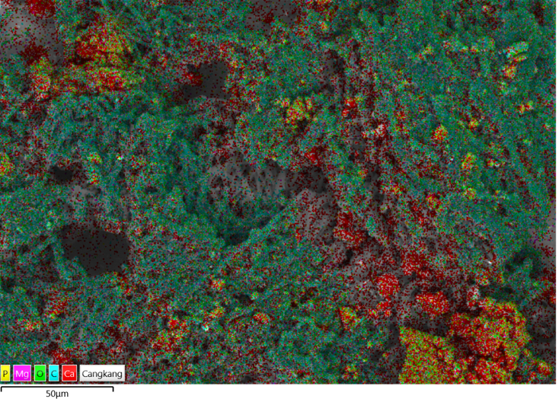
Figure 2. Elemental mapping of duck eggshell powder (Cairina moschata).

Elemental mapping performed on duck eggshell powder (Cairina moschata) reveals the spatial distribution of key chemical constituents using color-coded indicators: green represents oxygen (O), red for calcium (Ca), purple for magnesium (Mg), blue for carbon (C), and yellow for phosphorus (P). As depicted in Fig. 2, the mapping indicates that carbon, oxygen, and calcium are the most abundant elements. The predominance of calcium confirms its essential role in maintaining the structural integrity and rigidity of the eggshell, ensuring effective protection of the embryo. Carbon, primarily present in the form of calcium carbonate (CaCO₃), contributes significantly to mechanical stability. Meanwhile, oxygen is involved in biochemical and metabolic processes related to embryonic development. Though present in smaller quantities, magnesium and phosphorus may contribute to additional mineral functionalities and biological processes. These findings affirm that the duck eggshell structure is highly mineralized, with a strong presence of calcium carbonate as the primary compound.

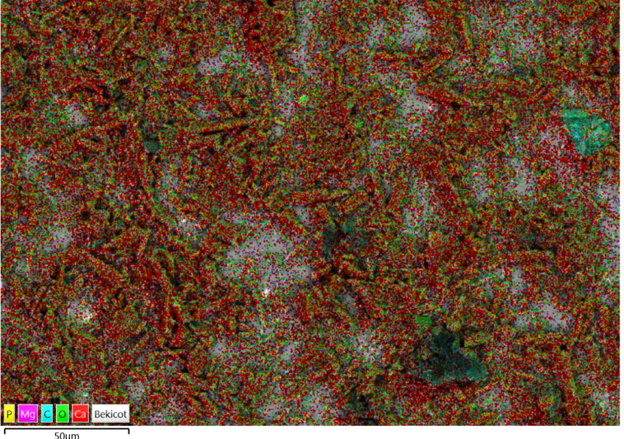
Figure 3. Elemental mapping of snail shell powder (Achatina fulica)

The elemental distribution of snail shell powder (Achatina fulica), as illustrated in Fig. 3, similarly shows dominant presence of oxygen (O), calcium (Ca), and carbon (C), indicated by green, red, and blue colors, respectively. The intense green areas suggest a high concentration of oxygen, which, along with calcium and carbon, signifies the presence of calcium carbonate as the principal component of the shell matrix. The red regions confirm calcium as a major contributor to the shell’s mechanical strength, while the blue regions reflect the carbon content bound in carbonate forms. Trace levels of magnesium (Mg) and phosphorus (P), marked in purple and yellow respectively, are also detected and may play secondary roles in shell biomineralization. Collectively, the elemental composition supports the conclusion that snail shells are predominantly formed from calcium carbonate, similar to avian eggshells, but with potentially different microstructural organization and mineral ratios.

Discussion of Elemental Composition in Powder
TABLE 2. Elemental Composition of Duck Eggshell Powder
Element | Line Type | Weight %
C | K series | 45.39
O | K series | 41.00
Ca | K series | 13.05
Fe | K series | 0.43
F | K series | 0.00
Mg | K series | 0.12
P | K series | 0.00
Cr | K series | 0.00
Total |  | 100.00

The elemental analysis of duck eggshell powder (Cairina moschata) revealed that the most dominant element was carbon (45.39%), followed by oxygen (41.00%) and calcium (13.05%). The presence of both oxygen and carbon typically indicates the formation of calcium carbonate (CaCO₃), which is the primary constituent of duck eggshells. Calcium plays a crucial role in providing mechanical strength and structural integrity to the shell, while carbon relates directly to the carbonate compound. Other trace elements, such as magnesium, iron, chromium, phosphorus, and fluorine, were detected in negligible amounts, contributing insignificantly to the overall composition. In summary, duck eggshell powder is primarily composed of calcium carbonate, offering strong mechanical protection to the biological structure.

TABLE 3. Elemental composition of snail shell powder
Element | Line Type | Weight %
C | K series | 45.39
O | K series | 41.00
Ca | K series | 13.05
Fe | K series | 0.43
F | K series | 0.00
Mg | K series | 0.12
P | K series | 0.00
Cr | K series | 0.00
Total |  | 100.00

The elemental analysis of snail shell powder (Achatina fulica) showed that the predominant element was oxygen (54.84%), followed by calcium (29.81%) and carbon (15.31%). The high content of oxygen and calcium suggests the presence of calcium oxide (CaO) as a significant component. Calcium, again, contributes to the mechanical durability of the shell, while the presence of carbon indicates carbonate structures. Minor elements such as magnesium, iron, chromium, phosphorus, and fluorine were present in trace amounts, exerting minimal impact on the main chemical makeup. Overall, the composition of snail shells is dominated by calcium-based compounds, especially calcium oxide, which imparts strong structural protection.

CONCLUSION
The conclusion of this study indicates that powdered duck eggshell (Cairina moschata) and powdered snail shell (Achatina fulica) have promising potential as alternative dental filler materials. The hardness testing results and elemental composition analysis via SEM-EDX revealed that both materials contain key elements such as calcium, carbon, and oxygen, which contribute to the mechanical strength required for dental filling applications. The dominance of calcium carbonate in the shell structure supports the potential of these materials as dental filler substitutes.
Based on the hardness test results, the composition variation consisting of 100% snail shell (Achatina fulica) and 0% duck eggshell (Cairina moschata) exhibited a higher hardness value compared to the inverse variation (0% snail shell and 100% duck eggshell), with a measured value of 77.50 kgf/mm². The higher calcium content in Achatina fulica shell has been shown to provide better mechanical strength. In contrast, the variation with 100% duck eggshell (Cairina moschata) exhibited a lower hardness value of 43.33 kgf/mm², which is likely due to the lower calcium content in the duck eggshell compared to the snail shell. Nevertheless, both materials still demonstrate potential as alternative fillers; however, further studies are required to evaluate their performance in practical dental applications.

References
- C. A. Ghiorghe, G. Iovan, V. Carlescu, B. Istrate, G. Pancu, and S. Andrian, Comparative evaluation of hardness and elasticity modulus of tooth-colored materials for dental restoration, Rev. Chim. 68, 2623–2627 (2017).
- F. Elfakhri, R. Alkahtani, C. Li, and J. Khaliq, Influence of filler characteristics on the performance of dental composites: A comprehensive review, Ceram. Int. 48, 27280–27294 (2022).
- H. A. Rodríguez, W. M. Kriven, and H. Casanova, Development of mechanical properties in dental resin composite: Effect of filler size and filler aggregation state, Mater. Sci. Eng. C 101, 274–282 (2019).
- F. Leestiana, Y. Setiyorini, and A. Purniawan, A new alternative for dental material development, J. Teknol. 2, 1 (2015).
- N. N. A. Minanti, I. N. Tika, and I. W. Karyasa, Differential scanning calorimetry characterization of calcium silicophosphate biomaterial synthesis, J. Wahana Mat. dan Sains 10, 22–33 (2016).
- N. Nayiroh, Study on the effect of green mussel shell filler particle volume fraction variation on the physical and mechanical properties of polyester polymer composites, B.Sc. thesis, UIN Malang (2020).
- A. S. Suryawanshi and N. Behera, In-vitro wear measurements of dental composite influenced by chewable tobacco environment, J. Tribol. 29, 84–95 (2021).
- T. P. Sathishkumar, J. Naveen, and S. Satheeshkumar, Hybrid fiber reinforced polymer composites – A review, J. Reinf. Plast. Compos. 33, 454–471 (2014).
- Ifwandi, Dental bridge procedure for restorative dentures: A review, J. Syiah Kuala Dent. Soc. 8, 76–83 (2023).
- A. P. Fugolin, A. R. Costa, E. Kono, E. Quirk, J. L. Ferracane, and C. S. Pfeifer, Resin composites containing thiourethane-functionalized fillers, Eur. Polym. J. (2021).
- A. Mufidun and A. Abtokhi, Utilization of simping clam shell (Placuna placenta) powder filler and polyester matrix as a base material for composite board fabrication, J. Neutrino 9, 1–7 (2016).
- F. Kundie, C. H. Azhari, A. Muchtar, and Z. A. Ahmad, Effects of filler size on the mechanical properties of polymer-filled dental composites: A review of recent developments, J. Phys. Sci. 29, 141–165 (2018).
- M. Sydor, G. Pinkowski, and A. Jasińska, The Brinell method for determining hardness of wood flooring materials, Forests 11, 8 (2020).
- E. Wulandari, F. R. A. Wardani, N. Fatimattuzahro, and I. D. A. R. Dewanti, Addition of gourami (Osphronemus goramy) fish scale powder on porosity of glass ionomer cement, Dent. J. 55, 33–37 (2022).
- A. Amanda, D. N. Ratih, and E. Mulyawati, The effect of sisal (Agave sisalana) nanofiber in epoxy resin sealer on root canal obturation’s push-out bond strength, Maj. Kedokt. Gigi Indones. 7, 137 (2022).
- S. Najeeb, Z. Khurshid, J. P. Matinlinna, F. Siddiqui, M. Z. Nassani, and K. Baroudi, Nanomodified PEEK dental implants: Bioactive composites and surface modification – A review, Int. J. Dent. 2015, Article ID 381759 (2015).
- S. Victor M., B. Andhika, and I. Syauqiah, Utilization of chitosan from snail shell waste (Achatina fulica) as zinc (Zn) heavy metal adsorbent, Konversi 5, 22 (2018).
- F. N. Gunawan and A. Limanto, Comparative study of natural polymers and titanium as medical implant in terms of safety, J. Ris. Rumpun Ilmu Kedokt. 2, 103–122 (2023).
- Julinawati, Marlina, N. Rosnani, and Sheilatin, Applying SEM-EDX techniques to identify the types of minerals in jade (giok) from Takengon, Aceh, J. Nat. 15, 44–48 (2015).
- K. Al-Ahdal, N. Silikas, and D. C. Watts, Rheological properties of resin composites according to variations in composition and temperature, Dent. Mater. 30, 517–524 (2014).

