Effect of Transient Thermal Flame (TTF) Heat Treatment Position on Tensile Strength and Distortion in Flux Cored Arc Welding (FCAW) of Aluminum 5083
Bagas Fitra Ferdiawan^{a)}, Nur Subeki^{b)}, and Mohamad Irkham Mamungkas^{c)}
Department of Mechanical Engineering, University of Muhammadiyah Malang
Jl. Raya Tlogomas No. 246, Malang 65144, Indonesia.

^{a)} bagasfitra10@gmail.com
^{b)} Corresponding author: nursubeki@umm.ac.id
^{c)} irkham@umm.ac.id
Abstract. This study investigates the effect of heat treatment position using the Transient Thermal Flame (TTF) method in the Flux-Cored Arc Welding (FCAW) process on the tensile strength and distortion of aluminum alloy 5083. An experimental approach was employed to compare different heat treatment variations, with tensile and distortion testing as the primary evaluation parameters. The results indicate that applying TTF heat treatment at 100 degrees Celsius can significantly reduce distortion and improve tensile strength compared to welding without heat treatment. The highest Ultimate Tensile Strength (UTS) was achieved in specimens with neutral TTF treatment, reaching 464.34 MPa, while the lowest distortion was observed in specimens with TTF− treatment (1.70 mm). These findings demonstrate that the TTF method can be an effective approach to enhance the quality of aluminum 5083 welded joints by reducing residual stress and minimizing distortion.

INTRODUCTION
Welding is an essential fabrication process widely applied in construction, aerospace, and shipbuilding [1]. Among various techniques, Flux Cored Arc Welding (FCAW) is favored for its efficiency and adaptability, particularly in structural and piping applications [2], including shipbuilding, offshore construction, and the petrochemical sectors, due to its ability to produce reliable mechanical properties in welded joints [3]. To further enhance production quality, engineers have developed methods to reduce deformation and residual stress, thereby optimizing post-weld heat treatment [4].
A major challenge in ship panel welding is distortion caused by high temperature gradients, leading to residual stresses from thermal shrinkage and phase transformation [5]. These imperfections, if uncontrolled, compromise quality and durability, increasing repair costs [6]. Common approaches to mitigate distortion include heat sink methods and Static Thermal Tensioning (STT) [7], which has also been applied successfully to MIG welding of AA5083 [8].
Aluminum alloy 5083 is widely used in ship structures due to its strength and corrosion resistance [9,10], yet its welding is difficult because of its low melting point, high thermal conductivity, hydrogen solubility, oxide formation, and shrinkage [11]. FCAW helps overcome some of these issues by improving heat control and weld quality [12]. Recent studies show that transient thermal tensioning (TTT) reduces distortion and residual stress [13]. Building on this, the present work applies Transient Thermal Flame (TTF), in which simultaneous heating on both sides of the plate is expected to improve tensile strength and minimize distortion [14].
The thermal characteristics of aluminum often cause problems such as residual stress, distortion, and dimensional tolerance issues [15–17]. Numerical methods like thermal elastic–plastic finite element analysis are often used to study these effects and propose alignment techniques to mitigate deformation [18]. Previous research also highlighted the role of preheating in reducing distortion and improving fatigue performance [19].
This study investigates the effect of TTF heat treatment during FCAW of aluminum 5083, with focus on its influence on tensile strength and distortion. Since data on TTF application in aluminum structures remain limited, the findings aim to contribute to better understanding of distortion control and joint performance.

Methodology

Research Location and Duration
The experimental research was conducted at a welding workshop located in Sidoarjo, Indonesia. Tensile and microstructure tests were carried out at the Materials Testing Laboratory of Politeknik Negeri Malang, while distortion testing was conducted independently by the researchers. The study was carried out from October 2024 until the completion of all testing activities.

Research Design
This study applied an experimental method with a control group design to investigate the influence of heat treatment positions on the mechanical and physical properties of welded specimens. The independent variable in this research was the variation of flame position during welding, while the dependent variables were the mechanical and physical properties, represented by tensile strength and distortion. This design allows a clear comparison between the independent and dependent variables to evaluate the effect of flame position.

Research Variables
The experimental research involved three categories of variables. The constant variables included the use of Aluminum 5083 as the base material, ER 5356 filler wire with a diameter of 1.2 mm, welding current of 160 A, voltage of 20 V, material thickness of 4 mm, flame temperature of 100 °C, welding speed of 11,000 mm/s, shielding gas composition of Ar 82% + CO₂ 18% with a flow rate of 14–15 L/min, welding position 1G, and DC+ current polarity. The independent variable was the variation of flame position during welding. Meanwhile, the dependent variables were the tensile strength and distortion of the welded joints.

Equipment and Materials
The main equipment used in this research included an FCAW welding machine, ER 5356 electrode wire, a cutting grinder, a modified automatic welding tool, tensile testing machine, and distortion testing device. Supporting tools such as a sigmat, dial indicator, thermocouple cables, thermogun, NI cDAQ-9172 hardware, and a laptop equipped with LabVIEW software were also employed. Additional safety and process equipment such as welding gloves, welding helmet, and shielding gas cylinders (oxygen, argon, and LPG) were used to ensure smooth operation and safety during the welding process.

Research Procedure
The experimental procedure was divided into three main stages: preparation, welding, and testing.
In the preparation stage, a literature review was conducted to gather relevant information on FCAW welding of Aluminum 5083, tensile testing standards, and distortion testing methods. Experimental design was then formulated, including the determination of flame position variations, sample preparation, and parameter control.
During the welding stage, the FCAW process was carried out according to the predetermined parameters, with careful monitoring and recording of operational data. The welded specimens were prepared for testing by machining them into tensile specimens in accordance with ASTM E8/E8M standards. For distortion testing, reference lines were drawn on the plates, and measurements were conducted on a flat table using a dial indicator to calibrate the lowest surface points.
The testing stage involved conducting tensile tests to determine the mechanical properties of the welded joints and distortion tests to measure dimensional changes caused by the welding process.
Finally, a systematic documentation of all steps, results, and interpretations was compiled into the research report. The overall workflow of this study is presented in the research flowchart shown in Fig. 1.
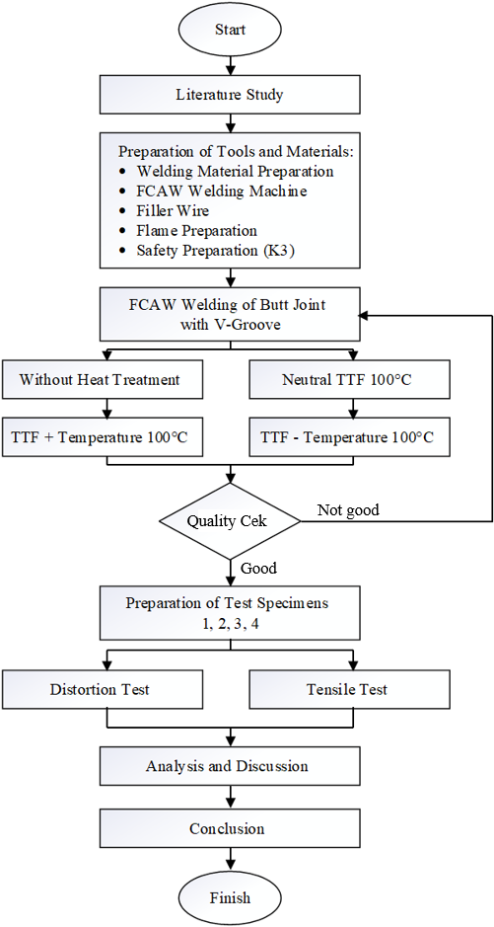
Figure 1. Research Flowchart.

Data Analysis Method
Data were analyzed using quantitative descriptive analysis. Tensile test and distortion measurement results were tabulated and compared across treatment variations. The results were then interpreted in narrative form and visualized through tables and diagrams to provide a clear and comprehensive explanation of the effects of flame position on the mechanical and physical properties of the welded Aluminum 5083 specimens.

Results and Discussion
After performing tensile and distortion tests, the experimental data were collected and analyzed. Each tensile test was conducted three times for every variation, while the distortion test was carried out once for each variation. The results are presented in the following subsections.

Tensile Test Results
The tensile test results for specimens welded with and without thermal treatment are summarized in Table 1. The variations include welding without preheating, welding with transient thermal flame (TTF+) at 100 °C, welding with transient thermal flame (TTF−) at 100 °C, and welding with neutral TTF at 100 °C.

TABLE 1. Tensile Test Results of Aluminum 5083 Welded Specimens.
Condition | Sample | Ultimate Strength (MPa) | Yield Strength (MPa)
Without Preheating | A | 166.65 | 3.51
 | B | 38.76 | 1.44
 | C | 140.00 | 59.93
Average |  | 115.14 | 21.63
TTF+ (100 °C) | A | 132.08 | 44.83
 | B | 87.56 | 32.85
 | C | 91.76 | 9.12
Average |  | 103.80 | 28.93
TTF− (100 °C) | A | 135.54 | 3.20
 | B | 68.24 | 10.44
 | C | 88.15 | 10.63
Average |  | 97.31 | 8.09
TTF Neutral (100 °C) | A | 589.88 | 56.13
 | B | 151.47 | 7.40
 | C | 651.66 | 10.26
Average |  | 464.34 | 24.60

500
400
300
200
100
0
464.34
115.14
103.8
97.31
TP TTF ( +) TTF TTF ( - )
Flame position (mm)
Figure 2. Effect of Flame Position on Ultimate Tensile Strength.

35
30
25
20
15
10
5
0
28.93
24.6
21.63
8.09
TP TTF (+) TTF TTF ( - )
Flame position (mm)
Figure 3. Effect of Flame Position on Yield Strength.
The comparison of the average ultimate tensile strength (UTS) values is illustrated in Fig. 2. As seen in the figure, the highest UTS was obtained from the specimen welded with neutral TTF at 100 °C, reaching 464.34 MPa. In contrast, specimens with TTF+ and TTF− recorded lower values of 103.80 MPa and 97.31 MPa, respectively, while the specimen welded without preheating reached 115.14 MPa.
The comparison of the average yield strength (YS) values is presented in Fig. 3. The specimen welded with TTF+ at 100 °C produced the highest YS of 28.93 MPa, followed by neutral TTF at 24.60 MPa, welding without preheating at 21.63 MPa, and TTF− at 8.09 MPa.
These results indicate that the flame position during preheating has a significant impact on both UTS and YS. While the neutral TTF condition considerably improved UTS, the TTF+ condition was more favorable in enhancing YS.

Distortion Test Results
The temperature distribution during the welding process was monitored using thermocouples (TC0, TC1, TC2, and TC3) that were positioned at different locations on the plate. The thermal histories obtained from these measurements for each welding variation are presented in Figures 4–7. For the specimen welded without preheating, the highest temperature recorded at TC0 reached 135 °C, as shown in Figure 4. In comparison, when welding with TTF+ at 100 °C, the maximum temperature at TC0 increased to 175 °C (Figure 5). For the TTF− condition at 100 °C, the peak temperature at TC0 was slightly lower, reaching 170 °C (Figure 6). Meanwhile, the neutral TTF treatment at 100 °C resulted in a maximum temperature of 166 °C at TC0 (Figure 7). These variations clearly indicate that the application of thermal treatment alters the heat distribution across the welded plate, which subsequently affects the mechanical and physical responses of the joints.

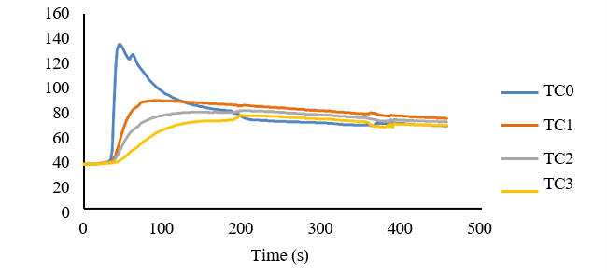
Figure 4. Temperature profile of Al 5083 during welding without preheating at 36 °C.

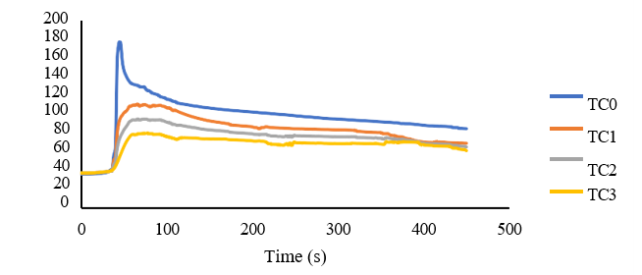
Figure 5. Temperature profile of Al 5083 during welding with TTF+ at 100 °C.

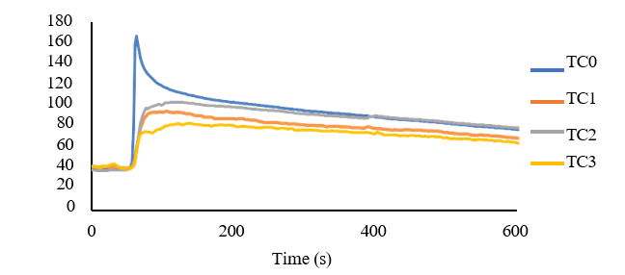
Figure 6. Temperature profile of Al 5083 during welding with TTF at 100 °C.

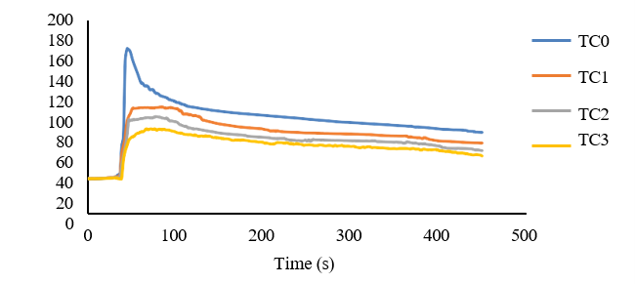
Figure 7. Temperature profile of Al 5083 during welding with TTF− at 100 °C.

The influence of the preheating method on distortion is illustrated in Figures 8–11. Welding without preheating produced the greatest distortion, reaching 11.53 mm as shown in Figure 8. In contrast, the application of TTF+ at 100 °C resulted in the smallest distortion, with a value of 1.70 mm (Figure 9). Welding with TTF− at 100 °C exhibited a slightly higher distortion of 2.40 mm (Figure 10), while the neutral TTF treatment at 100 °C recorded a distortion of 2.54 mm (Figure 11). These results demonstrate that the use of transient thermal flame preheating significantly reduces welding distortion, with the TTF+ method providing the most effective reduction among the tested variations.

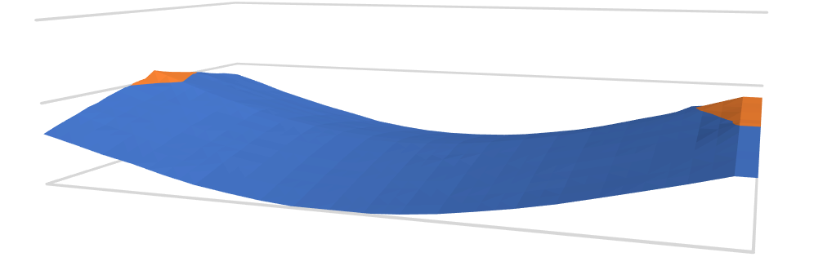
Max : 11.53 mm Min : 0 mm
20

10

0
200
100
0
10-20
0-10
Length (mm)
Figure 8. Distortion profile of Al 5083 welded without preheating at 36 °C.

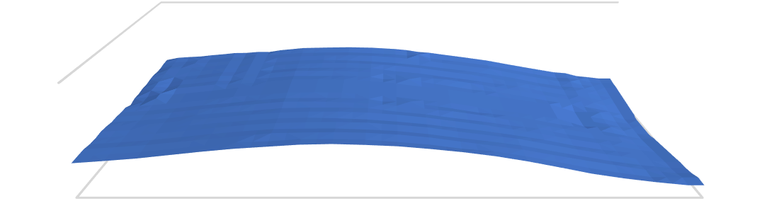
5
0
210
140
70
0
5-5
0-5
Length (mm)
Max : 2.40 mm Min : 0 mm
Figure 9. Distortion profile of Al 5083 welded with TTF+ at 100 °C.

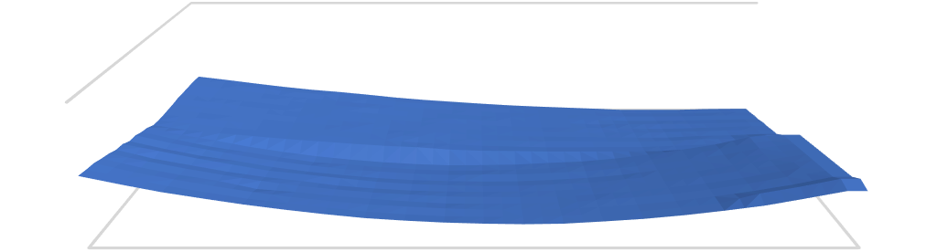
5
0
210
140
70
0
5-5
0-5
Length (mm)
Max : 2.54 mm Min : 0 mm
Figure 10. Distortion profile of Al 5083 welded with TTF at 100 °C.


Max : 1.70 mm Min : 0 mm
5
210
0
140
70
0
5-5
0-5
Length (mm)
Figure 11. Distortion profile of Al 5083 welded with TTF− at 100 °C.

Discussion
The results demonstrate that thermal treatment significantly affects the mechanical performance and distortion behavior of aluminum 5083 welded joints. Heat treatment is known to increase the yield strength of aluminum alloys by up to 18.5% through work hardening, while also reducing ductility due to microstructural changes [22]. In this study, the tensile test revealed that the highest UTS was achieved in the neutral TTF condition (464.34 MPa), while the highest YS was obtained in the TTF+ condition (28.93 MPa). This indicates that the optimal balance between strength and ductility depends on the flame position during preheating.
Furthermore, distortion measurements showed that specimens without preheating suffered severe distortion (11.53 mm), whereas preheated specimens exhibited much lower values, ranging from 1.70 mm to 2.54 mm. The lowest distortion was achieved in the TTF+ condition, supporting previous studies that thermal tensioning methods are effective in reducing welding-induced deformation and residual stress [23–25].
Overall, it can be concluded that the application of transient thermal flame as a preheating technique enhances the tensile properties and significantly minimizes distortion in aluminum 5083 welded joints. Among the variations, neutral TTF was the most effective for improving UTS, while TTF+ was the best in reducing distortion. These results provide valuable insights for optimizing welding procedures of aluminum alloys in industrial applications.

CONCLUSION
The findings of this study demonstrate that preheating at 100 °C combined with Transient Thermal Flame (TTF) treatment significantly reduces welding distortion and enhances tensile strength compared to the condition without preheating. The highest ultimate tensile strength (UTS) was achieved in the specimen with neutral TTF, reaching 464.34 MPa, while the lowest distortion was observed in the TTF− specimen, measuring 1.70 mm. These results indicate that the application of TTF can serve as an effective method to improve the quality of Al 5083 welded joints by minimizing residual stresses and distortion. Furthermore, TTF treatment was also shown to strengthen the material structure, where both mechanical properties and fatigue life were improved after its application. This improvement contributes to better identification of potential failures and weaknesses in welded joints, particularly for critical applications.

References
- M.H.M. Hashim, A.M.T. Arifin, S.A. Osman, T.S. Kiat, and A.F.M. Salihin, Study on MIG and TIG weldment behaviour using finite element approach, J. Adv. Res. Appl. Sci. Eng. Technol. 46(2), 81–89 (2025).
- A. Świerczyńska, B. Varbai, C. Pandey, and D. Fydrych, Exploring the trends in flux-cored arc welding: scientometric analysis approach, Int. J. Adv. Manuf. Technol. 130(1–2), 87–110 (2024).
- U. Gürol, Heat input effect of the FCAW process on the microstructure and mechanical properties of structural steel joints, Uludağ Univ. J. Fac. Eng. 27(3), 1207–1220 (2022).
- M. Jufri, The effects of transient temperature around welds on mechanical properties of A36 steel plate, J. Energy Mech. Mater. Manuf. Eng. 1(1), 36–46 (2017).
- F. Akyel, S. Olschok, and U. Reisgen, Dissimilar material combination in laser beam welding: reduction of distortion and residual stress, in High-Power Laser Materials Processing: Applications, Diagnostics, and Systems IX, edited by S. Kaierle and S.W. Heinemann (SPIE, 2020), p. 11.
- E. Caballero, H. Ruíz, and J. Blandón, Analysis of the influence of welding conditions on the angular deformation and residual stresses in thick plate using FEM, in 2024 9th International Engineering, Sciences and Technology Conference (IESTEC) (IEEE, 2024), pp. 198–203.
- N. Subeki, Jamasri, M.N. Ilman, and P.T. Iswanto, The effect of heating temperature in static thermal tensioning (STT) welding on mechanical properties and fatigue crack propagation rate of FCAW in steel A36, AIP Conf. Proc. 1788, (2017).
- M.N. Ilman, Kusmono, M.R. Muslih, N. Subeki, and H. Wibowo, Mitigating distortion and residual stress by static thermal tensioning to improve fatigue crack growth performance of MIG AA5083 welds, Mater. Des. 99, 273–283 (2016).
- R. Sanders and G. Marshall, Aluminum applications in marine transportation, AM&P Tech. Artic. 181(4), 23–27 (2023).
- T. Ralebakeng, M.P. Mubiayi, and N. Ndou, Investigating the effect of process parameters on corrosion resistance and associated properties for friction stir welded AA5083, Weld. Int. 38(4), 298–318 (2024).
- D. Istrate, et al., Correlation between mechanical properties—structural characteristics and cavitation resistance of rolled aluminum alloy type 5083, Metals 13(6), (2023).
- S. Doshia, V. Ketan, and N.D. Mehta, Progress in the welding of Al alloy thin sheet and future prospectus for automobile, J. Eng. Technol. Ind. Appl. 10(46), 42–49 (2024).
- H. Wibowo, F. Surahmanto, and M.N. Ilman, Identifying the influence of transient thermal tensioning treatments on minimizing distortion and improving fatigue behavior of steel welded, East.-Eur. J. Enterp. Technol. 4(12), 37–46 (2023).
- S. Pałubicki and W. Czapiewski, The effect of a heat input to the joint during the gas metal arc welding of ferritic-austenitic steel 1.4462 on welding deformations, Mater. Sci. Weld. Technol. 68(1), 1–12 (2024).
- R.P. Verma, K.N. Pandey, K. András, R. Khargotra, and T. Singh, Difficulties and redressal in joining of aluminium alloys by GMA and GTA welding: a review, J. Mater. Res. Technol. 23, 2576–2586 (2023).
- I. Hossain, A. Bhowmik, A. Pattanaik, R. Kumar, A.K. Singh, and S. Pandey, Computational investigation of plasma arc welding process for aluminium alloys, Eng. Res. Express 6(2), (2024).
- Sabdin, Hussein, and Sued, A review on thin plates joining method using arc welding as the heat sources, J. Ind. Eng. Innov. 1(2), 1–6 (2019).
- Z. Li, G. Feng, D. Deng, and Y. Luo, Investigating welding distortion of thin-plate stiffened panel steel structures by means of thermal elastic plastic finite element method, J. Mater. Eng. Perform. 30(5), 3677–3690 (2021).
- N. Subeki, Jamasri, M.N. Ilman, and P.T. Iswanto, The influence of preheat on distortion and fatigue crack propagation rate of FCAW weld in A36 steel structure, Appl. Mech. Mater. 842, 83–91 (2016).
- J. Tan, Z. Gao, S. Ren, Q. Xu, K. Wang, and Q. Zeng, Improving the microstructures and mechanical properties of U71Mn rail steel liner friction welded joint by normalizing treatment, Mater. Today Commun. 38, 107736 (2024).
- N. Guo, H. Hu, X. Tang, X. Ma, and X. Wang, The effect of TIG welding heat input on the deformation of a thin bending plate and its weld zone, Coatings 13(12), 2008 (2023).
- L. Yi, G. Yu, Z. Tang, X. Li, and Z. Gu, Investigation of the hot stamping-in-die quenching composite forming process of 5083 aluminum alloy skin, Mater. 16(7), (2023).
- Gumelang, D. Kurniawati, and H. Supriyanto, Effect of cooling media variation on tensile strength of SMAW welding of St41 steel, Turbine 1(1), 1–6 (2023).
- M.N. Ilman, Kusmono, M.R. Muslih, N. Subeki, and H. Wibowo, Mitigating distortion and residual stress by static thermal tensioning to improve fatigue crack growth performance of MIG AA5083 welds, Mater. Des. 99, 273–283 (2016).
- S.H. Susilo, E. Yudiyanto, A. Setiawan, K. Khambali, S. Suryanto, and F. Alauddin, Effect of static thermal tensioning and preheating on angular distortion in FCAW welded SS400 steel corner joints, LOGIC: J. Rancang Bangun Teknol. 24(2), 39–48 (2024).

