Predictive Maintenance and Intelligent Mobility: Estimating the Residual Lifespan of Rolling Components
Sabah Louragli^{1, a)}, Bouchra Abouelanouar^{1, b)} and Abdeslam Lachhab^{1, c)}
¹Modeling, Materials and Systems Control Team. Higher school of technology, University of Moulay Ismail. Meknes, Morocco,
^{a)} s.lourgli@edu.umi.ac
^{b)} b.abouelanouar@umi.ac.ma
^{c)} a.lachhab@umi.ac.ma
Abstract. Intelligent Mobility is reshaping transportation systems by harnessing advanced data analytics to enhance performance, durability, and reliability. High-resolution data collected from critical rolling components including axles, wheels, and bearings plays a pivotal role in this transformation. Such data enables a comprehensive characterization of wear mechanisms, the identification of influencing factors, and the early detection of potential failure modes. The integration of Big Data frameworks with artificial intelligence algorithms further optimizes transport flow management, thereby improving infrastructure safety and maximizing operational availability. These technological advancements provide robust solutions to contemporary challenges in sustainability, efficiency, and proactive asset management. In this study, we present a predictive maintenance framework centered on the formulation of a quantitative wear law to estimate the residual lifespan of critical rolling components.

Introduction
The latest significant advance in rail mobility services lies in the integration of Industry 4.0 tools and methodologies into maintenance strategies. This includes advanced analytics and the exploitation of Big Data to ensure high availability with minimal downtime, while complying with AFNOR quality standards. These developments require the deployment of maintenance strategies that are both effective and resource-efficient, aimed at achieving these objectives without unnecessary time and cost expenditures. The rail sector, which relies on systematic and regular maintenance programs, faces a major challenge: the optimization of operations in railway technical centers (TMF) is still often insufficient. Rail transport remains a vital pillar of the transportation industry; however, wheel wear represents a critical threat to vehicle safety and performance. This wear progressively alters the wheel profile, compromising both train stability and operational safety. The wheel–rail system, in particular, is highly sensitive to this phenomenon and requires an in-depth analysis of the contact mechanics between these two components. Such contact modifies both the shape and position of the contact patches, which becomes especially problematic in small-radius curves. Although Hertzian theory is commonly used to model this contact, it does not always apply in conformal contact situations. Alternative approaches, such as the Kalker method and finite element modeling, have been developed to better represent non-Hertzian wheel–rail contact phenomena. However, these methods remain computationally intensive and are often less suited for large-scale simulations.

Railway Wheels: A Key Element in Operational Safety
Railway wheels are not merely mechanical components; they are classified as safety-critical parts under international standards such as EN13262. Their role extends beyond load transmission and guidance, contributing directly to the safe and reliable operation of the railway system. Any wheel defect whether caused by rolling contact fatigue, material degradation, or excessive wear can lead to derailments or significant service disruptions. Accordingly, the European standard EN15313 sets strict inspection and maintenance requirements for wheels in service, specifying threshold values for Flange Width (Fw), Flange Height (Fh), and Flange Gradient (qR), as illustrated in “Fig.1”. Modern railway operations increasingly adopt predictive maintenance strategies to ensure wheel integrity, particularly in high-speed and heavy-freight applications where wheel–rail dynamic interactions are especially demanding. The use of advanced materials combined with real-time monitoring technologies contributes to extending wheel service life while ensuring compliance with safety standards established by both regulatory authorities and manufacturers.
Wheel–Rail Contact: Predictive Modeling and Wear Management

The frictional interaction between the wheel and rail is a complex tribological phenomenon that plays a pivotal role in the performance, safety, and durability of railway systems; although the contact patch is relatively small, it sustains extremely high loads and dynamic stresses, directly influencing adhesion, rolling contact fatigue, and surface wear, with a significant consequence being the progressive wear of train wheels due to rail materials being intentionally manufactured harder than wheel materials a deliberate engineering choice since replacing or repairing a rail segment entails extended downtime, considerable logistical effort, and operational stoppages, whereas wheels can be more easily and quickly reprofiled or replaced within regular maintenance cycles; thus, designing rails to resist wear, even at the expense of faster wheel degradation, is a practical compromise that reduces service disruptions and infrastructure costs; as illustrated in “Fig.2”, finite element simulations enable engineers to examine stress concentrations across the wheel surface and predict regions prone to wear or fatigue, while recent research such as that by the U.S. Federal Railroad Administration using the Extended CONTACT software has advanced modelling of elastic-plastic shear, heat generation, and interfacial dynamics under operational conditions; furthermore, thermo-mechanical tests during emergency braking have recorded contact temperatures exceeding 1000°C, causing microstructural changes, crack initiation, and spalling on both wheel and rail surfaces; consequently, friction management strategies, including Top-of-Rail (TOR) products that optimize the coefficient of friction, have become essential, and intelligent control techniques, such as fuzzy logic algorithms enhanced by particle swarm optimization, are now deployed to monitor and improve adhesion in real time, thereby increasing traction and braking efficiency.

Wheel-Rail Wear

Railway wheel wear refers to the progressive degradation of a wheel’s geometry over time, primarily resulting from repeated contact with the rail, applied loads, and operating conditions, and is characterized by three key geometric parameters flange width, flange height, and flange gradient which serve to detect material loss or profile changes that could compromise safety and ride comfort; to ensure accurate monitoring, measurement instruments are generally classified into two categories, the first comprising mechanical tools such as flange measuring gauges and internal face-spacing gauges for direct manual readings, and the second including digital and optical systems such as the Calipri C42, which enable non-contact, rapid, and highly precise assessments, increasingly adopted for their ability to automate inspections and minimize human error; data gathered from these instruments are used to schedule maintenance, prevent critical failures, and estimate the remaining service life of wheels, and when integrated with predictive approaches, this information becomes a powerful asset for optimizing wheel management strategies.

Limitations of Mechanical Measurement Instruments for Wheel Inspection

Despite their widespread use in railway maintenance, mechanical measurement instruments for wheel inspection present significant limitations in precision, reliability, and operational efficiency, with one of the main concerns being their sensitivity to operator positioning manual flange gauges and internal face-spacing calipers require exact alignment with the measurement surface, and any deviation in angle or contact point can cause substantial errors; moreover, manual readings from analog scales are subject to interpretation biases, particularly under varying lighting or environmental conditions, and their operation generally requires at least two operators one to hold and align the instrument and another to record the readings introducing a communication layer that can compromise data accuracy through miscommunication, transcription errors, or delays between measurement and recording; these challenges highlight the need for improved measurement protocols or a shift toward automated digital systems that reduce human intervention and ensure repeatability, and in current practice, monitoring the geometric degradation of railway wheels over time often involves the use of a mechanical device for wheel profile measurement (see “Fig.3”) to accurately assess parameters such as flange width, flange height, and flange gradient..

Modernizing Wear Monitoring

The limitations of mechanical measurement tools such as their sensitivity to precise positioning, susceptibility to reading errors, and requirement for coordination between two operators significantly reduce the reliability and consistency of the data they produce, making it difficult to standardize measurements and compromising the quality of the collected information; in response, digital measurement instruments are increasingly adopted as a more effective and reliable alternative, offering fast, accurate, and repeatable measurements while minimizing human error, and their capability to automatically record data supports the creation of structured, scalable databases that, when analyzed through statistical or predictive methods, yield valuable insights into the future wear of railway wheels; the transition from manual to digital tools thus marks a critical step toward predictive maintenance, enabling operators to anticipate interventions, optimize maintenance planning, and improve operational safety.

Methodologies
This paper presents an in-depth investigation of railway axle maintenance practices, comparing the traditional approach, which relies on conventional measuring instruments, with an innovative method integrating intelligent technologies based on digital monitoring equipment; the study focuses on a sample of 400×8 rail wheels, analyzing data from performances achieved between 2022 and 2023 using the traditional method (SNCF and JEFI tools) and from results obtained in 2023 through the integration of digital measurement technology (“TABLE 1”). The database was thoroughly examined, reviewed, and analyzed, with selection criteria including data from various measuring devices, exploration of historical records, and the automatic remote transfer of information between maintenance centers; the findings underscore the critical importance of maintaining a structured and centralized database of measurements, as this information constitutes a key resource for modeling and predicting the service life of railway equipment, thereby improving the precision and effectiveness of predictive maintenance strategies; notably, the application of condition-based and predictive maintenance techniques has shown a marked reduction in maintenance costs while optimizing rolling stock availability, and the integration of IoT sensors and artificial intelligence models into axle monitoring enables real-time supervision and significantly enhances early anomaly detection.

TABLE 1. Average wear of the three factors (flange width, flange height, flange gradient) from 2022 to 2023.
 | Flange width Fw (mm) | Flange height Fh (mm) | Flange gradient Qr (mm)
2022 | 0.56 | 0.53 |  | 0.46
2023 | 0.50 | 0.52 | 0.50

The establishment of a structured database is of vital importance for the in-depth analysis of rail wheel wear, as it ensures optimal centralization of data collected over extended periods, providing a comprehensive overview of wear trends and enabling the tracking of key parameters such as flange width (Fw), flange height (Fh), and flange gradient (qR); moreover, within the framework of predictive maintenance, the assumption that wheel wear follows a normal distribution implies that the factors influencing this wear are sufficiently stable and predictable.

ANNUAL MONITORING OF FW, FH AND QR FULL FLEET OVERVIEW
The three graphs below illustrate the evolution of wheel wear throughout 2022 across these parameters, offering a detailed examination of wear behavior that serves as a basis for interpreting trends, identifying critical patterns, and evaluating opportunities to enhance predictive maintenance strategies.

.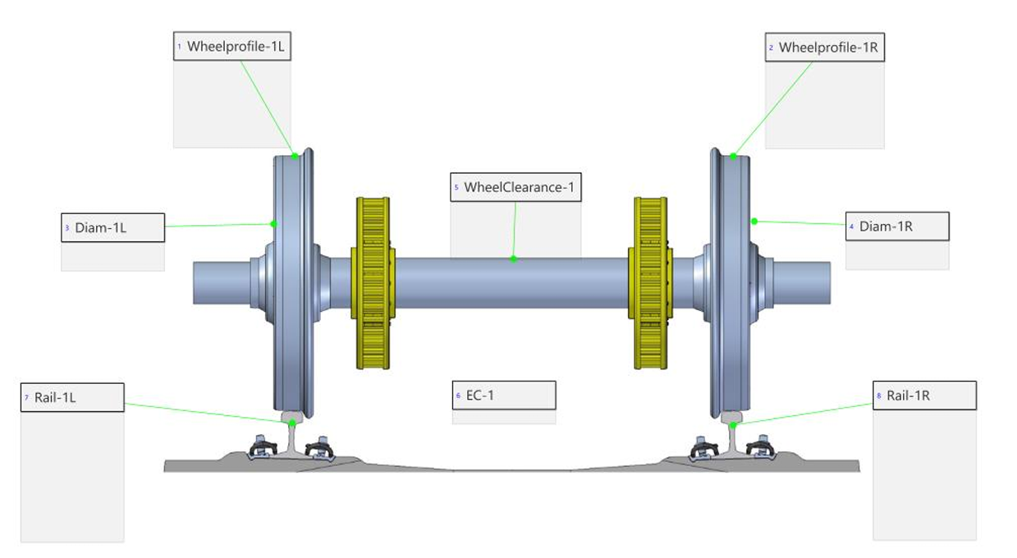

Figure 1. Key wheel profile parameters: flange width (Fw), flange height (Fh), and flange gradient (qR) for in-service wear assessment.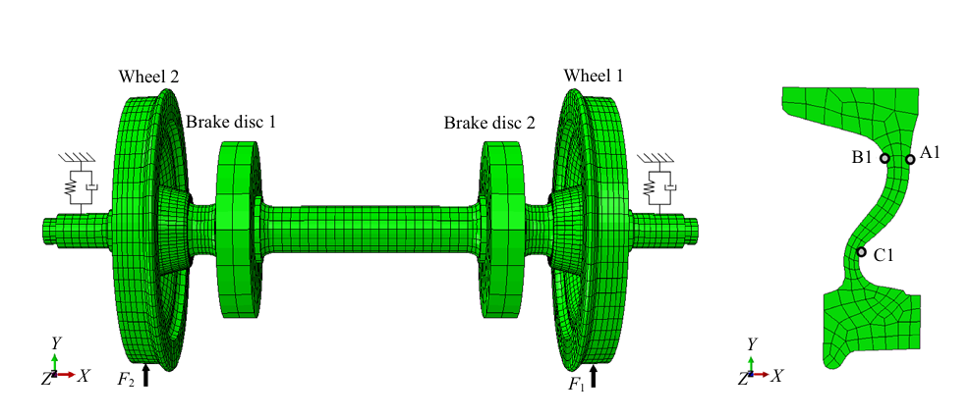
Figure 2. Finite element model of a railway wheelset and Mesh Zones for Stress analysis.

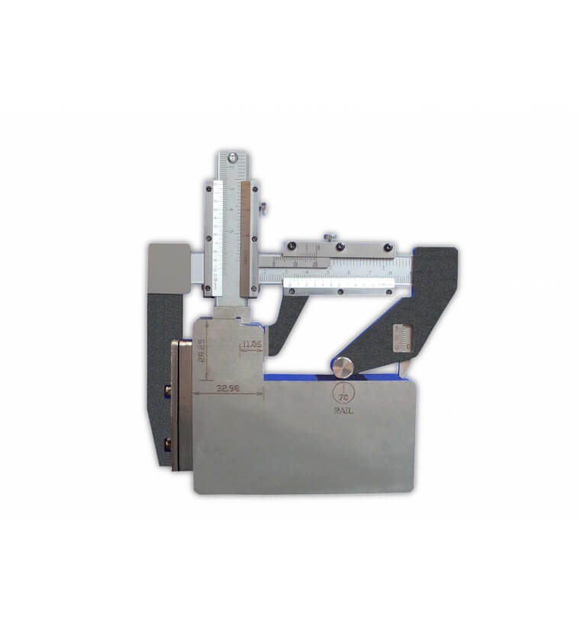
Figure 3. Mechanical device for wheel profile measurement.

FIGURE 4: Fw factor wear evolution in 2022 – 420 railway vehicles.

FIGURE 5: Fh factor wear evolution in 2022 – 420 railway vehicles.

FIGURE 6: qR factor wear evolution in 2022 – 420 railway vehicles.

Interpretation of Wheel Wear Trends and The Limitations of Manual Measurement Methods

The three graphs illustrate the evolution of wheel wear across a fleet of 420 railway vehicles during 2022, focusing on three key technical parameters: flange width (Fw), flange height (Fh), and flange gradient (qR) (see “Fig.4”, “Fig.5”, and “Fig.6” respectively). These measurements are essential indicators for monitoring the condition of wheelsets and implementing maintenance strategies. Initial analysis reveals significant variability in the measured wear values for each parameter. Fw wear (“Fig.4”) is mostly concentrated below 0.4 mm, although some values exceed 1.0 mm. Similarly, Fh wear (“Fig.5”) shows occasional outliers reaching up to 1.6 mm, while qR values (“Fig.6”) are more uniformly distributed but still exhibit a wide range of variation. This dispersion in the wear population is only partially attributable to real-world operational factors such as track curvature, braking intensity, and axle positioning. A substantial part of the variability is amplified by the inherent limitations of the mechanical measurement tools used. These manual instruments often lack precision and depend heavily on the skill of the technician performing the measurement. In addition, they suffer from poor reproducibility, lack digital traceability, and are unable to collect high-frequency or continuous data. Consequently, the observed inconsistency in results may reflect not only physical wear but also the imprecision and subjectivity of manual measurement techniques. This highlights a major limitation of the current system: reliance on human operators using analog tools prevents the effective implementation of a predictive maintenance strategy. Transitioning to digital measurement systems, such as onboard sensors or automated vision-based inspections, would enable the acquisition of high-resolution, continuous, and traceable data. Such data could then be processed by machine learning algorithms to predict wear progression and optimize maintenance scheduling.

CONCLUSION
The first essential step toward implementing predictive maintenance is the adoption of digital measurement tools. These technologies provide the foundation for automated, accurate, and repeatable data collection. Aligned with the principles of Industry 4.0, such tools enable the creation of reliable databases that are crucial for developing models to predict future wheel wear. Therefore, the shift to digital systems is not merely a technical upgrade in measurement practices; it represents a strategic move toward smarter, proactive, and more efficient maintenance. The encouraging results observed in this work validate the potential of digitalization as a transformative lever for the railway maintenance sector. In particular, the consistency and reliability of the collected data open promising avenues for the implementation of machine learning and artificial intelligence techniques in future research. Moving forward, efforts will be directed toward integrating operational variables such as axle position, track curvature, and environmental conditions to enhance model precision. These developments will pave the way for a fully predictive and optimized maintenance framework capable of minimizing downtime, reducing costs, and improving safety across the network. Future work will focus on specifying the data analysis and AI methodologies, including algorithm selection, input/output parameter definition, and validation strategies, to transition from a conceptual framework to an operational predictive maintenance model.

Acknowledgments
We would like to express our sincere gratitude to all those who supported this study. We are especially grateful to the company that provided us with the database used in this study.

References

- J. Smith et A. Jones, «Wheel wear in railway transport systems,» Journal of Railway Engineering, vol. 22(3), pp. : 45-60, 2019.
- M. White et P. Green, «. Impact of wheel wear on railway safety and performance,» Railway Safety Review, pp. 98-105, 2018.
- P. Taylor et J. Evans, «Railway wheel wear modeling and analysis,» Journal of Applied Mechanics, vol. 35, n° %12, pp. 76-85, 2019.
- Chen, X., Wang, C., Liu, Y., & Yang, L. (2021). Health monitoring and failure analysis of railway wheels based on vibration signals. Engineering Failure Analysis, 122, 105254.
- Ferreira, P., & Andrade, P. (2023). Lifecycle monitoring of railway wheels using predictive analytics and onboard sensors. Transportation Research Procedia, 68, 267–275.
- EN 13262:2020. Railway applications – Wheelsets and bogies – Wheels – Product requirements.
- EN 15313:2016. Railway applications – In-service wheelset operation requirements – Wheels and wheelsets.
- Bose, A., Qiao, X., & Chen, M. (2024). Real-time optimization of wheel–rail adhesion using fuzzy logic and swarm intelligence. arXiv preprint. https://arxiv.org/abs/2406.13650
- Federal Railroad Administration. (2023). Advanced Modeling of Wheel-Rail Friction Phenomena. U.S. Department of Transportation. https://railroads.dot.gov/elibrary/advanced-modeling-wheel-rail-friction-phenomena
- Liu, Y., Wang, W., Zhao, X., & Li, Z. (2023). Wheel–rail material compatibility and its effect on wear and fatigue: A review. Wear, 520–521, 205379. https://doi.org/10.1016/j.wear.2023.205379
- Marinov, M., Ren, G., & Yang, L. (2023). Influence of Top-of-Rail friction modifiers on wear and emission in rail transport. Machines, 13(3), 200. https://www.mdpi.com/2075-1702/13/3/200
- Zhao, Y., Wang, L., & He, J. (2024). Experimental study on thermal–mechanical behavior of wheel–rail contact under emergency braking. Journal of Engineering and Applied Science, 71(1), Article 540.
- Bracciali, A. (2021). Overview of railway wheel wear monitoring techniques. International Journal of Rail Transportation, 9(2), 75–89. https://doi.org/10.1080/23248378.2020.1819123
- Jeong, S., Lee, H., & Kim, J. (2022). Development of optical sensing systems for monitoring wheel-rail contact parameters. IEEE Transactions on Instrumentation and Measurement, 71, 1–9. https://doi.org/10.1109/TIM.2022.3146789
- Chen, L., Wang, Y., & Zhang, X. (2023). Artificial intelligence-based predictive maintenance for railway wheelsets using sensor fusion. Proceedings of the Institution of Mechanical Engineers, Part F: Journal of Rail and Rapid Transit, 237(2), 135–149.
- S. Alfi, S. Bruni et G. Diana, «A data-driven approach for predictive maintenance of railway wheelsets,» Proceedings of the Institution of Mechanical Engineers, Part F: Journal of Rail and Rapid Transit, vol. 235(4), n° %1377-390, pp. 377-390, 2021.
- W. Li, P. Wang, A. Núñez et R. Dollevoet, «Predictive maintenance decision-making for railway track systems using machine learning approach,» Transportation Research Part C: Emerging Technologies, vol. 113, pp. 1-18, 2020.
- Y. Cao, S. Yang et Z. Wang, «Intelligent fault diagnosis of railway wheelsets using deep learning and IoT-based monitoring systems.,» IEEE Transactions on Intelligent Transportation Systems, vol. 24(5), pp. 4896-4908, 2023.

