Optimization of Energy Harvesting in a Nonlinear Oscillator with Time Delayed Piezoelectric Coupling
Zakaria Ghouli
Royal Naval School, Casablanca, Morocco
Polydisciplinary Faculty of Taroudant, University Ibn Zohr, Taroudant, Morocco
ghoulizakaria@gmail.com

Abstract:
This work explores quasi-periodic (QP) vibrations for efficient energy harvesting (EH) in a nonlinear oscillator with delayed piezoelectric coupling. We analyze a harmonically excited van der Pol oscillator, a classical nonlinear dynamics model, coupled to a piezoelectric transducer with time-delayed feedback. The focus is on primary resonance, where excitation frequency aligns with the natural frequency, maximizing energy extraction.
Using the multiple scales method, we derive approximate analytical expressions for the QP response and power output. The impact of time delay on harvested power is examined, revealing that tuning delay parameters enhances EH efficiency. Unlike conventional resonance-based EH, limited to a narrow frequency range, QP motion enables broadband energy extraction, extending operational range.
Our findings suggest that introducing time delay in piezoelectric coupling optimizes EH from ambient vibrations, beneficial for applications like structural health monitoring, low-power wireless sensor networks, and self-powered devices in fluctuating environments. This study provides insights into nonlinear dynamics, time delay, and EH, aiding the design of adaptive and efficient vibration-based EH systems.
Keywords— vibration, quasi-periodic, energy harvesting, time delay, piezoelectric.
1. Introduction
Vibration-based energy harvesting (EH) from nonlinear systems has received growing attention as a viable solution for powering small-scale devices in environments characterized by ambient and low-frequency vibrations. Among the recent advancements in this domain, the incorporation of time-delay effects into nonlinear harvesters has proven to be a powerful strategy for enhancing energy conversion efficiency, especially under quasi-periodic (QP) and broadband excitation regimes.
Time delay, acting as a control parameter, can be introduced in either the mechanical or electrical domains of the harvester system. When embedded in the mechanical subsystem, delay-modulated feedback can alter the oscillator's dynamic behavior and extend the frequency bandwidth over which energy can be harvested efficiently [1,2]. In these cases, QP and large-amplitude oscillations are frequently observed, leading to improved performance compared to traditional narrowband harvesters.
In the electrical domain, delay can be introduced via feedback circuits or memory elements, significantly affecting the electromechanical coupling and charge dynamics. Works by Ghouli et al. [3,4,6] have demonstrated that electrical time-delay feedback not only enriches the system's dynamic response but also enhances energy output within specific parameter ranges. These results align with the observations of Zhou et al. [10] and Daqaq et al. [11], who showed that appropriate time-delay strategies in piezoelectric systems can lead to substantial performance gains in EH systems.
Zakaria Ghouli and his collaborators have extensively investigated the role of time delay in nonlinear energy harvesting systems. His contributions include a variety of configurations, such as delayed Duffing, van der Pol, and flow-induced oscillators, both analytically and numerically [1–7]. The studies demonstrated that time delay can induce QP regimes, optimize energy extraction, and provide adaptive response over wide excitation frequency ranges.
In parallel, Grzegorz Litak and collaborators have contributed significantly to the understanding of nonlinear, stochastic, and multistable energy harvesting systems. Their investigations revealed how mechanisms such as noise-induced switching, coherence resonance, and bifurcation-induced transitions can be harnessed to enhance energy capture [14–17]. In collaboration with Ghouli, Litak recently analyzed the effect of high-frequency excitation on bistable harvesters, uncovering complex dynamic responses that can be utilized for broadband harvesting [8].
Building on these foundations, the present study investigates the dynamics and the ability of a nonlinear Van der Pol-based oscillator, connected to a delayed piezoelectric circuit, to harvest energ and subjected to harmonic excitation. This configuration captures essential features of electromechanical energy harvesters with memory effects. Through a combination of bifurcation analysis, frequency-response diagrams, and time-domain simulations, we aim to characterize the system’s nonlinear dynamics and assess its efficiency in broadband energy harvesting.
The remainder of the manuscript is structured as follows. In Section 2, we develop the mathematical model of a nonlinear energy harvesting system based on a Van der Pol oscillator, including time-delayed piezoelectric feedback. Section 3 outlines the numerical methodology used to solve the coupled differential equations and presents the dynamic analysis approach. In Section 4, numerical results are discussed in detail, highlighting the influence of time delay on system behavior and energy harvesting performance. Finally, Section 5 concludes the study and suggests directions for future work.
2. Formulation of the Energy Harvester Model
In this paper, a nonlinear energy harvesting device is analyzed, combining a mechanical oscillator of the Van der Pol type with a time-delayed piezoelectric circuit (Figure 1). The system dynamics are captured by the following dimensionless model:
$$\ddot{x}\left(t\right)+x\left(t\right)-\left[α-β{x\left(t\right)}^{2}\right]\dot{x}\left(t\right)-χv\left(t\right)=f\cos\left(ωt\right)$$ | (1)
$$\dot{v}\left(t\right)+μv\left(t\right)+κ\dot{x}\left(t\right)=λv(t-τ)$$ | (2)
Here, x(t) denotes the dimensionless displacement of the mechanical oscillator, and v(t) is the dimensionless voltage across the piezoelectric transducer. The term f cos(ωt) represents an external harmonic excitation with amplitude f and frequency ω. The parameters α and β control the linear and nonlinear damping characteristics of the mechanical oscillator, respectively, while χ characterizes the strength of the electromechanical coupling between the mechanical and electrical subsystems.
Equation (2) governs the dynamics of the piezoelectric circuit. The parameter μ represents the electrical resistance or dissipation in the circuit, and κ accounts for the mechanical-to-electrical energy conversion through the piezoelectric effect. The term λ v(t−τ) introduces a time-delayed feedback, which models memory effects in the charge transport dynamics, where λ is the delay gain and τ is the delay time.
The choice of a Van der Pol-type nonlinearity is motivated by its ability to produce self-sustained and complex oscillatory regimes under external excitation. Coupling such nonlinear dynamics to a time-delayed piezoelectric circuit can lead to rich dynamical phenomena, including quasi-periodic oscillations, multistability, bifurcations, and even chaotic responses. These regimes are of particular interest in the context of energy harvesting, as they can be exploited to improve the system's ability to operate efficiently over a broad frequency range, beyond classical linear resonance.
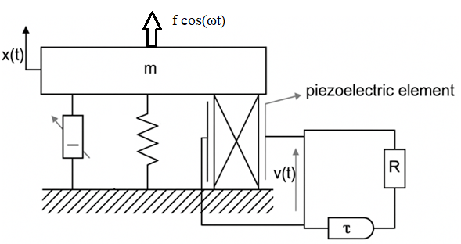
Figure 1: Illustrative diagram of the energy harvesting device

The model (1)-(2) is fully nondimensionalized, allowing for generality in analysis and simulation. The parameters can be tuned to explore various dynamical regimes and optimize the energy harvesting performance. Previous studies by Ghouli et al. [1–7], as well as by Litak and collaborators [8–10], have demonstrated that introducing time delay—especially within the electrical part of the system—can significantly enhance the output power and broaden the effective bandwidth of vibration energy harvesters.
In the following sections, we analyze the system’s response using numerical simulations and bifurcation analysis to determine the influence of the time-delay parameters λ and τ on the dynamical behavior and energy harvesting efficiency.

3. Numerical Methodology and Dynamic Analysis
To investigate the complex dynamics of the Van der Pol-type energy harvester with time-delayed electrical feedback, we implement a robust numerical approach suited for delay differential equations (DDEs). The presence of the delayed term v(t−τ) in the electrical equation transforms the system into a functional differential equation, requiring specific integration schemes that account for the system's memory. The numerical resolution is carried out using a modified Runge-Kutta method adapted for DDEs, with a constant time step and an appropriate interpolation technique to evaluate delayed states. The initial history function for the delayed variable v(t), for t<0, is chosen as a smooth constant or a low-amplitude sinusoidal function to ensure well-posed initialization and avoid numerical artifacts during the transient phase.
The simulations are performed over a sufficiently long time interval to allow the system to reach its asymptotic regime, thus ensuring accurate capture of quasi-periodic and potentially chaotic behaviors. The step size is chosen small enough to preserve numerical accuracy and stability, particularly given the nonlinear and delayed nature of the governing equations. For each set of system parameters, especially the time delay τ, the feedback gain λ, and the excitation frequency ω, the temporal evolution of the system is recorded and analyzed.
The primary quantities of interest in our analysis include the displacement x(t), the voltage response v(t), and the instantaneous power output defined by the product $κ\dot{x}\left(t\right)v(t)$. To assess the system's energy harvesting performance, we compute the time-averaged power over a post-transient interval, excluding initial transients, according to the expression:
$$〈P〉=\frac{1}{T_{1}-T_{0}}\int_{T_{0}}^{T_{1}}{κ \dot{x}\left(t\right) v(t)}dt$$ | (3)
This measure serves as a benchmark for evaluating the influence of time delay on energy harvesting efficiency across a range of excitation frequencies.
To characterize the nature of the system’s response, we employ several complementary tools. Poincare maps are used to identify periodic and quasi-periodic attractors by sampling the state variables at discrete intervals synchronized with the forcing period. Fourier analysis of the steady-state signals provides insight into the spectral composition of the response, distinguishing between regular, quasi-periodic, and chaotic behaviors. Furthermore, Lyapunov exponents are estimated to quantify the degree of sensitivity to initial conditions, enabling the identification of chaotic regimes induced by the delay. These diagnostic techniques collectively allow us to map the parameter space and uncover regions where the system exhibits enhanced broadband energy harvesting, especially due to the activation of large-amplitude quasi-periodic oscillations.
4. Results from Numerical Study and Their Discussion
The numerical results presented in this section are based on simulations of the Van der Pol-type energy harvester with time-delayed electrical feedback. We explore the effects of the time delay τ, the feedback gain λ, and the excitation frequency ω on the system’s dynamic behavior and energy harvesting performance. The following figure provide a detailed overview of the system’s response for different parameter configurations.
These results emphasize the importance of time-delay feedback in optimizing energy harvesting. The time delay broadens the resonance curve, enabling efficient energy capture across a wider frequency range. Moreover, the feedback gain λ must be carefully tuned to avoid chaotic behavior, which, while it may momentarily increase power, reduces overall efficiency due to the erratic nature of the response. The spectral analysis further supports the idea that time-delayed feedback induces quasi-periodic and chaotic behaviors, which are key to enhancing the performance of the harvester.
Figure 2 illustrates the impact of incorporating time delay into the electrical circuit on the energy harvesting (EH) performance of the system. For reference, the case where no time delay is present is depicted in black, while the response with time delay is shown in red for comparison. A noticeable enhancement in the quasi-periodic (QP) output power can be observed over a specific range of excitation frequencies, denoted by omega ω. This suggests that the introduction of time delay in the electrical domain plays a crucial role in modifying the system’s dynamic behavior. More specifically, the delayed electrical circuit appears to amplify the oscillation amplitude in the vicinity of the resonance frequency, leading to an overall improvement in harvested energy.

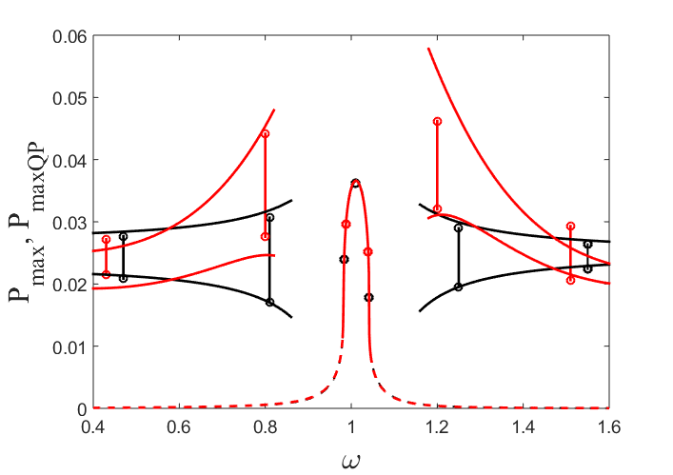
Fig. 2. Power amplitude as a function of excitation frequency ω. The red curves represent the system with time-delayed electrical feedback, while the black curves correspond to the system without delay.
These findings highlight the potential of time-delay engineering as an effective strategy for optimizing EH performance by broadening the operational frequency range and increasing energy extraction efficiency.
To ensure the stability of quasi-periodic (QP) vibrations during energy harvesting, it is crucial to construct the corresponding stability diagram. This involves analyzing the nontrivial solution of the system by examining the eigenvalues of the associated Jacobian matrix $j$. The boundaries that define the regions of existence and stability of QP oscillations are given by the conditions $Tr\left( j\right)<0$ and$Det\left( j\right)=0$. Figure 3a presents the stability map in the (f, ω) parameter plane for τ =6.2, where the grey areas indicate regions of stable quasi-periodic (SQP) solutions, and the white area corresponds to stable periodic (SP) solutions. Figure 3b shows the time histories and the corresponding output power responses at the points labeled 1, 2, and 3 in Fig.3a. As the system moves from point 1 to points 2 or 3, the response transitions from SP to SQP oscillations via a secondary Hopf bifurcation. This results in a mild amplitude modulation and a significant increase in the output power at point 3.
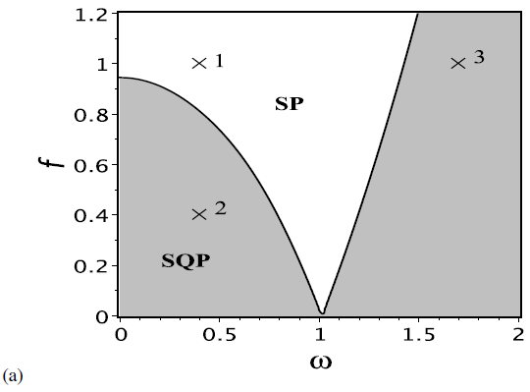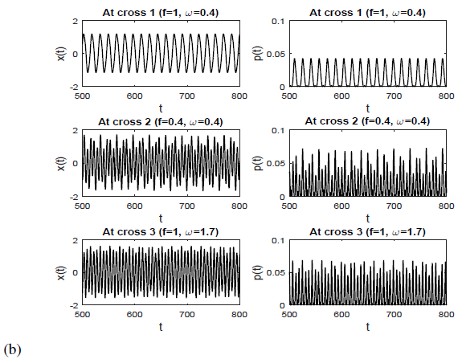
Fig. 3. (a) Stability chart in the plane (f, ω), (b) time and power histories corresponding to different
regions picked from (a). SP: stable periodic, SQP: stable QP.
5. Conclusion and Future Work
The present study has explored the complex dynamics and energy harvesting potential of a nonlinear Van der Pol-type oscillator coupled to a time-delayed electrical circuit via piezoelectric transduction. Through numerical simulations, we demonstrated that the introduction of electrical feedback with delay can induce rich dynamical behaviors, including quasi-periodic and chaotic oscillations. These regimes significantly broaden the effective frequency bandwidth of energy harvesting, enabling efficient power extraction even beyond the classical resonance zone.
Our results highlight the critical influence of two key control parameters: the time-delay τ\tauτ and the feedback gain λ. A judicious choice of these parameters allows the system to exploit nonlinear phenomena such as resonance overlapping and higher harmonic activation, which contribute to improved energy conversion efficiency. The ability to harness such behaviors makes time-delayed feedback a promising strategy for designing next-generation energy harvesting devices, especially in low-frequency, ambient vibration environments.
Future work will aim to extend the model by incorporating additional nonlinearities and more realistic piezoelectric coupling mechanisms. Another promising direction involves the study of alternative feedback architectures, such as parametric, dissipative, or adaptive feedback, to further enhance control and efficiency. Experimental validation is also foreseen to verify the theoretical predictions and to assess the practicality of the proposed system in real-world applications like wireless sensor networks or self-powered monitoring platforms. Furthermore, the integration of machine learning and optimization algorithms could pave the way for real-time tuning of system parameters, maximizing harvested energy under variable excitation conditions.
In conclusion, this work underscores the strong potential of time-delay engineering in nonlinear energy harvesting systems. By effectively leveraging complex dynamics, such as quasi-periodicity and chaos, these systems offer a versatile and robust platform for energy harvesting across broad frequency spectra. With further development and validation, they may contribute to the emergence of efficient, autonomous, and adaptive energy harvesting technologies.
References
- Z. Ghouli, M. Hamdi, F. Lakrad, and M. Belhaq, J. Sound Vib. 407, 271–285 (2017).
- Z. Ghouli, “On the Performance of a Flow Energy Harvester Using Time Delay,” in Virtual International Conference on Soft Computing, Optimization Theory and Applications, Springer (2021), pp. 271–281.
- Z. Ghouli, M. Hamdi, and M. Belhaq, Nonlinear Dyn. 89, 1625–1636 (2017).
- M. Belhaq, Z. Ghouli, and M. Hamdi, Nonlinear Dyn. 94, 2537–2546 (2018).
- Z. Ghouli and M. Belhaq, Eur. Phys. J. Spec. Top. 230, 3591–3598 (2021).
- Z. Ghouli and M. Belhaq, “Energy harvesting in a nonlinear harvester device using time delay,” AIP Conf. Proc. 2750, 020001 (2024).
- Z. Ghouli, “Maximizing Energy Collection from Nonlinear Harvesting Systems through Optimization and Control Techniques with Induced Time Delays,” in New Insights on Oscillators and Their Applications to Engineering and Science, IntechOpen (2024).
- Z. Ghouli and G. Litak, J. Vib. Eng. Technol. 11, 99–106 (2023).
- A. Erturk and D. J. Inman, Piezoelectric Energy Harvesting (John Wiley & Sons, Hoboken, NJ, 2011), pp. 1–350.
- S. Zhou, J. Cao, and A. Erturk, Appl. Phys. Lett. 108, 013902 (2016).
- M. F. Daqaq, R. Masana, A. Erturk, and D. D. Quinn, Appl. Mech. Rev. 66, 040801 (2014).
- B. P. Mann and N. D. Sims, J. Sound Vib. 319, 515–530 (2009).
- F. Cottone, H. Vocca, and L. Gammaitoni, Phys. Rev. Lett. 102, 080601 (2009).
- G. Litak, M. I. Friswell, and S. Adhikari, Appl. Phys. Lett. 96, 214103 (2010).
- M. Borowiec, G. Litak, and M. I. Friswell, Commun. Nonlinear Sci. Numer. Simul. 18, 383–394 (2013).
- D. Younesian, G. Litak, and M. Borowiec, Nonlinear Dyn. 85, 1813–1826 (2016).
- G. Litak and M. Borowiec, Meccanica 54, 547–557 (2019).

