A Sustainable Approach to Develop Moroccan Phosphate Resources for Lithium-ion Batteries
Said Azerblou ^{1, a)}, Redouane Oubah ^{2, b)}, Hamza Ouachtouk ^{1, c)}, Elmostafa Tace ^{1, d)}

¹ Laboratory of Chemistry-Physics of Materials, Faculty of Sciences Ben M’Sick B. P. 7955, University Hassan II of Casablanca, Morocco
² Laboratory of Applied Geophysics, Geotechnics, Engineering Geology and Environment, Mohammadia School of Engineers, Mohammed V University in Rabat, 10090, Morocco

^{a)} Corresponding author: saidazerblou@gmail.com
^{b)} oubah.redouane@gmail.com
^{c)} hamzawachtouk@gmail.com
^{d)} elmostafa.tace@univh2c.ma

Abstract. Lithium Iron Phosphate (LFP) cathode materials have attracted enormous attention and are considered an outstanding electrode for Lithium-Ion Batteries (LIB); a vital component in the sustainable energy transition. Leading countries are competing to secure an independent supply of strategic raw materials, especially those required for the manufacture of LFP cathodes. Morocco possesses large mineral resources and production capabilities essential for LFP cathodes, with a production capacity of 30 million tons of phosphates. The actual commercialized product is the Merchant-Grade Acid (MGA) with 54% P₂O₅, while the production of LFP cathodes requires a more concentrated Technical Grade Acid (TGA) that contains 62% of P₂O₅, indicating that an upgrade of the phosphorus concentration is necessary. Our article proposes an innovative approach based on various patented transformations and circular economy practices, with the aim of increasing the concentration of phosphoric acid to create battery-grade precursors, essential to produce LFP cathodes. A detailed study of previous works reveals that the use of hydrothermal synthesis, with phosphoric acid as the main metal precursor, remains the dominant technique and precursor for the manufacture of LFP cathodes, both in academic and industrial scales. Subsequently, sustainable methods have been established, using renewable energy sources, non-conventional resources, and waste recycling approaches, including impurity removal, liquid-liquid extraction, and evaporation, to achieve the required TGA. These processes will allow Morocco to produce 1 million tons of P₂O₅ yearly (TGA quality), enabling a manufacturing capacity of 8 million Electric Vehicles (EVs) per year utilizing LFP chemistry. This work lays the foundation for sustainable electric mobility in Morocco by developing a local manufacturing ecosystem for LIB.
Keywords: Battery-grade precursors; Sustainable processes; Technical Grade Acid; Lithium-on batteries; Lithium iron phosphate.
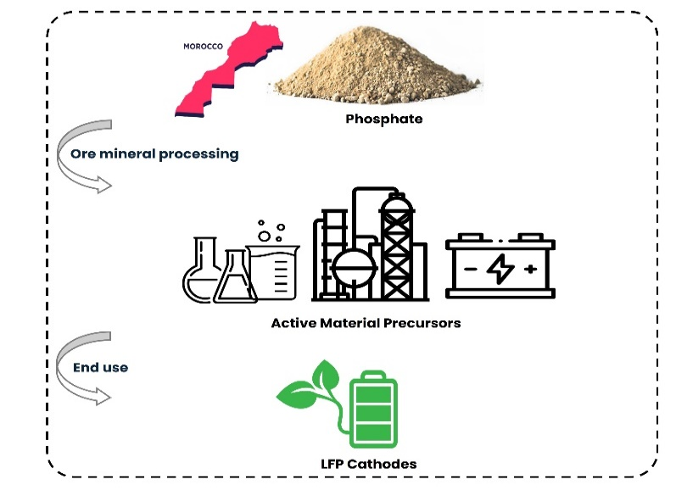
Graphical abstract

Introduction
The shift from fossil fuels to green and sustainable energy is regarded as a viable alternative to achieve carbon and climate neutrality, while addressing the major environmental issues related to the overconsumption of limited fossil resources, such as global warming and greenhouse gas emissions [1–3]. Since its introduction in the 1990s by SONY, LIB played a pivotal role in the energy transition, particularly in EVs and portable electronic devices, thanks to their advantages such as high energy density, long lifespan, and low self-discharge [4–6]. Since then, researchers have explored multiple types of cathode materials, including NMC (lithium-nickel-manganese-cobalt oxide), NCA (lithium-nickel-cobalt-aluminum oxide), and LFP (lithium iron phosphate) [7, 8]. The LFP has attracted significant interest and is recognized as a distinguished cathode for LIB. It is widely employed, notably for electric mobility, and considered more cost-effective than NMC and NCA compounds, while ensuring thermal stability and a longer life compared to other conventional cathodes [9–11]. LFP chemistry is projected to dominate a substantial portion of the LIB market, rising from 14.63 billion USD in 2023 to 72.76 billion USD by 2034, as seen in Fig. 1-b. In China, LFP batteries have surpassed other chemistries to become the predominant battery cathode, and their popularity is increasing outside China as patents expired in 2022–2023, eliminating previous use limitations [12, 13]. Numerous current-production EVs use LFP batteries, such as the Beyond Your Dream (BYD) Tang, the MG 4, and the Tesla Model 3 Standard Range [14]. At the same time, LFP has gained increasing significance as a research subject, as illustrated in Fig. 1-a, which depicts the substantial rise in the volume of published works on the use of LFP in LIB during the last two decades (2005-2024).

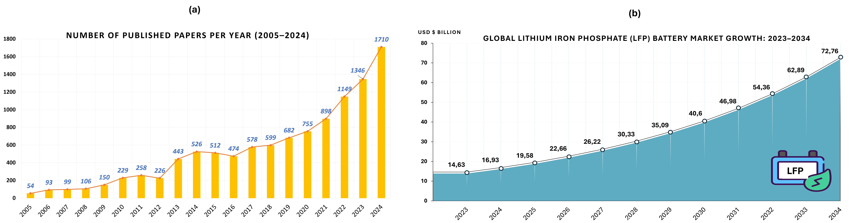
FIGURE 1. a) The rise in the volume of papers related to LFP LIBs over the past two decades (2005-2024), as sourced from the Scopus database, using the following query : (TITLE-ABS-KEY (lithium AND ion AND batteries) AND TITLE-ABS-KEY (lithium AND iron AND phosphate) OR TITLE-ABS-KEY (LFP) OR TITLE-ABS-KEY (LiFePO₄) AND PUBYEAR > 2004 AND PUBYEAR < 2025 ), b) The expected industrial growth of the LFP batteries from 2023 to 2034

The substantial demand for this chemistry drives nations to strengthen the entire value chain of these elements, commencing with the mining and manufacture of raw materials, which is crucial for ensuring market independence. The European Union (EU) developed a strategy to improve existing raw material refining facilities and use circular economy approaches to reduce dependence on foreign sources and foster local production of battery-grade precursors [15–17]. China, a key player in the battery market, is building up its precursor Cathode Active Materials (pCAM) production capabilities through collaborations and new initiatives; for instance, the capacity augmentation achieved with the founding of CNGR Advanced Materials in 2014 and the “BASF and Shanshan Joint Venture,” which encompasses facilities for raw material transforming, pCAM production, and recycling [18]. South Korea and other developing countries, such as Indonesia, have taken steps to improve their national resources by creating an integrated industrial ecosystem for the production of local battery-grade precursors [19, 20]. In Morocco, although the country has considerable mineral resources, with a production of 30 million metric tons of phosphates, the marketed product is not immediately used to manufacture LFP cathodes and must be refined to meet battery quality requirements.
This research aims to bridge the gap between Morocco’s underground resources and the needs of the battery industry for local LFP precursors. First, through a bibliographical study, we determined the precursors used for the synthesis of LFP cathodes. We then shed light on the Moroccan resources and capacities on these essential precursors. Finally, we proposed a sustainable processes to transform the current commercial product into TGA for the manufacture of LFP cathodes. Our work constitutes a step towards a green and sustainable energy transition by proposing transformational techniques of local natural resources for the manufacturing of EVs.

MethodoLogy
Our approach is based on a methodology that combines the analysis of previous studies and practical cases to propose transformational processes of Morocco’s mineral resources to commercial LFP cathodes. Fig. 2 presents the approach followed.

(1) Thorough Study of the existing manufacturing processes to define the raw materials and minerals needed for LFP cathodes production.

(2) Determine the phosphorus source used for LFP cathodes; The Scopus database is employed to figure out the most used phosphorus precursor for LFP cathode synthesis. The research methodology follows strict criteria, such as sources of high impact and peer-reviewed journals, recent publications (2015-2025), relevance with battery materials, and use of specific keyword queries (for example, Lithium Iron Phosphate, LFP, LiFePO₄, etc.). The search yielded 270 documents, which were classified in the Zotero reference manager. Each article was screened for its technical relevance, data quality, and precursor definition. After analysis, 172 articles were selected for in-depth reading. Then, relevant information was extracted, including phosphorus precursors and electrochemical performance in battery applications.

(3) Following the identification of the most often used phosphorus precursor in LFP manufacture, an analysis was carried out to assess the availability of this crucial component in Morocco, as well as the current refining processes and their appropriateness to the production of LFP’s battery-grade precursors.

(4) To further develop the existing refining processes and produce domestic LFP battery-grade precursors from Moroccan phosphorus resources, upgraded transformational processes have been developed to enable the manufacturing of compatible battery-grade materials.

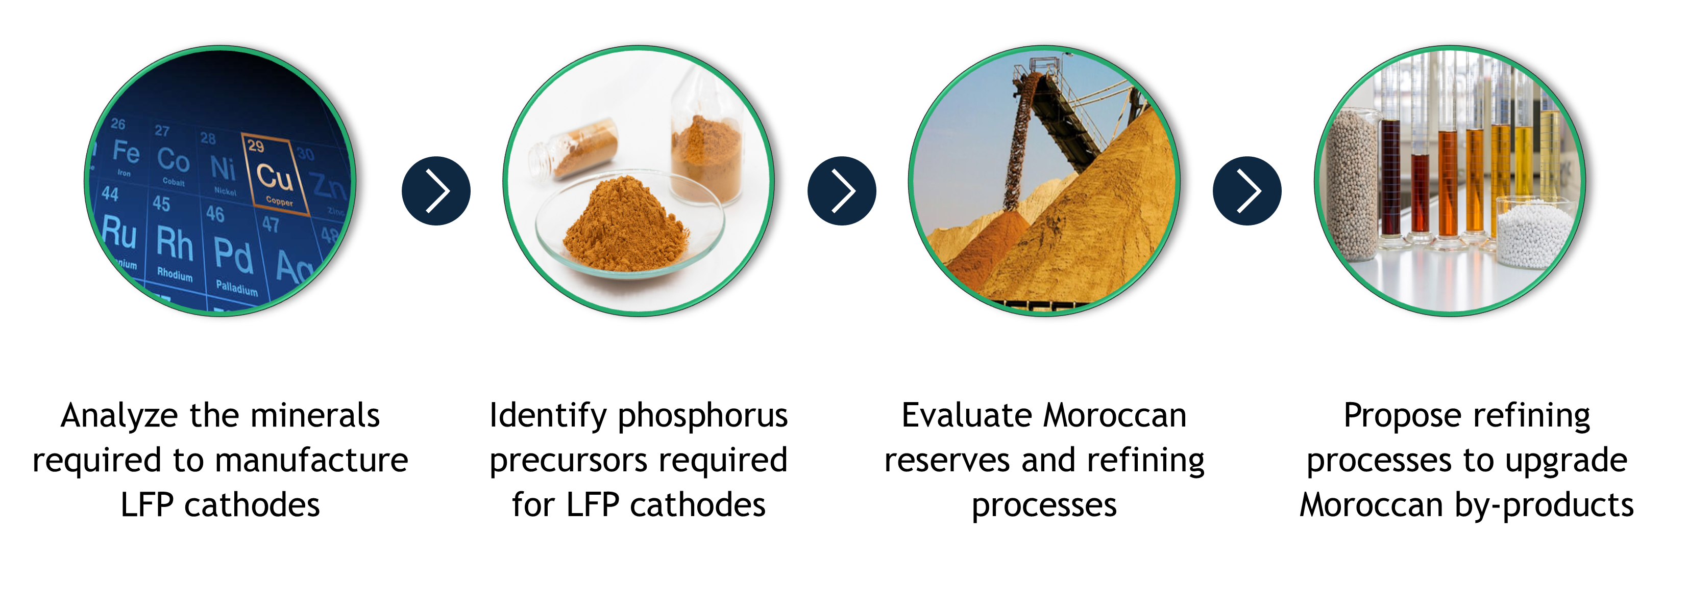
FIGURE 2. Research methodology

Results and discussion

Minerals and precursors required for LFP manufacturing
Raw minerals are critical components in the production of LFP cathodes, constituting more than fifty percent of the total cell cost. [5]. The predicted demand for metals for LIB is expected to reach 13.5 million metric tons by 2030, representing a ninefold increase compared to 2020 [21]. An individual EV working with LFP chemistry requires 26 kg of phosphorus, 41 kg of iron, and 6 kg of lithium for the manufacturing of the battery cathode [22]. Fig. 3 illustrates the elemental composition of an isolated electric vehicle employing LFP cathodes.
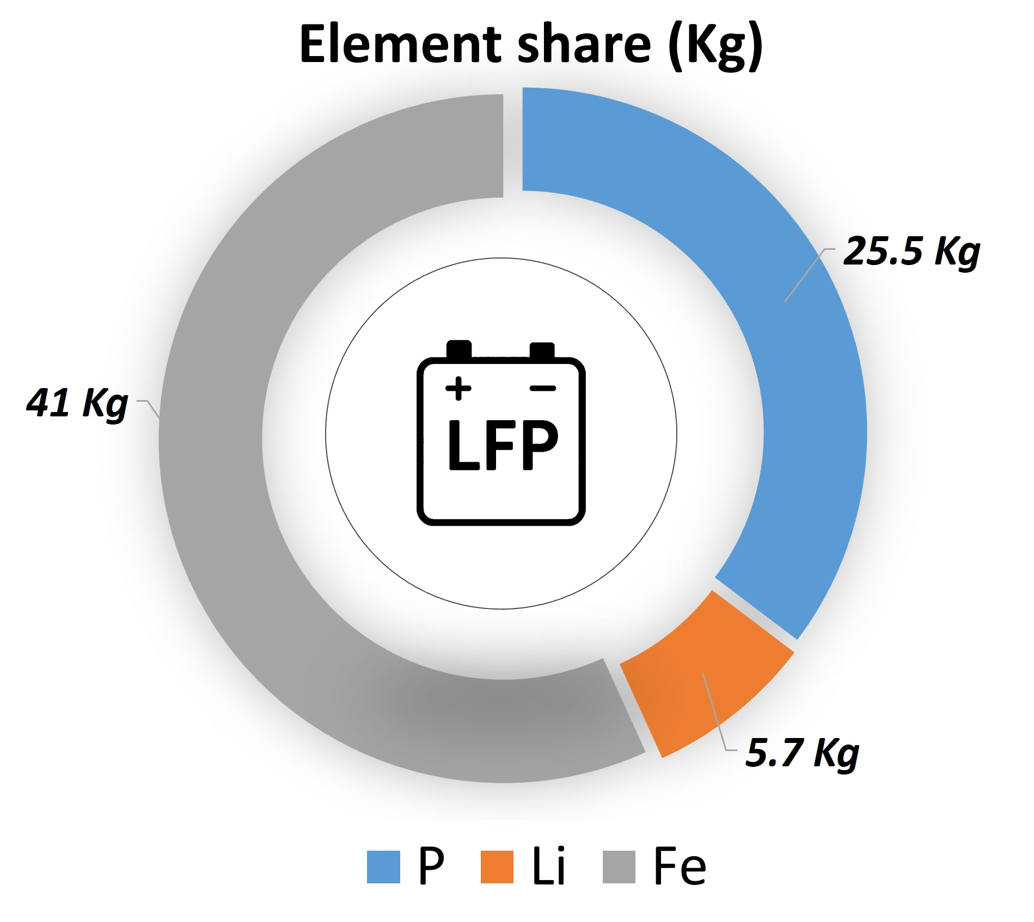
FIGURE 3. Elemental share of LFP cathodes (data from [23])

To examine the phosphorus precursor sources utilized in LFP batteries, an in-depth examination of recent publications from the past decade (2015–2024) in the Scopus database has been conducted. It is noteworthy that hydrothermal synthesis has been employed in the research query because it is the major and industrially established method for making LFP cathodes. The hydrothermal process involves combining stoichiometric ratios of precursors in an aqueous solution, which is then subjected to autoclave treatment at temperatures exceeding 100°C, typically between 120 and 220°C, in a controlled environment (pH, temperature, and duration), followed by high-temperature sintering with a carbon source to improve material conductivity. Hydrothermal synthesis enables the production of pure, homogeneous, and well-crystallized powders [24–26], while reducing the drawbacks encountered by other synthesis methods, such as the solid-state method, which presents difficulties in controlling the synthesis parameters. (temperature, particle size, processing time), high energy consumption and environmental consequences due to the use of fossil fuels.
Multiple precursors are utilized in the synthesis of LFP cathodes, including phosphoric acid, ammonium salts, and lithium/sodium phosphates, among others. Fig. 4 demonstrates that phosphoric acid is the primary phosphorus precursor employed in the production of LFP cathodes; this acid results from the treatment of beneficiated phosphate with sulfuric acid (H₂SO₄).

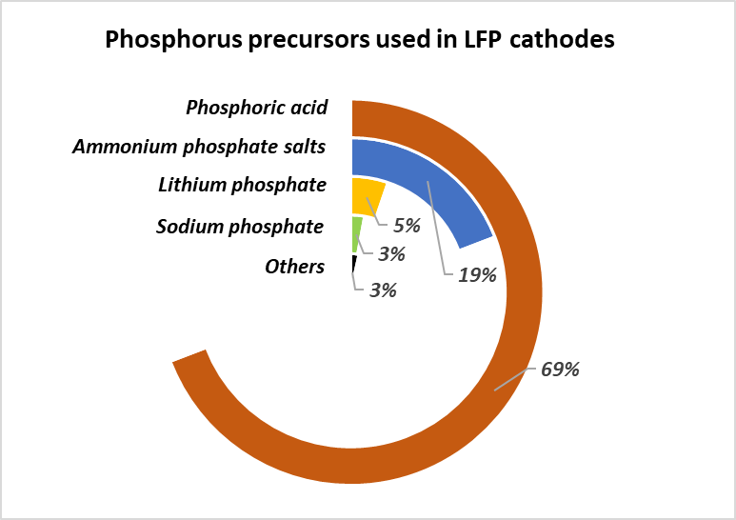
FIGURE 4. Phosphorus precursors used to produce LFP cathodes, sourced from the Scopus database using the following query:(TITLE-ABS-KEY (lithium AND iron AND phosphate) OR TITLE-ABS-KEY (lfp) OR TITLE-ABS-KEY (LiFePO4) AND TITLE-ABS-KEY (hydro-thermal) OR TITLE-ABS-KEY (hydrothermal) AND TITLE-ABS-KEY (lithium AND ion)) AND PUBYEAR > 2014 AND PUBYEAR < 2025,

Moroccan reserves and refining processes:
Morocco is a major player in the worldwide phosphate industry. The country has the largest phosphate deposits and has produced well over 30 million metric tons per year [22]. Figs. 5-a and 5-b display the resources and production of phosphate rock in Morocco, respectively. The Moroccan phosphorus reserves include four production sites: Khouribga, Benguerir, Youssoufia, and Boucraa, along with one project development site. The locations are shown in Fig. 6.
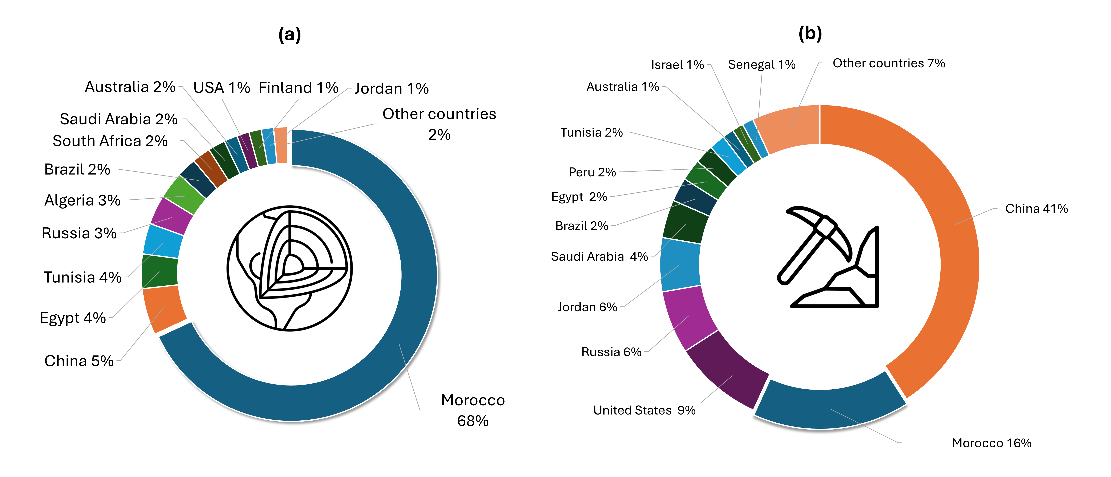
FIGURE 5. a) Global phosphate production, b) phosphate production share in the world (data from [22])
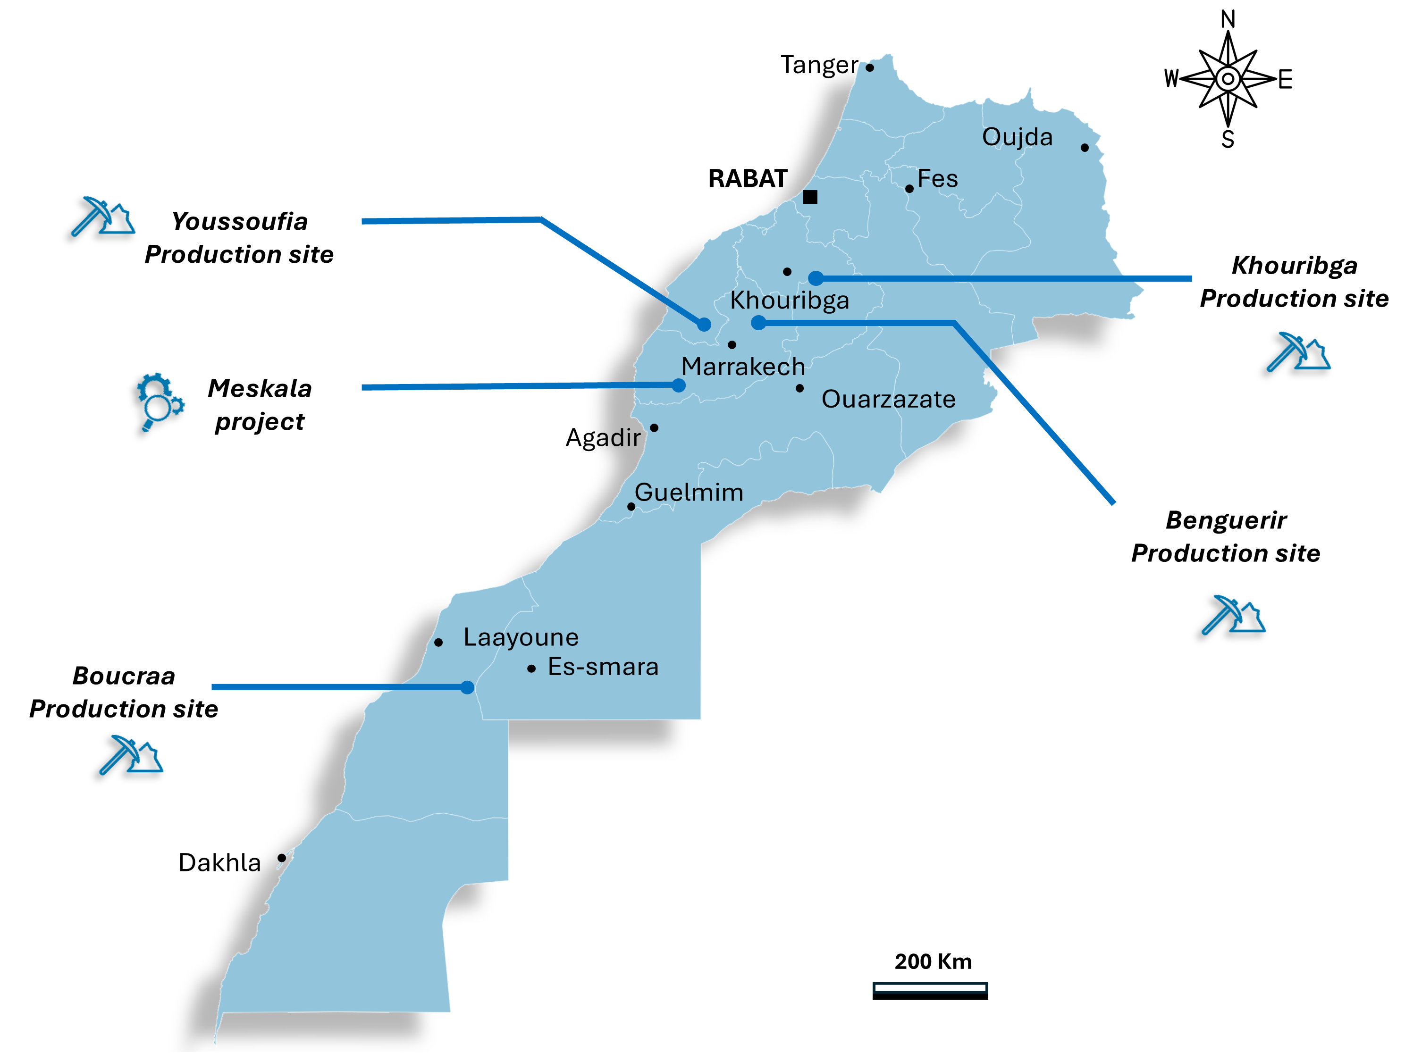
FIGURE 6. Phosphate production and project development sites in Morocco

The most exploited technique for producing phosphoric acid is the wet process (known as WPPA: Wet Process Phosphoric Acid), which uses sulfuric acid (H₂SO₄) to acidulate phosphate rocks. As seen in Fig. 7, the wet method involves the sulfuric attack of phosphate rock in a reactor and the filtering of the generated gypsum (CaSO₄). Finally, water is removed by the evaporation process, and the obtained product is called merchant-grade acid (MGA) that contains 52-55% P₂O₅ [27–29].

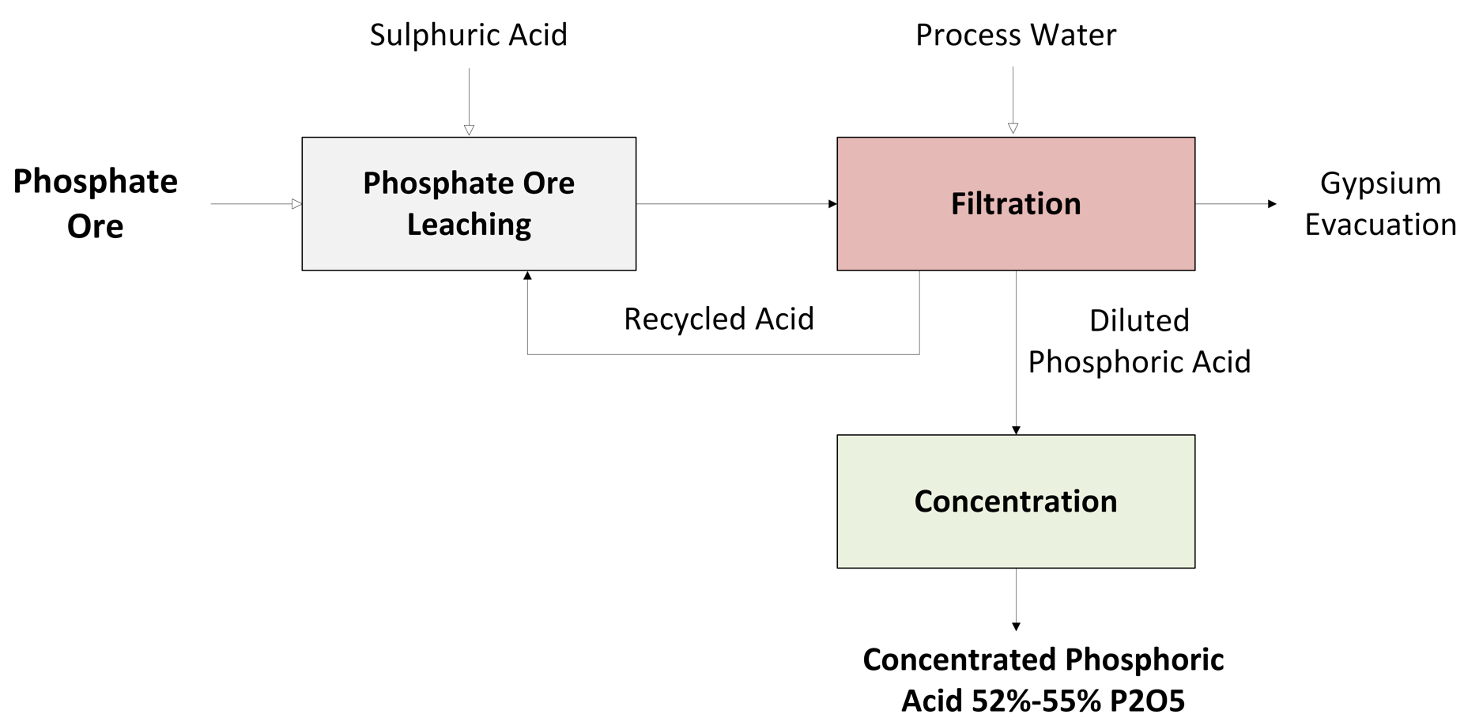
FIGURE 7. Principal steps in producing Phosphoric Acid by the wet process (WPPA)

Phosphorus upgrading to meet battery requirements
To further improve the phosphorus concentration in MGA from 54% to 62% P₂O₅, aligning it with battery-grade phosphoric acid, impurities must be eliminated. These impurities may originate from the process itself, such as sulfuric acid and process water, or phosphate ore, including calcium, carbonates, sodium, aluminum, organic matter, and trace contaminants, primarily heavy metals [28]. Multiple purification techniques have been employed to yield high-quality phosphoric acid, including ion exchange, precipitation, adsorption, liquid-liquid extraction, reverse osmosis, and nanofiltration [30–32]. Liquid-liquid extraction is regarded as one of the most prevalent methods for purifying phosphoric acid; therefore, this approach is recommended for refining Moroccan phosphoric acid to provide a suitable phosphorus source for battery production. Several techniques are involved in the extractive purification of aqueous phosphoric acid. They include the process of purification of crude phosphoric acid, extraction, washing of the extract, and recovery of phosphoric acid. Fig. 8 illustrates the proposed processes involved in synthesizing TGA for battery manufacturing.

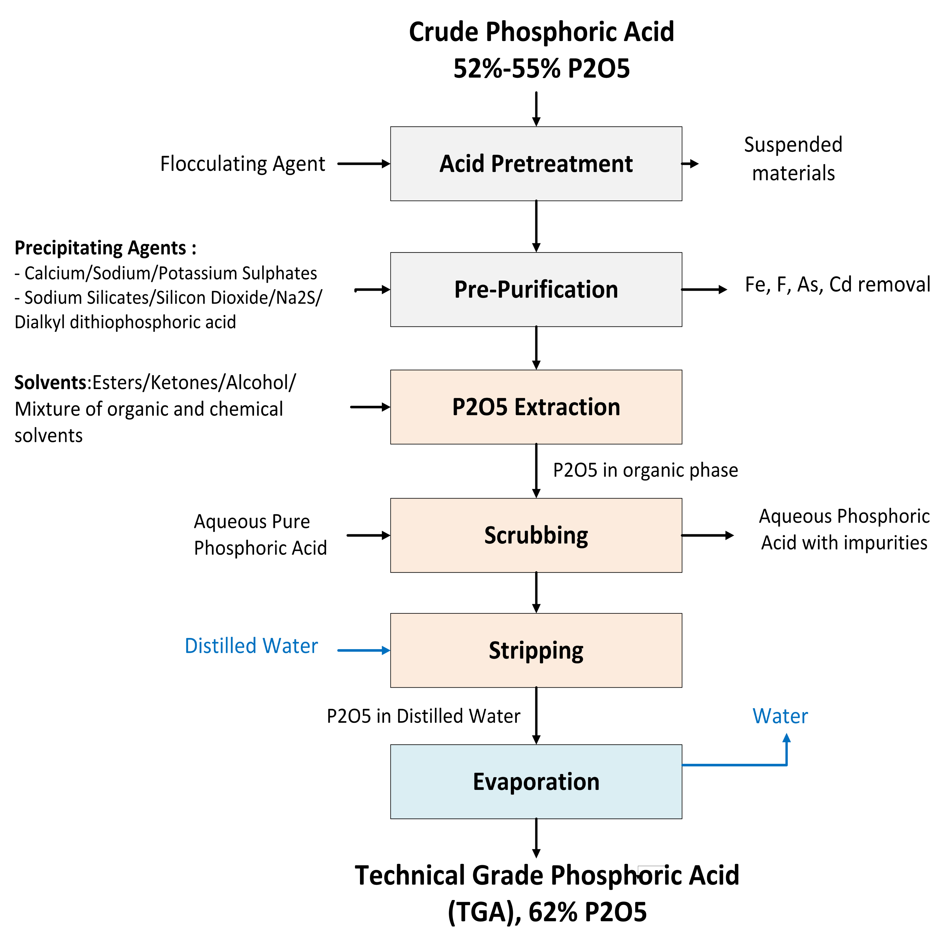
FIGURE 8. Suggested methods for upgrading and purifying phosphoric acid

Firstly, the crude phosphoric acid is pretreated to eliminate suspended materials and organic compounds using flocculating agents. After that, impurities such as iron, arsenic, and fluoride are extracted by precipitating agents like sulfates (sodium, potassium, or calcium), silicate, etc, simultaneously with a complexing agent, particularly dialkyl dithiophosphoric acid, to remove cadmium and arsenic [27, 32]. Subsequently, is utilized to dissolve the pre-purified phosphoric acid is dissolved via counter-current flow of an organic solvent, like esters, alcohols, ketones, or a mixture of these solvents [33–35]. After extracting P₂O₅ into the organic phase (with impurity traces), most of the contaminants remain in the aqueous part. The scrubbing (washing) operation is performed using purified phosphoric acid to eliminate extracted impurity traces from the organic phase. Following that, distilled water is used to transfer the P₂O₅ from the organic solvent to the aqueous solution (stripping stage). The obtained product is a dilute phosphoric acid free of impurities that need concentration. Finally, concentrated phosphoric acid of high purity (62% P₂O₅) was obtained through evaporation. The suggested method uses a closed-loop system for the recovery and reuse of agents, including solvents and dilute phosphoric acid, to promote circular economy practices.
Concerning the environmental impact of the suggested processes, and according to ISO 14067 standard and the GHG (Greenhouse Gas) Protocol Product Life Cycle Accounting and Reporting Standard, it is estimated that the carbon footprint of purified phosphoric acid is 5,30 kg CO₂ equivalent for each kilogram of purified acid [36], including all steps within the phosphorus value chain: raw material extraction, processing and transport. In order to address this ecological issue, the OCP group is developing initiatives to capture CO₂ emissions and reduce their impact on energy and water use: the objective is to recover 100% of the emissions generated by the process and to transform them into green by-products. It includes the implementation of a process to reduce fluorinated gases in phosphoric acid production units, which led to a 48% decrease in annual fluorinated gaseous emissions in 2023 compared to 2020. Furthermore, washing systems for the purification of hydrogen sulfide gases have been installed for all phosphoric acid pretreatment units, ensuring compliance with national and international emission limits for H₂S. In addition, the carbonates eliminated from the washing plants are gathered to minimize the CO₂ content before phosphoric acid processing. Furthermore, the company (OCP group) changed the phosphate transport between production sites by using slurry pipelines instead of conventional trains. This action significantly reduced the relative CO2 emissions. Regarding energy consumption, interesting initiatives have been taken by the group to use renewable energy sources such as photovoltaic systems and wind turbines. The objective of these actions is to satisfy the energy needs of the mining sites and chemical facilities with carbon-free sources. On the other hand, to attain full autonomy of water need using unconventional water, OCP developed strategies focusing on seawater desalination and reused water recycling, while leveraging the circular economy practices. Further technical investigations are recommended to precisely analyze the potential environmental impact of the proposed processes, mainly using Life Cycle Analysis (LCA). The yield of the suggested transformation is nearly 90-95% [33–35]. The current phosphate processing plant generates 1.2 million tons of P₂O₅ annually as an MGA (54%) [37]. The implementation of suggested transformational processes is intended to produce more than one million tons of P₂O₅ per year, in a TGA concentration (62%), compatible with battery requirements.
As mentioned earlier, 26 Kg of elemental phosphorus is required to manufacture an LFP battery for each EV. Given that 1 mole of P₂O₅ contains 2 moles of pure phosphorus, the weight ratio between P₂O₅ and P is expressed by R₁.
$$R_{1}=\frac{Molecular weight \left(P_{2}O_{5}\right)}{Molecular weight \left(P\right)}=\frac{142}{2*31} ≈ 2.3$$

According to this ratio, the phosphoric acid treatment process in Morocco is expected to generate around 430,000 tons of elemental phosphorus annually. Due to the crucial role played by Moroccan phosphate in the worldwide food security, we suppose that only half of the production quantity will be employed in the LFP manufacturing; this corresponds to an annual production of 215,000 tons of elemental P. An amount that enables the manufacturing of almost 8 million EVs annually. Despite the lack of an official technical specification of the intended Moroccan LFP. This locally fabricated cathode (from TGA) is expected to strictly adhere to the international exigencies in terms of purity, gravimetric capacity (160 mAh/g), and voltage (3.3 V). These expectations are frequently supported, particularly by the ambitions of world-renowned companies that aim to manufacture LFP cathodes by exploiting phosphate from Morocco. Notably, LG Chem and its subsidiary, Youshan, are planning to build a plant with an annual capacity of 50,000 tons of LFP cathode materials. In addition, the joint company AL MADA-CNGR Advanced Materials is expecting to produce 60,000 tons of these cathode elements within the COBCO complex [38, 39].
From another perspective, Morocco’s ability to implement TGA production facilities is facing geopolitical, regulatory, and supply chain threats. Despite political stability in the country, the international phosphate market is still vulnerable to trade limitations, export strategies, and competition from major producers such as China. These factors may affect market access and prices. Insufficient regulatory framework for battery-grade critical minerals hinders investment in upgrading phosphoric acid from 54% to 62% P₂O₅. Regarding the phosphate supply chain, the OCP group today is still prioritizing raw and intermediate exports with no domestic battery-grade refining capacity. Delays in infrastructure development, market volatility, and stricter environmental compliance requirements could hinder the creation of a reliable, large-scale TGA supply chain in the short term. This suggests that significant technical obstacles are emerging, particularly highlighted by the example of phosphoric acid, which points to the restricted ability to process Moroccan raw materials into battery-grade precursors and the lack of sophisticated processing infrastructure and industrial synergy with LIB manufacturing [22]. Enabling local TGA production will allow for the valorization of domestic phosphate reserves, rather than exporting low-value raw materials, and will generate high-quality battery-grade precursors essential for LFP cathodes, thereby reducing dependence on imported high-purity phosphoric acid or LFP precursors. As China largely dominates the global LFP market, the suggested model would guarantee Morocco a constant, sustainable, and stable supply for Europe and Africa. It would benefit from its strategic geographical location as well as advantageous trade and tax agreements, while mitigating the effects of fluctuation in international markets and trade disputes.

CONCLUSION
Countries are competing to establish independence on minerals essential for the clean energy transition. This work explores Morocco’s ability to transform its natural resources in order to ensure its autonomy in terms of essential raw materials for LIB. Morocco has significant deposits and production capacities in phosphate resources, crucial for the manufacture of LFP cathodes, the prominent electrode of LIB. A thorough analysis revealed that high-purity phosphoric acid (TGA) is the main phosphorus precursor employed in the production of LFP. Although the country has vast mineral resources and a potential production of 30 million metric tons of phosphates, the commercialized product is the phosphoric acid containing 54% P₂O₅, which is not suitable for the production of LFP cathodes and requires additional refining processes to achieve the battery-grade specifications. Thus, purification processes, including impurity removal, liquid-liquid extraction, and evaporation, were set up to upgrade the concentration of phosphoric acid at a level corresponding to TGA quality (62% P₂O₅) required for the production of the LFP cathodes. By developing these processes, Morocco would be able to generate TGA-grade equivalents of over 1 million tons of P₂O₅ annually, enabling a production capacity of 8 million electric vehicles per year using LFP chemistry. The application of these transformation procedures could increase Morocco’s competitiveness on the international stage of LIB, encourage the establishment of a domestic batteries industry, and reduce dependence on importation, thus placing the country in a strategic supplier position within the framework of the energy transition. This work is mainly a study of concepts and process design that aims to come up with a workable flow sheet for turning Moroccan phosphate into battery-grade materials needed for LFP cathodes. However, more economic and technical studies are needed to validate the proposed processes in order to reach the final goal of building an integrated industrial ecosystem for local EV manufacturing.

REFERENCES

1. Liu, Y. et al., Recent progress of Mn-based NASICON-type sodium ion cathodes. Energy Storage Materials, 2023. 57: p. 69–80. https://doi.org/10.1016/j.ensm.2023.02.005.
2. Scrosati, B., Hassoun, J., Sun, Y.-K., Lithium-ion batteries. A look into the future. Energy & Environmental Science, 2011. 4(9): p. 3287–3295. https://doi.org/10.1039/C1EE01388B.
3. Ouachtouk, H. et al., Synthesis, Characterization, Magnetic, Elastic, and Electronic Properties of La2ZnMnO6 Double Perovskite. Journal of Superconductivity and Novel Magnetism, 2024. 37(8): p. 1541–1550. https://doi.org/10.1007/s10948-024-06776-9.
4. Ozawa, K., Lithium-ion rechargeable batteries with LiCoO2 and carbon electrodes: the LiCoO2/C system. Solid State Ionics, 1994. 69(3–4): p. 212–221. https://doi.org/10.1016/0167-2738(94)90411-1.
5. Ding, Y. et al., Automotive Li-Ion Batteries: Current Status and Future Perspectives. Electrochemical Energy Reviews, 2019. 2(1): p. 1–28. https://doi.org/10.1007/s41918-018-0022-z.
6. Zubi, G. et al., The lithium-ion battery: State of the art and future perspectives. Renewable and sustainable energy reviews, 2018. 89: p. 292–308. https://doi.org/10.1016/j.rser.2018.03.002.
7. Zhou, L. et al., Recent Developments on and Prospects for Electrode Materials with Hierarchical Structures for Lithium‐Ion Batteries. Advanced Energy Materials, 2018. 8(6): p. 1701415. https://doi.org/10.1002/aenm.201701415.
8. Cheng, A.L. et al., Electric vehicle battery chemistry affects supply chain disruption vulnerabilities. Nature Communications, 2024. 15(1): p. 2143. https://doi.org/10.1038/s41467-024-46418-1.
9. Ioakimidis, C.S. et al., Life Cycle Assessment of a Lithium Iron Phosphate (LFP) Electric Vehicle Battery in Second Life Application Scenarios. Sustainability, 2019. 11(9): p. 2527. https://doi.org/10.3390/su11092527.
10. Fallah, N., Fitzpatrick, C., Is shifting from Li-ion NMC to LFP in EVs beneficial for second-life storages in electricity markets?. Journal of Energy Storage, 2023. 68: p. 107740. https://doi.org/10.1016/j.est.2023.107740.
11. Li, M. et al., 30 Years of Lithium‐Ion Batteries. Advanced Materials, 2018. 30(33): p. 1800561. https://doi.org/10.1002/adma.201800561.
12. Nikhil Bhandari et al., Global Batteries The Greenflation Challenge. 2022. https://www.goldmansachs.com/insights/goldman-sachs-research/batteries-the-greenflation-challenge.
13. Oskaras, A. et al., Global EV Outlook 2024- Moving towards increased affordability. International Energy Agency, 2024. April 2024: . https://iea.blob.core.windows.net/assets/a9e3544b-0b12-4e15-b407-65f5c8ce1b5f/GlobalEVOutlook2024.pdf.
14. Hasselwander, S., Meyer, M., Österle, I., Techno-Economic Analysis of Different Battery Cell Chemistries for the Passenger Vehicle Market. Batteries, 2023. 9(7): p. 379. https://doi.org/10.3390/batteries9070379.
15. Horizon Europe, Sustainable processing, refining and recycling of raw materials (Batteries Partnership). CORDIS - EU research results, 2021. CL5-2021-D2-01–01: . https://cordis.europa.eu/programme/id/HORIZON_HORIZON-CL5-2021-D2-01-01.
16. Ahlbrecht, K. et al., Powering Europe’s Green Revolution: Paving the Way to a More Resilient and Sustainable Battery Industry-Research and Innovation Roadmap on Battery Technologies. 2023.
17. Jacques, P., BATTERIES | Towards a competitive European industrial battery value chain for stationary applications and e-mobility. EMIRI, RECHARGE, EUCAR, 2020.
18. Rechenberger, D., Fuhu, C., BASF and Shanshan form battery materials joint venture in China. BASF Shanshan Battery Materials Co., Ltd, 2021. https://www.basf.com/basf/www/global/en/media/news-releases/2021/08/p-21-294.
19. Hubungi, GEM Secures the South Korean Market and Enters the North American Market by Joining Hands with SK On & ECOPRO. GEM Recycling for future, 2023. https://www.gemindonesia.com/CompanyNews/info_itemid_7291.html?utm_source=chatgpt.com.
20. Huanneng New Materials (Indonesia) Co., Ltd., Huayou Cobalt Completes Its First Overseas Ternary Precursor Project and Successfully Begins Production-News Releases-Huayou New Energy Technology (Quzhou) Co., Ltd. Huayou Cobalt, 2023. https://www.huayou.com/en/news/corporate-news/260?utm_source=chatgpt.com.
21. Kwasi, A. et al., The Cost of Producing Battery Precursors in the DRC. BloombergNEF, 2021. https://assets.bbhub.io/professional/sites/24/BNEF-The-Cost-of-Producing-Battery-Precursors-in-the-DRC_FINAL.pdf.
22. Azerblou, S. et al., Toward carbon–neutral transportation: Harnessing Morocco’s critical minerals for sustainable lithium-ion batteries. Sustainable Energy Technologies and Assessments, 2025. 75: p. 104245. https://doi.org/10.1016/j.seta.2025.104245.
23. Nekahi, A. et al., Sustainable LiFePO4 and LiMnxFe1-xPO4 (x=0.1–1) cathode materials for lithium-ion batteries: A systematic review from mine to chassis. Materials Science and Engineering R: Reports, 2024. 159: . https://doi.org/10.1016/j.mser.2024.100797 https://www.scopus.com/inward/record.uri?eid=2-s2.0-85192083476&doi=10.1016%2fj.mser.2024.100797&partnerID=40&md5=ccc69f63789e88f29897f0f8db94ddd5.
24. Li, Z. et al., Controlled Hydrothermal/Solvothermal Synthesis of High‐Performance LiFePO ₄ for Li‐Ion Batteries. Small Methods, 2021. 5(6): p. 2100193. https://doi.org/10.1002/smtd.202100193.
25. Lei, Q. et al., Clean and efficient synthesis of LiFePO4 cathode material using titanium white waste and calcium dihydrogen phosphate. Waste Management, 2024. 174: p. 362–370. https://doi.org/10.1016/j.wasman.2023.12.019.
26. Yan, X. et al., Control and influence of morphology, particle size and structure of LiFePO4 on its properties. Solid State Ionics, 2024. 410: p. 116535. https://doi.org/10.1016/j.ssi.2024.116535.
27. De Boer, M.A., Wolzak, L., Slootweg, J.C., Phosphorus: Reserves, Production, and Applications. Phosphorus Recovery and Recycling, 2019.p. 75–100. https://doi.org/10.1007/978-981-10-8031-9_5 http://link.springer.com/10.1007/978-981-10-8031-9_5.
28. Azaroual, M. et al., Thermo-kinetic and Physico-Chemical Modeling of Processes Generating Scaling Problems in Phosphoric Acid and Fertilizers Production Industries. Procedia Engineering, 2012. 46: p. 68–75. https://doi.org/10.1016/j.proeng.2012.09.447.
29. Schipper, W., Non-fertilizer uses of phosphorus : An overview. Global Phosphorus Institute (GPI), 2024. https://doi.org/10.26434/chemrxiv-2024-8kw51-v2 https://chemrxiv.org/engage/chemrxiv/article-details/667255475101a2ffa8eb0ae7.
30. Xu, C. et al., Removal of calcium from phosphoric acid produced by the nitric acid process using solvent extraction with TCHDGA and stripping with water. Hydrometallurgy, 2024. 229: p. 106379. https://doi.org/10.1016/j.hydromet.2024.106379.
31. Amin, M.I. et al., Recovery of high grade phosphoric acid from wet process acid by solvent extraction with aliphatic alcohols. Hydrometallurgy, 2010. 105(1–2): p. 115–119. https://doi.org/10.1016/j.hydromet.2010.08.007.
32. El-Asmy, A.A. et al., Purification of phosphoric acid by minimizing iron, copper, cadmium and fluoride. Separation and Purification Technology, 2008. 61(3): p. 287–292. https://doi.org/10.1016/j.seppur.2007.11.004.
33. Ren, Y. et al., Liquid–Liquid Equilibrium Data of Extraction with Tri-n-butyl Phosphate on Phosphoric Acid Containing Sodium Sulfate or Potassium Sulfate. Journal of Chemical & Engineering Data, 2016. 61(5): p. 1735–1742. https://doi.org/10.1021/acs.jced.5b00867.
34. Li, X. et al., Purification of Wet Process Phosphoric Acid by Solvent Extraction using Cyclohexanol. Solvent Extraction Research and Development, Japan, 2017. 24(1): p. 23–35. https://doi.org/10.15261/serdj.24.23.
35. Ye, C., Li, J., Wet process phosphoric acid purification by solvent extraction using N-octanol and tributylphosphate mixtures. Journal of Chemical Technology & Biotechnology, 2013. 88(9): p. 1715–1720. https://doi.org/10.1002/jctb.4023.
36. Carbon Cloud, Phosphoric acid (H3PO4), purified. E338. 2025. https://apps.carboncloud.com/climatehub/product-reports/id/216857142454.
37. OCP Group, Annual Financial Report 2023. Annual Financial Report, 2024. https://ocpsiteprodsa.blob.core.windows.net/media/2024-04/Rapport%20Financier%20Annuel%202023.pdf.
38. Plastics Technology, LG Chem to Build LFP Cathode Plant in Morocco. 2023. https://www.plastics-technology.com/news/lg-chem-to-build-lfp-cathode-plant-in-morocco.
39. Industrie.ma, COBCO Launches Morocco’s First Lithium-Ion Battery Materials Manufacturing Plant in Jorf Lasfar. 2025. https://industries.ma/cobco-launches-moroccos-first-lithium-ion-battery-materials-manufacturing-plant-in-jorf-lasfar/.

