Smart Supervision and Control for Fault Location in Microgrids with Renewable Energy and Storage Systems
Hafsa El Meskini^{1, a)}, Mohamed Azeroual^{1, b)}, and Seddik Bri^{1, c)}
¹SEIMC Research Group, LASMAR Laboratory, Higher School of Technology, Moulay Ismail University of Meknes, Morocco

^{a)} h.elmeskini@umi.ac.ma
^{b)} m.azeroual@umi.ac.ma
^{c)} s.bri@umi.ac.ma

Abstract. A microgrid is a decentralized energy system comprising various power sources and various consumers. Electrical faults, leading to service outage, equipment failure, and reduced reliability, are some of the central issues in such systems. Integration of artificial intelligence (AI) offers a smart solution not only for energy generation, storage, and consumer optimization, but also for maintaining system stability. AI is also essential in detecting faults and anomalies extremely fast, especially in decentralized networks. This paper outlines the design of an intelligent monitoring system for energy management, fault detection, and their localization in a DC microgrid. The approach is tested through simulations on a 400V DC microgrid under different conditions of faults such as different resistances and locations. The results show that the system operates rapidly and accurately with fault isolation within less than 1 millisecond. Compared to other approaches, the presented scheme is novel in terms of high reliability, fast response, and overall efficiency.

Keywords: Energy Management, Artificial Intelligence (AI), Renewable Energy, Microgrids, Fault location.

introduction
In the last few years, the increasing growth of electrical energy systems has caused an enormous rise in the number of transmission and distribution lines worldwide [1]. Electrical faults remain among the largest issues in assuredly keeping up the power supply [2]. Fast fault detection is essential for effective monitoring and control of the grid. The intelligent protection systems come in—they detect faults early, prevent extensive damage, and protect individuals and equipment.
That challenge has been a major draw for researchers, especially when used with microgrids. The goal is to stabilize and make those systems more reliable with improved fault detection and location, while reducing downtime and maintenance costs. Different methods have been introduced to identify where a fault has happened, using both or either ends of a transmission line data [3]. For example, the authors in [4] introduced a rapid fault diagnosis technique for DC microgrids. The method consists of three main steps:

- Detecting the fault from the time derivative of the current at line terminals,
- classifying the type of fault,
- And fault detection based on line parameters and a multi-objective genetic algorithm.

The authors in another study [5] propose a method that does not make use of terminal communication. Instead, it relies on local voltage and current measurement. Fault detection takes place by comparing a calculated pseudo voltage (PSDV) with a threshold. The least squares (LS) method is then utilized to estimate the resistance and location of the fault. All of these techniques aim to enhance microgrids to be more intelligent and resilient. Grounded on this principle, the proposed scheme presents a smart monitoring system addressing energy management, fault detection, and identification of their location in a DC microgrid. We applied the system to a 400V system under various fault scenarios, i.e., fault resistance and location variation, and the result was promising performance.

Architecture of the proposed DC microgrid
The DC microgrid studied in this work is a six-terminal system that combines multiple energy sources, including solar (PV), wind, and the AC grid.The AC grid is used to ensure stability and continuity of service.When renewable generation from the DC microgrid exceeds local demand, the excess can be injected into the AC grid or when generation is insufficient, the DC microgrid can import energy from the AC grid. It also includes energy storage, a DC load, and an AC load. To ensure protection, circuit breakers (CBs) are placed at both ends of each transmission line.
All energy sources are connected to the DC bus through appropriate converters. The PV panels and wind turbine use DC/DC boost converters, while the battery system is linked through a bidirectional DC/DC converter, controlled by a PID regulator to manage charging and discharging. This configuration helps maintain stable operation and reliable protection across various conditions. The overall structure of the microgrid is shown in Figure 1, and the main system parameters are listed in Table 1.

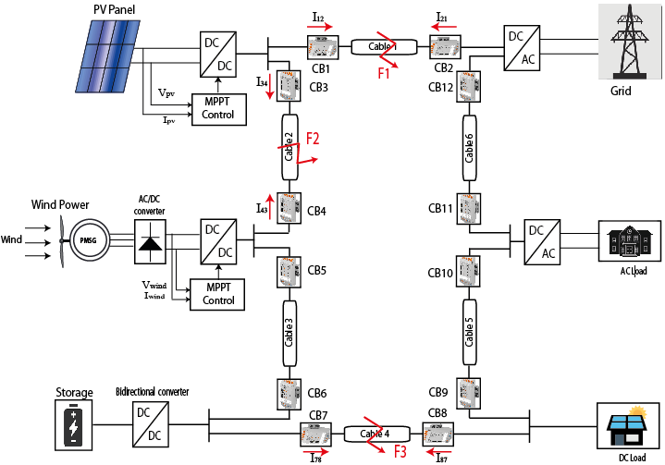
Figure 1. Structure of DC microgrid system:

Table 1. Parameters of different system components
DC BUS
Bus voltage | 400V
Resistance per unit | 12.73mΩ/km
Inductance per unit | 0.9337mH/km
Capacitance per unit | 12.7Nf/km
Segment length L | 2000m
Fault resistance R | 0.5Ω
Snubber resistance R | 10Ω
Snubber capacitance C | 10μF
Solar power | 100Kw
Wind turbine | 100Kw
Battery | 230V ,300Ah
Load | 16Kw

PV modeling
The solar photovoltaic (PV) system consists of multiple cells connected in series and parallel to achieve the desired output characteristics in terms of power, current, and voltage [6]. These cells convert sunlight into electricity and are influenced by changes in temperature and solar irradiance. The PV system used in this study is represented by an equivalent electrical circuit that includes a current source (representing the photo-generated current, Iph), a parallel diode, and two resistors to account for internal losses—one in series and one in parallel, as illustrated in Figure 2.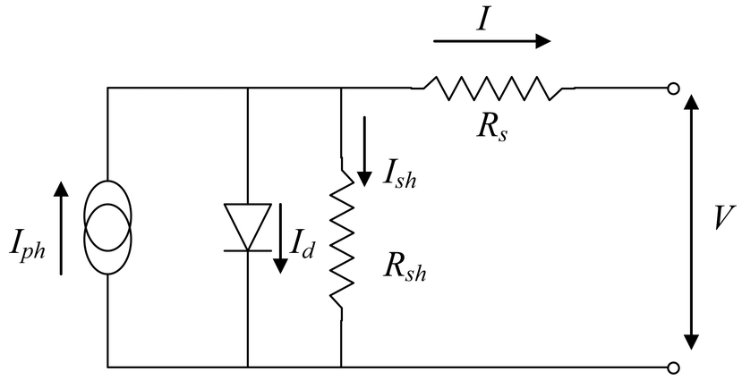
The mechanical power of the wind turbine is determined by the following equation:
Figure 2. Equivalent circuit of solar cell
The mathematical model that expresses the performance of a photovoltaic panel is given by the following equation (1):

$Ipv=Iph-Is\left(e^{\frac{Vpv+Rsh*Ipv}{n*k*T}}-1\right)-\frac{Vpv-Rs*Ipv}{Rsh}$ (1)

Where:
I_{PV}: Output current
V: Output voltage
Iph​: Photogenerated current (depends on solar irradiance and temperature)
I_{S}​: Reverse saturation current of the diode
q: Charge of electron (1.602 × 10⁻¹⁹ C)
k: Boltzmann constant (1.381 × 10⁻²³ J/K)
T: Temperature in Kelvin
n: Ideality factor of the diode (typically 1–2)
Rs​: Series resistance
Rsh​: Shunt resistance

Wind modeling
The operation of a wind turbine is based on converting the kinetic energy of the wind, captured by the blades, into mechanical energy using the rotating shaft. This mechanical energy is then transformed into electrical energy using a permanent magnet synchronous generator (PMSG) [7]. Finally, the three-phase alternating current produced by the PMSG is rectified into direct current using a rectifier. The energy produced by a wind turbine influenced by several factors such as wind speed, blade surface area, and air density.
The mechanical power of the wind turbine is determined by the following equation (2):

$Pmech=\frac{1}{2}ρπR^{2}C_{p}\left(λ_{t},β\right){v_{w}}^{3}$ (2)
where:
ρ: air density
R: rotor blade radius
V_{w}: wind speed
Cp: power coefficient, which evaluates the efficiency of the turbine and blades as a function of the tip speed ratio λt​ and the angle (β).

Modelling of BES
Lithium batteries are the most widely used energy storage systems due to their high performance, high efficiency and long lifespan [8]. The battery state of charge is defined by (3):
$SOC$_{batt} = 100[1-(1$\frac{1}{Qbatt}$ ∫ $\int_{0}^{t}{i_{batt}(t)dt }$)] (3)
Where;
𝑖_{batt}: the battery's current (A)
𝑄_{𝑏att}: the battery capacity (Ah)

DC-DC Converters and MPPT
DC-DC converters play an important part in DC microgrids. They are responsible for voltage level modification so that energy from different sources could be used efficiently by different parts. In the configuration used here, both the photovoltaic (PV) panels and the permanent magnet synchronous generator (PMSG) are connected to the DC bus through boost converters, which elevate and regulate their output voltage.
To guarantee that every source delivers maximum power, the converters are controlled using an MPPT algorithm. As for the battery, it is interfaced to the grid through a bidirectional DC-DC converter. The converter switches between two modes: it discharges in boost mode when the bus voltage drops below 400V, and it charges in buck mode when the voltage is higher than that.
This operation is regulated by a PID controller that continuously adjusts the duty cycle of the converter in order to reduce voltage error, thus making the battery charge and discharge smooth and stable.

$u\left(t\right)=K_{pe}\left(t\right)+K_{i} ∫e\left(t\right)dt+K_{d}\frac{de\left(t\right)}{dt}$ (4)

The error between the reference voltage and the actual voltage is given by:

$$e\left(t\right)=Vref-V_{load}(t)$$
Where:
K_{pe}: proportional gain
K_{i}: integral gain
K_{d}: derivative gain
u(t): control signal sent to the DC-DC converter

The MPPT algorithm is used to continuously extract the maximum power from PV and wind sources, even under changing conditions like temperature, irradiance, or wind speed. It works by adjusting the duty cycle of the boost converter. In this system, the Perturb and Observe (P&O) algorithm is used.

Fault Detection and Diagnosis Strategy
The fault detection and isolation method used in the DC microgrid is based on monitoring the current in each line through Intelligent Electronic Devices (IEDs). These devices continuously supervise the system and manage the operation of circuit breakers installed at both ends of every line.

If the current on a line goes beyond a set threshold, it indicates a fault. The IEDs then react by sending a command to open the circuit breakers, quickly isolating the affected section to prevent further issues. The breakers used in this system can interrupt fault currents in less than 1 millisecond. The overall approach is illustrated in Figure 3 and Figure 4.

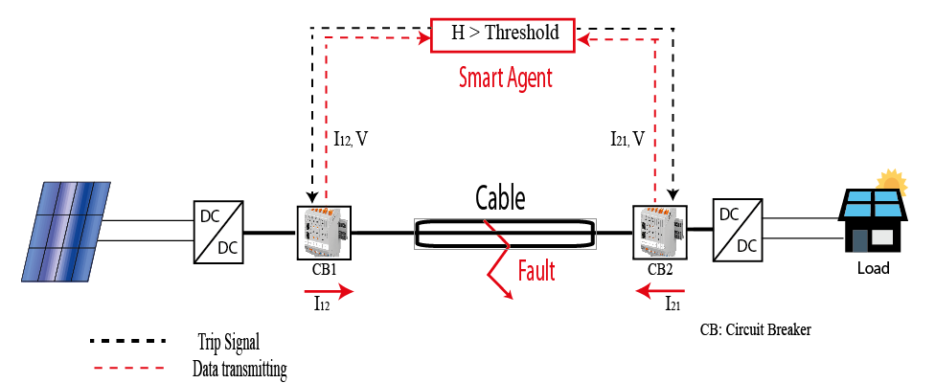
IED

Figure 3. Fault detection and isolation method
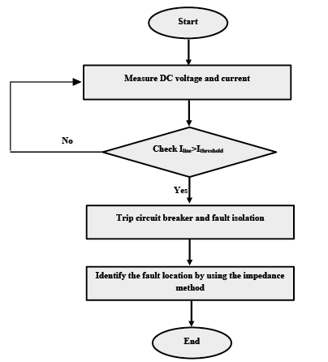

Figure 4. Diagram that describes the method of fault detection and isolation

Simulation and Results

Energy Management System
The Energy Management System plays a key role in keeping the microgrid stable and running smoothly, even as solar and wind power fluctuate. Its main objective is to keep the DC bus voltage close to 400V and ensure that power supply matches the load demand. To do this, the system relies on a battery connected through a bidirectional DC-DC converter.
- When the bus voltage exceeds 400 volts or the generated power is greater than the load demand, the converter acts as a buck converter, diverting excess energy to the battery.
- Conversely, when the bus voltage drops below 400 volts or the generated power is insufficient, the converter switches to boost mode, drawing power from the battery to support the DC bus.

To test the proposed method, the simulation starts with the total power generated from renewable sources being lower than the load demand PL, as shown in Figure 5. Throughout the simulation, the source power fluctuates to reflect realistic variations in solar and wind generation. The battery system responds by compensating for the power imbalance:
- It discharges when the generated power is insufficient to meet the load.
- It charges when $Pt>PL$​, absorbing the excess energy.
This scenario highlights the effectiveness of the EMS in maintaining power balance and ensuring system stability under dynamic operating conditions. The DC bus voltage (Figure 6 (a)) quickly stabilizes at the reference value of 400 V, confirming the EMS and converter’s ability to maintain voltage stability under varying conditions. The SOC (Figure 6 (b) ) initially drops as the battery discharges to support the load, then rises as excess energy is used to recharge it—demonstrating effective power balancing.

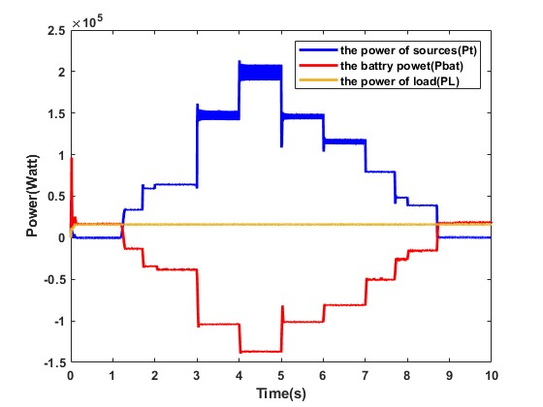
Figure 5. Power Flow in the Microgrid Under a Dynamic Scenario
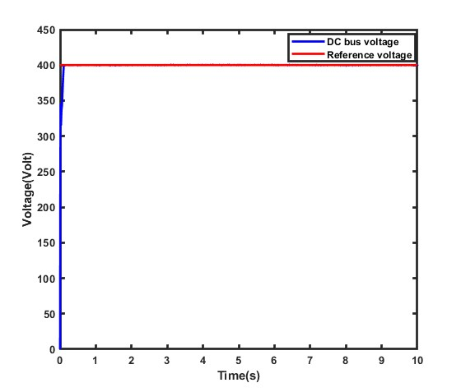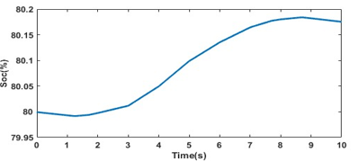
- (b)
Figure 6. (a) DC Bus voltage regulation, (b) battery state of charge (b).

Performance evaluation for short-circuit fault in cable 1
The proposed fault location method is tested during a line-to-line fault in the PV section over a 6s simulation. The system operates normally until t = 3 s, when a fault occurs on the PV line (cable 1), causing a sharp rise in current and a rapid voltage drop. The current quickly exceeds the predefined threshold, triggering the protection mechanism.
Figure 7 (a) shows the current profile, while Figure 7 (b) illustrates the voltage response during the fault event.
At t = 3 seconds, the system detects a fault on line 2, which corresponds to the PV section. It quickly identifies the fault and opens the circuit breakers at both ends of the affected line to isolate the problem.

Right after the fault is cleared, the voltage returns to normal and stabilizes around 400 volts, while the fault current drops sharply to zero—showing that the protection system worked as intended. Figure 8 shows how the breakers behaved during this event. Before the fault (from 0 to 3 seconds), the breakers are closed, meaning everything is running normally. Once the fault is detected, they open (between 3 and 5 seconds) to disconnect the faulty section and keep the rest of the system safe. Also this figure shows that the circuit breakers can clear faults in less than 1 millisecond.

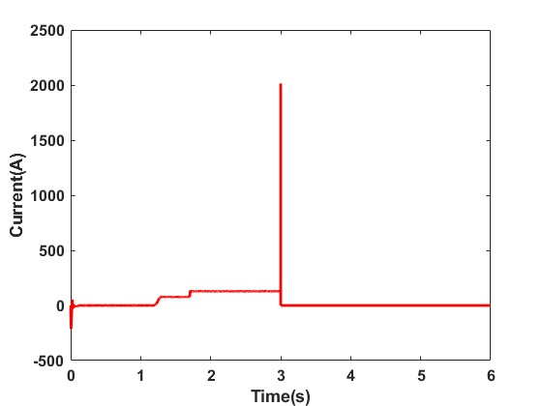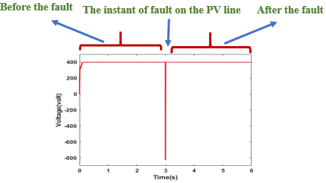

- (b)
Figure 7. (a) Fault Current Profile, (b) DC Bus Voltage Response
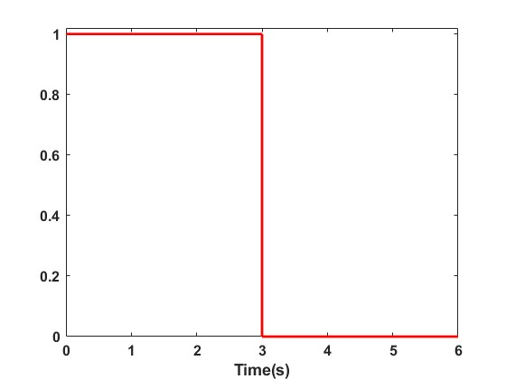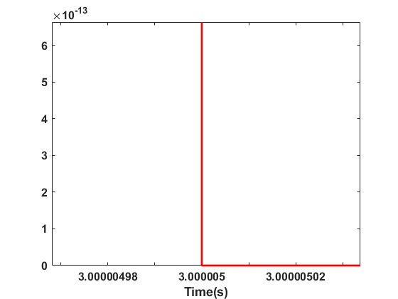

Figure 8. Circuit Breaker Status Durng Fault Isolation (1 = Closed, 0 = Open).

Performance evaluation for short-circuit fault in cable 6

The system show normal operation until t=4s, when t=4s, a fault is affected on the wind line (cable 6) and causes a sudden increase in current and a rapid decrease in voltage. The current is increased rapidly, exceeding the threshold value (1000 A). Figure 9 (a) shows the current behavior and Figure 9 (b) shows the voltage behavior.
After the fault, the voltage returns quickly to 400 volts and the current becomes equal to 0, indicating that the affected line is isolated. Figure 10 present the control signal of the circuit breaker during this event, demonstrating effective fault detection and isolation.
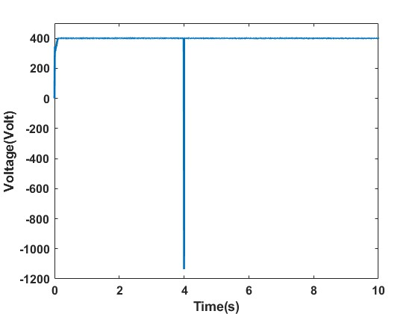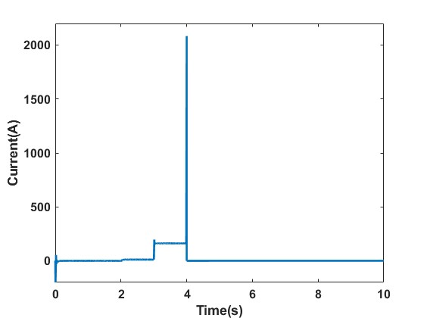
- (b)
Figure 9. (a) Fault Current Profile, (b) DC Bus Voltage Response
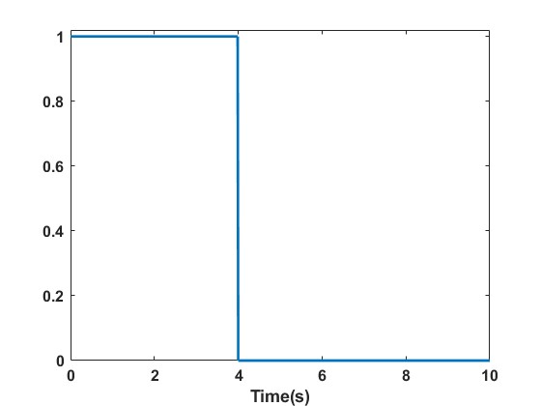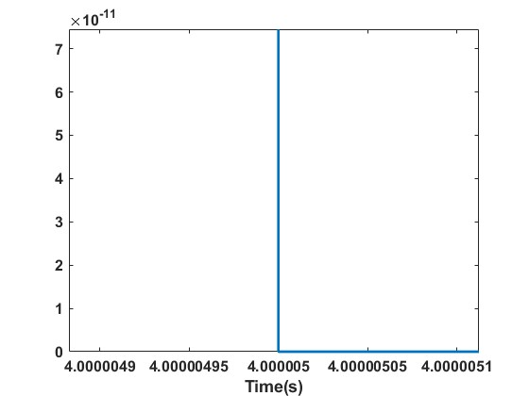

Figure 10. Circuit Breaker Status During Fault Isolation (1 = Closed, 0 = Open).

The results of the simulation carried out confirm the effectiveness of the proposed method in managing energy and handling faults within the DC microgrid. The system maintains stable voltage, ensures reliable power flow, and responds quickly to fault conditions by accurately detecting and isolating the affected lines.

CONCLUSION

This work presented an intelligent supervision system for energy management, fault detection, and fault location in a DC microgrid. The proposed method effectively maintains power balance and voltage stability through real-time control of renewable sources and battery storage, even under fluctuating generation conditions. Simulation results confirmed the system’s ability to detect and isolate faults quickly, ensuring safe and reliable microgrid operation. Overall, the approach demonstrates strong potential for enhancing the resilience and performance of future DC microgrids.

References

- Luo, X., Wang, J., Dooner, M., & Clarke, J. “Overview of current development in electrical energy storage technologies and the application potential in power system operation”. Applied energy, 137, 511-536, (2015).
- Bhalla, A., & Bhalja, B. R. “A new fault detection and relay coordination technique for low voltage DC microgrid”. Electric Power Systems Research, 236, 110907, (2024).
- Belagoune, S., Bali, N., Bakdi, A., Baadji, B., & Atif, K. “Deep learning through LSTM classification and regression for transmission line fault detection, diagnosis and location in large-scale multi-machine power systems”. Measurement, 177, 109330, (2021).
- Anjaiah, K., Pattnaik, S. R., Dash, P. K., & Bisoi, R. “A real-time DC faults diagnosis in a DC ring microgrid by using derivative current based optimal weighted broad learning system”. Applied Soft Computing, 142, 110334, (2023).
- Bhargav, R., Bhalja, B. R., & Gupta, C. P. “Novel fault detection and localization algorithm for low-voltage DC microgrid”. IEEE Transactions on Industrial Informatics, 16(7), 4498-4511, (2019).
- Al-Ezzi, A. S., & Ansari, M. N. M. “Photovoltaic solar cells: a review”. Applied System Innovation, 5(4), 67, (2022).
- Tripathi, S. M., Tiwari, A. N., & Singh, D. “Grid-integrated permanent magnet synchronous generator-based wind energy conversion systems: A technology review”. Renewable and Sustainable Energy Reviews, 51, 1288-1305, (2015).
- Xu, J., Cai, X., Cai, S., Shao, Y., Hu, C., Lu, S., & Ding, S. “High‐energy lithium‐ion batteries: recent progress and a promising future in applications”. Energy & Environmental Materials, 6(5), e12450, (2023).

