Design and Implementation of Smart Meter for Optimizing and Management of Electrical Energy in Morocco
Alhussein BAGAYOGO ^{1,a)}, Omar Kabouri ^{1,b)},Aboubakr EL Makrini ^{1,c)}, Mohamed Azeroual ^{2,d)},
Hassane EL Markhi ^{1,e)}

¹Science and Engineering Research Laboratory, Faculty of Sciences and Technology, Sidi Mohamed Ben Abdellah University, Fez, Morocco.
²SEIMC Research Group, LASMAR Laboratory, Higher School of Technology, Meknes, Moulay Ismail University, Meknes, Morocco.

Author Emails
a) Corresponding author: Alhussein.bagayogo@usmba.ac.ma
b) Omar.kabouri@usmba.ac.ma
c) Aboubakr.elmakrini@usmba.ac.ma
d) Mohamed.azeroual1@usmba.ac.ma
e) Hassane.elmarkhi@usmba.ac.ma
Abstract: Sustainable energy systems play a crucial role in transforming the energy sector, but their intermittent and unpredictable output remains a major challenge for their effective integration into electricity grids. Smart meters are an important technological solution because they can process data and improve the flow of electricity. This article presents a smart meter prototype designed to improve the balance between supply and demand, minimize energy losses, and support dynamic pricing models. The first step in development was to design the electronic architecture of the measurement unit, which included different control circuits for current, voltage, communication, relay-based switching, and display functions. Subsequently, the components and the HT5023 microcontroller were assembled on a printed circuit board (PCB) to form a complete hardware system. The final configuration allows for both energy import and export functionality, facilitating the calculation of injected and consumed power for producers and consumers. In addition, the system incorporates a robust communication protocol, the Device Message Language Specification (DMLS), which ensures secure and reliable real-time energy data exchange. Preliminary simulation results are promising: in a voltage range between 120 V and 230 V and a current range between 0 A and 20 A, the smart meter successfully monitored in real time the import of energy from an external source and the export to external loads. In addition, the protection relay tripped automatically whenever the load threshold was exceeded.
Keywords— Smart meter, Renewable energy, Energy Transition, Measurement.
INTRODUCTION
The energy transition that we are experiencing today represents a major global shakeup to reduce reliance on fossil fuels in favor of renewable alternatives like solar and wind. Morocco has large potential in renewable resources and has pledged to include these energies into its energy mix not to mention its goal to reach 52% by 2030 [1] [2]. The increasing integration of renewable energies, in particular photovoltaics, requires an adaptation of energy distribution techniques and network architectures. Unlike conventional centralized power plants, renewable sources are generally decentralized and intermittent, which creates new challenges in terms of stability, flow management, and energy quality. Traditional power grids, based on a unidirectional radial architecture, must evolve towards intelligent and bidirectional models. Smart grids appear to be an essential solution for managing distributed production, allowing real-time supervision and optimization of consumption and storage[3]. The integration of smart meters, SCADA systems, and IoT technologies promotes dynamic balancing between supply and demand.
At this level the smart meter is pivotally important as it revolutionizes measurement, monitoring, and analysis of energy flows. However, current solutions have major flaws: they do not account for the unique dynamics of renewable energies, in particular dynamic import and export of energy between producers and consumers. This failure inhibits the development of an interactive and flexible energy model, where each actor could optimize his participation and optimization. Finally, current smart meters. also have problems with communication and real-time data security, which negatively affects the transparency and reliability of the electricity[4]. In responding to these problems, this research proposes to design a smart meter that is particularly adapted to both renewable energy and non-renewable energy management in Morocco. This new device will have two important innovations: - An import-export feature so that the user can track precisely all incoming and outgoing flows and thereby optimize management and valorization of produced energy locally. - A communications protocol such as DMLS that also can ensure safe, timely transfer of energy data while helping to bolster accountability and trust in the energy system. - A feature with Control relays to manage loads and detect fraud.
The smart energy management system shown in Fig. 1 includes a smart meter, a battery storage system, and a renewable energy source that utilizes a DC bus to efficiently distribute energy before it is converted to AC using a DC/AC inverter. At the center of the architecture, the smart meter is positioned to monitor energy transactions between loads, the power grid, and the units that produce power from renewable energy sources. In addition, the smart meter provides data communications to manage energy such that it can be done without overload or fraud. While on the DC bus, it has alternative sources and battery storage, so it has energy autonomy, even if the production is erratic. The AC bus distributes energy to both domestic and industrial loads using a grid, ensuring that there is always a reliable energy supply[5] . The image illustrates real-time operation, showing how power and data streams interact, while the integration with a communications infrastructure enables real-time monitoring and adaptive decision-making to optimize energy management.

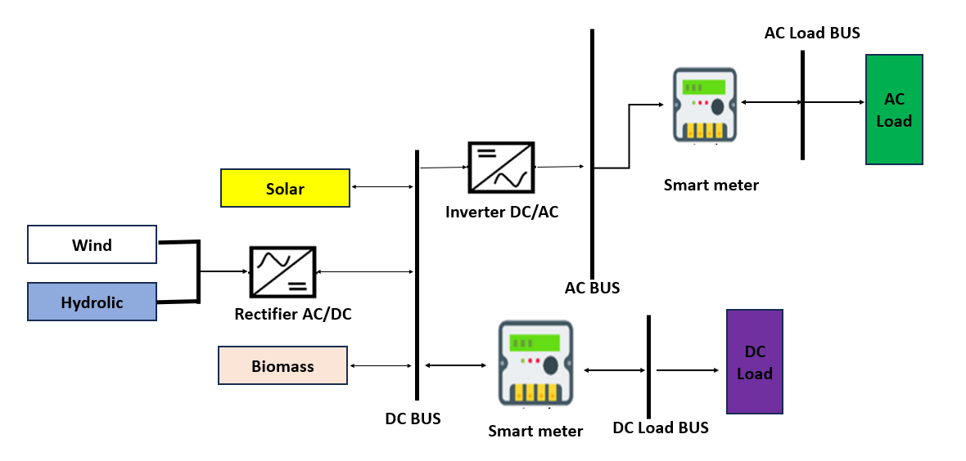
Fig. 1. The Network schematic includes a new smart meter.

This approach responds to Morocco's strategic needs in terms of optimizing the production and distribution of renewable energies while supporting the transition to a more sustainable, resilient, and technologically advanced energy model [6].

METHODS

The three-phase smart meter developed in this paper aims to optimize energy management in real-time by accurately measuring the import and export of electricity. Fig. 2 initiates the procedure by recording energy supply data, enabling the tracking of both energy production and consumption. A validation of energy sources is also made to establish operational energy flows. The data are utilized to measure in real time a range of electric parameters regarding energy import as well as energy export, which are voltage (V), current (A), apparent power (S), active power (P), reactive power (Q), energy utilized (kWh), and power factor (PF). The system also incorporates advanced functionalities that include measuring frequency and power factor, as well as establishing the overall harmonic distortion of both voltage and current. All these measures enable us to correctly measure energy exchange dynamics in the network. The gathered data are transferred into a relay control module, which is essential in fraud detection as well as in detecting nonconformities. In case a nonconformity is detected, i.e., a fraud on the meter or a nonconformity in energy utilization, a corrective measure is triggered immediately, up to cutting the power supply in order not to produce energy waste or a network violation. In case no nonconformities are detected, data are confirmed and stored to be later analyzed.
A communications module then facilitates information transfer via a web interface as well as a client-server. This allows energy data to be monitored in a remote form as well as promotes energy flexibility by dynamically modulating energy flows according to demand. In addition, live data transfer supports anticipatory power grid management, which allows users as well as power grid owners to coordinate consumption with production variability.
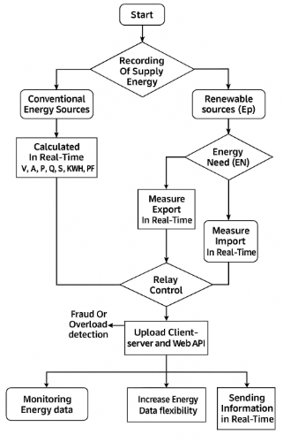
Fig. 2. The process flowchart
DESIGN AND FUNCTION OF A SMART METER
The design of this scalable smart meter has been made using several key components to optimize electricity management, import, and export. These include a microcontroller HT5023 that ensures intelligent energy measurement management, a Voltage transformer EE19-005101, a Current transformer JD01 80A-400VAC-18VDV, an HTZ810V1.3 Bluetooth module, resistive attenuators for voltage input regulation, an SD card storage module, an RTC ER14250, and an integrated power supply module. Fig.3 illustrates the architecture of this advanced system.

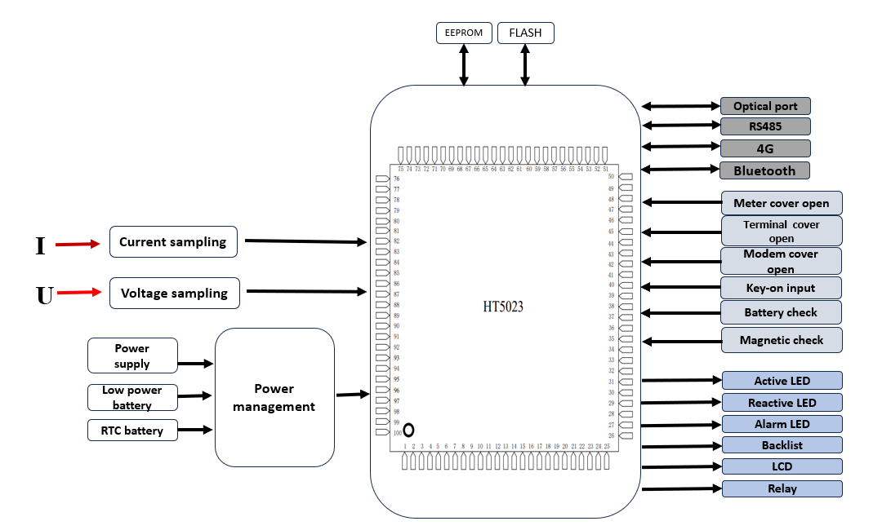
Fig. 3. Smart meter architecture

The SM measures and analyzes electrical data by sampling current and voltage via dedicated circuits connected to a microcontroller (MCU). These analog signals are converted into digital, making it possible to calculate the active and reactive energy, the instantaneous power, and the energy quality parameters. The system manages its power supply through a combination of sources: a main power supply, a backup battery for minimal operation in case of failure, and a PSTN battery to maintain the clock in real-time. A management module optimizes the transitions between these sources to guarantee service continuity. For safety and supervision, the meter is equipped with sensors detecting unauthorized openings of the covers, monitoring the state of the batteries, and identifying manipulation attempts by magnetic fields. The collected data is transmitted via communication interfaces such as RS485 for local connections, 4G and Bluetooth for remote access, and an optical port for on-site configuration or diagnosis. Finally, the microcontroller controls LEDs to indicate the state of the system, an LCD screen to display essential information (voltage, current, energy), and relays to activate or deactivate the electrical circuits according to the detected commands or events.

VOLTAGE MEASURING INSTRUMENT

Fig. 4 shows a voltage measurement circuit designed for the input of the HT5023 microcontroller. It makes it possible to convert the high voltages of a three-phase electrical network into signals compatible with the microcontroller. At the input, the phase (L) and the neutral (N) of the network pass through a set of protection resistors (RM7, RM8, RM9, RM10, RM11, and RM12), forming a voltage divider that reduces the voltage of the network to a safe level and suitable for the microcontroller. The resistors RM31 and RM32, associated with the capacitors CM5 and CM6, play a filtering and stabilizing role, eliminating rapid variations and unwanted noise on the signal. The output voltages thus obtained, V3P and V3N, are proportional to the voltages of the electrical network and are transmitted to the input of the HT5023 microcontroller for their analysis. This circuit ensures both the protection of the microcontroller against overvoltages and the provision of a stable and accurate measurement signal.
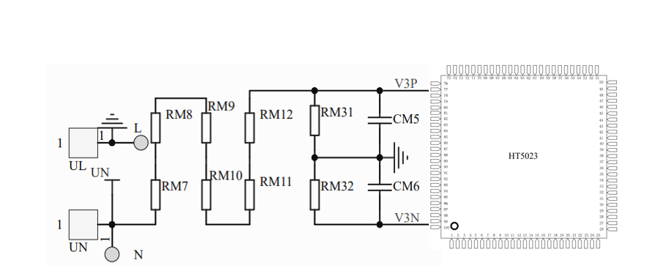
Fig. 4. Voltage block diagram.

CURRENT MEASURING INSTRUMENT

Fig.5 illustrates a current measurement circuit designed for the input of the HT5023 microcontroller. It makes it possible to convert the input currents (IA, IB, and IC) into voltage signals compatible with the capabilities of the microcontroller. The circuit is divided into three sections to measure the currents of phases IA, IB, and IC. For the IA phase, the IA+ and IA- signals pass through the resistors RM1 and RM6, which act as protection and attenuation elements. Capacitors CM2 and CM3, connected in parallel with these resistors, provide signal filtering to eliminate unwanted noise and stabilize the output. The corresponding output voltages, V1P and V1N, are then transmitted to the microcontroller. Similarly, for phase IB and IC, the signals IB+, IC+, and IB-, IC- pass through a network of resistors (RM2, RM3, RM4, and RM5). This network reduces the current and transforms it into a compatible voltage signal. The capacitors CM1 and CM4, arranged in parallel, perform filtering to provide stable output voltages, V2P and V2N and V3P and V3N also directed to the microcontroller's input. This circuit thus makes it possible to condition the current signals coming from phases IA, IB, and IC into voltages adapted for the HT5023 microcontroller. It guarantees an accurate measurement while protecting the microcontroller against sudden variations or noises in the input signal.
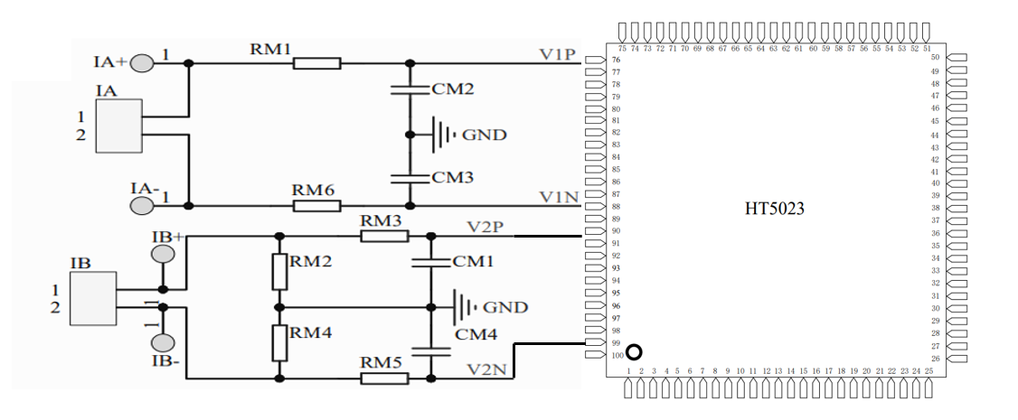
Fig. 5. Current block diagram.

COMMUNICATION MODEL

The exchange of data between data collection systems and measurement equipment using the COSEM protocol is based on an interface model structured around the client/server paradigm. The measurement equipment, such as smart meters, play the role of servers. The applications responsible for data collection or counting are modeled as one or more application processes (AP). The communication is systematically carried out between a client access point and a server access point: the client initiates the service requests, and the server responds by providing the required data. In this model shown in Fig. 6, a client access point can interact with one or more server access points simultaneously, thus facilitating the management of multiple measurement equipment in parallel. Likewise, a server access point can respond to several client access points at the same time, guaranteeing effective two-way communication[7] [8]. To structure this communication, the DLMS /COSEM protocol relies on well-defined communication profiles. A DLMS/COSEM communication profile is a set of protocol layers, with the COSEM application Layer (Application Layer, or AL) at the top. Each profile is specified by the protocol layers used, their parameters, as well as by the type of application control service (ACSE) included in the application layer[9].

RELAY CONTROL

This device is essential to protect electrical infrastructures against anomalies and guarantee optimal network operation, especially when they are integrated with renewable energy production systems. It makes it possible to establish or break the connection between different components of the electrical network in response to control signals or abnormal events, such as overloads, short circuits, or frequency anomalies.
A proposed smart meter integrates management with three main states (Disconnected, Connected, and Ready for reconnection), offering a smooth and secure transition between these states thanks to manual, local, and remote commands to optimize the control, protection, and reliability of the energy network, especially in the context of the integration of renewable energies.
CASE STUDY
This case study, illustrated in Fig. 7, promotes smart metering in a grid-connected solar photovoltaic (PV) system consisting of panels with an on-grid inverter, a residential load (house), and a smart meter connecting to the public electricity grid. The electricity generated from the energy produced by the solar panels is converted to AC electricity using the inverter and used to supply the house. Any energy excess is exported to the grid, and any energy deficit (if the house load demand is greater than what is supplied from solar production) will be imported from the grid. The smart meter is important and provides good measures of both imported and exported power. The diagram indicates that at some points in time that the system is exporting 4.71 kW to the grid and importing 2.35 kW, both are dynamic energy flows. The bi-directional measure means that accurate billing, invoicing, monitoring consumption and production, and enabling smart grid functionality are possible. The arrangement shown here demonstrates how smart metering can support optimized energy management, particularly in times of intermittence in renewable generation.
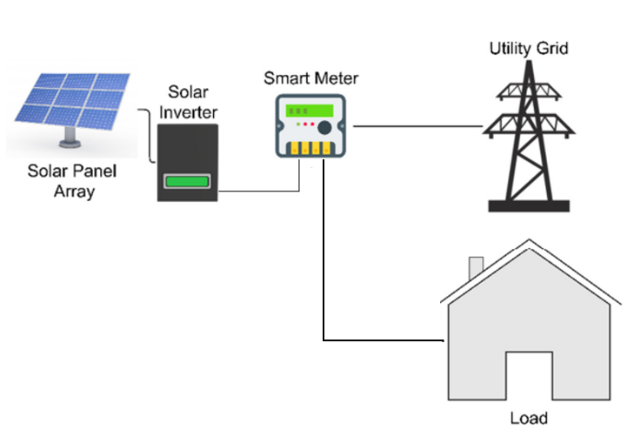
Fig. 7. Framework.
RESULTS AND DISCUSSION
TEST ERROR
Table 1 shows the accuracy errors of the smart meter, tested on a calibration bench on which we applied varying currents from 1 to 10 A to each phase. We can see that these are normal, as they are between ±1%, which reassures us about the measurement of real-time values.
Table 1. Error Analysis of the Smart Meter.
Phase A (A) | Phase B (A) | Phase C (A) | Phase A(%) | Phase B (%) | Phase C (%)
9.975 | 10.053 | 10.064 | +0.0355 | +0.0138 | +0.0319
9.000 | 9.002 | 9.030 | -0.0558 | +0.0291 | +0.0069
8.115 | 8.005 | 8.030 | +0.4663 | +0.0138 | +0.0000
7.250 | 7.068 | 7.090 | +0.0066 | +0.0458 | -0.0486
6.028 | 6.029 | 6.058 | -0.0685 | +0.0291 | +0.0222
5.019 | 5.058 | 5.070 | +0.0086 | +0.0458 | +0.0305
4.108 | 4.038 | 4.047 | +0.1647 | -0.0027 | +0.0069
2.994 | 3.039 | 3.045 | +0.0247 | +0.0125 | +0.0222
2.531 | 2.531 | 2.535 | +0.0087 | +0.0134 | +0.0245
1.083 | 1.008 | 1.009 | +0.0217 | +0.0153 | +0.0178
These results demonstrate the robustness and reliability of the counting systems designed using our PCB.
VOLTAGE AND CURRENT DATA PERFORMANCE

Fig. 8 analyzes the behavior of voltage and current in a three-phase electrical system over time using the smart meter. In Fig. 8(a), we observed that the voltage starts around 120 V, then rises quickly to about 230 V, where it remains stable with some small variations. This indicates that the power is working normally. In Fig. 8(b), it is noted that the current begins at 0 A, then gradually increases up to 10 A before varying and reaching a peak at 20 A. However, at the end, the current drops abruptly to 0 A. This sudden fall is explained by the shareholder cut-off relay integrated into the meter, which makes it possible to cut off the power in case of exceeding the maximum authorized power, resulting in an automatic cut-off to avoid overloading.

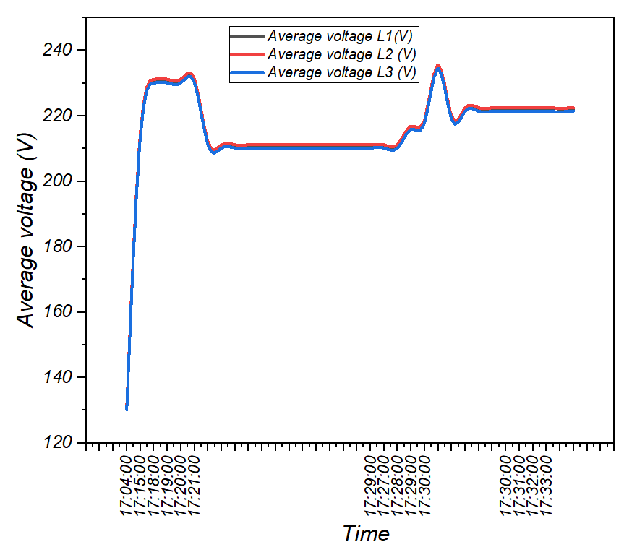
(a) Voltage measure
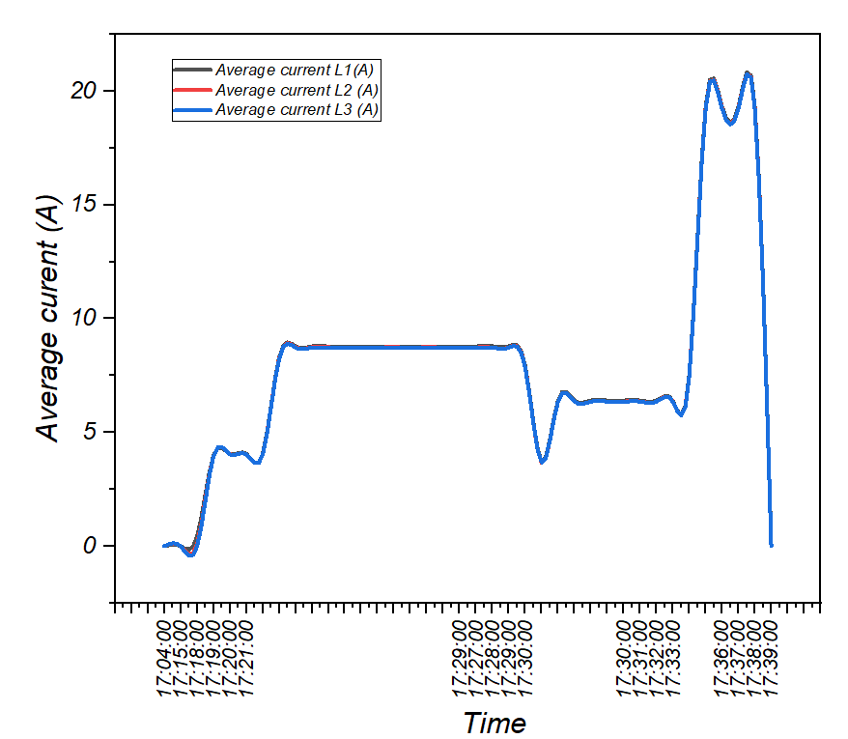
(b) Current measure
Fig. 8 . Variation of Voltage and Current depending on the time
In summary, the voltage remains stable, but the current varies according to demand and ends up being cut when the power exceeds the authorized limit. This shows that a protection mechanism is in place to avoid overloads and ensure the proper functioning of the network.

HOURS PROFILE IMPORT AND EXPORT

In Fig. 9, we can follow the dynamics of energy flows measured in real-time by the smart meter and highlight the variation of imported and exported energy at different periods, thus illustrating the interactions between a production system and an energy consumption system with the electrical network. The import curve, located to the left of the ordinate axis, indicates the amount of energy taken from the grid by the system to satisfy the demand, and to the right, we have the export curve, which indicates the energy injected into the grid due to the availability of a surplus of production in particular in the presence of a generator or renewable sources.

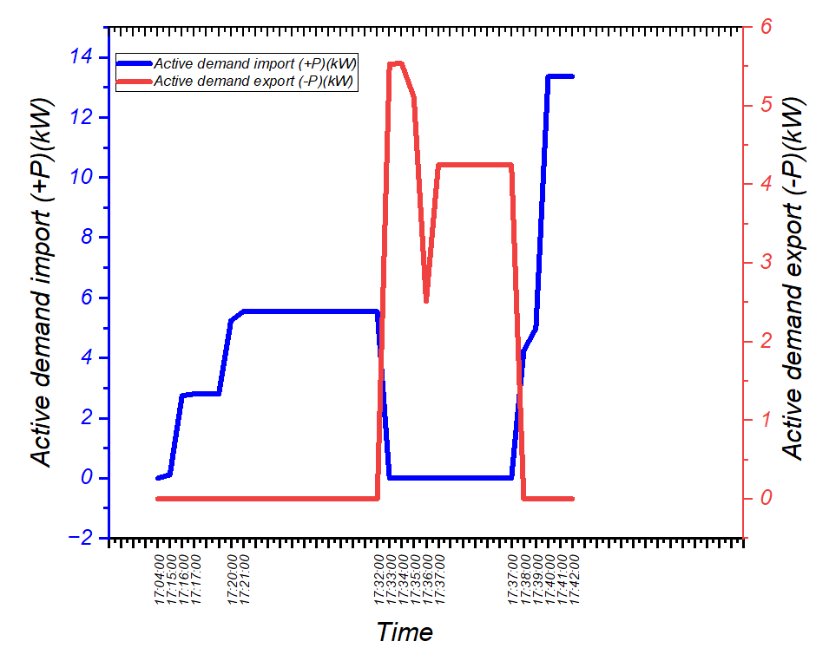
(c) Active power demand

Fig. 9. Hours Profile Import and Export

CONCLUSION

This article presents the development of a three-phase smart energy meter incorporating advanced power quality features. The system design is based on an optimized architecture, using voltage and current circuits and adapted DLMS/COSEM communication protocols. The results obtained during the various simulations show accuracy errors of between ±1% at the input of each phase, A, B, and C. This first stage allowed us to record the load curves for voltages between 0V, 120V, and 230V, and currents between 0, 10, and 20A, which were very satisfactory in terms of analysis. In addition, these initial results from the meter could enable us to integrate it into microgrid and smart grid infrastructures in order to optimize load balancing and manage energy flows in real time, as the experimental validation of measurements based on enhanced simulation has demonstrated the reliability of the device in the laboratory.

In future research, several axes can be explored to enrich the capabilities of the Smart meter. One of the possible developments concerns the integration of artificial intelligence algorithms to improve the analysis of energy data and to allow non-intrusive load monitoring. This approach would make it possible to identify and classify electrical appliances without additional sensors, thus optimizing the management of energy consumption. Finally, exploring advanced communication protocols and blockchain-based solutions could strengthen the security and confidentiality of the data collected, thus paving the way for new applications in the field of intelligent energy management.
References
[1] K. Choukri, A. Naddami, et S. Hayani, « Renewable energy in emergent countries: lessons from energy transition in Morocco », Energ Sustain Soc, vol. 7, nº 1, p. 25, déc. 2017, doi: 10.1186/s13705-017-0131-2.
[2] The Signals, Systems and Components Laboratory, Sidi Mohamed Ben Abdellah University,FST Fez, Morocco et al., « Renewable Energy Potential and Available Capacity for Wind and Solar Power in Morocco Towards 2030 », JESTR, vol. 11, nº 1, p. 189‑198, févr. 2018, doi: 10.25103/jestr.111.23.
[3] A. Leonard, A. Ahsan, F. Charbonnier, et S. Hirmer, « Renewable energy in Morocco: Assessing resource curse risks », Renewable and Sustainable Energy Reviews, vol. 192, p. 114210, mars 2024, doi: 10.1016/j.rser.2023.114210.
[4] F. Al-Turjman et M. Abujubbeh, « IoT-enabled smart grid via SM: An overview », Future Generation Computer Systems, vol. 96, p. 579‑590, juill. 2019, doi: 10.1016/j.future.2019.02.012.
[5] M. Azeroual et al., « Fault location and detection techniques in power distribution systems with distributed generation: Kenitra City (Morocco) as a case study », Electric Power Systems Research, vol. 209, p. 108026, août 2022, doi: 10.1016/j.epsr.2022.108026.
[6] O. Ghizlane et C. Yamina, « Innovation in renewable energy in Morocco: economic opportunities and policy measures », S. F. J. of Dev., vol. 5, nº 10, p. e4490, oct. 2024, doi: 10.46932/sfjdv5n10-015.
[7] M. Dumay, H. Al Haj Hassan, P. Surbayrole, T. Artis, D. Barthel, et A. Pelov, « Enabling Extremely Energy-Efficient End-to-End Secure Communications for Smart Metering Internet of Things Applications Using Static Context Header Compression », Applied Sciences, vol. 13, nº 21, p. 11921, oct. 2023, doi: 10.3390/app132111921.
[8] M. Dumay, H. Al Haj Hassan, P. Surbayrole, T. Artis, D. Barthel, et A. Pelov, « Enabling Extremely Energy-Efficient End-to-End Secure Communications for Smart Metering Internet of Things Applications Using Static Context Header Compression », Applied Sciences, vol. 13, nº 21, p. 11921, oct. 2023, doi: 10.3390/app132111921.
[9] S. Hwan Ju et H. Suk Seo, « Design Key Management System for DLMS/COSEM Standard-based Smart Metering », IJET, vol. 7, nº 3.34, p. 554‑557, sept. 2018, doi: 10.14419/ijet.v7i3.34.19380.

