Energy Management Strategy for Grid-Connected Hybrid Renewable Energy System with Lithium Battery Storage
Omar KABOURI ^{1, a)}, Alhussein BAGAYOGO ^{1, b)}, Fatima Zahra MOUGHRAOUI ^{1, c)}, Mohamed AZEROUAL^{2, d)}, Hassan EL MOUSSAOUI ^{1, e)}, and Hassane EL MARKHI ^{1, f)}
¹Science and Engineering Research Laboratory, Faculty of Sciences and Techniques, Sidi Mohamed Ben Abdellah University, Fez, Morocco.
²SEIMC Research Group, LASMAR Laboratory, Higher School of Technology, Moulay Ismail University, Meknes, Morocco.
Author Emails
^{a)} Corresponding author: omar.kabouri@usmba.ac.ma
^{b)}Alhussein.bagayogo@usmba.ac.ma ^{c)} fatimazahra.moughraoui@usmba.ac.ma
^{d)} mohamed.azeroual1@usmba.ac.ma ^{e)} hassan.elmoussaoui@usmba.ac.ma
^{f)} hassane.elmarkhi@usmba.ac.ma

Abstract. In recent years, hybrid energy source systems (HESS) have emerged as a promising solution for delivering reliable electrical power to remote and off-grid areas. These systems typically integrate two or more renewable energy sources (RESs), such as photovoltaic (PV) panels and wind turbines (WT). However, because RESs are inherently variable and weather-dependent, they often cause fluctuations in both power output and voltage levels. To address these challenges, energy storage technologies play a vital role by helping to stabilize the system, smooth out fluctuations, and ensure a more consistent and dependable power supply in hybrid PV/WT configurations. This paper presents a robust control strategy for a grid-connected microgrid (MG) that includes PV and WT systems with a battery energy storage (BESS). The proposed energy management system (EMS) aims to overcome the inherent fluctuations of PV and WT power sources, as well as the stochastic nature of load demand. The EMS uses dynamic power flow coordination to successfully eliminate energy exchange oscillations between the HESS and the utility grid while maintaining DC bus voltage stability. In addition, the incorporation of the BESS significantly reduces power losses, thereby enhancing the overall efficiency of the MG. The simulation results demonstrate that the proposed EMS effectively balances power across all components of the system while maintaining stable DC bus voltage with less than 2% overshoot. The system successfully manages power fluctuations from unpredictable PV and WT sources while quickly adapting to changing load demands. This results in improved energy stability, reduced dependence on traditional grids, and more reliable battery charging.
Keywords: Microgrid, PV, WT, Grid, Battery, Energy Management Strategy.

Introduction
The global community is rushing towards cleaner energy to tackle the impending climate change and depletion of fossil fuel resources. has accelerated the world's shift to renewable energy sources, as WT and PV panels have emerged as the leading renewables due to their abundant resources, dropping costs and zero environmental impact [1]. However, the main drawback of these RES is their inherent variability their power generation is directly dependent on weather conditions, this intermittent generation behavior creates substantial operational difficulties, particularly in maintaining the essential equilibrium between electricity supply and fluctuating consumer demand patterns [2]. There is an overall solution to meet these challenges, which is to install MGs based on decentralized RESs, energy storage systems, and intelligent control is one way to address these issues overall and create a flexible and integrated energy ecosystem. MG relies heavily on energy storage systems especially BES, to address the intermittency of RESs. These BES systems play a key role in maintaining voltage stability in MGs and storing excess energy when RESs generate more power than is required. When there is insufficient renewable power available the stored energy is then released back into the system, an MG can function in isolated mode or synchronously interface with the utility grid [3]. MGs enable bidirectional connectivity with the utility grid via a point of common coupling (PCC) allowing for flexible power exchange based on operating requirements. When local generation exceeds consumption demands, surplus energy is transferred from the MG to the grid. Conversely, when electrical demand within the MG exceeds its generation capacity, additional power is drawn from the external grid to make up the power requirement [4].
Recent years have seen substantial advances in MG research, with a focus on improving control mechanisms, power management techniques, and power management efficiency. Current MG deployments require power management systems with great capabilities to easily coordinate multiple generators and loads while maintaining a steady supply of power. Effective energy management improves the dependency on renewable sources, storage, and load needs within the MG architecture. Numerous control strategies have been considered in MGs, and these include simple rule-based approaches to more complex techniques such as model predictive control (MPC) [5], optimization strategies [6], and fuzzy logic (FL) [7]. This paper presents an effective energy management strategy for a grid-connected MG incorporating a hybrid renewable generation system with battery energy storage to stabilize DC bus voltage and power within the system. The proposed approach aims to minimize dependence on the utility grid, reduce costs, and decrease environmental pollution through the strategic integration of clean energy technologies.
The key contributions of this work include:
- Design and performance simulation of a Grid-connected hybrid MG system integrating PV, WT, and battery energy storage.
- Development of an adaptive EMS to optimize system performance and address parameter uncertainties in hybrid renewable energy configurations.
- Implementation of an intelligent EMS enabling real-time monitoring and autonomous decision-making under dynamic operating conditions.
- DC bus voltage stabilization and power system deviation mitigation under variable meteorological conditions and dynamic load demands.
- Comprehensive performance evaluation of the Grid-Connected MG system across diverse operational scenarios using MATLAB/Simulink.
The rest of the paper is organized as follows: Section II describes the MG configuration and component models. Section III explains the control strategy and the EMS algorithm. Section IV presents a simulation and discusses the results. Section V concludes the paper.

System modeling and description
The grid-connected MG architecture used in this study is shown in Figure 1, comprising PV and WT systems as primary renewable energy sources, supplemented by battery energy storage and grid connectivity to reliably meet AC load demands while enabling optimal economic operation. The PV/WT system is interfaced to the DC bus through a DC/DC boost converter equipped with perturb and observe (P&O) maximum power point tracking (MPPT) control to maximize energy extraction under varying irradiance and wind speed conditions. Energy storage is provided by a battery bank connected to the DC link via a bidirectional DC-DC buck-boost converter, facilitating efficient bidirectional power flow between the DC bus and storage system. This configuration enables the battery to operate in both charging and discharging modes, depending on system power balance requirements and the state of charge of the battery. Grid integration is achieved through a three-phase voltage source converter (VSC) that interfaces the DC link with the utility grid. The VSC operates bidirectionally, functioning as an inverter during power export to the grid or as a rectifier when importing power from the grid, thereby providing operational flexibility and enhancing system reliability.

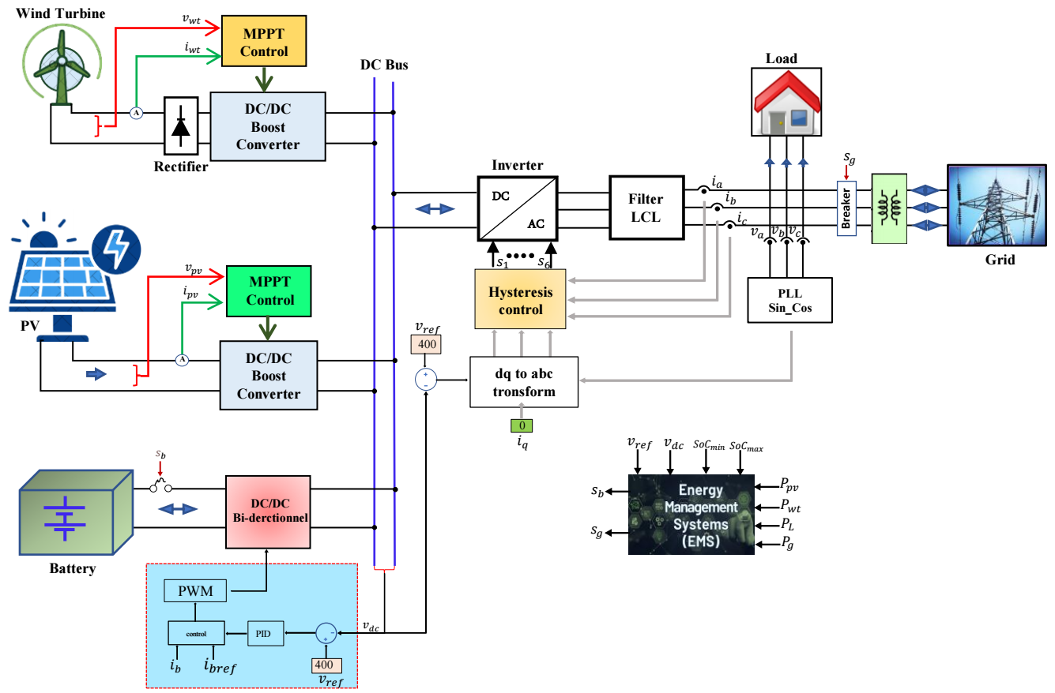
Figure 1. Architecture of the grid-connected HGS with battery storage.

Photovoltaic system
The PV system consists of a series of PV panels linked to a DC bus via a boost DC/DC converter. This converter is controlled by the MPPT algorithm. In this work, the P&O algorithm was used to modify the duty cycle to provide consistent and efficient power extraction from the PV array under different environmental circumstances. This algorithm was chosen because of its simplicity and efficiency. The power output of the PV system is quantitatively described by Eq. (1) [6].
$P_{pv_out}(t)= P_{pv_rated}\frac{G_{t}(t)}{1000}\left[1+ α_{t}(\left(T_{amb}+\left(0.0256G_{t}\right)\right)-T_{C_{STC}})\right]$ (1)

Wind turbine model
A WT transforms wind energy into mechanical energy, which powers a generator to produce electrical energy. The mechanical power produced by a WT can be represented as Eq. (2) [7].
$P_{Wind}= \frac{1}{2}ρA{V_{Wind}}^{3}C_{p}\left(λ,β\right)$ (2)
The power coefficient (Cp) serves as a critical parameter for quantifying the aerodynamic efficiency of WT in extracting kinetic energy from wind flow. This dimensionless coefficient exhibits a complex nonlinear relationship with both the blade pitch angle (β) and the tip speed ratio (λ), representing the intricate aerodynamic interactions governing turbine performance. According to Betz's theoretical limit, the maximum achievable power coefficient is constrained to approximately 0.593, which can be mathematically represented through Eq (3) incorporating empirical coefficients C1 through C6. The tip speed ratio λ, as defined in Eq (4), represents the ratio of the tangential velocity at the blade tip to the upstream wind velocity, thereby characterizing the operational regime of the wind turbine rotor [8].
$C_{p}\left(λ, β\right)$ = $C_{1}$($\frac{C_{2}}{λ_{i}} {- C}_{3}β-C_{4})$ $e^{-\left(\frac{C_{5}}{λ_{i}}\right)}$ + ${ C}_{6}λ$ (3)
$λ= \frac{ω_{r}R}{V}$ (4)
Where:
${λ_{i}}^{-1}$ = ${\left(λ+0.08β\right)}^{-1}$ – ${0.035\left(1+ β^{3}\right)}^{-1}$ (5)

Battery
In this study, the energy storage device is modeled as a battery. This battery model includes E, the battery's open-circuit voltage, and the resistor $R_{b}$. The battery supply voltage is defined as follows Eq. (6):
$E$ = $E_{0}$ - $\frac{kQ}{Q- \int_{0}^{t}{i_{b}dt}}$ + A$\exp^{(-B\int_{0}^{t}{i_{b}dt})}$ (6)
Further, the SoC of the battery over time can be estimated as follows in Eq. (7) [7]:
${SoC}_{Bat}$ = 100$\left(1+ \frac{\int_{0}^{t}{i_{b}dt}}{Q}\right)$ (7)
Where: the constant voltage of the battery is denoted by $E_{0}$, whereas K and Q, respectively, denote the polarisation voltage and capacity of the battery. denotes ∫$i_{b}$dt specifies the battery charging unit, A indicates the amplitude of the exponential zone, and B represents the inverse of the tie zone exponential constant.

Grid model
The output currents of the inverter d-q rotating frame are as follows, Eq. (8) [9]:
$\left\{\begin{aligned}l_{f}\frac{di_{gd}(t)}{dt}= -R_{f}i_{gd}\left(t\right)-wl_{f}i_{gd}\left(t\right)+V_{fd}-V_{gd} \\ l_{f}\frac{di_{gq}(t)}{dt}=-R_{f}i_{gq}\left(t\right)-wl_{f}i_{gq}\left(t\right)+V_{fq}-V_{gq}\end{aligned}\right.$ (8)
Where $V_{gd}$ ,$V_{gq}$ are the d-q components of the inverter voltage, $i_{gd}$, $i_{gq}$the grid current.

Energy Management Strategy
The management of the power flow is an important process for optimizing the system components and the efficient operation of the system. The proposed EMS can be divided into two parts: standalone operation when disconnected from the utility network, and integrated operation while maintaining grid connectivity. The operational logic of the proposed energy management strategy is illustrated through the flowchart presented in Figure 2.
The EMS operates by continuously monitoring critical system parameters, including the power generated by photovoltaic (P_{PV}) and wind turbine (P_{WT}) sources, the state of charge (SoC) of the battery, and the DC bus voltage (V_{dc}). The system begins by measuring these key parameters and calculating the net power using Eq. (9):
$P_{net}= P_{PV}+P_{wt}$ - $P_{Loads}$ (9)
The EMS decision-making process follows a systematic approach based on the net power calculation. When P_{net} > 0, indicating excess power generation, the system enters the "Excess power" mode. In this scenario, the EMS first evaluates the battery's state of charge. If SoC < 80%, the surplus energy is directed to charge the battery, ensuring optimal energy storage utilization. However, when the battery reaches or exceeds 80% SoC, all surplus energy is injected into the grid to prevent overcharging and maintain battery longevity. Conversely, when P_{net} ≤ 0, indicating a power deficit, the system enters "Deficit power" mode. The EMS then checks if the battery's SoC is greater than 20%. If this minimum threshold is met, the battery is discharged to compensate for the power shortfall. When the SoC falls to or below 20%, the battery is protected from deep discharge, and the required power is instead absorbed from the grid to meet the load demand.
Figure 2. Flowchart of EMS for grid-connected MG
This control strategy ensures several key objectives: maximizing RES utilization efficiency, protecting battery life through controlled charging and discharging cycles, maintaining DC bus voltage stability, and ensuring seamless power balance between generation, storage, and consumption. The proposed strategy minimizes battery overcharging and deep discharge while optimizing RESs utilization.

RESULTS and discussion
The studied grid-connected microgrid, as illustrated in Figure 1, is simulated using MATLAB/Simulink. Table 1 represents the parameters for each component of the proposed system. This section presents the study's primary findings obtained through comprehensive testing under a specific operational scenario involving dynamic variations in electrical load demands, solar irradiation levels, and wind speeds. Through this detailed computational model, we thoroughly evaluate how well the energy management approach performs in balancing energy supply and demand, optimizing renewable energy utilization, employing the BESS to mitigate power fluctuations, maintaining the stability of the DC bus voltage at its reference value of 400V, and ensuring seamless operation across both grid-connected and islanded modes under diverse operating conditions.
Table1: Component Parameters of Grid-Connected MG.
PV system: TPS105S-295W | P_{max =} 295.26 W, I_{sc =} 8.32 A,  V_{m =} 37 V, I_{mp} = 7.98 A  V_{oc =} 45.2 V
Battery (Li-thium) | 230V, 300 Ah,  initial SoC = 17%
Wind turbines | C₁= 0.5176, C₂= 116, C₃= 5, C₄= 0.4, C₅= 21, C₆= 0.0068
boost converter | C = 0.01F, L = 1e-3 H
Load | P_{max} = 26 kW, P_{min} = 1.2 kW

Moreover, to evaluate the dynamic performance behavior of the proposed hybrid system, systematic stepwise changes in solar irradiation and wind velocity profiles were introduced deliberately, as seen from Figures 3(a) and 3(b).
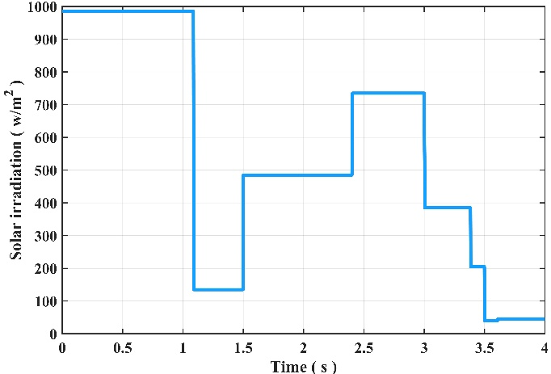  (a) | 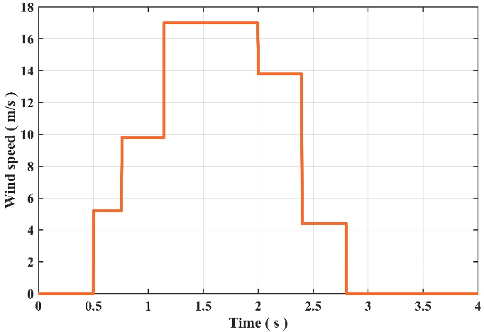  (b)
Figure 3. (a) Solar irradiation (W/$m^{2})$, (b) wind speed (m/s)
The profile for solar irradiance was aimed at mimicking real meteorological conditions, including transitions from peak solar intensity level (1000 W/m²) to low irradiation levels. Accordingly, the wind speed profile was established to replicate real meteorological conditions, with rapid transitions from time spans of quiescence to maximum wind speeds of approximately 18 m/s, subsequently followed by a gradual decrease to zero wind conditions. Such comprehensive testing conditions enable a thorough evaluation of the EMS's operational robustness, especially its capability for sustaining DC bus voltage stability and maximizing energy storage utilization during time spans of significant meteorological variability. The implementation of these realistic scenarios provides valuable insights into the system’s adaptive capabilities and its ability to ensure seamless power delivery despite the inherent unpredictability of renewable energy sources.

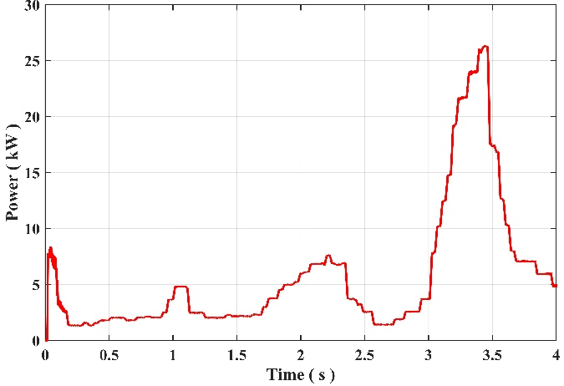  (a) | 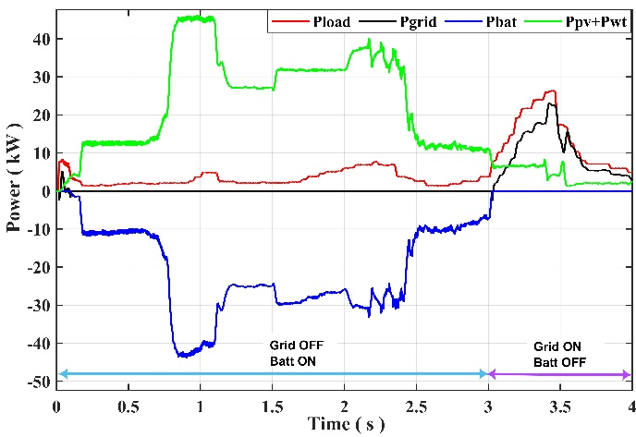  (b)
Figure 4. (a) AC load power, (b) PV/WT, grid, load, and battery power.
The load profile applied to the hybrid system during the simulation period is shown in Figure 4(a). The profile begins with a power demand of roughly 6 Kw and shows dynamic and variable load behavior. After that, there are several oscillations before it peaks at approximately 26 Kw in 3.4 seconds. The purpose of this load pattern is to simulate actual consumption circumstances, which are marked by abrupt spikes and dips in demand. This type of profile is especially helpful for evaluating how responsive and resilient the EMS is to sudden changes in load. Figure 4(b) depict the power of the component of the system, during the initial 0 to 3 s, the PV and WT generators produced more power than the load required, resulting in surplus energy used to charge the battery bank, with the SoC increasing slightly from 17% to 17.25% as shown in Figure 5(a), while the grid remained disconnected. However, between 3s to 4 seconds, reduced solar irradiance and wind speed, coupled with increased load demand, caused a power deficit. As the battery SoC remained below 20%, the EMS prevented deep discharge by disconnecting the battery and switching to grid-support mode to meet the shortfall. Confirming its ability to respond to fluctuations in both generation and consumption dynamically, regulate voltage and frequency effectively, and coordinate power flows economically.

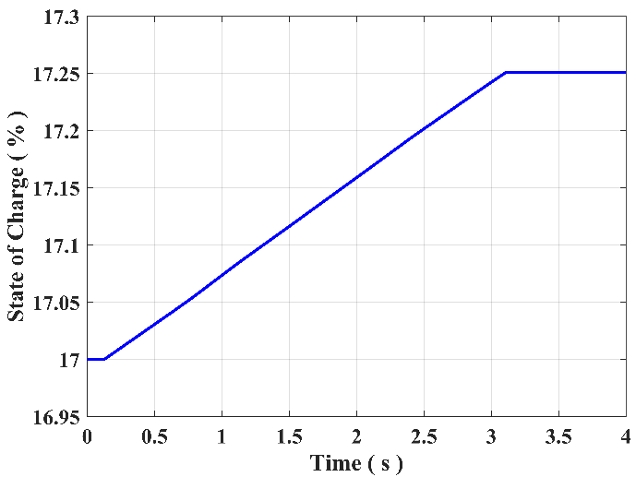  (a) | 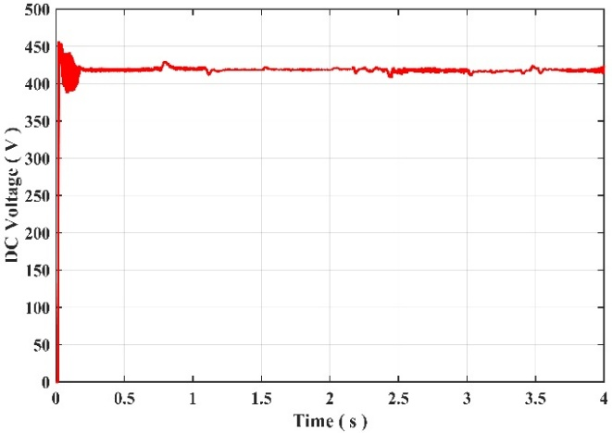 (b)
Figure 5. (a) SoC of the battery. (b) DC bus voltage.
Maintaining a stable DC bus voltage is critical for overall system reliability and performance. The controller-based EMS effectively regulates the Buck-Boost converter output to maintain the DC bus voltage near its reference value. As demonstrated in Figure 5(b), the DC bus voltage exhibits excellent stability throughout the simulation period, remaining constant at approximately 400V with only minor fluctuations of less than 2% of the reference voltage.
These simulation results demonstrate that the proposed EMS is exceptionally capable of managing complex energy flows effectively, maintaining robust system stability and DC bus voltage regulation under dynamic conditions, and seamlessly adapting to simultaneous changes in both renewable generation and load demand patterns. The validated performance across diverse operational scenarios confirms the strategy’s superior suitability for addressing the fundamental challenges of renewable energy intermittency, load variability, DC-bus voltage fluctuations, and critical system protection requirements while ensuring reliable, efficient, and economically optimized operation of grid-connected hybrid MG applications.

Conclusion
This research demonstrates that our energy management system effectively handles renewable power variability by maintaining DC voltage stability with less than 2% overshoot and implementing intelligent battery control within 20-80% state of charge limits. The approach successfully eliminates grid oscillations while reducing system losses through coordinated power flow management between solar, wind, and storage components. Our findings show reliable operation across different modes, offering communities a practical pathway to energy independence from conventional grid infrastructure.

Reference
1. Q. Hassan, S. Algburi, A. Z. Sameen, H. M. Salman, and M. Jaszczur, ‘A review of hybrid renewable energy systems: Solar and wind-powered solutions: Challenges, opportunities, and policy implications’, Results in Engineering, vol. 20, p. 101621, Dec. 2023, doi: 10.1016/j.rineng.2023.101621.
2. N. H. Saad, A. A. El-Sattar, and A. E.-A. M. Mansour, ‘A novel control strategy for grid connected hybrid renewable energy systems using improved particle swarm optimization’, Ain Shams Engineering Journal, vol. 9, no. 4, pp. 2195–2214, Dec. 2018, doi: 10.1016/j.asej.2017.03.009.
3. S. Parhizi, H. Lotfi, A. Khodaei, and S. Bahramirad, ‘State of the Art in Research on Microgrids: A Review’, IEEE Access, vol. 3, pp. 890–925, 2015, doi: 10.1109/ACCESS.2015.2443119.
4. M. Azeroual, T. Lamhamdi, H. El Moussaoui, and H. El Markhi, ‘Simulation tools for a smart grid and energy management for microgrid with wind power using multi-agent system’, Wind Engineering, vol. 44, no. 6, pp. 661–672, Dec. 2020, doi: 10.1177/0309524X19862755.
5. F. Kamal and B. Chowdhury, ‘Model predictive control and optimization of networked microgrids’, International Journal of Electrical Power & Energy Systems, vol. 138, p. 107804, Jun. 2022, doi: 10.1016/j.ijepes.2021.107804.
6. A. L. Bukar, C. W. Tan, and K. Y. Lau, ‘Optimal sizing of an autonomous photovoltaic/wind/battery/diesel generator microgrid using grasshopper optimization algorithm’, Solar Energy, vol. 188, pp. 685–696, Aug. 2019, doi: 10.1016/j.solener.2019.06.050.
7. O. Kabouri, M. Azeroual, H. El Markhi, and A. Bagayogo, ‘A Novel Fuzzy Logic EMS for Hybrid Microgrids with Photovoltaic, Wind, Fuel Cell, and Energy Storage Integration’, E3S Web Conf., vol. 601, p. 00059, 2025, doi: 10.1051/e3sconf/202560100059.
8. M. A. Abdullah, A. H. M. Yatim, C. W. Tan, and R. Saidur, ‘A review of maximum power point tracking algorithms for wind energy systems’, Renewable and Sustainable Energy Reviews, vol. 16, no. 5, pp. 3220–3227, Jun. 2012, doi: 10.1016/j.rser.2012.02.016.
9. S. Rajshekar, L. C. Saikia, and L. Nandyala, ‘Optimizing wind energy integration with fuzzy PID DSTACOM and hybrid MPPT for reduced harmonic distortion’, Computers and Electrical Engineering, vol. 124, p. 110391, May 2025, doi: 10.1016/j.compeleceng.2025.110391.

