Integration of Wind Energy to Optimize Electric Vehicle Charging: Wind Turbine Modeling
Mina BEN RAOUANE^{1, a)} and Lahcen BALLI^{1, b)} and Isamel DRIOUCH^{1, c)}
¹ Engineering Sciences and Applications Laboratory (LSIA), National School of Applied Sciences (ENSAH),
Abdelmalek Essaadi University, Tetouan, Morocco.
a) mina.benraouane@etu.uae.ac.ma
b) lballi@uae.ac.ma
c) i.driouch@uae.ac.ma
Abstract. The integration of renewable energy into electric vehicle (EV) charging is a promising solution to reduce carbon emissions and improve energy management. By utilizing sources such as wind and solar power, this approach enables more sustainable EV charging while enhancing grid stability through smart charging systems and energy storage. This paper explores the role of wind energy in optimizing EV charging by focusing on wind turbine modeling. Accurate modeling of wind turbines is crucial for predicting energy output, optimizing power generation, and ensuring efficient integration with charging stations. By leveraging advanced modeling techniques, this approach can improve energy management strategies and enhance the stability of the power grid.
Keywords: Wind Energy, Electric Vehicle Charging, Renewable Energy, Energy Management, Energy Storage.

INTRODUCTION
In Morocco, the breakdown of energy-related CO₂ emissions reflects the country's economic structure and energy system. In 2022, the electricity and heat sector contributed about 32% of total emissions, mainly from fossil fuel combustion. The transport sector accounted for approximately 29% of emissions, predominantly from cars, despite a growing number of electric vehicles—around 23,000 in 2022 [1]. Residential heating, primarily using fossil fuels, contributed about 14%, while the industrial sector was responsible for around 6.6%, mainly due to fossil fuel use in processes like cement production. These figures underscore the necessity for Morocco to adopt renewable energy solutions and promote cleaner transportation options to reduce overall CO₂ emissions [2].
In Morocco, the rising energy demand, intensified by the charging of electric vehicles (EVs), puts pressure on the grid, which is already limited in integrating renewable energy sources.
Integrating renewable energy sources, particularly wind energy, into EV charging infrastructure offers a sustainable solution to this challenge. Wind power is a clean and abundant resource that can enhance the sustainability of EV charging while reducing reliance on fossil fuels.

RESEARCH OBJECTIVES AND METHODOLOGY
This research deals with modeling energy processes in a hybrid system that includes wind energy focused. The first phase consists of gathering wind speed data and assessing potential sites for the installation of wind turbines so that energy capture specific to the needs of EV charging can be efficient.
A complete mathematical model is then developed using equations of wind energy conversion along with aerodynamic characteristics of turbine, mechanical dynamics of the drivetrain, and electrical characteristics of the PMSG. The system is further refined by adding sophisticated control elements, such as multilevel inverter (MLI) rectifier control and maximum power point tracking (MPPT) control, which allow aggressive power extraction while providing stabilized dc voltage for charging.
In this phase, modeling and simulation are performed in MATLAB/Simulink to estimate energy production under different wind speed ranges. Constant and variable wind speeds are tested to identify the system’s response.
MLI Rectifier Control
Wind Energy Conversion
MATLAB/Simulink
Aerodynamic Characteristics
Energy Production Estimation
Mechanical Dynamics
Electrical Characteristics
Case Studies
Site Assessment
MPPT Control
Wind Speed Data
Simulation and Validation
Research
Objectives
and
Methodology
Control Elements
Mathematical Modeling
Wind Energy Capture
FIGURE 1. Research methodology for integrating wind energy into electric vehicle charging systems

SYSTEM DESCRIPTION: hybrid energy system for electric vehicle (EV) charging
The illustrated architecture presents a hybrid energy system integrating photovoltaic panels and a wind turbine to supply power for electric vehicle (EV) charging. Solar energy is conditioned via a DC/DC converter, while wind energy is converted from AC to DC, both feeding into a common DC bus. This bus supplies energy to DC fast charging stations, battery storage systems (via bidirectional DC/DC converters), and the utility grid through a DC/AC inverter.
An Energy Management System (EMS) monitors and controls energy flows in real-time, supported by a communication and data storage unit. The system enables efficient energy distribution, grid interaction, and enhanced renewable energy utilization for sustainable and resilient EV charging infrastructure.

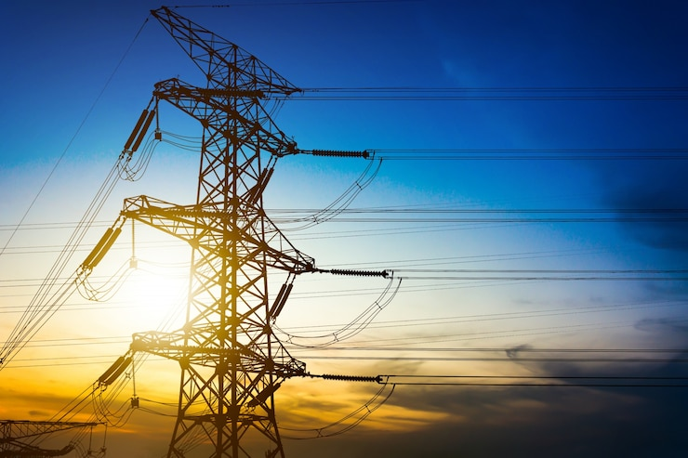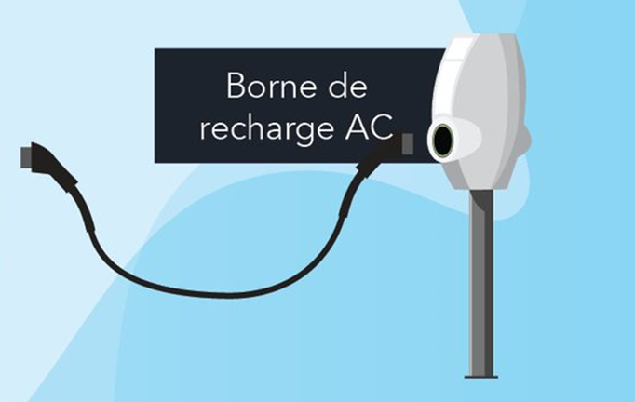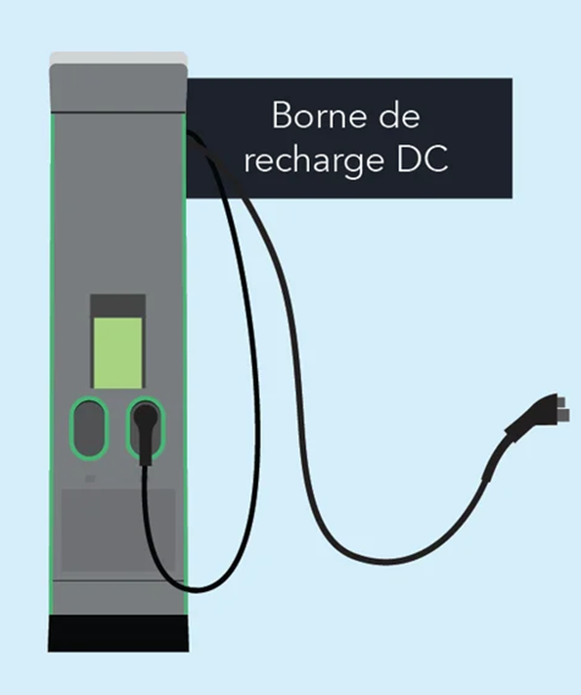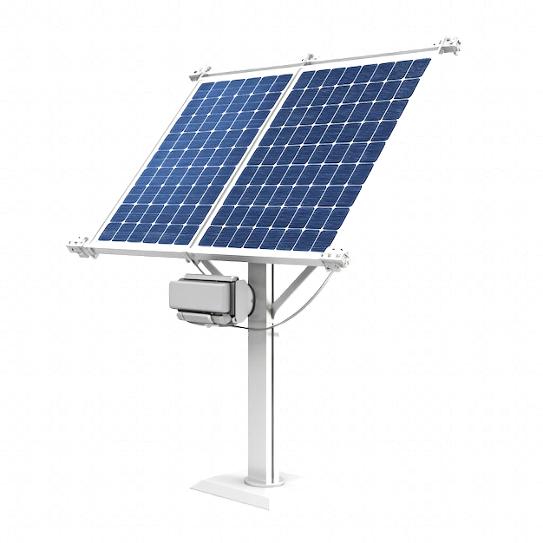
AC/DC Converter
DC/DC Converter
DC/DC Converter
DC/AC Converter
DC charging station
AC charging station
Storage elements
electric vehicle
Electrical grid
DC bus
Photovoltaic panel
wind turbine
Energy Management System (EMS)
Communication
data storage
FIGURE 2. Hybrid energy production and management system for electric vehicle charging
This study focuses specifically on the integration of wind energy as a power source within electric vehicle (EV) charging systems. The proposed wind-based system is designed to operate within a Hybrid Renewable Energy Storage System (HRESS), using a DC bus as the central coupling point for energy distribution. The conversion process from wind energy to usable electrical energy is illustrated in Figure 3. Wind drives the rotation of a turbine, which is mechanically coupled to a gearbox and a drive shaft. This mechanical assembly is connected to a Permanent Magnet Synchronous Generator (PMSG) that converts mechanical power into three-phase AC electrical power. The generated AC power is then converted into DC using a three-phase Pulse Width Modulated (PWM) rectifier. The rectifier output is connected to a DC bus with a constant voltage level Vdc.

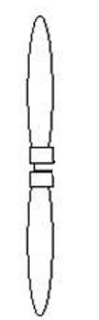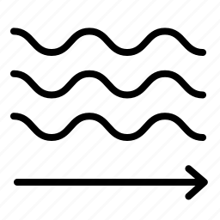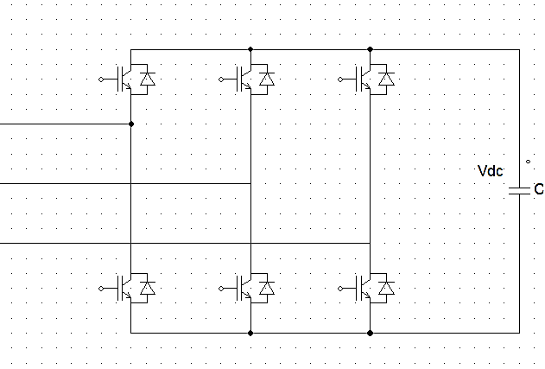
PWM Rectifier
Generator
Wind
Turbine + Gearbox + Shaft
DC Bus
FIGURE 3. Conversion diagram of wind energy into DC electricity – Configuration of the wind system under study

Wind Turbine Modeling

The Power Coefficient Cp
The power coefficient Cp which is a measure of aerodynamic efficiency for wind turbines and is a function of the wind turbine’s specific features. Based on data collected from a wind turbine, and following formulations proposed in previous studies, we use the following equation to approximate the power coefficient for this type of turbine [3]:
$C_{p}\left(λ,β\right)=c_{1}\left(\frac{c_{2}}{λ_{i}}-c_{3}β-c_{4}\right)×e^{\frac{-c_{5}}{λ_{i}}}+c_{6}λ$
Where:
$\frac{1}{λ_{i}}=\frac{1}{λ+0,08β}-\frac{0,035}{β^{3}+1}$
Constants :
c₁=0,5167 ; c₂=116 ; c₃=0,4 ; c₄=5 ; c₅=21 ; c₆=0,0068
λ is the tip speed ratio, defined as the ratio between the linear speed of the turbine blades, and the wind speed V [3,4]:
$λ=\frac{Ω_{turbine} ×R}{V}$

Mechanical Power of the Turbine
The aerodynamic power extracted at the turbine rotor is expressed as [3,4,5]:
$P_{aer}=C_{p}×P_{V}=Cp\left(λ ,β\right)×\frac{ρ×S×V^{3}}{2}$

Mechanical Torque of the Turbine
Based on the expression for the power produced by the turbine and knowing the rotational speed of the turbine, the mechanical torque is given by [6]:
$C_{aer}=\frac{P_{aer}}{Ω_{turbine}}=\frac{1}{2Ω_{turbine }}Cp\left(λ,β\right)×ρ×π×R^{2}×V^{3}$

Gearbox Modeling
The gearbox connects the turbine and the generator, adapting the slower turbine speed to the higher generator speed. It is commonly modeled by the following two equations [6]:
$Ω_{mec}=G×Ω_{turbine}→G=\frac{Ω_{mec}}{Ω_{turbine}}$
$C_{g}=\frac{1}{G}×C_{aer}→G=\frac{C_{aer}}{C_{g}}$

Shaft Modeling
The fundamental equation of dynamics allows us to determine the evolution of the mechanical speed based on the total mechanical torque 𝐶total applied to the rotor [6]:
$J×\frac{dΩ_{mec}}{dt}=C_{mec}=C_{g}-C_{em}-C_{vis}$
The resistive torque due to friction is modeled using a viscous friction coefficient f, with the following equation [6]:
$C_{vis}=f×Ω_{mec}$

MPPT Control with Mechanical Speed Regulation
The MPPT method optimizes turbine speed to maximize power by tracking where the power gradient relative to speed is zero. It assumes slow wind speed variations, negligible turbine acceleration torque, and ignores viscous friction. Wind speed can then be estimated as follows [6]:
$V_{estim}=\frac{R{×Ω}_{turbine estim}}{λ_{C_{pmax}}}$

Modeling of the Permanent Magnet Synchronous Generator (PMSG)
The mathematical model of the PMSG can thus be expressed as follows [6]:
$\left[\begin{aligned}V_{d} \\ V_{q}\end{aligned}\right]=\left[\begin{matrix}-R_{s} & 0 \\ 0 & -R_{s}\end{matrix}\right]\left[\begin{aligned}I_{d} \\ I_{q}\end{aligned}\right]+\left[\begin{matrix}{-L}_{d} & 0 \\ 0 & {-L}_{q}\end{matrix}\right]\frac{d}{dt}\left[\begin{aligned}I_{d} \\ I_{q}\end{aligned}\right]+Ω\left(\left[\begin{matrix}0 & L_{q} \\ {-L}_{d} & 0\end{matrix}\right]\left[\begin{aligned}I_{d} \\ I_{q}\end{aligned}\right]+\left[\begin{aligned}0 \\ φ_{f}\end{aligned}\right]\right)$
R_{s}: the resistance of a single stator phase winding.
The magnetic flux equations are given by:
$φd=Ld×Id+φ_{f}$
$φq=Lq×Iq$
Where:
L_{d} is the stator inductance along the d-axis,
L_{q} is the stator inductance along the q-axis,
φ_{f} is the effective magnetic flux produced by the permanent magnets through the stator windings.
The active and reactive power are given by:
$P=\frac{3}{2}(Vd×Id+Vq×Iq)$
$Q=\frac{3}{2}(Vq×Id+Vd×Iq)$
The expression of the electromagnetic torque is given by:
$Cem=\frac{3}{2}p\left(φ_{d}I_{q}{- φ}_{q}I_{d}\right)$
The dynamic equation of the PMSG is given as follows:
$C_{g}-C_{em}-fΩmec=J\frac{dΩmec}{dt}$

Modeling of a Rectifier with PWM (Pulse Width Modulation)
A three-phase PWM rectifier is used to interface the wind turbine with the DC bus. This converter not only enables efficient power conversion but also significantly reduces harmonic distortion in the generator currents [4,6]:
$\begin{matrix}D_{i} conducts if V_{j}=\operatorname{Max}\left(V_{j}\right);i=1,2,3;j=a,b,c \\ d_{i} conducts if V_{j}=\operatorname{Min}\left(V_{j}\right);i=1,2,3;j=a,b,c\end{matrix}$

The output voltage Vdc of the rectifier is given by:
$V_{dc}=\operatorname{Max}\left(V_{j}\right)-\operatorname{Min}\left(V_{j}\right);j=a,b,c$
The phase voltages at the input of the rectifier, Va ref, Vb ref, and Vc ref, are expressed as a function of the switching states of the switches (Sa, Sb, and Sc) and the DC bus voltage Vdc as follows:
$\left[\begin{aligned}V_{a ref} \\ V_{b ref} \\ V_{c ref}\end{aligned}\right]=\frac{V_{dc}}{3}\left[\begin{matrix}2 & -1 & -1 \\ -1 & 2 & -1 \\ -1 & -1 & 2\end{matrix}\right]\left[\begin{aligned}S_{a} \\ S_{b} \\ S_{c}\end{aligned}\right]$
The rectifier–DC side coupling can be expressed by the following equation:
$C\frac{{dV}_{dc}}{dt}=\left[\begin{matrix}S_{a} & S_{b} & S_{c}\end{matrix}\right]\left[\begin{aligned}I_{a} \\ I_{b} \\ I_{c}\end{aligned}\right]$

Control of the Wind Energy Conversion System
Among the various vector control strategies for synchronous machines, the most widely adopted is the one that sets the direct-axis current reference Id to zero. This method leads to a simplification of the electromagnetic torque expression derived from equation (16), resulting in a linear relationship given by [4,6]:
$Cem ref=\frac{3}{2}p\left(φ_{f}×I_{q ref}\right)$
From equations (11), the decoupling terms can be defined and are subsequently considered as disturbances with respect to the control system. To keep the study simple, we focus on the decomposition of voltages. In the first equation, the voltage along the d-axis is split into two components [4,6].
$\left\{\begin{matrix}V_{d}=-V_{dref}+e_{p} \\ e_{p}=+Ω×L_{q}×I_{q}\end{matrix}\right.$
$V_{dref}=\left(R_{s}+L_{d}.s\right){×I}_{d}$
By analogy, the second equation can be treated similarly and defined as:
$\left\{\begin{matrix}V_{q}=-V_{qref}+e_{q} \\ e_{q}=-Ω×L_{d}×I_{d}+Ω×φ_{f}\end{matrix}\right.$
$V_{qref}=\left(R_{s}+L_{q}.s\right){×I}_{q}$
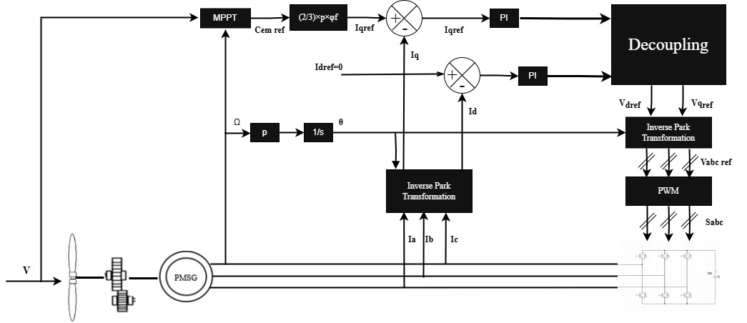
FIGURE 4. Block Diagram of the Wind Turbine Control System

The block diagram shown in Figure.5 represents the global model of the system, developed by implementing and integrating the previously presented mathematical equations in MATLAB/Simulink.

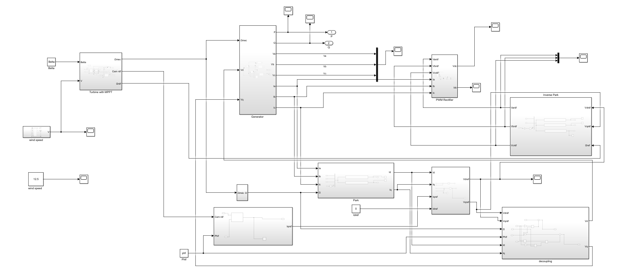
FIGURE 5. The global block diagram of the studied system developed in MATLAB/Simulink

Simulation and Results
For the system simulation, we use the Vestas V164-10.0 wind turbine. The table 1 presents the parameters used.

TABLE 1. Technical Specifications of the Vestas V164-10.0 MW Wind Turbine
Parameter | Value | Unit
Rated power | 10 | MW
Nominal wind speed | 12.5 | m/s
Rotor diameter | 164 | m
Tip speed | 89 | m/s
λmax | 7.12 | -
Cpmax | 0.4 | -
G | 40 | -

The objective of the simulation is to evaluate the impact of wind conditions on the mechanical, energy, and electrical parameters of the conversion chain, in order to optimize electric vehicle charging using the harvested wind energy. Two wind profiles are considered:
• Constant wind speed (Figure.6a);
• Variable wind speed (Figure.6b).

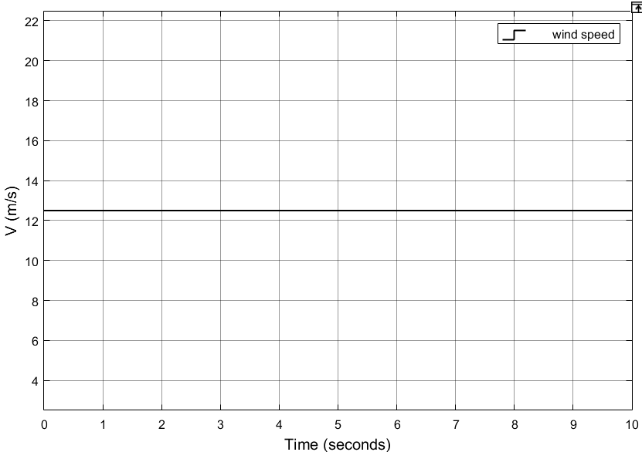 | 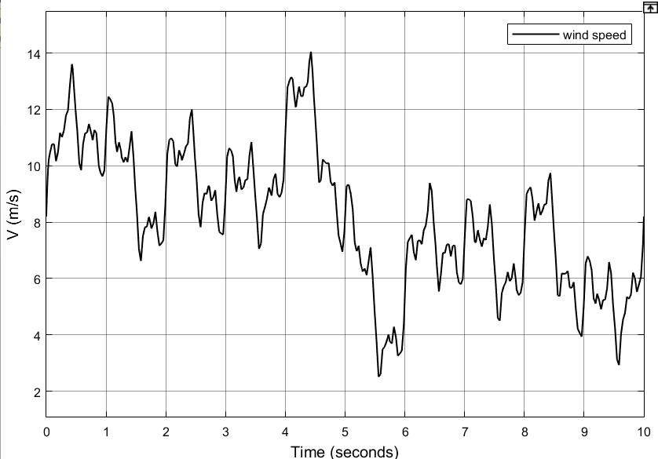
(a) |  | (b)
FIGURE 6. Wind profile: (a) Constant wind speed; (b) Variable wind speed
Figure 7 illustrates the temporal evolution of the power coefficient. In the case of a constant wind speed, the curve exhibits an increasing trend during the turbine startup phase, subsequently stabilizing at approximately Cp≈0.28, meaning the turbine converts about 28% of the wind’s kinetic energy into mechanical power. Conversely, for a variable wind speed, the power coefficient Cp similarly increases during the startup period but then oscillates around a mean value of 𝐶𝑝=0.36 , corresponding to approximately 36% energy conversion efficiency. This behavior clearly highlights the significant influence of the wind speed profile on the turbine's power coefficient 𝐶𝑝.

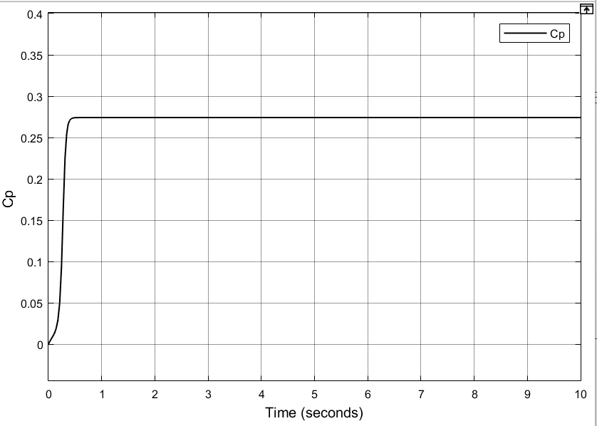 | 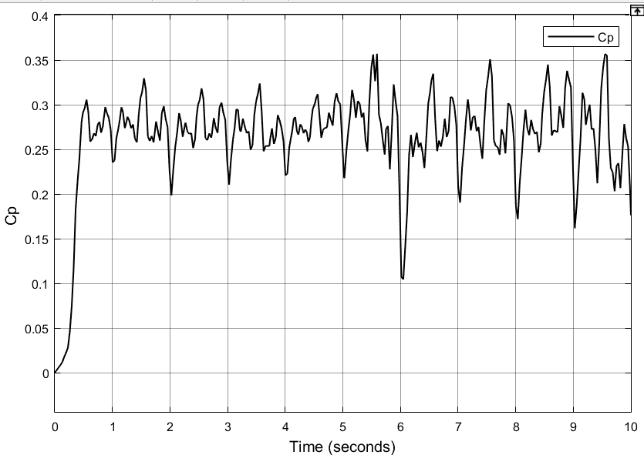
(a) | (b)
FIGURE 7. Evolution of the Power Coefficient with Constant Wind Speed (a) and Variable Wind Speed (b)
Figure 8 depicts the temporal variation of the turbine’s mechanical torque. The results clearly demonstrate the significant influence of the wind profile on the mechanical torque. Under steady wind conditions (Figure.8(a)), the torque remains stable at 7,5 × 10⁶ N·m. In contrast, under variable wind conditions (Figure.8(b)), the torque exhibits substantial fluctuations, ranging between 0.2× 10⁶ and 9× 10⁶ N·m.

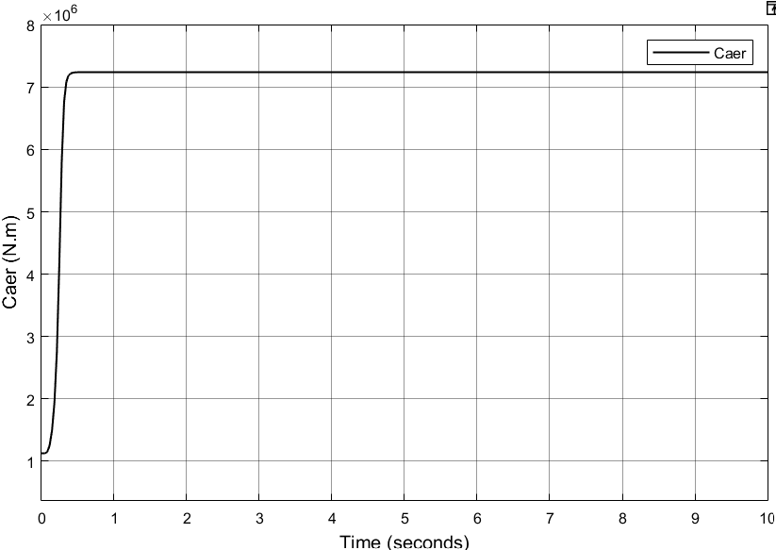 | 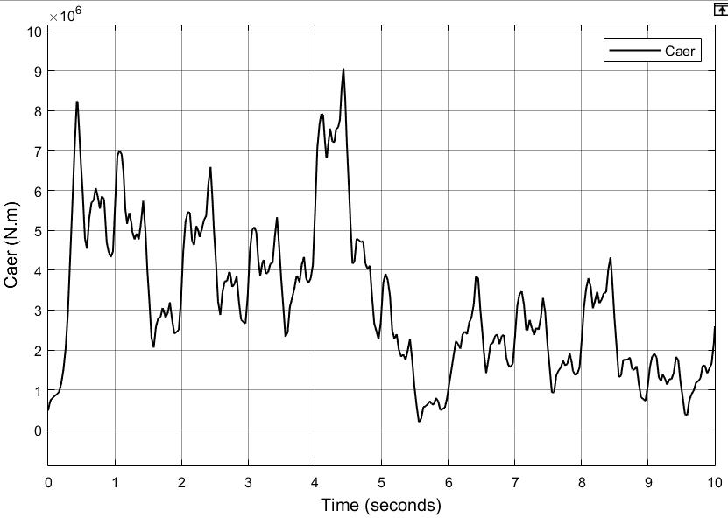
(a) | (b)
FIGURE 8. Evolution of the Turbine Torque with Constant Wind Speed (a) and Variable Wind Speed (b)
Figure 9 shows the evolution of the DC voltage Vdc for constant (Figure 9(a)) and variable (Figure 9(b)) wind speeds. In scenario (a), although the voltage reaches a quasi-steady average value of approximately 200 V after a transient of about 0.5 s, noticeable oscillations persist, indicating that the regulation system does not fully suppress voltage fluctuations under steady wind conditions. In scenario (b), voltage variations are more pronounced, ranging from negative values to over 400 V, particularly during rapid wind speed changes. These results highlight the need to improve the control strategy to reduce voltage ripple and enhance stability, especially under dynamic operating conditions.
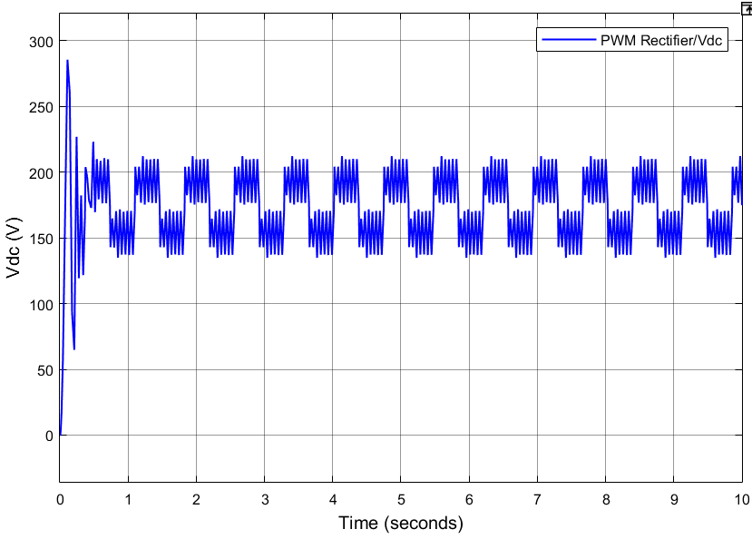 | 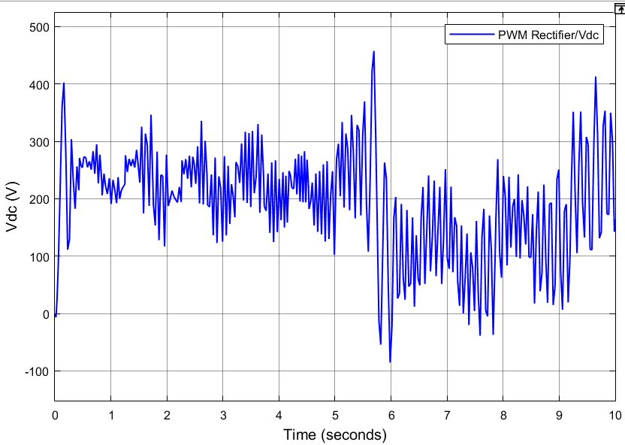
(a) | (b)
FIGURE 9. Evolution of the DC Voltage at the Rectifier Output with Constant Wind Speed (a) and Variable Wind Speed (b)

CONCLUSION
This study has demonstrated the feasibility and effectiveness of integrating wind energy into electric vehicle (EV) charging systems. Through advanced modeling of the wind turbine, GSAP, and PWM rectifier, combined with an MPPT control strategy, the system achieved optimized energy production, recovering up to 28% of wind power under constant wind speed and up to 36% under variable wind conditions. The control approach ensured maximum power extraction.
Future work will focus on extending the hybrid system by simulating photovoltaic (PV) integration, wind/PV-grid interconnection, and a complete hybrid system model. Additionally, the development of an intelligent Energy Management System (EMS) using artificial intelligence will be explored to further enhance performance and autonomy.

Acknowledgments
I would like to express my sincere gratitude to the CNRST for its support through the “PhD-ASsociate Scholarship – PASS” program.

References
- International Energy Agency (IEA), https://www.iea.org (accessed 2025).
- Statista, https://www.statista.com (accessed 2025).
- J. A. Baroudi, V. Dinavahi, and A. M. Knight, “A review of power converter topologies for wind generators,” Renewable Energy, pp. 2369–2385, 2007.
- S. M. Muyeen, R. Takahashi, T. Murata, and J. Tamura, “Operation and control of HVDC-connected offshore wind farm,” IEEE Transactions on Sustainable Energy, pp. 30–37, 2010.
- C. Armenta-Déu and J. C. Reyes, “Design of a Modular Multipoint Electric Vehicle Charging Station Powered by Wind Energy,” Research Article, (2024).
- M. E. Haque, M. Negnevitsky, and K. M. Muttaqi, “A novel control strategy for a variable-speed wind turbine with a permanent-magnet synchronous generator,” IEEE Transactions on Industry Applications, vol. 46, no. 1, pp. 331–339, 2010.

