Towards Optimized and Efficient Photovoltaic Systems: Intelligent and Innovative approach for Energy Management
Meryem YAHYAOUI¹, Mohamed Karom¹, Hajar Chadli¹, Khalid Salmi¹, Mohammed Saber², Sara Chadli¹

¹Electronics and Systems Laboratory, Faculty of Sciences, Mohammed First, University, Oujda/60000, Morocco
²Laboratory Electronics, Computer and Image Systems, National School of Applied Sciences, Mohammed First University, Oujda, Morocco
1meryem.yahyaoui@ump.ac.ma
Abstract. Photovoltaic (PV) systems play a critical role in the energy transition across the world. However, managing them while they are in operation is not straightforward, as their performance is determined not just by climatic variability but also by sudden weather changes. A Proportional Integral Derivative (PID) controller is a widely used solution to manage energy generation, by effectively changing the values of its set parameters in a systematic way. However, the limitation of a PID controller is how quickly it can adjust to changes in the environment. This research intends to enhance the control and performance of photovoltaic systems by utilizing neural network models instead of conventional PID controllers. The proposed recurrent model can predict energy production levels based on previous as well as present weather conditions to provide a more intelligent management of the PV systems. Unlike PID controllers, which are more tend to follow a fixed process, the model learns from prior experiences and can also alter the output parameters of the system in response to changes in conditions instantaneously. This allows the system to cope better with the existing climatic conditions and optimize performance and energy efficiency of management. Simulations were carried out to verify the new approach and compare them with regular PID simulations. The findings show that the production and response time of the recurrent neural model in photovoltaic systems are far superior to those of the PID controller. This technique can be utilized more quickly without losing quality when new weather data becomes available, representing a powerful alternative for improving the production of solar energy systems.

Introduction
Solar energy is an inexhaustible and eco-friendly resource due to its abundance and universal availability. The total solar energy reaching the Earth's surface daily far exceeds global energy demands, both present and future. If harnessed efficiently, it can meet projected energy requirements without depleting natural resources or harming the environment [1]. Unlike fossil fuels, solar energy does not emit greenhouse gases during operation, and its use reduces dependence on conventional energy sources, contributing positively to climate goals [2]. Governments and international organizations have therefore set ambitious targets to expand solar energy, making large-scale photovoltaic systems and solar power stations central to many national energy strategies [3]. Countries that implement these systems effectively can conserve fossil fuel reserves, reduce energy import dependence, and improve energy security. Despite its advantages, managing and optimizing PV system performance remains a technical challenge. Meteorological variables such as solar irradiance, temperature variations, and unpredictable weather conditions strongly influence energy output and system stability [4]. These variables are inherently dynamic, making real-time monitoring and control complex. Sudden cloud cover, dust accumulation, or temperature fluctuations can reduce PV panel efficiency and disrupt stable energy generation. Traditionally, proportional-integral-derivative (PID) controllers have been used to regulate PV systems. While they provide reliable performance under steady or predictable conditions, PID controllers are limited in adapting to fast-changing environments due to their fixed parameters and slower response times [5]. This limitation illustrates the importance for adaptive and intelligent control methods able to deal with uncertain, nonlinear, and rapidly changing situations. Artificial intelligence (AI) in particular has potential and is currently being used in applications such as anomaly detection [6], grid stability [7], predicting energy demands [8], and pattern recognition [9]. For renewable energy, AI is being utilized to provide accurate predictions of PV power output [10].

These models process large volumes of historical and real-time data, generating precise forecasts without requiring exhaustive physical modeling or costly instrumentation [11]. Machine learning (ML) algorithms are particularly effective in handling nonlinear relationships and complex interdependencies among variables [12]. Among ML techniques, Support Vector Machines (SVM) [13], Decision Trees, and Recurrent Neural Networks (RNNs) [14] have been widely explored for time-series forecasting. RNNs, and especially their advanced variant Long Short-Term Memory (LSTM) networks, are highly effective in modeling temporal sequences and capturing long-term dependencies in data [15]. LSTM networks are well-suited for predicting solar radiation and PV power output, which exhibit significant temporal variability. Studies have shown that LSTM models outperform other established methods, including Gradient Boosting Regression, Feedforward Neural Networks, and the Persistence Model, for day-ahead solar radiation forecasting [16]. This performance demonstrates the robustness of LSTM networks and their ability to generalize from complex temporal data, making them ideal for PV system applications where both past and future variable patterns must be considered to optimize energy output and grid injection strategies [17].
The objective of this study is to develop an LSTM-based model to predict PV energy production from historical meteorological variables and to compare its performance with a conventional PID control strategy.

Methodology
This section presents the methodology followed in this study to predict PV energy production. It includes data collection and preprocessing, selection of input and output variables, and evaluation of model performance.

  - Dataset Description

Historical meteorological data and PV production measurements were collected for Casablanca, Morocco, from 18 January 2022 to 15 February 2022, with a 5-minute resolution. The dataset sources include measured data and satellite-derived irradiance values.

The meteorological variables considered as model inputs are:
- All-sky irradiance (W/m²): actual irradiance considering clouds and atmospheric effects.
- Clear-sky irradiance (W/m²): theoretical maximum irradiance under cloud-free conditions.
- Ambient temperature (°C): air temperature at 2 m height, affecting PV efficiency.
- Relative humidity (%): air moisture content influencing irradiance scattering.
- Wind speed (m/s): air velocity, slightly impacting panel cooling.
The output variable is PV energy production (kWh), representing the energy generated by the PV system.

All input variables were normalized before training to improve model stability. A correlation analysis was performed to identify the most influential variables (results are presented in Section 3.1).

2.2 Evaluation Metrics

The dataset was divided into two parts: 80% for training and 20% for testing. The models aim to predict PV energy production based on past meteorological conditions.
The performance of both approaches the LSTM prediction model and the PID control is assessed using four statistical metrics, computed on an independent test set:
- Mean Squared Error (MSE): Measures the average squared difference between predicted and actual values:

- Root Mean Square Error (RMSE): Represents the square root of the average squared prediction error:
- Mean Absolute Error (MAE) : It calculates the mean absolute difference between predictions and observations
- Coefficient of Determination (R²) : It indicates how well the model's predictions match the actual values

Where Y_{i} : observed PV production, Y : predicted PV production, : mean of observed values,N : Number of samples

Results and Discussion
  - Variable importance analysis

A correlation analysis was conducted to explore the relationships between meteorological variables and PV production, and the results are presented in two matrices (Fig. 1 and Fig. 2):

- The first matrix reveals a strong correlation between theoretical and consumed PV production (r=0.96), as well as significant correlations with air temperature, clear-sky irradiance, and all-sky irradiance.
- The second matrix includes additional variables and confirms the negative impact of relative humidity on PV production, while wind speed shows negligible influence. The curtailed solar energy exhibits low correlation with other parameters, suggesting losses unrelated to meteorological conditions.

This analysis helps identify the most influential variables for the next steps of predictive modeling.

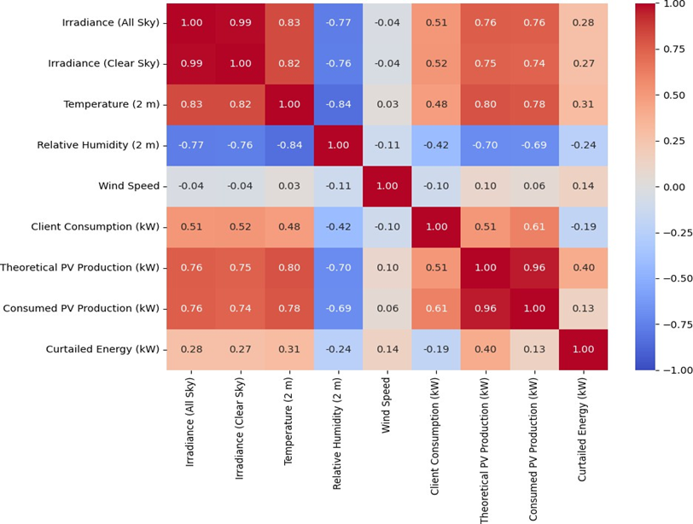

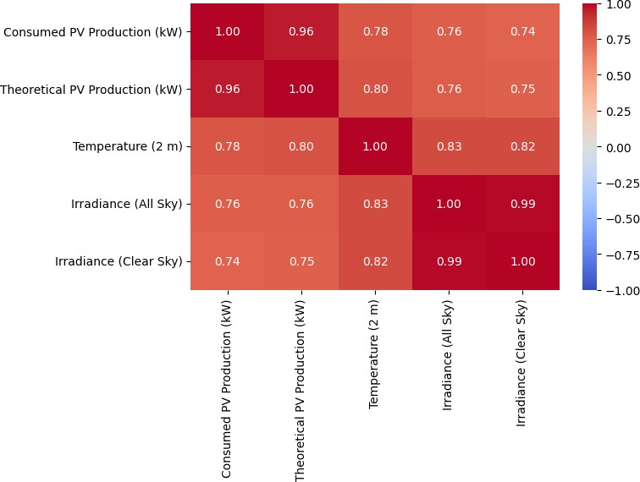
FIGURE 1. Correlation matrix

FIGURE 2. Correlation among Significant Variables

3.2 Model Training and Evaluation
Figure 3 illustrates the training and validation loss curves of the LSTM model over a total of 50 epochs, using Mean Squared Error (MSE) as the evaluation metric. From the very first epochs, a significant and rapid reduction in both training and validation losses is observed, indicating that the model is effectively capturing the underlying patterns and temporal dependencies present in the data. This early convergence reflects the LSTM’s strong capability to learn sequential structures and adapt to the problem at hand. As training continues, the loss values for both datasets gradually approach near-zero levels and stabilize, reflecting a consistent learning behavior. Furthermore, the close alignment between the training and validation loss curves throughout the entire training process provides clear evidence that the model maintains good generalization performance, with no signs of overfitting. This outcome is supported by the adopted hyperparameter configuration, including a dropout rate of 0.3, a batch size of 64, a learning rate of 0.001, and the use of early stopping, which together prevent the model from memorizing the training data. As a result, the model learns meaningful representations that transfer well to unseen samples. In conclusion, the LSTM model demonstrates a high level of accuracy, stability, and generalization, making it a suitable and reliable choice for modeling and predicting time-series behavior in this context.

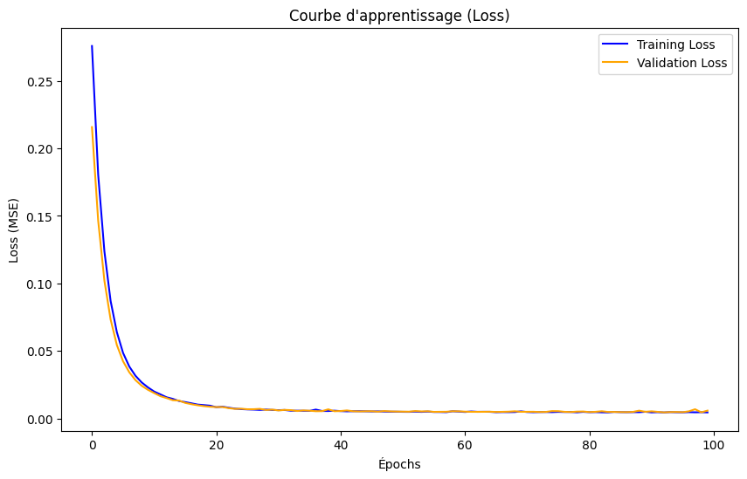 FIGURE 3. LSTM model loss during training and validation.

3.3 Evaluation of the PID-Controlled

Figure 4 shows a comparison between the actual PV power production, recorded every 5 minutes over a one-month period, and the adjusted production using a Proportional-Integral-Derivative (PID) controller. The yellow curve represents the real PV output, while the green curve indicates the output adjusted by the PID algorithm. It is evident that the PID- controlled output closely follows the real production profile across all time intervals. The alignment between the two curves demonstrates that the PID controller is capable of reacting effectively to the system’s dynamics and tracking the reference signal with a high level of accuracy. The response is particularly consistent during the rising and falling edges of the production cycles, where abrupt changes in PV output are managed smoothly by the controller. Despite the presence of some oscillations and fine fluctuations especially in regions with higher production peaks, the general behavior of the adjusted signal remains stable and well-regulated. This suggests that the PID controller is able to maintain system stability and minimize error over time, even in the presence of variability and noise in the PV signal. Overall, the PID-based adjustment appears to be an effective approach for real-time tracking and regulation of PV output in dynamic conditions.
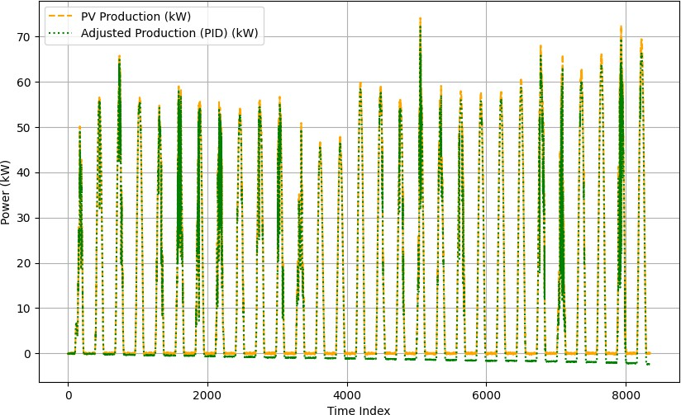

FIGURE 4. Data PV production and PID-adjusted output comparison.

3.4 Performance Comparison between LSTM and PID models

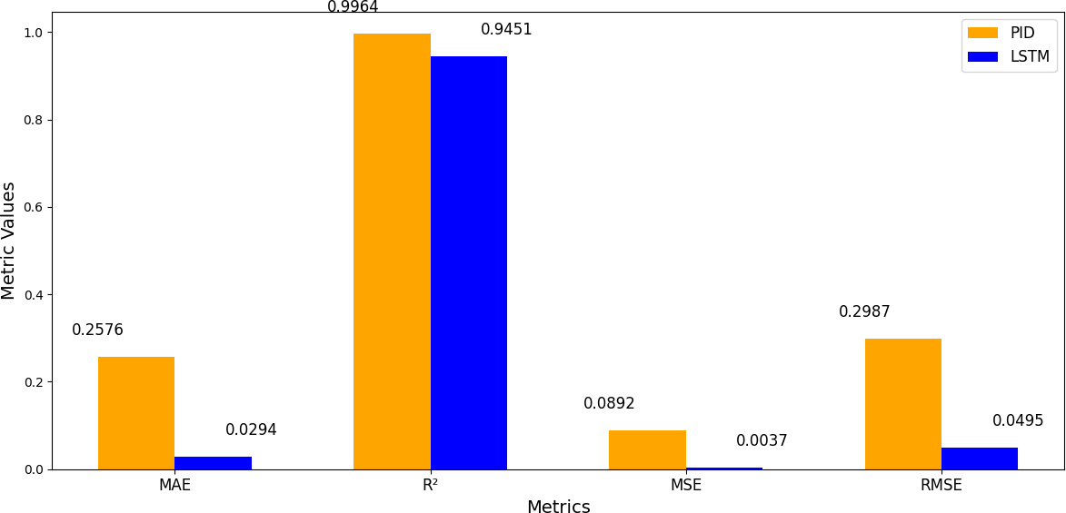
Figure 5 presents a quantitative comparison between the PID controller and the LSTM model based on four common performance metrics: Mean Absolute Error (MAE), Coefficient of Determination (R²), Mean Squared Error (MSE), and Root Mean Squared Error (RMSE).

FIGURE 5. Comparison of PID and LSTM performance metrics for PV output regulation.

These results clearly demonstrate that the LSTM model significantly outperforms the PID controller in minimizing prediction errors. The LSTM’s MAE is approximately nine times lower than that of the PID, indicating a much higher average precision in forecasting PV output. Similarly, the MSE of the LSTM (0.0037) is drastically smaller than that of the PID (0.0892), reflecting a substantially lower average squared deviation from actual values. The RMSE values reinforce this conclusion, with the LSTM showing a marked ability to reduce larger errors compared to the PID, which is critical for dynamic PV output regulation. On the other hand, the PID slightly outperforms the LSTM in the R² metric (0.9604 versus 0.9451), indicating slightly better variance explanation.
Nevertheless, the slightly higher R² value obtained by the PID controller can be explained by its rule-based design, which continuously minimizes short-term tracking errors. This local adjustment improves variance explanation but does not necessarily reduce overall prediction errors, as reflected by the higher MAE, MSE, and RMSE values compared to the LSTM. Beyond this model-driven comparison, the physical interpretation of meteorological variables provides further insight. Irradiance emerges as the dominant factor driving PV production, while temperature reduces module efficiency at higher values due to increased semiconductor resistance. Relative humidity negatively affects output by scattering incoming radiation and lowering effective irradiance, whereas wind speed shows only a marginal positive effect by slightly cooling the panels. These findings confirm both the statistical results of the correlation analysis and the importance of considering meteorological influences when developing accurate PV forecasting models.
In conclusion, while both approaches effectively adjust PV output, the LSTM model provides more accurate and reliable predictions, making it the preferred choice for applications demanding fine-grained time series forecasting and control.

Conclusion

The analysis demonstrates that both the PID controller and the LSTM model can regulate PV output effectively. However, the LSTM model clearly outperforms the PID in terms of prediction accuracy, showing significantly lower MAE, MSE, and RMSE values. The correlation analysis also highlights the dominant influence of irradiance and the negative impact relative humidity on PV production. Overall, the LSTM provides a more precise and reliable approach for PV output forecasting and control, making it the preferred solution for applications requiring accurate time-series predictions.

References
- Ullah et al., « Solution Combustion Synthesis of Transparent Conducting Thin Films for Sustainable Photovoltaic Applications », Sustainability, vol. 12, no 24, Art. no 24, janv. 2020, doi: 10.3390/su122410423.
- A. Almutairi, A. G. Abo-Khalil, K. Sayed, et N. Albagami, « MPPT for a PV Grid-Connected System to Improve Efficiency under Partial Shading Conditions », Sustainability, vol. 12, no 24, Art. no 24, janv. 2020, doi: 10.3390/su122410310.
- D. Murillo-Yarce et al., « A Review of Control Techniques in Photovoltaic Systems », Sustainability, vol. 12, no 24, Art. no 24, janv. 2020, doi: 10.3390/su122410598.
- H. Xue, J. Ma, J. Zhang, P. Jin, J. Wu, et F. Du, « Power Forecasting for Photovoltaic Microgrid Based on MultiScale CNN-LSTM Network Models », Energies, vol. 17, no 16, Art. no 16, janv. 2024, doi: 10.3390/en17163877.
- D. H. Kim et J. Park, « Intelligent PID control by immune algorithms based fuzzy rule auto-tuning », présenté à Lecture Notes in Artificial Intelligence (Subseries of Lecture Notes in Computer Science), 2003, p. 474‑482. doi: 10.1007/3-540-44967-1_57.
- G. Li, S. X. Wu, S. Zhang, et Q. Li, « Neural Networks-Aided Insider Attack Detection for the Average Consensus Algorithm », IEEE Access, vol. 8, p. 51871‑51883, 2020, doi: 10.1109/ACCESS.2020.2978458.
- X. Yuan, J. Zhou, B. Huang, Y. Wang, C. Yang, et W. Gui, « Hierarchical Quality-Relevant Feature Representation for Soft Sensor Modeling: A Novel Deep Learning Strategy », IEEE Transactions on Industrial Informatics, vol. 16, no 6, p. 3721‑3730, 2020, doi: 10.1109/TII.2019.2938890.
- W. Qiao, K. Huang, M. Azimi, et S. Han, « A Novel Hybrid Prediction Model for Hourly Gas Consumption in Supply Side Based on Improved Whale Optimization Algorithm and Relevance Vector Machine », IEEE Access, vol. 7, p. 88218‑88230, 2019, doi: 10.1109/ACCESS.2019.2918156.
- X. Yuan, C. Ou, Y. Wang, C. Yang, et W. Gui, « A Layer-Wise Data Augmentation Strategy for Deep Learning Networks and Its Soft Sensor Application in an Industrial Hydrocracking Process », IEEE Trans Neural Netw Learn Syst, vol. 32, no 8, p. 3296‑3305, août 2021, doi: 10.1109/TNNLS.2019.2951708.
- T. Yang, B. Li, et Q. Xun, « LSTM-Attention-Embedding Model-Based Day-Ahead Prediction of Photovoltaic Power Output Using Bayesian Optimization », IEEE Access, vol. 7, p. 171471‑171484, 2019, doi: 10.1109/ACCESS.2019.2954290.
- G. Li, S. Xie, B. Wang, J. Xin, Y. Li, et S. Du, « Photovoltaic Power Forecasting with a Hybrid Deep Learning Approach », IEEE Access, vol. 8, p. 175871‑175880, 2020, doi: 10.1109/ACCESS.2020.3025860.
- W. VanDeventer et al., « Short-term PV power forecasting using hybrid GASVM technique », Renewable Energy, vol. 140, p. 367‑379, sept. 2019, doi: 10.1016/j.renene.2019.02.087.
- M. Barman et N. B. Dev Choudhury, « Season specific approach for short-term load forecasting based on hybrid FA-SVM and similarity concept », Energy, vol. 174, p. 886‑896, mai 2019, doi: 10.1016/j.energy.2019.03.010.
- F. Rodríguez, A. Fleetwood, A. Galarza, et L. Fontán, « Predicting solar energy generation through artificial neural networks using weather forecasts for microgrid control », Renewable Energy, vol. 126,
p. 855‑864, oct. 2018, doi: 10.1016/j.renene.2018.03.070.
- G. M. Yagli, D. Yang, et D. Srinivasan, « Automatic hourly solar forecasting using machine learning models », Renewable and Sustainable Energy Reviews, vol. 105, p. 487‑498, mai 2019, doi: 10.1016/j.rser.2019.02.006.
- S. Srivastava et S. Lessmann, « A comparative study of LSTM neural networks in forecasting day- ahead global horizontal irradiance with satellite data », Solar Energy, vol. 162, p. 232‑247, mars 2018, doi: 10.1016/j.solener.2018.01.005.
- B. Brahma et R. Wadhvani, « Solar Irradiance Forecasting Based on Deep Learning Methodologies and Multi-Site Data », Symmetry, vol. 12, no 11, Art. no 11, nov. 2020, doi: 10.3390/sym12111830.

