Study of Natural Convection Using Hybrid Nanofluids in a Two-Dimensional Enclosure with an Obstacle
Ilham LAHLAL¹, Fatima-Zahra Barhdadi^{1,2}, Ikrame Jamal¹, Salma Bendaouad¹, Salah Daoudi¹, Pablo Salgado Sanchez³
¹Laboratory of Mechanics and Energy (LME), Faculty of Sciences, Mohammed First University, Oujda/60000, Morocco
² Ecole Supérieure d'Ingénierie Appliquée et innovation, Oujda/60000, Morocco
³ E-USOC, Center for Computational Simulation, E. T. S. de Ingenieria Aeronautica y del Espacio, Universidad Politecnica de Madrid, Spain

¹ilham.lahlal@ump.ac.ma
Abstract. The aim of this work is to numerically investigate natural convection and heat transfer in a two-dimensional enclosure that contains a centered obstacle, using two hybrid nanofluids: Al₂O₃-Ag and TiO₂-Ag. In this study, we analyze how the heat transfer is influenced by the Rayleigh number, the type of nanoparticle, and the hybrid nanofluid, including a comparison between heated and adiabatic obstacles. It is found that the Nusselt number increases as the Rayleigh number rises, indicating improved heat transfer. The improvement in heat transfer is more pronounced with Ag-based nanofluids.Hybrid nanofluids demonstrate the highest heat transfer efficiency.

Keywords: Natural Convection, Numerical Simulation, Hybrid Nanofluid, Rayleigh Number, Heat Transfer.

- Introduction
In many industrial and technological applications, heat transfer by natural convection is important. These cover the usage of radiators and heat exchangers in industrial operations, as well as the cooling of processors and electronic components, among a wide range of possibilities. Numerous studies have been conducted to provide a better understanding of this phenomenon by considering various fluids (Newtonian, non-Newtonian, and nanofluids) and geometric configurations.
Natural convection in a horizontal channel with openings and isothermal rectangular heating blocks was studied numerically by Alami et al. [1]. The authors looked at how heat transfer and the gravity-driven airflow were affected by the height of the blocks, the distance between them, the width of the openings, and the Rayleigh number. Their findings show that these control parameters have a significant impact on the flow structure. Pawan Karki et al. [2] used the Lattice Boltzmann Method to analyze how adiabatic square obstacles affect natural convection in a square cavity with heated vertical walls, results show that increasing the size of a central obstacle initially enhances heat transfer before reducing it beyond an optimal size .Similarly, Merrikh and Mohamad [3] employed an adiabatic obstacle within the enclosure as a strategy to enhance heat transfer.
House et al. [4], on the other hand, focused on qualitative analyses of a centrally placed solid body with varying thermal conductivities inside the enclosure, but their study did not provide detailed quantitative results. Raji et al. [5] conducted a numerical study to investigate the effect of subdividing an internal obstacle. Their findings indicate that both heat transfer and flow intensity decrease significantly with an increasing number of obstacle blocks and higher thermal conductivity ratios.
Recently, Lahlal et al. [6] analyzed a square enclosure featuring a centrally placed triangular adiabatic obstacle. They demonstrated that heat transfer increases with both the Rayleigh number and the obstacle’s aspect ratio. This work highlights the significant influence of obstacle geometry and size on the thermal performance of natural convection.
The use of nanofluids is another approach that has attracted attention recently [7], since they were first proposed by Choi and Eastman in 1995 [8]. Natural convection in a cavity filled with nanofluid has been studied in many theoretical works. For example, a numerical investigation on heat transfer in a square enclosure with a sinusoidally shaped side filled with a porous material was carried out by Khanafer et al. [9]. They showed that the number of corrugations and the amplitude of the corrugated surface have an impact on the cavity's heat transfer properties. A comprehensive numerical analysis of a closed cavity with water-based nanofluids (water-Al2O₃ and water-CuO) was carried out by Lahlal et al. [10].
Hybrid nanofluids were developed recently to improve the thermal characteristics of mono nanofluids and solve their stability problems. Because of their synergistic effect, hybrid nanofluids, which are made up of at least two different kinds of nanoparticles combined with a base fluid, have the potential to improve stability and thermophysical characteristics [11]. Hosseinzadeh et al. [12] studied the influence of ternary hybrid nanoparticles (GO–MgO–TiO₂) on the solidification process .Their findings demonstrated that the ternary nanofluid can significantly accelerate solidification. Ouyang et al. [13] investigated the unsteady flow of water-based nanofluids containing Al₂O₃, CuO, and Cu nanoparticles. Their results showed that ternary and hybrid nanofluids with a 4% nanoparticle volume fraction significantly outperform mono nanofluids.
The objective of this work is to numerically investigate natural convection and heat transfer in a two-dimensional enclosure using three hybrid nanofluids (Al₂O₃-Ag and TiO₂-Ag), in order to analyze the effects of the Rayleigh number, the presence of an obstacle, the type of nanoparticle, and the type of hybrid nanofluid on the flow behavior, thermal fields, and heat transfer performance.

- Numerical Models
2.1 Description of the Problem

This study investigates natural convection within a rectangular cavity containing a centrally located adiabatic square obstacle, as shown in Fig. 1. The cavity, characterized by its height H and width L, is filled with a water-based hybrid nanofluid composed of either Al₂O₃-Ag and TiO₂-Ag nanoparticles. The left and right walls are maintained at constant hot (T_{h}) and cold (T_{c}) temperatures, respectively, while the top and bottom walls are thermally insulated. The cavity is considered to extend infinitely in the out of plane direction, allowing the problem to be modeled as two-dimensional.
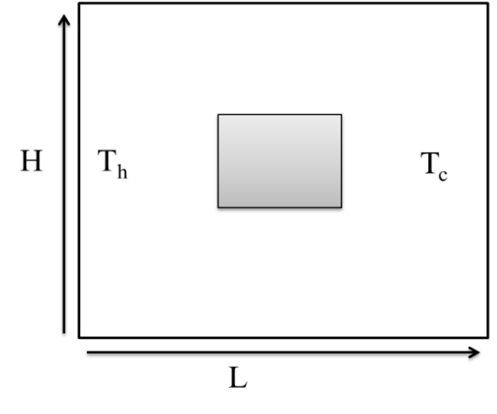
Fig. 1.The problem’s geometry
Table 1: Properties of Hybrid Nanofluids
Properties | Hybrid Nanofluids
Density
Heat Capacity
Dynamic Viscosity
Thermal conductivity

2.2 Mathematical Formulation
Using the Boussinesq approximation in the steady state, the Boussinesq hypothesis assumes that all thermophysical properties remain constant, except the fluid density in the buoyancy term of the Navier-Stokes equations, which varies linearly with temperature according to the following expression:
$$ρ=ρ_{0}[1-β\left(T-T_{0}\right)]$$
Where: $ρ_{0}$represents the density measured at a reference temperature $T_{0}$. The coefficient β designates the coefficient of thermal expansion, expressed in $K^{-1}$.
The continuity, momentum, and energy equations are expressed as follows:
(1)
(2)
(3)
(4)
With the following boundary conditions. A no-slip condition is imposed on all the cavity and obstacle walls. The left vertical wall is maintained at a hot temperature, while the right vertical wall is kept at a cold temperature .The top and bottom horizontal walls of the cavity are thermally insulated, implying, and the obstacle walls are adiabatic, meaning , where denotes the normal direction to the surface.
Here, andrepresent the velocity components in the x and y directions, respectively. The symbols μ and α correspond to the kinematic viscosity and thermal diffusivity, while β is the thermal expansion coefficient, and g is the gravitational acceleration. The subindex ‘nf’ refers to ‘nanofluid’.
2.3 Grid testing and code validation
Five distinct meshes with grid sizes of 41x41, 51x51, 61x61, 71x71, and 81x81 were examined. The change in NUavg between the two grid sizes 61×61 and 81×81 was under 0.1%, implying that any difference between the two grid sizes would have little effect on the results. The time to compute the problem rises substantially with the increase of computer cells, as for example the time it took to compute the problem with the 41 × 41 mesh was approximately 1890 s and the time it took to compute the problem with the 81 × 81 mesh exceeded 5177 s. Accordingly, the grid size of 61 × 61 was utilized for all subsequent simulations since this grid provides a reasonable balance between numerical accuracy and computational time.

Comparing our work with Putra's experimental data [14], where a cavity without an obstacle was analyzed with an emphasis on the scenario where the concentration parameter is zero, allowed us to verify its validity. Figure 3 illustrates this comparison in terms of the average Nusselt number along the wall, showing good agreement. Three distinct Rayleigh numbers were used in the computations: Ra = 2 10⁷, 5.6 10⁷ and 9.2 10⁷.

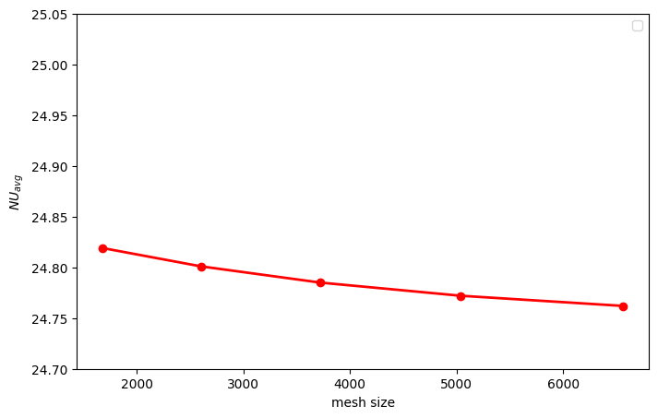
Fig. 2.Effect of grid independence on the average Nusselt number for pure water (φ = 0) at Ra = 2×10⁷
Fig. 3. Comparison between our numerical results and the experiments of Putra et al [14].

- Results and discussion

3.1 The effect of obstacle

Figure 4 shows the variation of the average Nusselt number as a function of the Rayleigh number for a square cavity filled with water under natural convection, comparing two configurations: with and without an obstacle. Results indicate that the presence of an obstacle enhances heat transfer, as the curve corresponding to the cavity with the obstacle consistently exhibits higher Nusselt number values. This enhancement is attributed to the disruption of conventional convection flow structures caused by the obstacle, which increases temperature gradients and promotes the formation of recirculation zones.
Figure 5 depicts a comparison of the isotherms for both situations showing substantial differences in temperature distributions. The cavity without the obstacle has isotherms that are generally parallel to the hot and cold walls, confirming classical thermal stratification; heat is transferred primarily by natural convection. However, the configuration of the obstacle at the center of the cavity disturbs this pattern, and isotherms are compressed locally around the obstacle, generating higher temperature gradients in these regions. The contours illustrate that the obstacle increases the thermal mechanisms via a more complex temperature field, which significantly enhances the effectiveness of natural convection in the cavity.
The obstacle causes a disturbance which alters the flow structure and enhances thermal mixing, thereby improving overall heat transfer. Put in other words, the presence of the obstacle results in larger density gradients and more vigorous fluid motion, and, in turn, more effective convective transport.

Fig.4. Comparison of heat transfer in cavities without and with an obstacle.

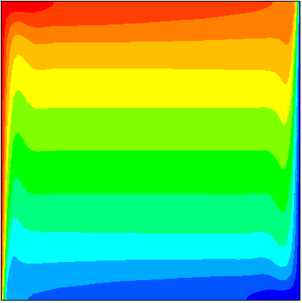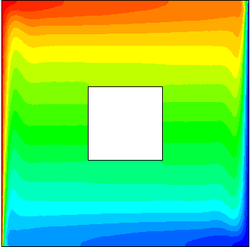
Fig. 5. Isotherms obtained in cavities without (left) and with (right) an obstacle.

3.2 Effect of Adiabatic and Heated Obstacles on Heat Transfer
Figure 6 compares the average Nusselt number as a function of the Rayleigh number for two configurations: a cavity with an adiabatic obstacle and a cavity with a heated obstacle. Results show that the adiabatic obstacle configuration promotes more efficient heat transfer than the heated obstacle across all examined cases. In the presence of an adiabatic obstacle, the flow and temperature gradients within the cavity are more strongly influenced by the main hot and cold walls, thus enhancing the effectiveness of natural convection. Conversely, when the obstacle is heated, that is, its surface temperature is maintained equal to that of the hot wall T_{obstacle} =T_{h}, it acts as an additional heat source, which reduces the overall temperature gradients responsible for efficient heat transfer from the main walls. The cavity with the adiabatic obstacle maintains steeper temperature gradients and exhibits a more significant increase in Nu_{avg} with rising Rayleigh, indicating better global thermal dissipation.
Figure 7 clearly demonstrates how temperature distributions differ in a cavity containing a heated obstacle compared to an adiabatic obstacle. In the case of the heated obstacle, not only does it radiate heat like the hot wall, it also acts as an additional heat source, causing distortion of the isotherms around the heated obstacle, producing a more homogenous temperature distribution. However, in this case, the heated obstacle decreases the effect of the hot and cold walls, and therefore, diminishes the temperature gradients essential to efficient heat transfer. Alternatively, the adiabatic obstacle does not release or absorb heat as it is thermally insulated, but it does disrupt the convective flow. Thus, the isotherms are influenced more by the hot and cold walls, boosting the temperature gradients in their vicinity and enhanced convective heat transfer. Therefore, the adiabatic obstacle recognizes the location of the main heat transfer, hot and cold walls, allowing thermal inefficiencies to be maximized by concentrating the primary heat transfer flux in between hot and cold walls compared to the heated obstacle which uniformly distributes heat less effectively.
The streamlines in Figure 8 shed light on the implications of the thermal nature of the obstacle on the flow structures. The heated obstacle unsettles the flow and creates localized recirculations that are stronger than the main flow and that are consequently caused by the heat it is supplying to the flow surface. Therefore, this disturbance weakens the main convection cells that connect the hot and cold walls and leads to a low-velocity zone surrounding the obstacle that diminishes the overall heat transfer performance of the convection within the cavity. In the case of an adiabatic obstacle, the streamlines show a more organized flow, presenting as two large convection cells that directly link the primary hot and cold walls. The adiabatic obstacle does not add heat, but its ability to reorganize the heat transfer process by redirecting the flow while helping maintain a higher velocity within the cavity promotes better thermal transport. Overall, this presents a better flow organization and strongly demonstrates the more advantageous dynamic features of the adiabatic obstacle in natural convection
Fig 6. Comparison of heat transfer between cavities with adiabatic and heated obstacles.
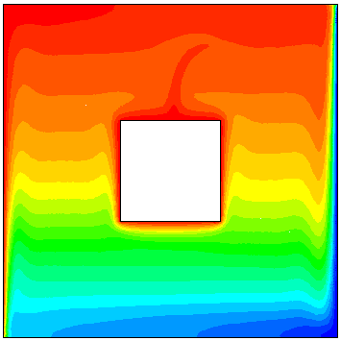
Fig. 7. Isotherms obtained in cavities with adiabatic (left) and heated (right) obstacles.

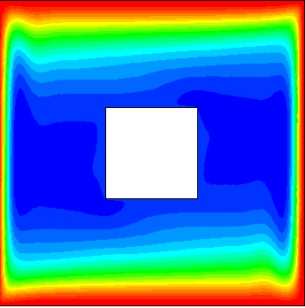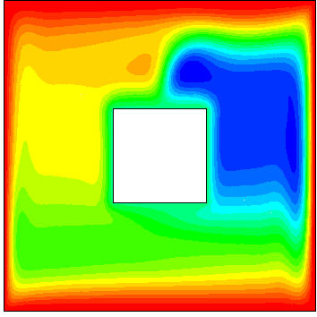
Fig. 8. Streamlines obtained in cavities with adiabatic (left) and heated (right) obstacles.

3.3 Effect of Hybrid Nanofluid Type on Convective Heat Transfer
Figure 9 demonstrates the trends in average Nusselt number, Nuavg, and Rayleigh number, Ra, for pure water, hybrid nanofluid (Ag, Al₂O₃–water), and hybrid nanofluid (Ag, TiO₂–water). The results indicate that hybrid nanofluids yield enhanced natural convection heat transfer performance in comparison to pure water. Due to the thermal conductivity of pure water being relatively low, it consistently exhibited the lowest Nuavg values under all experimental conditions. The hybrid nanofluid (Ag, Al₂O₃–water) performs slightly better than the pure water case, since the addition of nanoparticles not only improves the thermal conductivity but also enhanced conductive transport. Out of the fluids defined in the experiment, the hybrid nanofluid (Ag, TiO₂–water) performed slightly higher due to the more favorable thermal properties of TiO₂ nanoparticles, with higher Nuavg values than the (Ag, Al₂O₃–water). From the results, it is clear that hybrid nanofluids can be utilized to optimize temperature gradients and flow structures, with a significant increase in overall thermal performance shown for both hybrid nanofluids in comparison to pure water.
Fig 9. Effect of hybrid nanofluid type.
3.4 Comparative results with mono-nanofluids
The table 2 summarizes comparative studies on both mono- and hybrid nanofluids for heat transfer applications.

works | Average Nusselt Number
works | mono nanofluid | hybrid nanofluid
our work | 24.60 | 27.35
Hanifa et al [15] | 0.662 | 0.651
Khan et al [16] | 6.173 | 8.108
Table 2: Comparative results with mono and hybrid nanofluids
- Conclusion
The current numerical study offers a greater understanding of natural convection and heating transferring phenomena in a two-dimensional cavity filled with hybrid nanofluids of Al₂O₃-Ag and TiO₂-Ag. Numerical results reveal that several parameters strongly influence thermal performance. First and foremost, the Rayleigh number is important; a higher Rayleigh number drives more convective motion and heat and mass transfer itself contributes to a higher mean Nusselt number, which indicates a better transfer of heat. In addition, the presence of an obstacle inside the enclosure, whether heated or adiabatic, alters the flow and temperature field characterizations and alters the overall thermal performance the flow that those structures contribute to the overall performance of the enclosure. Additionally, this study assesses the performance of hybrid nanofluids employed in heating transferring mechanisms. These fluids benefit from the effect of two different nanoparticle types which synergistically lends itself to better thermophysical properties to enhance conductivity and increase conduction driven heating transfer. Compared with simple nanofluids, hybrid nanofluids showed a significant increase in Nusselt number, due to their larger thermal diffusivity.
- References
- El Alami M, Najam M, Semma E, Oubarra A, Penot F. Electronic components cooling by natural convection in horizontal channel with slots. Energy Conversion and Management, Vol. 46, pp. 2762–772, (2005).
- KARKI, Pawan, YADAV, Ajay Kumar, et ARUMUGA PERUMAL, D. Study of adiabatic obstacles on natural convection in a square cavity using lattice Boltzmann method. Journal of Thermal Science and Engineering Applications, 2019, vol. 11, no 3, p. 034502.
- A.A. Merrikh and A.A. Mohamad, Blockage effects in natural convection in differentially heated enclosure, Journal of Enhanced Heat Transfer, 8, 55–72, 2001.
- J.M. House, C. Beckermann, T.F. Smith, Effect of a centered conducting body on natural convection heat transfer in an enclosure, Numerical Heat Transfer Part A, 18, 213–225, 1990.
- Raji, A., Hasnaoui,M., Nami,M., Slimani, K., Ouazzani, M.T.: Effect of the subdivision of an obstacle on the natural convection heat transfer in a square cavity. Comput. Fluids 68, 1–15 (2012).
- Lahlal, I., Talbi, H., Alla, M., Amghar, K., & Daoudi, S. (2024, May). Enhancement of Natural Convection Heat Transfer in Energy Storage Systems: Utilization in a Cavity Including an Adiabatic Obstacle. In International Conference on Electronic Engineering and Renewable Energy Systems (pp. 551-560). Singapore: Springer Nature Singapore.‏
- CHUKAMI, Babak Safari et HEYHAT, Mohammad Mahdi. The effect of tube orientation on thermal characteristics in flow boiling of a hybrid nanofluid–A numerical study. Case Studies in Thermal Engineering, 2025, vol. 66, p. 105759.
- S.U.S. Choi, J.A. Eastman, Enhancing thermal conductivity of fluids with nanoparticles, in: ASME International Mechanical Engineering Congress and Exhibition, 1995. San Francisco, USA.
- K. Khanafer, K. Vafai, M. Lightstone, Buoyancy-driven heat transfer Enhancement in a two-dimensional enclosure utilizing nanofluids. Int J of Heat and Mass Transfer. 46 (2003) 3639–3653.
- I. Lahlal, S. Daoudi, K. Amghar, D. Bahia. Improving Natural Convection in a Nanofluid Filled Cavity Through SMART Numerical Simulation. In International Conference on Smart Medical, IoT & Artificial Intelligence,Cham: Springer Nature Switzerland.‏ (2024) 99-105.
- Y. Yu, J. Du, J. Hou, X. Jin, R. Wang, Investigation into the underlying mechanisms of the improvement of thermal conductivity of the hybrid nanofluids, Int. J. Heat Mass Tran. 226 (December 2023) (2024) 125468, https://doi.org/10.1016/j.ijheatmasstransfer.2024.125468.
- K. Hosseinzadeh, S. Faghiri, S. Akbari, J.R. Kermani, B. Jafari, M.B. Shafii, Effect of ternary hybrid nanoparticles (GO–MgO–TiO2) and radiative heat transfer on the solidification process of PCM inside a triplex tube with hollow fins, Int. J. Thermofluids 20 (2023) 100443, http://dx.doi.org/10.1016/j. ijft.2023.100443.
- Y. Ouyang, M.F. Md Basir, K. Naganthran, I. Pop, Unsteady magnetohydrodynamic tri–hybrid nanofluid flow past a moving wedge with viscous dissipation and joule heating, Phys. Fluids 36 (2024) http://dx.doi.org/10.1063/5.0208608.
- Putra N., Roetzel W., Das S.K., 2003. Natural convection of nanofluids. J. Heat Mass Transfer, 39, pp. 775-784.
- Hanif, H., Ilias, M. R., Iqbal, Z., Shafie, S., Alhazmi, S. E., & Alqarni, M. M. (2024). Heat transfer in hybrid nanofluid flow between two coaxial cylinders. Case Studies in Thermal Engineering, 59, 104327.
- Khan, N. H., Paswan, M. K., & Hassan, M. A. (2022). Natural convection of hybrid nanofluid heat transport and entropy generation in cavity by using Lattice Boltzmann Method. Journal of the Indian Chemical Society, 99(3), 100344.

