Development and Analysis of a Hybrid Passive Cooling System Coupling Superficial Geothermal Energy and Phase Change Materials.

Azziz CHETOUNI ^{a,b} , Samir Idrissi Kaitouni ^{c}, Youness Khattari ^{d}, Eric Schall ^{b}, Abdelmajid Jamil ª.

ª Higher School of Technology of Fez, Sidi Mohamed Ben Abdellah University, BP 242, Fez, Morocco.
^{b} Laboratory of Engineering Sciences Applied to Mechanics and Electrical Engineering (SIAME), University of Pau and Pays de l’Adour/E2S UPPA, EA4581, 64000, Pau, France.
^{c} Green Energy Park (IRESEN & UM6P), Benguerir, Morocco.
^{c} Engineering Sciences Laboratory, Polydisciplinary Faculty of Taza, Sidi Mohamed Ben Abdellah University Fes, Morocco.

Corresponding author.
E-mail address: azziz.chetouni@usmba.ac.ma (A. CHETOUNI).
Abstract:
Faced with the growing energy challenges in buildings due to climate change, this study proposes a hybrid passive cooling system that combines a shallow geothermal heat exchanger (UGS) with a finned heat exchanger filled with phase change material (PCM). Air is first cooled in the UGS and then further conditioned in the secondary PCM-based exchanger. Theoretical modeling and transient numerical simulations were conducted to evaluate system performance under current and projected 2050 climate conditions in Fez, Morocco (RCP4.5 and RCP8.5 scenarios). Results show that system efficiency strongly depends on the UGS dimensions and the convective heat transfer coefficient in the PCM exchanger. Under optimal conditions using a 6 × 2 × 4 m³ underground chamber and achieving a heat transfer coefficient above 40 W/m²·K the system reduces air temperature by over 20°C, from 45°C down to approximately 22°C. Optimizing geometric parameters and operating conditions is essential to maximize the system’s thermal performance and adaptability to future climates.
Keywords: Passive cooling, Underground space, Climate change, Building energy efficiency, Energy demand.
- Introduction
Rising global temperatures and the growing frequency of extreme climatic events are intensifying energy challenges worldwide, especially in the building sector, which accounts for over 30% of global energy use and nearly 60% of electricity consumption [1] [2]. These climatic changes significantly affect heating, ventilation, and air-conditioning (HVAC) needs, influencing both energy efficiency and thermal comfort. A major cause of this global warming is the continuous emission of greenhouse gases (GHG) from fossil fuel combustion [3]. Consequently, cooling energy demand is expected to rise dramatically in hot regions. In Morocco, for example, studies predict an increase of about 67% in cooling demand over the next decade due to extended heat periods [4][5]. Similarly, energy use for cooling in Mexico could double by 2100 [6]. In contrast, heating demand may decline by 33% in Canada and by up to 78% in Germany and Finland by 2060, mainly due to improved energy efficiency and milder winters [7].
These projections underline the urgent need for sustainable and passive cooling technologies capable of maintaining indoor comfort while reducing energy dependency and greenhouse emissions.
Among emerging solutions, shallow geothermal systems (UGS) and phase change materials (PCM) have demonstrated strong potential for enhancing passive thermal regulation in buildings. UGS can utilize the stable underground temperature as a natural cooling source, while PCMs can store and release thermal energy through phase transition. However, most existing studies on UGS–PCM coupling remain limited to small-scale experiments or simulations under current climate conditions, often neglecting the effects of geometric parameters, airflow velocity, and PCM type. Moreover, the long-term resilience of these systems under future climate scenarios is rarely explored.
To address these gaps, this work proposes and evaluates an innovative hybrid passive cooling system that couples a shallow geothermal heat exchanger (UGS) with a finned air/PCM heat exchanger. The objective is to enhance cooling performance and energy efficiency for buildings located in hot climates such as Fez, Morocco. The study employs a combined theoretical and numerical approach: first, transient heat transfer models were developed for both UGS and PCM exchangers; then, simulations were performed under current and 2050 climatic scenarios (RCP4.5 and RCP8.5). A detailed parametric analysis was conducted to assess the influence of design and operational factors, including geometry, air velocity, fin configuration, and PCM selection.
The scientific contributions of this work lie in three main aspects. First, the system integrates a fully finned concentric-tube air/PCM exchanger with a large underground chamber (6 × 2 × 4 m³), designed for thermal buffering in semi-arid climates. Second, the analysis accounts for both current and future climate conditions, providing a long-term perspective rarely addressed in PCM-based cooling studies. Third, the paper presents a quantitative comparison of multiple PCMs (water, hexadecane, tetradecane) and airflow configurations to identify optimal operating conditions. Overall, the study advances the understanding and optimization of hybrid passive cooling technologies for energy-efficient and climate-resilient buildings.
- Methodology
- Description of the system
Seasonal variations in surface air temperature influence the soil thermal profile, with significant fluctuations observed between summer and winter. However, due to the high thermal inertia of the ground, the amplitude of these fluctuations diminishes with increasing depth, reaching a point where the temperature remains nearly constant throughout the year. This stable value, referred to as the undisturbed ground temperature (UGT), is typically close to the annual average of the outdoor air temperature. As a result, the ground serves as a natural thermal reservoir capable of supplying heat in winter and coolness in summer. This property can be exploited for passive air conditioning using ground-coupled heat exchange systems, such as the Earth-to-Air Heat Exchanger (EAHE), commonly known as the Canadian well, where air is circulated through buried pipes to exchange heat with the ground.
The system investigated in this study applies this principle for air cooling in a hot climate, specifically that of Fez, Morocco, where summer temperatures are particularly high. The proposed configuration is a hybrid system combining two heat exchangers arranged in series (see Fig. 1): a ground-to-air heat exchanger (UGS) followed by an air-to-phase change material heat exchanger (Air/PCM HEX). Outdoor air is first drawn through underground pipes into a buried chamber (UGS) located at a depth where the ground temperature is stable, enabling an initial cooling stage through thermal exchange with the surrounding soil. The pre-cooled air then flows through a horizontal heat exchanger filled with a phase change material (PCM), such as frozen water. This second exchanger is designed as a cylindrical tube equipped with longitudinal fins to enhance heat transfer on the air side, which is typically limited by the low thermal conductivity of air. The entire system is thermally insulated to ensure adiabatic conditions, and a small fan placed downstream of the Air/PCM HEX facilitates the delivery of cooled air to the conditioned space. The present study focuses solely on evaluating the thermal performance of the two heat exchangers, without considering the impact on indoor environmental conditions.
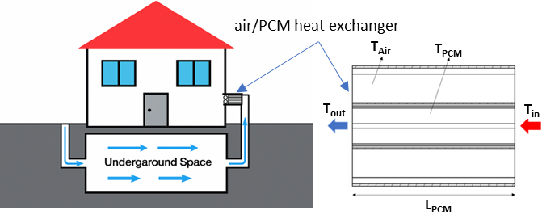
Fig. 1: Schematic diagram of a hybrid passive cooling system combining a shallow (UGS) and an air/PCM heat exchanger.
Figure 2 illustrates the evolution of outdoor air temperature in Fez (Morocco), presented on an hourly scale (left) and a monthly scale (right), under three climatic scenarios: the current climate, and projections for the year 2050 according to the RCP4.5 and RCP8.5 scenarios. A noticeable increase in both average temperatures and extreme heat events is projected for the future, reflecting the anticipated effects of global warming. The hourly profiles reveal a greater diurnal temperature variation, while the monthly trends highlight an intensification of summer heat periods. A vertical blue line marks August 19th, the reference day selected for the comparative performance analysis of the proposed system under the different climate conditions. This visualization underscores the potential impact of climate change on building cooling demand, reinforcing the relevance of integrating innovative passive solutions such as the hybrid system proposed in this study.
In this study, outdoor air temperature was considered as the primary climatic input for simulations, as it directly governs the thermal behavior of both UGS and PCM exchangers. Other parameters such as humidity, wind speed, and solar radiation were not included, since their impact on the thermal exchange process is negligible compared to air temperature.
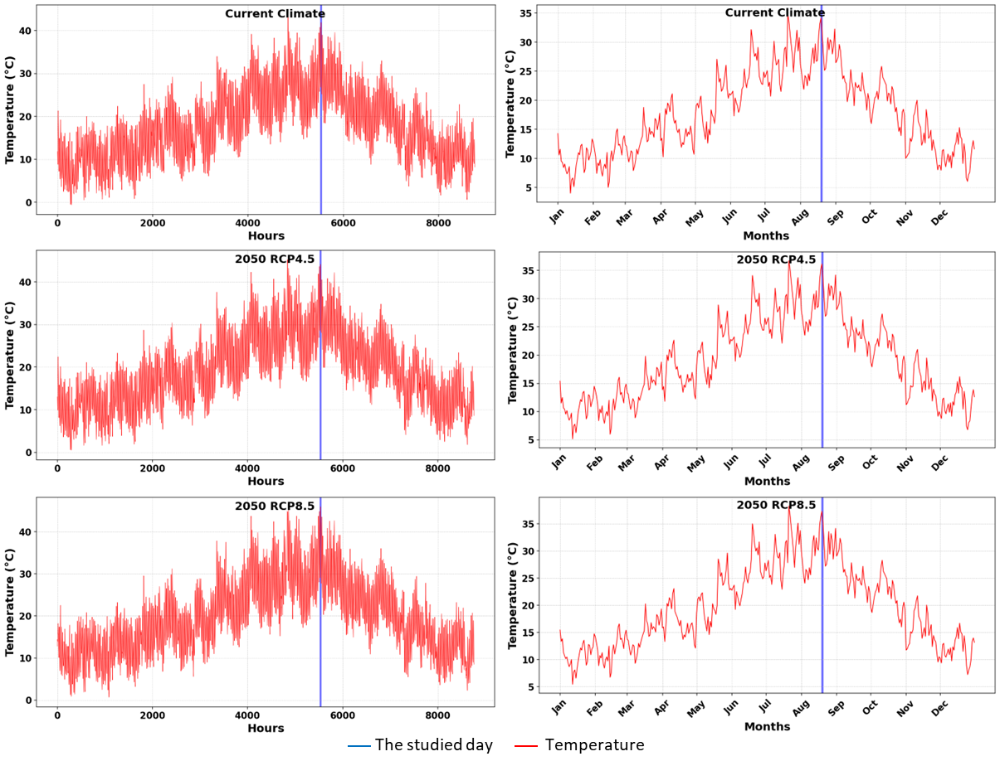
Fig. 2: Temporal evolution of outdoor air temperature in Fez (Morocco) according to three climate scenarios: current climate, 2050 projection according to RCP4.5 and RCP8.5.
The design of the UGS and PCM exchanger was based on climatic data specific to Fez. The average air temperature during the hot season (June–August) is approximately 29.4°C, with peaks above 45°C during extreme days. In contrast, the cold season (December–February) averages around 9.5°C, with occasional lows below 4°C. The annual average temperature of ~19.5°C was used to estimate the undisturbed ground temperature at the burial depth, typically ranging from 20 to 22°C. These reference values were essential in selecting water as the PCM (melting point ~0°C) and defining the heat exchanger's thermal loads under both current and future climate scenarios.
The selected PCM was water, with thermal conductivity of 0.58 W/m·K, latent heat of fusion of 334 kJ/kg, and density of 1000 kg/m³, with a melting point close to 0 °C. Water-based PCMs are widely available commercially, in forms ranging from ice storage blocks to encapsulated modules. The underground chamber (UGS) was assumed to be built from reinforced concrete (λ ≈ 1.4 W/m·K, ρ ≈ 2400 kg/m³), providing structural stability and adequate thermal buffering. The chamber was thermally insulated at the upper boundary to ensure adiabatic conditions.
- Theoretical modeling
- Underground space
Thermal phenomena occurring in underground space, both in space and time, need to be analyzed to be modeled using partial differential equations. Transient heat transfer in the ground is described by the parabolic Fourier partial differential equation. To model the thermal behavior of the underground system, the following assumptions are made:
- The inlet duct to the underground room is assumed to be perfectly insulated. Thus, the temperature of the air entering the underground room is assumed to be equal to that of the outside air.
- The air supply duct to the living space is also assumed to be insulated, which means that the temperature of the air entering the living space is identical to that of the air in the underground space.
Based on the law of conservation of energy and in accordance with the work presented in [11], an energy balance can then be established for the system under study.
(1)
$$Cp_{air}\left(L_{UGS}W_{UGS}H_{UGS}\right)\frac{∂T_{UGS}}{∂t}=\overset{˙}{m}Cp_{air}T_{ai}-\left(\overset{˙}{m}Cp_{air}T_{UGS}+\sum_{i=1}^{6}{ } k_{UGS}\frac{T_{UGS}-T_{i}}{Δ_{UGS}}A_{i}\right)$$
Where:
L_{UGS}, W_{UGS}, and H_{UGS} are the underground space dimensions (length, width, and height, respectively).
To solve the equation, it simplifies to a first-order differential equation, giving the following equation:
(2)
$$\frac{dT_{UGS}}{dt}+\frac{R}{S}T_{UGS}=\frac{Y}{S}$$
Where:
(5)
(4)
(3)
$$S=ρ_{\text{air }}Cp_{\text{air }}\left(L_{UGS}W_{UGS}H_{UGS}\right)$$
$$Y=\overset{˙}{m}Cp_{air}T_{ai}+\frac{k_{wall}}{Δ_{wall}}\left(A_{1}T_{1}+A_{2}T_{2}+A_{3}T_{3}+A_{4}T_{4}+A_{5}T_{5}+A_{6}T_{6}\right)$$
$$R=\overset{˙}{m}Cp_{\text{air }}+\frac{k_{\text{wall }}}{Δ_{\text{wall }}}\left(A_{1}+A_{2}+A_{3}+A_{4}+A_{5}+A_{6}\right)$$
We have a first-order differential equation whose solution is:
(6)
$$T_{UGS}=e^{-\frac{R}{S^{t}}}\left(\int{ }\frac{Y}{R}e^{\frac{R}{S}t}dt+C\right)$$
Considering that the temperatures of the underground space walls (T₁, T₂, T₃, T₄, T_{5,} and T₆) are equal to the ground temperature, which remains relatively constant at the optimum depth throughout the year, and is equal to the average annual ambient air temperature.
$$T_{UGS}=\frac{Y}{R}+Ce^{-\frac{R}{S}t}$$
At (t =0) the subsurface air temperature is equal to the ground temperature, which is equal to the mean annual ambient air temperature (T_{m}). The value of C can be calculated as follows:
(7)
(8)
$\begin{matrix} & \\ C=T_{m}-\frac{Y}{R} & T_{UGS}=\frac{Y}{R}+\left(T_{m}-\frac{Y}{R}\right)e^{-\frac{R}{S}t}\end{matrix}$
$Tm :$ Average melting temperature of PCM
- Air to frozen water/PCM heat exchanger
The thermal energy balance applied to air and water/PCM, and the heat flux exchanged between air and water/PCM, give the following equations [8], respectively:
$\begin{matrix} & (mCp)_{air}\frac{dT_{air}}{dt}=U_{a_{-PCM}}A_{t}\left[T_{PCM}-T_{air}\right]+{\left(\overset{˙}{m}C_{p}\right)}_{air}\left(T_{UGS}-T_{out}\right) \\ & m_{PCM}\frac{d\left(Cp_{PCM}⋅T_{PCM} + h_{L}F_{L}\right)}{dt}=U_{a_{-PCM}}A_{t}\left[T_{air}-T_{PCM}\right] \\ & Φ_{\text{net }}=U_{a_{-}PCM}⋅A_{t}\left[T_{air}-T_{PCM}\right]\end{matrix}$
(11)
(9)
(10)
Where $Ua_{_PCM}$is the overall heat transfer coefficient calculated by the equation below:
$U_{a_{-}PCM}={\left(\frac{1}{η_{r}⋅h_{a-PCM}}+\frac{A_{t}⋅ln⁡\left(\frac{D}{D_{1}}\right)}{2⋅π⋅λ_{P}⋅L_{PCM}}\right)}^{-1}$
(12)
A_{t} is the external total heat exchanger pipe and fins calculated by the following equation:
(13)
$$A_{t}=A_{f}+A_{P}$$
Where:
$$\begin{matrix} & A_{f}=\left(2⋅f_{f}+f_{th}\right)⋅f_{\text{num }}L_{PCM} \\ & A_{P}=\left(π⋅D-f_{th}⋅f_{\text{num }}\right)⋅L_{PCM}\end{matrix}$$
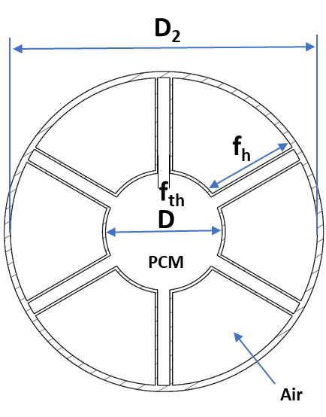
For turbulent air flow, the average Nusselt number for air is calculated by the following equation:
$\begin{matrix} & N_{u}=0,00529⋅Re^{0.868} {10}^{4}⩽Re⩽{5.10}^{4} \\ & h_{a_{-PCM}}=\frac{{N_{\text{u} }λ}_{\text{air }}}{D_{h}} { R}_{e}=\frac{V⋅D_{h}}{v} D_{h}=D_{2}-D\end{matrix}$
$ηr :$ is the region efficiency calculated by the following equation:
$η_{r}=1-(1-η)\frac{A_{f}}{A_{t}}$
Where:
Fig. 3: Schematic of the air to the PCM heat exchanger.
$$\begin{matrix} & η=0,979+4,40⋅{10}^{-4}⋅c_{1}-7,45⋅{10}^{-5}⋅c_{2} \\ & c_{1}=\frac{N_{u}L_{PCM} ^{2}λ_{\text{air }}}{λ_{P}D_{h}\frac{f_{th}}{2}} { c}_{2}=\frac{N_{u}L_{PCM} ^{2}}{A⋅Re⋅P_{r}} A=\left(\frac{π}{4}\right)⋅\left(D_{2} ^{2}-D^{2}\right)\end{matrix}$$

Discretization and numerical solving
(15)
(14)
$$\begin{matrix} & \left(1+β_{1}Δt+2β_{2}Δt\right)⋅T_{air} ^{t+Δt}+\left(-β_{1}Δt\right)⋅T_{PCM} ^{t+Δt}=T_{air} ^{t}+2β_{2}Δt⋅T_{UGS} ^{t+Δt} \\ & (1+αΔt)⋅T_{PCM} ^{t+Δt}+(-αΔt)⋅T_{air} ^{t+Δt}=T_{PCM} ^{t+Δt}\end{matrix}$$
Where:
(16)
$$α=\frac{U_{a-PCM}At}{m_{PCM}Cp_{equ}} { β}_{1}=\frac{U_{a-PCM}At}{m_{air}Cp_{air}} { β}_{2}=\frac{\overset{˙}{m}cp_{air}}{m_{air}cp_{air}}{ T}_{air}=\frac{T_{UGS}{ + T}_{ou}}{2}$$
$$Cp_{equ}=Cp_{b}+\frac{0.1Ls\sqrt{2}γexp⁡\left(-\frac{2γ{\left(T_{pcm-ini}-T_{m}\right)}^{2}}{ΔT^{2}}\right)}{ΔT\sqrt{π}}$$
Where:
(17)
$$Cp_{b}=\left(1+β\right)Cp_{s}+\frac{βCp_{l}}{2} β=\frac{1}{π}\left[\arctan\left(-\frac{2γ\left({ T}_{pcm-ini}-T_{m}\right)}{ΔT}\right)+\frac{π}{2}\right]$$
The thermal model was implemented in Python, where the coupled air–PCM energy balance equations were solved using an implicit time-marching approach with analytical reformulation. At each 1-second time step, the system of equations was rearranged to obtain closed-form expressions for air and PCM temperatures, thus avoiding the use of iterative solvers or matrix inversion. This approach offers computational efficiency while preserving numerical stability. The enthalpy method with a smoothed effective heat capacity function was applied to account for phase change behavior around the melting temperature.
Model validation was performed by comparing simulation results with experimental data from Ouzzane and Bady [8], showing a maximum absolute deviation of **0.8°C** and a relative error below 5% (see Fig. 4). These results confirm the accuracy of the implemented solver for predicting transient thermal behavior in passive air-based energy systems. Nevertheless, this validation relies on a single reference case, which may be considered a limitation. Future work will aim to extend validation with additional datasets, particularly experimental measurements under Moroccan climatic conditions.
- Results and Analysis
Preliminary results from the simulations indicate that the proposed hybrid system offers promising potential for reducing energy consumption while maintaining thermal comfort in buildings. The performance of the system was evaluated under the current climate conditions and projected future climates for Fez, Morocco. For both cooling and heating, the system demonstrated significant energy savings compared to conventional HVAC systems.
Key findings reveal that the effectiveness of the cooling process depends heavily on the heat transfer coefficient in the PCM heat exchanger. When the coefficient is low, the cooling performance of the system is diminished, underlining the importance of optimizing the heat exchanger’s design and operational conditions. Additionally, the dimensions of the primary UGS system play a crucial role in the system’s overall efficiency, highlighting the need for careful system design to maximize cooling capacity.
The study’s conclusions suggest that integrating UGS with PCM-based heat exchangers can substantially improve the energy efficiency of buildings in hot climates. The system not only addresses the immediate need for reducing energy consumption but also serves as a sustainable solution for adapting to future climate scenarios. These findings open the door for further research into hybrid systems that combine renewable energy sources with innovative materials, contributing to the development of more sustainable and resilient building technologies.
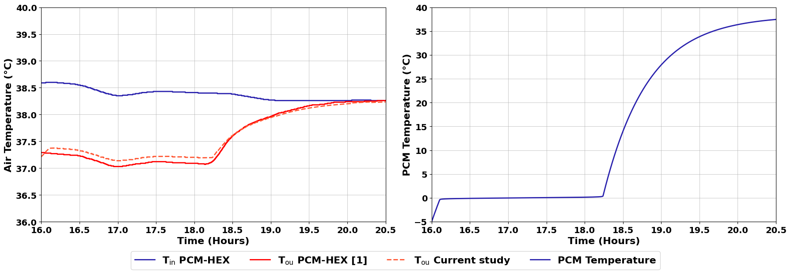
Fig. 4. Validation of the thermal model of the PCM-HEX exchanger: comparison between the results of the present study and those of the literature [8].
Figure 4 illustrates the thermal evolution of the PCM-HEX exchanger. The graph on the left shows air temperature variations at the exchanger inlet and outlet. The blue curve corresponds to the air inlet temperature, while the red curves represent the outlet temperature, comparing the results of the present study (dotted line) with those reported in the literature [8] (solid line). This comparison demonstrates a strong agreement between both data sets, validating the reliability of the proposed model. Quantitatively, the maximum absolute deviation between the simulated outlet air temperatures and those from [8] is approximately 0.8 °C, with a mean relative error below 5%. These results confirm the model’s accuracy under transient thermal conditions. It can also be observed that the air outlet temperature rises progressively between 18:00 and 20:00, indicating a reduction in heat transfer efficiency due to the gradual exhaustion of the PCM’s latent storage. Meanwhile, the graph on the right shows the temperature evolution of the PCM itself, which starts at a sub-zero temperature and steadily increases, reaching nearly 38 °C confirming complete melting during this interval.
Table 1 summarizes the studied configurations, including UGS dimensions, air velocity, fin number, and PCM type. This synthesis provides a direct overview of the test matrix and facilitates comparison of results.
Table 1: Summary of studied configurations
Parameter studied | Values considered | Figure reference
UGS dimensions (m³) | 1.5×0.5×1 ; 3×1×2 ; 6×2×4 | Fig. 5
Air velocity (m/s) | 1.5 ; 2.5 ; 3.5 | Fig. 6b
Number of fins | 3 ; 6 ; 12 | Fig. 6c
PCM type | Water ; Hexadecane ; Tetradecane | Fig. 6d

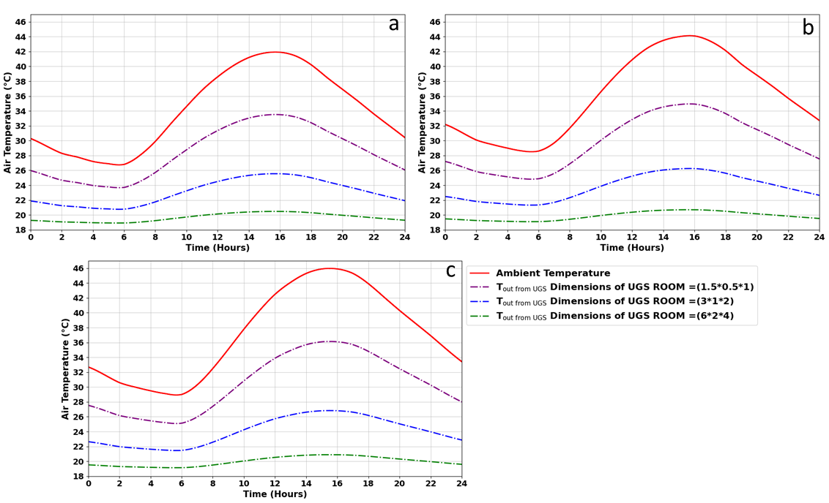
Fig. 5. Influence of Underground Space (UGS) dimensions on air temperature at the outlet of the passive geocooling system, for three climate scenarios: current climate (a), future climate 2050 according to RCP4.5 (b) and RCP8.5 (c).
Figure 5 shows the hourly evolution of air temperature at the outlet of the UGS (Underground Space) system for the reference day of August 19, characterized by extreme thermal conditions. Three underground chamber volumes were studied: small (1.5 × 0.5 × 1 m³), medium (3 × 1 × 2 m³) and large (6 × 2 × 4 m³). The curves are compared with the ambient outdoor temperature in each of the climatic contexts simulated for the city of Fez (Morocco).
The results show that increasing the volume of the underground chamber significantly improves cooling performance. A larger volume enables better heat dissipation thanks to more extensive heat exchange with the ground. Thus, for the largest configuration (6 × 2 × 4 m³), the outlet air temperature remains almost constant at around 21-22°C, even when the ambient temperature peaks at over 44°C. Conversely, small volumes are more sensitive to external fluctuations, limiting their ability to maintain a stable supply air temperature.
This analysis highlights the decisive influence of UGS sizing on the overall efficiency of the geocooling system. Sufficient underground volume gives the system greater thermal inertia, guaranteeing a lower, more even supply temperature, which is essential to ensure thermal comfort in summer, even in the face of global warming.
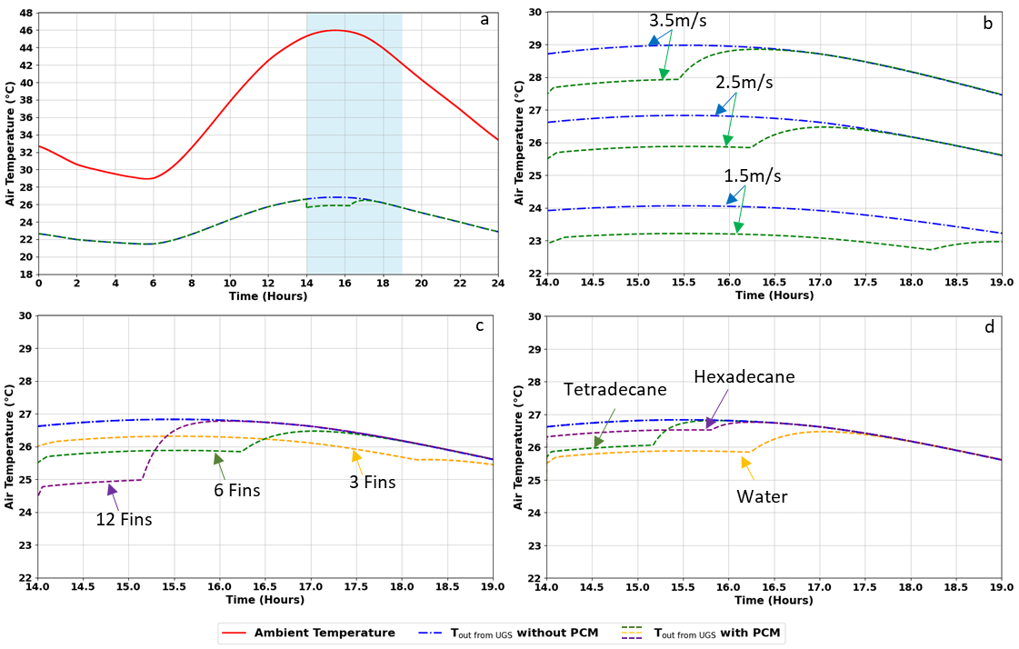
Fig. 6. Parametric analysis of the thermal performance of the UGS/PCM hybrid passive cooling system according to various influencing factors.
This figure presents a sensitivity study to assess the impact of several design and operating parameters on the air temperature at the outlet of the hybrid cooling system, combining a shallow geothermal exchanger (UGS) and a phase-change material exchanger (PCM).
- Sub-figure (a): This graph illustrates the hourly evolution of the outdoor ambient temperature (red curve) and the air temperature at the outlet of the UGS system, with (dotted green line) and without (dotted blue line) use of the PCM, for the typical day of August 19 in Fez (Morocco). A peak ambient temperature of over 45°C is observed between 2 and 6 p.m. (blue zone), a critical period during which the system shows a notable capacity for thermal smoothing. The addition of the PCM significantly reduces the outlet temperature by 2 to 3°C during the overheating period, demonstrating the system's ability to temporarily store excess heat.
- Sub-figure (b): This graph shows the effect of air velocity (1.5, 2.5 and 3.5 m/s) on the system's thermal performance. For each speed, outlet temperatures are compared between the system with PCM (dotted green line) and without PCM (dotted blue line). An increase in airflow velocity improves overall convective heat exchange, resulting in a decrease in outlet air temperature. The gap between the two configurations (with and without PCM) also widens with increasing velocity, confirming the effectiveness of the PCM when heat transfer is favoured by more intense convection.
- Sub-figure (c): This section examines the impact of the number of fins (3, 6 and 12) integrated into the Air/PCM exchanger on the outlet air temperature. A significant improvement in thermal performance is observed as the number of fins increases, due to the larger heat exchange surface between the air and the PCM. The 12-fin case enables the temperature to be kept below 25°C for extended periods of time, reinforcing the thermal comfort potential offered by the system.
- Sub-figure (d): This graph compares the thermal performance of the system for different types of phase-change materials: water, hexadecane and tetradecane. Each PCM has a distinct melting temperature, influencing its ability to absorb heat at different temperature ranges. Water offers the best performance in terms of air temperature reduction, thanks to its high heat capacity and melting temperature close to Fez's summer climate. Hexadecane and tetradecane offer comparable but slightly lower results, suggesting that the choice of PCM must be carefully matched to the local thermal profile to maximize system efficiency.
Optimal Configuration and Cooling Efficiency
The analysis identified the configuration that offers the most effective cooling performance. The optimal setup consists of an underground space (UGS) chamber with dimensions of 6 × 2 × 4 m³, combined with an Air/PCM heat exchanger equipped with 12 longitudinal fins and using water as the phase change material. For an airflow velocity of 3.5 m/s, this configuration achieves a global convective heat transfer coefficient exceeding 40 W/m²·K, resulting in a reduction of outlet air temperature from over 45°C to approximately 22°C during peak summer conditions. These results highlight the importance of geometric optimization, airflow enhancement, and PCM selection in improving the thermal performance of the hybrid passive cooling system under current and future climatic scenarios.
Energy Savings and Techno-Economic Perspective
To evaluate the energy savings, the system's performance was compared with a conventional HVAC unit (COP = 2.5). Over a 4-hour peak cooling period, the hybrid UGS + PCM system delivered approximately 0.88 kWh of cooling with an electrical input limited to 0.24 kWh (fan consumption), yielding an effective COP of ~3.67. In comparison, a conventional system would require about 0.352 kWh to deliver the same cooling load. This results in an electricity saving of approximately 32% under typical summer conditions.
- Conclusion
In conclusion, this study underscores the relevance of integrating hybrid approaches into the design of passive cooling strategies for buildings. By combining shallow geothermal energy (UGS) with phase-change materials (PCM), the proposed system offers a sustainable and efficient response to the growing demand for summer thermal comfort. The results of theoretical modeling and numerical simulations confirm the superior performance of this hybrid solution compared to conventional passive systems, even under future climate scenarios (RCP4.5 and RCP8.5) projected to 2050.
Parametric analyses identified key optimization factors, such as the geometry of the underground volume, air velocity, and the design of the Air/PCM exchanger.
This work opens new research avenues focused on the multi-objective optimization of the system, including performance, cost, and architectural integration, as well as its potential coupling with other renewable technologies to enhance the energy autonomy of buildings.
- The proposed hybrid UGS–PCM system significantly improves passive cooling performance under hot climates.
- Parametric analyses highlight the dominant influence of UGS size and air/PCM convective coefficient.
- Optimal configuration (6 × 2 × 4 m³ UGS, 12 fins, water PCM, air velocity 3.5 m/s) achieves cooling up to 20 °C (from 45 °C to ~22 °C).
- Water was identified as the most suitable PCM for Fez climate conditions.
- Compared to a conventional HVAC unit (COP = 2.5), the hybrid system reduces electricity consumption by ~32%.
- The approach remains robust under future climate scenarios (RCP4.5 and RCP8.5), ensuring long-term applicability.
Acknowledgements
The authors wish to express their sincere gratitude to the National Center for Scientific and Technical Research (CNRST) for the financial support provided through the “PhD-Associate Scholarship – PASS” program.

References
[1] “- IEA.” Accessed: Mar. 21, 2025. [Online]. Available: https://www.iea.org/t%26c/
[2] K. K. W. Wan, D. H. W. Li, W. Pan, and J. C. Lam, “Impact of climate change on building energy use in different climate zones and mitigation and adaptation implications,” Appl Energy, vol. 97, pp. 274–282, 2012, doi: 10.1016/j.apenergy.2011.11.048.
[3] T. R. Knutson, R. Zhang, and L. W. Horowitz, “Prospects for a prolonged slowdown in global warming in the early 21st century,” Nov. 30, 2016, Nature Publishing Group. doi: 10.1038/ncomms13676.
[4] G. Tomrukcu and T. Ashrafian, “Climate-resilient building energy efficiency retrofit: Evaluating climate change impacts on residential buildings,” Energy Build, vol. 316, Aug. 2024, doi: 10.1016/j.enbuild.2024.114315.
[5] S. Idrissi Kaitouni, R. Chahboun, Z. Bouhssine, M. Cakan, J. Brigui, and M. Ahachad, “Simulation-based assessment of the climate change impact on future thermal energy load and indoor comfort of a light-weight ecological building across the six climates of Morocco,” Thermal Science and Engineering Progress, vol. 45, Oct. 2023, doi: 10.1016/j.tsep.2023.102137.
[6] M. Jiménez Torres, D. Bienvenido-Huertas, O. May Tzuc, A. Bassam, L. J. Ricalde Castellanos, and M. Flota-Bañuelos, “Assessment of climate change’s impact on energy demand in Mexican buildings: Projection in single-family houses based on Representative Concentration Pathways,” Energy for Sustainable Development, vol. 72, pp. 185–201, Feb. 2023, doi: 10.1016/j.esd.2022.12.012.
[7] M. Olonscheck, A. Holsten, and J. P. Kropp, “Heating and cooling energy demand and related emissions of the German residential building stock under climate change,” Energy Policy, vol. 39, no. 9, pp. 4795–4806, Sep. 2011, doi: 10.1016/j.enpol.2011.06.041.
[8] M. Ouzzane and M. Bady, “Investigation of an innovative Canadian well system combined with a frozen water/PCM heat exchanger for air-cooling in hot climate,” Appl Therm Eng, vol. 213, Aug. 2022, doi: 10.1016/j.applthermaleng.2022.118737.
[9] M. Ghamari et al., “Advancing sustainable building through passive cooling with phase change materials, a comprehensive literature review,” Jun. 01, 2024, Elsevier Ltd. doi: 10.1016/j.enbuild.2024.114164.
[10] M. M. Aghoei et al., “Phase change materials (PCM) as a passive system in the opaque building envelope: A simulation-based analysis,” J Energy Storage, vol. 101, Nov. 2024, doi: 10.1016/j.est.2024.113625.
[11] M. Alkaragoly, M. Maerefat, and M. Z. Targhi, “A novel hybrid passive cooling system for providing thermal comfort conditions and reducing energy consumption in buildings in hot climates,” Renew Energy, vol. 234, Nov. 2024, doi: 10.1016/j.renene.2024.121209.

