Thermal Performance of a single-slope-solar Distiller with Internal Reflectors for Phosphate Sludge Drying
Mohammed REZKI¹, a), Khaoula KHALES², Noureddine ABOURICHA¹, Sabah EL AMRAOUI¹, Nouhaila ASDIOU¹, Ali FADDOULI³, Mounia ACHAK^{1,2}, g)
¹Science Engineer Laboratory for Energy, National School of Applied Sciences, Chouaïb Doukkali University, El Jadida, Morocco
²Chemical & Biochemical Sciences. Green Process Engineering, CBS, Mohammed VI Polytechnic University, Ben Guerir, Morocco
³Multidisciplinary Laboratory of Research and Innovation (LaMRI), EMAFI Team, Polydisciplinary Faculty, University of Sultan Moulay Slimane, Khouribga, Morocco

- mhammedrezki@gmail.com
- achak_mounia@yahoo.fr
Abstract. The management of industrial phosphate sludge, a by-product of phosphate ore processing, presents a major environmental and industrial challenge due to its high moisture content and pollutant load. Solar drying through distillation has emerged as a sustainable, cost-effective, and eco-friendly alternative to conventional sludge treatment methods. This study investigates the performance of a single-slope solar distiller with internal reflectors to enhance heat absorption and improve drying efficiency. An experimental campaign was conducted to evaluate the influence of solar irradiation on the distiller’s productivity and to examine the physico-chemical transformations of both the sludge and the recovered distillate. The results show that solar drying significantly reduces the sludge’s moisture content, achieving a peak drying temperature of 88.5°C. Chemical analyses revealed a considerable reduction in total phosphorus and Kjeldahl nitrogen concentrations, indicating improved environmental safety of the treated sludge. Furthermore, the system produced an average daily distilled water yield of 482.35 ml/m²/day, with higher output observed under intense solar conditions. These findings underscore the potential of solar distillation as a sustainable solution for phosphate sludge valorization, and suggest that further enhancements, such as improved solar absorber coatings or hybrid thermal storage, could increase system performance and scalability for industrial applications.
Keywords: phosphate sludge, solar distillation, drying, internal reflectors, environmental management

1. INTRODUCTION
Phosphate sludge, poses severe environmental and handling challenges. Traditional storage methods, such as unlined evaporation ponds, lead to land degradation and potential contamination of water sources [1]. The presence of phosphate sludge impacts the environment by contaminating soil and groundwater, creating health hazards for local communities, and reducing the availability of arable land for agriculture. Over 29.1 million tonnes of phosphate sludge are generated annually [2].
Solar drying presents an innovative, cost-effective, and sustainable solution for treating phosphate sludge, reducing its volume and improving its handling properties [3]. This thermal process reduces the water content of the sludge, facilitating its transport and potential valorization [4]. Moreover, it aligns with sustainability goals by minimizing environmental risks and enhancing material recovery.
Several recent studies have explored the transformation of phosphate sludge into value-added materials, such as lightweight aggregates and geopolymers [5][6]. Others have tested solar-based solutions for different types of industrial waste but with limited analysis of chemical transformations and distillate recovery.
Building on these findings, this study evaluates the thermal performance of a modified single-slope solar distiller equipped with internal reflectors, under the climatic conditions of El Jadida, Morocco.
The main objectives of this research are to:
- assess the distiller’s efficiency in reducing sludge water content,
- examine the changes in the physico-chemical properties of both sludge and distillate, and
- explore the system’s potential as a sustainable solution for industrial sludge management.

2. METHODOLOGY

2.1. Experimental Setup
In this study, a single-slope solar distiller with internal aluminum reflectors was designed and tested to enhance solar irradiation capture and improve the thermal drying of phosphate sludge. The system consisted of a rectangular basin made of black-painted iron (thickness: 2 mm), with a surface area of 0.25 m², which corresponds to the active solar absorption surface. This basin contains the phosphate sludge and acts as the primary absorber of solar energy.
To improve the internal heat distribution, the inner walls of the distiller were lined with polished aluminum mirrors acting as internal reflectors, redirecting additional solar irradiation toward the sludge surface and enhancing evaporation. However, as shown in Figure 1, the basin's size partially obstructs some reflector surfaces. This design trade-off was necessary to maintain a sufficient sludge volume while still benefiting from internal reflection.
The transparent glass cover was inclined at an angle of 30°, which corresponds to the latitude of El Jadida (33.23°). This inclination ensures maximum solar energy absorption throughout the day based on optimal solar incidence. A distillate collection channel was positioned at the base of the glass cover to collect condensed vapor.
The entire unit was thermally insulated using polystyrene on all external surfaces, and sealed with silicone to prevent heat loss and vapor leakage. The structure was installed in an open outdoor location free from shading, ensuring full exposure to solar radiation.
Solar irradiation was measured using a pyranometer positioned next to the distiller, oriented at the same inclination angle as the glass cover. Internal temperatures (sludge, glass, air, insulation, etc.) were monitored using type-K thermocouples, and the water production was measured hourly using a graduated cylinder. The final sludge mass was determined by weighing before and after drying using a precision balance.
Preliminary control tests were carried out without mirrors to assess the impact of internal reflectors (without mirrors) were performed in preliminary trials. However, only the results of the distiller with internal reflectors are presented in this paper. A comparative study is planned for future work.
Figure 1 illustrates a schematic of the full experimental configuration, including sensor positions, reflector layout, and measurement locations.
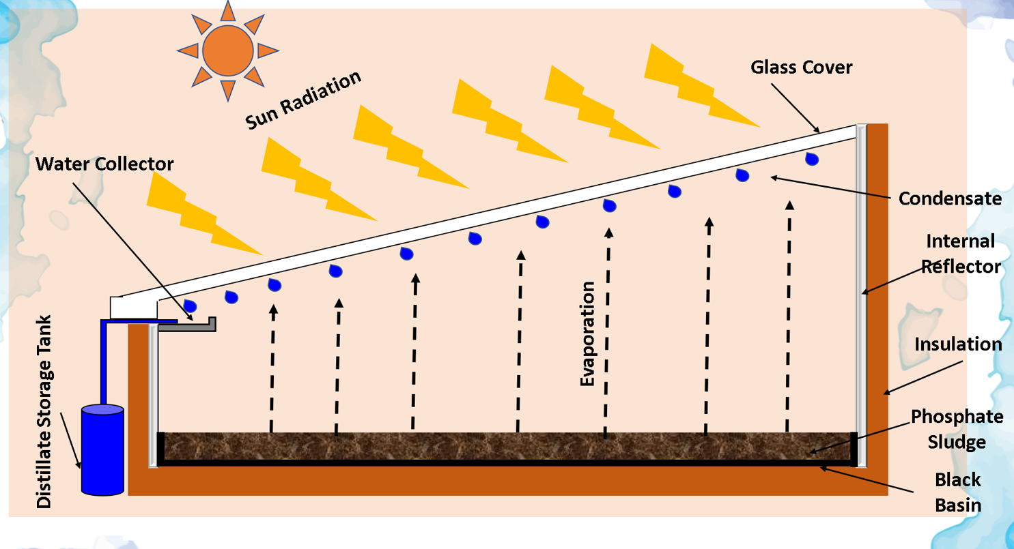
Figure 1. Schematic Diagram of the Experimental Configuration

2.2. Instrumentation, Monitoring, and Experimental Procedures
To evaluate the thermal and operational performance of the solar distillation system, a comprehensive set of instruments was employed.
Solar Irradiance Measurement: Global solar irradiation was measured using a pyranometer (±10 W/m² accuracy), placed on the same inclination plane as the glass cover (30°) to ensure accurate measurement of incident solar irradiance. The data was logged at 30-minute intervals.
Temperature Monitoring: Eight K-type thermocouples were strategically placed in the system to monitor thermal behavior at the following points:
Ambient air
Inner glass surface
Outer glass surface
Sludge surface (center of basin)
Water vapor layer
Internal insulation wall
Sludge water
External cover
The thermocouples were connected to a KEYSIGHT 34972A LXI Data Acquisition Unit for automated logging every 30 minutes.
Distillate Yield Measurement: The distilled water was collected hourly using graduated cylinders placed at the outlet and weighed with a digital balance (±0.01 g precision) to determine hourly production rates.

TABLE 1. Summary of Measurement Instruments
Parameter | Sensor / Device | Accuracy | Measurement Interval
Solar irradiation | Pyranometer | ±10 W/m² | 30 min
Temperature (sludge, glass, air, insulation) | K-type thermocouples (8 points) | ±0.1°C | 30 min
Distillate yield | Graduated cylinder + digital balance | ±0.01 g | Hourly
Weight loss of sludge | Laboratory-scale balance | ±0.01 g | Start/End of each test
Physico-chemical analyses (pH, TP, EC, TDS) | Standard APHA methods | — | Before & After during

Experimental Protocol: The experimental campaign lasted five consecutive days (from 08:00 to 18:00), under clear-sky conditions. Each day, a fresh batch of phosphate sludge (~1.5 kg) was placed in the basin. At the end of each day, the dried sludge was weighed to determine the moisture content reduction.
Weight Monitoring: Initial and final weights of the sludge were recorded using a calibrated laboratory-scale balance to estimate the evaporated water mass.
Physico-Chemical Analysis: Both sludge and water samples (before and after treatment) were analyzed to evaluate drying and purification effects. Parameters measured included:
pH
Total Phosphorus (TP)
Orthophosphates (PO₄³⁻)
Electrical Conductivity (EC)
Total Dissolved Solids (TDS)
All analyses were conducted in triplicate following standard protocols, including APHA 4500-P for phosphorus measurement, to ensure data reliability and repeatability.

3. RESULTS AND DISCUSSION

3.1. Temporal Evolution of Solar Radiation
The temporal evolution of solar radiation incident on the inclined surface (θ = 30°) during the experimental period is shown in Figure 2. The results reveal a typical diurnal pattern, with solar irradiance increasing steadily from sunrise and reaching its maximum between 12:00 and 15:00, when the sun is near its zenith. The peak radiation recorded was approximately 1000 W/m². After this period, a gradual decline was observed as the solar altitude decreased toward sunset. Minor day-to-day fluctuations were attributed to variations in atmospheric conditions such as humidity and cloud cover. These observations confirm that the performance of the solar distiller closely follows the intensity of incident solar radiation, emphasizing the critical role of midday solar peaks in achieving optimal thermal and evaporative performance.
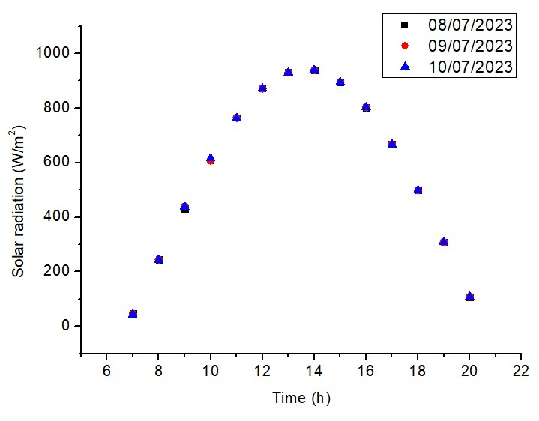
Figure 2. Variation of solar radiation as a function of time

3.2. Distillate Productivity

The daily yield of the solar distiller was directly influenced by the solar radiation intensity. The average distilled water production was 482.35 ml/m²/day, with a peak sludge drying temperature of 88.5°C recorded during high radiation periods. These findings confirm the system's efficiency in converting solar energy into thermal energy for effective sludge drying.
Although the highest recorded temperature of 88.5°C was reached on July 10, 2023, the distillate yield was lower compared to previous days. This discrepancy may be explained by environmental factors such as lower ambient humidity or higher wind speed, which could have reduced condensation efficiency. It is also possible that vapor losses occurred before reaching the glass surface, or that saturation in the condensation zone limited water recovery.

3.3. Physico-Chemical Changes in Sludge and Distillate
The physico-chemical analysis of both sludge and distillate revealed significant transformations resulting from the solar drying process. The distillate exhibited a slightly acidic pH, mainly due to the volatilization of acidic components such as fluorapatite. Most of the total phosphorus was retained in the sludge matrix, indicating limited phosphorus transfer to the distillate and efficient mineral conservation within the solid phase. Meanwhile, the electrical conductivity (EC) and total dissolved solids (TDS) decreased markedly, reflecting the progressive removal of soluble ionic species and impurities from the sludge. These results demonstrate that the solar distillation system not only achieves effective dehydration but also contributes to partial purification, improving both environmental safety and the reusability of the treated sludge.

TABLE 2. Physico-chemical characteristics of phosphate sludge before and after drying

Parameters | Raw sludge | Sludge after dryin
Mass (kg) | 1.764 | 0.416
Humidity (%) | 76.21 | 3.8
Total dry matter (g/kg) | 237.86 | 961
Volatile dry matter (g/kg) | 9.259 | 29.37
Total phosphorus (g/l) | 3.093 | 1.072
Kjeldahl nitrogen (g/kg) | 1.73 | 0.39
COT (%) | 13 | 0
TDS (kg/l) | 1.144 | -
pH | 7.61 | -
CE (µs/cm) | 2305.6 | -

3.4. Chemical characteristics of the recovered distillate
The results of the chemical analysis of the distillate collected during the first three days of drying are presented in Table 2. Due to the low quantities of water produced after these initial days, further chemical analyses could not be performed. The findings show a significant reduction in the concentrations of mineral matter in the distillate. The pH of the distillate became acidic, likely due to the evaporation of acidic components from the sludge, particularly fluorapatite. Furthermore, the majority of the total phosphorus remained in the sludge.
TABLE 3. characteristics of the recovered distillate
Parameters | Day 1 | Day 2 | Day 3
CE (µs/cm) | 162.9 | 48.43 | 128.8
TDS (kg/l) | 81.66 | 24.43 | 64.525
pH | 4.85 | 4.74 | 5.23
Orthophosphates (mg/l) | 0.508 | 0.287 | 0.539
Total phosphorus (g/l) | 0.754 | 1.424 | 0.739
Kjeldahl nitrogen (g/l) | 0.322 | 0 | 0.077
DCO (go₂/l) | 0.213 | 0.154 | 0.184

3.5. Temperature Distribution Within the System
The temporal evolution of various temperatures within the solar distiller over different days is illustrated in Figures 3, 4, and 5. It is evident that the time-variation curves of the temperatures for each component of the distiller follow a similar pattern. The temperatures increase over time, reaching their maximum between 12 PM and 3 PM, and then decrease until 8 PM. This pattern is due to the intensity of solar flux. The maximum temperature recorded during the drying days was for the sludge, with a value of 88.503°C. This result indicates that our system effectively concentrates the maximum amount of solar radiation to dry the phosphate sludge.

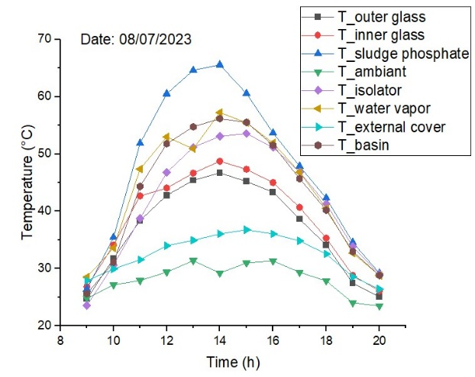
Figure 3. Variation of different temperatures as function of time 08/07/2023
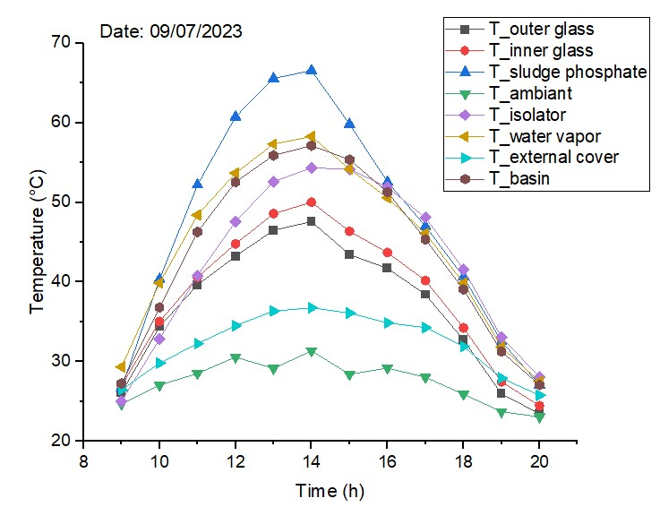
Figure 4. Variation of different temperatures as function of time 09/07/2023
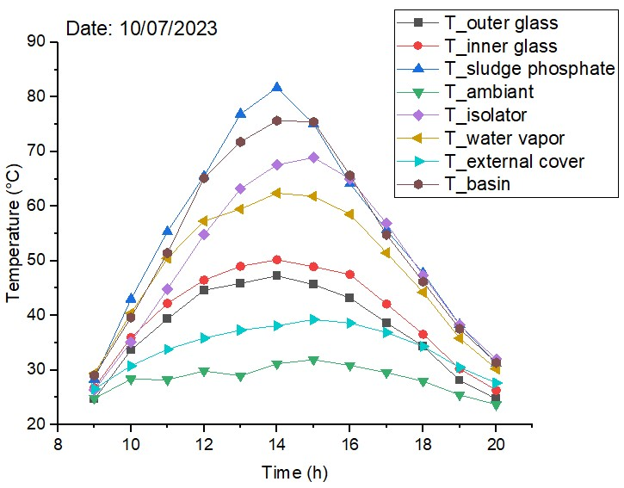
Figure 5. Variation of different temperatures as function of time 10/07/2023

3.6. Temporal Variation in water Production
The evolution of the volume of distillate produced over different drying days is shown in Figure 6. The distiller's output increases throughout the day, reaching a peak between 1 PM and 3 PM, and then decreases as the day progresses. This pattern mirrors the variation in solar flux intensity. It can be concluded that higher solar irradiation leads to greater distillate production.

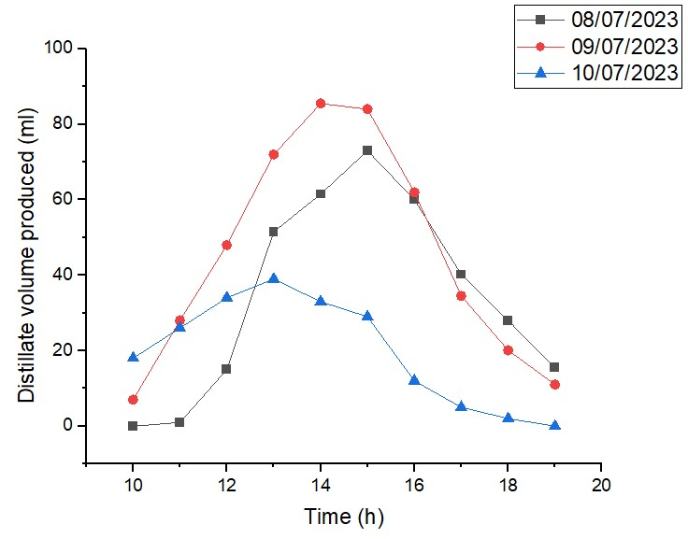
Figure 6. Variation of distillate volume produced as function of time

CONCLUSION
The experimental investigation of solar drying for phosphate sludge using a single-slope solar distiller with internal reflectors has demonstrated promising results in terms of both efficiency and sustainability. The system achieved an average distillate yield of 482.35 ml/m²/day, with peak performance observed during high solar radiation periods. The substantial reduction in moisture and the observed physico-chemical transformations, including the decrease in total phosphorus content, underscore the method’s potential.
This study confirms that solar distillation is a viable, low-cost, and eco-friendly alternative to conventional drying techniques for industrial sludge. Future improvements could focus on integrating thermal storage materials or advanced reflective coatings to enhance performance under variable weather conditions, making the system more adaptable to large-scale applications.
Further integration of thermal storage materials or photovoltaic-thermal hybrids may further enhance the system’s performance and nighttime productivity.

References
- M. Chaanaoui et al., “Prototype of phosphate sludge rotary dryer coupled to a parabolic trough collector solar loop: Integration and experimental analysis,” Solar Energy, vol. 216, pp. 365–376, Mar. 2021, doi: 10.1016/j.solener.2021.01.040.
- N. Abdenouri et al., “Solar drying and thermodynamic sorption properties of phosphate sludge downstream of mine waste reclamation processes,” Mater. Today Proc., vol. 51, pp. 1924–1930, Jan. 2022, doi: 10.1016/j.matpr.2021.03.136.
- Hakkou, M. Benzaazoua, and B. Bussière, “Valorization of Phosphate Waste Rocks and Sludge from the Moroccan Phosphate Mines: Challenges and Perspectives,” Procedia Engineering, vol. 138, pp. 110–118, Jan. 2016, doi: 10.1016/j.proeng.2016.02.068.
- M. Loutou et al., “Phosphate sludge: Thermal transformation and use as lightweight aggregate material,” J. Environ. Manage., vol. 130, pp. 354–360, Nov. 2013, doi: 10.1016/j.jenvman.2013.09.004.
- S. Moukannaa et al., “Recycling of phosphate mine tailings for the production of geopolymers,” J. Clean. Prod., vol. 185, pp. 891–903, Jun. 2018, doi: 10.1016/j.jclepro.2018.03.094.
- A. Fadhel et al., “Investigation of a Linear Fresnel solar collector (LFSC) prototype for phosphate drying,” Energy Nexus, vol. 10, p. 100188, Jun. 2023, doi: 10.1016/j.nexus.2023.100188.

