Moroccan Dam Level Dataset: A High Resolution Satellite-Based Monitoring Dataset for Moroccan Dams
Younes Ouargani^{1,a)}, El Khattabi^{1,b)}, and Fakhre-Eddine Mohamed Amine^{2,c)}
1Laboratory of Conception and Systems (Electronics, Signals, and Informatics),
Faculty of Science, Mohammed V University Rabat, 4 Avenue Ibn Batouta BP 1014 RP, RABAT, Morocco
2Dept. Of Computer Science, Faculty of Science and Technology, Ancienne Route de l’Aéroport, Km 10, Ziaten. BP : 416. Tanger - Maroc
- Corresponding author: younes_ouargani@um5.ac.ma
- e.noussaima@um5r.ac.ma
- mohamedamine.fakhreeddine@etu.uae.ac.ma
Abstract. Water reservoirs are crucial for hydropower, irrigation, and urban water supply within the Water-Energy-Food (WEF) Nexus. However, real-time monitoring is limited due to sparse in-situ data and climate variability. We present Moroccan Dam Level Dataset, a publicly available dataset combining high-resolution satellite imagery and water level data from Morocco’s official dam level platform. The dataset offers multi-temporal observations of reservoir dynamics. It provides spatially and temporally detailed insights for water resource management, renewable energy integration, and smart grid systems. Covering 31 major dams out of 65, the dataset spans 165 days, providing 5,115 dam-observation days and 1,023 aerial images. Each record includes Sentinel-2 optical imagery , official water level data, and geospatial metadata. The dataset represents a cumulative maximum capacity of 3.306 billion m³. The Moroccan Dam Level Dataset is an open-access resource designed to advance climate adaptation, water governance, and energy research.

INTRODUCTION
In the face of escalating global challenges such as population growth, economic development, and climate change, the effective management of water resources has never been more critical. Water reservoirs serve as crucial infrastructure, providing essential services across various sectors. They facilitate hydropower generation, ensure reliable irrigation for agriculture, and supply clean drinking water to urban areas. Within the interconnected framework of the Water- Energy-Food (WEF) Nexus, these reservoirs play a pivotal role in maintaining ecological balance and supporting sustainable development.
Reservoir monitoring is a critical aspect of water resource management, hydropower generation, and sustainable de- velopment. Traditional methods relying on ground-based gauges and stations have been the norm, but they come with significant limitations such as sparse coverage, high operational costs, and the inability to provide real-time data in remote or inaccessible locations. These challenges hinder effective decision-making for water resource management, hydropower optimization, and agricultural planning.
However, the field of reservoir monitoring has seen significant advancements through the use of remote sensing technologies, offering new opportunities for comprehensive water resource management. Chen et al.’s study [1] on groundwater storage changes in Victoria, Australia, employed a combination of satellite gravity measurements from the Gravity Recovery and Climate Experiment (GRACE) [2] and in situ data from boreholes. Their findings revealed a steady decline in groundwater levels since the early 1990s, with significant depletion rates observed between 2005 and 2009. The study demonstrated a strong correlation between groundwater depletion and drought conditions, attributing much of this depletion to increased agricultural and domestic water extraction. Notably, Chen et al. highlighted the remarkable agreement between GRACE estimates and borehole measurements, showcasing the potential of satellite gravity data for monitoring groundwater resources when ground observations are sparse or unavailable.
The study by Lee et al. [3] presents a detailed methodology for monitoring water level changes in dams using high- resolution Synthetic Aperture Radar (SAR) [4] data. They successfully demonstrated the use of advanced remote sensing techniques, such as Interferometric SAR (InSAR) and edge detection algorithms, to estimate water levels with high accuracy. The study highlights the feasibility of using SAR imagery to supplement traditional gauged data in remote or politically inaccessible areas. By constructing a Digital Surface Model (DSM) for the upstream face of the dam and applying the Hough Transform algorithm for waterline boundary detection, Lee et al. achieved a strong correlation (0.99) between SAR-derived and gauged water level data, with residuals within ±1 m. This method

provides a reliable alternative to traditional water level monitoring techniques, particularly in regions where in situ data is scarce or difficult to obtain.
Ismail et al. [5] conducted a pioneering study evaluating the potential of Sentinel-2 satellite images for monitoring water quality in artificial reservoirs, specifically focusing on Morocco’s Bin El Ouidane Reservoir. The researchers integrated in situ sampling with remote sensing data to assess correlations between water quality parameters (WQP) and satellite reflectance. By analyzing physicochemical parameters such as Chlorophyll A, dissolved Oxygen, and Nitrate, they demonstrated strong relationships (R² > 0.52) between these WQP and Sentinel-2 bands. Utilizing stepwise regression, they developed predictive models and created thematic maps using GIS software, successfully indicating the eutrophication stage in the reservoir. While not measuring water level, their approach highlighted the feasibility of high-resolution satellite data for spatially comprehensive water quality monitoring, offering a significant advancement over traditional in situ methods by providing instantaneous and extensive coverage.
El Orfi et al.’s study [6] demonstrates the accuracy and reliability of satellite imagery-based techniques in monitor- ing the spatial and temporal evolution of water resources. By employing the Modified Normalized Difference Water Index (MNDWI) derived from Landsat 5-TM, Landsat 7-ETM, and Landsat 8-OLI images, the researchers were able to estimate fluctuations in water volumes stored in the Ahmed El Hansali dam reservoir with high precision. The study’s comparison of remote sensing estimates with recorded data from the OumErRbia Hydraulic Basin Agency (OERHBA) revealed a determination coefficient (R²) exceeding 0.90, indicating strong agreement between the two datasets. This level of accuracy underscores the effectiveness of satellite imagery in providing reliable and consistent information for water resource management, particularly during periods of data scarcity such as dry years.
The existing research highlights several gaps in reservoir monitoring, previous studies utilizing GRACE satellite data [2] and SAR imagery [4], such as Chen et al.’s [1] groundwater study and Lee et al.’s [3] dam level monitor- ing, faced limitations due to high revisit times and accessibility issues associated with these technologies. Lee et al. demonstrated the effectiveness of SAR imagery in achieving high accuracy (R² = 0.99) for water level estimation, particularly in dams with steep slopes, but acknowledged challenges related to revisit frequencies and data access. Additionally, Ismail et al.’s [5] focus on water quality with Sentinel-2 images demonstrated the potential of optical data but did not extend to comprehensive dam level monitoring across multiple locations. El Orfi et al. [6] further explored satellite imagery-based techniques for water resource monitoring, employing the Modified Normalized Dif- ference Water Index (MNDWI) derived from Landsat 5-TM, Landsat 7-ETM, and Landsat 8-OLI images to estimate fluctuations in water volumes stored in the Ahmed El Hansali dam reservoir with high precision. Their study revealed a determination coefficient (R²) exceeding 0.90 when compared with recorded data from the OumErRbia Hydraulic Basin Agency (OERHBA), underscoring the reliability of optical imagery for water level estimation.
Our work addresses these critical research gaps in reservoir monitoring by introducing a novel dataset that combines high-resolution Sentinel-2 optical imagery with official dam level data, offering unparalleled temporal and spatial cov- erage. Unlike previous studies relying on GRACE satellite data or SAR imagery, which could face limitations such as high revisit times, accessibility issues, and their restricted applicability to high slope areas, MDLD provides frequent and detailed observations of major dams in Morocco. This dataset uniquely bridges the gap between ground-based observations and advanced aerial imagery, enabling comprehensive analysis of dam levels across multiple locations. By addressing the limitations of prior work, such as Ismail et al.’s [5] and El Orfi et al.’s [6] limited scope, our work expands the applicability of satellite-derived data to reservoir monitoring. The dataset’s extensive spatial and temporal coverage supports national-level water management planning and policy-making while facilitating innovative applica- tions in the Water-Energy-Food Nexus. This dataset assists various applications, including hydropower optimization [7], irrigation planning [8, 9], climate resilience strategies [10], and renewable energy integration [11], contributing to sustainable water management within the WEF Nexus.
The main contributions of our paper are as follows:

- We present Moroccan Dam Level Dataset (MDLD) the first dataset to provide high resolution aerial imagery of moroccan dams coupled with official dam information and precise temporal in-situ data.

- We deliver unprecedented coverage with 47.7% of major moroccan dams (31 out of 65 [12]), 165 days, 1,023 aerial images, and 5,115 dam-observation days.

- We address limitations in previous studies by expanding coverage beyond single dams or regions, making our dataset accessible to a broader range of comparative studies and trend analyses.

METHODOLOGY

This section details the methodology employed in developing and pre-processing the Moroccan Dam Level Dataset. The Data Sources subsection provides a comprehensive view of the resources used for our data collection, the data preprocessing and filtering subsection details the steps taken to ensure a high data quality and consistency.

Data Sources

The Moroccan Dam Level Dataset (MDLD) integrates multiple data sources to enable comprehensive reservoir moni- toring across Morocco’s water infrastructure network. A cornerstone of this dataset is the Global Dam Watch (GDW) Database [13], developed by the Global Dam Watch consortium to address the need for a comprehensive and globally consistent dataset on dams and reservoirs. The GDW Database catalogs numerous river barriers worldwide, rang- ing from wooden locks to concrete dams. While these structures provide essential benefits such as irrigation and hydropower, they also pose significant environmental and social challenges. Existing global datasets often exhibit regional biases or specific applications, such as hydropower dams affecting fish migration, leading to inconsistencies. To overcome these limitations, the GDW consortium developed a database that integrates, harmonizes, and enhances existing global datasets for large-scale analyses. The version 1.0 of the GDW database contains 41,145 barrier lo- cations and 35,295 associated reservoir polygons, representing a cumulative storage capacity of 7,420 km³ and an artificial terrestrial surface water area of 304,600 km². Reservoir locations and their bounding boxes were identified using the GDW Database, which provides essential attributes for each dam, including construction dates, reservoir capacity, and precise coordinates. These details are critical for targeted monitoring efforts.
Complementary to the GDW Database, official dam level data were sourced from Maghreb Assoudoud [12], Mo- rocco’s national dam level monitoring platform. This platform offers daily updates on reservoir levels, volumes, and filling rates, serving as the primary government resource for monitoring water levels across Morocco’s dam network. Maghreb Assoudoud platform focuses on 65 reservoirs, they represent a significant portion of Morocco’s reservoir capacity. These dams are vital to urban water supply systems, agricultural irrigation, and national water security.
Satellite imagery from Sentinel-2 [14], part of the European Union’s Copernicus program, provides a consistent, high-resolution temporal perspective for monitoring reservoir water level variations over time. The two identical satellites in the Sentinel-2 constellation work together to ensure global coverage, offering optical images at 10m spatial resolution with a 5-day revisit cycle. This frequency makes Sentinel-2 particularly effective for tracking aquatic body dynamics through its multispectral imagery, which includes visible and near-infrared bands. These capabilities enable reliable detection of water surfaces and differentiation from surrounding land areas. The freely available Sentinel-2 data make it an ideal tool for long-term monitoring studies requiring temporal consistency and high-quality observations.

Data Preprocessing and Filtering

To ensure data accuracy and consistency, a rigorous preprocessing methodology was employed to develop the Mo- roccan Dam Level Dataset (MDLD). This methodology addressed common challenges associated with integrating satellite imagery and ground-based monitoring data, such as weather interference, temporal misalignment, and varia- tions in data quality. The preprocessing steps included:

- Reservoir Extraction: The process of identifying water bodies involved a comprehensive integration of the Global Dam Watch (GDW) Database with Maghreb Assoudoud’s reservoir data. By utilizing unique identifiers from both sources, we matched dams to extract precise geographic coordinates and boundary information. From GDW, we obtained detailed metadata about each dam, including its location and bounding boxes. Meanwhile, Maghreb Assoudoud provided critical operational data such as filling rates and total capacities.

- Cloud Filtering: Sentinel-2 images were filtered to exclude those with more than 20% cloud cover, ensuring clear views of reservoir surfaces. Clouds obscure the water body surface and impede accurate delineation of reservoir boundaries, making this a critical step in processing optical satellite data.

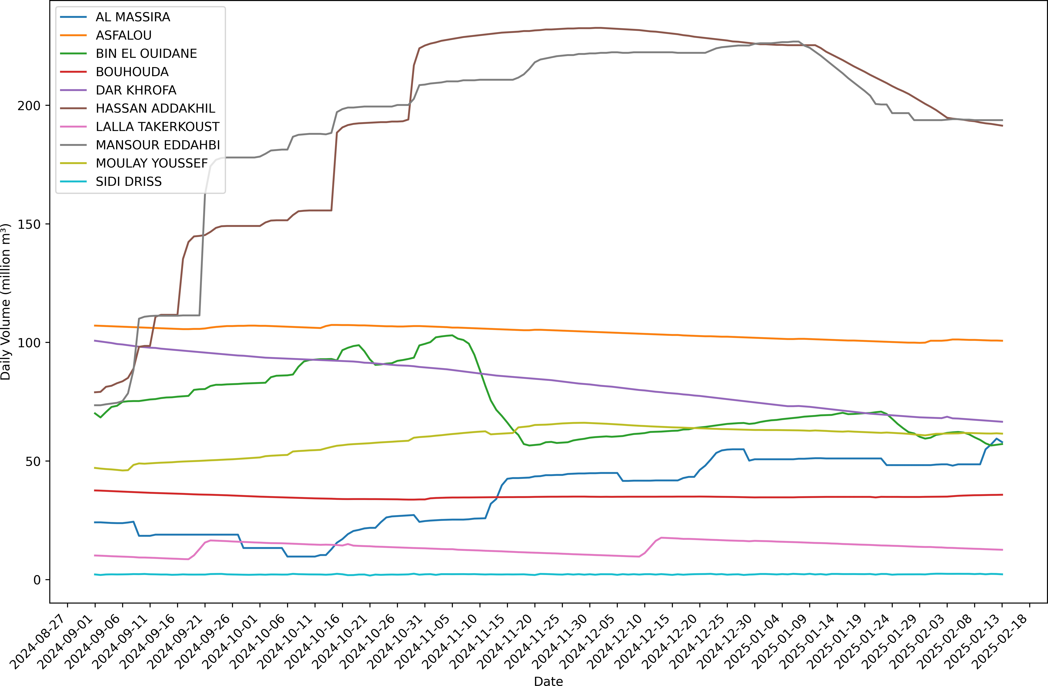
FIGURE 1: Daily Water Storage Dynamics of selected Dams over the dataset duration.

- Temporal Alignment: A 5-day interval was established to align satellite observations with Sentinel-2’s revisit cycle, ensuring consistent temporal spacing for tracking reservoir changes. This approach maximized data cov- erage while minimizing redundancy since it matched the satellite constellation’s natural observation frequency. This synchronization was crucial for aligning our spatial data with temporal records, enabling precise extraction of water levels and surface conditions over time.
This methodical preprocessing approach ensures the dataset remains accurate, cloud-free, and temporally consistent with hydrological records.

RESULTS

The MDLD dataset for tracking reservoir levels throughout Morocco’s dam network was created using the data col- lecting and preprocessing techniques previously mentioned. This results in a 165-day dataset that covers 31 important reservoirs throughout the research period and 5,115 dam-observation days. In order to capture seasonal fluctuations in reservoir levels, including both rainy and dry periods that are characteristic of Morocco’s climatic patterns, the resulting dataset spans a 165-day timeframe. The 5,115 dam-observation days offer enough data points to spot trends and patterns in the 31 covered dams. Figure 1 showcases the filling rate progression for some of the covered dams, the figure showcases the geographical diversity as demonstrated in vastly varying filling rates mostly caused by varying weather and precipitation conditions. The figure also demonstrates the variation in filling rate dynamics dictated by different conditions, such as small dam size (e.g. SIDI DRISS dam which has a small total size with small variations as it remains close to ts full capacity the majority of the time). Conversely, other dams such as MANSOUR EDDAHBI or HASSAN ADDAKHIL have varying dynamics based on season.
Each dam-observation day corresponds to a single day of monitoring data for a particular reservoir, making the dataset a significant collection of observations. The 31 reservoirs received 5,115 dam-observation days; the avail-

TABLE 1: Summary of Key Metrics for Moroccan Dam Level Dataset

Metric Value
Number of Dams Covered 31
Total Major Dams in Morocco [12] 65
Coverage Rate 47.7%
Dataset Duration 165 days
Dam-Observation Days 5,115
Aerial Images 1,023
Ratio 1 image per 5 obs. days
Cumulative Max Capacity 3.306 billion m³

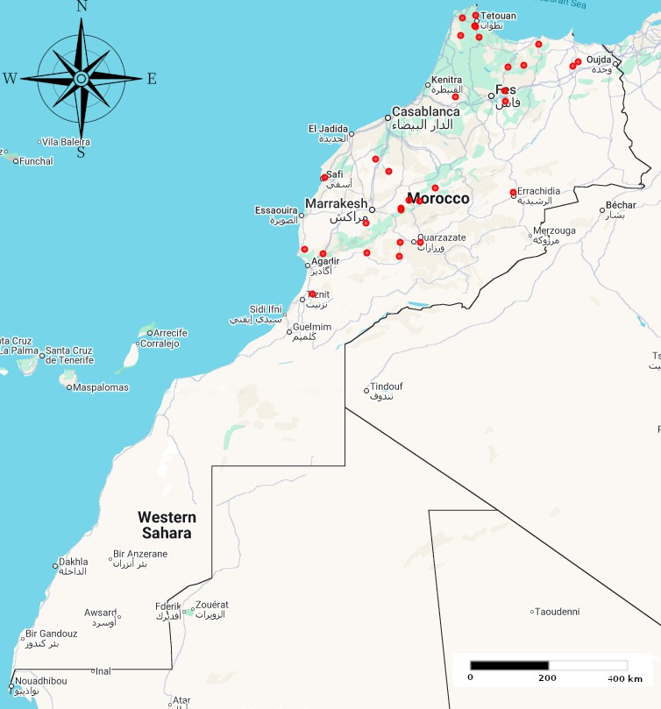
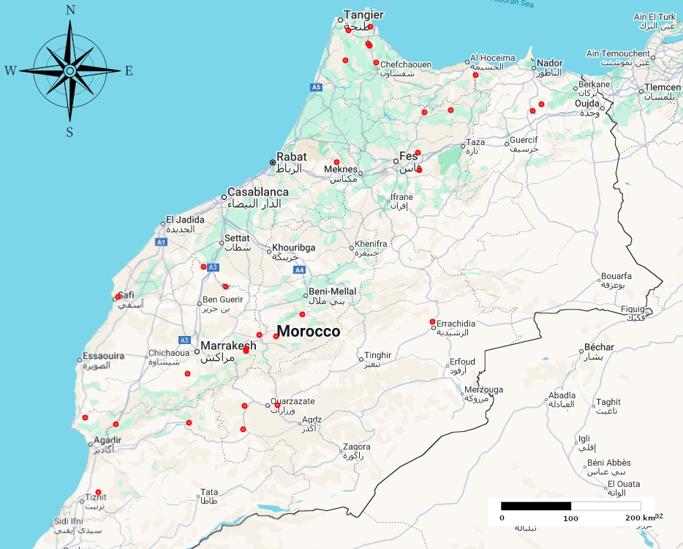
(a) Full scale view of the covered dam locations in (b) Magnified view of the covered dam locations in the MDLD dataset the MDLD dataset
FIGURE 2: Map of the covered dam locations in the MDLD dataset

ability of data from the monitoring platforms and cloud cover conditions determined which reservoirs had more comprehensive data coverage. Although the precise number varied depending on local weather circumstances and satellite picture quality during the covered period, each reservoir contributed an average of around 165 observation days to the dataset. The summary of key metrics and data coverage summary can be seen in Table 1.
The 31 major reservoirs that are part of this dataset were chosen based on their coverage by the Maghreb Assoudoud monotoring system and the GDW dataset. The limited coverage is mainly due to the limited intersection between the water bodies and their non-normalized naming conventions in the GDW dataset and Maghreb Assoudoud. Large multipurpose dams used for agriculture and urban water supply, are examples of the various kinds of water storage facilities represented by these reservoirs. The dataset is geographically diverse as the reservoirs are dispersed through Morocco as can be seen in Fig. 2 (with dam locations marked with red dots) and indicative of the nation’s several climatic zones and water management situations.
The final dataset consists of 1,023 aerial shots, each of the images is accompanied by comprehensive supporting data that enables detailed analysis of reservoir conditions:
- Sentinel-2 optical images for reservoir surface area detection : The main visual information for tracking variations in reservoir water levels over time is provided by these high-resolution satellite photos. The photos are offered in a variety of spectral bands, ensuring good accuracy when identifying water surfaces and differen- tiating them from nearby land regions. Each image is guaranteed to show the reservoir surface clearly thanks to the cloud filtering procedure, which makes it possible to calculate estimated water levels and measure the water extent with accuracy. These photos’ 10-meter spatial resolution makes it possible to identify even the smallest changes in reservoir limits, which qualifies the dataset for applications requiring in-depth monitoring.

- The maximum capacity (million mS), daily water level in both volume (million mS), and filling rate (%) are provided by official water level data (from Maghreb Assoudoud) : This ground-truth data offers crucial context for analyzing reservoir conditions and acts as the reference data for confirming satellite-based observa- tions. Calculating filling rates and understanding the relative importance of observed water levels depend on the maximum capacity data, which shows each reservoir’s entire storage capability when fully filled. Accurate quantitative information on the actual amount of water stored at each observation date is provided by daily water level measurements in million m³. The accuracy of these readings in each dam site is guaranteed by the specialized hydrological monitoring tools set up at each dam site to take the readings. The filling rate percent- ages offer an understandable indication of how filled each reservoir is at any point in time and are computed by dividing the current water volume by the maximum capacity.

- Geospatial metadata taken from the GDW Database, such as dam names, locations, and bounding boxes
: The geographic context required to find and identify each reservoir in the satellite images is provided by this information. Throughout the analytical process, dam names make it simple to identify and refer to certain reservoirs. Accurate georeferencing of satellite pictures and alignment with ground-based measurements are made possible by location data, which provides exact latitude and longitude coordinates. Algorithms for water surface extraction and automatic image processing depend on the bounding box information, which specifies the geographical extent of each reservoir region. Understanding the background and importance of observed water level variations can be aided by the extra information about dam features included in this metadata, such as construction dates, types of dams, and main uses.

The final dataset offers a strong basis for water management applications and reservoir monitoring studies. This dataset may be used for a variety of studies, thanks to its mix of high-quality satellite images, precise ground-truth measurements, and extensive metadata. The geographic distribution and temporal coverage of the dataset throughout Morocco’s main reservoirs make it especially useful for analyzing regional patterns of water availability and assisting with evidence-based water management choices.

DISCUSSION

The Moroccan Dam Level Dataset addresses critical issues in water resource management, offering valuable insights into the multifaceted applications and impacts of such a dataset. This section explores its implications across various domains, emphasizing its significance for sustainable development and policy-making.
The results from the Moroccan Dam Level Dataset show clear patterns in reservoir filling rates and water level changes across different regions and seasons. The dataset reveals how weather and precipitation directly affect dam storage, with some reservoirs experiencing rapid declines during dry periods and others showing stable or increasing levels after rainfall. The geographic diversity in the data highlights regional differences in water availability and management challenges. By comparing satellite-derived reservoir extents with official water level records, the dataset allow exploring the reliability of remote sensing for monitoring dam levels. The frequent temporal coverage allows for tracking short-term fluctuations and gives an indication over long-term trends, which is useful for identifying drought events, evaluating water allocation strategies, and supporting operational decisions for hydropower and irrigation. The integration of multiple data sources also demonstrates the value of combining satellite imagery with ground-based measurements for more accurate and comprehensive reservoir monitoring.
The dataset is instrumental in advancing agricultural planning by offering precise reservoir level data, which fa- cilitates the creation of accurate irrigation schedules for farmers, thereby enhancing crop yields and food security, especially during dry seasons when drought resilience is critical. Moreover, the dataset supports energy storage and grid stability through its role in evaluating sites for pumped-storage hydropower systems, crucial for integrating re- newable energy into power networks and reducing dependence on fossil fuels. Beyond immediate applications, the dataset’s long-term value lies in its ability to inform climate resilience strategies by enabling policymakers to analyze reservoir level trends, devise adaptive measures against climatic variability, improve drought monitoring, and refine climate models. Additionally, its open-access nature fosters collaboration among stakeholders, promoting innovation and best practice exchange, while also serving as a standardized resource for international cooperation in addressing shared water management challenges.

CONCLUSION
The Moroccan Dam Level Dataset represents a significant advancement in water resource monitoring, offering com- prehensive insights into reservoir dynamics across Morocco. By successfully integrating satellite remote sensing with ground-based hydrological data, the dataset provides high-resolution imagery and precise metrics, enabling de- tailed analysis of reservoir levels over time. Covering 31 major dams, this initiative captures approximately 47.7% of Morocco’s key water storage facilities, offering a geographically diverse and temporally consistent resource for researchers and policymakers.
Our methodical preprocessing approach ensures the dataset remains accurate, cloud-free, and temporally consistent with hydrological records. It provides a robust foundation for researchers studying reservoir dynamics, water-energy management, and climate resilience. The finished dataset is well-suited for various research applications, including drought monitoring, seasonal variation studies, and trend analysis. Additionally, its consistency and quality make it ideal for machine learning applications where model performance relies heavily on data reliability. Through compre- hensive quality control measures implemented throughout the data collection and processing phases, researchers can confidently utilize this dataset for their analytical needs. By offering open access to standardized data, the initiative promotes international collaboration and serves as a template for similar efforts in other regions.
For future work, we propose enhancing the scope of our study beyond the current subset of covered dams in Morocco, and extend the dataset to encompass all tracked dams within the Maghreb-Assoudoud platform. Expanding spatial coverage would enable a comprehensive analysis of water storage dynamics across this broader area. In addition to spatial expansion, future research could consider extending the temporal dimension of the dataset. Such an extension would facilitate a deeper comprehension of both short-term variations and long-term patterns in water storage dynamics across the region. Complementary approaches can also be investigated to mitigate the constraints posed by satellite imagery, particularly its reduced efficiency under persistent cloud cover conditions. One promising solution involves the utilization of unmanned aerial vehicles (UAVs) for high-resolution imagery acquisition, which could serve as an effective complement to satellite data under challenging cloud cover conditions.

REFERENCES
- J. L. Chen, C. R. Wilson, B. D. Tapley, B. Scanlon, and A. Güntner, “Long-term groundwater storage change in Victoria, Australia from satellite gravity and in situ observations,” Global and Planetary Change 139, 56–65 (2016).
- W. Bertiger, S. Bettadpur, C. Dunn, B. Haines, G. Kruizinga, D. Kuang, S. Nandi, L. Romans, M. Watkins, and S. Wu, “GRACE: Millimeters and Microns in Orbit,” (2002).
- Y.-K. Lee, S.-H. Hong, and S.-W. Kim, “Monitoring of Water Level Change in a Dam from High-Resolution SAR Data,” Remote Sensing 13, 3641 (2021), number: 18 Publisher: Multidisciplinary Digital Publishing Institute.
- W. M. Brown, “Synthetic Aperture Radar,” IEEE Transactions on Aerospace and Electronic Systems AES-3, 217–229 (1967).
- K. Ismail, A. Boudhar, A. Abdelkrim, H. Mohammed, S. Mouatassime, A. Kamal, E. Driss, E. Idrissi, and W. Nouaim, “Evaluating the potential of Sentinel-2 satellite images for water quality characterization of artificial reservoirs: The Bin El Ouidane Reservoir case study (Morocco),” Meteorology Hydrology and Water Management 7 (2019), 10.26491/mhwm/95087.
- T. El Orfi, M. El Ghachi, and S. Lebaut, “Contributions of remote sensing in the diachronic study of the spatial and temporal evolution of the Ahmed El Hansali dam water reservoir from 2002-03 to 2018-19,” E3S Web of Conferences 183, 02004 (2020).
- W. Girma, A. G. Awoke, H. Hailu, and A. M. Melesse, “Multi-criteria decision analysis for optimal placement of pumped hydro-energy storages: the case of existing hydropower reservoirs of Ethiopia,” Applied Water Science 15, 234 (2025).
- L. Piedelobo, D. Ortega-Terol, S. Del Pozo, D. Hernández-López, R. Ballesteros, M. A. Moreno, J.-L. Molina, and D. González-Aguilera, “HidroMap: A New Tool for Irrigation Monitoring and Management Using Free Satellite Imagery,” ISPRS International Journal of Geo- Information 7, 220 (2018).
- S. Ambast, A. K. Keshari, and A. Gosain, “Satellite remote sensing to support management of irrigation systems: concepts and approaches,” Irrigation and Drainage 51, 25–39 (2002).
- Q. Ma, X. Gui, Z. Duan, J. Li, Y. Li, and L. Xiong, “Leveraging multi-source satellite imagery for improving daily reservoir water storage and inflow estimation in a catchment hydrological model,” Journal of Hydrology 661, 133761 (2025).
- M. Argentiero and P. M. Falcone, “The role of Earth observation satellites in maximizing renewable energy production: Case studies analysis for renewable power plants,” Sustainability 12, 2062 (2020), publisher: MDPI.
- “Maghreb-Aassoudoud - DGE,” http://maghreb-assoudoud.water.gov.ma/fr/site, accessed: 2025-02-28.
- B. Lehner, P. Beames, M. Mulligan, C. Zarfl, L. De Felice, A. Van Soesbergen, M. Thieme, C. Garcia De Leaniz, M. Anand, B. Belletti, K. A. Brauman, S. R. Januchowski-Hartley, K. Lyon, L. Mandle, N. Mazany-Wright, M. L. Messager, T. Pavelsky, J.-F. Pekel, J. Wang, Q. Wen,
M. Wishart, T. Xing, X. Yang, and J. Higgins, “The Global Dam Watch database of river barrier and reservoir information for large-scale applications,” Scientific Data 11, 1069 (2024).
- M. Drusch, U. Del Bello, S. Carlier, O. Colin, V. Fernandez, F. Gascon, B. Hoersch, C. Isola, P. Laberinti, P. Martimort, A. Meygret, F. Spoto,
O. Sy, F. Marchese, and P. Bargellini, “Sentinel-2: ESA’s Optical High-Resolution Mission for GMES Operational Services,” Remote Sensing of Environment The Sentinel Missions - New Opportunities for Science, 120, 25–36 (2012).

