Advanced MPPT and Pitch Control for Grid-Connected WECS Based on PMSG: Validation Using dSPACE 1104
Btissam MAJOUT^{1, a}, Ikram SAADY¹, Badre BOSSOUFI¹, Mohammed KARIM¹, and Houssam ECH-CHAOUY ²
¹ LIMAS Laboratory, Faculty of Sciences Dhar El Mahraz, Sidi Mohamed Ben Abdellah University, Fez, Morocco
² TSI Laboratory, Higher School of Technology, Sidi Mohamed Ben Abdellah University, Fez, Morocco
^{a)} Corresponding author: btissam.majout@usmba.ac.ma
Abstract. This paper presents an advanced MPPT and pitch control strategy designed for a grid-connected Wind Energy Conversion System based on a Permanent Magnet Synchronous Generator (WECS-PMSG). The primary objective of this study is to address the limitations of conventional MPPT and pitch control strategies by integrating Artificial Neural Network (ANN) algorithms, thereby improving performance and ensuring the protection of the system under varying wind conditions. The performance of the proposed control strategy was evaluated through simulations in MATLAB/Simulink using a real wind speed profile. Furthermore, experimental validation was conducted on the dSPACE DS1104 platform to verify the effectiveness and reliability of the proposed controller in real-time implementation. The results demonstrate high performance of the proposed controller, with a 50% improvement in response time, a significant reduction in overshoot, exceptional precision with a steady-state error of 0.2%, and a 43% decrease in torque ripple compared to the conventional PI controller.
Keywords— WECS, PMSG, MPPT, Pitch control, PI, ANN.

Introduction
Over the last three decades, wind energy has emerged as one of the most promising renewable energy sources, with significant advancements in its development and integration into electrical power systems [1]. Despite these achievements, Wind Energy Conversion Systems (WECS) still face significant challenges due to the inherent variability of wind, such as fluctuations in speed and turbulence [2]. These variations can lead to reduced energy capture, increased mechanical stress, and potential instability in the grid. To fully harness the potential of wind energy and ensure stable and efficient operation, the implementation of robust, adaptive, and intelligent control systems is crucial [3], [4]. Among the key control mechanisms in WECS are MPPT and pitch control, both of which play critical roles in optimizing performance. MPPT maximizes energy capture by continuously adjusting the turbine’s operating point in response to changing wind conditions. Meanwhile, pitch control contributes to system stability by modulating blade angles to prevent mechanical stress and protect the turbine during extreme wind events [7], [8].

Numerous techniques and approaches have been suggested in the literature to enhance the performance of MPPT and pitch control in WECS systems. The review in [9] presents a comprehensive overview of the different MPPT and pitch control algorithms developed for WECS. Although these methods have been extensively studied and applied, they continue to exhibit certain limitations, such as sensitivity to parameter variations and increased computational complexity. These challenges often result in high processing demands, which can hinder real-time implementation in practical applications [10-12]. To overcome these limitations, this study proposes an advanced MPPT and pitch control strategy for WECS based on PMSG. The core innovation lies in the integration of intelligent algorithms, specifically Artificial Neural Networks (ANN), into both MPPT and pitch control schemes. This intelligent approach enables improved adaptation to dynamic operating conditions and enhances overall system performance. The proposed control strategy was first validated through simulations in MATLAB/Simulink using a real wind speed profile. Subsequently, experimental validation was carried out using the dSPACE DS1104 platform. The results demonstrate marked improvements in system behavior, notably in terms of reduced response time, minimized overshoot, improved precision, and enhanced power quality and current injection into the grid under varying wind conditions. These outcomes clearly underline the advantages of intelligent control techniques compared to conventional methods.
The paper is structured as follows: Section 2 provides a detailed description of the dynamic model of the WECS-PMSG. Section 3 presents the principles of pitch control and MPPT, along with ANN-based improvements. Section 4 discusses simulation and experimental results under variable wind conditions. Finally, Section 5 is devoted to a brief conclusion.

WECS-PMSG Mathematical Model
Figure 1 presents the configuration of the WECS-PMSG system considered in this study. It illustrates the main components, including the wind turbine, the PMSG, and the grid connection interface.
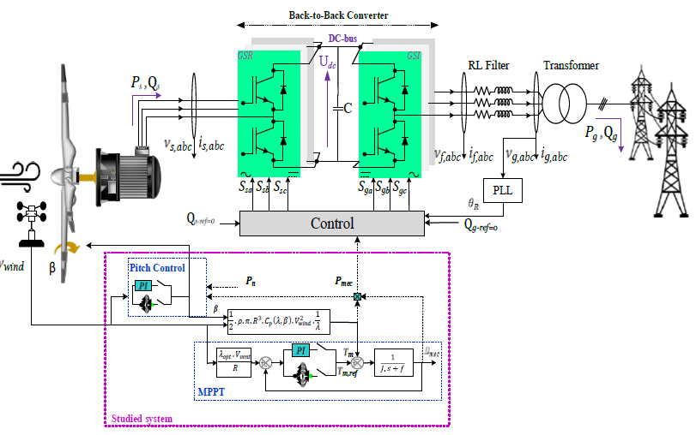
Figure 1. Configuration of the studied WECS-PMSG.
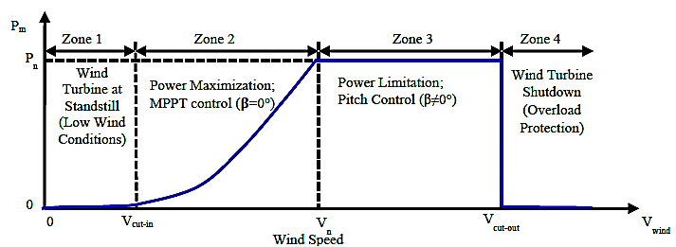

Figure 2. Operation zones of a WECS.

As presented in Fig. 2, a WECS system operates within four distinct zones based on wind speed. In Zone 1, the wind speed is too low to generate power, and the turbine remains inactive. In Zone 2, the wind speed reaches the cut-in threshold, allowing power generation to begin, with MPPT strategies ensuring optimal energy extraction. In Zone 3, the wind speed exceeds the rated value, and pitch control is activated to regulate power output and protect the system by adjusting the blade angles to limit aerodynamic forces and prevent overloading. Finally, in Zone 4, the system operates in a protective mode for safety reasons.

Turbine Model
The turbine model is formulated using the following mathematical expressions:

$E=\frac{1}{2}.ρ.S.V_{wind}^{3}$ (1)

$P_{m}=C_{p}\left(β,λ\right).E=\frac{1}{2}.ρ.S.C_{p}\left(β,λ\right).V_{wind}^{3}$ (2)
$\left\{\begin{aligned}C_{p}\left(β,λ\right)=0.5176\left(\frac{116}{λi}-0.4β-5\right)e^{\frac{-21}{λi}}+0.0068.λ \\ \frac{1}{λi}=\frac{1}{λ +0.08.β}-\frac{0.035}{1+ β^{3}} \\ λ=\frac{R.Ω}{V_{wind}}\end{aligned} \right.$ (3)
$T_{m}=\frac{P_{m}}{Ω}=\frac{1}{2}.\frac{ρ.S.R^{3}.C_{p}\left(β,λ\right).Ω^{3}}{λ^{3}}$ (4)

Where ρ denotes the air density, $S$ represents the rotor’s swept area, and $V_{wind}$ corresponds to the wind velocity. The parameters $β$ and $λ$ are blade pitch angle and the tip speed ratio, respectively. $C_{p}\left(λ,β\right)$ is the aerodynamic power efficiency, while $T_{m}$ is the mechanical torque. Theoretically, the maximum achievable value of the power coefficient
$C_{p}$ is 0.593, corresponding to the Betz limit of 59%. In practice, $C_{p}$ typically ranges from 0.4 to 0.5 depending on the turbine’s aerodynamic model. In this study, the aerodynamic power $C_{p}\left(β,λ\right)$ attains a maximum value of $C_{p, max}=0.48$ at $λ= 8$and $β=0°$.

PMSG Model
The mathematical model of the PMSG in the stationary (𝛼, 𝛽) reference frame is expressed as follows :

Stator electric equations:
$\left\{\begin{aligned}v_{sα}=R_{s}.i_{sα}+\frac{dΨ_{sα}}{dt} \\ v_{sβ}=R_{s}.i_{sβ}+\frac{dΨ_{sβ}}{dt}\end{aligned}\right.$ (5)
Stator magnetic equations:
$\left\{\begin{aligned}Ψ_{sα}=L_{s}.i_{sα}+∅_{f}\cos{θ_{s}} \\ Ψ_{sβ}=L_{s}.i_{sβ}+∅_{f}\sin{θ_{s}}\end{aligned}\right.$ (6)
Mechanical equations:
$\left\{\begin{aligned}J\frac{dΩ}{dt}+f_{c}.Ω=T_{m}-T_{em} \\ T_{em}=\frac{3}{2}.p.[Ψ_{sα}i_{sβ}-Ψ_{sβ}i_{sβ}] \end{aligned}\right.$ (7)

Control schemes of WECS-PMSG
As previously mentioned, the MPPT algorithm and pitch control play a key role in WECS by optimizing energy extraction and ensuring system stability and efficiency, especially in grid-connected WECS. This section provides a detailed study of the MPPT algorithm and pitch control models, followed by a comprehensive description of the proposed approach model. The goal is to enhance the performance and adaptability of the system, ensuring a better response to dynamic wind conditions and thereby ensuring optimal integration with the grid.

MPPT Control & Pitch control
The MPPT control aims to enhance the efficiency of WECS by extracting the maximum available power from the wind. Several methods have been developed to achieve this, including Tip Speed Ratio (TSR), Perturb and Observe (P&O), Sliding Mode Control (SMC), and Backstepping Control (BSC). Among these, TSR is the most widely used in industrial wind turbines due to its simplicity, reliability, and effectiveness in maintaining high efficiency [8]. In the Tip Speed Ratio (TSR) control method, the turbine’s rotational speed is adjusted to keep a constant and optimal ratio between the blade tip speed and the wind speed [11]. This optimization maximizes energy capture by ensuring the turbine operates at its most efficient power point. The rotational speed is regulated through a PI (Proportional-Integral) controller, which adjusts the torque to maintain this optimal TSR, thus ensuring stable and efficient performance across varying wind conditions. Figure 3 shows the studied MPPT control scheme.

$$+$$
$$\frac{1}{J.s+f}$$
$$Ω_{m}$$
$$T_{mec}$$
$$T_{mec_ref}$$
$$V_{vent}$$
$$-$$
$${PI}_{Ω_{m}}$$
$$-$$
$$+$$
$$\frac{λ_{opt}.V_{vent}}{R}$$
MPPT
$$Ω_{m_ref}$$
Figure 3. MPPT based TSR control.

Pitch control regulates the blade angle to optimize power extraction and protect the system from overloading at high wind speeds. This process typically involves three phases: the first phase generates the reference pitch angle (βref), the second phase regulates the pitch angle β, and the final phase controls the speed of pitch angle variation ($Ω$) [11], [13]. To achieve these tasks, three PI controllers are employed: one for speed regulation, one for pitch angle adjustment, and one for power control (see Fig. 4).

Figure 4. Pitch control Model.

$$+$$
$$\frac{1}{1+τ_{pitch}s}$$

$$P_{n}$$
$$β$$
$$P_{m}$$
$$-$$
$${PI}_{β}$$
$$-$$
$$+$$
Pitch control
$${PI}_{P_{m}}$$

$$Ω_{max}=10°/s$$
$$Ω_{min}=-10°/s$$
$$β_{min}=0°$$
$$β_{max}=90°$$
WECS-PMSG
$$-$$
$$+$$
$$Ω_{ref}$$
$${PI}_{Ω}$$
$$\frac{1}{s}$$

$$Ω$$
$$β_{ref}$$

Proposed control
According to an in-depth literature analysis and the results obtained, PI regulators exhibit inherent limitations, particularly in handling system nonlinearities and dynamic variations. These drawbacks affect performance, leading to slower response times, reduced precision, overshoot, and decreased robustness under fluctuating operating conditions [14], [15]. To address these challenges, PI controllers have been replaced with advanced controllers based on ANN algorithm.
An ANN is a computational framework inspired by the structure and functioning of biological neural systems. It is capable of learning from historical data and identifying patterns, which makes it particularly effective for solving complex and nonlinear problems. Typically, an ANN is composed of a set of interconnected processing units, or neurons, arranged in three main layers: input, hidden, and output [16]. The mathematical formulation of a single neuron is expressed as follows:

$y_{i}^{ANN}=f\left(\sum_{i}^{n}{w_{i}x_{i}+b}\right)$ (8)

Where 𝑛 denotes the number of inputs to the neural network, $y_{i}^{ANN}$ represents the network output vector. The function $f$ is the activation function, 𝑥 {$x_{i}$=1, 2,...𝑛} defines the input vector, while 𝑤𝑖 corresponds to the weight matrix and $b$ is the bias.

The process of designing an ANN controller can be summarized in four key steps. The first step is the collection of datasets. In this study, the datasets are derived from the classical simulation based on PI. These data are then randomly divided into three subsets for training, validation, and testing, as follows:

- 70% of the total dataset was used for training.
- 15% was allocated for testing.
- The remaining 15% was reserved for validation.

In the second step, we began by setting up the neural network controllers using MATLAB’s graphical interface, "nntool" (R2021b). The artificial neural network (ANN) we used is a feedforward Multi-Layer Perceptron (MLP), which is composed of three layers: an input layer, a hidden layer, and an output layer. To enhance the network’s performance, two activation functions were selected: the hyperbolic tangent activation function (tansig) and the linear activation function (purelin). These functions are mathematically defined by Eq. (9) and Eq. (10), respectively:

$f_{1}(s)=\frac{e^{αs}-e^{-αs}}{e^{αs}+e^{-αs}}$ (9)

$f_{2}(s)=βs$ (10)

Where α and β denote the gains of the activation functions. The function 𝑓1 as assigned to the hidden layer, while 𝑓2 was applied in the output layer.

To design the optimized ANN controllers, we conducted extensive training of the network. The parameters including the number of neurons, hidden layers, weights, and biases were initially assigned small random values. The weights and biases were then adjusted using the Levenberg-Marquardt backpropagation algorithm (trainlm), while the number of hidden layers was determined experimentally through trial and error. Finally, the performance of the trained networks was evaluated using two metrics: the Mean Squared Error (MSE) and the regression coefficient (R). The MSE captures the average squared difference between the ANN predictions and the target outputs, whereas R reflects the linear correlation between the network outputs and the expected results.

Figures 5 and 6 illustrate the architecture and training performance of the PI-ANN controller implemented for MPPT and pitch control, respectively.

$$Ԑ(Ω)$$
$$H_{1}^{1}$$

$$H_{2}^{1}$$

$$H_{3}^{1}$$

$$H_{8}^{1}$$

$$H_{7}^{1}$$

I
O
$$T_{m-ref}$$

Figure 5. ANN-Based MPPT Controller: (a) Topology, (b) Training Performance (MSE & R).

$$Ԑ(P_{m})/Ԑ(β)/Ԑ(Ω)$$
$$H_{1}^{1}$$

$$H_{2}^{1}$$

$$H_{3}^{1}$$

$$H_{10}^{1}$$

$$H_{9}^{1}$$

I
O
$${PI}_{P_{m}}/ {PI}_{β}/{PI}_{Ω}$$

Figure 6. ANN-based Pitch Angle Controller: (a) Topology, (b) Training Performance (MSE & R).

The figures show that, for all designed controllers, the MSE remains below 0.006 and the R coefficient exceeds 0.98, confirming the effectiveness and reliability of the implemented control strategies.

Simulation Results and Interpretation
To rigorously assess its performance, the proposed control strategy was tested through MATLAB/Simulink simulations using a real wind profile recorded in Essaouira, Morocco. The wind speed varies between 2 and 16 m/s (see Fig. 7), covering all operational zones of the wind energy conversion system and allowing a comprehensive evaluation under low, nominal, and high wind conditions. The results were subsequently compared with those obtained using a conventional PI controller to emphasize the advantages of the proposed approach in terms of tracking accuracy, response time, overshoot, and power and current quality. To further validate the effectiveness of the strategy, a real-time implementation was performed on the dSPACE DS1104 platform, providing experimental confirmation of the simulation results and demonstrating the practical feasibility of the method.

MATLAB/SIMULINK Simulation Results
Time (s)
Wind Speed Profile (m/s)
Vn=9,82
Figure 7. Wind Speed Profile

(a)
(b) | (c)
(d)
Figure 8. MATLAB/Simulink Simulation Results: (a) Mechanical Speed; (c) Power Coefficient (Cp), and Tip Speed Ratio (λ); (d) Pitch Angle (β), and Mechanical Power; (d) Electromagnetic Torque;

A comprehensive analysis of the results presented in this section demonstrates that the advanced PI-ANN controllers significantly enhance the performance of the WECS-PMSG system under various operating conditions, compared to conventional PI controllers. Even in the presence of fluctuating wind speeds, the system maintains stable performance, ensuring high power quality and enhanced robustness. The mechanical rotational speed Ω_{m} closely tracks its reference with high precision, exhibiting negligible dynamic error compared to the PI controller (see Fig. 8(a)), even under varying wind conditions. The parameters Cp, β, and λ demonstrated optimal adaptation, with minimal fluctuations, ensuring efficient wind energy capture and maintaining a stable mechanical power output P_{m} (see Fig. 8 (b) and (c)). Moreover, the electromagnetic torque T_{em} closely follows its reference values, while maintaining significantly lower ripple levels compared to those observed with the PI controller (see Fig. 8(d)).

DS1104 R&D Simulation Results
The simulation results obtained from MATLAB/Simulink demonstrated that the proposed control strategy (PI-ANN) significantly outperformed the classical PI controller. To validate these findings, experimental tests were conducted using the DS1104 R&D board. In this test, we used the same wind profile with a solver configuration, employing Euler discretization and a 10 kHz sampling frequency. The control algorithm was first translated into executable code through automatic code generation from Simulink, then implemented on the DS1104 platform and monitored using ControlDesk. Analyzing the various plots in Fig. 9, it is clear that the experimental results closely align with the corresponding simulation results. This strong correlation not only validates the effectiveness of the proposed control strategy for WECS-PMSG, but also reinforces its suitability for experimental validation and practical implementation.

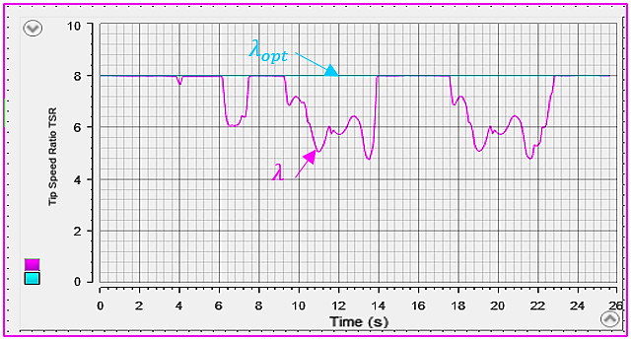  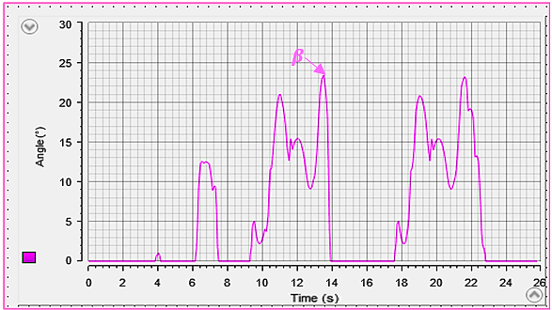 | 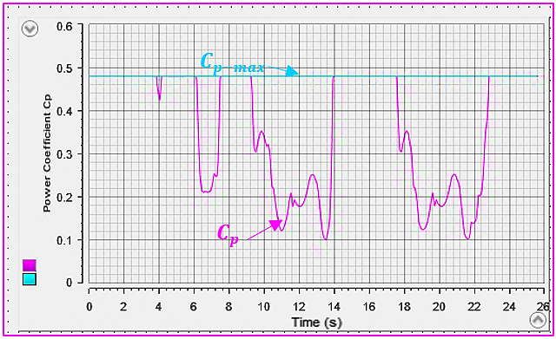
(a) | (b)
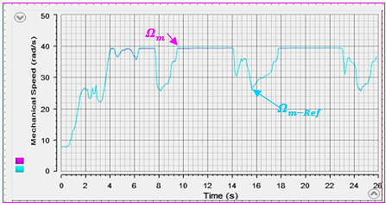 | 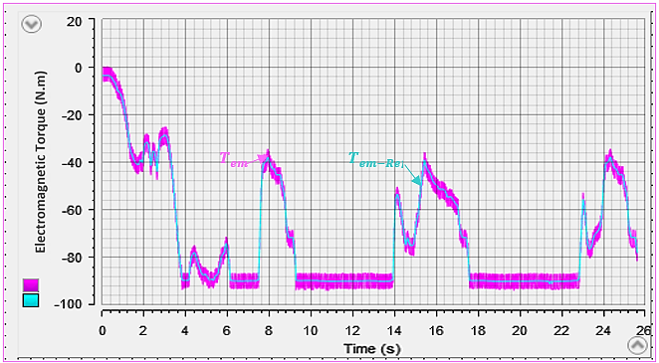
(c) | (d)
Figure 9. DS1104 R&D Simulation Results: (a) Tip Speed Ratio (𝜆) and Pitch Angle (β); (b) Power Coefficient (Cp); (a) Mechanical Speed; (e) Electromagnetic Torque.

CONCLUSION
In this paper, an advanced MPPT and pitch control strategy for a grid-connected WECS-PMSG was proposed, integrating Artificial Neural Networks to overcome the limitations of conventional approaches. The effectiveness of the proposed method was assessed through simulations using a real wind speed profile and validated experimentally on the dSPACE DS1104 platform. The results demonstrated a substantial enhancement in system performance, including a 50% improvement in response time, a significant reduction in overshoot, a steady-state error reduced to 0.2%, and a 43% decrease in torque ripple, resulting in higher precision and better stability compared to the conventional PI controller. These enhancements demonstrate the significant potential of intelligent control techniques in optimizing wind energy conversion, enabling efficient energy capture while maintaining system protection under highly variable wind conditions. Building on this work, future research will focus on designing intelligent observers to replace conventional speed sensors, further improving system reliability, reducing hardware dependence, and paving the way for more cost-effective and robust wind energy systems.

References
- H. Salime, B. Bossoufi, S. Motahhir, and Y. El Mourabit, “A novel combined FFOC-DPC control for wind turbine based on the permanent magnet synchronous generator,” Energy Reports, vol. 9, no. December, pp. 3204–3221, 2023, doi: 10.1016/j.egyr.2023.02.012.
- Y. El Mourabit et al., “Enhanced Performance in PMSG-Based Wind Turbine Systems: Experimental Validation of Adaptive Backstepping Control Design,” Energies, vol. 16, no. 22, 2023, doi: 10.3390/en16227481.
- B. Majout et al., “A Review on Popular Control Applications in Wind Energy Conversion System Based on Permanent Magnet Generator PMSG,” Energies, vol. 15, no. 17, 2022, doi: 10.3390/en15176238.
- B. Majout et al., “Comparative Analysis of Predictive and Direct Power Control Strategies for PMSG-Based WECS,” Lect. Notes Networks Syst., vol. 669 LNNS, no. April, pp. 715–725, 2023, doi: 10.1007/978-3-031-29860-8_72.
- H. Matayoshi, A. M. Howlader, M. Datta, and T. Senjyu, “Control strategy of PMSG based wind energy conversion system under strong wind conditions,” Energy Sustain. Dev., vol. 45, pp. 211–218, 2018, doi: 10.1016/j.esd.2018.07.001.
- Ananth et al., “Tip speed ratio based MPPT algorithm and improved field oriented control for extracting optimal real power and independent reactive power control for grid connected doubly fed induction generator,” Int. J. Electr. Comput. Eng., vol. 6, no. 3, pp. 1319–1331, 2016, doi: 10.11591/ijece.v6i3.9306.
- M. Yin, W. Li, C. Y. Chung, L. Zhou, Z. Chen, and Y. Zou, “Optimal torque control based on effective tracking range for maximum power point tracking of wind turbines under varying wind conditions,” IET Renew. Power Gener., vol. 11, no. 4, pp. 501–510, 2017, doi: 10.1049/iet-rpg.2016.0635.
- U. et Al., “Small wind turbine sensorless MPPT: Robustness analysis and lossless approach,” IEEE Trans. Ind. Appl., vol. 50, no. 6, pp. 4113–4121, 2014, doi: 10.1109/TIA.2014.2313650.
- C. V. Govinda, S. V. Udhay, C. Rani, Y. Wang, and K. Busawon, “A Review on Various MPPT Techniques for Wind Energy Conversion System,” 7th IEEE Int. Conf. Comput. Power, Energy, Inf. Commun. ICCPEIC 2018, pp. 310–326, 2018, doi: 10.1109/ICCPEIC.2018.8525219.
- A. Lemmassi, A. Derouich, A. Hanafi, A. Byou, M. Benmessaoud, and N. El Ouanjli, “Low-cost MPPT for triple-junction solar cells used in nanosatellites: A comparative study between P&O and INC algorithms,” e-Prime - Adv. Electr. Eng. Electron. Energy, vol. 7, p. 100426, 2024, doi: 10.1016/j.prime.2024.100426.
- O. C. Castillo, V. R. Andrade, J. J. R. Rivas, and R. O. González, “Comparison of Power Coefficients in Wind Turbines Considering the Tip Speed Ratio and Blade Pitch Angle,” Energies, vol. 16, no. 6, 2023, doi: 10.3390/en16062774.
- N. Niassati, M. Mohseni, H. Amiri, K. Seyedtabaei, and A. Hajihosseinlu, “A new maximum power point tracking technique for wind power conversion systems,” 15th Int. Power Electron. Motion Control Conf. Expo. EPE-PEMC 2012 ECCE Eur., pp. 1–6, 2012, doi: 10.1109/EPEPEMC.2012.6397311.
- Nagai et al., “Performance of a 3 kW wind turbine generator with variable pitch control system,” Appl. Energy, vol. 86, no. 9, pp. 1774–1782, 2009, doi: 10.1016/j.apenergy.2008.12.018.
- B. Majout et al., “Artificial neural network-based direct power control to enhance the performance of a PMSG-wind energy conversion system under real wind speed and parameter uncertainties: An experimental validation,” Energy Reports, vol. 11, no. September 2023, pp. 4356–4378, 2024, doi: 10.1016/j.egyr.2024.03.039.
- J. Taghinezhad and S. Sheidaei, “Prediction of operating parameters and output power of ducted wind turbine using artificial neural networks,” Energy Reports, vol. 8, pp. 3085–3095, 2022, doi: 10.1016/j.egyr.2022.02.065.
- A. Kumbhar, P. G. Dhawale, S. Kumbhar, U. Patil, and P. Magdum, “A comprehensive review: Machine learning and its application in integrated power system,” Energy Reports, vol. 7, pp. 5467–5474, 2021, doi: 10.1016/j.egyr.2021.08.133.

