Performance Analysis of Lead-free Cs₂PtI₆-Based Double Perovskite Solar Cell with and without Hole Transporting Layer Using SCAPS-1D Simulation Software
Md. Sojibur Rahman^{1, a)}, Md. Sazedur Rahman^{1, b)} and Md. Morsalin^{1, c)}
¹Department of Electrical and Electronic Engineering, Hajee Mohammad Danesh Science and Technology University, Dinajpur-5200, Bangladesh.
a)Corresponding author: sojiburrahman701@gmail.com
b)sazedur@hstu.ac.bd
c)mdmorsalin.hstu@gmail.com
Abstract: The escalating global demand for sustainable and environmentally benign photovoltaic (PV) technologies has catalyzed the exploration of innovative materials and architectures for solar cell applications. This study explores the optimization of cesium platinum iodide (Cs₂PtI₆)-based perovskite solar cells (PSCs) by integrating a copper(I) oxide (Cu₂O) hole transport layer (HTL) within an ITO/TiO₂/Cs₂PtI₆/Cu₂O/Au structure, conducted by SCAPS-1D. This research investigates key parameters such as absorber layer thickness, doping concentration, defect density, series and shunt resistance, and operational temperature on device performance for both with and without HTL. The optimized device achieves a remarkable power conversion efficiency (PCE) of 29.69%, a fill factor (FF) of 87.92%, current density (Jsc) of 31.01 mA/cm² and 1.09 V is of open-circuit voltage (Voc). These results underscore the potential of Cs₂PtI₆-based solar cells with Cu₂O as a high-efficiency, environmentally sustainable PV technology and offering a promising pathway for advancing renewable energy solutions.

Introduction
Solar (photovoltaic) energy is becoming the most sustainable energy source, owing to its limitless availability and the absence of greenhouse gas (GHG) emissions during utilization. Photovoltaic (PV) technologies harness sunlight to generate electricity, whereas photocatalytic processes exploit the same solar radiation to drive water splitting reactions, yielding hydrogen and oxygen, and enabling photochemical carbon dioxide reduction (1). The vast solar influx received annually by the Earth’s surface renders solar energy an unparalleled choice for sustainable power generation. Among various PV technologies, dye-sensitized solar cells (SCs), despite their comparatively low efficiency and dependence on bulky liquid electrolytes, are favored for their environmental benignity and cost-effectiveness (2).
Perovskite solar cells (PSCs), notable for their structurally simple architecture, have garnered significance interest because of their tunable bandgaps, low fabrication costs, and impressive optoelectronic attributes, such as high charge carrier mobility, extended diffusion lengths, and superior light absorption properties(3). The hybrid organic-inorganic PSCs, in particular, present a compelling alternative to traditional silicon-based SCs, primarily because of their lower production expenses and simpler manufacturing processes . Over the past decade, these hybrid PSCs have exhibited a dramatic rise in power conversion efficiency (PCE), ascending from a mere 3.8% to an impressive 25.2% (4). Nevertheless, their commercialization remains constrained by inherent limitations such as thermal and photochemical instability, largely due to the volatility of the organic components.
Perovskite materials are generally described by the ABX₃ structure, where monovalent cations such as methylammonium (CH₃NH₃⁺) or formamidinium (NH₂CH=NH₂⁺) occupy the A site, divalent cations like Pb²⁺, Sn²⁺, or Ge²⁺ are situated at the B site, and halide anions (I⁻, Cl⁻, or Br⁻) fill the X site (5). Our investigation replaces the conventional organic A-site cations with inorganic cesium and substitutes the typical divalent metal cation with tetravalent platinum, yielding Cs₂PtI₆ is a double perovskite structure that is entirely inorganic and devoid of lead. Unlike the commonly used Sn²⁺, which readily oxidizes to Sn⁴⁺ and compromises device stability, the Cs₂PtI₆ compound exhibits superior chemical resilience, corrosion resistance, and electrical conductivity. While many lead-free perovskites suffer from subpar optical absorption and short carrier diffusion lengths, Cs₂PtI₆ overcomes these limitations through strong covalency within its [BX₆]²⁻ clusters, a hallmark of the A₂BX₆ structure. The first reported Pb-free double perovskite such as Cs₂AgBiBr₆ observed with a PCE of about 8% (6).
Cs₂PtI₆ demonstrates exceptional optoelectronic properties, including a minority carrier lifetime of approximately 2 μs and an absorption coefficient of 4 × 10⁵ cm⁻¹ at a photon energy of ~1.5 eV, surpassing the performance metrics of widely studied MAPbI₃ (7). Its stability is evidenced by an aqueous half-life of 40 days and thermal durability extending up to 60 days at elevated temperatures (7). With a low defect density (Nt) of 2.5 × 10¹² cm⁻³, Cs₂PtI₆ still maintains a high carrier lifetime, underscoring its potential as an advanced photo-absorbing layer (PAL).
Our study introduces an inorganic platinum-based absorber within a lead-free Cs₂PtI₆-based n-i-p PSC configuration. Simulations conducted using SCAPS 1D-3.3.2.0 allowed us to design a device architecture comprising ITO/TiO₂/Cs₂PtI₆/C₂O/Au, optimizing performance through systematic evaluation. The research extensively assesses the device performance with and without HTL layer, to determine the optimal material combination for high-efficiency Cs₂PtI₆ PSCs. Additionally, we explore the influence of absorber thickness, defect densities, series and shunt resistances on overall device performance. The findings culminate in a refined PSC structure, specifically ITO/TiO₂/Cs₂PtI₆/Cu₂O/Au that means with HTL device, characterized by enhanced PV performance indicators, including Jsc, PCE, fill factor (FF), and Voc.

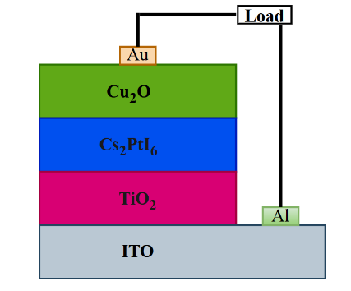 | 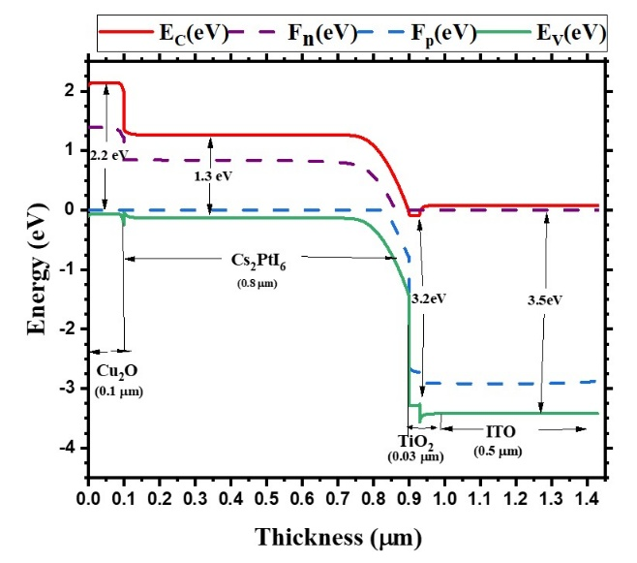
(a) | (b)
FIGURE 1. (a) Device structure and (b) Energy band diagram.

Numerical simulation and device structure

SCAPS-1D numerical simulation
The SCAPS-1D (version 3.3.10) software is used in this study to investigate the PV parameters. The software is exposed by Prof. Marc Burgelman et al. at the ELIS department, Gent University, Belgium (8). SCAPS-1D software operates based on solving numerical equations such as the continuity equation for holes and electrons (9) in the CB and VB and the Poisson's equation. The Poisson’s (equation (1)) and continuity equations (equation (2) for electrons and equation (3) for holes) are depicted below(10):
$\frac{d^{2}}{dx^{2}}ψ\left(x\right)= \frac{q}{ε_{0}ε_{r}}[p\left(x\right)-n\left(x\right)+N_{D}- N_{A}+ ρ_{p}+ρ_{n}]$ ()
$\frac{∂n}{∂t}= \frac{1}{q}\frac{∂J_{n}}{∂x}+\left(G_{n}-R_{n}\right)$ ()
$\frac{∂p}{∂t}= \frac{1}{q}\frac{∂J_{p}}{∂x}+ \left(G_{p}-R_{p}\right)$ ()
Where, $ε_{0}$ stands for the permittivity of free space, ψ represents the electric potential, p(x) and n(x) represent the hole and electron densities respectively, $ρ_{n}$ represents electron distribution and $ρ_{p}$ represents the hole distribution, $J_{p}$ and $J_{n}$ stand for the current densities, $G_{p}$ and $G_{n}$ stand generation, $R_{p}$ and $R_{n}$ represent the recombination for holes and electrons, respectively, and q represents the electric charge. SCAPS-1D treats the device as a 1-dimensional structure, which neglects effects like grain boundaries, lateral inhomogeneities, and interface roughness, and it cannot fully capture ion migration, interfacial chemical reactions, or phase instabilities, which are important in halide perovskites. The simulation is conducted under illumination using an AM 1.5G solar spectrum at a power density of 1000W/m².
TABLE 1. Parameter values of the ITO, Absorber, HTL, and ETL layers (11,12).
Parameters | ITO | TiO₂ | Cs₂PtI₆ | Cu₂O
Thickness (μm) | 0.5 | 0.03 | 0.7 | 0.05
E_{g} (eV) | 3.5 | 3.2 | 1.3 | 2.2
χ (eV) | 4 | 4 | 4.2 | 3.4
ε_{r} (relative) | 9 | 9 | 8.2 | 7.5
N_{c} (cm⁻³) | 2.2×10¹⁸ | 2×10¹⁸ | 1×10¹⁸ | 2×10¹⁹
N_{v} (cm⁻³) | 1.8×10¹⁹ | 1×10¹⁹ | 1×10¹⁸ | 1×10¹⁸
μ_{n} (cm²V⁻¹s⁻¹) | 20 | 30 | 1.6 | 200
μ_{p} (cm²V⁻¹s⁻¹) | 10 | 10 | 1.6 | 8600
N_{A} (cm⁻³) | 0 | 0 | 1×10¹⁷ | 1×10¹⁸
N_{D} (cm⁻³) | 1×10²¹ | 6×10¹⁹ | 0 | 0
N_{t} (cm⁻³) | 1×10¹⁵ | 1×10¹⁵ | 1×10¹⁵ | 1×10¹⁵
Here, E_{g}: Bandgap, χ: Electron Affinity, ε_{r}: Dielectric permittivity, N_{c}: CB effective DOS, N_{v}: VB effective DOS, μ_{n}: Electron mobility, μ_{p}: Hole mobility, N_{A}: Shallow uniform acceptor density ,N_{D}: Shallow uniform donor density and N_{t}: Defect density.
TABLE 2. Parameters for interface defects (11,12).
Parameters | Cu₂O/Cs₂PtI₆ interface | Cs₂PtI₆/TiO₂ interfaces
Defect type | Neutral | Neutral
Capture cross-sector: electron | 1×10⁻¹⁵ | 1×10⁻¹⁵
Capture cross-sector: hole | 1×10⁻¹⁵ | 1×10⁻¹⁵
Energetic distribution | Single | Single
Reference for defect energy level | Above the highest EV | Above the highest EV
Total density (cm⁻²) | 1×10⁻¹¹ | 1×10⁻¹¹

Device structure and simulation parameters
The proposed PSC device structure is depicted in Fig. 1(a). The PSC structure consists of ITO/TiO₂/Cs₂PtI₆/Cu₂O/Au where Cs₂PtI₆ is used as an absorber, p-type Cu₂O is used as an HTM, and n-type TiO₂ is used as an ETM. The energy band diagram (EBD) of the proposed PSC device is shown in Fig. 1(b). When light shines on the SC, it creates energy levels called quasi-Fermi levels (F_{p} and F_{n}). This confirms that the light successfully generates carriers in the PSC (12). There is a little offset in the CB/VB of the absorber layer observed from the energy band diagram in Fig. 1(b), which facilitates the generation of electron-hole pairs in the SC(13). There is also a little offset in the CB/VB between the absorber layer, the HTL, and the ETL. However, a too-large offset can create a resistance that reduces the cell's FF. This larger difference is likely caused by a mismatch between the energy levels of the materials. The input parameters that are used in this simulation such as thickness, bandgap, electron affinity, mobility for electrons and holes, relative permittivity, acceptor and donor densities, the effective density of states (DOS) in the valence bands (VB), and conduction (CB), total Nt of HTL, absorber, and ETL are given in Table 1. The interfacial defects between absorber/HTL and ETL/absorber are also given in Table 2. The performance of the designed SC is evaluated at different temperatures to investigate the efficiency of the device changes under varying temperature conditions.

Results and Discussions

Impact of Absorber Thickness Variation
The absorber layer is a significant layer for determining SC efficiency, as its thickness and material quality directly affect photon absorption, carrier diffusion, and recombination rates (14). In this study, we investigated the effect of absorber thickness on SC performance for configurations both with and without a HTL, as shown in Fig. 2(a). Thickness was varied from 0.1 µm to 1.5 µm, and output parameters—PCE, J_{SC}, FF, and Voc—were analyzed. Results reveal that PCE and JSC increase with thickness up to 0.8 µm, beyond which performance declines. At the optimal thickness of 0.8 µm, the device with HTL achieved PCE and J_{SC} values of 29.69% and 31.01 mA/cm², while the device without HTL achieved 29.61% and 30.00 mA/cm², respectively, attributed to enhanced photon absorption and charge generation.
Beyond 0.8 µm, increased recombination and resistance reduce both PCE and J_{SC}. As seen in Fig. 2(a), FF initially rises with thickness but later declines due to increasing resistance, especially in thicker layers. V_{OC} for the device with HTL shows a decreasing trend with thickness, due to resistive losses and recombination. Interestingly, the PCE of the HTL-free device increases slightly with thickness, likely due to better carrier generation and photon absorption, facilitating improved collection efficiency (15).
Based on this comprehensive performance analysis, the optimal absorber thickness is identified as approximately 0.8 µm, striking a balance between minimal recombination and efficient photon absorption and is selected as the reference for further study.
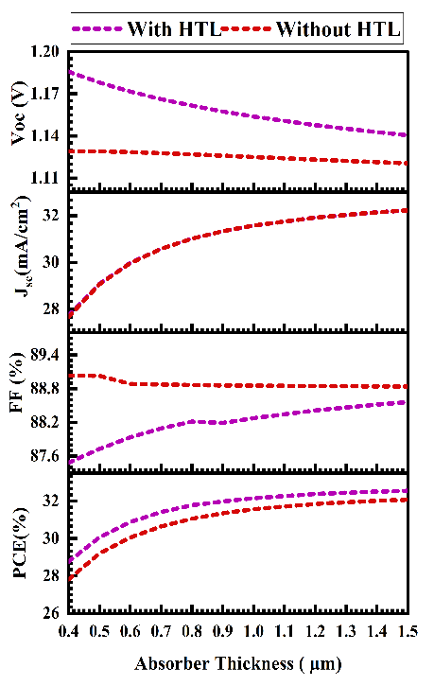 | 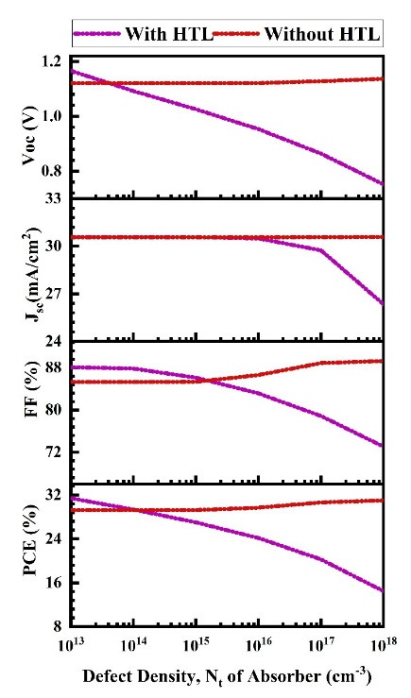
(a) | (b)
FIGURE 2. (a) Absorber thickness variation and (b) Defect density (Nt) variation effect on PV performance.

Impact of Absorber Defect Density Variation
The significance of Nt in determining the overall performance and efficiency of perovskite SCs (PSCs) is undeniably critical, as the perovskite absorber layer can exhibit a variety of structural imperfections—such as vacancies, voids, Schottky, and Frenkel defects—which, when present in high concentrations, can severely compromise the operational stability and resilience of the device (16). To thoroughly evaluate the impact of these intrinsic defects, a series of simulations were conducted in which the absorber Nt was systematically varied from 10¹³ cm⁻³ to 10¹⁸ cm⁻³ and the resultant effects on PV parameters were analyzed, as illustrated in Fig. 2(b). The PV parameters—PCE, Voc, FF, and Jsc—were analyzed for two configurations: with and without HTL. This degradation can be primarily attributed to the enhanced charge carrier recombination that occurs with increasing Nt (17), wherein the defects act as recombination centers that diminish the charge carrier lifetime .Moreover, as Nt increases, it significantly influences the bulk recombination current, thereby degrading all key performance metrics of the SC and ultimately impairing the device’s functionality, since a greater number of defect sites provide more opportunities for carrier trapping and non-radiative recombination (18). The results, illustrated in Fig. 2(b), reveal that the inclusion of an HTL leads to higher initial values of all PV parameters at low defect densities, indicating superior performance under optimal conditions. Specifically, at a low Nt of 10¹³ cm⁻³, the device with HTL exhibits a V_{OC}​ of approximately 1.19 V, J_{SC}​ of 30.1 mA/cm², FF of 87.5%, and a peak PCE of around 31.9%. However, as the absorber Nt increases beyond 10¹⁴ cm⁻³, all PV parameters for the HTL-based device decline sharply. In contrast, devices without HTL demonstrate relatively stable performance across the Nt range, albeit with lower initial efficiency. The less sensitive response may be attributed to the absence of selective transport layers, which reduces the overall dependency on interface quality but limits peak performance. Interestingly, at higher defect densities (above 10¹⁶ cm⁻³, devices without HTL begin to outperform their HTL-based counterparts in PCE, despite the latter's initially higher performance. This inversion indicates that, while HTLs can boost efficiency under low-defect conditions, they become less effective or even detrimental under high defect regimes due to raised recombination at the HTL/absorber interface.
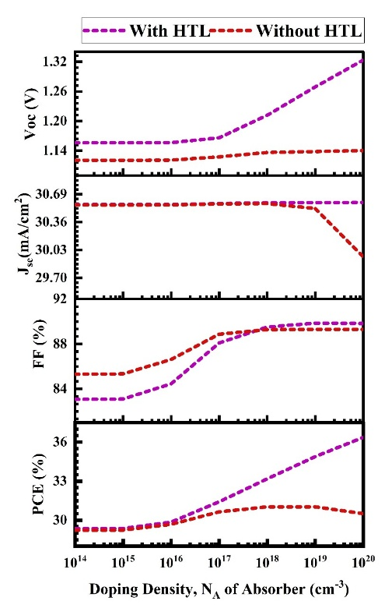 | 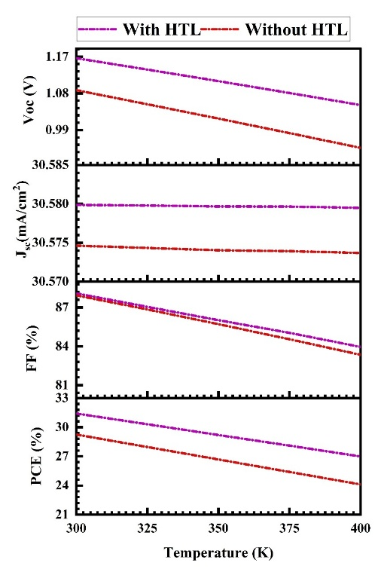
(a) | (b)
FIGURE 3. (a) Absorber doping density and (b) temperature variation effect on PV performance.

Impact of Absorber Doping Density Variation
The PV behavior of Cs₂PtI₆-based PSCs is highly influenced by the doping density (N_{A}) of the absorber layer (19), with key device parameters responding distinctly to variations from 10¹⁴ to 10²⁰ cm⁻³, as shown in Fig. 3(a). X. Simulations were conducted for both device types with and without a HTL to examine the individual and combined effects of doping on charge dynamics and interfacial behavior. As N_{A} increases from 10¹⁴ cm⁻³, a significant enhancement in Voc is seen, especially in HTL-based devices, due to a stronger built-in electric field that aids exciton dissociation and prevents carrier backflow (20). V_{OC} in HTL-integrated structures surpasses 1.3 V at 10²⁰ cm⁻³, while V_{OC} in HTL-free cells shows modest improvement, stabilizing below 1.2 V.
Jsc remains fairly consistent across the doping range, with a slight increase in HTL-based devices peaking near 10¹⁸ cm⁻³. However, JSC in HTL-free devices declines at very high doping (≥10¹⁹ cm⁻³), likely due to increased bulk recombination or energy band misalignments (21).
PCE shows the combined influence of these trends. The HTL-based device demonstrates steady PCE improvement, exceeding 36% at high doping levels. In contrast, PCE for the HTL-free device rises until ~10¹⁸ cm⁻³, then declines, supporting the idea that excessive doping causes trap-assisted recombination and reduces carrier lifetimes (22).
In summary, increasing absorber doping enhances internal electric fields, aiding exciton dissociation and charge extraction. However, performance gains diminish at extreme doping levels due to recombination losses (23). From a practical perspective, a doping concentration around 10¹⁹ cm⁻³ offers the best balance of field strength, carrier mobility, and minimal recombination, especially for HTL-based PSCs.
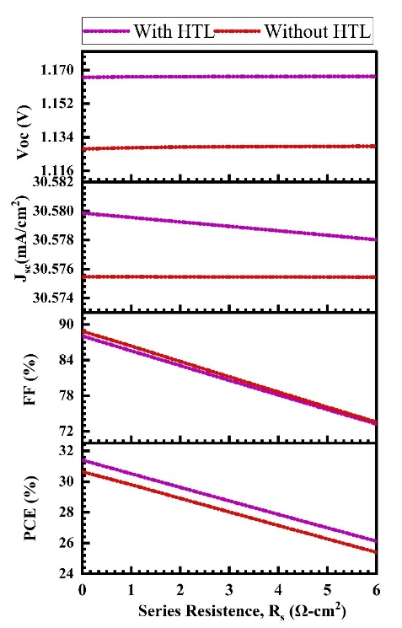 | 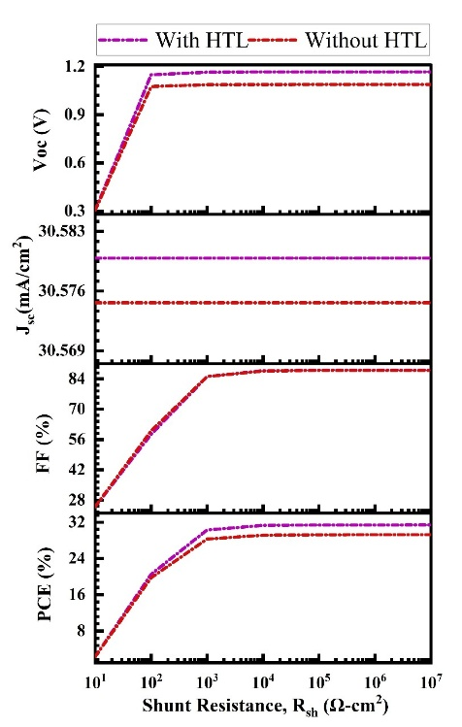
(a) | (b)
FIGURE 4. (a) Series resistance and (b) shunt resistance variation effect on PV performance.

Impact of Temperature Variation
The PCE of a SC is closely affected by operating temperature, as thermal variations can alter the device’s structural, mechanical, and electrical properties. These changes, primarily due to increased internal stress and pressure, impact PV behavior and can accelerate degradation, posing challenges to long-term stability (24).
As shown in Fig. 3(b), the temperature effect was studied from 300 K to 400 K, with all other parameters held constant. The results indicate that PV performance consistently declines with increasing temperature, with optimal performance at 300 K. This reduction is mainly due to decreased electron and hole mobilities, which hinder charge transport and collection. The Voc shows a linear decline with temperature, attributed to the exponential increase in reverse saturation current. Additionally, higher temperatures increase interfacial defects, reducing charge carrier diffusion length and further lowering V_{OC} and PCE(25). Notably, devices with a HTL exhibit superior performance compared to those without, highlighting the HTL's role in thermal stability.

Impact of Series and Shunt Resistance Variation
Figure 4(a) shows that increasing Rₛ from 0 to 6 Ω·cm² causes a slight decline in Jsc and a significant drop in FF and PCE, while Voc remains mostly unchanged. The device with HTL consistently outperforms the one without HTL. The highest PCE of 32.98% is achieved at Rₛ = 0 Ω·cm², highlighting the need to minimize Rₛ to reduce resistive losses and maximize efficiency. As seen in Fig. 4(b), increasing Rsh from 10¹ to 10⁷ Ω·cm² leads to a notable rise in Voc, FF, and PCE, particularly up to 10³ Ω·cm², after which they plateau. Jsc remains largely constant. Higher Rsh minimizes leakage paths and improves diode behavior, emphasizing the importance of maintaining high shunt resistance for optimal device performance (26).

conclusion
The study concludes that the optimized Cs₂PtI₆-based PSC using the structure ITO/TiO₂/Cs₂PtI₆/Cu₂O/Au demonstrates excellent PV performance. The simulation using SCAPS-1D shows that the device with a Cu₂O (HTL) achieves a high PCE of approximately 29.7%, with a J_{SC} of 31.01 mA/cm², a V_{OC} of 1.09 V, and a FF of 87.92%. Compared to the HTL-free configuration, which also performs well, the HTL-based structure consistently delivers better overall performance across all key parameters. The Cu₂O HTL plays an important role in enhancing device stability and efficiency. It improves carrier extraction, reduces recombination, and provides better thermal and operational stability. The HTL-equipped device maintains higher PCE, V_{OC}, and FF even under increasing temperature and defect conditions, indicating that its inclusion is vital for optimal performance.
Device optimization was critical in achieving these results. The optimized thickness of absorber was found to be around 0.8 µm, balancing photon absorption with minimal recombination. A doping concentration of approximately 10¹⁹ cm⁻³ in the absorber layer proved most effective in creating a strong internal electric field without inducing significant recombination losses. Additionally, minimizing series resistance and maximizing shunt resistance further improved performance, with simulations predicting a theoretical PCE of up to 32.98% under ideal conditions. The HTL-based cell even surpassed 36% efficiency at very high doping levels in simulations, reinforcing the benefits of careful structural tuning. However, its fabrication feasibility is still challenging, further research on cost-effective synthesis routes and interface engineering is necessary for scalable fabrication of Cs₂PtI₆-based PSCs.
Importantly, this research highlights the potential of Cs₂PtI₆ as a lead-free, stable, and high-performing absorber material. With strong visible-light absorption, resilience under ambient and thermal stress, and long carrier lifetimes, Cs₂PtI₆ offers a promising alternative to toxic lead-based perovskites. The successful integration of Cu₂O as an environmentally benign HTL further supports the development of sustainable and efficient PV devices. Overall, this study demonstrates that Cs₂PtI₆-based PSCs, when properly engineered, can deliver high efficiency while aligning with environmental and health safety goals.

Reference

1. Wan S, Ou M, Zhong Q, Wang X. Perovskite-type CsPbBr3 quantum dots/UiO-66(NH2) nanojunction as efficient visible-light-driven photocatalyst for CO2 reduction. Chemical Engineering Journal [Internet]. 2019;358:1287–95. Available from: https://www.sciencedirect.com/science/article/pii/S1385894718320734
2. Ahmed MI, Habib A, Javaid SS. Perovskite Solar Cells: Potentials, Challenges, and Opportunities. International Journal of Photoenergy [Internet]. 2015 Jan 1;2015(1):592308. Available from: https://doi.org/10.1155/2015/592308
3. Riyad MdNH, Sunny A, Khatun MostM, Rahman S, Ahmed SR Al. Performance evaluation of WS2 as buffer and Sb2S3 as hole transport layer in CZTS solar cell by numerical simulation. Engineering Reports [Internet]. 2023 May 1;5(5):e12600. Available from: https://doi.org/10.1002/eng2.12600
4. Chen J, Wang Y. Personalized dynamic transport of magnetic nanorobots inside the brain vasculature. Nanotechnology [Internet]. 2020;31(49):495706. Available from: https://dx.doi.org/10.1088/1361-6528/abb392
5. Chen Q, De Marco N, Yang Y (Michael), Song TB, Chen CC, Zhao H, et al. Under the spotlight: The organic–inorganic hybrid halide perovskite for optoelectronic applications. Nano Today [Internet]. 2015;10(3):355–96. Available from: https://www.sciencedirect.com/science/article/pii/S1748013215000560
6. Kung PK, Li MH, Lin PY, Jhang JY, Pantaler M, Lupascu DC, et al. Lead-Free Double Perovskites for Perovskite Solar Cells. Solar RRL [Internet]. 2020 Feb 1;4(2):1900306. Available from: https://doi.org/10.1002/solr.201900306
7. Schwartz D, Murshed R, Larson H, Usprung B, Soltanmohamad S, Pandey R, et al. Air Stable, High-Efficiency, Pt-Based Halide Perovskite Solar Cells with Long Carrier Lifetimes. physica status solidi (RRL) – Rapid Research Letters [Internet]. 2020 Aug 1;14(8):2000182. Available from: https://doi.org/10.1002/pssr.202000182
8. Burgelman M, Decock K, Khelifi S, Abass A. Advanced electrical simulation of thin film solar cells. Thin Solid Films [Internet]. 2013;535:296–301. Available from: https://www.sciencedirect.com/science/article/pii/S0040609012013028
9. Uddin MS, Al Mashud MdA, Toki GFI, Pandey R, Zulfiqar M, Saidani O, et al. Lead-free Ge-based perovskite solar cell incorporating TiO2 and Cu2O charge transport layers harnessing over 25% efficiency. Journal of Optics [Internet]. 2023; Available from: https://doi.org/10.1007/s12596-023-01570-7
10. Jabr RA, Hamad M, Mohanna YM. Newton-Raphson Solution of Poisson’s Equation in a Pn Diode. International Journal of Electrical Engineering & Education [Internet]. 2007 Jan 1;44(1):23–33. Available from: https://doi.org/10.7227/IJEEE.44.1.3
11. Razy M Al, Niloy AB, Ahmed S, Jannat F, Anan MI, Datta PG, et al. Performance prediction of perovskite solar cell integrated with lead-free cesium platinum Iodide (Cs2PtI6) absorber and CuInS2 quantum Dot as HTL. Micro and Nanostructures [Internet]. 2024;185:207727. Available from: https://www.sciencedirect.com/science/article/pii/S2773012323002248
12. Hossain MK, Rubel MHK, Toki GFI, Alam I, Rahman MF, Bencherif H. Effect of Various Electron and Hole Transport Layers on the Performance of CsPbI3-Based Perovskite Solar Cells: A Numerical Investigation in DFT, SCAPS-1D, and wxAMPS Frameworks. ACS Omega. 2022 Nov 29;7(47):43210–30.
13. Khan Z, Noman M, Tariq Jan S, Daud Khan A. Systematic investigation of the impact of kesterite and zinc based charge transport layers on the device performance and optoelectronic properties of ecofriendly tin (Sn) based perovskite solar cells. Solar Energy [Internet]. 2023;257:58–87. Available from: https://www.sciencedirect.com/science/article/pii/S0038092X23002499
14. Alam I, Ashraf MA. Effect of different device parameters on tin-based perovskite solar cell coupled with In2S3 electron transport layer and CuSCN and Spiro-OMeTAD alternative hole transport layers for high-efficiency performance. Energy Sources, Part A: Recovery, Utilization, and Environmental Effects [Internet]. :1–17. Available from: https://doi.org/10.1080/15567036.2020.1820628
15. Reza S. Design and optimization of Sr3SbI3 based novel inorganic high efficiency perovskite solar cell. 2021.
16. Rai S, Pandey BK, Dwivedi DK. Modeling of highly efficient and low cost CH3NH3Pb(I1-xClx)3 based perovskite solar cell by numerical simulation. Opt Mater (Amst) [Internet]. 2020;100:109631. Available from: https://www.sciencedirect.com/science/article/pii/S0925346719308481
17. Zekry Z, Eldallal G. Effect of MS contact on the electrical behaviour of solar cells. Solid State Electron [Internet]. 1988;31(1):91–7. Available from: https://www.sciencedirect.com/science/article/pii/0038110188900901
18. Johnston MB, Herz LM. Hybrid Perovskites for Photovoltaics: Charge-Carrier Recombination, Diffusion, and Radiative Efficiencies. Acc Chem Res. 2016 Jan 19;49(1):146–54.
19. Raj A, Kumar M, Bherwani H, Gupta A, Anshul A. Evidence of improved power conversion efficiency in lead-free CsGeI3 based perovskite solar cell heterostructure via scaps simulation. Journal of Vacuum Science & Technology B [Internet]. 2020 Dec 9;39(1):012401. Available from: https://doi.org/10.1116/6.0000718
20. Sadanand, Dwivedi DK. Modeling of CZTSSe solar photovoltaic cell for window layer optimization. Optik (Stuttg). 2020 Nov 1;222.
21. Sadanand, Dwivedi DK. Modeling of CZTSSe solar photovoltaic cell for window layer optimization. Optik (Stuttg). 2020 Nov 1;222.
22. Srivastava A, Sharma AK, Jha PK, Kumar M, Chourasia NK, Chourasia RK. Parametric optimization for the performance analysis of novel hybrid organo-perovskite solar cell via SCAPS-1D simulation. Heliyon. 2024 Oct 15;10(19).
23. Sadanand, Dwivedi DK. Modeling of CZTSSe solar photovoltaic cell for window layer optimization. Optik (Stuttg). 2020 Nov 1;222.
24. Mateker WR, McGehee MD. Progress in Understanding Degradation Mechanisms and Improving Stability in Organic Photovoltaics. Advanced Materials [Internet]. 2017 Mar 1;29(10):1603940. Available from: https://doi.org/10.1002/adma.201603940
25. Chouhan AS, Jasti NP, Avasthi S. Effect of interface defect density on performance of perovskite solar cell: Correlation of simulation and experiment. Mater Lett [Internet]. 2018;221:150–3. Available from: https://www.sciencedirect.com/science/article/pii/S0167577X18304592
26. Karimi E, Ghorashi SMB. Simulation of perovskite solar cell with P 3 HT hole-transporting materials . J Nanophotonics. 2017 Mar 6;11(3):032510.

