Performance Improvement of a Standalone PV System Using a Nonlinear Integral Sliding Mode Controller
Noureddine ECH-CHERKI^{1a}, Oumaima Echab¹, Youssef Errami¹, Abdellatif Obbadi¹, Smail Sahnoun¹, Charaf Hajjaj¹
¹ Laboratory: Electronics, Instrumentation and Energy (LEIE), Faculty of Science, Chouaib Doukkali University, 24000 El Jadida Morocco.
^{a)} Auteur correspondant : cherki.ucd@gmail.com. Tel: +212666216109.
Abstract. This article proposes a nonlinear Integral Sliding Mode Controller (ISMC), based on a variable structure discontinuous control law, for Maximum Power Point Tracking (MPPT) of a standalone Photovoltaic (PV) system subject to rapid variations in solar radiation. This PV system is used to generate electricity for standalone sites with a resistive load via a boost converter. The control scheme and PV system were simulated in the MATLAB/Simulink environment. The efficiency of the proposed controller was compared to that of the conventional controller based on the Perturb and Observe (P&O) algorithm. The simulation results demonstrate that the ISMC offers superior performance, with a 98.07% reduction in power overshoot and a 54% reduction in response time compared to the P&O controller under different irradiation conditions.
Keywords— MPPT, Boost Converter, Duty cycle, Perturb and Observe, Standalone PV system, Integral Sliding Mode Controller.

INTRODUCTION
Energy production comes from Renewable (RE) and non-renewable energy sources. There are many renewable energy systems, including Hydroelectric Power Systems (HPS), Wind Energy Conversion Systems (WECS) and PV systems. Recently, PV energy has revolutionized the field of clean energy, overcoming the disadvantages of traditional energy sources [1]. RE sources are a good solution for supplying energy to isolated sites. The basic component of PV energy is the PV panel. The PV panel has a single Maximum Power Point (MPP) [2]. These PV systems use boost converters to provide maximum power to the load. In order to Track the Maximum Power Point (MPPT), the converter studied is equipped with an appropriate algorithm [3]. In the literature, several algorithms have been implemented by researchers, these include Perturbation and Observation (P&O) [4], the Open Circuit Voltage (OCV) method [5], and Incremental Conductance (IC) [6], which are considered traditional methods because they are very simple and easy to use. To overcome these limitations, techniques for extracting MPP must be studied in more detail for optimize their efficiency. It is essential to study MPPT techniques in more detail in order to optimize the efficiency of the systems under consideration. To overcome the shortcomings of the above-mentioned algorithms, a Sliding Mode Controller (SMC) was introduced by [7]. SMC is widely used to regulate PV systems [8], whether grid-connected or stand-alone, for accurately track reference voltage and current and extract the MPP provided by the PV generator [9]. This type of control is appreciated for its robustness in the face of parametric uncertainties and external disturbances, as well as for its fast dynamic response. However, SMC has a major disadvantage, namely the phenomenon of chattering, which manifests itself in rapid oscillations around the sliding surface (S). This behavior results from the discontinuous nature of the control law and induces high switching frequencies. Several techniques have been developed in the literature to mitigate this undesirable effect. Among these is Integral Sliding Mode Control (ISMC) [10]. This approach consists of integrating an integral term into the definition of the surface S. In addition to minimizing unwanted oscillations, ISMC improves reference tracking accuracy and enhances the overall stability of the system. Several studies have proposed Adaptive Sliding Mode Control (ASMC) algorithms applied to PV systems to ensure MPPT. For example, the authors of [11] proposed ASMC combined with an improved optimization method with a two-loop control scheme capable of dynamically generating the surface S, The simulation results show superior performance for ASMC compared to P&O. An Adaptive Proportional-Integral Sliding Mode Control (APISMC) variant integrating a Reference Voltage Optimizer (RVO) and a PI controller to adjust the surface S, offering increased robustness against irradiance variations for rapid MPP achievement, was developed by [12]. Finally, studies by [13] proposed a two-loop ASMC architecture where the first loop, based on P&O, generates the reference voltage, while the second uses an adaptive controller associated with an observer estimating uncertainties and disturbances, supplemented by a fuzzy controller to attenuate chattering, with stability validated by Lyapunov and simulations confirming the effectiveness and significant reduction in oscillations.
In this paper, ISMC theory is implemented to improve the performance of a standalone PV system. More specifically, the ISMC strategy is applied to control the boost converter to ensure fast and accurate MPPT, even under variable irradiation conditions.
This article is structured as follows. The first section is an introduction to this work, setting out its contributions and objectives. The second section presents the proposed PV system and its mathematical modeling. The third section focuses on the proposed nonlinear strategy for controlling the PV system. Section four presents simulation results and comparisons with other studies, while section five provides a conclusion to the work.

MODELLING THE PROPOSED PV SYSTEM
Isolated sites can be powered from the proposed PV system shown in Figure 1, which contains a PV generator connected to a resistive load via a boost converter. The boost converter is used to adjust the power generated by the PV generator to the load in the event of a change in irradiation. The PV generator consists of a set of interconnected PV cells. The electrical circuit of a PV cell can be represented by an equivalent circuit, as shown in figure 2. The dynamic modeling of the PV generator is in equation (1) [14].
(1)
Irradiation (G) and temperature (T) having a direct influence on i_{ph}, such as:
(2)
The i_{PV} generated by the PV generator when several identical modules are linked in parallel (N_{pp}), series (N_{ss}) or series-parallel (N_{ss}*N_{pp}) is defined as follows:
(3)
Where; i_{ph} and i_{sc} are the photocurrent and short-circuit current, respectively (A), G_{r}=1000W/m², T_{r}= 293K, R_{s} and R_{sh} are the series and shunt resistors (Ω), respectively. Ns is the number of series cells.

Figure 3 illustrates the I-V (Figure 3.a) and P-V (Figure 3.b) characteristics of the generator. According to this figure, there is a strong dependence between the current of the PV generator and the irradiance, which strongly influences the MPP of the PV generator. The PV module parameters used in this work are listed in Table 1.
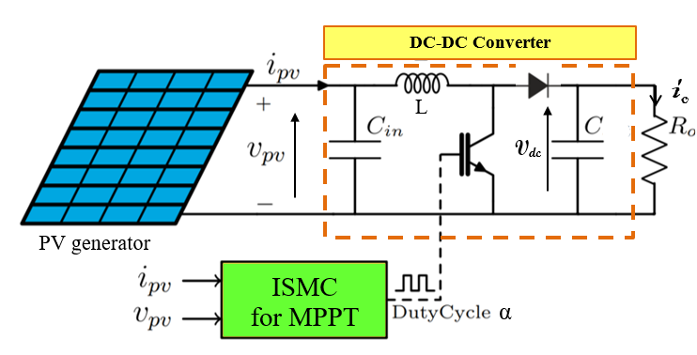
FIGURE 1. Topology of proposed PV system
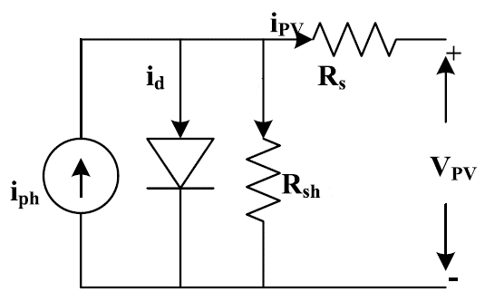
FIGURE 2. PV cell equivalent diagram
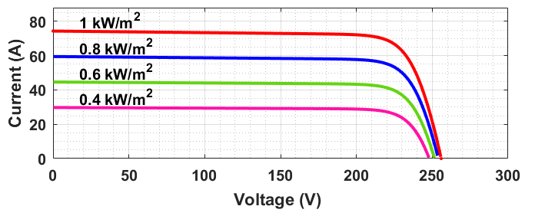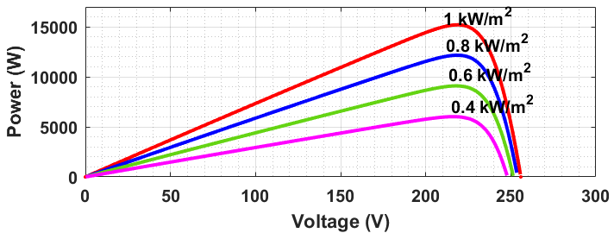
(a) (b)
FIGURE 3. PV generator characteristics I-V (a) and P-V (b) different levels of irradiation
Table 1: Parameters for PV module.
Parameters | Values
P_{mp} | 480.22 W
V_{mp} | 79.08 V
I_{mp} | 6.12 A
N_{s} | 127
R_{s} | 0.485 Ω
R_{sh} | 598.38 Ω
A | 1.056
I_{sh} | 0.031

Figure 4 shows the equivalent DC-DC converter circuits for the two switching modes. The mathematical model of this converter is shown in equation (4) [15]. Table 2 shows the parameters of our PV system.
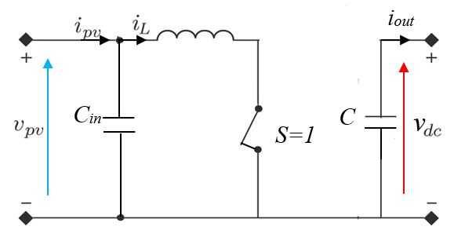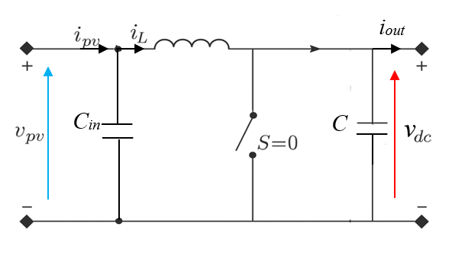
(a) State ON (b) State OFF

FIGURE 4. Equivalent DC-DC converter circuits
(4)
Where L, C_{in}, C and R are respectively the boost electrical parameters, V_{pv} and i_{pv} are the voltage and current supplied by the PV generator, V_{dc} is the output voltage, i_{L} is the inductor current, α is the duty cycle.

Table 2. PV system parameters
Parameter | C_{in}(µF) | C(µF) | L(mH) | R(Ω) | F_{s}(khz)
Value | 1000 | 1500 | 3.3 | 500 | 5

THE PROPOSED NONLINEAR TECHNIQUE ON ISMC
In order to ensure optimal power extraction from the PV generator throughout the day, Figure 4 shows the two operating modes of the step-up converter under study. First, The P&O algorithm, illustrated in Figure 5, is used to determine the reference voltage V_{ref} corresponding to the MPP of the PV generator. Its operation is based on applying an incremental disturbance to the voltage at the operating point, followed by observing the change in output power. First, an initial value of V_{ref} is set close to the voltage V_{MPP} estimated from the electrical characteristics of the PV module. The ΔV step size is then defined to ensure a compromise between convergence speed and accuracy around the MPP. At each calculation cycle, the voltage V(k) and current I(k) delivered by the generator are measured, and then the instantaneous power P(k) = V(k).I(k) is evaluated. This value is compared to the power of the previous cycle P(k-1) in order to decide the direction of the disturbance to be applied to update V_{ref} . Subsequently, an advanced regulator based on ISMC, shown in Figure 6, is implemented to force the PV voltage V_{pv} to accurately follow V_{ref}, while providing the appropriate duty cycle 𝛼 to control the switching of the step-up converter.
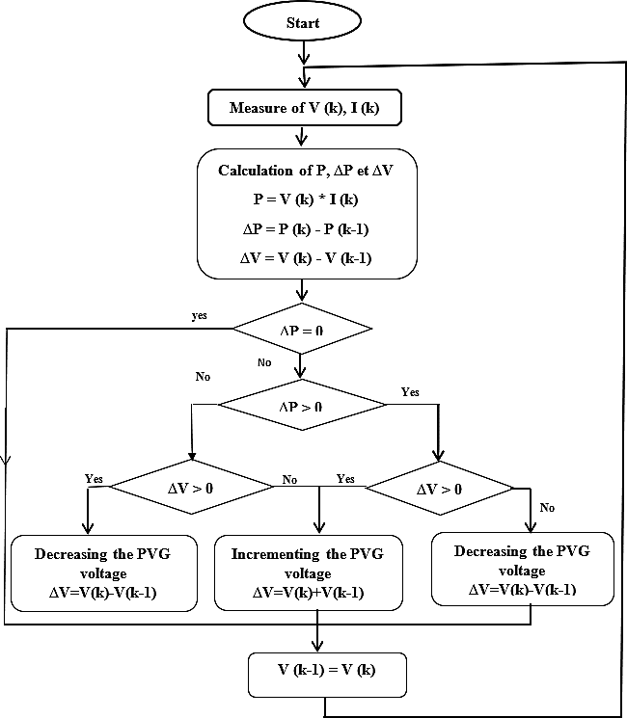
FIGURE 5. P&O algorithm for MPPT
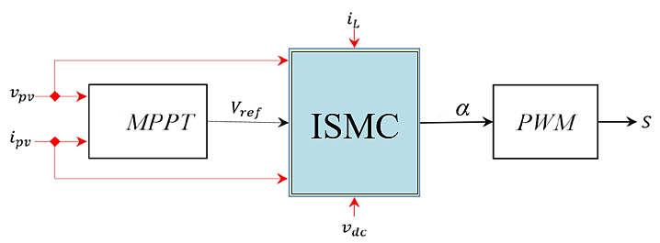
FIGURE 6. Diagram of the MPPT-ISMC solution proposed
The objective of the ISMC controller for the standalone PV system is to maximize the efficiency of PV energy conversion under all irradiance conditions. This design consists of two main steps: Selection of a surface S with integral action and elaboration of a control law. The S and its derivative (ϭ) are given by [16]:
(5)
(6)
When e(t) is the voltage error between V_{pv} and V_{ref} [e(t)= V_{ref} - V_{pv}], β is the gain.
To ensure efficient switching about the surface while guaranteeing high performance, the control integrates two terms [17].
(7)
Where u_{eq} represents the equivalent control to stabilize the system, u_{n} is the switching control to ensure the attraction of the controlled variable to the surface S. u_{n} is written as:
(8)
Where λ is the gain (0<λ).
The u_{eq} is determined by resolving the equation below:
(9)
By replacing the expressions in equations (4) and (5) in equation (9), we derive the following expression:
(10)
Finally, the input of the proposed controller is derived from equations (8) and (10) as follows:
(11)

THE SIMULATION RESULTS
In this section, we present the simulation results to test the robustness of the proposed control system compared with the conventional method. The developed controller has been tested under sudden and linearly varying irradiation conditions, as illustrated in figure 7. The temperature is maintained at 25°C. A comparative study has been carried out to ensure the superiority of the ISMC controller over the conventional P&O controller. The graphical results are presented in Figures 8 to 11.
The obtained results highlight the limited tracking speed of the conventional controller under irradiance variations, leading to significant fluctuations in the output voltage V_{out} ​and output current I_{out} in steady-state conditions, as illustrated in Fig.8 and Fig.9. In contrast, the proposed control scheme based on ISMC demonstrates superior dynamic performance, providing faster and more accurate tracking. According to the same figures, it is evident that the behavior of V_{out}​ and I_{out} is significantly improved with the ISMC compared to the P&O algorithm, particularly in terms of response time and reduced steady-state oscillations.
Figure 10 compares P_{MPP} extracted from the PV generator with P_{PO} and P_{ISMC} corresponding to rapid changes in irradiation conditions. The results show that the ISMC controller closely follows the reference with an almost instantaneous response time and a 98.07% reduction in power overshoot. In contrast, the P&O algorithm exhibits a slower rise, persistent oscillations around the MPP, and overshoot during rapid transitions. These observations confirm the superiority of ISMC control in terms of speed, accuracy, and stability compared to P&O. Given the direct relationship between output power P_{out} and voltage V_{out}, MPPT performance and energetic precision are influenced by dynamic voltage response. As a result, the ISMC controller ensures greater stability with lower levels of fluctuation. Figure 10 clearly illustrates the absence of chattering in the variations in output power obtained with the ISMC control strategy proposed in comparison with the P&O method.
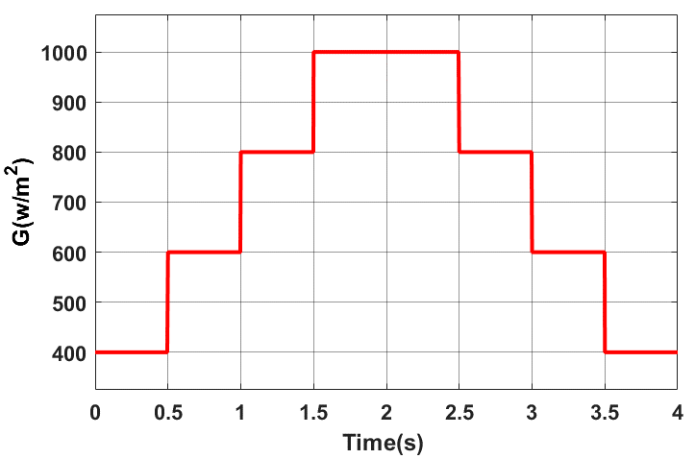
FIGURE 7. Irradiation profile.
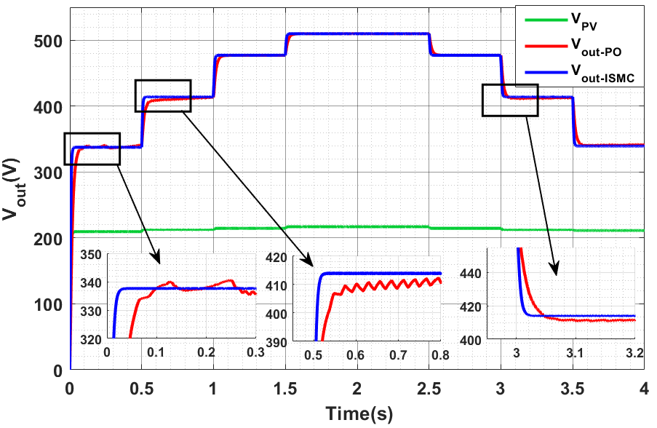
FIGURE 8. Output voltage of the boost converter for both controls studied
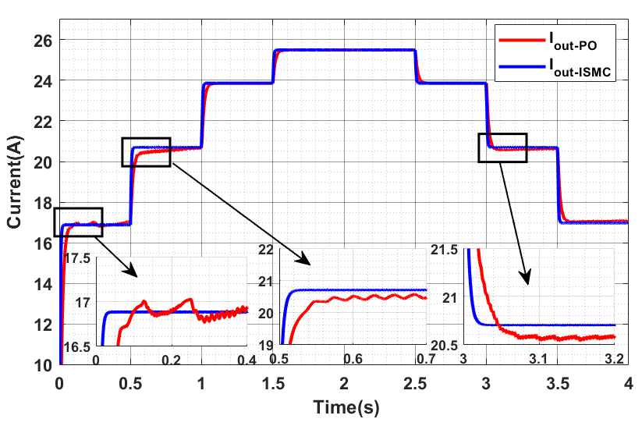
FIGURE 9. Output current of the boost converter for both controls studied
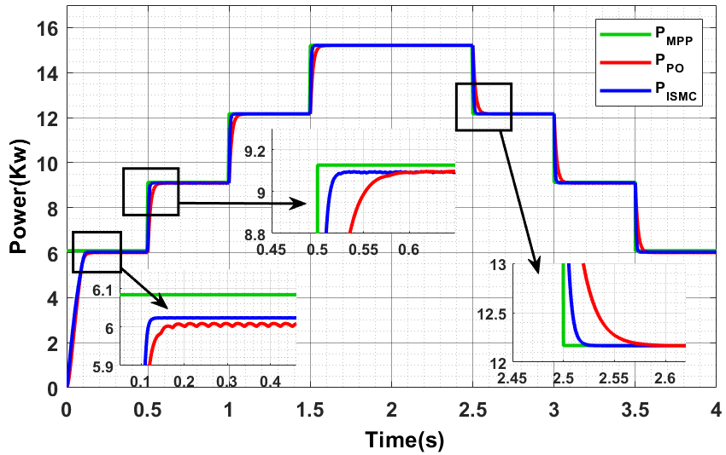
FIGURE 10. Output power of the boost converter for both controls studied
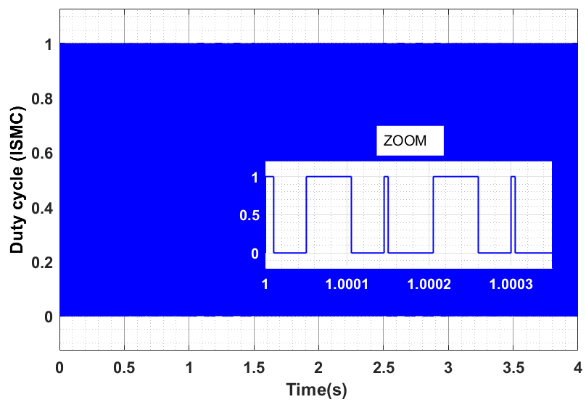
FIGURE 11. Duty cycle for ISMC controller
Figure 11 shows the evolution of the duty cycle (α) applied by the proposed ISMC controller to the boost converter. Over the entire interval (0–4 s), the control appears as a solid area due to the very high switching frequency characteristic of the binary operation of the sliding mode. Zooming in between 1 s and 1.0003 s reveals repetitive transitions between α =0 and α = 1, illustrating the fast switching strategy used to keep the system on the sliding surface and ensure optimal MPP tracking. This behavior guarantees an extremely fast and robust response to changing conditions. It is important to note that the duty cycle α is a fundamental parameter in Boost converter operation, as it determines the output voltage level according to the theoretical relationship [13]:
(12)

CONCLUSION
The improvement of the energy quality and the search for the maximum power point of a stand-alone PV system have been presented by the proposed nonlinear sliding-mode controller with integral action. The autonomous system studied contained a PV generator attached to a resistive load via a power boost converter. The latter is controlled by a duty cycle α generated by the ISMC strategy. To verify the effectiveness of the proposed controller, a comparative study, based on the results of a numerical simulation, is carried out between the ISMC and the traditional P&O algorithm. The results obtained show that the ISMC controller has greatly improved the performance of our PV system, delivering maximum power in minimum response time compared with the traditional P&O. These results also show a significant reduction in overshoot during rapid irradiation variations. In conclusion, the ISMC strategy appears to be a very reliable solution for optimizing the energy performance of standalone PV systems.

REFERENCES
- Echab, O., Ech-Cherki, N., Nassar-Eddine, I., Chetouani, E., Obbadi, A., Errami, Y., & Aoutoul, M. (2025, May). Improved MPPT algorithm for grid-connected PV system. In 2025 5th International Conference on Innovative Research in Applied Science, Engineering and Technology (IRASET) (pp. 1-5). IEEE.
- K. Pawel, R. Mieski, W. Irena. “Modular PV System for Applications in Prosumer Installations with Uncontrolled, Unbalanced and Non-Linear Loads”. Energies, vol. 17, no 7, p. 15-94, 2024.
- K. El mezdi, A. El magri, I. El myasse, I. Watil, A. Bahatti, L. Elaadouli, N. Ouabi, “Performance improvement through nonlinear control design and power management of a grid connected wind battery hybrid energy storage system”, Results in Engineering, vol. 20, p. 101491, 2023.
- A. Saberi, M. Niroomand, B.M. Dehkordi, “An Improved P&O Based MPPT for PV Systems with Reduced Steady‐State Oscillation”. International Journal of Energy Research, vol. 2023, no 1, p. 4694583, 2023.
- M. Krishnan and K. R. Bharath, “A Novel Sensorless Hybrid MPPT Method Based on FOCV Measurement and P&O MPPT Technique for Solar PV Applications”, International Conference on Advances in Computing and Communication Engineering (ICACCE), Sathyamangalam, India, pp. 1-5, 2019.
- B. Siddique, M. Abuasad, A. Asif, R. M. Rehman, A. U. Sadiq, M. T. Ullah, “Implementation of incremental conductance MPPT algorithm with integral regulator by using boost converter in grid-connected PV array”, IETE Journal of Research, vol. 69, no 6, p. 3822-3835, 2023.
- Aminnejhad, H., Kazeminia, S., & Aliasghary, M. (2021). Robust sliding-mode control for maximum power point tracking of photovoltaic power systems with quantized input signal. Optik, 247, 167983.
- Gohar Ali, H., Vilanova Arbos, R., Herrera, J., Tobón, A., & Peláez-Restrepo, J. (2020). Non-linear sliding mode controller for photovoltaic panels with maximum power point tracking. Processes, 8(1), 108.
- Bag, A., Subudhi, B., & Ray, P. K. (2019). A combined reinforcement learning and sliding mode control scheme for grid integration of a PV system. CSEE Journal of power and energy systems, 5(4), 498-506.
- Direm, C., & Hartani, K. (2024). Enhancing Regenerative Energy Capture in Electric Vehicles: Braking Performance through Integral Sliding Mode Control. SAE International Journal of Vehicle Dynamics, Stability, and NVH, 8(10-08-02-0012), 215-229.
- M. G. M. Abdolrasol, A. Afida, A. H. Mutlag, T. S. Ustun, “Optimal fuzzy logic controller based PSO for photovoltaic system”. Energy Reports, vol. 9, p. 427-434, 2023.
- Gohar Ali, M., & Vilanova i Arbós, R. (2020). Adaptive sliding mode controller with improved pattern search method for maximum power point tracking in PV systems. Energies, 13(15), 3946.
- Torchani, A., et al. (2024). Adaptive PI sliding mode control with reference voltage optimizer for MPPT in boost converters. Solar Energy, 265, 112079.
- Le, H. T., & Vu, T. H. (2025). Fuzzy-assisted adaptive sliding mode control with disturbance observer for photovoltaic MPPT. IEEE Transactions on Sustainable Energy
- Ech-Cherki, N., Errami, Y., Obbadi, A., Sahnoun, S., & Nassar-Eddine, I. (2023). Control of a grid-connected photovoltaic system based on MPPT and vector control. In Smart Applications of Artificial Intelligence and Big Data (pp. 169-185). CRC Press.
- Katche, M. L., Makokha, A. B., Zachary, S. O., & Adaramola, M. S. (2023). A comprehensive review of maximum power point tracking (mppt) techniques used in solar pv systems. Energies, 16(5), 2206.
- SABOUNI, Boudjema, MAKHLOUFI, Khadidja, ZERIKAT, Mokhtar, et al. Experimental Implementation of an Adaptive Fuzzy Sliding Mode Control Design for IM Speed Control. In : International Conference on Artificial Intelligence in Renewable Energetic Systems. Cham: Springer Nature Switzerland, 2023. p. 286-300.

