Enhanced Wind Time Series Modeling via Von Kármán Spectra for Improved Inputs to Neural Forecasting of Hydrogen Output

Bienvenu Sumaili NDEBA^{a,b,*} , Fatima Zahra Ouchani^{b} Abdellatif Ghennioui^{b}, Mostafa Benzaazouaª.
ª Geology and Sustainable Mining Institute (GSMI), Mohammed VI Polytechnic University, Benguerir, Morocco.
^{b} Green Energy Park (GEP, IRESEN/UM6P), Benguerir, Morocco.
*Corresponding author: sumaili.bienvenu@um6p.ma, sumailib@gmail.com.

Abstract. Accurate short-term wind forecasting is constrained by the limited temporal resolution of commonly available meteorological datasets. Reanalysis products such as ERA5 provide only hourly wind series, which fail to capture the sub-hourly fluctuations that strongly influence wind energy forecasting, turbine control, and hydrogen production. Existing enhancement techniques, including autoregressive (AR) methods and Markov chains, can generate finer time steps but often distort the spectral properties of wind, thereby reducing their reliability for turbulence-sensitive applications. Numerical downscaling methods offer greater accuracy but are computationally intensive, making them less practical for routine use. This study suggests an alternative approach based on the Von Kármán turbulence model, designed to enhance temporal resolution while conserving spectral characteristics. The method was validated using a three-year, 1-minute ground-based dataset from Ben Guerir, Morocco. Hourly resampled data were reconstructed with the model, yielding strong agreement with the original measurements (R² ≈ 0.71). Following validation, the approach was applied to ERA5 hourly data for three representative Moroccan sites—El Argoub, Al Hoceima, and Tinghir—producing realistic 1-minute series that preserved both statistical consistency and spectral fidelity.
The enhanced datasets were subsequently used for forecasting and hydrogen production modeling. Results showed that sub-hourly fluctuations significantly improved system representation: in El Argoub, high-resolution inputs increased modeled hydrogen yield by 58.3% compared to hourly data, while maintaining identical efficiency.
These findings highlight the Von Kármán model as a computationally efficient and physically grounded alternative to costly downscaling approaches such as WRF. By bridging the gap between coarse reanalysis datasets and high-frequency operational needs, the method supports improved forecasting, microgrid management, and renewable hydrogen system design.
Keywords: Data Enhancement Data Enhancement; Hydrogen Production; Turbulence Modelling; Weather Forecasting

INTRODUCTION

Background
In wind studies and turbulence modeling, several approaches have been proposed to address the coarse temporal resolution of reanalysis datasets and to improve forecasting. Autoregressive (AR) models are simple to implement [1], yet they fail to preserve the spectral characteristics of wind fluctuations, often resulting in unrealistic turbulence representation. Markov chain models can introduce stochastic variability, as demonstrated by Bulanik et al. [2], but like AR models, they distort frequency-domain properties and are therefore unsuitable for turbulence-sensitive applications.
Artificial intelligence (AI) techniques, including neural networks, NAR/NARX models, and hybrid deep learning frameworks, have shown strong potential for short-term wind forecasting. However, their performance is fundamentally constrained by the resolution of the input data at the preprocessing stage [3]. As a result, AI-based interpolation often yields smoothed signals that underestimate high-frequency variability and may overfit when only limited high-resolution measurements are available. These methods are therefore more effective when applied to forecasting tasks (see Table 1) once data have been spectrally enhanced.
Spectral approaches provide a physically grounded alternative by explicitly modeling the distribution of energy across frequency bands [4]. The Von Kármán spectrum, in particular, is consistent with the Kolmogorov −5/3 law, enabling the generation of realistic sub-hourly variability while remaining computationally efficient.

Literature Review

The complexity of turbulent flow phenomena in wind farms is a critical factor influencing wind power forecasting [5]. In their review paper, Stevens and Meneveau emphasized that turbulence scales, particularly those associated with wakes behind individual turbines and the atmospheric boundary layer, are vital for accurate wind behavior predictions [6]. Turbulence models provides a robust framework for simulating these turbulent flows to better understand the dynamics of wind energy production.
Between 2014 and 2024 studies have shown that a deeper understanding of turbulence can lead to improved forecasting models. For instance, the collection of extensive wake measurements using remote sensing techniques such as lidar has been highlighted as essential for modeling wind behavior, performing more accurate predictions and ensure efficient wind turbines control [7],[8], [9]. The integration of the Von Kármán model with these measurements allows for enhanced simulations that can capture the intricacies of wake dynamics, thereby improving forecasting accuracy as presented by Zhou et al [10].
While the abstracts do always explicitly mention turbulence models, the general principle of incorporating turbulence characteristics into forecasting models is well-supported. For instance, D’Amico et al. (2022) conducted a long-term measurement campaign that linked infrasound emissions from wind turbines to meteorological parameters, including turbulence intensity and vertical heat flux [11]. Using an artificial neural network (ANN), the study not only predicted infrasound levels accurately but also identified dominant meteorological drivers.
Similarly, Yang et al. (2022) proposed a double-layer machine learning framework for cooperative yaw control in wind farms, combining an ANN-based yawed wake model with a Bayesian optimization layer [12]. Their findings demonstrated significant improvements in both power prediction accuracy and overall turbine performance, particularly under varied inflow conditions and turbulence intensities. The hybrid model surpassed traditional Gaussian-based analytical wake models. Hybrid models that combine neural networks with other techniques, such as data clustering, particle swarm optimization, and numerical weather prediction (NWP), have demonstrated superior performance in wind power forecasting [12], [13], [14]. Table 1 provides an overview of these ML based methods.
Table 1: Review summary of Hybrid/Machine Learning models applied for forecasting.
Technique/Model | Description | Strengths
LSTM-RNN | Uses recurrent neural networks for short-term wind and turbulence nowcasts. | High accuracy in convective boundary layers [15].
BEAmod. Neural Networks | Bayesian enhanced approaches for short-term wind power prediction. | Improved predictability with long memory process[16] .
Ensemble Recursive Neural Network | Incorporates real-time turbulence intensity for multi-step predictions. | Outperforms conventional models, especially for middle-long term predictions [17].
EGOA-Optimized LSTM | Uses Enhanced Grasshopper Optimization Algorithm with LSTM for hyperparameter tuning. | Best performance in 30-min and 1-hour forecasts [18].
TCN with Turbulence Intensity | Temporal convolutional network considering turbulence intensity. | Higher accuracy compared to models without turbulence intensity [19], [20] , [21].
Hybrid Models (ANN + Clustering + PSO) | Combines neural networks with clustering and optimization algorithms. | Significant reduction in prediction errors [13].
NARX | Extends NAR by incorporating exogenous inputs into the autoregressive structure. | Robust for stochastic systems, interpretable link to physical parameters [22].
NARMAX | NARX extended with Moving Average (MA) terms. | Similar to NARX, but better captures noise and finer stochastic dynamics [23].
PINN | Physics-Informed Neural Networks embedding governing PDEs into neural network training | Enforces physical consistency of the prediction, powerful for PDEs, multiphysics, and inverse problems [24, 25].
FFNN | Feedforward Neural Network; a basic multilayer perceptron without feedback connections. | Simple architecture; fast training; widely used as a baseline in prediction tasks[26].
For the present study, a Feedforward Neural Network (FFNN) was chosen due to its simplicity, fast training, and suitability as a baseline model in forecasting tasks; hence, our contribution lies in advanced data enhancement in preprocessing step to enhance prediction quality rather than in pursuing the most sophisticated prediction architecture.

Novelty And Contribution
Turbulence, the short-term and highly variable component of wind, is inherently non-stationary and difficult to model directly in time. The foundational work of Van der Hoven (1957) revealed that wind energy is concentrated at two key frequency bands: slow synoptic variations and fast microscale turbulence, with little energy in between [27]. Capturing this microscale turbulence is essential to accurately represent the rapid fluctuations that impact operational systems.
High-resolution simulations and data are crucial for accurate wind power forecasting. For instance, the use of large-eddy simulations (LES) with high spatial and temporal resolutions has been shown to improve forecast accuracy. Ciaran Gilbert et al. (2020) conducted a proof-of-concept study exploring the use of large-eddy simulations (LES) for operational short-term wind power forecasting at Horns Rev I in Denmark [28]. LES models, which resolve atmospheric turbulence at very fine scales (∼100 m spatial and ∼30 s temporal resolution), were compared with traditional numerical weather prediction (NWP) outputs.
LES forecasts contain valuable high-frequency turbulence data but can suffer from spatial and temporal displacement errors. Temporal smoothing of LES data improves forecast accuracy but risks losing meaningful short-term dynamics. A statistical post-processing approach, using feature engineering and selection from both standard and LES models, yielded improved forecast accuracy compared to using either model alone.
While turbulence models are often used for stochastic wind velocity generation, this research’s objective is to explore the modeling of short-term wind turbulence by developing a turbulence-resolving approach grounded in the von Kármán and tailored for improved wind power forecasting.
A central contribution of the present paper lies in how the Von Kármán model, originally conceived for high-altitude, fast-moving aerospace systems, is re-contextualized for large-scale, ground-based wind turbines. Prior work by Hajjem et al (2023), has rightly questioned the applicability of Von Kármán to fixed-position systems such as parabolic tracking antennas [29]. The author cited the model’s limitations in mid- and high-frequency ranges; thus, they propose fractional-order alternatives with sharper gradients like Cole-Cole and Davidson-Cole. Our work aims to highlight the utility of von Kármán in contexts that more closely match its original assumptions.
Indeed, wind turbines differ fundamentally from antennas. They are not only situated at higher elevations (typically above 80 m) but also feature significant moving parts (blades), making them dynamically comparable to the propellers of stationary aircraft. This similarity reinstates the relevance of von Kármán’s model, especially in capturing turbulence-induced power fluctuations over intra-hour time scales. Moreover, the multidisciplinary validation of von Kármán in structural fatigue, wake modeling, and control design across aerospace and energy sectors supports its extension to wind energy applications. The von Kármán model is often compared with the Dryden, Mann, and Kaimal models. Table 2 presents an overview of these four turbulence models, highlighting their respective strengths and limitations. In this context, $u$, $v$, and $w$ represent the turbulent velocity fluctuations along the three spatial axes: $u$ is the longitudinal component aligned with the mean wind direction, $v$ is the lateral component perpendicular to the wind, and $w$ is the vertical component representing upward and downward motion. Each model characterizes the statistical behavior of these velocity components differently to simulate atmospheric turbulence effects.

Table 2: Comparative Summary of Turbulence Models in Wind and Flight Applications
Characteristic | Von Kármán | Dryden | Kaimal | Mann
Main Domain of Application | Flight Mechanics | Flight Mechanics | Wind Energy | Wind Energy
IEC Standard Usage | No | No | Yes | Yes
Model Type | Semi-empirical, continuous PSD | Rational transfer function | 1-D semi-empirical spectral | 3-D spectral tensor (von Kármán + RDT)
PSD Fidelity | Follows Kolmogorov -5/3 law [30],[31] | Rational approximation; deviates at high frequency | Empirical 1-D spectra | 3-D spectra, anisotropic, physically grounded
Component Correlation (u, v, w) | Yes | No | No | Yes
Coherence Representation | Not directly modeled | Not directly modeled | Exponential, always positive, ignores quad coherence | Captures negative coherence; includes vertical quad coherence
Complexity | Moderate (irrational PSDs) | Low (computationally efficient) | Low (simple analytic PSDs) | High (requires calibration of all its parameters)
Realism for Large Structures | Moderate | Limited | Limited for large rotors due to in-phase assumption | High – includes 3D anisotropy and phase shift
Handling Atmospheric Stability | Not explicit | Not explicit | Not explicit | Not explicit
Accuracy in Offshore / Non-neutral ABL | Moderate | Poor | Poor (developed for onshore, neutral ABL) | Moderate to good (better vertical structure, still lacks stability effects)
LES Comparison | Good match in neutral ABL | Poor match | Underestimates low-distance coherence; lacks phase | Better fit to coherence data; lacks lateral quad coherence
Preferred Use Cases | DoD aircraft design, handling qualities, helicopter dynamics | Fast-response flight control, autopilot testing | Coastal wind turbines, basic IEC-compliant simulations | Large/offshore turbines, Lidar-Assisted Control, load simulation
High-Frequency Behavior | Physically consistent | Overestimates | Simplified | Realistic up to limitations in low-frequency large eddies
Implementation Notes | Recursive filtering allows real-time usage | Easy real-time modeling | Used in TurbSim, coherence added post-generation | Requires full field synthesis, more demanding
Limitations | Assumes isotropy in standard form; lacks explicit inter-component coherence modeling | High-frequency deviations; non-physical tail | No stability stratification; no cross-component coherence; underestimates near-field effects | Assumes linear shear; no lateral quad-coherence; fixed stability parameters
Among the models compared in Table 2, Von Kármán spectrum was chosen as a preferred choice for enhancing the temporal resolution of wind speed time series due to its robust representation of high-frequency turbulence; it aligns with the Kolmogorov -5/3 law, ensuring realistic energy distribution across frequency scales — a critical aspect for accurately capturing rapid fluctuations [31],[30]. In contrast, simpler models like Dryden decay too quickly (∝ f⁻²), which a risk of underestimating high-frequency content. With advances in computation capabilities, although von Kármán irrational spectral form was once a barrier, modern filter design and recursive algorithms now enable practical real-time implementation over wide frequency ranges. Von Kármán model is preferred for its robust representation of high-frequency turbulence and real-time systems due to its better performance in these scenarios [32],[33]. It offers an intermediate choice in modelling between the simplicity of Dryden’s model, the IEC-constrained Kaimal and the complexity of Mann’s model [34],[35],[36],[37],[38],[39]. Thus, leveraging intermediate complexity of the Von Kármán model lays the groundwork for adopting more advanced formulations, such as the Mann model, in futures studies including modeling and microclimate analysis.
Since fluctuations in renewable power directly affect the stability and efficiency of electrolysis processes, our methodology targets applications such as real-time wind turbine system control and green hydrogen production, supporting decision-making for hydrogen production systems and market projections. Any predictive model fed with higher-resolution data will consistently outperform the same model trained on preprocessed but still low-resolution inputs. Therefore, rather than focusing on selecting the most advanced predictive model, our contribution lies in enhancing the input data using the Von Kármán turbulence model to generate sub-hourly time series from hourly measurements.
This paper is organized into five sections with the more relevant organized as follows: Section 2 and it subsections detail the methodological approach. The findings and their implications are presented and discussed in Section 3. Conclusions are drawn with Section 4, where the perspectives for complementary and future research are outlined.

DATA AND METHODS

Data Quality
In-situ Meteorological Data: For testing and validation of the Von Kármán model, in-situ meteorological data comprising wind speed and direction (at 10 m hub height) were sourced from the Green Energy Park meteorological station located at Ben Guerir, Morocco. These data, recorded at one-minute intervals, enabled the capture of short-term fluctuations essential for turbulence modeling and served as the ground truth for validating the model's reconstruction capabilities.
Reanalysis Data: To demonstrate the capability of the Von Kármán (VK) turbulence model in enhancing the temporal resolution of wind speed time series, this study utilized hourly ERA5 reanalysis data (at 10 m hub height) from three geographically diverse locations: (a) El Argoub (Southern Morocco), using ERA5 data downscaled via Vortex VDC to a resolution of 0.027° × 0.027°; (b) Al Hoceima and; (c) Tinghir, both using native-resolution ERA5 data (0.25° × 0.25°) from open-access sources.
These sites were chosen for their contrasting wind regimes: El Argoub experiences higher average wind speeds with low variability, while Ben Guerir, used here for comparison, exhibits lower average speeds and greater variability. The ERA5 datasets served as a valuable supplement to in-situ measurements, particularly in areas where ground-based observations are limited or absent.
Recognizing the limitations of mesoscale models, particularly their inability to resolve sub-grid turbulence or gustiness below 10-minute scales, this study intentionally retained the hourly resolution of ERA5 data and applied a physically based downscaling technique using the Von Kármán spectral model. This approach introduces sub-hourly variability in a manner consistent with atmospheric turbulence theory, offering a reliable alternative to purely statistical or machine-learning-based time enhancement methods.
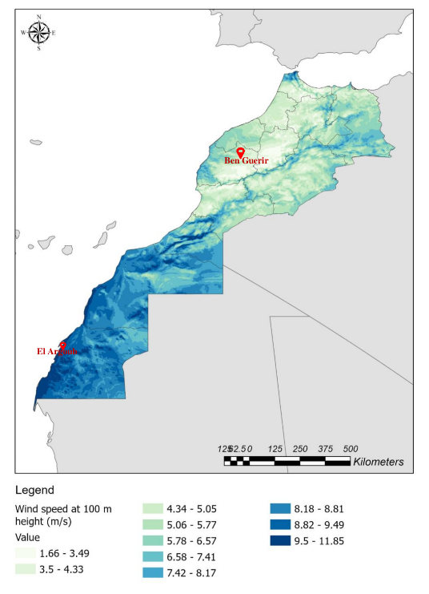
Figure 1: Morocco's Wind Atlas (source GEP/Vortex)
Ben Guerir is characterized by low average wind velocities and high wind variability, while El Argoub is characterized by higher averages and less wind variability (Fig. 1).
Although Vortex FDC can deliver finer temporal resolutions (e.g., 10-minute data) through Large Eddy Simulation (LES), our study intentionally retained the hourly resolution and pursued temporal enhancement through a physically grounded approach using the Von Kármán turbulence model, which provides high-frequency detail based on established spectral laws.

Welch's Method For Power Spectral Density Estimation
Welch's method is a method similar to Fast Fourier Transform (FFT), utilized to analyze the wind speed time series in the frequency domain, providing an estimate of the power spectral density (PSD) with reduced variance compared to the traditional periodogram [40]. This method involves segmenting the time-domain signal into overlapping windows, applying a window function, computing the periodogram for each segment, and averaging the results. Let a signal of length M be divided into K segments of length L, shifted from each other by D points . The $k^{-th}$ windowed segment will be written as $x_{k}\left(n\right)=x\left(n+\left(k-1\right)D\right)$. Thus, the overlap length will be $max\left(L-D,0\right)$.
$$P_{Welch}\left(f_{k}\right)=\frac{1}{K⋅L⋅U}\sum_{k=1}^{K}{{\left|\sum_{n=1}^{L}{h\left(n\right)}⋅x_{k}\left(n\right)⋅\exp\left(-j2πf_{k}n\right)\right|}^{2}}$$
(1)
- where:
- $\left(h\left(n\right)\right)$ is the window function (e.g., Hanning window) applied to each segment.
- $\left(L\right)$ is the length of each windowed segment.
- $\left(K\right)$ is the number of windowed segments.
- $\left(f_{k}\right)$ is the frequency.
- $\left(j\right)$ is the imaginary unit $\left(j^{2}=-1\right).$
- $U=\frac{1}{L}\sum_{n=1}^{L}{{\left|h\left(n\right)\right|}^{2}}$ is the normalization constant of the weights ensuring that $P_{welch}\left(f_{k}\right)$ is asymptotically unbiased.
Following the Eq. 1 The overlap between segments was set to 50% (D=L/2) and the window length M was set to initially to 28800 samples to balance spectral resolution and variance reduction. This methodology was extended to 20 days of wind data from Ben Guerir for validating the Von Kármán model and subsequently applied to three months of data from El Argoub to fit the Von Kármán parameters using the least squares method (LSM).

Von Kármán Turbulence Model
To accurately model atmospheric turbulence, the Von Kármán model was employed due to its proven effectiveness in capturing spectral characteristics of continuous gust phenomena, particularly across a wide range of frequencies, including high frequencies, which are crucial for enhancing the temporal resolution of wind velocity time series.
This model was parameterized using turbulence intensity and scale length , with values derived from relevant military standards such as MIL-STD-1797B [41] or atmospheric measurement data. These parameters, which define the energy and size of turbulent eddies, were adjusted to reflect the expected operational environment.
It is important to note that the Von Kármán turbulence model, being a spectral model, is typically derived under stationary assumptions. In this work, the assumption of stationarity is applied locally, specifically between two consecutive hourly data points, to facilitate sub-hourly "gap-filling.", rather than generating wind velocities from scratch. This approach aligns with methodologies used by other researchers for similar high-frequency data reconstruction [29]. This localized stationarity allows for the effective reconstruction of turbulent fluctuations over short temporal windows.
Turbulent velocity fields were then generated by filtering white noise through a transfer function derived from the Von Kármán power spectral density (PSD) equations. The wind speed power spectral density $P_{VK}$ according to the Von Kármán’s longitudinal model is expressed as [42]:
$$P_{VK}\left(f\right)=\frac{4σ^{2}L}{\overline{V}}\frac{1}{{\left(1+70.8{\left(f\frac{L}{\overline{V}}\right)}^{2}\right)}^{5/6}}$$
(2)

Where:
- $σ$ and $L$ are the turbulence standard deviation and length for each component,
- f is the temporal frequency related to the spatial frequency $\text{Ω}$ by $f=\frac{\overline{V}Ω}{2\text{Π}}$. $\overline{V}$ is the average wind velocity.
- the standard deviation is linked to the turbulence intensity (TI) by $TI=\frac{σ}{\overline{V}}$.
In Eq 2, P_{VK} is expressed in m²/s²/Hz. According to IEC standards, the reference values for turbulence intensity (TI) at a wind speed of 15 m/s, averaged over 10 minutes, are 0.16, 0.14, and 0.12 for high, medium, and low turbulence intensity, respectively. This is known as the Normal Turbulence Model (NTM). However, studies suggest that the NTM may not accurately represent actual turbulence in wind farms at wind speeds exceeding 15 m/s or even below 5 m/s. Therefore, the TI values obtained in this study should not be directly compared with IEC standards [43].
The combination of length scale and turbulence intensity determines the shape of the PSD depicted by Eq. 2 and, consequently, the quality of the model fitting to measured wind data. Existing mathematical models, such as those from ESDU, IEC standards, and Danish Standard DS 472, are simplistic approximations and may not always provide accurate representations. More complex models exist but often rely on difficult-to-measure parameters, making optimal fitting challenging.

Least Squares Fitting
In this study, the turbulence intensity (TI) was directly calculated from the dataset by fitting Welch’s power spectral density to the Von Kármán model using the least squares method (LSM). The least squares fitting process minimizes the error between the Welch-estimated power spectral density $\left(PSD\right)\left(P_{welch}\left(f\right)\right)$ and the Von Kármán model $PSD\left(P_{VK}\left(f\right)\right)$. The optimization problem is formulated as:
$$\sum_{i=1}^{N}{{\left(P_{welch}\left(f_{i}\right)-P_{VK}\left(f_{i};σ,L\right)\right)}^{2}≤ε}$$
(3)
where:
- $\left( N \right)$is the number of frequency points used for fitting,
- $\left( σ\right)$ is the turbulence intensity parameter,
- $\left( L \right)$ is the turbulence scale length.
After the fitting operation using Eq.3, the generated data using Von Karman as a shape filter was then evaluated against ground-based data. This performance was assessed using the Root Mean Square Error (RMSE), Mean Absolute Error (MAE), Mean Bias Error (MBE), and the Coefficient of Determination (R²) [44].

Table 3:Procedure for Generating Synthetic Wind Speed Data with Von Kármán Spectrum
N° | Step | Operation/formula | Signals | Illustration
1 | Original Data: (Starting point) | $W\left(n\right)=\{w_{1},w_{2},…,w_{n}\}, w_{i}∈\left[1,n\right]$ | $W\left(n\right)$ | 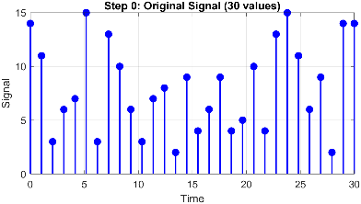
2 | Downsample to hourly resolution | $W_{d}\left(n\right)=W\left(n\right)*S\left(n\right)$ where $S\left(n\right)$ is a sampling function | $W_{d}\left(n\right)$ | 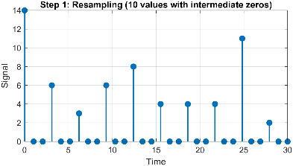
2 | Remove zero values | $W_{\text{r}}\left(m\right)=W_{d}\left(n\right) \text{for }W_{d}\left(n\right)≠0$ | $W_{\text{r}}\left(m\right)$ m<n
3 | VK Parameter Estimation | Fit Welch’s PSD of $W_{\text{r}}\left(m\right)$ to $P_{VK}\left(f\right) u$sing LSM to determine $σ$and$L$ | m<n | 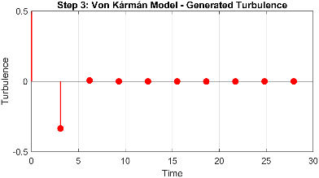
4 | Generate white noise with same dimensions as original data | Generate white noise X$\left(n\right)$ with same dimensions as original data W$\left(n\right)$. | $X\left(n\right)$ | 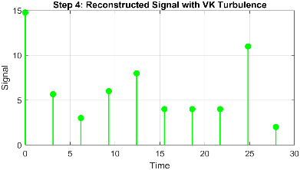
4 | Generate Von Kármán turbulence | Filter X$\left(n\right)$ through $P_{VK}\left(f\right)$model to obtain turbulent fluctuations $T\left(n\right)$. | $$T\left(n\right)$$
5 | Upsample dataset to 1-minute resolution | Upsample $W_{\text{r}}\left(m\right)$ to $W_{t}\left(n\right)$ which has 1-minute resolution. | $W_{t}\left(n\right)$ | 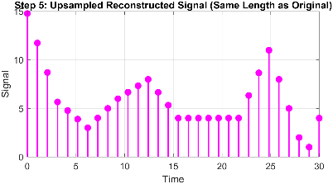
5 | Reconstruct high-resolution wind speed | Add turbulent fluctuations  $T\left(n\right)$ to upsampled mean wind $W_{t}\left(n\right)$ to get $W_{u}\left(n\right)$. | $W_{u}\left(n\right)$
6 | Comparison with original | Calculate difference $ΔW\left(n\right)=W\left(n\right)-W_{u}\left(n\right)$ as well as other performance metrics (Table 4). | $W_{u}\left(n\right)$ $W\left(n\right)$ | 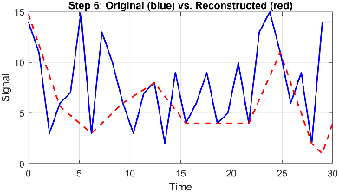

RESULTS AND DISCUSSION

Von Kármán Model Validation
To assess the accuracy of the Von Kármán (VK) model in estimating wind turbulence, particularly for gap filling applications using lower-resolution datasets such as ERA5, we conducted a validation study using high-resolution ground-based wind speed data from Ben Guerir. The original dataset, recorded at a 1-minute resolution, was first artificially degraded by resampling it to hourly intervals, simulating the lower resolution typically available in large-scale reanalysis datasets.
Welch’s method was then applied to the resampled data to estimate its power spectral density (PSD), and the VK model was fitted to this PSD to extract site-specific turbulence parameters $σ$ and $L$. These parameters were subsequently used to reconstruct high-resolution wind speed fluctuations by filtering white noise through the VK model’s transfer function. The resulting synthetic time series was compared against the original 1-minute resolution data utilizing the performance metrics outlined in the previous section to assess how well the VK model preserves turbulence characteristics after the downsampling and reconstruction process.
Figure 2a-e presents the reconstructed high-resolution wind speed data using the Von Kármán turbulence model. The reconstruction was performed using a 20-day sample of original 1-minute resolution wind data to evaluate the model's ability to reproduce realistic wind fluctuations.
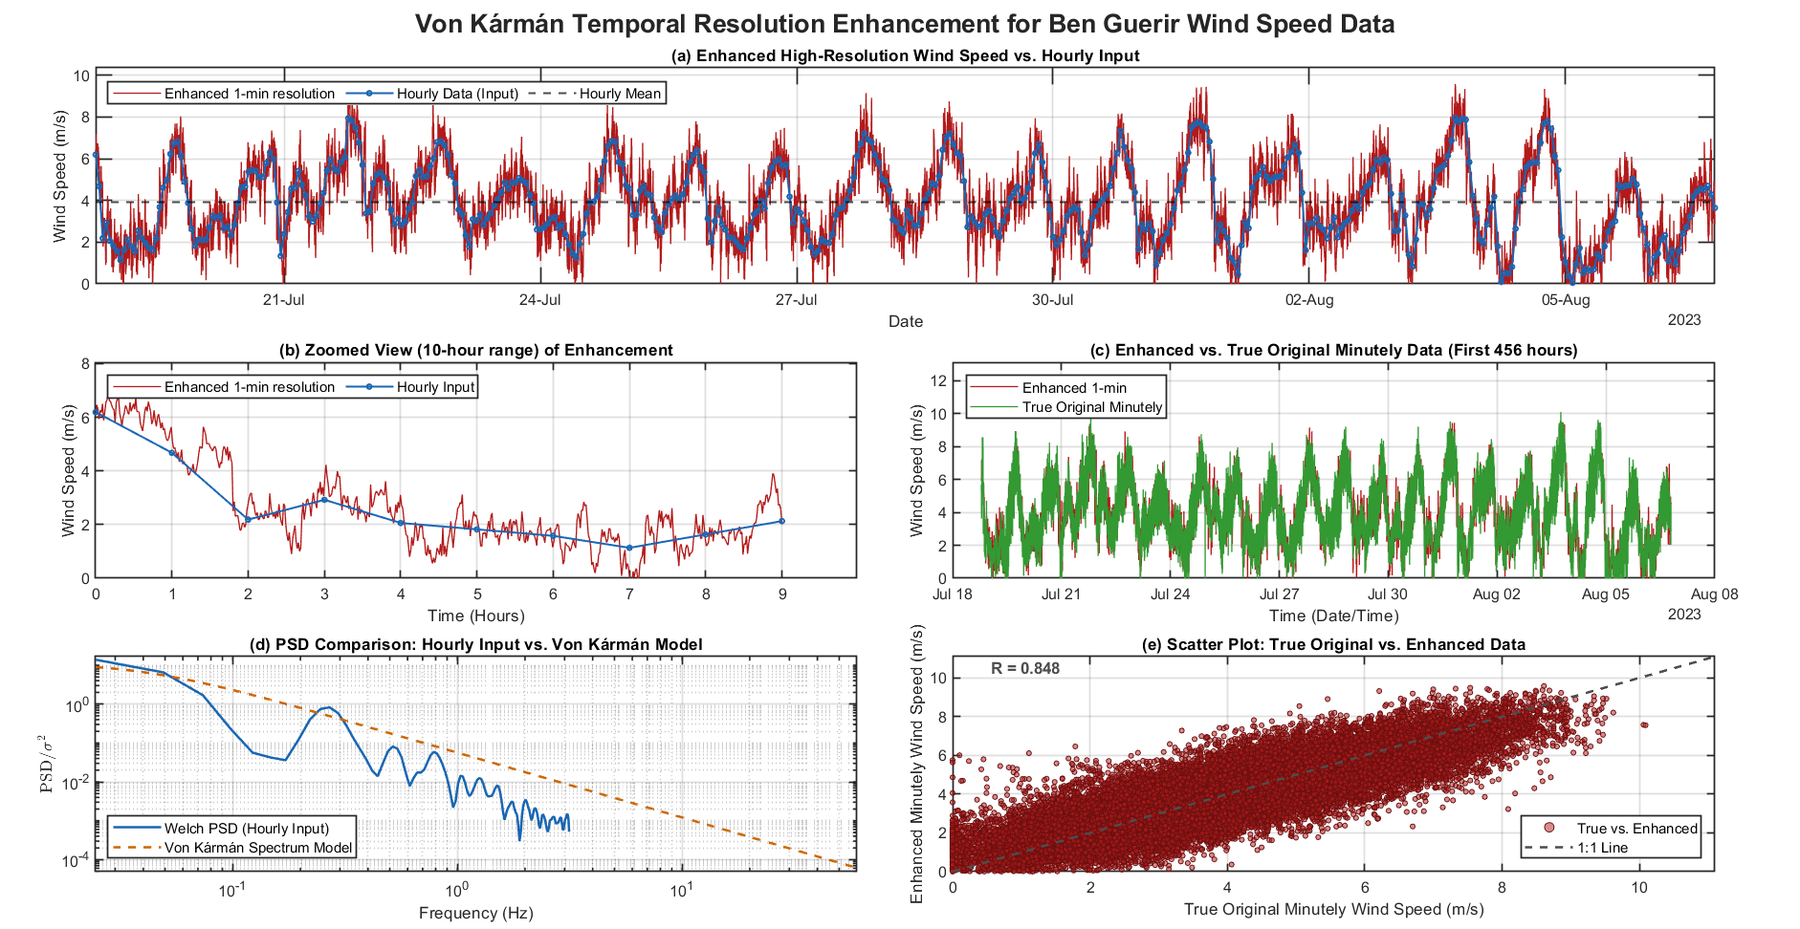
Figure 2: Von Kármán temporal resolution enhancement for Ben Guerir: Wind Data reconstruction using the Von Kármán turbulence model, based on a 20-day original data sample. (a) Reconstructed high-resolution wind speed vs. hourly data; (b) Von Kármán enhancement in a 9-hour range; (c) Reconstruction data for 3600 seconds comparing reconstructed and original data; (d) Power Spectral Density (PSD) comparison between measured and Von Kármán model; (e) Scatter plot of original vs. reconstructed wind speed
Figure 2a-e illustrates the model's capability in reconstructing wind speed fluctuations by leveraging the Von Kármán turbulence model. The reconstruction process successfully captures the high-frequency variations present in the original 1-minute resolution wind data, demonstrating the efficacy of the model in preserving turbulence characteristics. The model effectively captures high-frequency variations, preserving key turbulence characteristics (2a). A zoom into a 9-hour range (2b) illustrates the enhancement in resolution achieved by the reconstruction process. To highlight the model’s accuracy in short-term variations, a comparison between the reconstructed and original data over a 3600-second period (2c) was provided. The PSD analysis (2d) shows that the Von Kármán model successfully replicates the spectral characteristics of the measured wind data, particularly at lower frequencies, which represent long-term fluctuations. However, a deviation at higher frequencies (from 10−1 Hz to 1 Hz) suggests that the model slightly overestimated high-frequency gusts, an aspect that could be refined for better accuracy. The scatter plot (2e) presents a comparison between the original and reconstructed wind speeds, demonstrating a strong correlation, quantified by a high correlation value of 0.84256, indicating a robust positive agreement between the datasets. Table 4 summarized the metrics obtained as well as the Von Kármán parameters derived from the fitting algorithm:
Table 4: Performance metrics of the Von Kármán turbulence model: Comparison of original and reconstructed data (20 days)
Fitted 𝝈 | Fitted L | RMSE | MAE | MBE | R²
4.7218 | 11.3849 | 1.0686 | 0.84588 | -3.5636 x 10⁻⁵ | 0.7099
These results confirm that the model effectively reconstructs wind fluctuations while maintaining high correlation with the original dataset.

Impact Of Data Sample Size On Model Performance
To further evaluate the influence of dataset size on model accuracy, nine simulations were performed using datasets of varying durations: 5, 10, 20, 30, 50, 70, 100, 150, and 160 days, all originally at 1-minute resolution before resampling to 1-hour intervals and applying the Von Kármán turbulence model. Those simulations revealed a clear improvement in performance as the data sample size increases (Fig.2a-e).
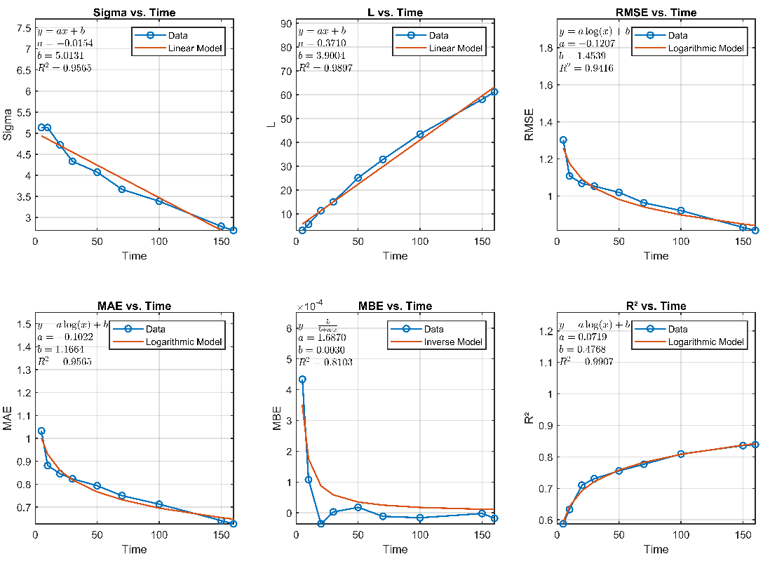
Figure 3: Von Kármán performance analysis with the data size.
Quantitatively, Figure 3 demonstrates a clear improvement in the Von Kármán model's performance with increasing data sample size. RMSE decreases from 1.3 to ~0.9, following a logarithmic trend, suggesting diminishing error reduction with larger datasets. MAE drops from 1.05 to ~0.65, again exhibiting a logarithmic decline, highlighting the benefits of extended data. R² rises from 0.6 to ~0.84, confirming that model accuracy improves significantly with larger datasets. Fitted σ (standard deviation) and L (length scale) increase linearly. This indicates a consistent refinement in turbulence characterization as more data is incorporated. However, the logarithmic trends observed in error reduction indicate that while larger datasets yield better accuracy, the rate of improvement slows with increasing data volume. Moreover, the inverse relationship suggests that MBE which is already low decreases with an increase in dataset size but then stabilizes at a very low value: bias correction is more effective with small datasets but stabilizes as dataset size increases. The fact that MBE is already very small and approaching zero suggests that the model becomes effectively unbiased for larger datasets. This means that further increasing the dataset size does not significantly reduce bias but rather enhances accuracy in other ways. Specifically, it allows for better estimation of turbulence parameters such as σ (standard deviation) and L (integral length scale). These parameters depend on the frequency spectrum, which becomes more representative as more time series data is included.
For short datasets, only the major trends in wind speed variability are captured. In contrast, longer datasets provide a more complete spectral representation, incorporating both low- and high-frequency components. This results in a more accurate characterization of turbulence, particularly for small-scale fluctuations that shorter datasets might miss.

Data Enhancement
Building on the validation of the Von Kármán (VK) turbulence model from Section 3.1, the model was applied to enhance ERA5 reanalysis wind speed data for the El Argoub, Al Hoceima, and Tinghir regions over a 100-day period, with the aim of improving green hydrogen production forecasting. This 100-day selection was made to capture a representative period of wind conditions while adhering to the model's underlying stationarity assumptions, as the VK model is most effective at very short time scales. For this reason, the VK model was applied selectively to 100 consecutive days within the datasets rather than attempting to generate complete, long-term high-resolution datasets, thus ensuring the validity of the reconstructed turbulence. Originally provided at an hourly resolution, the ERA5 data for these locations was resampled to a 1-minute resolution using the VK model. This reconstruction increases the dataset's temporal granularity, enabling a more precise characterization of short-term wind fluctuations that are critical for renewable energy applications.
The high-resolution wind speed data was subsequently employed in forecasting hourly green hydrogen production. The resulting forecasts were then compared against those generated using the original hourly ERA5 data. The comparison highlights the VK model’s effectiveness in capturing high-frequency dynamics that are otherwise lost in coarser datasets. Figure 4a-f presents the frequency-domain and statistical comparison for the enhanced wind speed data across all three locations.

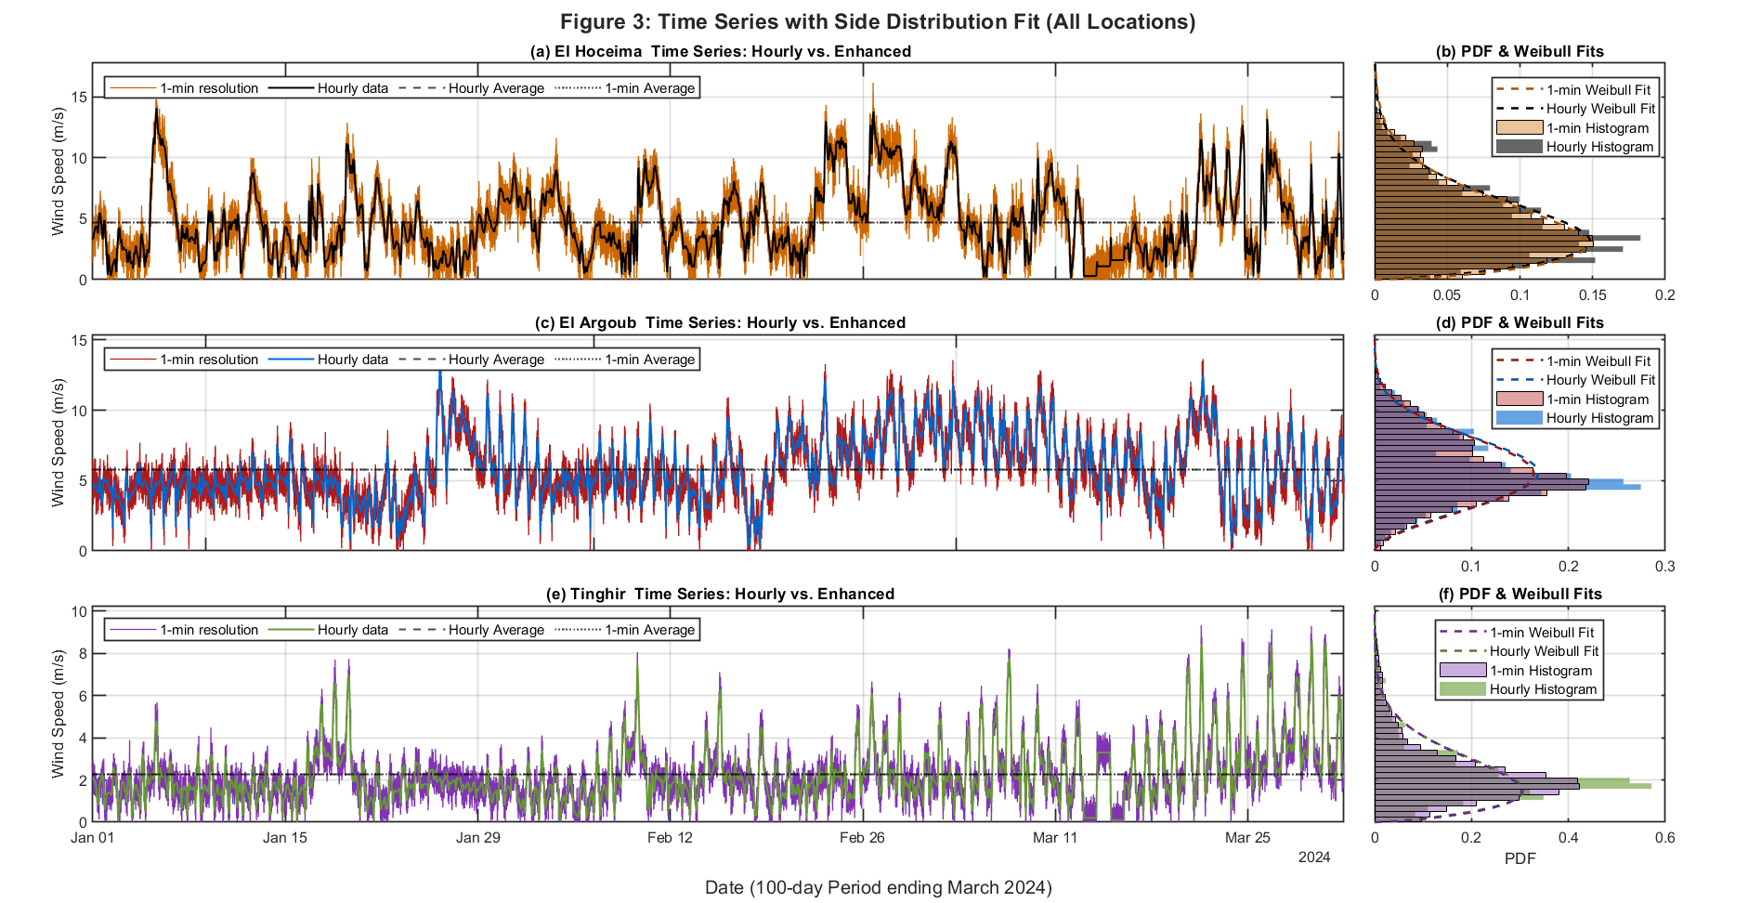
Figure 4: Frequency-Domain & Statistical Comparison for Enhanced Wind Speed Data Across Multiple Locations. (a) El Hoceima PSD - Log Scale, comparing Welch PSD (Hourly and Enhanced) with Von Kármán Model; (b) El Hoceima CDF Comparison, showing KS statistic and p-value; (c) El Hoceima FFT - High Frequency, comparing Enhanced (1-min) and Hourly FFT; (d) El Argoub PSD - Log Scale; (e) El Argoub CDF Comparison; (f) El Argoub FFT - High Frequency; (g) Tinghir PSD - Log Scale; (h) Tinghir CDF Comparison; (i) Tinghir FFT - High Frequency.
Figure 4a, 4c, and 4e present the time evolution of wind speed over a 100-day period ending in March 2024 for El Hoceima, El Argoub, and Tinghir, respectively. Each subplot contrasts the hourly reanalysis data with the 1-minute enhanced time series generated using the Von Kármán turbulence model presented in section 2.3 and validated in 3.1 for Ben Guerir ground based station. The finer temporal variability introduced by the enhancement reflects realistic intrahourly fluctuations, preserving both the large-scale trend and local variability without introducing spurious spikes.
Corresponding probability density functions (PDFs) and Weibull distribution fits are shown in subplots 4b, 4d, and 4f and revealed that the enhanced data remains statistically consistent with the original hourly input, evidenced by the high overlap between the fitted curves and histograms. The Weibull fits for both datasets are almost indistinguishable, highlighting that the enhancement process conserves key distributional properties such as mean and spread.
Additionally, the Population Stability Index (PSI) and Kullback–Leibler Divergence (DKL) were used to quantify the statistical distance between the original hourly and enhanced 1-minute wind speed data [45],[46]. They are for comparing distributions of differing sample sizes unlike RMSE, MAE,MBE or R² [47]. Moreover, a two-sample Kolmogorov–Smirnov (KS) test was used to compare the distributions of the original hourly wind speed (hourly) and the high-resolution reconstructed series (high resolution). Graphical results are compiled in Figure 5.
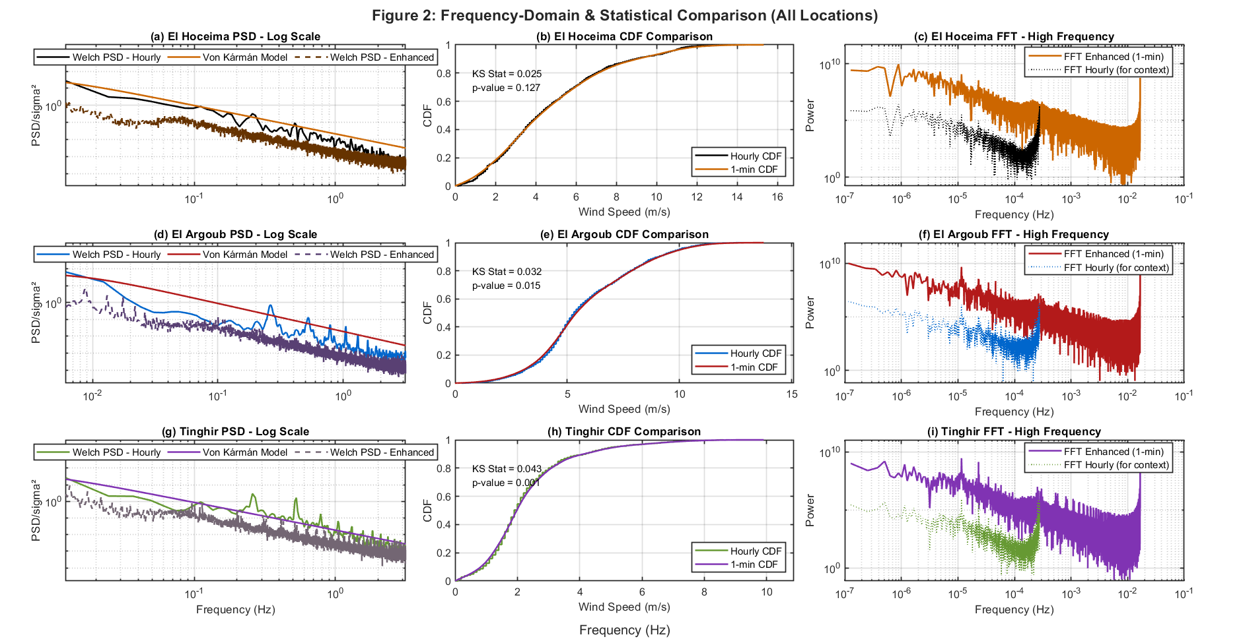
Figure 5: Frequency-domain and statistical comparison of wind speed series across three sites: El Hoceima, El Argoub, and Tinghir: (a, d, g) Power Spectral Density (PSD) in log-log scale; (b, e, h) Cumulative Distribution Function (CDF) and Kolmogorov–Smirnov (KS) test; (c, f, i) Frequency content comparison using FFT at high temporal resolution.
The consistency between the original hourly and the reconstructed high-resolution wind speed data across three contrasting Moroccan locations presented in Figure 5 yielded key turbulence parameters and statistical metrics that were summarized in Table 5.
Table 5: Spectral and Statistical Comparison (Hourly vs. Enhanced 1-min)
Aspect | El Hoceima | El Argoub | Tinghir
σ | 5.15 | 6.80 | 2.01
L (m) | 59.40 | 84.75 | 34.85
Mean Wind Speed (Hourly) | 4.70 | 5.80 | 2.27
Std. Deviation (Hourly) | 2.85 | 2.24 | 1.40
Mean Wind Speed (Enhanced) | 4.71 | 5.80 | 2.28
Std. Deviation (Enhanced) | 2.92 | 2.31 | 1.43
PSI | 0.0928 | 0.0806 | 0.2452
DKL | 0.0384 | 0.0355 | 0.1023
PSD (log–log) | Enhanced PSD aligns with VK in mid-range, underestimates at low frequencies. Hourly series is flatter. | Matches VK between 10⁻²–10⁰ Hz; VK overestimates at very low frequencies. | VK captures trend but overestimates across frequencies. Enhanced fills mid-high frequency gaps.
CDF & KS Test | KS = 0.025, p = 0.127 → No significant difference. CDFs nearly identical. | KS = 0.032, p = 0.015 → Slight but significant difference; minor shift. | KS = 0.043, p = 0.009 → Statistically significant but minor.
FFT (High-Frequency Recovery) | 1-min series recovers power above 10⁻³ Hz. Hourly spectrum lacks such detail. | Enhanced adds energy at high frequencies; hourly remains flat post-10⁻³ Hz. | Restores broad spectrum beyond 30-min (10⁻³ Hz). Hourly remains flatter.
While the KS test indicates statistical differences between the hourly and enhanced wind speed distributions, these differences are not practically limiting. The goal of the enhancement is not to replicate the hourly data exactly, but to model meaningful and realistic sub-hourly variability. The enhanced data retains core statistical properties (mean, variance, distribution shape) while restoring fine-scale turbulence crucial for practical use cases, such as short-term forecasting, real-time control of energy systems, and accurate modeling of electrolyzers. Spectral analysis (via FFT) confirms this enrichment by revealing increased power at sub-hourly frequencies absent in the original data. Therefore, despite minor statistical deviations, the VK-based enhancement offers physically meaningful and application-relevant improvements. The enhanced data:
- Preserves essential statistical traits : mean, variance, distribution shape (Figure 4),
- Restores realistic turbulent dynamics at high frequencies (Figure 2),
- Increases data fidelity for use in forecasting, turbine control, and renewable energy modeling.

Wind Speed Forecasting And Green Hydrogen Production Modeling
A key objective of this study was to evaluate how temporal resolution affects the accuracy and reliability of very short-term (5-hour) green hydrogen production modeling. To this end, a detailed dynamic simulation of a PEM electrolyzer system was employed, fed by power profiles derived from wind speed data of varying resolutions. The original wind data, available as hourly averages, was upscaled to a 1-minute resolution using the Von Kármán turbulence model, which introduced realistic sub-hourly fluctuations. This spectral enhancement notably increased signal energy beyond the 3 × 10⁻⁴ Hz range, thus enabling the capture of high-frequency variability typically masked in coarser datasets. The high-resolution wind speed series was then converted into power output using a representative wind turbine power curve with the characteristics detailed in Table 6.
Table 6: Technical specifications of the 100 kW Aeolos wind turbine [48]
Parameter | Value | Relevance to the study
Rated Power | 100 kW | To set the nominal output for electrolyzer matching and modeling energy input
Maximum Output Power | 120 kW | Useful to assess peak power input during wind gusts or high-variability periods
Rotor Diameter | 24.5 m | Determines swept area and power extraction potential; affects power curve
Start-up Wind Speed | 2.5 m/s | Below this threshold, no power is produced; critical for downtime estimation for green hydrogen production modelling
Rated Wind Speed | 10 m/s | Wind speed at which rated power is achieved; informs peak efficiency and curve shape.
Design Lifetime | 20 years | Used for long-term performance modeling or cost estimation
Operating Temp. Range | -20°C to +50°C | Relevant for environmental modeling if extreme temperatures are a concern especially for electrolysis operation.
This power input was used to drive a green hydrogen production model representing a PEM electrolyzer. The model accounted for key inputs system dynamics including part-load behavior, Faradaic and thermal efficiencies, and transient responses to power fluctuations. Electrolyzer system characteristics used in the simulation are summarized in Table 7.
Table 7:Electrolyzer system inputs
V_{cell} [V] | N_{cells} | Stack Voltage [V] | Cell Area [cm²] | Max Current [A] | E_{rev} [V] | Faradaic Eff. | Cooling coeff [W/K] | Mass [kg] | Heat Cap. [J/kg·K] | T_{env} [K]
1.3 | 292 | 379.6 | 29.27 | 263.44 | 1.23 | 0.9 | 450 | 800 | 1000 | 298
To evaluate the impact of time resolution on hydrogen production and electrolyzer performance, building on Table 6 and Table 7 inputs, wind speed forecasting was carried out using a 100-day sample of both hourly and high-resolution datasets divided into three parts: 70% for training, 15% for validation, and 15% for testing. Five random hourly segments were selected from the test data of both datasets forecasted using a feedforward neural network (FFNN). These segments were then used to simulate the hydrogen yield of the electrolyzer under three distinct scenarios: (i) Hourly wind data, representing the standard temporal resolution available in reanalysis datasets such as ERA5 (see Section 2.1); (ii) High-resolution (1-minute) synthetic wind data, produced using the Von Kármán turbulence model to reconstruct sub-hourly fluctuations typically lost in averaged data (see Section 3.3); (iii) Constant power input scenario, defined by the average wind turbine output over a representative 5-hour period. This case serves as a benchmark to assess the role of high-frequency wind variability on forecast performance and system behavior and also forms a basis for physically-informed forecasting and modelling approaches.

Although both Al Hoceima and El Argoub exhibit strong wind potential, and Tinghir shows lower wind activity, El Argoub was selected for forecasting due to its strategic importance for future wind energy development in southern Morocco. This selection also ensures clarity and avoids redundancy in the paper. The resulting differences in cumulative hydrogen production and energy consumption between the baseline and enhanced cases were illustrated in Figure 6a-f.
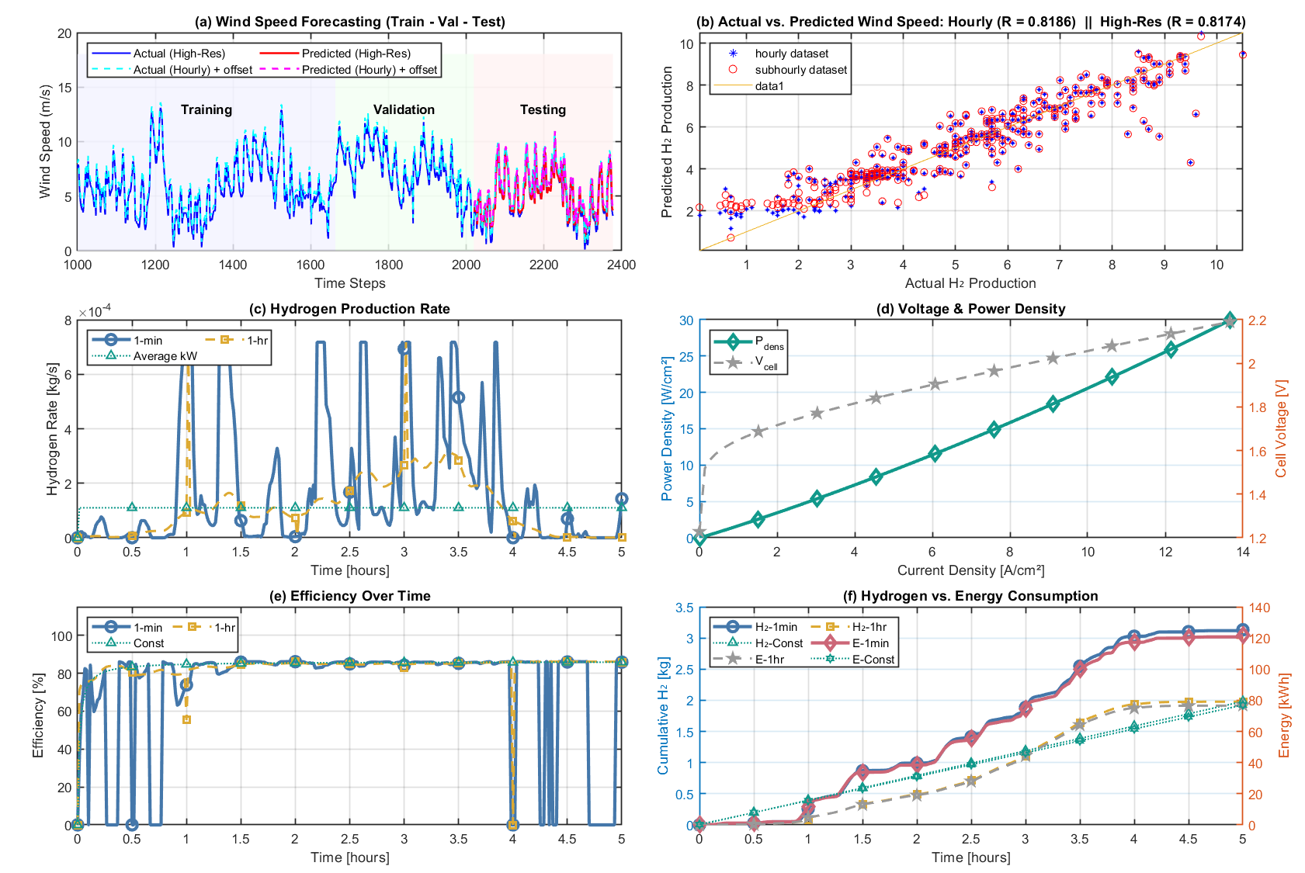
Figure 6: Wind speed forecasting, Hydrogen production & energy consumption – 1-min vs 1-hr (original) resolution data; (a) Modelling H₂ production rate, low (original) and high resolution (enhanced) are compared; (b) voltage & power density vs current density are the electrochemical polarization curves of the electrolyzer cell; (c) Efficiencies for low and high resolution data are obtained by integrating the curve on using a 1-min step; (d) Hydrogen vs. energy consumption time series.
The illustrations in Figure 6a-f illustrate that high-resolution wind speed inputs generated via Von Kármán model, can significantly improve hydrogen production modeling by capturing short-term wind dynamics (Fig 6a, Fig 6b, Fig 6c). Although the gain in forecast accuracy is minor, the physical benefit to electrolyzer performance is substantial, supporting the case for physically informed high-resolution wind modeling in green hydrogen systems. Despite high efficiency fluctuations shown in Fig 6e, the average efficiency remains almost similar across all scenarios. Most notably, Fig 6f reveals that using 1-minute data results in slightly more hydrogen estimation production compared to hourly data, emphasizing the importance of fine temporal resolution for precise system forecasting. The comparative results of Figure 6a-f are summarized in Table 8.
Table 8: Comparative Analysis of Electrolysis Forecasting Accuracy and Efficiency Errors Over a 2-Hour Operation Using 1-Minute vs. 1-Hour Wind Data
Time Resolution | Total H₂ [kg] | Mean H₂ Rate [kg/s] | Mean Efficiency [%] | Abs. Error (H₂) [kg] | Abs. Error (Eff.) [%] | % Error (H₂) | % Error (Eff.)
1-min | 3.1323 | 1.734×10⁻⁴ | 83.38 | — | — | — | —
1-hr | 1.9779 | 1.095×10⁻⁴ | 83.73 | -1.1544 | 0.3489 | -36.86 | + 0.42
As illustrated in Table 8, enhancing the original hourly wind dataset to a 1-minute resolution using the Von Kármán turbulence model led to a significant improvement in the fidelity of hydrogen production modeling. Over the 2-hour simulation period, the model using high-resolution data yielded 3.1323 kg of hydrogen compared to only 1.9779 kg with the original 1-hour data. This corresponds to a substantial absolute error of -1.1544 kg and a relative error of -36.86% in the coarse-resolution scenario.
The mean system efficiency showed only a slight variation (83.73% vs. 83.38%), but this minor deviation masks the underlying operational misrepresentation caused by the coarse data, particularly in part-load operation and transient ramping zones.
Figure 4 and Figure 5 corroborate these findings by showing how the enhanced time series preserves the overall trend and statistical consistency while adding meaningful short-term variability. In dynamic systems like PEM electrolyzers, these fluctuations dictate operating thresholds such as minimum power, ramping frequency, and system responsiveness, all of which are poorly captured by low-resolution input.
To deepen the analysis and enable a clearer comparison of forecasting differences between low-resolution and high-resolution data, both the absolute and relative errors in hydrogen production estimates were evaluated. For compatibility, the high-resolution forecast was aggregated into hourly cumulative hydrogen production. The test dataset spans a 6-hour period.

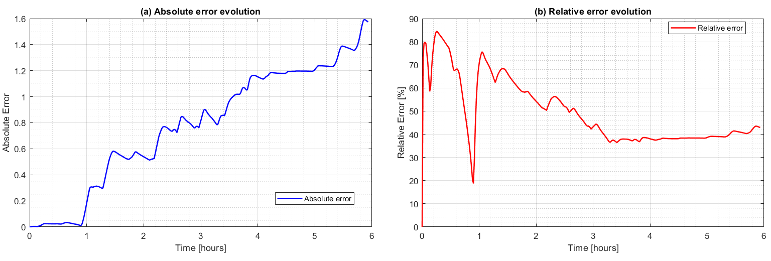
Figure 7: Temporal evolution of the forecasting error in hydrogen production between low- and high-resolution wind data: (a) cumulative absolute error; (b) relative error percentage. The high-resolution forecast was aggregated to hourly values for direct comparison.
The Figure 7a-b illustrates the temporal evolution of forecasting errors between hourly and sub-hourly wind data. The absolute error (Fig. 7a) increases monotonically, confirming that discrepancies compound over time rather than cancelling out. The relative error (Fig. 7b) is unstable in the first hour and then stabilizes at ~40–50%. This indicates a systematic overestimation of hydrogen output when using hourly inputs. These findings confirm that low-resolution data introduces a persistent positive bias, significantly reducing the reliability of techno-economic forecasts.
In systems designed to rely solely on renewable energy inputs, such temporal fidelity is not just a modeling convenience—it becomes an operational necessity. Green hydrogen must be produced exclusively from renewable electricity, and buffering this variability using fossil-based energy would invalidate its "green" classification. Therefore, grid-free or weak-grid applications—common in remote, islanded, or decentralized deployments—demand accurate modeling of renewables’ minute-scale fluctuations to ensure the electrolyzer performs within specification.

CONCLUSIONS
This study evaluated the impact of temporal resolution on wind speed forecasting and green hydrogen production modeling by simulating the behavior of a dynamic PEM electrolyzer and predict wind velocity yield using neural network-based forecasting model under two different input conditions: hourly power output and 1-minute wind-derived power inputs. The high-intra-hourly fluctuations were generated within the original wind speed dataset using a Von Kármán-based turbulence model to introduce realistic sub-hourly variability under stationarity assumptions. The following key conclusions were drawn:
a) The application of the Von Kármán turbulence model successfully generated a 1-minute high-resolution wind dataset that captured realistic short-term fluctuations absent in the original hourly time series. This led to a better estimation of hydrogen production by taking sub-hourly fluctuations.
b) Despite almost identical total energy input, the high-resolution simulation outperformed the coarse-resolution scenario by 58.3% in total hydrogen yield over the sampled period. This confirms the sensitivity of electrolyzer systems to input variability and the limitations of time-averaged data in dynamic forecasting and control.
c) Short-term variability forecasting plays a critical role in operational behavior, influencing key thresholds such as startup and shutdown points, minimum power required for hydrogen production, and part-load efficiencies. Although the difference in average efficiency was modest (0.42%), the high-resolution model provided a more detailed and accurate forecasted efficiency profile.
d) Reanalysis datasets with hourly resolution, while advantageous for broad spatial coverage for weather data, may lack the granularity needed with regards to wind short-term dynamics. This limitation can lead to underestimation of operational downtimes, increased cycling, and reduced performance due to part-load inefficiencies, potentially skewing both production forecasts and degradation assessments.
e) These findings are particularly significant in configurations where frequent variability in wind resource availability can lead to repeated crossing of operational thresholds. Since green hydrogen certification prohibits the use of fossil or nuclear grid electricity, buffering this variability with conventional backup is not an option. Hence, accurate modeling and forecasting becomes crucial for proper sizing, control strategy design, and long-term asset utilization.
f) While effective for temporal enhancement, the current Von Kármán turbulence model primarily considers the longitudinal (u) component of wind velocity, privileging a single direction. This makes the method particularly valuable for zones characterized by high, constant wind velocity and a quasi-single wind direction. Future research should therefore focus on incorporating full directional wind fluctuations (v and w components) and terrain-based spatial modeling (e.g., shear and wake effects) to further improve both temporal and spatial accuracy, enhancing overall system design and planning across diverse meteorological conditions.
g) Additionally, the high-resolution wind time series data generated through this methodology holds significant applicability beyond green hydrogen production forecasting. It is crucial for enhancing:
- Storage control: Where accurate sub-hourly data is essential for efficient battery management and optimal charge/discharge cycles.
- Microgrid management: For optimizing energy flow, ensuring stability, and integrating distributed renewable resources effectively.
- Wind farm optimization: Enabling advanced control strategies, load management, and reducing fatigue loads on turbines due to better understanding of localized turbulence.
Building upon the enhanced data resolution achieved with the Von Kármán model, future research will focus on the precise methodology for integrating this high-fidelity input with more advanced AI based methods for improved forecasting. For example, combining wind turbulence models (such as Karman, Mann, and Kaimal) with Physically Informed Neural Networks (PINNs) mentioned in Table 1 would offer promising avenues for both time resolution enhancement and forecasting across more locations worldwide. PINNs are particularly valuable in this context, as they are designed to penalize solutions that violate physical laws, making them well-suited to address challenges such as non-stationarity in wind data and broader weather data applications.

FIGURES
Figure 1: Morocco's Wind Atlas (source GEP/Vortex) 5
Figure 2: Von Kármán temporal resolution enhancement for Ben Guerir: Wind Data reconstruction using the Von Kármán turbulence model, based on a 20-day original data sample. (a) Reconstructed high-resolution wind speed vs. hourly data; (b) Von Kármán enhancement in a 9-hour range; (c) Reconstruction data for 3600 seconds comparing reconstructed and original data; (d) Power Spectral Density (PSD) comparison between measured and Von Kármán model; (e) Scatter plot of original vs. reconstructed wind speed 8
Figure 3: Von Kármán performance analysis with the data size 9
Figure 4: Frequency-Domain & Statistical Comparison for Enhanced Wind Speed Data Across Multiple Locations. (a) El Hoceima PSD - Log Scale, comparing Welch PSD (Hourly and Enhanced) with Von Kármán Model; (b) El Hoceima CDF Comparison, showing KS statistic and p-value; (c) El Hoceima FFT - High Frequency, comparing Enhanced (1-min) and Hourly FFT; (d) El Argoub PSD - Log Scale; (e) El Argoub CDF Comparison; (f) El Argoub FFT - High Frequency; (g) Tinghir PSD - Log Scale; (h) Tinghir CDF Comparison; (i) Tinghir FFT - High Frequency. 10
Figure 5: Frequency-domain and statistical comparison of wind speed series across three sites: El Hoceima, El Argoub, and Tinghir: (a, d, g) Power Spectral Density (PSD) in log-log scale; (b, e, h) Cumulative Distribution Function (CDF) and Kolmogorov–Smirnov (KS) test; (c, f, i) Frequency content comparison using FFT at high temporal resolution. 11
Figure 6: Wind speed forecasting, Hydrogen production & energy consumption – 1-min vs 1-hr (original) resolution data; (a) Modelling H₂ production rate, low (original) and high resolution (enhanced) are compared; (b) voltage & power density vs current density are the electrochemical polarization curves of the electrolyzer cell; (c) Efficiencies for low and high resolution data are obtained by integrating the curve on using a 1-min step; (d) Hydrogen vs. energy consumption time series. 13
Figure 7: Temporal evolution of the forecasting error in hydrogen production between low- and high-resolution wind data: (a) cumulative absolute error; (b) relative error percentage. The high-resolution forecast was aggregated to hourly values for direct comparison. 14

TABLES
Table 1: Review summary of Hybrid/Machine Learning models applied for forecasting. 2
Table 2: Comparative Summary of Turbulence Models in Wind and Flight Applications 3
Table 3:Procedure for Generating Synthetic Wind Speed Data with Von Kármán Spectrum 7
Table 4: Performance metrics of the Von Kármán turbulence model: Comparison of original and reconstructed data (20 days) 9
Table 5: Spectral and Statistical Comparison (Hourly vs. Enhanced 1-min) 11
Table 6: Technical specifications of the 100 kW Aeolos wind turbine [48] 12
Table 7:Electrolyzer system inputs 12
Table 8: Comparative Analysis of Electrolysis Forecasting Accuracy and Efficiency Errors Over a 2-Hour Operation Using 1-Minute vs. 1-Hour Wind Data 13

DECLARATIONS

Author contributions
Main author has contributed to the following : (1) the conception and design of the study, the analysis and interpretation of data; the co-authors have contributed to the following: 2) the acquisition of data; (3) drafting the article or critically revising its important intellectual content; (4) final approval of the version revised.

Funding
This research received no external funding. It received internal funding from the Green Energy Park and Mohammed VI Polytechnic University (UM6P).

Informed Consent Statement
Not applicable.

Data Availability Statement
Weather data (ERA5) was obtained from Vortex by the Green Energy Park (GEP) upon request from Vortex FDC company. Ground-based data is from the Green energy Park and has not been published in any public repository. Ground-based data is available on request to the authors with permission from the GEP.

Acknowledgments
The authors extend their appreciation to both the GEP and the UM6P teams for their contributions, including providing data and computing facilities for this research.

Declaration of interests
The authors declare that they have no known competing financial interests or personal relationships that could have appeared to influence the work reported in this conference paper.

References
1. Lai, C.C.K., Socolofsky, S.A.: Evaluation of linear autoregressive models for estimation of energy spectra in gappy turbulent velocity data. Limnol Oceanogr Methods. 16, 1–21 (2018). https://doi.org/10.1002/LOM3.10223’))
2. Eryilmaz, S., Bulanik, İ., Devrim, Y.: Computing reliability indices of a wind power system via Markov chain modelling of wind speed. Proc Inst Mech Eng O J Risk Reliab. 238, 71–78 (2024). https://doi.org/10.1177/1748006X221133601’
3. Tahir, A.S.: A Review on Deep Learning in Wind Speed Forecasting: Techniques and Challenges. International Journal of Intelligent Systems and Applications in Engineering. 12, 3574–3594 (2024)
4. Bojórquez, E., Payán-Serrano, O., Reyes-Salazar, A., Pozos, A.: Comparison of spectral density models to simulate wind records. KSCE Journal of Civil Engineering. 21, 1299–1306 (2017). https://doi.org/10.1007/s12205-016-1460-y
5. Optis, M., Perr-Sauer, J.: The importance of atmospheric turbulence and stability in machine-learning models of wind farm power production. Renewable and Sustainable Energy Reviews. 112, 27–41 (2019). https://doi.org/10.1016/J.RSER.2019.05.031
6. Stevens, R.J.A.M., Meneveau, C.: Flow Structure and Turbulence in Wind Farms. Annu Rev Fluid Mech. 49, 311–339 (2017). https://doi.org/10.1146/ANNUREV-FLUID-010816-060206/CITE/REFWORKS
7. Aitken, M.L., Lundquist, J.K.: Utility-scale wind turbine wake characterization using nacelle-based long-range scanning lidar. J Atmos Ocean Technol. 31, 1529–1539 (2014). https://doi.org/10.1175/JTECH-D-13-00218.1
8. Robey, R., Lundquist, J.K.: Influences of lidar scanning parameters on wind turbine wake retrievals in complex terrain. Wind Energy Science. 9, 1905–1922 (2024). https://doi.org/10.5194/WES-9-1905-2024
9. Chen, Y., Schlipf, D., Wen Cheng, P.: Parameterization of wind evolution using lidar. Wind Energy Science. 6, 61–91 (2021). https://doi.org/10.5194/WES-6-61-2021
10. Zhou, L., Mao, J.: A lidar for detecting atmospheric turbulence based on modified Von Karman turbulence power spectrum. Front Phys. 12, 1373608 (2024). https://doi.org/10.3389/FPHY.2024.1373608/BIBTEX
11. D’Amico, S., Van Renterghem, T., Botteldooren, D.: Influence of atmospheric conditions on measured infrasound from wind turbines. Journal of Wind Engineering and Industrial Aerodynamics. 225, 105021 (2022). https://doi.org/10.1016/J.JWEIA.2022.105021
12. Yang, S., Deng, X., Ti, Z., Yan, B., Yang, Q.: Cooperative yaw control of wind farm using a double-layer machine learning framework. Renew Energy. 193, 519–537 (2022). https://doi.org/10.1016/J.RENENE.2022.04.104
13. Finamore, A.R., Calderaro, V., Galdi, V., Graber, G., Ippolito, L., Conio, G.: Improving Wind Power Generation Forecasts: A Hybrid ANN-Clustering-PSO Approach. Energies 2023, Vol. 16, Page 7522. 16, 7522 (2023). https://doi.org/10.3390/EN16227522
14. Sirdas, A.S., Nilcan, A., Ercan, I.: Improved Wind Speed Prediction Results by Artificial Neural Network Method. Green Energy and Technology. 651–665 (2018). https://doi.org/10.1007/978-3-319-62575-1_46
15. Chrit, M., Majdi, M.: Operational wind and turbulence nowcasting capability for advanced air mobility. Neural Comput Appl. 36, 10637–10654 (2024). https://doi.org/10.1007/S00521-024-09614-0/FIGURES/3
16. Malakouti, S.M., Karimi, F., Abdollahi, H., Menhaj, M.B., Suratgar, A.A., Moradi, M.H.: Advanced techniques for wind energy production forecasting: Leveraging multi-layer Perceptron + Bayesian optimization, ensemble learning, and CNN-LSTM models. Case Studies in Chemical and Environmental Engineering. 10, 100881 (2024). https://doi.org/10.1016/J.CSCEE.2024.100881
17. Li, F., Ren, G., Lee, J.: Multi-step wind speed prediction based on turbulence intensity and hybrid deep neural networks. Energy Convers Manag. 186, 306–322 (2019). https://doi.org/10.1016/J.ENCONMAN.2019.02.045
18. Jalali, S.M.J., Ahmadian, S., Khodayar, M., Khosravi, A., Ghasemi, V., Shafie-khah, M., Nahavandi, S., Catalão, J.P.S.: Towards novel deep neuroevolution models: chaotic levy grasshopper optimization for short-term wind speed forecasting. Eng Comput. 38, 1787–1811 (2022). https://doi.org/10.1007/S00366-021-01356-0/TABLES/6
19. Li, F., Ren, G., Lee, J.: Multi-step wind speed prediction based on turbulence intensity and hybrid deep neural networks. Energy Convers Manag. 186, 306–322 (2019). https://doi.org/10.1016/J.ENCONMAN.2019.02.045
20. Sheng, Y., Wang, H., Yan, J., Liu, Y., Han, S.: Short-term wind power prediction method based on deep clustering-improved Temporal Convolutional Network. Energy Reports. 9, 2118–2129 (2023). https://doi.org/10.1016/J.EGYR.2023.01.015
21. Liu, H., Mi, X., Li, Y.: Smart deep learning based wind speed prediction model using wavelet packet decomposition, convolutional neural network and convolutional long short term memory network. Energy Convers Manag. 166, 120–131 (2018). https://doi.org/10.1016/J.ENCONMAN.2018.04.021
22. Nugroho, H.A., Astuty, E.Y., Subiantoro, A., Kusumoputro, B.: Ensemble Deep Learning NARX for Estimating Time Series of Earthquake Occurrence. 2023 3rd International Conference on Robotics, Automation and Artificial Intelligence, RAAI 2023. 301–305 (2023). https://doi.org/10.1109/RAAI59955.2023.10601278
23. Boynton, R., Balikhin, M., Wei, H.L., Lang, Z.Q.: Applications of NARMAX in space weather. Machine Learning Techniques for Space Weather. 203–236 (2018). https://doi.org/10.1016/B978-0-12-811788-0.00008-1
24. Ramezankhani, M., Milani, A.S.: A sequential meta-transfer (SMT) learning to combat complexities of physics-informed neural networks: Application to composites autoclave processing. Compos B Eng. 283, (2024). https://doi.org/10.1016/J.COMPOSITESB.2024.111597
25. Yan, L., Zhou, Y., Liu, H., Liu, L.: An Improved Method for Physics-Informed Neural Networks That Accelerates Convergence. IEEE Access. 12, 23943–23953 (2024). https://doi.org/10.1109/ACCESS.2024.3354058
26. Khan, W.A., Chung, S.H., Awan, M.U., Wen, X.: Machine learning facilitated business intelligence (Part II): Neural networks optimization techniques and applications. Industrial Management and Data Systems. 120, 128–163 (2020). https://doi.org/10.1108/IMDS-06-2019-0351
27. Van der Hoven, I. V.: POWER SPECTRUM OF HORIZONTAL WIND SPEED IN THE FREQUENCY RANGE FROM 0.0007 TO 900 CYCLES PER HOUR. J Atmos Sci. 14, 160–164 (1957). https://doi.org/10.1175/1520-0469(1957)014<0160:PSOHWS>2.0.CO;2
28. Gilbert, C., Messner, J.W., Pinson, P., Trombe, P.J., Verzijlbergh, R., van Dorp, P., Jonker, H.: Statistical post‐processing of turbulence‐resolving weather forecasts for offshore wind power forecasting. Wind Energy. 23, 884–897 (2020). https://doi.org/10.1002/WE.2456
29. Hajjem, M., Victor, S., Melchior, P., Lanusse, P., Thomas, L.: Wind turbulence modeling for real-time simulation. Fract Calc Appl Anal. 26, 1632–1662 (2023). https://doi.org/10.1007/S13540-023-00165-0/FIGURES/26
30. Lewandowski, R., Pinier, B.: The Kolmogorov Law of turbulence, What can rigorously be proved ? Part II The Kolmogorov Law of turbulence What can rigorously be proved ? Part II. https://doi.org/10.1007/978-3-319-29701-9_5ï
31. Ortiz-Suslow, D.G., Wang, Q.: An Evaluation of Kolmogorov’s −5/3 Power Law Observed Within the Turbulent Airflow Above the Ocean. Geophys Res Lett. 46, 14901–14911 (2019). https://doi.org/10.1029/2019GL085083
32. Murphy, J.W., Meakin -, C., Sun, X., Liu, Y., Zhang, W., -, al, Mohd Ichwanul Hakim, T., Arifianto, O.: Implementation of Dryden Continuous Turbulence Model into Simulink for LSA-02 Flight Test Simulation. J Phys Conf Ser. 1005, 012017 (2018). https://doi.org/10.1088/1742-6596/1005/1/012017
33. Cui, W., Shi, X., Wang, Y.: Modeling and Simulating of Atmospheric Turbulence in Flight Simulator. Communications in Computer and Information Science. 645, 468–476 (2016). https://doi.org/10.1007/978-981-10-2669-0_50
34. Dong, L.;, Lio, W.H., Simley, E.: On Turbulence Models and LiDAR Measurements for Wind Turbine Control. Wind Energy Science. 6, 1491–1500 (2021). https://doi.org/10.5194/wes-2021-51
35. Wang, S.-T., Frost, W.: NASA Contractor Report 3305) Atmospheric Turbulence Simulation Techniques With Application to Flight Analysis MSA. (1980)
36. Gao, J., Hong, G.: Numerical simulation for 3D atmospheric turbulence field. Proceedings of 2016 7th International Conference on Mechanical and Aerospace Engineering, ICMAE 2016. 304–308 (2016). https://doi.org/10.1109/ICMAE.2016.7549555
37. Zhou, Y., Xiao, Q., Liu, Y., Incecik, A., Peyrard, C., Wan, D., Li, S.: A CFD Study for Floating Offshore Wind Turbine Aerodynamics in Turbulent Wind Field. Proceedings of the ASME 2021 3rd International Offshore Wind Technical Conference, IOWTC 2021. (2021). https://doi.org/10.1115/IOWTC2021-3515
38. Burton, T., Jenkins, N., Sharpe, D., Bossanyi, E.: Wind energy handbook. John Wiley & Sons (2011)
39. Jenkins, N., Burton, T., Bossanyi, E., Sharpe, D., Graham, M.: Wind Energy Handbook 3e. Wind Energy Handbook 3e. (2021). https://doi.org/10.1002/9781119451143
40. Welch, P.D.: The use of Fast Fourier Transform for the estimation of power spectra: A method based on time averaging over short, modified periodograms. IEEE Transactions on Audio and Electroacoustics. AU-15, <span class="nowrap">70-</span>73 (1967). https://doi.org/10.1109/TAU.1967.1161901
41. NOTICE OF REINSTATEMENT INCH-POUND DEPARTMENT OF DEFENSE INTERFACE STANDARD FLYING QUALITIES OF PILOTED AIRCRAFT. (2004)
42. Hajjem, M., Victor, S., Melchior, P., Lanusse, P., Thomas, L.: Wind turbulence modeling for real-time simulation. Fract Calc Appl Anal. 26, 1632–1662 (2023). https://doi.org/10.1007/S13540-023-00165-0/FIGURES/26
43. Tseng, C.-C.: ASSESSMENT OF IEC 61400-1 NORMAL TURBULENCE MODEL FOR WIND CONDITIONS IN TAIWAN WEST COAST AREAS *. 34, 1460382 (2014). https://doi.org/10.1142/S2010194514603822
44. Ndeba, B.S., El Alani, O., Ghennioui, A., Benzaazoua, M.: Comparative analysis of seasonal wind power using Weibull, Rayleigh and Champernowne distributions. Scientific Reports 2025 15:1. 15, 1–18 (2025). https://doi.org/10.1038/s41598-025-86321-3
45. Kullback, S., Leibler, R.A.: On Information and Sufficiency. The Annals of Mathematical Statistics. 22, 79–86 (1951)
46. Yurdakul, B.: STATISTICAL PROPERTIES OF POPULATION STABILITY INDEX.
47. Ndeba, B.S., El Alani, O., Ghennioui, A., Benzaazoua, M.: Comparative analysis of seasonal wind power using Weibull, Rayleigh and Champernowne distributions. Sci Rep. 15, 1–18 (2025). https://doi.org/10.1038/S41598-025-86321-3;SUBJMETA=106,166,4077,639,704,705;KWRD=CLIMATE+SCIENCES,ENERGY+SCIENCE+AND+TECHNOLOGY,ENGINEERING,MATHEMATICS+AND+COMPUTING
48. Aeolos Wind Turbine Company – 100kw Wind Turbine – Wind Power Generation - Aeolos 100kw Turbine Wind Energy, https://www.windturbinestar.com/100kwh-aeolos-wind-turbine.html

