Impact of Linear Thermal Bridges on Building Energy Efficiency in Morroco.
Mouhcine KARMA^{1, a)}, Ayoub Gounni^{1,b)} ,Mustapha El Alami^{1,c)} ,Hicham Doghmi^{2, d)}
Author Affiliations
¹ University Hassane II of Casablanca, Faculty of Sciences Ain Chok, Morroco
²University Chouaib Doukkali, Faculty of Sciences El Jadida, Morroco
Author Emails
^{a)}mouhcine.karma@gmail.com
^{b)}gounni.ayoub@gmail.com
^{c)}elalamimus@gmail.com
^{d)}doghmi.h@ucd.ac.ma
Abstract. In Morocco, the building sector represents 33% of the national energy consumption, with a recognized potential for energy savings of up to 40% through improving the thermal performance of the building envelope. While existing research has extensively highlighted the critical impact of thermal bridges on heat loss and energy consumption in various climates, their specific effect within the diverse and extreme Moroccan climatic context has not been comprehensively documented. This study addresses this gap by investigating the impact of linear thermal bridge discontinuity on building heating and cooling needs. A comparative analysis was conducted on a typical residential dwelling using conventional Moroccan construction methods, both with and without thermal bridge treatment. The dynamic thermal simulations and energy calculations were performed on an hourly basis, adhering to the ISO 13790 and ISO 10211 standards. The results reveal that implementing standardized thermal bridge breaks can lead to substantial energy savings, specifically 24% of the total average annual heating and cooling needs in Morocco's coldest climatic zone (Ifrane) and 13% in the warmest zone (Errachidia). These findings underscore the crucial role of thermal bridge treatment in enhancing building energy efficiency and supporting national sustainability goals

InTRODUCTION
Over the past several decades, Morocco’s building sector has experienced a significant increase in energy demand compared to other sectors, now representing the largest share of national energy consumption at 25% [1]. This growth is largely attributable to demographic expansion and a rising standard of living for a broad segment of the Moroccan population. The declining cost of heating and cooling equipment has further contributed to this trend, making thermal comfort an essential criterion during the building design phase.
To address this rapid surge in energy demand and in light of the country’s reliance on imported electricity, the Moroccan government has implemented a strategy grounded in two main approaches: improving energy efficiency and integrating as well as developing renewable energy sources.
Within buildings, approximately 40% of potential energy savings can be achieved by enhancing the thermal performance of the building envelope (including walls and windows). Consequently, thermal insulation of the envelope is typically the most systematic, intuitive, and effective solution for achieving bioclimatic design—an approach that optimizes heating and cooling requirements and thereby reduces operating costs.
In this context, numerous research efforts have focused on developing effective insulation methods, innovative insulating materials, and bio-based insulation solutions. Our study primarily investigates the impact of minimizing linear thermal bridges on the thermal performance of the building envelope, heating and cooling needs, dynamic temperature evolution, and perceived indoor comfort.
To highlight and popularize the energetic implications of interrupting thermal bridges, we have concentrated our work on a comparative study of the impact of thermal bridges—with and without mitigation measures—on the aforementioned parameters. This analysis is conducted in the context of a typical construction method and under Morocco’s extreme climate conditions

PRBLEM STATEMENT
Bioclimatic design, which aims to maximize passive heating and cooling, is a key strategy for reducing energy consumption. A core element of this approach is reinforcing the thermal performance of exterior walls, with insulation being the most common solution. A great deal of research has been conducted to develop effective insulation methods and materials, including innovative and bio-based insulators.
A thermal bridge is a specific section of a building's envelope where thermal resistance is significantly reduced. This can occur due to the penetration of materials with different thermal conductivities, changes in wall thickness, or distinct surface conditions at wall junctions. The consequences of these thermal bridges are significant, leading to additional heat losses that can account for up to 40% of total losses [2], as well as an increased risk of condensation, which can cause structural deterioration.
Numerous studies have explored various aspects of thermal bridges within building envelopes. For instance, Al-Awadi [3] investigated their impact, revealing that annual air conditioner consumption in detached houses exceeds that of attached houses. Martin [4] underscored the critical importance of meticulously accounting for thermal bridges in energy calculations, especially as building envelope insulation levels increase. A study by Ge and Baba [5] on a two-story residential building in a cold climate demonstrated that annual heating energy demand is 8–13% higher when thermal bridges are modeled with a 3D dynamic method compared to the equivalent U-value method. Fabrizio [6] concluded that overestimating heat losses through simplified evaluations can lead to higher refurbishment costs and increased summer cooling energy requirements.
Despite this body of international research, the specific impact of thermal bridges on energy consumption in Morocco's diverse and extreme climate zones remains under-researched. This study aims to fill that gap. We specifically investigate the impact of linear thermal bridge discontinuity on the thermal performance of building envelopes, their heating and cooling requirements, and indoor thermal comfort. The primary objective is to quantify and disseminate the energy implications of thermal bridge treatment. We conducted a comprehensive comparative study, analyzing the effects of thermal bridges, both with and without treatment, within the context of common Moroccan construction methods and the country's extreme climatic conditions. While the study focuses on two extreme climatic zones, the results have implications for the entire country.

MATERIALS AND METHODS

Selection of Extreme Climatic Zones
To effectively represent extreme climatic conditions, two specific zones were selected based on the accumulation of heating and cooling degree-hours. The degree-hour method is an established analytical technique employed to quantify the severity of the outdoor climate in relation to desired indoor comfort conditions during both winter and summer periods. A degree-hour is defined as the deviation between a reference indoor base temperature (typically 18°C for heating and 21°C for cooling) and the average hourly outdoor temperature recorded. Heating Degree-Hours (HDH) are accumulated hourly during periods when heating is predominantly required. Conversely, Cooling Degree-Hours (CDH) are similarly accumulated during periods necessitating cooling. The annual heating degree-hour (HDH) is mathematically expressed as:

$${HDH}_{annual}=\sum_{356}{\sum_{24}{max(T_{base,heating}-T_{ext,i,j}, 0)} }$$ | (1)
Where $T_{base,heating}$represents the base temperature for heating, and $T_{ext,i,j}$​ is the average hourly outdoor temperature for day i and hour j. It is important to note that if the outdoor temperature $T_{ext,i,j}$​ exceeds the heating base temperature $T_{base,heating}$indicating no heating demand, the contribution to HDH for that specific hour becomes zero.
Similarly, the annual cooling degree-hour (CDH) is formulated as:

$${CDH}_{annual}=\sum_{356}{\sum_{24}{max(T_{ext,i,j}-T_{base,cooling}, 0)} }$$ | (2)
Analogous to the heating calculation, if the quantity $\left(T_{ext,i,j}-T_{base,cooling}\right)$ yields a negative value, implying that the outdoor temperature is below the indoor comfort base temperature and thus no cooling is required, the CDH for that specific hour is set to zero.
Six distinct geographical zones, each with a representative city, were selected for this study. Table 1 (or the relevant figure/table reference) summarizes the calculated cooling and heating degree-hours, utilizing base temperatures of 21°C and 18°C respectively. These calculations were performed using a comprehensive database of hourly outdoor temperature recordings spanning 12 years (2000-2011) for the chosen cities. Furthermore, the climatic zoning adhered strictly to the current thermal regulations for buildings in Morocco [7].

 |  | TABLE 1. cooling and heating degree-hours
 | City |  | HDH (°C.hour) | CDH (°C.hour)
Zone 1 | Agadir |  | 14776.1 | 13183.4
Zone 2 | Tanger |  | 19757.8 | 10594.4
Zone 3 | Fez |  | 17102 | 31080.5
Zone 4 | Ifrane |  | 45579.4 | 12402.8
Zone 5 | Marrakech |  | 18097.8 | 25003.1
Zone 6 | Errachidia |  | 24806.7 | 33760.2

The calculated values clearly indicate that the most extreme climatic zones are Zone 4 and Zone 6. Zone 4 is represented by the city of Ifrane, identified as the coldest region within the kingdom's territory, exhibiting a maximum Heating Degree-Hour $({HDH}_{max})$accumulation of 45579.4 °C·hour. Conversely, Errachidia, representing Zone 6, stands as the warmest city, with a maximum Cooling Degree-Hour $({CDH}_{max})$ accumulation of 33760.2 °C·hour. These findings underscore the distinct thermal demands characteristic of these two regions.

Architectural Configuration and Building Envelope
The study was conducted on a typical two-story residential building. The thermophysical characteristics of the building envelope elements were determined according to TH-BAT rules [10].
TABLE 2. Building envelope elements

 | NO | Components | Tick m | Thermal conductivity W/m.K | Thermal Resist. m².K/W | density kg/m³ | Heat capacity J/(kg.K)
Vertical walls | 1 | Plasterboards | 0,010 | 0,250 | 0,040 | 825 | 1000
Vertical walls | 2 | Glass wool insulation | 0,100 | 0,040 | 2,500 | 135 | 1030
Vertical walls | 3 | Hollow concrete block | 0,200 |  | 0,230 | 1000 | 1000
Vertical walls | 4 | Exterior rendering mortar | 0,020 | 1,00 | 0,020 | 1700 | 1000
Upper Floor | 1 | Interior plaster and sand-based render | 0.013 | 0.800 | 0.016 | 1440 | 1000
Upper Floor | 2 | Reinforced concrete | 0.200 | 2.300 | 0.087 | 2350 | 1000
Upper Floor | 3 | Expanded polystyrene (EPS) insulation panels | 0.280 | 0.035 | 8.000 | 20 | 1000
Upper Floor | 4 | Concrete with sand aggregate | 0.200 | 1.400 | 0.143 | 2200 | 1000
Upper Floor | 5 | Pure bitumen | 0.002 | 0.170 | 0.012 | 945 | 1000
Ground Floor
Ground Floor | 1 | Concrete screed | 0,040 | 1.150 | 0,035 | 1700 | 1000
Ground Floor | 2 | Reinforced concrete (with >2% steel reinforcement) | 0,200 | 2.500 | 0.080 | 2160 | 1000
Ground Floor | 3 | Extruded polystyrene (XPS) insulation | 0,100 | 0,030 | 3,333 | 30 | 1450
The model building selected for this comparative study represents a single-family dwelling, characterized by an architectural design [Fig. 1] and a construction method common in Morocco. Table 2 summarize the description of the building envelope elements and their thermo-physical properties used in the calculations. Meanwhile, Figure 2 illustrates the junctions that are the subject of modeling and simulation.

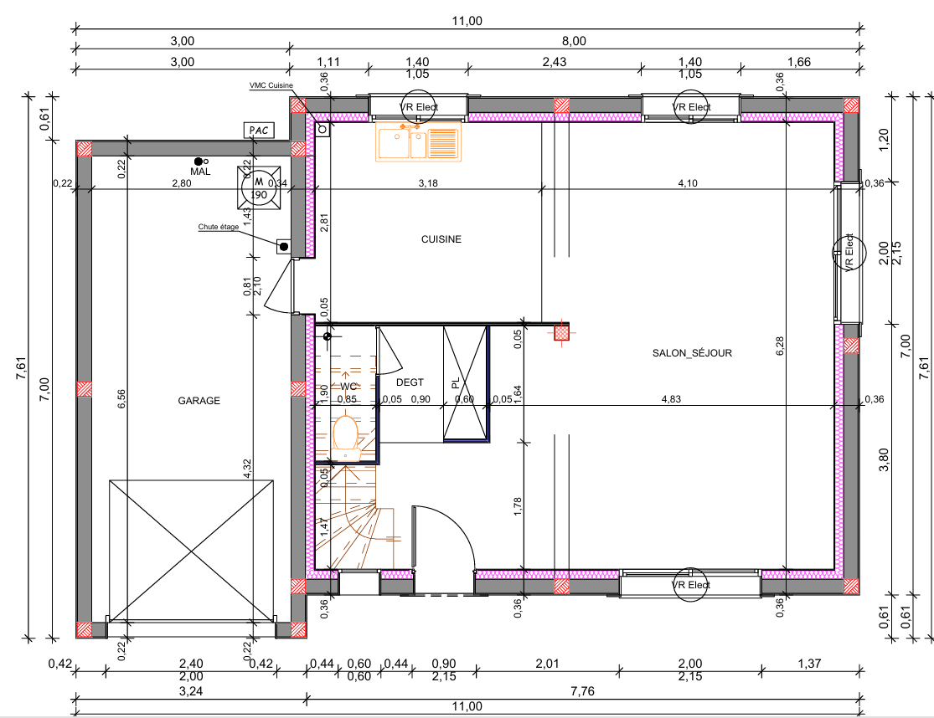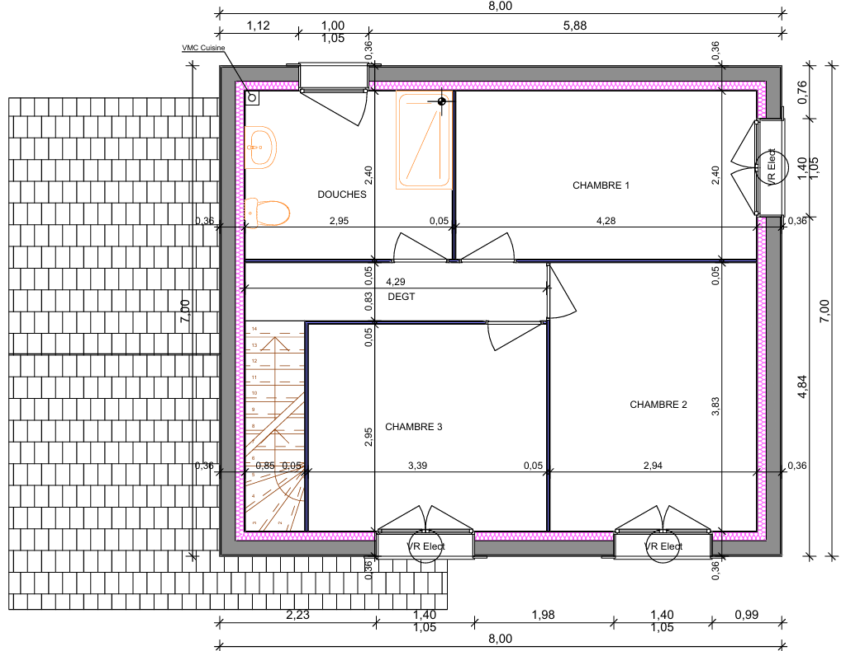
Fig. 1 : Architectural design

Modeling and Simulation
The modeling and simulation of thermal bridges were performed using the finite element method (FEM), in strict accordance with ISO 10211 standards[8]. This approach, widely recognized in thermal analysis, allows for a precise calculation of heat flow at complex building junctions.
To investigate the energy performance of a typical two-story residential building, we used the CLIMAWIN software. This powerful tool enabled us to perform dynamic thermal simulations on an hourly basis, providing detailed data on heating and cooling energy demands over monthly and annual periods. Our calculations of energy needs were based on the ISO 13790 standards[9], which define a robust method for assessing building energy performance. Our analysis specifically focused on key junctions in the building envelope, including:
- Lower Floor / Peripheral Wall connection
- Upper Floor / Peripheral Wall connection
- Intermediate Floor / Peripheral Wall connection
For each of these connections, we calculated the linear thermal transmittance (Psi value) for two scenarios: "Without Break" and "With Break" thermal bridge configurations. This allowed us to quantify the precise impact of thermal bridge treatment. For example, for the intermediate floor / peripheral wall connection, the Psi value significantly decreased from 0.960 W/(m·K) without a break to 0.220 W/(m·K) with a break. Similarly, for the lower floor connection, the Psi value was reduced from 0.720 W/(m·K) to 0.210 W/(m·K), and for the upper floor connection, it dropped from 0.810 W/(m·K) to 0.230 W/(m·K).
These results, derived from our detailed modeling, highlight the substantial reduction in heat loss achieved by implementing standardized thermal bridge solutions, providing a strong foundation for our subsequent analysis of energy savings

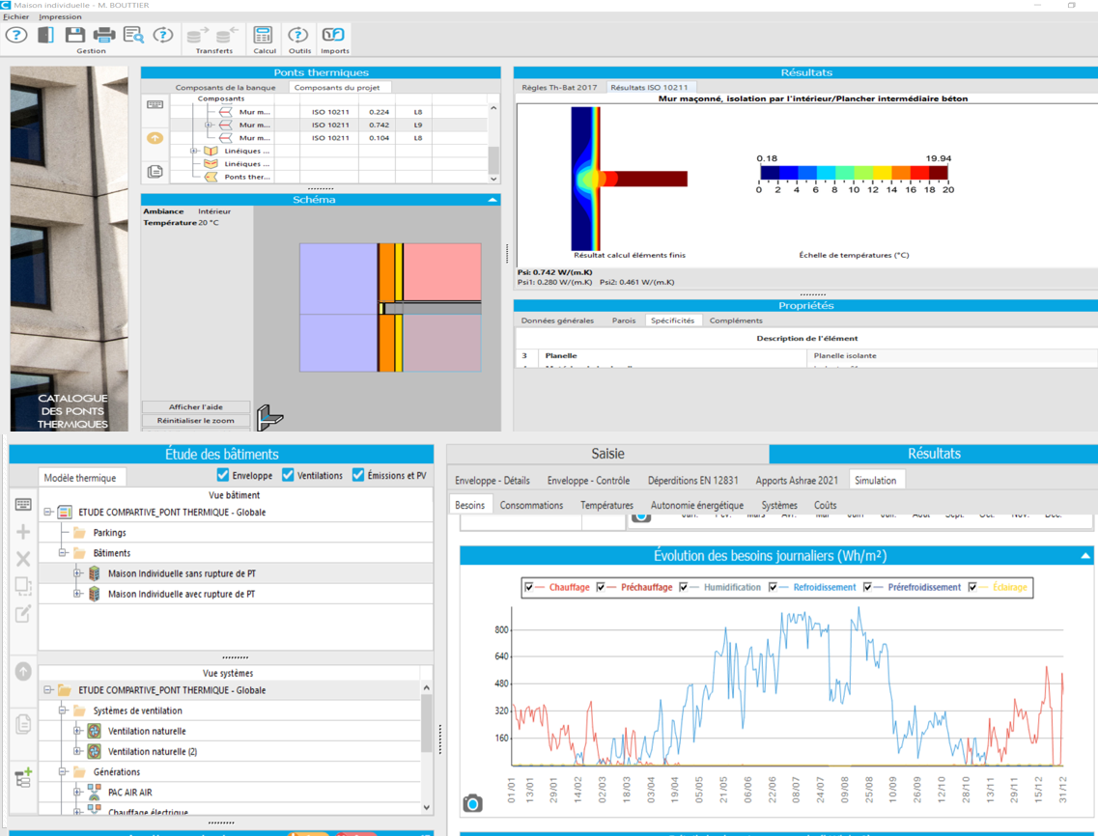
Fig 2 : Building Modelling in CLIMAWIN program

ReSULTS AND DISCUSSION
Simulations allowed for the visualization of temperature distribution at thermal bridges, both with and without treatment (Figure 3 and 4). The obtained results highlight the significant reduction in thermal losses and the improvement in temperature distribution following the integration of thermal bridge breakers.

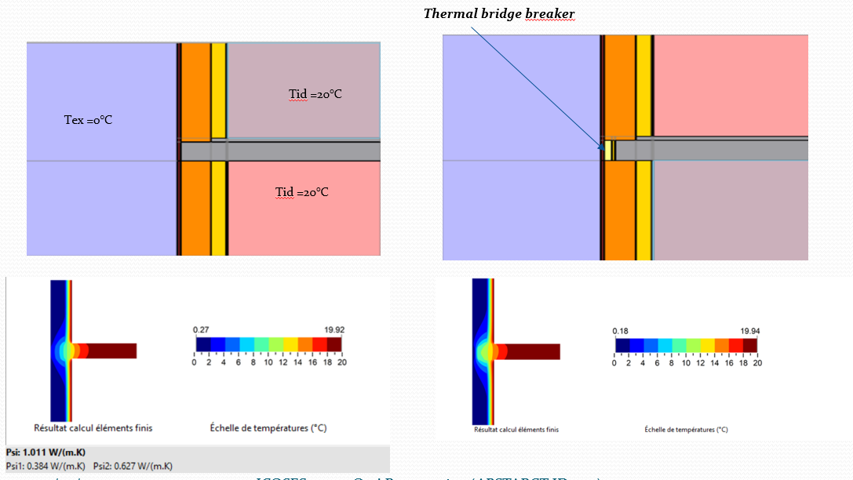
Fig 3 : Temperature distribution at junction “vertical walls / Intermediate floor “
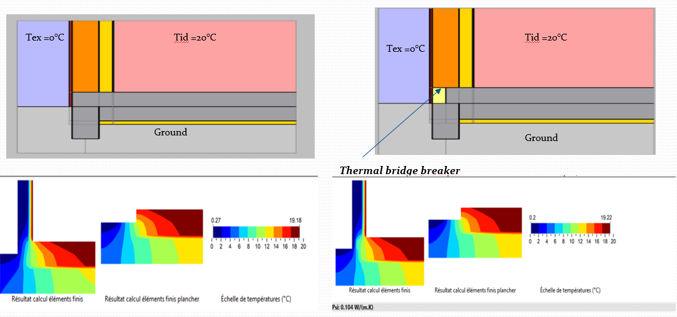
Fig 4 : Temperature distribution at junction “vertical walls / Ground floor “

The study of monthly total energy needs (heating and cooling) in KWh/m² demonstrated a clear improvement in the building's overall performance after thermal bridge treatment. More specifically, the analysis of indoor dynamic thermal behavior (Figure 5: IFRANE – Indoor Dynamic Thermal Behavior; Figure 6: ERRACHIDIA – Indoor Dynamic Thermal Behavior) revealed the following impacts :
- Ifrane (coldest zone): Figure 10 shows that the implementation of standardized linear thermal bridge breaks represents a potential energy saving of 23% of the total average annual heating and cooling needs in Morocco's coldest climatic zone. Figure 8 illustrates the hourly heating needs in the coldest month for Ifrane.
- Errachidia (warmest zone): For this region, and according to Figure 10, energy savings reach 13% of the total average annual heating and cooling needs. Figure 9 presents the hourly cooling needs in the warmest month for Errachidia.
These results confirm the crucial importance of thermal bridge treatment in improving the energy efficiency of buildings in Morocco, particularly in extreme climatic zones. The significant savings demonstrate that integrating thermal bridge breaking solutions is an effective measure to reduce energy consumption and enhance indoor thermal comfort.
Fig 5 : Ifrane – Indoor Dynamic Thermal Behavior
Fig 6 : Errachidia – Indoor Dynamic Thermal Behavior

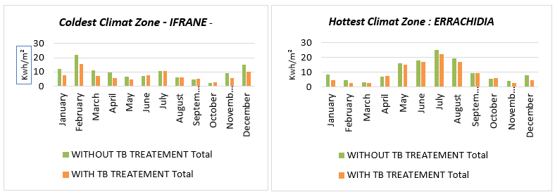Fig 7 : Monthly Total Energy Needs Kwh/m²
Fig 8 : hourly heating needs in the coldest month for Ifrane

Fig 9 : hourly cooling needs in the warmest month for Errachidia

13%
Fig 10 : Annual Energy Requirements Kwh/m²

CONCLUSION
The study has clearly demonstrated the positive and substantial impact of integrating linear thermal bridge breakers on the energy performance of buildings in Morocco. Simulation results indicate that thermal bridge treatment can generate potential energy savings of 24% of the total average annual heating and cooling needs in the coldest region and 13% in the warmest region.
Although the Moroccan thermal regulation (RTCM) was implemented to improve the thermal performance of new constructions, the impact of thermal bridges is often underestimated in practice. Our study highlights the significant energy-saving potential that can be unlocked by integrating standardized thermal bridge breaker solutions. This directly contributes to achieving national energy efficiency and sustainable development goals
By focusing on a single building type (individual dwelling) and two climatic zones, this study presents some limitations regarding generalizability. Future research could extend this analysis to other building typologies, such as multi-family housing and commercial buildings, to provide a more comprehensive view of the role of thermal bridges in the national building stock. Integrating an experimental validation of the model would also be a crucial step to strengthen the scientific rigor of the results.

References
- Agence Marocaine pour l'Efficacité Énergétique (AMEE). Guide sur la Réglementation Thermique des Constructions au Maroc (RTCM). [Online]. Available: https://www.amee.ma/sites/default/files/inline-files/Guide%20RTCM%20.pdf. [Accessed: Jun. 15, 2025].
- Ministère de la Transition Écologique et Solidaire. Fascicule sur les Ponts Thermiques. [Online]. Available: https://rt-re-batiment.developpement-durable.gouv.fr/IMG/pdf/5-fascicule_ponts_thermiques.pdf. [Accessed: Jun. 15, 2025].
- Al-Awadi, "Investigation of the effect of thermal bridges on the annual energy consumption of detached and attached houses," Energy and Buildings, vol. 182, pp. 248-257, 2019
- Martin, "Thermal bridging in BER calculations," Mannok Build, 2017.
- H. Ge et F. Baba, "Dynamic Effect of Thermal Bridges on the Energy Performance of a Low-Rise Residential Building," Energy and Buildings, vol. 105, p. 106–118, octobre 2015.
- Fabrizio, "Different methods for the modelling of thermal bridges into energy simulation programs: Comparisons of accuracy for flat heterogeneous roofs in Italian climates," Applied Energy, vol. 97, p. 405–418, septembre 2012.
- Ministère de l'Habitat, de la Politique de la Ville et de l'Urbanisme. Réglementation Thermique des Bâtiments au Maroc. [Online]. Available: https://www.mhpv.gov.ma/wp-content/uploads/2018/03/RT-fr-1.pdf. [Accessed: Jun. 15, 2025].
- International Organization for Standardization (ISO). ISO 10211:2017 - Thermal bridges in building construction – Heat flows and surface temperatures – Detailed calculations. [Online]. Available: https://www.iso.org/obp/ui/#iso:std:iso:10211:ed-2:v1:en. [Accessed: Jun. 15, 2025].
- International Organization for Standardization (ISO). ISO 13790:2008 - Energy performance of buildings – Calculation of energy use for space heating and cooling. [Online]. Available: https://www.iso.org/standard/41974.html. [Accessed: Jun. 15, 2025]
- Ministère de la Transition Écologique. Arrêté du 4 août 2021 modifiant l'arrêté du 24 décembre 2012 relatif aux caractéristiques thermiques et aux exigences de performance énergétique des bâtiments nouveaux et des parties nouvelles de bâtiments. [Online]. Available: https://rt-re-batiment.developpement-durable.gouv.fr/IMG/pdf/annexeiv_arrete_4_aout_2021.pdf. [Accessed: Jun. 15, 2025].

