Fuzzy Logic-Based Energy Management for Hybrid Microgrids
Fatima Zahra MOUGHRAOUI ^{1, a)}, Lahcen El iysaouy^{1, b)}, Omar KABOURI ^{1, c)}, Mohamed AZEROUAL ^{2, d)}, and Hassane EL MARKHI ^{1, e)}
¹LRSI Laboratory, Faculty of Science and Technology Fez, USMBA, Morocco
²SEIMC Research Group, LASMAR Laboratory, Higher School of Technology, Moulay Ismail University of Meknes, Morocco

^{a)} f.moughraoui@usmba.ac.ma
^{b)} l.eliysaouy@usmba.ac.ma
^{c)} o.kabouri@usmba.ac.ma
^{d)} l.azeroual@umi.ac.ma
^{e)} h.elmarkhi@usmba.ac.ma

Abstract. As the demand for efficient and sustainable energy solutions continues to grow, Energy Management Systems (EMS) play a vital role in optimizing power distribution and ensuring the stability of hybrid renewable energy systems. This paper presents a fuzzy logic-based energy management approach for a hybrid microgrid that integrates photovoltaic (PV) panels, and wind energy systems. To enhance system reliability, a battery energy storage system (BESS) is incorporated as a backup to supply power when demand exceeds generation. The proposed EMS is initially developed and simulated in MATLAB/Simulink to evaluate its performance under varying load and generation conditions. A Buck-Boost converter regulates the voltage at 400V, ensuring stable power integration despite fluctuating weather conditions. Simulation results demonstrate that the system achieves satisfactory performance in terms of voltage stability, energy flow control, and robustness under dynamic conditions.

Keywords: Microgrid, Energy management system, Fuzzy logic, Smart grid.

introduction
With continuously rising requirements for sustainable and efficient solutions for energy, hybrid renewable energy systems are integrated for maintaining a stable and reliable power supply. Microgrids, with the integration of various energy systems such as photovoltaic (PV) panels and wind energy systems, are considered to be a sustainable solution for energy resilience building, reduced dependence on fossil fuels, and more efficient distribution of power. However, energy flow control within a hybrid microgrid is confronted with various challenges, including varying energy production, varying load demand, and optimal operation of batteries. To reduce such challenges, Energy Management Systems (EMS) are required for maintaining optimal distribution of power, stability in bus voltage, and optimal utilization of energy storage systems. Amongst different EMS strategies, control using fuzzy logic is considered due to uncertainties management and adaptability to varying conditions and flexibility in taking decisions [2] [3].

This paper presents a fuzzy logic EMS that can be employed to optimize energy distribution in a hybrid microgrid. The proposed EMS makes up for power shortages when demand is higher than supply by employing a battery energy storage system (BESS). The Buck-Boost converter is employed to stabilize the bus voltage at 400V to ensure stable power integration regardless of weather conditions and load variations. The EMS is designed and simulated using MATLAB/Simulink to evaluate its performance.
Principal goals of the present research are to:
• Develop a fuzzy logic-based EMS for hybrid microgrids.
• Simulate and assess its performance for varying load and generation conditions.
By utilizing fuzzy logic control, such a method would seek to increase efficiency, adaptability, and dependability in microgrid energy management and thus represent a desirable solution for current and future applications of renewable energy [4].

Architecture of the proposed Hybrid microgrid
Hybrid microgrid studied comprises three fundamental units: photovoltaic panels, a wind turbine system, and a battery energy storage system (BESS). They are interfaced through a shared DC bus with its voltage kept at 400 V by a Buck-Boost DC-DC converter. The control provides stable and smooth energy supply, irrespective of changing environmental conditions that influence renewable generation. The complete configuration of the entire system appears in Figure 1, and it captures the interconnection of energy sources, BESS, power converters, and load interfaces. The configuration provides real-time control of power flows, effective integration of renewables, and firm energy supply to DC and AC loads

Figure 1. Structure of hybrid microgrid system
The system's architecture aims to fully exploit renewable energy resources. The PV and wind generators function as the primary power generation units, providing power to the microgrid according to the solar irradiance and the speed of the wind. Owing to their intermittent nature, the role of the BESS is significant in balancing power by soaking up excess energy when the system produces more than demanded and by supplying energy when the system produces below the demand level. To support both AC and DC loads, the system has a DC/AC inverter on the DC bus. The arrangement provides direct supply to DC loads as well as effective conversion for standard AC appliances, raising the system's flexibility and suitability to usual house or commercial demand.

At the core of this architecture is the EMS, which supervises power flow based on real-time data. It monitors the state of charge (SoC) of the battery, load demand, and generation levels, and dynamically adjusts the operating mode of the system to optimize energy use while preserving voltage stability.

Energy Management System (EMS)
The proposed EMS is developed with fuzzy logic control for intelligent management of energy circulation in the hybrid microgrid. Unlike traditional controllers, fuzzy logic is not demanding in terms of accurate mathematical modeling and is quite effective in dealing with uncertainties, nonlinearities, and inaccurate measurements—circumstances that are often found in renewable energy systems [5]. This renders it a highly appropriate answer to deploy in dynamic microgrid systems where generation and load demand are changing unpredictably [6]. EMS processes in real time by continuously monitoring important input parameters such as PV and wind power outputs, state of charge of the battery pack, and load demand at a given time. From these parameters, the fuzzy logic controller calculates the energy balance of the system and decides what mode to run: charging or discharging of the battery, injecting power to the grid, or taking power from the grid with bus voltage stability. The controller is simulated using MATLAB/Simulink with a formalized set of membership functions and rule-based inferencing structures.
The rules favor the usage of renewable power with safeguards for overcharging and deep discharging of the battery, optimizing the efficiency of the system and extending battery longevity [7].
To accommodate the wide range of operating conditions, the EMS uses four distinct control modes, selected based on the power balance and the SoC level:

- Mode 1 – Battery Charging: If renewable generation exceeds load demand and the battery SoC is below 80%, the excess energy is used to charge the battery.
- Mode 2 – Grid Injection: When the battery is already charged (SoC ≥ 80%) and generation continues to exceed demand, surplus energy is injected into the utility grid.
- Mode 3 – Grid Import: If renewable generation is insufficient and the SoC is low, the EMS imports energy from the grid to meet demand and, if possible, partially recharge the battery.
- Mode 4 – Battery Discharging: When the battery SoC is sufficient (>20%) but renewable sources underperform, the EMS draws energy from the battery to supply the load.

The control logic governing transitions between these modes is illustrated in Figure 2. This flowchart presents the decision-making process of the EMS based on real-time system status, enabling clear visualization of how the system adapts under varying energy conditions.

Figure 2. Control flowchart of the fuzzy logic-based Energy Management System.
This fuzzy logic-based EMS provides an intelligent, flexible, and resilient energy regulation strategy for hybrid microgrids. Its ability to adapt to rapidly changing operating conditions enhances both the stability and sustainability of the overall system.

Simulation and Results
This fuzzy logic-based EMS provides an intelligent, flexible, and resilient energy regulation strategy for hybrid microgrids. Its ability to adapt to rapidly changing operating conditions enhances both the stability and sustainability of the overall system.

Renewable Generation and Load Profile

In the first scenario, the PV and wind generation profiles were simulated under varying environmental conditions, while the load remained constant. As shown in Figure 3, the renewable generation fluctuates significantly over time, requiring continuous EMS adaptation to balance supply and demand.

Figure 3. PV and wind power generation versus constant load demand over time.
Battery State of Charge (SoC)

The EMS dynamically managed the battery based on real-time energy balance. When excess renewable energy was available, the EMS directed it toward battery charging. Conversely, when generation was insufficient, the system discharged the BESS to supply the load. Figure 4 illustrates the evolution of the battery’s state of charge, confirming that the SoC remains within operational boundaries, avoiding both overcharging and deep discharging.
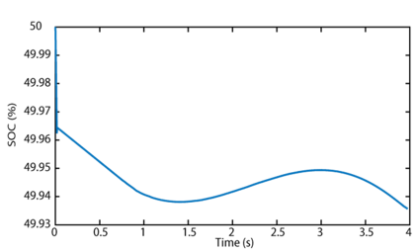
Figure 4. SoC of the battery over the simulation period.
DC Bus Voltage Stability

Maintaining a stable DC bus voltage is essential for system reliability. The fuzzy logic controller regulates the output of the Buck-Boost converter, keeping the DC bus voltage close to the nominal 400 V. As shown in Figure 5, the bus voltage remains tightly controlled throughout the simulation, even under variable generation and load conditions.
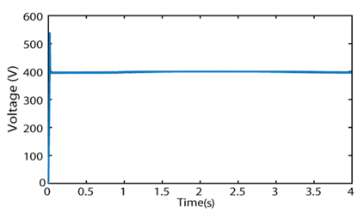
Figure 5. DC bus voltage regulation using the fuzzy logic-based EMS.
AC Bus Voltage and Frequency

In addition to the DC-side performance, the system also ensures AC voltage and frequency stability through the inverter. As illustrated in Figure 6, the AC voltage remains stable and within acceptable limits. Figure 7 shows the system’s frequency response, which remains close to 50 Hz, confirming that the EMS maintains power quality under all operating modes.
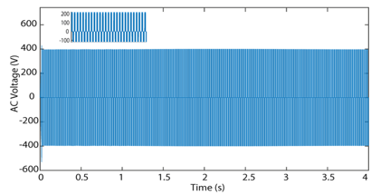
Figure 6. Output AC voltage waveform of the microgrid under varying conditions.
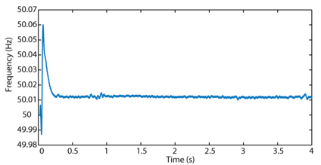
Figure 7. Frequency stability of the AC output during simulation.
These simulation results demonstrate that the proposed fuzzy logic-based EMS is capable of managing energy flow effectively, maintaining system stability, and adapting to changes in both generation and demand. This confirms its suitability for hybrid microgrid applications.

CONCLUSION
A fuzzy logic-based Energy Management System (EMS) was proposed in this study to efficiently balance power flow in a hybrid microgrid with photovoltaic panels, a wind turbine, and a battery energy storage system. The EMS was implemented and simulated in MATLAB/Simulink to assess its operation in response to dynamic generation and load conditions. Simulation experiments proved that EMS was capable of adapting in real time to changing conditions in renewable energy resources. The controller efficiently controlled the battery state of charge within acceptable operation ranges, controlled DC bus voltage at 400 V, and maintained stable AC output in terms of both voltage and frequency. By employing fuzzy logic, uncertainties and nonlinear dynamics were effectively handled by the system without employing accurate mathematical models. The control logic, applied through a collection of rule-based fuzzy inference structures, featured high flexibility and responsiveness over different operating modes. These results affirm that fuzzy logic is an applicable intelligent control strategy for hybrid renewable systems that can enhance energy reliability, battery lifespan, and overall system efficiency. The EMS will be deployed on an FPGA platform—Altera Cyclone IV EP4CE6—in a subsequent step using the Quartus II development environment. The hardware execution targets enhanced capabilities for real-time control and reduced computational delay, further taking the system towards practical realization with real-world operation in autonomous microgrid settings.

References

- Krishna, K. S., & Kumar, K. S. “A review on hybrid renewable energy systems”. Renewable and Sustainable Energy Reviews, 52, 907-916, (2015).
- Asghar, F., Talha, M., & Kim, S. H. “Fuzzy logic‐based intelligent frequency and voltage stability control system for standalone microgrid”. International Transactions on Electrical Energy Systems, 28(4), e2510, (2018).
- Shambhu Choudhary, S., Nath Gupta, T., & Hussain, I. “Intelligent Solar Grid Integration: Advancements in Control Strategies and Power Quality Enhancement”. International Journal of Circuit Theory and Applications, (2024).
- Elkholy, M. H., Metwally, H., Farahat, M. A., Senjyu, T., & Lotfy, M. E. “Smart centralized energy management system for autonomous microgrid using FPGA”. Applied Energy, 317, 119164, (2022).
- Zhou, D., and Huang, D. “A review on the progress, challenges and prospects in the modeling, simulation, control and diagnosis of thermodynamic systems”. Advanced Engineering Informatics, 60, 102435, (2024).
- Seng, U. K., Malik, H., Márquez, F. P. G., Alotaibi, M. A., & Afthanorhan, A.“Fuzzy logic-based intelligent energy management framework for hybrid PV-wind-battery system: A case study of commercial building in Malaysia”. Journal of Energy Storage, 102, 114109, (2024).
- Cong, L., Wang, W., & Wang, Y. “A review on health estimation techniques of end-of-first-use lithium-ion batteries for supporting circular battery production”. Journal of Energy Storage, 94, 112406, (2024).

