Design and Implementation of a Low-Cost IoT based MPPT Solar Board for Smart Low Power PV Systems
Abdelmalek MIMOUNI^{1,a)}, Youssef Chahet^{2,b)}, Aumeur El Amrani^{1,c)}, Mohamed El Amraoui^{2,d)}, Mohamed Azeroual^{1,e)} and Lahcen Bejjit^{1,f)}
¹SEIMC research Group, LASMAR, ESTM, Moulay Ismail University of Meknes, Morocco;
²LASMAR, Faculty of Sciences, Moulay Ismail University of Meknes, Morocco;
^{a)} Corresponding author: abdel.mimouni@edu.umi.ac.ma;
^{b)}youssef.chahet@edu.umi.ac.ma; ^{c)}a.elamrani@umi.ac.ma; ^{d)}m.elamraoui@umi.ac.ma; ^{e)}m.azeroual@umi.ac.ma; ^{f)}l.bejjit@umi.ac.ma.
Abstract. This work presents a low-cost, Internet of Things (IoT)-based Maximum Power Point (MPPT) solar board designed to enhance the performance and monitoring of low-power photovoltaic (PV) systems. The implemented board includes two INA219 sensors for the voltage and current measurements, as well as an ESP32 microcontroller that wirelessly transmits data to a ThingsBoard IoT platform and implements a Perturb and Observe (P&O) MPPT algorithm to control a DC-DC boost converter for efficient real-time tracking of the maximum power point of the PV panel. The system is appropriately applicable in off-grid or rural areas based on affordability as well as efficient design. The system demonstrated robust tracking performance across varying irradiation intensities, achieving an experimental tracking efficiency of 93.5% ± 1.4%. Additionally, an interactive dashboard provides real-time data on photovoltaic performance. The project is a flexible, robust, and intelligent solution for educational and small-scale off-grid applications.

Introduction
In recent years, increasing demand for green energy sources has positioned photovoltaic (PV) systems at the center stage in the transition to a sustainable energy solution. PV systems use solar energy and convert it into electric power, providing a clean and green energy option. However, the performance and efficiency of PV systems are highly dependent on environmental factors such as irradiance levels, temperature fluctuations, and partial shading, which can cause significant fluctuations in power output [1,2].
To address this challenge, Maximum Power Point Tracking (MPPT) algorithms are extensively used to guarantee that PV systems function under their maximum power point, thereby dynamically adjusting and optimizing electrical operating points to match changing environmental conditions [3]. Different MPPT methods have been proposed, from classic methods like Perturb and Observe (P&O) and Incremental Conductance (IncCond) to advanced approaches like Fuzzy Logic Control (FLC) and Artificial Intelligence methods. [4,5]. However, implementing these methods in reality is hampered by the challenges with respect to system complexity and cost, which may hinder accessibility and scalability in actual applications. Among the various available MPPT techniques, the P&O algorithm is one of the most commonly implemented owing to its ease and efficiency in tracking the MPP with low computational requirements. This has fueled increasing demand for low-cost, microcontroller-based solutions that can perform MPPT as well as provide real-time system monitoring and control functionality to maximize system performance and reliability [6].
Incorporating advanced technologies like embedded systems and the Internet of Things (IoT) into PV system allows data collection, processing, and real-time monitoring [7]. IoT integrated PV system enables users to monitor real-time energy generation, consumption, and weather conditions, thus improving system performance through optimized energy management, and decision-making. Furthermore, real-time monitoring systems store historical data, including voltage, current, power, solar irradiance, and temperature, enabling future data mining, analysis, fault detection, and predictive modeling. In addition, IoT-based monitoring systems enable improved efficiency, reliability, and low servicing costs [8–10].
DC-DC converters play a vital function in the implementation of MPPT by modulating the operating current and voltage in order to maximize the power extraction [11]. In this paper, a low-cost MPPT solar board with IoT features is designed. The system uses an ESP32 microcontroller in order to run a P&O algorithm for driving a DC-DC boost converter. INA219 sensors read voltage and current parameters, then ESP32 transfers this data wirelessly to the cloud-based ThingsBoard platform using an MQTT protocol. The achieved architecture supports efficient energy harvesting as well as real-time performance monitoring using a user interactive dashboard.
The remainder of this paper is structured as follows: Section 2 explains related work, Section 3 outlines system architecture and components, Section 4 describes the proposed system's experimental setup, Section 5 shows and discusses the results, and Section 6 concludes the paper.

Related works
There have been several proposed IoT based PV systems with different architecture and components to increase performance visualization and remote control functions. Indeed, WKhalid et al. [12] suggested a low-cost solution for PV system real-time observation and control by using IoT. This system incorporates voltage and current sensors to measure electrical parameters from the PV panel and battery storage unit. Data acquisition is managed by an Arduino Nano, while an ESP32 and GSM SIM900 module transmit the data to the Blynk platform via HTTP and TCP/IP protocols. Similarly, Rao et al.[13] created an IoT-based PV plant solar monitoring system consisting of three main components: data acquisition using Arduino and a sensor set (e.g., ACS712, voltage divider circuits), wireless transmission by using a Wi-Fi module, and data observation on the ThingSpeak open-source platform. Mimouni et al. [14] introduced a cost-effective and energy-efficient monitoring system for PV systems. The designed system facilitates the supervision of a PV setup comprising a solar panel, a load, and a DC-DC boost converter. The proposed architecture incorporates sensor-based data acquisition, which is processed by an ESP32 microcontroller. In addition, it allows wireless data transmission to the ThingsBoard platform via MQTT over Wi-Fi, for efficient storage and real-time visualization. He et al.[15] developed an open-source SCADA system for PV monitoring with a focus on IoT, employing voltage dividers and ACS712 sensors that interfaced with an ESP32-E microcontroller as a remote terminal unit. Data from the sensors is transmitted over MQTT to a locally hosted Node-RED dashboard on a Banana Pi M4, for real-time observation and storage of vital system parameters. Although present studies prove the viability of PV monitoring with a focus on IoT, they lack integration with MPPT a very essential feature for maximizing energy efficiency. However, some research efforts have sought to address this limitation. For example, Rouibah et al.[16] developed a low-cost prototype for online monitoring of maximum power output in residential PV systems, which integrates multiple sensors, with data processing and control managed by two Arduino Mega 2560 microcontrollers, while an ESP8266 Wi-Fi module enables wireless transmission to a web-based interface. Boubaker et al.[17] also designed a PV monitoring system with an integrated MPPT controller, allowing real-time optimization of power generation. This setup bases on an ESP32 microcontroller to gather both electrical performance data and environmental conditions, then sends this information to the ThingSpeak cloud for analysis and visualization. Fernández-Bustamante et al.[18] proposed a wireless control architecture that allows MPPT algorithm implementation on a central node with limited computational resources. The system includes voltage, current, irradiance, and temperature sensors, with an Arduino Zero and XBee 900 MHz RF module acting as a sensor-actuator node, while a NI myRIO-1900, programmed in LabVIEW, serves as the central computing unit. Although these studies make important contributions, further work is needed to develop integrated, low-cost solutions that combine robust MPPT control with IoT-based monitoring tailored to resource-constrained environments. This study introduces a reproducible, low-cost, and dual-sensor-based MPPT IoT architecture with wireless telemetry using MQTT and ThingsBoard. Unlike prior studies which often focus solely on data acquisition or MPPT independently, our system integrates both in a single ESP32-based platform, allowing closed-loop control and data visualization through a cloud dashboard. Its affordability, modularity, and real-time operation make it suitable for deployment in rural electrification, educational setups, and micro-grid energy systems.

System Architecture and Design
This system provides real-time MPPT and remote monitoring for low-power photovoltaic system by combining embedded control, sensor networks, and IoT-based wireless communication. The hardware architecture includes a solar panel, a load, and a DC-DC boost converter, along with a monitoring and control board equipped with a microcontroller, voltage and current sensors. In addition, a cloud-based IoT dashboard for real time monitoring; the system diagram is illustrated in Fig. 1.

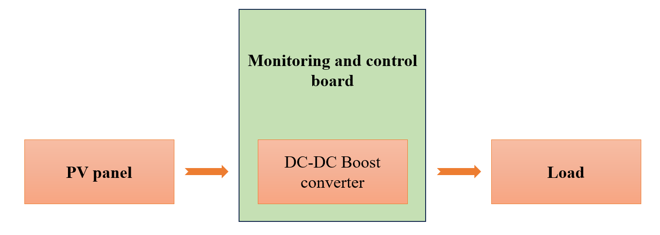
FIGURE 1. The proposed system diagram

System Components
Figure 2. shows the proposed system configuration, with the PV panel as the main energy source, a custom-designed DC-DC boost converter [19] employing to regulate the PV output voltage and enable MPPT, and the MPPT solar board-based IoT as the control and monitoring unit. Taking center stage is an ESP32 microcontroller selected for its dual-core processing and inbuilt Wi-Fi capabilities that dynamically control the converter's duty cycle. For accurate measurements, two INA219 sensors monitor electrical parameters: one for the solar panel output and another for the converter output. These sensors are interfaced with the ESP32 via I2C communication. All performance data is communicated wirelessly using MQTT protocol to ThingsBoard, an open-source IoT software that supports the possibility for remote monitoring of system performance through feature-rich, user-configurable dashboards.

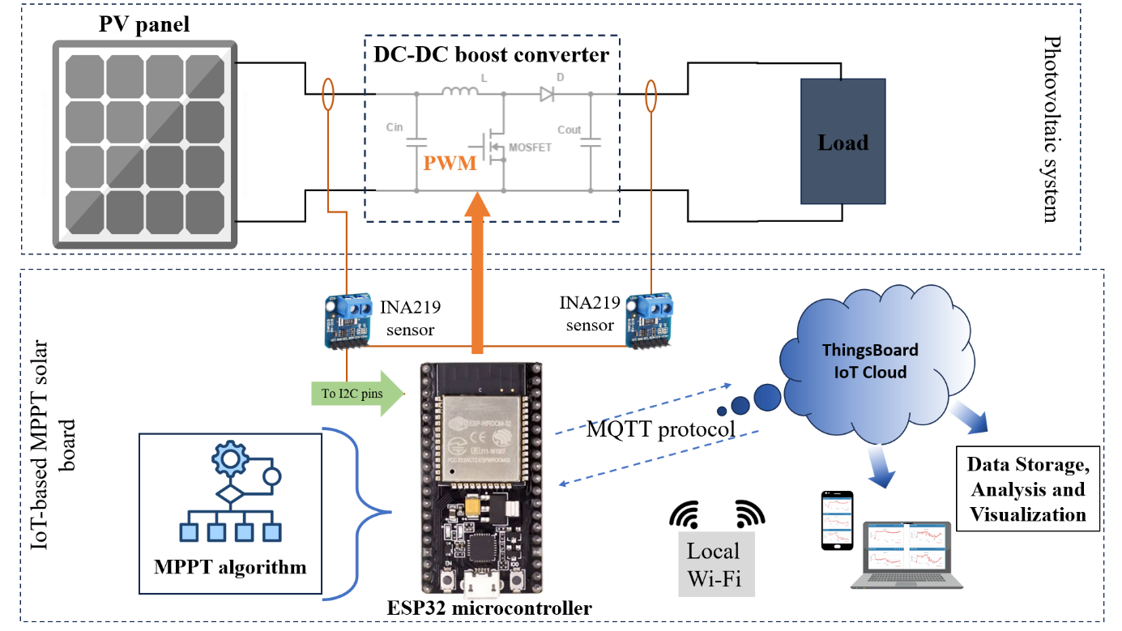
FIGURE 2. The proposed system configuration

Implementation Methodology
The P&O algorithm based MPPT technique is used for the proposed system. The algorithm operates by perturbing the PV voltage or current and observing the subsequent variation in the generated power. When the output power augment after a perturbation, the algorithm stays in an identical track; if the power decreases, the direction is inverted. The flowchart of the P&O MPPT algorithm is depicted in Fig. 3.[20]. The algorithm is implemented on an ESP32 microcontroller, which dynamically modulates the duty cycle to produce a PWM signal. This signal governs a DC-DC boost converter via the gate of a MOSFET.
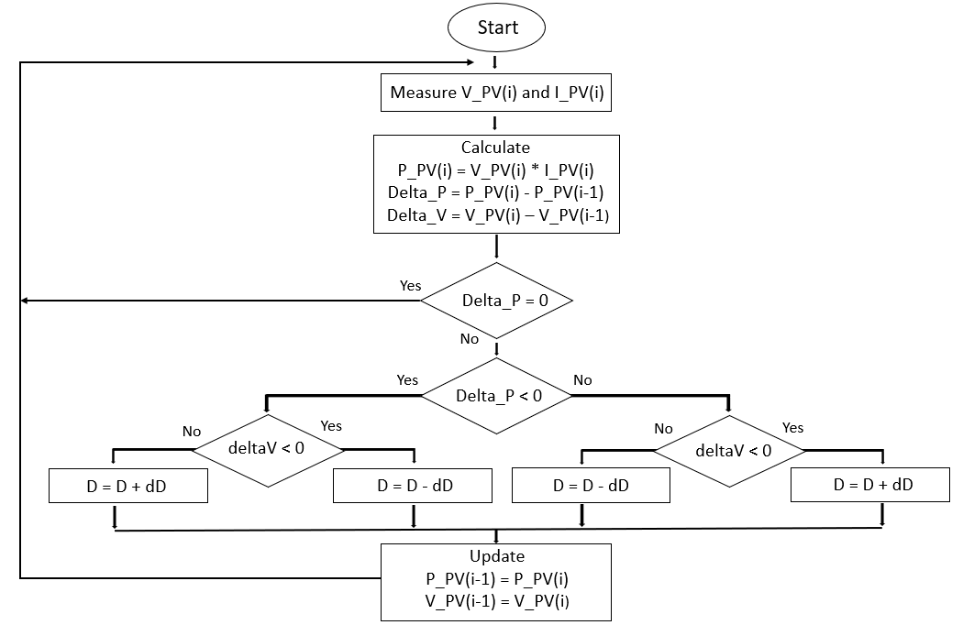
FIGURE 3. The flowchart of the P&O MPPT algorithm

Figure 4. depicts the flowchart of the proposed IoT-based MPPT solar board, which begins by initializing the required libraries and defining the necessary variables and objects. Next, it establishes a connection to the Wi-Fi network using the specified SSID and password and configures the ThingsBoard server with its IP address and port. Once connected, the algorithm continuously reads data from the sensors and publishes it to the platform via the MQTT protocol. The ESP32 microcontroller was programmed by the Arduino IDE.
The ESP32 uses MQTT to publish sensor data to the ThingsBoard platform at a predetermined interval of 5 seconds in order to guarantee dependable real-time monitoring. A small JSON-formatted payload containing the PV panel's and the load end's voltage, current, and power values is included in every message. The ESP32 employs MQTT authentication with a username and password and connects to a WPA2-encrypted wireless network. The system is built to support TLS (port 8883) in future updates, even though it is not enabled in this implementation yet. To ensure communication robustness, firmware procedures are also put in place for automatic reconnection and message retransmission in the event of network outages.
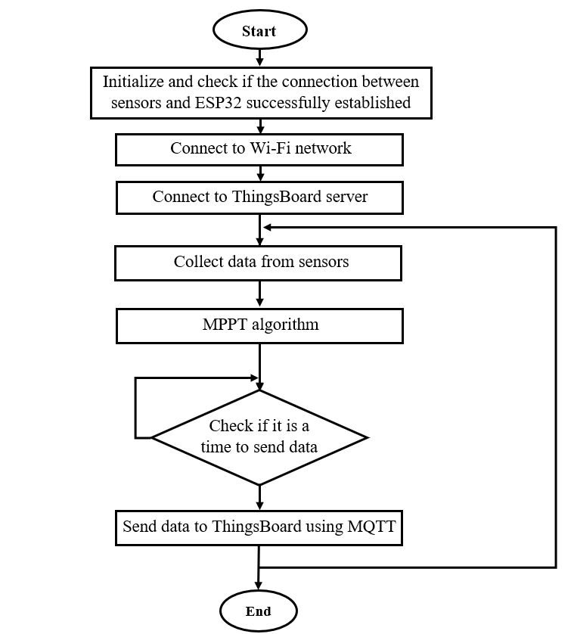
FIGURE 4. The flowchart of the proposed IoT-based MPPT solar board

Experimental Setup and Testing
The experimental system for testing the proposed IoT based MPPT solar board includes a monocrystalline PV panel attached to a custom-developed boost converter controlled by an ESP32 microcontroller implementing the P&O MPPT algorithm. Two INA219 sensors measure current and voltage: one from the PV panel end and the other from the output end of the converter interfaced with the ESP32 through the I2C protocol. The sensors’ serial clock (SCL) and serial data (SDA) lines are interfaced with the ESP32’s GPIO21 and GPIO22, respectively, with different I2C slave addresses (0x40 and 0x41). For safe data transmission, pull-up resistors are put in place between the SDA and SCL lines and the positive voltage supply. The ESP32 reads real-time electric measurements from both sensors and sends them wirelessly to the ThingsBoard IoT platform using the highlight MQTT protocol, allowing for real-time remote observation through a custom dashboard. Sensor accuracy was evaluated by comparing 30 samples of INA219 output with reference measurements from a calibrated PeakTech 2005 DMM. The average absolute error was 1.8%, with a maximum deviation of 2.7%. A comparison of multimeter measurements and INA219 readings is shown in Table 1. The suggested IoT-based MPPT solar board is shown in Figure 5, and the system's experimental configuration is shown in Figure 6.
Table 1: INA219 and multimeter comparison
Parameter | Multimeter (PeakTech 2005) | INA219 Reading | % Error
Voltage (V) | 11.95 | 11.76 | 1.59%
Current (A) | 0.67 | 0.65 | 2.99%

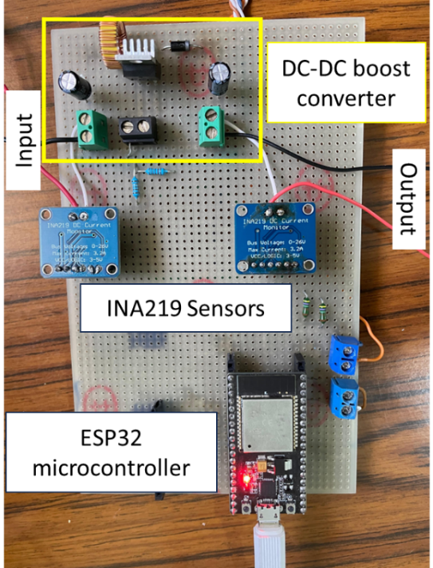
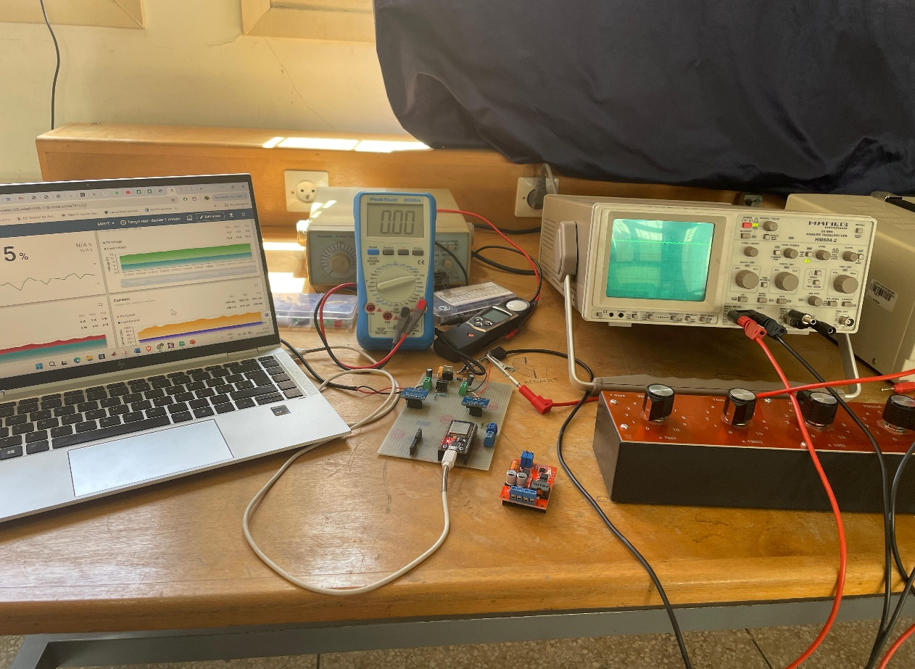
FIGURE 5. The proposed IoT-based MPPT solar board
Dashboard
Oscilloscope
Load
Monitoring and control board

FIGURE 6. The experimental setup of the IoT based MPPT solar board

Results and Analysis
The performance of the proposed IoT-based MPPT solar board was evaluated under variable irradiance conditions to assess its tracking accuracy, response stability, and data transmission reliability. The system demonstrated effective maximum power point tracking using the implemented P&O algorithm, with stable voltage and current regulation observed during both gradual and abrupt changes in sunlight intensity. The experimental tracking efficiency measured at 93.5% ± 1.4%. The DC-DC boost converter responded promptly to duty cycle adjustments, maintaining consistent operation near the optimal power point of the PV module. This behavior was evident in both time-domain voltage, current and power response curves obtained from real-time data logging.
The employment of two INA219 sensors provided accurate tracking for both the output of the PV panel and the converter, enabling verification of the energy conversion performance of the system. The reading provided had a close match with that given by the reference multimeter (PeakTech 2005 DMM), and this established the sensing system as accurate and trustworthy. Integration with the ThingsBoard platform provided smooth visualization of the metrics in real time through a custom dashboard. This capability proved particularly useful for remote performance diagnostics and trend analysis over extended time intervals. Therefore, Fig. 7. presents the custom dashboard which includes Timeseries Line Charts and cards for display the last measures.
Figure 8. shows the real time voltage, current, and power curves obtained from the ThingsBoard dashboard for a one-minute testing time. As shown in the figure, the PV module output is in constant operation as close as possible to the optimal power point, and the load voltage is controlled at around 12 V, indicating proper operation in the boost converter and successful MPPT performance.

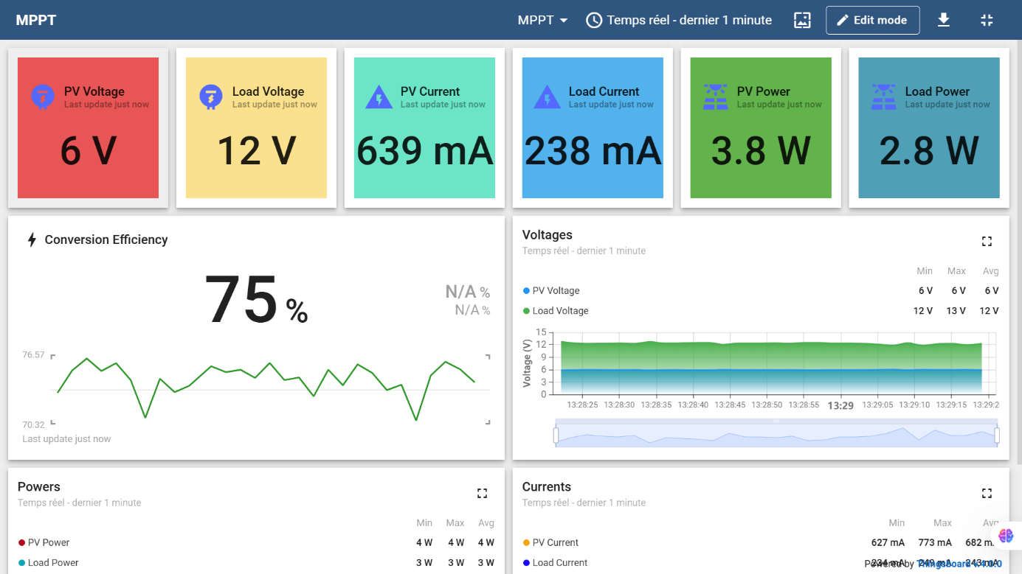
FIGURE 7. The custom dashboard

Moreover, the MQTT-based data transmission protocol was found to be robust and lightweight and had unnoticeable latency in dashboard update under normal Wi-Fi conditions. The system was able to sustain the state of being connected for the entire test periods, validating the real-world feasibility for application in rural or off-grid environments. The combination of power tracking efficiency, precise sensing, and IoT connectivity validates the efficiency of the proposed approach in maximizing the intelligence and autonomy in building-integrated PV systems at a low power.
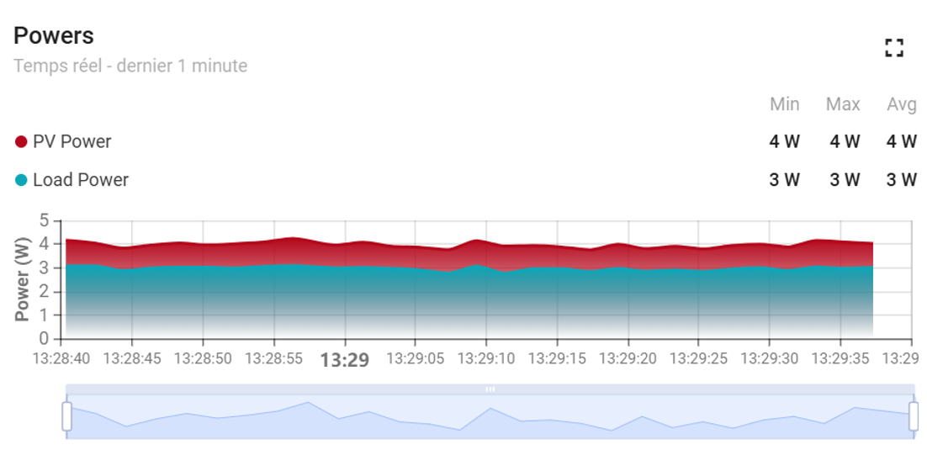
(a)

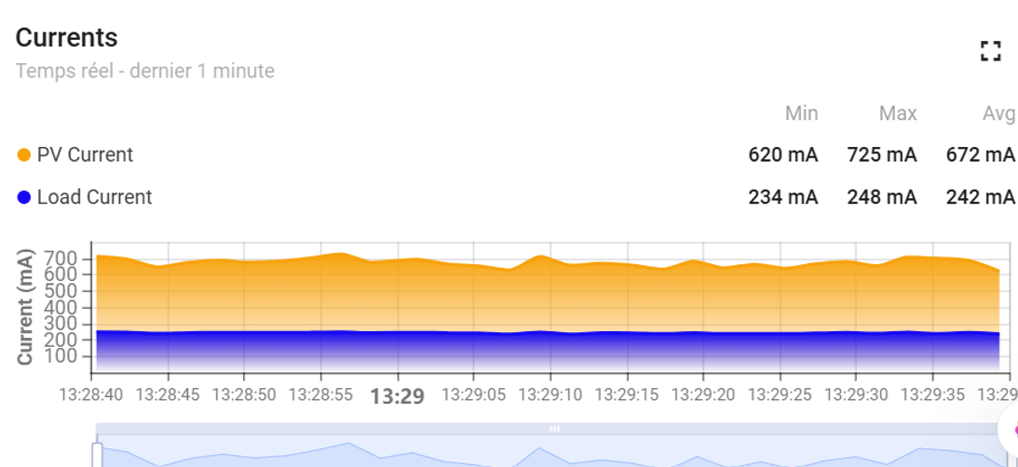
(b)

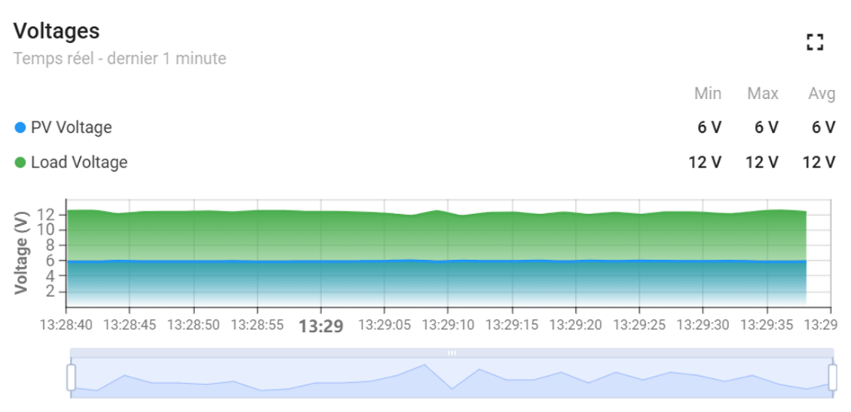
(c)

FIGURE 8. Curves for: Powers (a), Currents (b) and Voltages (c)

.

Conclusion
The paper presented the design, development, and testing of a low-cost, IoT-based MPPT solar board that aimed to increase the efficiency and monitoring performance of low power PV systems in off-grid environments. The system consists of a P&O MPPT algorithm running on an ESP32 microcontroller, a DC-DC boost converter, and two INA219 sensors for accurate voltage and current measurements. Real-time data transmission to the ThingsBoard IoT platform through MQTT supported remote visualization and performance monitoring through a dynamic dashboard. Experimental testing under varying irradiance conditions showed that the system could provide stable voltage regulation, an MPPT efficiency achieved 93.5%, and timely adaptation to environmental variations. The sensor measurements closely aligned with those recorded using a digital multimeter, ensuring the accuracy of the monitor subsystem. In addition, integration with a cloud-based IoT provided a robust and scalable approach for long-term performance diagnostics and system optimization. Future work includes integrating adaptive MPPT techniques, expanding to hybrid control systems (e.g., fuzzy logic), and enabling TLS-based MQTT security.

Acknowledgments
The first author is grateful for the financial support given by the National Center for Scientific and Technical Research (CNRST) in the framework of the "PhDAssociate Scholarship–PASS" Program.

References

1. Ang T-Z, Salem M, Kamarol M, Das HS, Nazari MA, Prabaharan N. A comprehensive study of renewable energy sources: Classifications, challenges and suggestions. Energy Strategy Reviews. 2022;43:100939.
2. Pourasl HH, Barenji RV, Khojastehnezhad VM. Solar energy status in the world: A comprehensive review. Energy Reports. 2023;10:3474–93.
3. Kumba K, Upender P, Buduma P, Sarkar M, Simon SP, Gundu V. Solar tracking systems: Advancements, challenges, and future directions: A review. Energy Reports. 2024;12:3566–83.
4. Mao M, Cui L, Zhang Q, Guo K, Zhou L, Huang H. Classification and summarization of solar photovoltaic MPPT techniques: A review based on traditional and intelligent control strategies. Energy Reports. 2020;6:1312–27.
5. Aifan G. Alsulami A, Alhussainy AA, Allehyani A, Alturki YA, Alghamdi SM, Alruwaili M, et al. A comparison of several maximum power point tracking algorithms for a photovoltaic power system. Front Energy Res. 2024;12:1413252.
6. Chellakhi A, Beid SE, Marghichi ME, Bouabdalli EM, Harrison A, Abouobaida H. Implementation of a low-cost current perturbation-based improved PO MPPT approach using Arduino board for photovoltaic systems. e-Prime - Advances in Electrical Engineering, Electronics and Energy. 2024;10:100807.
7. Mimouni A, Amrani AE, Amraoui ME, Bejjit L. Internet of Things for Photovoltaic Solar Energy Systems. NanoRevolution [Internet]. 1st ed. Boca Raton: CRC Press; 2025 [cited 2025 Jun 11]. p. 212–45. Available from: https://www.taylorfrancis.com/books/9781003499732/chapters/10.1201/9781003499732-12
8. Ma M, He B, Wang N, Shen R. A method for monitoring the solar resources of high-scale photovoltaic power plants based on wireless sensor networks. Sustainable Energy Technologies and Assessments. 2022;53:102678.
9. Kirmani S, Mazid A, Khan IA, Abid M. A Survey on IoT-Enabled Smart Grids: Technologies, Architectures, Applications, and Challenges. Sustainability. 2022;15:717.
10. Nath DC, Kundu I, Sharma A, Shivhare P, Afzal A, Soudagar MEM, et al. Internet of Things integrated with solar energy applications: a state-of-the-art review. Environ Dev Sustain [Internet]. 2023 [cited 2024 May 24]; Available from: https://link.springer.com/10.1007/s10668-023-03691-2
11. Majeed Shaikh A, Fawad Shaikh M, Ahmed Shaikh S, Krichen M, Ali Rahimoon R, Qadir A. Comparative analysis of different MPPT techniques using boost converter for photovoltaic systems under dynamic shading conditions. Sustainable Energy Technologies and Assessments. 2023;57:103259.
12. Khalid W, Jamil M, Khan AA, Awais Q. Open-Source Internet of Things-Based Supervisory Control and Data Acquisition System for Photovoltaic Monitoring and Control Using HTTP and TCP/IP Protocols. Energies. 2024;17:4083.
13. Rao CK, Sahoo SK, Yanine FF. Development of a Smart Cloud-based Monitoring System for Solar Photovoltaic Energy Generation. Unconventional Resources. 2025;100173.
14. Mimouni A, Chahet Y, El Amrani A, El Amraoui M, Bejjit L. Internet of Things Technology for an Autonomous Photovoltaic Solar Energy System Monitoring. Benhala B, Lachhab A, Raihani A, Qbadou M, Sallem A, editors. E3S Web Conf. 2025;601:00056.
15. He W, Baig MJA, Iqbal MT. An Open-Source Supervisory Control and Data Acquisition Architecture for Photovoltaic System Monitoring Using ESP32, Banana Pi M4, and Node-RED. Energies. 2024;17:2295.
16. Rouibah N, Barazane L, Mellit A, Hajji B, Rabhi A. A low-cost monitoring system for maximum power point of a photovoltaic system using IoT technique. 2019 International Conference on Wireless Technologies, Embedded and Intelligent Systems (WITS) [Internet]. Fez, Morocco: IEEE; 2019 [cited 2024 May 2]. p. 1–5. Available from: https://ieeexplore.ieee.org/document/8723724/
17. Boubakr G, Gu F, Farhan L, Ball A. Enhancing Virtual Real-Time Monitoring of Photovoltaic Power Systems Based on the Internet of Things. Electronics. 2022;11:2469.
18. Fernández-Bustamante P, Calvo I, Villar E, Barambones O. Centralized MPPT based on Sliding Mode Control and XBee 900 MHz for PV systems. International Journal of Electrical Power & Energy Systems. 2023;153:109350.
19. Mimouni A, El Amrani A, El Amraoui M, Bejjit L. Duty Cycle Study of a Non ideal DC DC Boost Converter for a Solar Photovoltaic System. 2024 4th International Conference on Innovative Research in Applied Science, Engineering and Technology (IRASET) [Internet]. FEZ, Morocco: IEEE; 2024 [cited 2024 Dec 30]. p. 1–8. Available from: https://ieeexplore.ieee.org/document/10549509/
20. Szemes PT, Melhem M. Analyzing and modeling PV with “P&O” MPPT Algorithm by MATLAB/SIMULINK. 2020 3rd International Symposium on Small-scale Intelligent Manufacturing Systems (SIMS) [Internet]. Gjovik, Norway: IEEE; 2020 [cited 2025 Jan 4]. p. 1–6. Available from: https://ieeexplore.ieee.org/document/9121579/

