An Experiment Study The Potential Of Using A Phase Change Material To Improve The Electrical Efficiency Of A Solar Panel
Mohamed BOUZELMAD^{1,a)}, Abdellah Asbayou^{2,b)}, Youssef Belkassmi^{1,c)}, Abdelhadi Kotri^{1,d)}, Rachid Oualaid^{2,e)}, Youssef EL BID^{2,f)}, Fatima Amallal^{1,g)}
¹ Laboratory of Physics, Energy and Information Processing, Polydiciplinary Faculty of Ouarzazate, University Ibn Zohr, Agadir-Morocco.
² Energies and Sustainable Development Research Team, Higher School of Technology Guelmim, Ibnou Zohr University, 81000, Morocco

Author Emails
a) Corresponding author: mohamed.bouzelmad@edu.uiz.ac.ma
b) abdellah.asbayou@
c) y.belkassmi@uiz.ac.ma
d) a.kotri@uiz.ac.ma
e) rachid.oulaid@edu.uiz.ac.ma
f) youssef.elbid@edu.uiz.ac.ma
g) fatima.amalal@edu.uiz.ac.ma

Abstract: This study examines how the performance of photovoltaic (PV) panels can be enhanced through the incorporation of phase change materials (PCM) as a thermal regulation strategy. The main objective is to evaluate the influence of PCM integration on the thermal behavior and electrical efficiency of PV systems via an experimental framework. A comparative analysis was conducted between standard PV panels and panels with a PCM layer added to their back cover. The investigation focused on real-time monitoring of the performance of the PV cells. The experimental findings recorded on August 10, 2023 revealed that the average operating temperature of the PV panel integrating PCM was 7.6°C lower than that of the standard module. Furthermore, instead exceeding the maximum power of 31.35 W, the PCM-enhanced photovoltaic system achieved a maximum power of 34.4 W recorded for the standard configuration. In terms of conversion efficiency, the modified module achieved 12.55%, compared to 11.23% for its conventional counterpart. These outcomes highlight the importance of integrating PCMs to improve energy performance of photovoltaic panels. This study provides a significant contribution to renewable energy systems, especially in optimizing photovoltaic technologies through the application of thermal energy storage materials.
Keywords: Phase change material, passive cooling, PCM
- Introduction
The classical energy sources adapted to response to the requirements of both the consumers and commercial sectors are expensive, polluting, and non-renewable [1]. Thus, alternative energy sources need to be investigated, exploited and developed to cope with these problems. Of these, renewable energy is the most promising type, especially solar energy. Solar energy is positioned to be a potential solution for the current energy scenario, owing to its sustainable and nearly infinite resource base compared to non-renewable resources [2][3]. The integration of phase change materials (PCMs) is recognized as a suitable approach for improving the operation of PV panels by alleviating efficiency losses brought about by increased temperatures [4]. Increased sunlight exposure to the PV panels may result in thermal degradation and a decrease in electrical output [5]. To reduce the panel temperature during the energy conversion process, PCM insertion is a feasible solution by absorbing excessive heat during the peak sunshine hours and releasing it when the solar intensity is low[6]. Scientists seek to understand the factors that determine the improvement in photovoltaic panel efficiency by examining the fundamental principles of PCM integration, thermal management methods, and experimental data [7]. Various PCMs, including those based on salt hydrate, paraffin, and others, have unique thermal properties and performance characteristics that influence the overall efficiency of the system [8]. Additionally, Lagharia et al. [9] analyzed the environmental effects and economic viability of PCM incorporated PV systems, considering factors such as reductions in carbon footprint, energy production, and material expense. . By merging information from theoretical models with that from actual studies, Mofijur et al.[10] expect that their research will lead to additional studies and the real-world application of PCM technology in solar energy.
There are only a few experiments conducted on PV/PCM modules that are recorded in the literature, with concepts involving the coolant of PV panels the phase change material RT32, among them. This study fills this gap by conducting a comprehensive experimental evaluation to determine whether the use of RT32 as a PCM can increase the productivity of a PV/PCM panel. The primary focus of this research lies in enhancing system productivity by augmenting the cooling of PV modules through PV/PCM systems. To the best of the authors' knowledge, no prior studies have combined experimental methodologies to investigate the utilization of RT32 integrated within PV panels. An experimental setup was constructed to accommodate two distinct photovoltaic systems, one using and one without phase change materials integration, and experimental measurements were performed throughout a whole hot-climate day, specifically on August 10th, in the town of Sidi Ifni, Morocco. The electrical performance and temperature reduction of the PV/PCM module were evaluated under summer weather conditions prevalent in Sidi Ifni, with a comprehensive focus on assessing power metrics and temperature variations.

Methodology
The current part delineates the layers of the system, along with their incorporation and setting. Additionally, subsequent sections elucidate the components under investigation and outline the testing procedures.

System elements

Photovoltaic cell
The JI.SOLAR3 system, manufactured by "Masterled Sarl" in Spain, was selected as the standard photovoltaic module for this study. Polycrystalline silicon photovoltaic cells were chosen over monocrystalline cells due to their lower cost. While monocrystalline cells are known to be more efficient in low light conditions, polycrystalline solar panels demonstrate superior performance in regions with abundant sunlight and warmer climates. Given the hot weather prevailing in the area of our experimental investigation, the polycrystalline panel was deemed more suitable. Table 1 presents the electrical properties of the photovoltaic cells under examination.
Table 1. Thermal characteristics of the phase change material implemented in this study and electrical properties of the solar PV System.
Item | Specific | Value | specific | Value
PV system | Peak Power (Pm) | 60 W | Module efficiency | 15.4%
PV system | Optimal Voltage (Vm) | 22.4 V | Length | 0.83 m
PV system | Current in Operation (Im) | 2.68 A | Width | 0.47 m
PV system | Voltage at Open Circuit (Voc) | 23.1 V | Area (A) | 0.39 m²
PV system | Current at Short Circuit (ISC) | 2.76 A | Temperature Sensitivity Coefficient | - /°C
PCM | Point of Material Melting | 41-48 °C | Liquid density | 770 kg/m³
PCM | Energy Required for Fusion | 160 kJ/kg | Solid density | 880 kg/m³
PCM | Heat Transfer Efficiency | 0.2 W/m°C | Specific heat | 2 kJ/kg.K

2.1.2. Phase change material
RT32 functions as the PCM within the investigated PV/PCM module, manifesting as a pure PCM that leverages phase transition phenomena between liquid and solid states (melting and freezing) to store and release substantial quantities of thermal energy while sustaining a relatively stable temperature profile. The selection of RT32 stemmed from its notable attributes, including its cost-effectiveness and widespread availability through local suppliers. It was incorporated into the system in its commercially sourced form without additional purification steps. The PCM exhibits commendable efficacy in the accumulation and dissipation of thermal energy, albeit with some inherent limitations, such as partial phase transition volumes and minor temperature differentials. The thermal properties pertinent to the RT32 PCM utilized in the experiment are detailed in Table 1.
2.2. System incorporation and functionality
The phase change material is situated on the rear surface of the photovoltaic panel, exhibiting a thickness of 4 cm. This particular value was selected based on comparative performance assessments, revealing its superior functionality compared to alternative thicknesses, as depicted in recent research [3]. Subsequently, the PCM was shielded with a layer of polyvinyl chloride (PVC) for protection. Notably, the entirety of the panel's rear surface was left uncovered to avoid interference with the electrical terminals, as delineated in Figure 1(b). However, Figure 1(a) illustrates a conventional photovoltaic module for reasons of comparison.
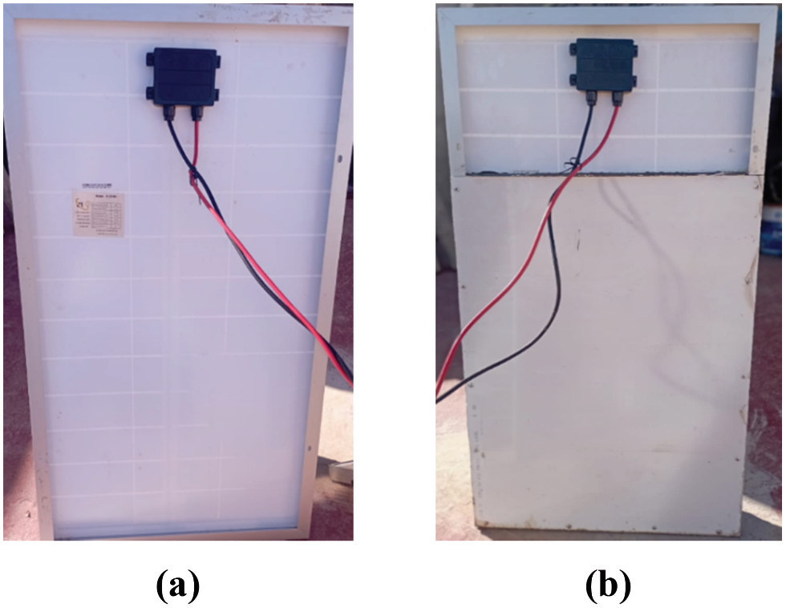
Figure 1 illustrates two configurations: (a) a conventional photovoltaic (PV) panel, while (b) the hybrid PV/PCM module.
2.3. The experimental methodology and investigated settings
The experimental arrangement comprises a PV/PCM hybrid module alongside a traditional PV system lacking PCM integration. Additionally, the setup incorporates three temperature sensors interfaced with an Arduino Mega 2560 microcontroller and a personal computer designated for data storage. Over the course of the experiment, comprehensive measurements encompassing humidity, current, voltage, and temperatures from each module, as well as surrounding air temperature, were conducted. Current and voltage readings were acquired from both panels, as delineated in Figure 2(a), employing an electrical resistance (R) of 15 Ω to regulate voltage and current, to prevent potential short-circuiting. Furthermore, temperature recordings of both PV panels were obtained from two distinct positions on the frontal aspect of each panel, as exemplified in Figure 2 (b). The collected dataset was archived on a computer system for subsequent analysis. Detailed information regarding the measurement instruments and equipment utilized for data acquisition is provided in Table 2. Experimental assessments were executed in the Moroccan town of Sidi Ifni.
Table 2. Sources for the components of the measuring device
Item | Device | Accuracy (a_{n}) | Uncertainty (U_{n})
Temperature | DS18B20 probe | $$±0.5°C$$ | 0.29%
Humidity | DHT11 probe | $$±5\%$$ | 2.88%
Voltage | Max471 probe | 2% | 1.15%
Current | Max471 probe | 2% | 1.15%
Irradiation | BH1750 probe | 4% | 2.3%
PV panel
AA
V
PC
The acquisition system Arduino mega 2560
Electrical resistance

(a)
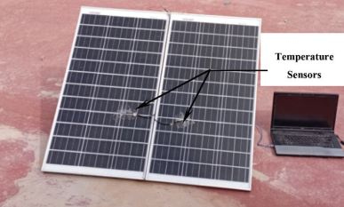
(b)
Figure 2. (a) Electrical setup of the photovoltaic module, and (b) temperature probe positioned at the forefront of both the photovoltaic panel and the PV/PCM module for temperature measurement.
The experimental efficiencies pertaining to the conversion of solar energy to electricity (ηe) for both the photovoltaic and PV/PCM modules were assessed through the hourly variations of electrical efficiency over the observation period. The efficiency (ηe) was computed using Equation (1), which incorporates the direct current (DC) producing power (Pe) and the incident solar power (Ps). The DC generating power (Pe) was determined by the product of the voltage (V) and current (I), as described in Equation (2). Meanwhile, the incident solar power (Ps) represents the solar power captured by the solar module, estimated by the multiplication of solar irradiation (G) by the effective area (A) of the solar panel, as formulated in Equation (3).
(1)
(2)
(3)
2.4. Examination of experimental uncertainty
Indeed, there exists a potential for error to manifest at various stages of the experimental process due to factors pertaining to measurement and the measurand [11]. It is advised by these authors to assess the uncertainty associated with the instrumentation employed in the investigation. Various parameters of the quantity under study were documented and analyzed. The uncertainty levels corresponding to each sensor are detailed in Table 2. Equation (4), as delineated by Chandrika et al. [12], presents a method for computing the average uncertainty denoted as U_{n}.
(4)
Herein, $a_{n}$represents the precision of the equipment as specified by the manufacturer. The determination of efficiency is conducted through a computation utilizing the relationship delineated in Equation (5).
(5)
Employing the precisions pertaining to voltage (2%), current (2%), and radiation (4%), the accuracy of efficiency was assessed to be 1%. Equation (4), as provided by Chandrika et al. [12], offers a means to compute the uncertainty, denoted as U_{n}. The uncertainty associated with electrical efficiency was determined to be 0.57%.

3. Results and discussion
On August 10th, 2024, the outcomes of external evaluations were compiled. Utilizing instrumentation, measurements were conducted on conventional PV systems and PV/PCM, facilitating the acquisition of essential parameters including voltage, current, temperature, and power outputs for each respective system. Additionally, meteorological data pertinent to the locale of Sidi Ifni, Morocco, encompassing ambient temperature, humidity levels, and solar radiation intensity, were systematically documented and are visually depicted in Figure 3. As articulated previously, the primary aim underlying the adoption of a PV/PCM module was to augment the operational efficiency of conventional PV arrays by instituting cooling mechanisms for the solar cells. Accordingly, during the evaluation of the PV-based hybrid system, a pivotal consideration revolved around the thermal conditions governing the solar cells.
In accordance with the meteorological data depicted in Figure 3(a), the morning of August 10th exhibited elevated humidity levels, registering at 27.6% at 7:00 AM. Subsequently, a decline to a minimum of 3.5% was observed. Consistent with the observations of Kazem et al. [13], it has been accepted that the electrical output of solar panels increases concomitant with a reduction in humidity levels. This phenomenon can be elucidated by the heightened solar irradiance incident upon the PV module under conditions of a reduced amount of humidity, thereby facilitating a rise in temperature from 20.6°C in the morning to 37.8°C in the afternoon on August 10th, as illustrated in Figure 3(b).
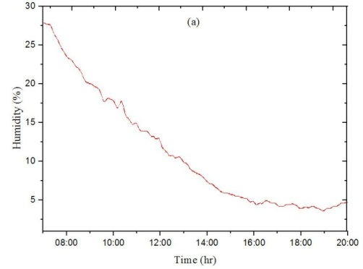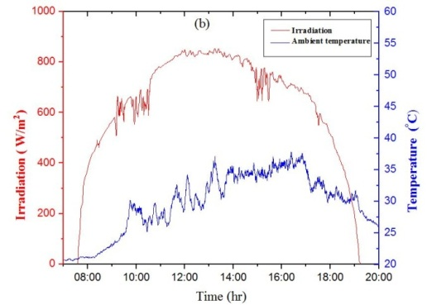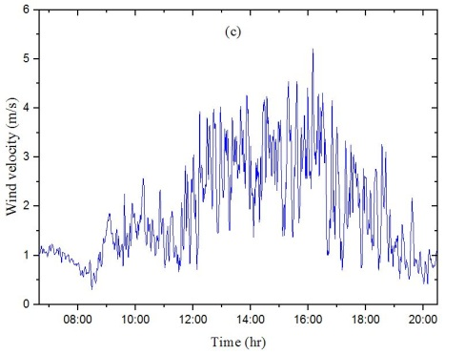
Figure 3. Weather statistics for August 10, including (a) humidity, (b) temperature and irradiance, (c) wind speed
Figure 3(c) illustrates the variability in wind velocity observed on the aforementioned August 10th, day. A discernible decrease in temperature on this day is attributed to the escalation in wind velocity. As elucidated by the findings of Ahmed et al. [14], wind serves as a natural coolant, dissipating accumulated dust and thereby mitigating the temperature of solar cells.
The temperature of the conventional PV module experienced an elevation from 20.5°C to a peak value of 60.7°C on August 10th, coinciding with the attainment of its maximum irradiance level of 722 W/m². In contrast, the temperature of the PV/PCM module reached a maximum of 53.1°C, demonstrating a reduction of approximately 7.6 degrees Celsius (12.5%) in comparison to the standalone configuration, as illustrated in Figure 4. Notably, around 11:20 AM, a discernible departure was observed: while the temperature of the PV panel exceeded 32°C, representing the threshold for the melting point of RT32, the temperature of the PV system integrated with PCM began to decline relative to the standalone PV panel.
The integration of Phase Change Materials within the PV system holds promise for further mitigation of PV temperature, particularly in instances where meteorological conditions induce a substantial rise in solar panel surface temperatures beyond the threshold of 32°C, corresponding to the melting point of the PCM. This underscores the heightened effectiveness of the PCM layer amidst harsher climatic conditions. Notably, the investigation conducted by Park et al. [15] elucidated that the PV/PCM system yielded a notable reduction in PV temperature, amounting to 5°C compared to conventional PV panels under analogous ambient temperature conditions similar to those observed in the present study, approximating 26°C. The observed temperature decline can be attributed to the thermal energy absorption exhibited by the PCM layer.
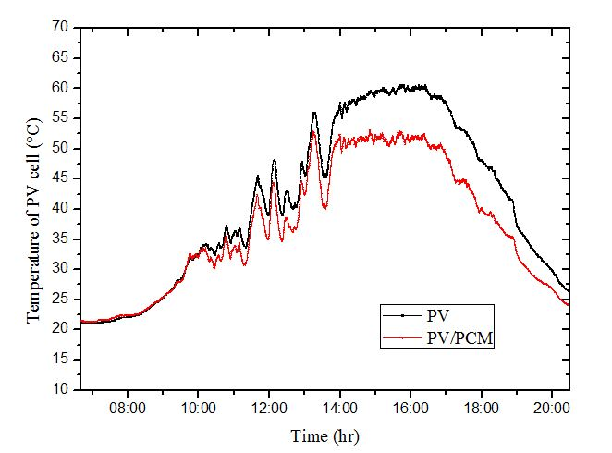
Figure 4. PV measured temperatures for PV/PCM module and conventional PV panel
Figure 5 delineates the recorded electric current measurements acquired on August 10th, plotted against time. Notably, the standalone PV system exhibited highest achievable currents of 1.5 A, whereas the hybrid PV panel integrated with Phase Change Materials surpassed this value slightly, registering at over 1.7 A, representing an enhancement of 13.33%. This disparity in performance may be elucidated by the PV/PCM module’s more pronounced temperature decrease and the correspondingly elevated solar irradiance levels.
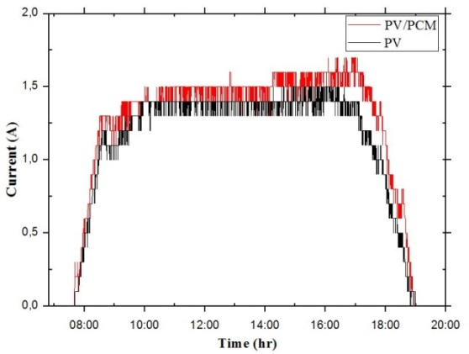
Figure 5. The electrical current computed for the PV/PCM and conventional PV systems
Figure 6 illustrates the temporal variation in voltage for both modules on August 10th. The data indicate that the maximum voltages generated were approximately 21.3 V for the conventional photovoltaic panel and 22.4 V for the PV/PCM system. The incorporation of phase change material into the PV panel in the hybrid system resulted in a modest increase in voltage, of approximately 5.16%.
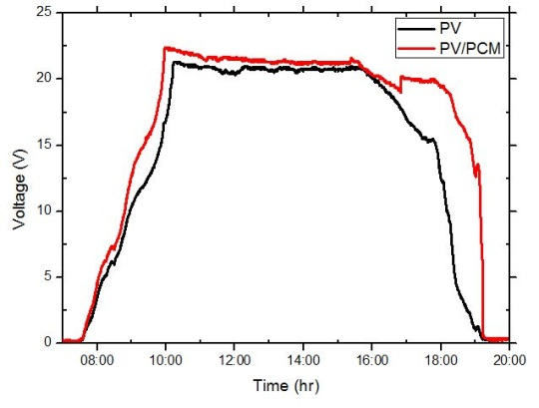
Figure 6. Measurements of voltage fluctuations for the conventional photovoltaic system and the PV/ PCM system were recorded on August 10th.
The multiplication of current and voltage measurements for the two panels yielded peak production power levels of 31.35 W and 34.4 W (a 9.72% increase) for the conventional photovoltaic system and the PV/PCM system, on August 10th, as illustrated in Figure 7. The integration of PCM contributed to a reduction in PV temperature, which enhanced the maximum output power by approximately 3.05 W. The absorbed solar energy in the PV cells of the PV/PCM system was effectively exported and saved in the phase change material area, leading to the refreshing of the photovoltaic panels and thereby enhancing the electrical performance of the PV/PCM system

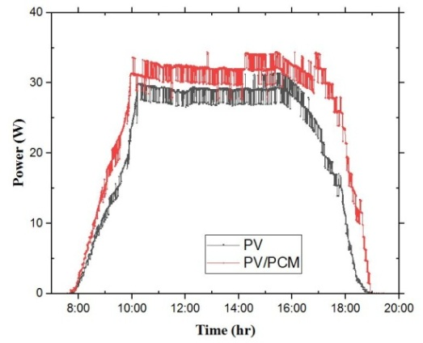
Figure 7. The computed electrical power for both the conventional photovoltaic panel and the PV/PCM system on August 10th
After calculating the solar power incident on every module uses the relationship provided in Equation (3), the electrical efficiency of every system was calculated using Equation (1). The consolidated results are presented in Figure 8, which compares the solar power and electrical efficiency of the conventional photovoltaic system and the PV/PCM system for one day of analysis. The maximum electrical efficiencies recorded were 11.23% for the PV system and 12.55% for the PV/PCM system, as can be seen in Figure 8. These efficiencies were 11.23% for the PV system and 12.55% for the PV/PCM system which could be seen from Figure 8. It was found that the use of PCM in the solar panel led to an improvement in the electrical efficiency of the solar panel of about 1.32%, subsequently leading to the effective reduction of the PV cells to consume the heat. This gain is much higher than that obtained by Alwan et al. [16] (approximately 1.18%) due to an increase in electric efficiency.
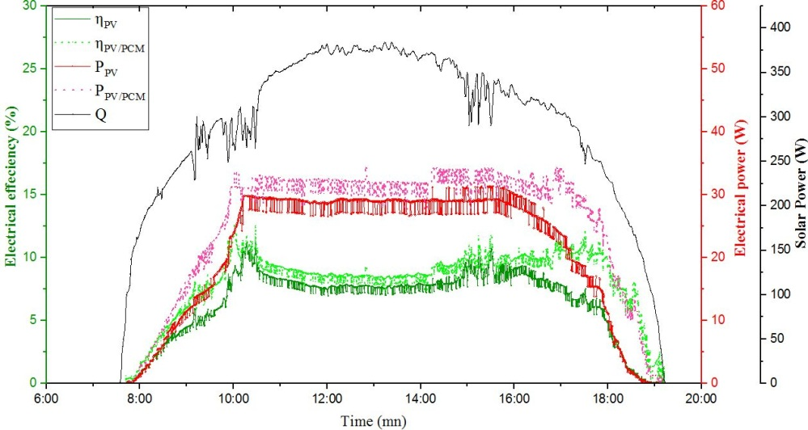
Figure 8. The electrical performance of hybrid PV/PCM and normal PV systems and solar irradiation on the modules and the output power from the module, on August 10th,
Conclusion
This study investigated the enhancement of the electrical performance of a standalone photovoltaic (PV) module through the incorporation of RT32 phase change material in a hybrid PV/PCM system. The assessment was conducted under real meteorological conditions. Experiments were carried out in August 2024 under ambient environmental conditions. The performance of both systems was evaluated by comparing photovoltaic temperatures and key electrical parameters, including current, voltage, and power. The principal findings of this study are as follows:
- In comparison to a solo PV system, the hybrid PV/PCM system had a lower highest PV temperature of around 7.6°C, illustrating the effect of decreasing the temperature within the PCM.
- The assessment of highest current and voltage from the two panels revealed a 9.72% improvement in the maximum power output of the photovoltaic panel.
- The maximum electrical efficiency attainable with the standalone system was 11.23% while the hybrid system achieved an efficiency of 12.55%.
Subsequent research will focus on optimizing a hybrid PV panel design incorporating fluid channels and a phase change material (PCM) layer. Furthermore, the infusion of high-thermal-conductivity nanomaterials into the PCM matrix will be examined to evaluate their efficacy in augmenting thermal properties. The electrical efficacy of the system will be empirically quantified via field studies.
Author Contributions
Mohamed Bouzelmad: Investigation, Methodology, Writing – original draft. Abdellah Asbayou: Conceptualization, Writing Youssef Belkassmi: Supervision, review & editing. Abdelhadi Kotri: Supervision, review & editing. Rachid Oualaid: Investigation, Methodology, Writing. Youssef EL BID: Writing – review & editing. Fatima Amallal: Investigation, Writing.
References
[1] M. Bouzelmad, Y. Belkassmi, A. Kotri, L. Elmaimouni, M. Gounzari, and A. Benahmida, “Numerical study of a hybrid photovoltaic solar thermal system in a transient condition,” in 2021 9th International Renewable and Sustainable Energy Conference (IRSEC), 2021, pp. 1–6, doi: 10.1109/IRSEC53969.2021.9741182.
[2] H. M. Maghrabie, A. S. A. Mohamed, and M. S. Ahmed, “Experimental investigation of a combined photovoltaic thermal system via air cooling for summer weather of Egypt,” J. Therm. Sci. Eng. Appl., vol. 12, no. 4, pp. 1–9, 2020, doi: 10.1115/1.4046597.
[3] M. Bouzelmad, Y. Belkassmi, A. Abdelrazik, and A. Abdelrazik, “Experimental and numerical study of enhancing the electrical performance of photovoltaic panel using phase change material in transient conditions,” Energy Sources, Part A Recover. Util. Environ. Eff., vol. 46, no. 1, pp. 294–314, 2024, doi: 10.1080/15567036.2023.2283142.
[4] C. Baylis and C. A. Cruickshank, “Review of bio-based phase change materials as passive thermal storage in buildings,” Renew. Sustain. Energy Rev., vol. 186, no. May, p. 113690, 2023, doi: 10.1016/j.rser.2023.113690.
[5] A. Kazemian, M. Khatibi, S. Entezari, T. Ma, and H. Yang, “Efficient energy generation and thermal storage in a photovoltaic thermal system partially covered by solar cells and integrated with organic phase change materials,” Renew. Sustain. Energy Rev., vol. 188, no. October, p. 113705, 2023, doi: 10.1016/j.rser.2023.113705.
[6] M. Bouzelmad, Y. Belkassmi, A. S. Abdelrazik, and A. Kotri, “Numerical Analysis of the Phase Change Material Impact on the Functionality of a Hybrid Photovoltaic Thermal Solar System in Transient Conditions,” J. Adv. Res. Fluid Mech. Therm. Sci., vol. 1, no. 1, pp. 1–21, 2023, doi: 10.37934/arfmts.112.1.121.
[7] D. S. Jayathunga, H. P. Karunathilake, M. Narayana, and S. Witharana, “Phase change material ( PCM ) candidates for latent heat thermal energy storage ( LHTES ) in concentrated solar power ( CSP ) based thermal applications - A review,” Renew. Sustain. Energy Rev., vol. 189, no. PB, p. 113904, 2024, doi: 10.1016/j.rser.2023.113904.
[8] J. Hirschey and S. Graham, “Review of Inorganic Salt Hydrates with Phase Change Temperature in Range of 5 to 60 ° C and Material Cost Comparison with Common Waxes,” no. July, 2018.
[9] V. V. T. Imtiaz Ali Lagharia, M. Samykanoa*, A. K. Pandeyb, K. Kadirgamac, “Sustainable Energy & Fuels,” 2020, doi: 10.1039/D0SE00681E.
[10] S. M. A. Mofijur, M. Mahlia, T. Silitonga, A. Ong, H. Silakhori, M. Hasan, M. Putra, N. Rahman, “Phase Change Materials ( PCM ) for Solar Energy Usages and Storage : An Overview,” pp. 1–20, 2007.
[11] Sudalaiyandi K, K. Alagar, V. K. R, M. P. VJ, and M. P, “Performance and emission characteristics of diesel engine fueled with ternary blends of linseed and rubber seed oil biodiesel,” Fuel, vol. 285, no. August 2020, p. 119255, 2021, doi: 10.1016/j.fuel.2020.119255.
[12] V. S. Chandrika, A. Karthick, N. M. Kumar, P. M. Kumar, B. Stalin, and M. Ravichandran, “Experimental analysis of solar concrete collector for residential buildings,” Int. J. Green Energy, vol. 18, no. 6, pp. 615–623, 2021, doi: 10.1080/15435075.2021.1875468.
[13] H. A. Kazem and M. T. Chaichan, “Effect of humidity on photovoltaic performance based on experimental study,” Int. J. Appl. Eng. Res., vol. 10, no. 23, pp. 43572–43577, 2015.
[14] S. Ahmed, R. Karal, B. K. Das, and A. Das, “Case Studies in Thermal Engineering Experimental investigation of cooling , wind velocity , and dust deposition effects on solar PV performance in a tropical climate in Bangladesh,” Case Stud. Therm. Eng., vol. 50, no. August, p. 103409, 2023, doi: 10.1016/j.csite.2023.103409.
[15] J. Park, T. Kim, and S. B. Leigh, “Application of a phase-change material to improve the electrical performance of vertical-building-added photovoltaics considering the annual weather conditions,” Sol. Energy, vol. 105, pp. 561–574, 2014, doi: 10.1016/j.solener.2014.04.020.
[16] A. A. Alwan and A. M. Hassan, “Experimental Study on Optimizing Photovoltaic Panel Efficiency : Harnessing Paraffin Wax Phase Change for Temperature Reduction,” Arab. J. Sci. Eng., 2024, doi: 10.1007/s13369-023-08581-3.

