Adaptive EKF Parameter Tuning for Battery EVs via Simulink Parameter Estimation
Hamza BENHAMMOU^{1, a)}, Kamal ANOUNE^{1, b)} and Abdelali TAJMOUATI^{1, c)}
¹ EMIT Laboratory, Energy & Materials, Instrumentation & Telecom, Physics Department, Faculty of Sciences and Technologies FST-Settat, Hassan First University (UHP), Settat, Morocco
^{a)} hamza.benhammou@outlook.com
^{b)} kamal.anoune@gmail.com
^{c)} tajmoua@gmail.com
Abstract. Keeping electric vehicle batteries safe and running smoothly for an extended period requires regular checks on their condition. That is where the Battery Management System (BMS) comes in. A popular tool for ascertaining the remaining battery charge, also known as its State of Charge (SoC), is the Extended Kalman Filter (EKF). However, the performance of the EKF is highly dependent on the precise calibration of its parameters, especially those covariance values that indicate how the filter handles noise in the data. Usually, tweaking these settings is a manual, time-consuming job, and frequently yields suboptimal results. To address this challenge, this study proposes an automated methodology for EKF parameter tuning. The optimal EKF settings are determined using Simulink's Parameter Estimation Tool with real battery data from Calce. Our goal was to minimize errors in our estimates and make the SoC tracking more accurate, which ultimately leads to better battery performance and reliability. As a result, by using the Parameter Estimation Tool, we reduced Mean Relative Error (MRE) to 2.996 × 10⁻6.

Introduction
Electric Vehicles (EVs) have gained a lot of popularity in the last decades due to the environmental crisis. To guarantee an extensive and safe longevity of the EVs [1], the BMS optimize battery operation of an EV by continuously monitoring important battery states [2]. The BMS monitors such state, the SoC, which indicates the remaining battery capacity. Then the BMS uses this state to evaluate the range and protect the battery of an EV [3].
To ensure an efficient management of the battery, an accurate estimation of SoC is necessary. The EKF a regressive algorithm enables the BMS to gage the SoC. The EKF is filter where the SoC is estimated in dynamic systems with uncertainties and noise instead of the Kalman Filter (KF) [4][5][6]. In Lithium-Ion Batteries (LiBs) of EVs [7], EKF is more common because LiBs are not linear systems while the KF performs in linear system dynamics [8]. The EKF estimates the SoC by extending KF linearization to a non-linear system through Taylor series approximation. The EKF also introduces a Jacobian matrix in the approximation of non-linear systems to predict and update the SoC [9][10].
In the literature, other SoC estimation methods such as Coulomb Counting method (CC), Neural Networks (NNs), Support Vector Machines (SVMs), and Particle Filters (PFs) exists, but each has their drawbacks which explains why the EKF is the most prominent. The first method is the CC, a simple method but lacks the possibility to calibrate the errors collected by current sensor drift and noise accumulation [11]. The second and third methods are Machine Learning (ML) based, where these methods are used to model complex battery nonlinearities without needing a precise physical model [12][13]. But they require a lot of data to train them, they severely lacking outside of their trained conditions, and there are computationally heavy in resource-limited embedded systems. Lastly, PF is highly regarded method for non-Gaussian and nonlinear systems, but also suffers from the same problem as NN and SVM, where it needs a massive computational power due to the large number of particles of the method [14]. The EKF is exceedingly suitable SoC estimation in real-time implementation such as BMS by balancing between modeling accuracy, computational precision and strength to noise [15].
The EKF provides prediction-update process that improve the precision of the SoC assessment by merging a noisy sensor data and model-based prediction [16]. In the prediction phase, the EKF approximate the SoC a system model and the last estimation. In the update phase, the estimation is adjusted based on the uncertainties of the new measurements [17][18][19]. The model employed by EKF is determined through an Equivalent Circuit Model (ECM) [20][21]. The characteristics of the model is determined though Hybrid Pulse Power Characterization (HPPC) test [22][23], a technique that ascertain the parameters of the model such as internal resistance, battery capacity, and the open circuit voltage [24][25][26]. The electrical characteristics of the battery are concluded by using an HPPC test and analyzing the voltage response to a controlled charge and discharge pulses. This data is then used in ECM to represent battery behavior in EKF-based SoC estimation. These parameters primarily influence the prediction of the EKF filter, which directly impacts its accuracy.
The tuning of EKF parameters can be performed manually or using one of the optimization methods. Unfortunately, an expertise in the system and extensive experimental adjustments are required to manually tuning the EKF parameters. The process of this tuning is time-consuming and often suboptimal. To resolve this challenge, we propose an adaptive EKF parameter tuning approach using Simulink's Parameter Estimation Tool [27]. This approach helps determine parameters such as covariances (Process noise Q, Measurement noise R, and Initial state P0), enhancing the filter's accuracy and adaptability [28] using real-world battery data from Calce.
In our research, we aim to explore the use of the Parameter Estimation Tool function in MATLAB/Simulink to determine optimized EKF parameters. With the help of third-order ECM [21][29] and the EKF model, these parameters offer improvements in the efficiency, reliability, and longevity of EV batteries by providing better real-time battery monitoring [30]. By using our method, we successfully reduced the MRE to 2.996 × 10⁻⁶, which is an excellent result and it's a step forward to a more accurate, adaptive, and intelligent BMS.

Mathematical model
The study of LIBs is unfortunately complicated due to the complex chemical interactions that occur at any given time. To facilitate this study, the ECMs have been introduced. One of the most accurate ones is the third-order ECM, which accurately depicts the battery's operation under various conditions [31]. This ECM as shown in Fig. 1 represents the significant elements of a LIB such as Open Circuit Voltage (OCV), an internal resistance (R₀) that accounts for energy losses and three sets of resistors and capacitors (R₁, C₁), (R₂, C₂), and (R₃, C₃) to account for the dynamic response over short and long timeframes.
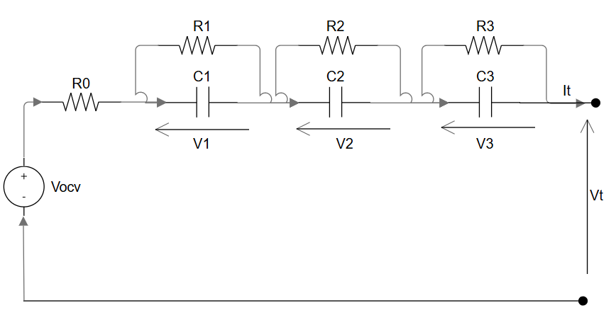
Figure 1. 3rd-order electrical equivalent circuit model.

Using Kirchhoff's Current Law in the closed loop of the ECM and for each RC branch, we can deduce equations (1), (2), (3), and (4), which are the basis for real-time SoC estimation and for efficient energy management in EVs, ensuring both reliability and performance optimization.
$Vt=Vocv-It.R0-V1-V2-V3$
$\dot{V1}=\frac{It}{C1}-\frac{V1}{R1C1}$
$\dot{V2}=\frac{It}{C2}-\frac{V2}{R2C2}$
$\dot{V3}=\frac{It}{C3}-\frac{V3}{R3C3}$

The battery terminal voltage is denoted as Vt, the open circuit voltage, which is a function of the SoC, is represented by V_{OCV}. The battery has a current, It, which is positive during discharge and negative during charge. The internal resistance is given by R0. The battery dynamics is characterized by three RC networks, where R1, R2, and R3 are the polarization resistances; C1, C2, and C3 are the corresponding capacitances; and V1, V2, and V3 represent the voltage drops across these networks.
In a BMS, SoC is a key indicator to determine how much energy is left in the LIB, but there is no physical way to measure it, so estimating SoC is the only option. To accomplish that, we use Coulomb counting that tracks variations in the battery charge by integrating the current over time [26]. The equation below describes how SoC evolves:
The initial SoC is defined as SoC (0). The nominal battery capacity, denoted as Qrated​, is measured in Ampere-hours (Ah). The battery current, which varies over time, is represented by the function I_{L}(t).
The continuous-time state-space model derived from the ECM is necessary for implementation in a digital BMS, which requires a discrete-time model. The continuous-state equation is given by using the integration factor of e^{τit} in equations (2), (3), and (4):
$V1\left(t\right)={{V1}_{ initial}e^{{-τ}_{1}t}- R}_{1}It\left(t\right)(1-e^{-τ_{1}t})$
$V2\left(t\right)={{V2 }_{ initial}e^{{-τ}_{2}t}- R}_{2}It\left(t\right)(1-e^{-τ_{2}t})$
$V3\left(t\right)={{V3}_{ initial}e^{{-τ}_{3}t}- R}_{3}It\left(t\right)(1-e^{-τ_{3}t})$

Then using the Forward Euler Discretization to the equations (1), (6), (7), (8), and (5):
$Vt(k+1)=V_{OCV}(k)-V_{1}(k)-V_{2}(k)-V_{3}(k)-R_{0}It(k)$
$V1\left(k+1\right)=V1\left(k\right) e^{{-τ}_{1}}+R_{1}\left(1-e^{-τ_{1}}\right)Δt It\left(k\right)$
$V_{2}\left(k+1\right)=V_{2}\left(k\right) e^{{-τ}_{2}}+R_{2}\left(1-e^{-τ_{2}}\right)Δt It\left(k\right)$
$V_{3}\left(k+1\right)=V_{3}\left(k\right) e^{{-τ}_{3}}+R_{3}\left(1-e^{-τ_{3}}\right)Δt It\left(k\right)$
$SOC\left(k+1\right)=SOC\left(k\right)-\frac{It (k)Δt}{Q_{rated}}$
The Coulomb-counting method is an easy way to approximate SoC, but over time, minor errors induce a diversion in SoC estimations due to drift sensor imprecisions and environmental interferences. To enhance accuracy, the EKF refines SoC estimation by combining real-time sensor data with predictions from a battery model, correcting errors as new information becomes available. To implement this, the system is represented in a discrete state-space form, derived from equations (10), (11), (12), and (13), as shown below:
$\left[\begin{aligned}\begin{matrix}SOC\left(k+1\right) \\ V1\left(k+1\right) \\ V2\left(k+1\right)\end{matrix} \\ V3(k+1)\end{aligned}\right]=\left[\begin{matrix}1 & 0 & 0 & 0 \\ 0 & e^{\frac{∆t}{τ1}} & 0 & 0 \\ 0 & 0 & e^{\frac{∆t}{τ2}} & 0 \\ 0 & 0 & 0 & e^{\frac{∆t}{τ3}}\end{matrix}\right]\left[\begin{matrix}SOC\left(k\right) \\ V1(k) \\ V2(k) \\ V3(k)\end{matrix}\right]+\left[\begin{matrix}\frac{∆t}{3600Q_{rated}} \\ (1-e^{-\frac{∆t}{τ1}})R1 \\ (1-e^{-\frac{∆t}{τ2}})R2 \\ (1-e^{-\frac{∆t}{τ3}})R3\end{matrix}\right]It(k)+w(k)$
From equation (14), we can determine the following:
- The state vector is: ${\left[\begin{matrix}SOC(k) & V1(k) & V2(k) & V3(k)\end{matrix}\right]}^{T}$
- State transition matrix: $\left[\begin{matrix}1 & 0 & 0 & 0 \\ 0 & e^{\frac{∆t}{τ1}} & 0 & 0 \\ 0 & 0 & e^{\frac{∆t}{τ2}} & 0 \\ 0 & 0 & 0 & e^{\frac{∆t}{τ3}}\end{matrix}\right]$
- Control vector: ${\left[\begin{matrix}\frac{∆t}{3600Q_{rated}} & (1-e^{-\frac{∆t}{τ1}})R1 & (1-e^{-\frac{∆t}{τ2}})R2 & (1-e^{-\frac{∆t}{τ3}})R3\end{matrix}\right]}^{T}$
- It(k) Represents the system control input and w(k) represents the system process noise, where its covariance is 𝑄.
We can also write the output voltage equation in the discrete domain from equation (9), whereis the observation noise, and R represents its covariance as:
$Vt(k)=V_{ocv}(k) - It(k) - V1(k) - V2(k) - V3(k)+v(k)$
The covariances Q and R of EKF can be written as:
$Q=\left[\begin{matrix}σ_{SOC}^{2} & 0 & 0 & 0 \\ 0 & σ_{V1}^{2} & 0 & 0 \\ 0 & 0 & σ_{V2}^{2} & 0 \\ 0 & 0 & 0 & σ_{V3}^{2}\end{matrix}\right]$
- $σ_{SOC}^{2}$ represents the uncertainty in State of Charge estimation.
- $σ_{V1}^{2}$, $σ_{V2}^{2}$ and $σ_{V3}^{2}$ represent uncertainties in the RC voltages.
$R=σ_{Vt}^{2}$
- The observation covariance R is a scalar because there is one sensor to measure voltage.
- $σ_{Vt}^{2}$ represents the variance in voltage measurements due to sensor noise and inaccuracies.
The initial state covariance vector P0 represents the uncertainty in the initial estimates of SoC and the internal states. If the initial state is uncertain, larger values are assigned, while more confident values are assigned smaller variances:
$P_{0}=\left[\begin{matrix}σ_{SOC,0}^{2} & σ_{V1,0}^{2} & σ_{V2,0}^{2} & σ_{V3,0}^{2}\end{matrix}\right]$
- $σ_{SOC,0}^{2}$​ represents initial uncertainty in State of Charge.
- $σ_{V1,0}^{2}$, $σ_{V2,0}^{2}$ and $σ_{V3,0}^{2}$ represent initial uncertainties in RC circuit voltages.
To calculate the SoC, equations (14) and (15) are implemented in EKF. Then the optimized EKF parameters were validated against experimental data, and their performance was compared with manually tuned EKF parameters. To evaluate its performance, we use the MRE metric, defined as:
The SôC and SoC represent respectively the estimated and real Soc from the dataset.

Battery System Model
The HPPC test is a commonly utilized method for accurately assessing the performance of LiBs in EVs under load. This test is used to determine the characteristics of the battery model; they are then applied in the BMS to evaluate the SoC accurately. In this research, we primarily focused on the discharge phase of the HPPC test [25]. The discharge phase consists of well-controlled discharge bursts at different SoC levels from a fully charged battery. Each burst has a defined duration, followed by a rest period to enable the battery to stabilize. This phase continues until a full discharge of the battery.
To test the robustness of our model, we utilized real-world experimental data from the CALCE illustrated in Fig. 2. Integrating this data significantly improves the precision of our real-time simulations. As a result, our EKF algorithm can deliver more reliable battery predictions, even under changing conditions. Ultimately, leveraging HPPC discharge data strengthens our lithium-ion battery models, making them more effective for real-world applications.

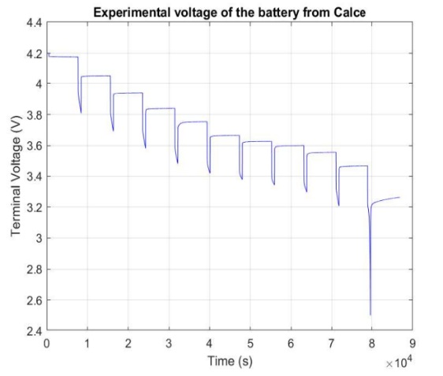 | 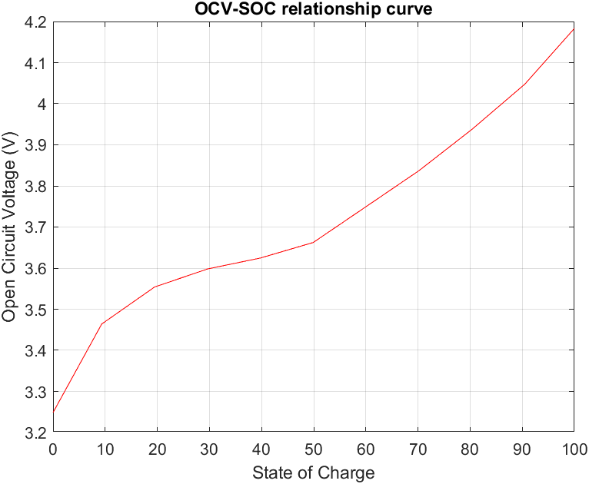
Figure 2. (a) Experimental Voltage data from Calce | Figure 2. (b) OCV-SOC relationship curve

TABLE 1. Battery model parameters for the 3RC model
Parameter | 3RC model
V_{OCV} (V) | [3.249, 3.464, 3.554, 3.598, 3.625, 3.662, 3.750, 3.837, 3.938, 4.047, 4.183]
R₀ (Ω) | [0.00033, 0.21, 0.17, 0.20, 0.192, 0.1923, 0.198, 0.195, 0.191, 0.193, 0.205]
R₁ (Ω) | [0.344, 6.048 × 10⁻⁷, 0.039, 0.001, 0.010, 0.018, 0.002, 0.013, 0.009, 0.010, 0.005]
Tau1 (s) | [13.097, 199.999, 197.398, 195.351, 197.546, 159.619, 199.999, 149.957, 168.046, 128.936, 64.495]
R₂ (Ω) | [0.178, 9.218 × 10⁻¹⁵, 0.030, 0.0236, 0.010, 0.003, 0.0446, 0.020, 0.018, 0.010, 0.022]
Tau2 (s) | [199.852, 199.955, 1.146, 181.740, 21.692, 0.019, 199.994, 34.229, 18.319, 13.272, 34.489]
R₃ (Ω) | [0.044, 3.20 × 10⁻¹⁸, 0.040, 0.039, 0.040, 0.039, 0.039, 0.039, 0.039, 0.039, 0.0433]
Tau3 (s) | [0.141, 16.303, 2.111, 0.672, 0.159, 0.741, 0.546, 0.672, 0.470, 0.406, 2.011]

The parameters are determined using Simulink Parameter Estimation, with initial values the optimized to get the most accurate tension U_{L} that correspond to the tension collected by CALCE.

Parameter Estimation Process
The optimization of the EKF covariance matrices (Q, P₀) was performed using the Simulink Parameter Estimation Tool (from the Simulink Design Optimization toolbox), which employs a nonlinear least-squares optimization algorithm to minimize the error between the model output and the experimental data.

TABLE 2. The result of optimization for EFK parameters
EKF Parameters | Initial Guesses | Constraints | Convergence Criteria
Q | 1e-12*eye (4) | Min: 1e-16*eye (4); Max: 1e-5*eye (4) | Tolerance: 0.001
P0 | [1e-8, 1, 1, 1] | Min: [0, 1, 1, 1]; Max: [1e-5, 1, 1, 1] | Tolerance: 0.001

Results and discussion
We used in this work Parameter Estimation tool in Simulink to optimize the characteristics of EKF, such as P0 (Initial state covariance), Q (Process noise covariance), and R (Observation noise covariance). Where P0 defines the uncertainty in the initial SoC estimate, Q determines how much uncertainty is assigned to the battery model, and R represents the noise associated with sensor readings. In Calce Data, there is just one measurement point, so R is a single positive scalar. With this information, we fix the value of R in this paper to 0.1 and optimize Q (a matrix 4x4) and P0 (a vector 4x1) for ECM 3rd degree.
TABLE 3. The result of optimization for EFK parameters
EKF parameter | Result | Description
P0 |  | Initial state covariance.
Q |  | Process noise covariance.
R | 0.1 | Observation noise covariance.
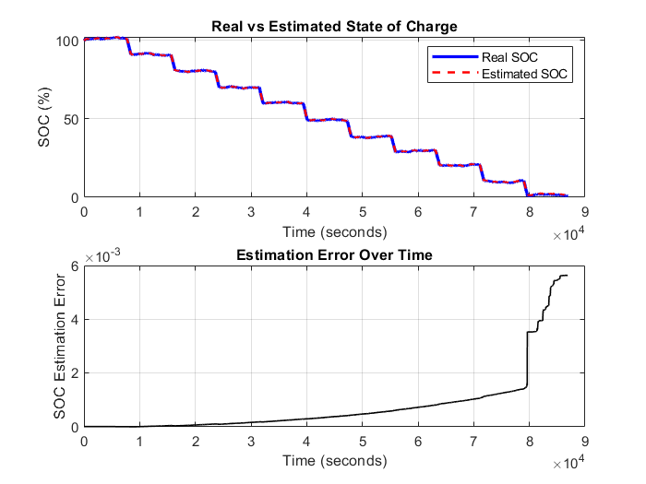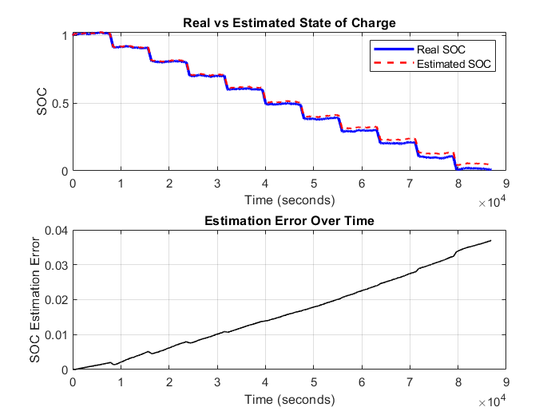
Figure 3. SoC optimized estimation. Figure 4. SoC manually tuned estimation.
The result of such optimization is illustrated in Fig. 3. This figure presents a comparison between the real SoC and the estimated SoC over time, illustrating the accuracy of the estimation method based on the EKF. The two curves (real SoC in blue and estimated SoC in orange) closely follow each other, indicating a highly accurate estimation process. The stepwise decrease in SoC reflects the battery’s discharge process, consistent with HPPC test conditions. The calculated MRE of 2.966 × 10⁻⁶ demonstrates an extremely low deviation between the estimated and actual SoC values. The presence of noise from sensor inaccuracies or modeling errors appears minimal and does not significantly deviate from the real SoC. A low MRE indicates that the EKF-based estimation is highly effective even in the presence of noise. The model can reliably track the SoC in real time, which is crucial for accurate battery management in EVs. Despite slight variations, the EKF successfully compensates for system noise and modeling uncertainties.
Figure 4 presents the evolution of the SoC over time, comparing the real and estimated SoC values. The results demonstrate a strong correlation between the two, indicating the moderated effectiveness of the manually tuned estimation approach. Both figures illustrate the SoC over time, comparing real and estimated values. While they follow a similar pattern of discharge, there are key differences in accuracy. The first figure (with an MRE of 2.966 × 10⁻⁶) demonstrates an exceptionally precise SoC estimation, with almost no visible divergence between the real and estimated SoC curves. While the second figure (with an MRE of 0.00036) still provides a highly accurate estimation, the error is relatively larger than in the first case. The slightly increased discrepancy suggests that manual tuning introduces some limitations in precision compared to automated or adaptive filtering methods.
The low MRE values confirm the model's reliability and demonstrate the EKF’s effectiveness in accurately estimating the SoC. However, there is still potential for refinement. Even with fine-tuning of covariance parameters or the incorporation of adaptive filtering techniques, performance could still be improved, especially under dynamic conditions.
To analyze the quantitative error, we have recalculated all the errors represented below:
TABLE 4. The result of optimization for EFK parameters
Measure | Manually Tuned EKF |  | Automatically Tuned EKF | Improvement factor
Mean Relative Error (MRE) |  | 3.8125 × 10⁻⁴ | 2.1477 × 10⁻⁶ | ~177×
Mean Absolute Error (MAE) |  | 0.0163 | 7.7019 × 10⁻⁴ | ~21×
Std. Deviation of Error (Std) |  | 0.0108 | 0.0012 | ~9×
Max Absolute Error (Max e) |  | 0.0370 | 0.0056 | ~6.6×
Root Mean Square Error (RMSE) |  | 0.0195 | 0.0015 | ~13×
95% CI for Mean Error |  | [0.0162, 0.163] | [7.6114 × 10⁻⁴, 7.7772 × 10⁻⁴]

The quantitative analysis conclusively shows that the Simulink Parameter Estimation Tool successfully optimized the EKF parameters (Q, P₀), resulting in a statistically significant (p < 0.001) improvement in SOC estimation accuracy. The automatically tuned EKF is not just better; it is superior by orders of magnitude, demonstrating significantly reduced bias (mean error), higher precision (standard deviation), and greater robustness (maximum error). This validates the proposed method as a highly effective solution to the challenge of manual parameter tuning.

Conclusion
In this paper, we use a 3rd order Thevenin ECM and real-world Calce data from HPPC discharge tests to develop a precise battery model in MATLAB/Simulink, and we focus on the role of a well-configured EKF in estimating the battery’s SoC. The Estimation Parameter tool helped refine EKF parameters to accurately approximate the SoC in real-time. The estimation of the SoC in LiBs is crucial for efficient battery management, particularly in EVs. In this study, we demonstrated the effectiveness of a well-optimized EKF and its results. The simulation results, implemented in MATLAB/Simulink, showed that the EKF could reliably track the SoC in real time, even in the presence of noise.
This well-parameterized EKF is highly precise, as evidenced by the excellent alignment between the real and estimated SoC curves under the HPPC test profile. The results demonstrate the model's effectiveness in handling the specific dynamics of the discharge pulses and rest periods in the HPPC test. While this is a strong indicator of potential robustness, future work will be necessary to explicitly validate performance under a broader range of dynamic conditions, such as variable charge-discharge cycles and different temperature profiles. There is some small division due to noise and model uncertainties, but our model effectively compensated for these variations to ensure accurate tracking.
Future work will focus on validating the optimized parameters under more dynamic, realistic driving cycles, incorporating full charge-discharge profiles and varying thermal conditions. A comparison between EKF and other methods, such as Neural Machine Networks and Vector Machines, is interesting to explore. Furthermore, we will explore online parameter adaptation techniques to enhance robustness against battery aging and changing operational environments.

References
- Farajnezhad M, Toh JS, Kuan S, Kamyab H. Impact of economic, Social, and environmental Factors on electric Vehicle adoption: a review.
- Attanayaka AMSMHS, Karunadasa JP, Hemapala KTMU. Estimation of state of charge for lithium-ion batteries - A Review. AIMS Energy. AIMS Press; 2019. pp. 186–210. https://doi.org/10.3934/ENERGY.2019.2.186
- Gaikwad KA, Bhanuse V. State of Charge Estimation Techniques [Internet].
- Ribeiro I, Ribeiro MI. Kalman and Extended Kalman Filters: Concept, Derivation and Properties [Internet]. 2014.
- Liu Z, Ebrahimzadeh Hassanabadi M, Dias-da-Costa D. A linear recursive smoothing method for input and state estimation of vibrating structures. Mech Syst Signal Process. 2025;222. https://doi.org/10.1016/j.ymssp.2024.111685
- Akatsuka J, Ishii T. System Noise Assessment and Uncertainty Analysis of a Conceptual Supersonic Aircraft. Aerospace. 2022;9(4). https://doi.org/10.3390/aerospace9040212
- Shen X, Zhang H, Li J, Du C, Yu Z, Cui Y, et al. State of power estimation for LIBs in electric vehicles: Recent progress, challenges, and prospects. J Energy Storage. Elsevier Ltd; 2025. https://doi.org/10.1016/j.est.2025.116042
- Anoune K, El Kafazi I, El Maliki A, Bossoufi B, NASIRI B, Zekraoui H, et al. Performance enhancement of drone LiB state of charge using extended Kalman filter algorithm. Clean Eng Technol. 2025;25. https://doi.org/10.1016/j.clet.2025.100917
- Im G. Notes on Kalman Filter (KF, EKF, ESKF, IEKF, IESKF). 2024;
- Zhao X, Sun B, Zhang W, He X, Ma S, Zhang J, et al. Error theory study on EKF-based SOC and effective error estimation strategy for Li-ion batteries. Appl Energy. 2024;353. https://doi.org/10.1016/j.apenergy.2023.121992
- Fahmy HM, Hasanien HM, Alsaleh I, Ji H, Alassaf A. State of health estimation of lithium-ion battery using dual adaptive unscented Kalman filter and Coulomb counting approach. J Energy Storage. 2024;88. https://doi.org/10.1016/j.est.2024.111557
- Zhang C, Song W, Lyu Y, Liu Z, Gao X, Hou Z, et al. Dual-branch convolutional neural network with attention modules for LIBS-NIRS data fusion in cement composition quantification. Anal Chim Acta. 2025;1351. https://doi.org/10.1016/j.aca.2025.343899
- Hao X, Wang S, Fan Y, Liu D, Liang Y, Zhang M, et al. A novel least squares support vector machine-particle filter algorithm to estimate the state of energy of lithium-ion battery under a wide temperature range. J Energy Storage. 2024;89. https://doi.org/10.1016/j.est.2024.111820
- Wang C, Wang S, Zhang G, Chen L, Shi H, Lin R, et al. Improved adaptive fusion parameter identification and chaotic gravitational search-Kalman particle filtering method for state-of-energy accurate estimation of lithium-ion batteries. J Power Sources. 2025;650. https://doi.org/10.1016/j.jpowsour.2025.237495
- Anoune K, Maliki A El. Microgrid Optimization Using a Developed Model of Genetic Algorithm Under MATLAB. In: Kumar S, ElBhiri B, editors. Advances in Sustainable Building Materials, Design and Energy Systems. Cham: Springer Nature Switzerland; 2025. pp. 11–7. https://doi.org/https://doi.org/10.1007/978-3-031-71914-1_2
- Tanner KT, Diaz-Ordaz K, Keogh RH. Implementation of a dynamic model updating pipeline provides a systematic process for maintaining performance of prediction models. J Clin Epidemiol. 2024;175. https://doi.org/10.1016/j.jclinepi.2024.111531
- Li W, Wang L, Yu G, Wang D. Time-varying dynamics updating method for chatter prediction in thin-walled part milling process. Mech Syst Signal Process. 2021;159. https://doi.org/10.1016/j.ymssp.2021.107840
- Demirci O, Taskin S, Schaltz E, Acar Demirci B. Review of battery state estimation methods for electric vehicles - Part I: SOC estimation. J Energy Storage. Elsevier Ltd; 2024. https://doi.org/10.1016/j.est.2024.111435
- Yun J, Choi Y, Lee J, Choi S, Shin C. State-of-Charge Estimation Method for Lithium-Ion Batteries Using Extended Kalman Filter With Adaptive Battery Parameters. IEEE Access. 2023;11:90901–15. https://doi.org/10.1109/ACCESS.2023.3305950
- Tran MK, Mathew M, Janhunen S, Panchal S, Raahemifar K, Fraser R, et al. A comprehensive equivalent circuit model for lithium-ion batteries, incorporating the effects of state of health, state of charge, and temperature on model parameters. J Energy Storage. 2021;43. https://doi.org/10.1016/j.est.2021.103252
- Wang S, Chen Q, Wang K, Wang Z, Wang Y. Parameter Identification of Lithium Iron Phosphate Battery Model for Battery Electric Vehicle. IOP Conf Ser Mater Sci Eng. IOP Publishing Ltd; 2019. https://doi.org/10.1088/1757-899X/677/3/032048
- Anoune K, El Maliki A, Belkasmi M. Maximizing energy efficiency in drones through accurate state of charge estimation using extended Kalman filter. International Journal of Applied Power Engineering. 2024;13(3):755–67. https://doi.org/10.11591/ijape.v13.i3.pp755-767
- Białoń T, Niestrój R, Skarka W, Korski W. HPPC Test Methodology Using LFP Battery Cell Identification Tests as an Example. Energies (Basel). 2023;16(17). https://doi.org/10.3390/en16176239
- Zhang H, Deng C, Zong Y, Zuo Q, Guo H, Song S, et al. Effect of Sample Interval on the Parameter Identification Results of RC Equivalent Circuit Models of Li-ion Battery: An Investigation Based on HPPC Test Data. Batteries. 2023;9(1). https://doi.org/10.3390/batteries9010001
- Benhammou H, Anoune K, Tajmouati A. Optimizing state of charge estimation using thevenin models and extended Kalman filter. Discover Electronics. 2025;2(1):70. https://doi.org/10.1007/s44291-025-00106-6
- Aslan E, Yasa Y. C-Rate- and Temperature-Dependent State-of-Charge Estimation Method for Li-Ion Batteries in Electric Vehicles. Energies . 2024;17(13). https://doi.org/10.3390/en17133187
- Daowd M, Omar N, Verbrugge B, Van Den Bossche P, Van Mierlo J. Battery Models Parameter Estimation based on Matlab/Simulink ®.
- Bavdekar VA, Deshpande AP, Patwardhan SC. Identification of process and measurement noise covariance for state and parameter estimation using extended Kalman filter. J Process Control. 2011;21(4):585–601. https://doi.org/10.1016/j.jprocont.2011.01.001
- Rahimifard S, Habibi S, Goward G, Tjong J. Adaptive smooth variable structure filter strategy for state estimation of electric vehicle batteries. Energies (Basel). 2021;14(24). https://doi.org/10.3390/en14248560
- van Mourik S, van der Tol R, Linker R, Reyes-Lastiri D, Kootstra G, Koerkamp PG, et al. Introductory overview: Systems and control methods for operational management support in agricultural production systems. Environmental Modelling and Software. Elsevier Ltd; 2021. https://doi.org/10.1016/j.envsoft.2021.105031
- Wang D, Kong J zhen, Yang F, Zhao Y, Tsui KL. Battery prognostics at different operating conditions. Measurement (Lond). 2020;151. https://doi.org/10.1016/j.measurement.2019.107182

