Effect of Hybrid Nanoparticles and Metal Foam on the Thermal Efficiency of PCM-Based Heat Sink for Electronic Components
Ibtissam AFAYNOU^{1, a)}, Hamza Faraji², Khadija Choukairy¹, and Mohamed Bourich²
¹Laboratory of Computer and Mathematical Process Engineering, National School of Applied Sciences, Moulay Slimane University, Khouribga, Morocco
²Cadi Ayyad University, UCA, National School of Applied Sciences, LaRTID Laboratory, Marrakech, Morocco
^{a)} Corresponding author: afaynouibtissam@gmail.com
Abstract. This study presents a numerical investigation of the passive cooling of an electronic component in a latent heat storage unit filled with metal foam and hybrid nano-enhanced phase change material (HNePCM). The electronic component is installed on a substrate and placed at the center of the lower wall inside a rectangular enclosure, where it generates a constant volumetric heat. A 2D mathematical model has been developed using the enthalpy-porosity approach and thermal equilibrium model. All transient two-dimensional numerical simulations are conducted using ANSYS FLUENT. The main focus of this study is to enhance the efficiency of PCM by incorporating both metal foam and hybrid nanoparticles. For this purpose, different types of nanoparticles are mixed with n-eicosane using a hybrid insertion technique. Specifically, graphene oxide (GO) and multi-walled carbon nanotubes (MWCNT) are chosen, with a fixed total nanoparticle volume fraction of 4%. The effect of metal foam and the volume fraction of the hybrid nanoparticles is evaluated by tracking the working temperature of the electronic component, the liquid fraction, and the improvement in the total effective thermal conductivity. The results indicate that the combined use of hybrid nanoparticles and metal foam leads to slight improvements in the efficiency of the PCM-based heat sink compared to the use of metal foam alone.

introduction
In recent decades, notable innovations have emerged in the design and advancement of contemporary electronic gadgets, which are now faster, more powerful, and more compact, with higher power density. These advancements have found applications across various fields, including transportation and communications. However, the miniaturization and compactness of these devices have led to elevated operating temperatures that often exceed critical thermal limits. This thermal stress is a major contributor to hardware failure, accounting for approximately 55% of damage and significantly reducing the lifespan of electronic components (1). Furthermore, research has shown that for each temperature increase of 10-20 °C, the electronic components may experience a 100% rise in failure rate. Conversely, a temperature reduction of just 1 °C can decrease the failure rate by approximately 4% (2). These findings highlight the urgent need for reliable and efficient thermal management technologies, which have become an essential challenge in modern electronics.
Recently, passive cooling techniques using phase change material (PCM)-integrated heat sinks have gained attention as promising solutions in thermal control systems. PCMs are particularly attractive because of their favorable thermophysical properties, including isothermal phase transition behavior, high latent heat, and non-toxic, non-flammable characteristics (3,4). However, a major limitation of PCMs is their inherently weak thermal conductivity (approximately 0.1 W/m.K (5)), which hampers the rate of heat transport during both melting and freezing processes. To address this issue, several thermal conductivity enhancement (TCE) strategies have been proposed, such as embedding metal fins (6), metallic foams (7) or carbon ones (8), and nanoparticles (9).
In this context, Rehman et al. (10) examined the thermal performance of a paraffin-based PCM embedded with nickel metal foam having 95% porosity through experimentation. Their findings revealed a six-fold increase in effective thermal conductivity compared to pure PCM. Similarly, Elshaer et al. (11) investigated the thermal management of electronic components using copper foam-embedded PCM under intermittent heat loads. By varying the pore per inch (PPI) values (10, 20, and 30) of the copper foam, they found that 30 PPI decreased the peak temperature by 8.9%.
More recently, researchers have proposed combining metal foams with nanoparticles to further enhance the thermophysical properties of PCMs. This approach has demonstrated improved heat transfer rates and higher thermal conductivities. Chen et al. (12) conducted a numerical study on the melting performance of lauric acid (as PCM) enhanced with Al₂O₃ nanoparticles and copper foam in a 2D enclosure with triangular double fins. Four configurations were analyzed: pure PCM, Al₂O₃+PCM, PCM+copper foam, and Al₂O₃+PCM+copper foam. The study revealed that the individual insertion of copper foam (95% porosity) significantly improved the melting process.
Similar findings were reported by Bernardo et al. (13), who numerically investigated aluminum foam with porosities of 80% and 90%, in combination with Al₂O₃ nanoparticles at volume fractions of 1% and 5%. Their results showed that the use of aluminum foam alone already enhanced the melting and solidification rates. In another numerical study, Li et al. (14) analyzed the thermal behavior of systems combining metal foam and nano-enhanced PCM (NePCM). The addition of 5% Cu nanoparticles and 95% porosity metal foam reduced the charging/discharging times by 25.9%/28.2% and 83.7%/88.2%, respectively.
Additionally, Alshaer et al. (15) numerically investigated the thermal performance of NePCM embedded in metal foam, focusing on the effect of different configurations on heat sink surface temperatures. Their study showed that combining carbon foam with multi-walled carbon nanotubes (MWCNTs) and a porosity below 75% reduced the surface temperature by 11.5%, while a configuration with 88% porosity achieved a 7.8% reduction.
A new subclass of NePCM is hybrid nano-enhanced PCMs (HNePCMs) has recently emerged, incorporating more than one type of nanoparticle. According to recent studies, including those by Faraji et al. (16), HNePCMs offer superior heat removal and improved nanoparticle dispersion uniformity in comparison with single-nanoparticles. However, the combined application of metal foam and HNePCMs for enhancing the thermal efficiency of heat sinks remains underexplored in current literature.
Furthermore, the novelty of this study lies in addressing the thermal control of a protruding electronic component (EC), which has not been explored in previous research. Most existing studies focus on applying a constant wall temperature or heat flux at the base of the heat sink, a setup that does not accurately reflect real-world conditions. In practice, ECs are non-isothermal, protrude from the surface, and produce volumetric heat over time. Additionally, they are installed on motherboards with high thermal conductivity and considerable thickness, which cannot be treated as isothermal surfaces. To realistically model this behavior, the study integrates a metallic substrate (the motherboard), acting as a fin, with a volumetric heat-generating protruding EC mounted on it. The proposed thermal management strategy combines the use of PCM, and the combination of metal foam and hybrid nanoparticles.
To fill this research gap, the present study conducts a numerical investigation into the melting behavior of a PCM-based heat sink designed for thermal control of an EC. The system integrates aluminum foam with HNePCM to enhance thermal cooling performance. The EC protrudes from and is placed on a substrate. The study analyzes the impact of these thermal conductivity enhancers (TCEs) on key performance metrics, including the EC’s temperature, PCM liquid fraction, and PCM effective thermal conductivity.

Methodology

Physical Model
The modeling domain applied in this investigation is displayed in Fig. 1. The system is composed of a rectangular enclosure containing n-eicosane (PCM) and includes a protruding EC positioned on a metal fin with a thickness of e_{s} = 5 mm. The enclosure has a height H = 113 mm and a width L = 56 mm. The heat source has a thickness e_{c}​ = 3 mm and a length l_{c}​ = 15 mm, and it generates a fixed power per meter value of Q = 150 W/m.
It should be noted here that we opted for a 2D modeling approach to balance model complexity with computational cost. This approach is based on the assumption of a unit length along the z-axis, which implies a sufficiently extended physical domain and can result in significant computational demands in terms of memory and processing time. Nevertheless, this simplification allows for the representation of the main heat transfer mechanisms and phase change behavior, while remaining efficient in terms of computation.
This study investigates the combined thermal performance of PCM, PCM incorporated into Al foam, and HNePCM with Al foam. The aluminum serves as the metal foam material with 10 pores per inch and a porosity of 0.95. Aiming to boost the thermal conductivity of PCM, hybrid nanoparticles (GO:MWCNT) are dispersed in the PCM, graphene oxide (GO), and multi-walled carbon nanotubes (MWCNT). The total volume fraction of nanoparticles is fixed at 4% and varied using three different mixing ratios (χ = 1:3, 2:2, and 3:1) to determine the most effective HNePCM composition. The thermophysical properties of the used materials are listed in Tables 1 and 2.

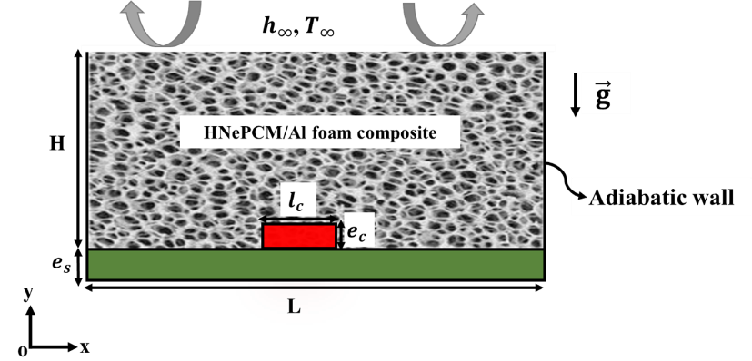
Figure 1. Computational domain.

TABLE 1. Thermophysical properties of N-eicosane (17,18).
Thermophysical properties | T_{m} (°C) | k  (W/m.K) | $μ$  (Pa.s) | L  (J/kg) | $$ρ$$  (kg/m³) | $$C_{p}$$  (J/kg. K) | $β$  (K⁻¹)
N-eicosane | 36 | 0.15 | 4.15 × 10⁻³ | 2.47 × 10⁵ | 769 | 2460 | 8.05 × 10⁻ ⁴

 | TABLE 2. Thermophysical properties of the materials used in this study (19,20).
Thermophysical properties |  | Thermal conductivity (W/m.K) | Specific heat  (J/kg. K) | Density (kg/m³) |  | Thermal expansion coefficient (K⁻¹)
Aluminum foam |  | 202.4 | 871 | 2719 |  | -
Electronic component |  | 170 | 740 | 3260 |  | -
Substrate |  | 19.7 | 900 | 3900 |  | -
GO |  | 5000 | 717 | 1800 |  | 45 × 10⁻⁶
MWCNT |  | 3000 | 796 | 1600 |  | 1.5 × 10⁻⁶

The HNePCM fluid was modeled as a homogeneous, single-phase mixture of PCM with GO and MWCNT nanoparticles. With the insertion of nanoparticles, the thermophysical properties of the pure PCM are altered based on the varying concentrations. The effective thermophysical properties, namely density, thermal conductivity, specific heat capacity, and viscosity, were calculated using standard mixture models, as outlined in the reference (21,22) and adopted by several researchers. A uniform dispersion of nanoparticles and negligible agglomeration were assumed. These effective properties were incorporated into the numerical model to simulate and evaluate the heat transfer performance of the heat sink during the phase change process, and are expressed as follows:

$$ρ_{HNepcm}=∅_{2}ρ_{{np}_{2}}+\left[\left(1-∅_{2}\right)\left\{∅_{1}ρ_{{np}_{1}}+(1-∅_{1}){ ρ}_{pcm}\right\} \right]$$ | ()

$$C_{p,HNepcm}=\frac{∅_{2}{\left(ρC_{p}\right)}_{{np}_{2}}+\left[\left(1-∅_{2}\right)\left\{∅_{1}{\left(ρC_{p}\right)}_{{np}_{1}}+(1-∅_{1}){\left(ρC_{p}\right)}_{pcm}\right\} \right]}{ρ_{HNepcm}}$$ | ()

$$L_{HNepcm}=\frac{(1-∅_{1}){\left(1-∅_{2}\right)\left(ρL\right)}_{pcm}}{ρ_{HNepcm}}$$ | ()

$$β_{HNepcm}=\frac{{∅_{2}\left(ρβ\right)}_{{np}_{2}}+\left[\left(1-∅_{2}\right)\left\{∅_{1}{\left(ρβ\right)}_{{np}_{1}}+(1-∅_{1}){\left(ρβ\right)}_{pcm}\right\} \right]}{ρ_{HNepcm}}$$ | ()

$$μ_{HNepcm}=\frac{μ_{pcm}}{{{(1-∅_{1})}^{2.5}\left(1-∅_{2}\right)}^{2.5}}$$ | ()

$$k_{HNepcm}=k_{Nepcm}×\frac{k_{{np}_{2}}+2k_{Nepcm}-2\left(k_{Nepcm}-k_{{np}_{2}}\right)∅_{2}}{k_{{np}_{2}}+2k_{Nepcm}+\left(k_{Nepcm}-k_{{np}_{2}}\right)∅_{2}}$$ | ()

In the above equations. (1)–(6), ∅₁ and ∅₂ are the concentrations of nanoparticles of type 1 and type 2, respectively. The subscripts HNepcm, Nepcm, pcm, np₁, and np₂, refer to the hybrid nano-enhanced PCM, single nano-enhanced PCM, PCM, type 1 of nanoparticles, and type 2 of nanoparticles, respectively.

Governing Equations
The following assumptions are made: the HNePCM and metal foam are considered pure, isotropic, and homogeneous; the fluid flow is considered to be laminar, Newtonian, and incompressible; and the Boussinesq approximation is applied. And the TCE, EC, and substrate materials are assigned extremely high viscosity (approximately 10²⁰ m²/s) and melting points to ensure they remain solid within the simulation domain. Based on these assumptions, the governing equations are derived as follows:
Continuity equation:
$$\frac{∂u}{∂x} + \frac{∂v}{∂y}=0$$ | ()
Momentum equation along the x-axis:
$$ρ_{HNepcm}\left(\frac{∂u}{∂t}+u\frac{∂u}{∂x}+v\frac{∂u}{∂y}\right)=-\frac{∂p}{∂x}+μ_{HNepcm}\left(\frac{∂^{2}u}{∂x^{2}}+\frac{∂^{2}u}{∂y^{2}}\right)+S_{x}$$ | ()
Momentum equation along the x-axis:
$$ρ_{HNepcm}\left(\frac{∂u}{∂t}+u\frac{∂u}{∂x}+v\frac{∂u}{∂y}\right)=-\frac{∂p}{∂y}+μ_{HNepcm}\left(\frac{∂^{2}v}{∂x^{2}}+\frac{∂^{2}v}{∂y^{2}}\right)+S_{y}$$ | ()
Where $S_{x}$ and $S_{x}$ are source terms, defined as:
$$S_{x}={- A}_{m}\frac{(1-f)²}{{(f}^{3}-0.001)}.u+\frac{μ_{HNepcm}}{K} u+\frac{1}{2}C_{i}ρ_{HNepcm}u\left|u\right|$$ | ()
$$S_{y}={- A}_{m}\frac{(1-f)²}{{(f}^{3}-0.001)}.v+\frac{μ_{HNepcm}}{K} v+\frac{1}{2}C_{i}ρ_{HNepcm}v\left|v\right|-{\left(ρβ\right)}_{Nepcm}g(T-T_{ref})$$ | ()
Energy equation:
$$\frac{∂T}{∂t}\left(ε {\left(ρc_{p}\right)}_{HNepcm}+(1-ε){\left(ρc_{p}\right)}_{mf}\right)+{(ρc_{p})}_{HNepcm}\left(u\frac{∂T}{∂x}+v\frac{∂T}{∂y}\right)=k_{eff}\left(\frac{∂²T}{∂x²}+\frac{∂²T}{∂y²}\right)-ερ_{HNepcm}L_{HNepcm}\frac{∂f}{∂t}$$ | ()

Initial and Boundary Conditions
The governing equations in this study are solved under the following initial and boundary conditions:

$t=0 , u = v = 0 , T_{ini}=T_{m}=36°C , f =0$ | ()

- No-slip boundary applied to the walls: $u=v=0$ | ()

- Insulated walls: $-k{\left.\frac{∂T}{∂η}\right|}_{wall}=0 , η⊥wall$ | ()

- Natural convection: $-k{\left.\frac{∂T}{∂y}\right|}_{ y=H}=h_{∞}\left(T-T_{∞}\right)$ | ()

- Boundary between surfaces (1 and 2):  ${-k}_{1}{\left.\frac{∂T}{∂η}\right|}_{interface}= {-k}_{2}{\left.\frac{∂T}{∂η}\right|}_{interface} , T_{1}=T_{2}\text{ , }η⊥wall$ | ()

Model Validation
Validation of the numerical model with nanoparticles was performed through comparison with the results of Khodadadi et al. (23). This validation concerns the freezing phenomenon of a copper nanoparticle–dispersed water PCM in a square cavity under differential heating. The left wall was maintained at 273.15 K, while the right wall was at 283.15 K. The upper and lower boundaries were treated as adiabatic. The freezing behavior of the NeMCP was analyzed for two nanoparticle concentrations: 0% and 20%. Figure 2 presents a comparison between our results and those reported by Khodadadi et al. (23), showing a strong agreement between the two studies.

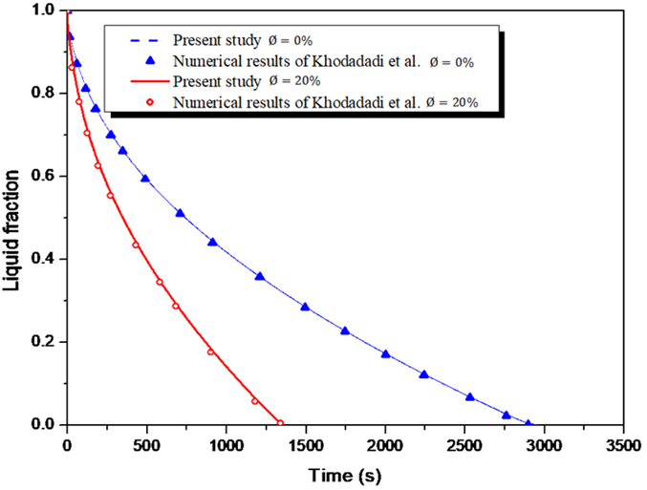
Figure 2. Comparison of numerical results with those of Khodadadi et al. (23) concerning the evolution of the NeMCP liquid fraction.
A mesh independence analysis is conducted using three mesh densities: coarse with 3,793, medium with 15,066, and fine with 18,074 elements. Triangular cells are employed, and the mesh close to the walls is refined, ensuring proper resolution of the thermal boundary layers.
As shown in Table 3 (A), at t = 1800 s, the differences in the operating temperature of the EC between the medium and fine meshes are negligible (0.12%).
A time step independence test is presented in Table 3 (B), using time steps of 1.5 s, 1 s, and 0.5 s with the mesh size of 15,066. The table indicates that the difference in the working temperature of the EC between 1 s and 0.5 s time steps is minimal (0.58%).
These results confirm that using a 1 s time step with the mesh of 15,066 elements offers a good compromise between computational accuracy and efficiency for the current study.

 | TABLE 3. Effect of mesh size and time step on the results at t = 1800 s.
- Mesh size |  | Temperature (°C) | Difference (%)
3,793 |  | 58.216 | -
15,066 |  | 59.375 | 1.10
18,074 |  | 59.302 | 0.12
- Time step (s) |  | Temperature (°C) | Difference (%)
1.5 |  | 59.00 | -
1 |  | 59.65 | 1.10
0.5 |  | 60.00 | 0.58

Results and discussion

Temperature of the Electronic Component
Figure 3 presents the profile of the average temperature of the EC for three heat sinks: PCM only, PCM/Al foam, and HNePCM+Al foam. It can be seen from this figure that the addition of Al foam and HNePCM significantly improves thermal regulation of the EC temperature versus the PCM-only case. For instance, in the PCM/Al foam case, the EC temperature drops by 15.85 °C at 4000 s, due to the enhanced effective thermal conductivity of the composite. In addition, similar thermal trends are observed in both PCM/Al foam and HNePCM+Al foam configurations, especially for GO:MWCNT ratios of 1:3 and 2:2. However, the 3:1 composition shows a slightly higher temperature. This is attributed to the increased viscosity from the higher GO content (3%), which raises thermal resistance, impedes buoyancy-driven flow, and decreases the overall heat transfer rate. Therefore, the impact of hybrid nanoparticles becomes negligible when metal foam is present, as the dominant enhancement in heat transfer is primarily due to the Al foam.

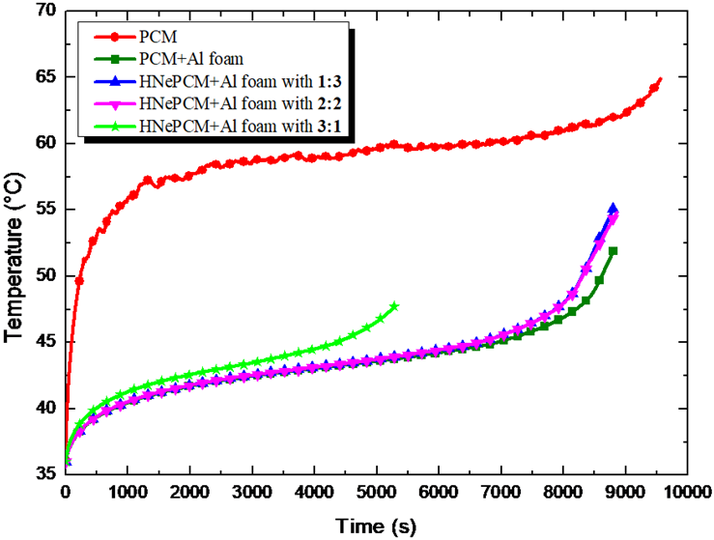
Figure 3. Profile of the working temperature of the EC for base PCM, PCM/Al foam, and HNePCM+Al foam for GO:MWCNT with different compositions.

Liquid Fraction
Figure 4 shows the evolution of the liquid fraction ($f$) for all the heat sink configurations studied, including pure PCM, PCM with aluminum foam, and HNePCM combined with aluminum foam, incorporating various GO:MWCNT ratios. It is evident that the pure PCM case exhibits the slowest melting duration, followed by the PCM/Al foam configuration. In contrast, the inclusion of hybrid nanoparticles significantly accelerates the melting process. Among the tested compositions, the mixture containing 3% GO and 1% MWCNT achieved the fastest melting rate. This trend is consistent with expectations, as GO has a substantially higher thermal conductivity compared to MWCNT (as shown in Table 2), thereby enhancing conductive heat transfer and expediting the phase change process.

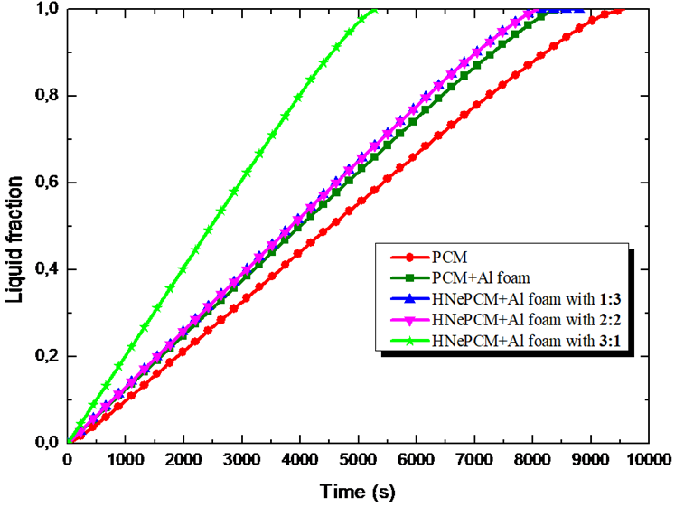
Figure 4. The evolution of the PCM fraction for PCM only, PCM/Al foam and HNePCM+Al foam for GO:MWCNT with different compositions.,

Effective Thermal Conductivity
Figure 5 shows the influence of the metal foam and HNePCM on the effective thermal conductivity ($k_{eff}$) of the PCM composite. As shown in Fig. 5, the $k_{eff}$ of the PCM increases significantly from 0.15 to 3.86 W/m.K upon embedding it in aluminum foam. A further enhancement to 4 W/m.K is achieved with the insertion of hybrid nanoparticles, particularly for a composition ratio of 3:1, compared to base PCM and PCM/Al foam. This enhancement is primarily attributed to the high thermal conductivity of the hybrid nanoparticles.
Although high volume fractions of nanoparticles can enhance thermal conductivity, they also lead to increased viscosity, which results in higher thermal resistance and adversely affects the fluid motion dynamics within the enclosure. This, in turn, reduces heat transport from the EC toward the PCM and may cause sedimentation and agglomeration of nanoparticles, leading to a deterioration in the effectiveness of the heat sink.
Furthermore, from a practical standpoint, this raises concerns about the economic viability of adding nanoparticles in such configurations. Given the high cost of advanced nanomaterials and potential stability issues, the marginal thermal benefits may not justify their use in real-world applications where metal foams already provide sufficient enhancement. Therefore, in PCM-based cooling systems with metal foam, the use of nanoparticles should be carefully evaluated based on specific application requirements and cost considerations.
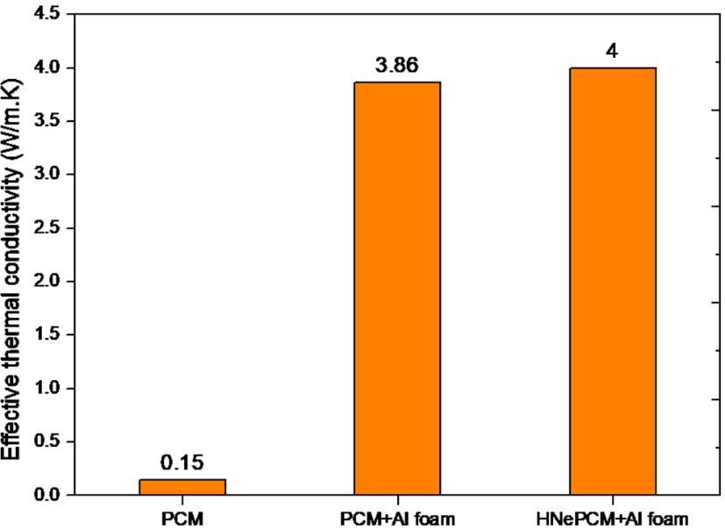
Figure 5. Change in the $k_{eff}$ for the heat sinks based on PCM, PCM+Al foam, and HNePCM+Al foam with the composition of 3:1.

CONCLUSION
A computational investigation was conducted to explore the melting behavior of a PCM in the presence of both aluminum foam and HNePCM within a rectangular enclosure containing a protruding electronic component. The influence of these thermal conductivity enhancers on the thermal efficiency of the heat sink was analyzed. The outcomes revealed that among the tested GO:MWCNT ratios, the 2:2 ratio was optimal in reducing both the electronic component’s operating temperature and the total melting time, achieving reductions of 26.92% and 18.13%, respectively, compared to the baseline PCM case. This configuration also resulted in a 26.67-fold increase in thermal conductivity while maintaining acceptable viscosity levels, making it the most balanced option for thermal management applications. However, the addition of hybrid nanoparticles had a negligible effect when metal foam was already present. Although higher thermal conductivity improves heat conduction, the increased viscosity can deteriorate the overall thermal efficiency of the system by suppressing natural convection. Therefore, while thermal performance improves, practical applications must carefully consider the trade-off between enhanced conductivity and increased viscosity.
Future work could involve three-dimensional (3D) modeling to overcome the limitations of the current 2D approximation.

Acknowledgments
None.

References
1. Alawadhi EM, Amon CH. PCM thermal control unit for portable electronic devices: Experimental and numerical studies. IEEE Transactions on Components and Packaging Technologies. 2003 Mar;26(1):116–25.
2. Hosseinizadeh SF, Tan FL, Moosania SM. Experimental and numerical studies on performance of PCM-based heat sink with different configurations of internal fins. In: Applied Thermal Engineering. 2011. p. 3827–38.
3. Faraji H, Faraji M, El Alami M. Numerical survey of the melting driven natural convection using generation heat source: Application to the passive cooling of electronics using nano-enhanced phase change material. J Therm Sci Eng Appl. 2020 Apr 1;12(2).
4. Arshad A, Jabbal M, Faraji H, Bashir MA, Talebizadehsardari P, Yan Y. Thermal process enhancement of HNCPCM filled heat sink: Effect of hybrid nanoparticles ratio and shape. International Communications in Heat and Mass Transfer. 2021 Jun 1;125.
5. en Zalba B, Mar ı ın JM, Cabeza LF, Mehling H. Review on thermal energy storage with phase change: materials, heat transfer analysis and applications [Internet]. Available from: www.elsevier.com/locate/apthermeng
6. Arshad A, Jabbal M, Sardari PT, Bashir MA, Faraji H, Yan Y. Transient simulation of finned heat sinks embedded with PCM for electronics cooling. Thermal Science and Engineering Progress. 2020 Aug 1;18.
7. Diani A, Rossetto L. Melting of pcms embedded in copper foams: An experimental study. Materials. 2021 Mar 1;14(5):1–13.
8. Zhao C, Opolot M, Liu M, Bruno F, Mancin S, Hooman K. Phase change behaviour study of PCM tanks partially filled with graphite foam. Appl Therm Eng. 2021 Sep 1;196.
9. Murali Naik J, Felix Prabhu F, Suresh R, Gopinathan R, Mohamed Nasrulla S, Joshi KA, et al. Investigating the performance of a NMPCM integrated heat sink for chipset cooling. Mater Today Proc. 2022 May;
10. Rehman T ur, Ali HM. Experimental investigation on paraffin wax integrated with copper foam based heat sinks for electronic components thermal cooling. International Communications in Heat and Mass Transfer. 2018;98:155–62.
11. Elshaer AM, Soliman AMA, Kassab M, Mori S, Hawwash AA. Experimental investigations on copper foam/PCM composite-based thermal control hardware (TCH) using foam samples with different pore sizes under intermittent thermal conditions. J Energy Storage. 2023 Nov 15;72:108320.
12. Chen SB, Saleem S, Alghamdi MN, Nisar KS, Arsalanloo A, Issakhov A, et al. Combined effect of using porous media and nano-particle on melting performance of PCM filled enclosure with triangular double fins. Case Studies in Thermal Engineering. 2021 Jun 1;25.
13. Buonomo B, Ercole D, Manca O, Nardini S. Numerical Analysis on a Latent Thermal Energy Storage System with Phase Change Materials and Aluminum Foam. Heat Transfer Engineering. 2020 Jul 3;41(12):1075–84.
14. Li Z, Shahsavar A, Al-Rashed AAAA, Talebizadehsardari P. Effect of porous medium and nanoparticles presences in a counter-current triple-tube composite porous/nano-PCM system. Appl Therm Eng. 2020 Feb 25;167.
15. Alshaer WG, Nada SA, Rady MA, Le Bot C, Palomo Del Barrio E. Numerical investigations of using carbon foam/PCM/Nano carbon tubes composites in thermal management of electronic equipment. Energy Convers Manag. 2015;89:873–84.
16. Faraji H, El Alami M, Arshad A. Investigating the effect of single and hybrid nanoparticles on melting of phase change material in a rectangular enclosure with finite heat source. Int J Energy Res. 2021 Mar 10;45(3):4314–30.
17. Saha SK, Srinivasan K, Dutta P. Studies on optimum distribution of fins in heat sinks filled with phase change materials. J Heat Transfer. 2008 Mar;130(3).
18. Nayak KC, Saha SK, Srinivasan K, Dutta P. A numerical model for heat sinks with phase change materials and thermal conductivity enhancers. Int J Heat Mass Transf. 2006 Jun 1;49(11–12):1833–44.
19. Afaynou I, Faraji H, Choukairy K, Arıcı M, Khallaki K. Heat transfer improvement of phase change materials by metal foams and nanoparticles for efficient electronic thermal management: A comprehensive study. Int J Heat Mass Transf. 2024 Aug 1;227.
20. Rodrigues BVM, Leite NCS, Cavalcanti B das N, da Silva NS, Marciano FR, Corat EJ, et al. Graphene oxide/multi-walled carbon nanotubes as nanofeatured scaffolds for the assisted deposition of nanohydroxyapatite: Characterization and biological evaluation. Int J Nanomedicine. 2016 Jun 13;11:2569–85.
21. Mahdi JM, Nsofor EC. Solidification enhancement in a triplex-tube latent heat energy storage system using nanoparticles-metal foam combination. Energy. 2017;126:501–12.
22. Valan Arasu A, Sasmito AP, Mujumdar AS. Thermal performance enhancement of paraffin wax with AL 2O 3 and CuO nanoparticles - A numerical study. Frontiers in Heat and Mass Transfer. 2011;2(4):1–7.
23. Khodadadi JM, Hosseinizadeh SF. Nanoparticle-enhanced phase change materials (NEPCM) with great potential for improved thermal energy storage. International Communications in Heat and Mass Transfer. 2007 May;34(5):534–43.

