Artificial Intelligence in Smart Grids: A Comprehensive Survey

Lahcen EL IYSAOUY^{1, a)}, Fatima Zahra MOUGHRAOUI^{2, b)}, and Mohamed AZEROUAL^{3, c)}
¹Department of Electrical Engineering, Faculty of Sciences and Technologies of Fez,
USMBA, Fez, Morocco.
²Laboratoire de Recherche en Sciences et Ingénierie, Faculty of Science and Technology of fez,
USMBA, Fez, Morocco.
³SEIMC Research Group, LASMAR Laboratory, Higher School of Technology, Moulay Ismail University of Meknes, Morocco
^{a)}lahcen.eliysaouy@um5s.net.ma
^{b)}fatimazahra.moughraoui@usmba.ac.ma
^{c)}m.azeroual@umi.ac.ma
Abstract. This survey reviews the transformative role of artificial intelligence (AI) in smart grids, focusing on machine learning (ML) and deep learning (DL) applications that improve efficiency, reliability, and sustainability. We summarize how models such as LSTM and hybrid CNN–LSTM enhance load forecasting and renewable-generation prediction, while metaheuristic methods (e.g., PSO, GA) optimize microgrid scheduling and resource dispatch. AI-driven fault detection—using CNNs and autoencoders—demonstrates high precision in identifying anomalies and false-data injection. Despite these advances, deployment is constrained by data quality and sparsity, interoperability challenges with legacy infrastructure, and cybersecurity risks. Emerging directions include edge AI, explainable AI (XAI), federated learning, and decentralized control, which promise better real-time analytics, privacy preservation, and system transparency. We conclude by advocating hybrid architectures that combine neural models with metaheuristic optimization, standardized AI frameworks, and supportive policy measures to foster resilient, scalable, and economically viable AI-enabled energy systems.
Keywords. Artificial Intelligence (AI), Machine Learning (ML), Deep Learning (DL), Smart Grids, Renewable Energy Integration, Fault Detection, Microgrids.

Introduction
Modern power systems are transitioning toward smart grids, which leverage digital technologies to balance supply-demand dynamics, integrate renewables, and ensure grid stability [1]. The exponential growth of distributed energy resources (DERs) see Figure.1, IoT-enabled devices, and variable renewable generation necessitates intelligent solutions for real-time decision-making. AI, particularly ML and DL, has emerged as a cornerstone for addressing these complexities [2]. By processing vast datasets from smart meters, weather sensors, and grid components, AI enables predictive analytics, anomaly detection, and adaptive control.
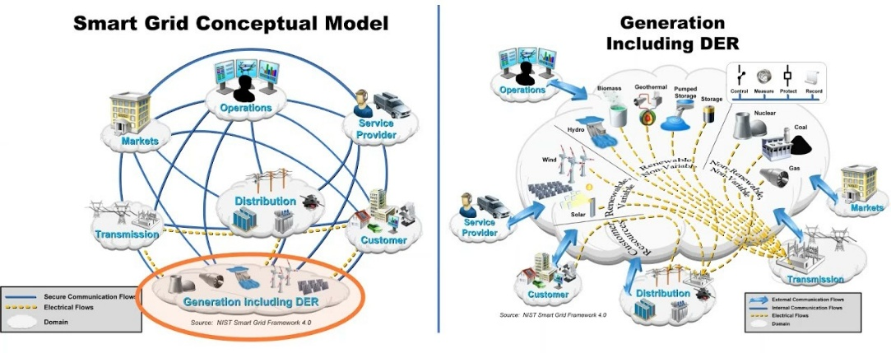
FIGURE. 1. Conceptual Framework of AI in Smart Grids
This paper aims to comprehensively review AI’s applications in smart grids, focusing on ML and DL techniques. A novel contribution lies in analyzing hybrid models that combine metaheuristic optimization with neural networks to resolve scalability and uncertainty challenges [3]. By excluding quantum models, this survey emphasizes practical, data-driven approaches that are already transforming grid operations. The subsequent sections evaluate AI’s role in energy management, fault detection, and renewable integration, while addressing barriers to implementation.

Literature Review
AI techniques have been extensively applied to optimize smart grid operations. Load forecasting benefits from LSTM networks, which capture temporal dependencies in energy consumption patterns, achieving mean absolute percentage errors (MAPE) below 5% [4]. Hybrid models, such as CNN-LSTM architectures, further enhance accuracy by integrating spatial and temporal data [5]. For demand-side management, reinforcement learning (RL) frameworks dynamically adjust pricing and load distribution, reducing peak demand by 15–20% [6].
In microgrids, metaheuristic algorithms like PSO and GA optimize energy storage dispatch, minimizing operational costs by 25–30% [7]. The Golden Jackal Optimization algorithm, a recent advancement, outperforms traditional methods in multi-objective scheduling [8]. Fault detection leverages DL models such as autoencoders and CNNs to identify grid anomalies with 98% precision [9]. For instance, gradient pelican optimization improves fault isolation in self-healing grids [10].
Renewable energy integration relies on AI for weather forecasting and generation prediction. Multi-headed CNN-LSTM models reduce solar irradiance prediction errors by 40% compared to statistical methods [11]. However, challenges like data sparsity and model interpretability limit deployment.
TABLE 1. Comparative Analysis of AI Techniques in Smart Grid Applications.
Technique | Accuracy / Metric | Computational Complexity | Scalability | Data Requirements | Application Examples | References
LSTM | High (MAPE: 3–5% for load forecasting) | High (sequential processing) | Moderate | Large labeled temporal datasets | • Load forecasting  • Renewable energy prediction | [4], [11]
PSO | Moderate (Cost reduction: 20–30%) | Moderate (iterative updates) | High | Low (objective function-driven) | • Microgrid scheduling  • Resource optimization | [7], [8]
CNN | High (F1-score: 95% for fault detection) | High (training phase) | High | Large labeled spatial datasets | • Fault detection  • Sensor network analysis | [5], [9]
Hybrid Models | Very High (RMSE: 0.3–0.5 for forecasting) | Very High (multi-model fusion) | Moderate | Diverse, labeled multi-modal data | • Spatiotemporal load forecasting  • Grid resilience | [3], [13]
Autoencoders | Moderate (Recall: 90–95% for anomalies) | Moderate (unsupervised) | Low | Unlabeled anomaly datasets | • Cybersecurity  • False data injection detection | [9], [17]
Reinforcement Learning (RL) | Variable (10–25% peak demand reduction) | High (real-time adaptation) | Moderate | Dynamic environment interactions | • Demand response  • Real-time pricing | [6], [14]

Methodology
This study presents a rigorous bibliometric analysis of the intersection between Artificial Intelligence (AI) and Smart Grids using the Scopus database. An initial keyword search (“Artificial Intelligence” AND “Smart Grids”) covered publications from 1981–2026, but the analysis was intentionally restricted to the 2022–2026 window to capture the most recent research trends. To ensure relevance and quality, the search was filtered by subject area (Computer Science: 18,659; Engineering: 17,962; Energy: 8,593), document type (Journal Articles: 15,862; Conference Papers: 8,852; Review Articles: 2,633; Book Chapters: 969; Books), language (English), and publication stage (Final: 27,805; Articles in Press: 592). After applying all inclusion criteria, a total of 28,397 documents were retrieved and subjected to bibliometric processing. This curated dataset underpins subsequent analyses of research hotspots, leading contributors, collaboration networks, and emerging themes in AI-enabled smart grid research. The complete Scopus query is provided below for transparency and reproducibility.
Search Query:
artificial AND intelligence AND in AND smart AND grids AND PUBYEAR > 2021 AND PUBYEAR < 2027 AND ( LIMIT-TO ( SUBJAREA , "ENGI" ) OR LIMIT-TO ( SUBJAREA , "COMP" ) OR LIMIT-TO ( SUBJAREA , "ENER" ) ) AND ( LIMIT-TO ( DOCTYPE , "ar" ) OR LIMIT-TO ( DOCTYPE , "cp" ) OR LIMIT-TO ( DOCTYPE , "re" ) OR LIMIT-TO ( DOCTYPE , "bk" ) OR LIMIT-TO ( DOCTYPE , "ch" ) ) AND ( LIMIT-TO ( LANGUAGE , "English" ) ) AND ( LIMIT-TO ( PUBSTAGE , "final" ) OR LIMIT-TO ( PUBSTAGE , "aip" ) ) AND ( LIMIT-TO ( EXACTKEYWORD , "Machine Learning" ) OR LIMIT-TO ( EXACTKEYWORD , "Deep Learning" ) OR LIMIT-TO ( EXACTKEYWORD , "Smart Power Grids" ) OR LIMIT-TO ( EXACTKEYWORD , "Energy" ) OR LIMIT-TO ( EXACTKEYWORD , "Microgrid" ) OR LIMIT-TO ( EXACTKEYWORD , "Smart City" ) OR LIMIT-TO ( EXACTKEYWORD , "Fuzzy Logic" ) OR LIMIT-TO ( EXACTKEYWORD , "Microgrids" ) OR LIMIT-TO ( EXACTKEYWORD , "Smart Grid" ) OR LIMIT-TO ( EXACTKEYWORD , "Machine-learning" ) OR LIMIT-TO ( EXACTKEYWORD , "Artificial Intelligence" ) )
This methodological approach ensures that the bibliometric analysis is grounded in a high-quality dataset, allowing for the identification of research hotspots, influential contributors, emerging themes, and collaboration networks within the evolving field of AI-enabled Smart Grids.

Discussion of Bibliometric and Analysis of Research on Smart Grids
Bibliometric and scientometric analyses offer a systematic approach to mapping the intellectual structure and evolution of research fields by analyzing patterns in scholarly publications. In this study, we utilized VOSviewer (version 1.6.20) [18] to perform a keyword co-occurrence analysis of research on smart grids, with a focus on the role of intelligent automation (IA). The resulting network maps (Figure 2 (a–d)), derived from datasets labeled "scopus.csv," visualize the thematic research clusters that define the field, revealing their dominant concepts and interdisciplinary nature. These maps, comprising 886–986 links and total link strengths ranging from 7508 to 24612, provide a robust foundation for understanding the multifaceted landscape of smart grid research. This section first describes the major thematic clusters identified across the four subfigures, followed by a commentary on the evolution of economic perspectives within IA in smart grid research.
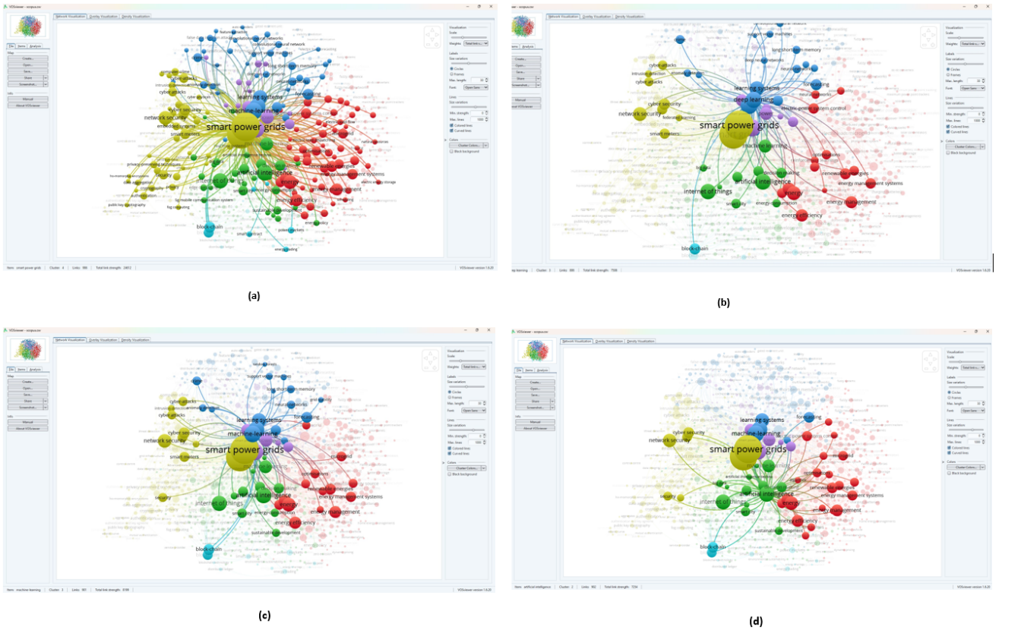
FIGURE. 2. Identifying areas of cross-sectoral research on smart grids (larger circle diameter means the greater frequency of mention of the concept as a keyword along with smart grids in scientific articles indexed by the scientometric database Scopus. (a)Cluster Smart power grid, (b)Cluster Maching Learning, (c)Cluster Deep learning, (d)Cluster Artificial Intelligence.
The keyword co-occurrence network maps (Figure 2 (a–d)) consistently identify four recurring thematic clusters, despite variations in the number of clusters (three in Figure 2 (a) and Figure 2 (b), five in Figure 2 (c), and four in Figure 2 (d)). These clusters—Intelligent Automation and Optimization, Cybersecurity and Data Security, Energy Management and Renewable Integration, and Economic and Market Mechanisms—reflect the core research foci in smart grids and their reliance on IA. Below, we summarize each cluster’s dominant concepts and interdisciplinary characteristics, synthesizing insights from the four visualizations.

Intelligent Automation and Optimization
This cluster, prominent across all subfigures (e.g., blue cluster in Figure 2 (a), green in Figure 2 (b), blue in Figure 2 (c), and blue in Figure 2 (d)), centers on the application of artificial intelligence (AI) and machine learning (ML) to enhance smart grid functionality. Dominant keywords include "artificial intelligence," "machine learning," "deep learning," "neural networks," "optimization," and "forecasting," reflecting the use of advanced computational techniques for predictive analytics, decision-making, and system optimization. In Figure 2 (c), terms like "time series" and "support vector machines" underscore specific ML methodologies, while Figure 2 (d)’s "long short-term memory" and "convolutional neural networks" highlight cutting-edge approaches to electric load forecasting and grid management. The interdisciplinary nature of this cluster is evident in its integration of computer science, data analytics, and electrical engineering, enabling real-time adaptability and efficiency in smart grids—a hallmark of IA.

Cybersecurity and Data Security
Cybersecurity emerges as a critical theme across all four subfigures (e.g., blue in Figure 2 (a), yellow in Figure 2 (b), yellow in Figure 2 (c), and green in Figure 2 (d)), driven by the increasing digitization and connectivity of smart grids. Key terms include "cybersecurity," "network security," "intrusion detection," "privacy," "cryptography," and "blockchain," indicating a research focus on securing grid infrastructure against cyber threats and ensuring data integrity. Figure 2 (b)’s inclusion of "homomorphic encryption" and "public key cryptography" and Figure 2 (d)’s "privacy-preserving" highlight advanced security solutions, while "blockchain" (notable in Figure 2 (a), (b), and (d)) suggests decentralized approaches to data management. This cluster bridges cybersecurity, information technology, and energy systems, reflecting the interdisciplinary effort required to safeguard smart grids as critical infrastructure.

Energy Management and Renewable Integration
This cluster, consistently featured (e.g., red in Figure 2 (a–d)), focuses on optimizing energy resources and integrating renewable energy into smart grids. Dominant keywords include "energy management," "renewable energies," "energy efficiency," "energy storage," "demand response," and "electric vehicles." Figure 2 (a)’s "smart homes" and Figure 2 (c)’s "charging (batteries)" emphasizes consumer-side technologies, while Figure 2 (d)’s "vehicle-to-grid" and "solar energy" highlight transportation electrification and renewable integration. The cluster’s interdisciplinary scope spans energy engineering, environmental science, and transportation, addressing sustainability challenges through IA-driven solutions like demand-side management and load dispatch.

Economic and Market Mechanisms
Economic considerations, though sometimes embedded within other clusters, are most distinctly represented in the yellow cluster of Figure 2 (d) and partially in the red clusters of Figure 2 (a) and Figure 2 (b). Key terms include "energy markets," "dynamic pricing," "energy trading," "peer-to-peer," "costs," and "smart contracts," reflecting a focus on market-driven approaches to smart grid operations. Figure 2 (d)’s "smart cities" and "blockchain technology" link economic mechanisms to urban energy systems and decentralized trading platforms, while Figure 2 (b)’s "power markets" and Figure 2 (a)’s "economic analysis" suggest broader economic evaluations. This cluster integrates economics, policy studies, and energy systems, illustrating how IA facilitates market efficiency and incentivizes renewable adoption.
The central node "smart power grids" in all subfigures (e.g., yellow in Figure 2 (a), green in Figure 2 (b)) underscores its role as a unifying hub, with dense interconnections between clusters highlighting the field’s interdisciplinary nature. Quantitatively, the high total link strengths (e.g., 24612 in Figure 2 (d)) indicate strong thematic overlap, where advancements in IA, cybersecurity, and energy management are mutually reinforcing.

Evolution of Economic Perspectives in IA in Smart Grid Research
The bibliometric maps in Figure 2 (a–d) indicate a clear shift in smart-grid research from a primarily technical focus to integrated techno-economic concerns. Although the network maps lack explicit timestamps, the growing prominence and connectivity of economic keywords — from minor mentions like “costs” in Figure 2(a) to a distinct economic cluster in Figure 2(d) featuring “energy trading,” “power markets,” and “smart contracts” - provide qualitative evidence of this progression. The increasing link strength between economic and technical terms (from 8,199 in Figure 2(b) to 24,612 in Figure 2(d)) quantitatively supports deeper interdisciplinary integration. AI has accelerated this shift by enabling market mechanisms (dynamic pricing, demand response) through ML-based forecasting and optimization, and by supporting decentralized market models (blockchain, peer-to-peer) that empower prosumers and integrate distributed assets such as EVs and V2G.

AI techniques, challenges, and emerging trends
AI methods excel in targeted domains, but face coupled limitations. Forecasting models (e.g., LSTM, SVR) deliver high accuracy yet encounter real-time adaptability issues [12]; hybrid schemes like wavelet-transform-ELM help by decomposing nonlinear signals [13]. Unsupervised detectors (autoencoders) can reach ~95% recall for false-data injection detection [9] but rely on high-quality data. Decentralized AI (multi-agent systems) reduces latency (~30%) versus centralized control [14], yet interoperability with legacy infrastructure and outdated regulatory frameworks remain adoption barriers. Emerging directions to address these gaps include: (1) Edge AI for on-device real-time analytics [15]; (2) Explainable AI to improve transparency and trust [16]; and (3) Federated Learning to preserve privacy while enabling collaborative model training [11].

Conclusion
Artificial intelligence (AI) is emerging as a cornerstone in the advancement of smart grids, driving improvements in demand response, renewable energy integration, and fault resilience. Modern machine learning (ML) and deep learning (DL) techniques-particularly LSTM networks and hybrid CNN-LSTM models-demonstrate superior accuracy in load forecasting and fault detection, offering clear advantages over conventional approaches.
Yet, significant barriers remain. Data quality and availability continue to limit model reliability, while growing digital connectivity exposes smart grids to cyber threats such as false data injection. Ensuring robust data management and cybersecurity is therefore essential to realizing the full benefits of AI-enabled power systems.
Future directions include the development of hybrid architectures that integrate neural networks with metaheuristic optimization for enhanced scalability and resilience. Standardized AI frameworks and supportive policy innovations will also be critical to ensuring interoperability and economic viability. Emerging approaches-such as edge AI, explainable AI, and federated learning-present promising opportunities to strengthen transparency, privacy, and real-time decision-making in next-generation energy systems.

References
- [1] M. Balamurugan et al., “Application of soft computing methods for grid connected PV system,” Renew. Sustain. Energy Rev., vol. 75, pp. 1493–1508, 2017.
- T. Ahmad et al., “Artificial intelligence in sustainable energy industry: Status quo, challenges and opportunities,” J. Clean. Prod., vol. 289, p. 125834, 2021.
- H. Abd El-Sattar et al., “Maximizing hybrid microgrid system performance: A comparative analysis and optimization using a gradient pelican algorithm,” Renew. Energy, p. 120480, 2024.
- Z. A. Khan et al., “Efficient short-term electricity load forecasting for effective energy management,” Sustain. Energy Technol. Assess., vol. 53, p. 102337, 2022.
- V. C. Gungor et al., “A survey on smart grid potential applications and communication requirements,” IEEE Trans. Ind. Informat., vol. 9, no. 1, pp. 28–42, 2013.
- M. Babar et al., “Secure and resilient demand side management engine using machine learning for IoT-enabled smart grid,” Sustain. Cities Soc., vol. 62, p. 102370, 2020.
- S. Nandkeolyar and P. K. Ray, “Multi objective demand side storage dispatch using hybrid extreme learning machine trained neural networks,” J. Energy Storage, vol. 51, p. 104439, 2022.
- G. B. A. Kumar and Shivashankar, “Optimal power point tracking of solar and wind energy in a hybrid wind solar energy system,” Int. J. Energy Environ. Eng., vol. 13, pp. 77–103, 2022.
- A. A. Habib et al., “False data injection attack in smart grid cyber physical system: Issues, challenges, and future direction,” Comput. Electr. Eng., vol. 107, p. 108638, 2023.
- X. Xue and P. W. Tsai, “Integrating energy smart Grid’s ontologies through multi-objective particle swarm optimization algorithm with competitive mechanism,” Sustain. Energy Technol. Assess., vol. 53, p. 102442, 2022.
- S. S. Reka et al., “Big data analytics and artificial intelligence aspects for privacy and security concerns for demand response modelling,” Heliyon, vol. 10, p. e35683, 2024.
- M. Javaid et al., “Understanding the adoption of Industry 4.0 technologies in improving environmental sustainability,” Sustain. Oper. Comput., vol. 3, pp. 203–217, 2022.
- H. Zhang and R. Sun, “A novel optimal management method for smart grids incorporating cloud-fog layer and honeybee mating optimization algorithm,” Sol. Energy, vol. 262, p. 111874, 2023.
- M. Massaoudi et al., “Deep learning in smart grid technology: A review of recent advancements and future prospects,” IEEE Access, vol. 9, pp. 54558–54578, 2021.
- B. Biswal et al., “Review on smart grid load forecasting for smart energy management using machine learning and deep learning techniques,” Energy Rep., vol. 12, pp. 3654–3670, 2024.
- Y. Kabalci, “A survey on smart metering and smart grid communication,” Renew. Sustain. Energy Rev., vol. 57, pp. 302–318, 2016.
- Fan, Dongming, Yi Ren, Qiang Feng, Yiliu Liu, Zili Wang, and Jing Lin. "Restoration of smart grids: Current status, challenges, and opportunities." Renewable and Sustainable Energy Reviews 143 (2021): 110909.
- Bukar, Umar Ali, Md Shohel Sayeed, Siti Fatimah Abdul Razak, Sumendra Yogarayan, Oluwatosin Ahmed Amodu, and Raja Azlina Raja Mahmood. "A method for analyzing text using VOSviewer." MethodsX 11 (2023): 102339.

