Temperature-Dependent Permeability of Cob: Impact on Hygrothermal Storage and Energy Efficiency in Buildings
Yousra TAOUIRTE^{1,2}, Hasna Louahlia ^{1, *}, Ayoub Gounni² and Mustapha El Alami²
¹ LUSAC Laboratory, University of Caen Normandy, Saint-Lo, France
² LPMAT Laboratory, Faculty of Sciences Ain Chock, Hassan II University, Casablanca, Morrocco.
*Correspondence: hasna.louahlia@unicaen.fr
Abstract. Porous earthen materials, such as cob, enhance building energy efficiency by acting as passive energy storage systems through heat and moisture regulation. Their ability to absorb, store, and release thermal energy depends on their hygrothermal properties, which are strongly influenced by temperature variations. This study examines the effect of temperature on the permeability of cob at 23 °C (representative of typical indoor comfort conditions) and 30 °C (representative of warm summer indoor or near-surface wall conditions), experimentally determined using the wet cup method. Results show a decrease in permeability with increasing temperature, with an average value of 3.53 × 10⁻¹¹ (Kg.m⁻¹.s⁻¹.Pa⁻¹) at 23°C and 1.87 × 10⁻¹¹ (Kg.m⁻¹.s⁻¹.Pa⁻¹) at 30°C. This reduction limits moisture exchange, decreasing latent heat transfer through adsorption and desorption. Consequently, more thermal energy is retained as sensible heat, increasing thermal inertia. Additionally, the open porosity and the hygroscopic diffusivity coefficient were evaluated at both temperatures, highlighting their role in heat and moisture storage. The findings provide new experimental evidence on how temperature influences the permeability of bio-sourced materials, together with complementary data on diffusivity coefficient and open porosity, enriching the understanding of cob’s hygrothermal behavior.
Keywords. Bioclimatic buildings, hygrothermal properties, moisture transfer, hygroscopic diffusivity, energy efficiency.

Introduction
Today, earthen construction is enjoying a revival, driven by a growing awareness of ecological issues and the need to develop sustainable solutions. Against a backdrop of energy transition and the fight against climate change, earth construction is positioning itself as a relevant alternative to conventional materials, offering environmental, economic, and health benefits [1]. Among the many traditional techniques available, cob is distinguished by its simplicity and efficiency. These materials, essentially made from raw earth, water, and often plant or animal fibers, can be used to build load-bearing, insulating walls while minimizing the building's carbon footprint [2]. Clay, naturally present in the earth, plays an essential role in ensuring the cohesion of the mixture, while fibers reinforce the structure and improve the mechanical and hygrothermal properties of the walls.
The energy efficiency of buildings is largely influenced by the materials' ability to regulate both heat and humidity. Building materials, particularly porous ones, play a key role in this regulation. The performance of these materials, specifically their ability to store and release heat and moisture, is strongly dependent on their hygroscopic properties, which in turn are influenced by temperature. Several recent studies have demonstrated that these properties vary with thermal conditions. For instance, Aït Oumeziane et al. [3], Poyet. [4], and Taouirte et al. [5] measured adsorption isotherms at different temperatures and observed that these isotherms are not identical at varying temperatures. These findings indicate that the ability of materials to adsorb moisture and store thermal energy changes with temperature, which alters their hygroscopic and thermal behavior. Feng et al. [6] and Aït Oumeziane et al. [3] also confirmed that the moisture buffering capacity, defined as a material’s ability to absorb or release moisture without significant temperature variation, is strongly affected by temperature. As temperature increases, the material’s moisture buffering capacity can vary, which affects its ability to regulate the internal humidity of a building.
In this context, Poyet et al. [7] proposed a theoretical framework to describe the relationship between temperature and the hygroscopic properties of materials. This theoretical model is validated by Colinart [8], [9], who conducted experiments to study the influence of temperature on relative humidity variations in building materials. The experimental results confirmed that temperature plays a crucial role in the hygroscopic behavior of materials, altering their capacity to adsorb and release moisture depending on climatic conditions.
This study investigates the influence of temperature on the vapor permeability of cob and examines its implications for heat storage and overall building energy efficiency. Permeability is analyzed at 23 °C and 30 °C, representative of typical indoor comfort and warm summer conditions, respectively. In addition, other key hygroscopic properties, such as the hygroscopic diffusivity coefficient, and open porosity, were evaluated. By addressing the temperature dependence of these parameters, the research provides valuable insights into the hygrothermal performance of cob, thereby supporting its application as a sustainable and high-performance building material across different climatic contexts.

Materials
The soil studied is characterized by a granulometric composition consisting mainly of three fractions: clay (7.64 %), silt (74.38 %), and sand (10.70 %) [10]. The clay fraction, composed of particles smaller than 2 µm, plays a crucial binding role, although its proportion is slightly below the optimal range (10–30 %) needed to prevent shrinkage cracks. The silt fraction improves workability and balances the texture, while the sand fraction ensures mechanical strength and limits shrinkage. The soil moisture content is 14 %. The clay activity, assessed by the methylene blue value (0.55 g/100 g), provides information on the adsorption capacity and cohesion of the particles. A precise balance between these fractions is essential to guarantee the structural and thermal performance of cob materials, adapted to local soils and intended use [11]. The mixture consists of a volumetric ratio of one bucket of soil to one bucket of flax straw fibers, corresponding to a fiber content of approximately 2.5 % by dry weight of the soil, ensuring a solid and durable structure. Figure 1 presents a cob sample made from this mixture.
All materials used in this study originate from the Normandy region, which simplifies sourcing while promoting the use of local resources, thereby reducing the carbon footprint. This choice offers several advantages, including minimizing the environmental impact associated with transportation, supporting the local economy, and ensuring better adaptation of materials to the specific climatic and geological conditions of Normandy. This approach aligns with a sustainable strategy aimed at fostering more ecological and resilient construction.

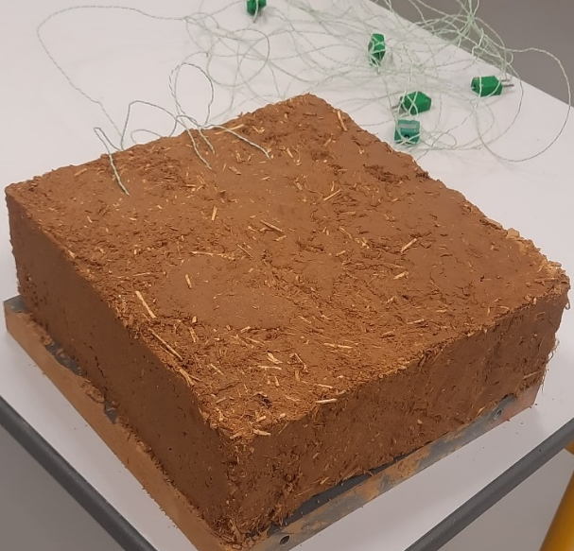
Figure 1. Cob sample

Experimental methods
In order to assess the influence of temperature on the water vapor permeability of cob materials, an experimental campaign is carried out in accordance with ISO 12572 [12], using the wet cup method. This method is based on the establishment of a controlled hygrometric gradient across the sample, generally between 50% and 98% relative humidity, to analyze the material's ability to diffuse water vapor. This method is selected because it reproduces high-humidity conditions representative of real applications and provides reliable and reproducible measurements compared to other approaches.
To achieve this, each cubic sample (7 cm³) is placed between two experimental compartments in which temperature and relative humidity were strictly regulated. On the lower side, a saturated saline solution is used to impose a constant, known humidity, enabling the partial pressure of water vapor to be fixed, while the upper side is left free, without hygrometric control, in order to create a concentration gradient conducive to diffusion (figure 2). A thermal gradient is also introduced to study the coupled effect of temperature and humidity on the material's transfer properties; to this end, two electrical resistors controlled by controllers were installed on either side of the sample to maintain distinct temperatures. All temperature and humidity sensors were calibrated beforehand to guarantee the reliability of the measured data. Combined temperature-humidity sensors of type HMP110, with an accuracy of ±1.5%, were positioned in the upper and lower compartments, while miniature sensors of type HIH-400-003, with an accuracy of ±3.5%, were inserted at various depths inside the sample as well as on its surfaces, enabling fine analysis of the hygrometric distribution. In addition, six K-type thermocouples, 0.5 mm in diameter and accurate to ±0.5°C, were strategically placed in the center of the sample, on its surfaces, and in the experimental environment, providing detailed monitoring of temperature trends throughout the test phase. All the sensors were connected to data acquisition cards linked to a computer, enabling automatic, continuous recording of measurements every 30 seconds. A data acquisition and processing program is developed using LABVIEW software, guaranteeing synchronization of measurements and complete traceability of experiments.
Based on the specified accuracies of the temperature and humidity sensors, the overall measurement uncertainty is estimated to be approximately ±2.5% using Gaussian error propagation.

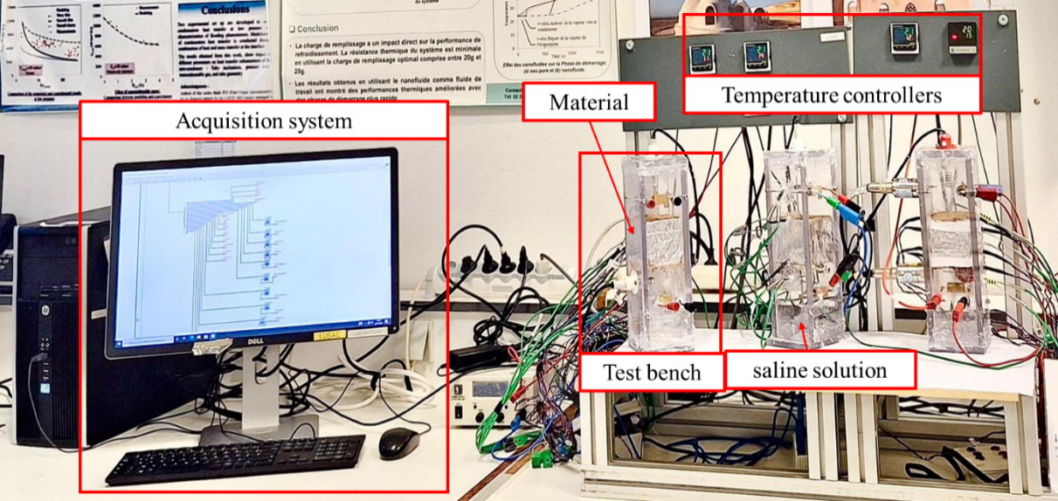
Figure 2. Experimental set-up

Modeling framework

Water vapor permeability
In steady-state conditions, the water vapor flux passing through the sample is determined from the slope of the linear regression curve linking the sample mass to time. This calculation is performed after excluding the initial phase, which exhibits nonlinear behavior, to ensure reliable results. The vapor flux measurement is based on tracking the sample mass over time. The variation in the sample's weight is then expressed as:

 | $$G=\frac{∆m}{∆t}$$ | (1)

Where 𝐺 is the mass gain over time [kg. s⁻¹], $∆m$ [kg] is the mass variation of the assembly during the time interval ∆t [s].
Thus, the flux density of the vapor, [kg.m⁻¹. s⁻¹], is expressed as follows:
 | $$g_{v}=\frac{δ_{m}∆P_{v}}{e}$$ | (2)

$δ_{m}$ [$kg$.m⁻¹. s⁻¹. Pa⁻¹] denotes the material's vapor permeability, $P_{v}$ [Pa] s the partial vapor pressure, and e [m] is the thickness of the sample.
We thus conclude the vapor flux density as:
 | $$g_{v}=\frac{G}{A}$$ | (3)
Where A [m²] is the exposed surface area of the sample, averaged between the inner and outer surfaces.
In conclusion, vapor permeability is determined from the established relations at steady state, as shown in equation (4).
 | $$δ_{m}=\frac{∆m.e}{∆t.A.∆P_{v}}$$ | (4)

Hygroscopic diffusivity coefficient
Water diffusivity measures a material's ability to diffuse water vapor. It depends on porosity, permeability and the surrounding temperature and pressure. A high-water diffusivity allows water to move quickly, while a low-porosity material has a lower diffusivity, making it more resistant to water infiltration.
The moisture flux density through a material in the isothermal regime and in the case of one-dimensional transfer is written as follows:
 | $$J=-D_{ω}\frac{∂ω}{∂x}$$ | (8)
 | $$J=-D_{ω}\frac{∂ω}{∂φ}\frac{∂φ}{∂x}$$ | (9)
The analogy between Fourier's law for thermal diffusion and Fick's law for mass diffusion is clearly demonstrated by this equation. Indeed, the water diffusivity $D_{ω}$ is equivalent to the thermal diffusivity. Water vapor transport theory is based on Fick's law. Consequently, vapor transfer in air by molecular diffusion can be expressed as a function of the vapor concentration gradient:
 | $$J=-δ_{m}\frac{δP_{v}}{δx}$$ | (10)

With
 | $$φ=\frac{P_{v}}{P_{s}}$$ | (11)

According to the two relations, the diffusion coefficient is:
 | $$D_{ω}=\frac{δ_{m}P_{s}}{\frac{∂ω}{∂φ}}$$ | (12)

Results and discussion

Effect of Humidity and Temperature on cob Porosity
Open porosity, also known as effective porosity [13], is the amount of empty space accessible from the volume of a material. It is measured as the fraction of the total volume occupied by open pores and can influence the material's physical and mechanical properties. Saturation of the sample occurs when all the pores in the material are filled with water, enabling open porosity to be calculated using the saturation mass water content value [14], [15].

 | $$ε_{o}\left(\%\right)=W.\frac{ρ_{M}}{ρ_{l}}$$ | (5)

W: Saturation water content by mass.
$ρ_{M}$: Dry bulk density.
$ρ_{l}$: Density of liquid water.
Regarding the water content of the cob material, it is investigated by Taouirte et al. [5] at two specific temperatures, 23°C and 30°C. The experimental measurements were adjusted using the GAB model, which allows for modeling the variations in water content based on relative humidity. As a result, the following equations were derived: (1) the water content of the cob at 23°C, and (2) the water content at 30°C.
 | $$W(φ)= \frac{0.196 φ}{\left(1-0.802 φ\right)\left(1+2.47 φ\right)}$$ | (6)

 | $$W(φ)= \frac{0.0021φ }{\left(1-0.704 φ\right)\left(1-0.682 φ\right)}$$ | (7)

It is important to highlight that the equilibrium water content decreases with increasing temperature for a given relative humidity, as shown in Figure 3. This indicates that at higher temperatures, the water adsorption capacity of cob materials is reduced. For instance, at a relative humidity of 80%, the difference in adsorbed water mass between 30°C and 23°C is 0.1%. These results clearly demonstrate the significant impact of temperature on the sorption process in the studied cob materials. Higher temperatures promote the desorption of water molecules due to the increased thermal energy, which reduces the affinity of the pores for retaining water. This relationship between temperature and sorption is crucial for understanding the hygroscopic behavior of cob materials in varying climatic conditions.

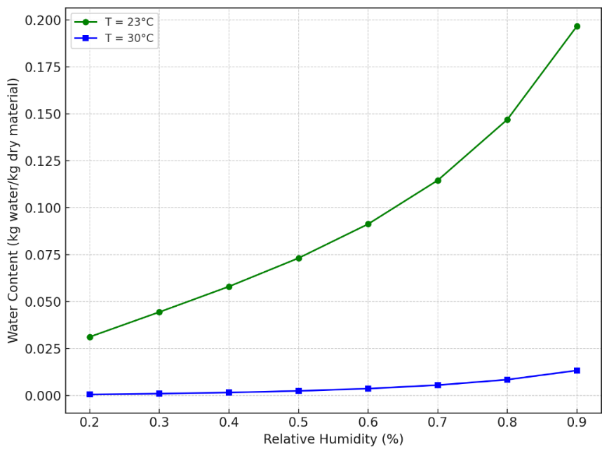
Figure 3. Water Content of the cob Material as a Function of Relative Humidity at 23°C and 30°C

Figure 4 shows the evolution of the open porosity of the cob as a function of relative humidity, for two temperatures: 23°C and 30°C. It is observed that open porosity increases with the increase in relative humidity but decreases with the temperature rise. When a material is exposed to a relative humidity of 40% and a temperature of 23°C, it absorbs moisture until it reaches a saturation point, where equilibrium is achieved. This saturation point means that the pores of the material are filled to the maximum moisture level that this combination of relative humidity and temperature can allow. As relative humidity increases, even if the temperature remains constant, the material can still absorb more moisture. This phenomenon can be explained by the characteristics of open porosity and the interactions between the pores and water vapor. In other words, when relative humidity increases, the concentration of water vapor in the air also increases, disturbing the adsorption equilibrium that is established in the material. This causes the internal surfaces of the pores to capture more water molecules to restore this equilibrium. Thus, a higher relative humidity means that a greater amount of water vapor is available to be adsorbed by the pore walls. However, when the temperature increases, a decrease in open porosity is observed. This phenomenon can be explained by the thermal effects on the material's structure. At higher temperatures, porous materials often undergo partial pore contraction due to a thermal reorganization of the bonds at the microscopic scale. This contraction reduces the available space for water adsorption, leading to a decrease in effective open porosity. Moreover, an increase in temperature alters the dynamics of interactions between water and the pore walls. A higher temperature generally reduces the adsorption forces of water molecules on the pore walls because the increased thermal energy favors the desorption of water molecules. Consequently, although water diffusion in the pore network is accelerated at high temperatures, the effective adsorption of water molecules decreases, limiting the overall absorption capacity of the material.

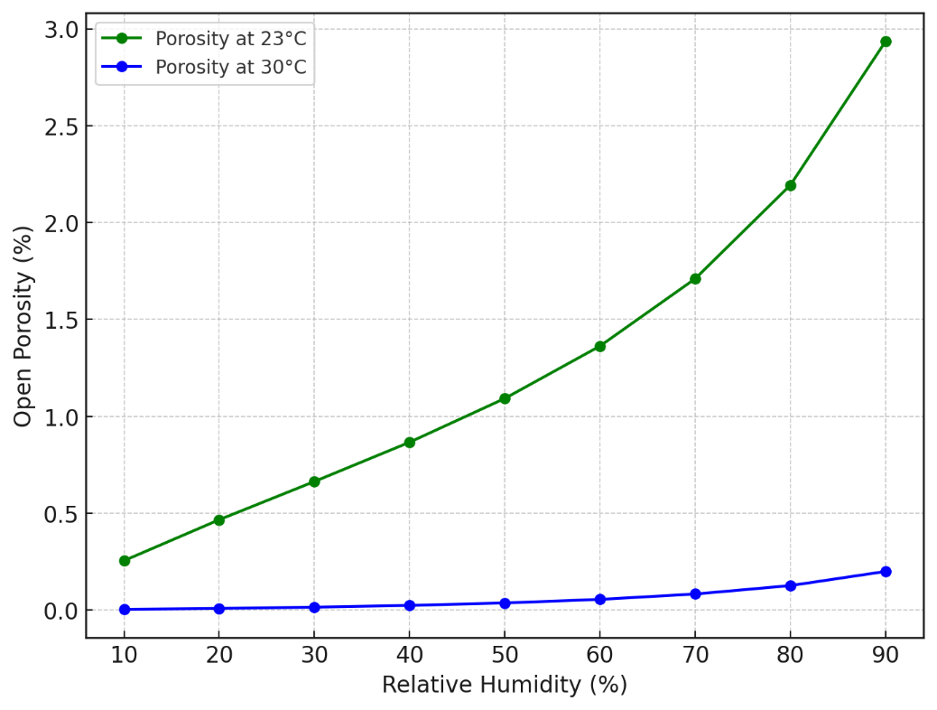
Figure 4. Open Porosity vs Relative Humidity at 23°C and 30°C

Impact of Temperature on Cob Permeability
Temperature plays a crucial role in the behavior of porous materials, influencing their ability to transport fluids through their structure. Thermal variations can lead to significant changes in permeability, depending on the intrinsic properties of the materials and their interactions with the environment. The effect of temperature on the permeability of porous materials can follow three main trends: a decrease in permeability with increasing temperature, an initial decrease followed by an increase, or a continuous increase. Kallel [16], [17] showed that for concrete tested at 30°C and 90°C under different relative humidities, temperature had no significant effect on permeability. In contrast, Lion et al. [18], studying mortars at 25°C, 105°C, and 200°C, found a significant increase in permeability with temperature, attributed to thermal cracking and an increase in porosity due to the dehydration of hydrates. Joshaghani and Ghasemi-Fare [19] studied the permeability of soils and observed that Ottawa sand permeability decreased by 50% between 20°C and 80°C, while kaolinitic clay permeability decreased slightly.
The effect of temperature on the permeability of the cob material is studied at two temperatures, 23°C and 30°C. The results, presented in Figure 5, show that the permeability of the material decreases with increasing temperature. This decrease can be explained by several factors. First, the reduction in air viscosity at higher temperatures could theoretically facilitate moisture transfer, but it could also lead to a redistribution of moisture within the material, thus limiting the water vapor transfer. Second, microstructural changes may occur at higher temperatures, such as the expansion or contraction of the internal structures of the material, altering the size and distribution of the pores. This change could reduce the connectivity of the pores, thereby decreasing permeability. Furthermore, we observed that the open porosity of the material decreases with increasing temperature. This reduction in open porosity is directly related to the observed decrease in permeability. When open porosity decreases, there are fewer connected pathways through the material, which restricts moisture flow. At higher temperatures, phenomena such as thermal expansion, moisture evaporation, and microstructural changes can contribute to this reduction in open porosity, tightening the pores or reducing their connectivity. As a result, the material's permeability decreases due to the reduced ability of these pores to allow moisture passage.

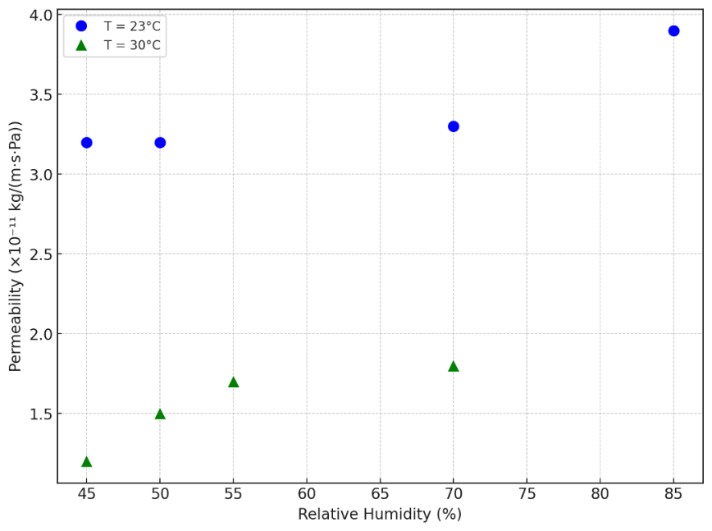
Relative humidity (%)
Permeability ($×$ 10⁻¹¹.kg.m⁻¹. s⁻¹. Pa⁻¹)
Figure 5. Variation of Cob Material Permeability as a Function of Temperature and Relative Humidity

Impact of Temperature and Humidity on Cob Diffusivity
The water vapor diffusivity of the materials investigated is presented in Figure 6 on a logarithmic Y-axis as a function of relative humidity, at constant temperatures of 23°C and 30°C. The results indicate that as relative humidity increases, the water vapor diffusivity decreases. This behavior can be attributed to the fact that at high relative humidity, the pores within the material are partially saturated, reducing the available pathways for moisture transport. At lower relative humidity, the pores are more accessible, which facilitates the movement of water vapor. In contrast, at higher humidity levels, pore saturation limits the diffusion process. Furthermore, at low relative humidity, the sorption capacity is still far from its maximum, meaning that there are more available pores for water vapor transport, thus increasing diffusivity. As relative humidity rises, the pores gradually fill, and the competition between adsorption and diffusion reduces the efficiency of moisture transport. Additionally, it is observed that the water vapor diffusivity increases with temperature, with higher values recorded at 30°C compared to 23°C. This higher temperature enhances the material’s ability to retain moisture by increasing the mobility of water molecules in the pores, thus improving the transport of water vapor.

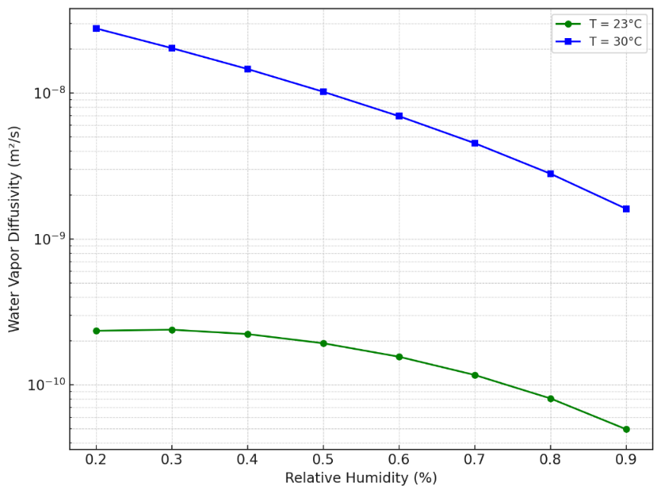
Relative humidity (%)
Water vapor diffusivity (m².s⁻¹)
Figure 6. Effect of Relative Humidity and Temperature on Water Vapor Diffusivity in cob Material

CONCLUSION
This study demonstrates that temperature has a significant impact on the hygroscopic properties of cob material, directly influencing its effectiveness for thermal storage and moisture regulation in buildings. At higher temperatures, the vapor permeability and porosity of the material decrease, which reduces latent heat transfer through adsorption and desorption, favoring the conservation of sensible heat. This improves the material's thermal inertia, allowing for better indoor temperature regulation.
However, this reduction in permeability and porosity limits the cob’s ability to absorb and store moisture, affecting its efficiency for latent heat storage. In other words, at higher temperatures, although the vapor diffusion capacity increases, pore saturation reduces the material’s ability to store heat in its latent form.
Thus, rammed earth remains an effective material for thermal regulation through sensible heat, but its overall energy efficiency depends on the balance between temperature variations and its moisture adsorption and diffusion capacities. These results highlight the importance of considering climatic conditions and thermal variations when using cob material in energy-efficient construction.

Acknowledgments
This work is conducted as part of the CobBauge project selected by the European cross-border cooperation program, INTEREG V France (Manche)–England. The authors would like to thank the ERDF for funding this work. The authors also acknowledge the scholarship support provided by the Moroccan National Center for Scientific and Technical Research (CNRST).

References
[1] Y. Taouirte, T. Kaoutari, H. Louahlia, A. Gounni, et M. El Alami, « Experimental Study on the Hygrothermal Effect of Incorporating Phase-Change Materials in Cob Construction », Buildings, vol. 15, nº 7, Art. nº 7, janv. 2025, doi: 10.3390/buildings15071047.
[2] F. Pacheco-Torgal et S. Jalali, « Earth construction: Lessons from the past for future eco-efficient construction », Construction and building materials, vol. 29, p. 512‑519, 2012.
[3] Y. Aït Oumeziane, S. Moissette, M. Bart, et C. Lanos, « Influence of temperature on sorption process in hemp concrete », Construction and Building Materials, vol. 106, p. 600‑607, mars 2016, doi: 10.1016/j.conbuildmat.2015.12.117.
[4] S. Poyet, « Experimental investigation of the effect of temperature on the first desorption isotherm of concrete », Cement and Concrete Research, vol. 39, nº 11, p. 1052‑1059, nov. 2009, doi: 10.1016/j.cemconres.2009.06.019.
[5] Y. Taouirte, A.-L. Tiffonnet, M. Marion, H. Louahlia, M. El Alami, et Ayoub Gounni, « Effect of Temperature on Moisture Migration in Earth and Fiber Mixtures for Cob Materials », Energies, vol. 16, nº 14, Art. nº 14, janv. 2023.
[6] C. Feng, H. Janssen, Y. Feng, et Q. Meng, « Hygric properties of porous building materials: Analysis of measurement repeatability and reproducibility », Building and Environment, vol. 85, p. 160‑172, févr. 2015, doi: 10.1016/j.buildenv.2014.11.036.
[7] S. Poyet et S. Charles, « Temperature dependence of the sorption isotherms of cement-based materials: Heat of sorption and Clausius–Clapeyron formula », Cement and Concrete Research, vol. 39, nº 11, p. 1060‑1067, nov. 2009, doi: 10.1016/j.cemconres.2009.07.018.
[8] T. Colinart et P. Glouannec, « Temperature dependence of sorption isotherm of hygroscopic building materials. Part 1: Experimental evidence and modeling », Energy and Buildings, vol. 139, p. 360‑370, mars 2017, doi: 10.1016/j.enbuild.2016.12.082.
[9] T. Colinart, P. Glouannec, M. Bendouma, et P. Chauvelon, « Temperature dependence of sorption isotherm of hygroscopic building materials. Part 2: Influence on hygrothermal behavior of hemp concrete », Energy and Buildings, vol. 152, p. 42‑51, oct. 2017, doi: 10.1016/j.enbuild.2017.07.016.
[10] « Technical-report_ESITC_feb2019.pdf ». Consulté le: 9 décembre 2022. [En ligne]. Disponible sur: http://www.cobbauge.eu/wp-content/uploads/2019/05/Technical-report_ESITC_feb2019.pdf
[11] M. C. Jiménez Delgado et I. C. Guerrero, « The selection of soils for unstabilised earth building: A normative review », Construction and Building Materials, vol. 21, nº 2, p. 237‑251, févr. 2007, doi: 10.1016/j.conbuildmat.2005.08.006.
[12] 14:00-17:00, « ISO 12572:2016 », ISO. Consulté le: 25 mai 2023. [En ligne]. Disponible sur: https://www.iso.org/fr/standard/64988.html
[13] F. A. Dullien, Porous media: fluid transport and pore structure. Academic press, 2012.
[14] A. E. Charola et E. Wendler, « An Overview of the Water-Porous Building Materials Interactions », Restoration of Buildings and Monuments, vol. 21, nº 2‑3, p. 55‑65, juin 2015, doi: 10.1515/rbm-2015-2006.
[15] T. Tracz, « Open porosity of cement pastes and their gas permeability », Bulletin of the Polish Academy of Sciences. Technical Sciences, vol. 64, nº 4, 2016.
[16] H. Kallel, H. Carré, C. La Borderie, B. Masson, et N. C. Tran, « Influence de la température et de l’hygrométrie sur la perméabilité à l’Azote du béton », in Rencontres Universitaires de Génie Civil, Bayonne, France, mai 2015. Consulté le: 20 août 2023. [En ligne]. Disponible sur: https://hal.science/hal-01167595
[17] H. Kallel, « Influence de la température et de l’hygrométrie sur le comportement instantané du béton », PhD Thesis, Université de Pau et des Pays de l’Adour-Laboratoire SIAME, 2016. Consulté le: 5 décembre 2024. [En ligne]. Disponible sur: https://univ-pau.hal.science/tel-02367577/
[18] M. Lion, F. Skoczylas, et A. Play, « Perméabilité au gaz des matériaux à matrice cimentaire en fonction de la température ».
[19] M. Joshaghani et O. Ghasemi-Fare, « Exploring the effects of temperature on intrinsic permeability and void ratio alteration through temperature-controlled experiments », Engineering Geology, vol. 293, p. 106299, nov. 2021, doi: 10.1016/j.enggeo.2021.106299.

