Numerical Study on the Efficiency Improvement of Latent Heat Storage Systems with Innovative Hexagonal Fins
Manal HARISS^{1*}, Ayoub Gounni¹, Mustapha El Alami¹
¹ Laboratory (LPMAT), Faculty of Sciences, Hassan II University of Casablanca-Morocco
^{a)} Corresponding author: harissmanal@gmail.com
^{b)} gounni.ayoub@gmail.com
^{c)} elalamimus@gmail.com

Abstract. Phase change material (PCM)-based latent heat thermal energy storage (LHTES) is studied in this work. Note that most phase change materials have weak thermal conductivity, posing challenges for the advancement of LHTES technology. Therefore, developing effective heat transfer enhancement approaches is critical for the substantial use of LHTES systems. This research proposes using a hexagonal-shaped fin to improve the efficiency of an LHTES unit. The bottom surface of the rectangular enclosure is continuously heated and filled with N-Eicosane. A reference configuration with only pure phase change material was compared with the hexagonal-shaped fin configuration. Using commercial CFD software based on the finite volume method, we conducted simulations to analyze the thermal performance of the LHTES. One of the primary goals of this investigation is to compare different configurations based on charging time. The results show that hexagonal fins significantly improve the thermal performance of the storage unit, reducing total melting time by 13.25% compared with the reference configuration. Furthermore, a comparison of the evolution of stored latent heat indicates that this physical property increases more rapidly with the addition of hexagonal fins than with the reference configuration. The addition of these innovative fins enables the maximum value of stored energy to be reached in a shorter time. These findings may be useful for managing the temperature of electronic components using phase change material.
Introduction
Resource scarcity and environmental pollution pose significant global challenges, impacting socio-economic development and requiring strategic long-term energy planning. Renewable energy, particularly solar energy, plays a vital role in reducing environmental impacts. However, its intermittency often leads to mismatches between supply and demand, making efficient energy storage essential. Latent heat thermal energy storage (LHTES) systems using phase change materials (PCMs) offer a promising solution, as PCMs can absorb and release energy through phase transitions. Nevertheless, their low thermal conductivity remains a key limitation, hindering heat transfer and delaying complete phase change. To address these issues, various thermal enhancement strategies are being investigated [1], including the integration of high-conductivity structures [2], [3], nanoparticles [4], and metallic foams [5].
N.B. Khedher et al. [6] incorporate innovative curved fins to improve phase change during melting and solidification. They examine numerically the geometrical characteristics of the fins in a shell-and-tube heat exchanger. Outcomes reveal that charging/discharging rate increases by 543/302% and 141/290% compared to the no-fin scenario, and straight fins, respectively. X. Chen et al. [7] proposed a shrinkable honeycomb structure to improve the cooling performance and temperature uniformity in proton exchange membrane fuel cell (PEMFC). The study evaluates various cooling channel configurations for a PEMFC, including parallel, serpentine, honeycomb, and shrinkable honeycomb designs. Better temperature uniformity and a lower maximum temperature of 332.2K are two advantages of the shrinkable honeycomb design over the others. F. Ren et al. [8] studied a bionic fin with the shape of an alveolar vessel and nanofluid. Compared to conventional rectangular fins, alveolar vascular fins provide better heat dissipation. The heat storage method was optimized using computational fluid dynamics (CFD) simulations. Outcomes revealed that a nanofluid with 5% copper nanoparticles in water has a 27.63% higher heat storage density than pure water. C. Wang et al. [9] proposed a novel biometric fishbone fin. The impact of the fin curvature and fractal position is numerically investigated. Results show the optimal thermal performance was achieved with a fishbone fin radian angle of 44.43°C, and a dimensionless position of 0.04. Furthermore, the optimized design increases the average heat transfer rate by 101.58% and decreases cycle time by 52.64% when compared to conventional straight regular fins. X Shen et al. [10] conducted a numerical investigation into the thermal performance of a PCM-based battery thermal management system that utilizes spider web-like fins. Outcomes revealed that this innovative structure exhibits improved cooling performance and provides efficient heat transfer paths.
The present study proposes a novel hexagonal fin configuration designed to overcome the thermal conductivity limitations of phase-change materials. Inspired by honeycomb structures, known for their robustness and efficiency in heat flow distribution, this innovative geometry takes advantage of both the benefits of conventional fins and those of hexagonal patterns. This original coupling optimizes heat transfer while ensuring more homogeneous PCM melting. The approach thus developed opens up new prospects for improving the thermal performance of latent heat storage systems.
NUMERICAL METHOD
As part of this study, the melting process in a latent heat storage system (LHTES) was represented using a numerical approach based on the finite volume method, coupled with the enthalpy-porosity method. The loading phase of the phase change material (PCM) was simulated using a computational fluid dynamics (CFD) tool. The structured mesh used comprised between 10,050 and 12,024 cells, depending on the configuration considered. In order to improve the accuracy of the results and better describe the internal evolution of the flow, adaptive mesh refinement was applied.
The two-dimensional transient heat transfer model set up for PCM melting is based on several simplifying assumptions:
- The thermophysical properties of the phase change material are assumed to be independent of temperature and time, to simplify numerical modeling;
- The molten fluid is represented as a Newtonian, homogeneous, and incompressible medium;
- Natural convection induced in the liquid phase is not taken into account;
- The flow is considered laminar.
The time-varying thermal and hydrodynamic fields were determined from the joint solution of the Navier–Stokes equations.
Continuity equation :
$$\frac{∂ρ}{∂t}+∇.ρ\vec{u}=0$$ | (1)
Momentum equation :
$$ρ(\frac{∂u}{∂t}+∇.ρ\vec{u}u)=∇(μ∇.u)-\frac{∂P}{∂x}+S_{x}$$ | (2)

$$ρ(\frac{∂v}{∂t}+∇.ρ\vec{u}v)=∇(μ∇.v)-\frac{∂P}{∂y}+S_{y}$$ | (3)
In the context of modelling, the solid-liquid transition zone is described using a porosity approach. This approach treats the interface region as a porous medium whose liquid fraction varies continuously between 0 and 1, which makes it possible to account for the phase change process. The introduction of a vector source term $\vec{S}$ into the momentum equation ensures the integration of this liquid fraction: when the material is entirely solid (zero liquid fraction), this term acts as an infinite resistance force, thus cancelling out the local velocity and ensuring the physical consistency of the model.
$\vec{S}$=$\frac{A_{mush}\vec{u}(1-β)²}{(β^{3}+ε)}$ (4)
The source term $\vec{S}$ is expressed as a function of the liquid fraction 𝛽 and includes a regularization parameter 𝜀 designed to avoid numerical singularities. The associated constant, known as the “mushy constant,” governs the resistance of the solid-liquid transition zone and controls the effective solidification rate. Its usual value is between ${10}^{5}$ and ${10}^{7}$.
Energy equation
The total enthalpy of the material is determined by combining the sensible enthalpy $h$with the contribution of latent heat ΔH :
$H=h+∆H$(5)
where
$h=h_{ref}+\int_{T_{ref}}^{T}{C_{p} dT }$(6)
In this expression corresponds to the specific heat capacity $C_{p}$at constant pressure, while $T_{ref}$ and $h_{ref}$denote the reference temperature and enthalpy used as points of comparison, respectively.
The amount of latent heat can be represented as a function of the specific latent heat of the material L, according to the expression:
$∆H=βL$(7)
In the context of a solid–liquid phase change problem, the energy equation is expressed as follows:
$\frac{∂(ρH)}{∂t}+∇.(ρ\vec{u}H)=∇.(λ∇T)+S$ | (8)

VALIDATION
The robustness of the numerical model developed in this work was examined by comparing it with reference data from the literature. To do this, we used the experimental study by Shokouhmand and Kamkari [11]on the melting of lauric acid contained in a square cavity (50×50 mm²), with a height of 120 mm. Under these conditions, the phase-change material is initially homogeneous at 299 K. Melting is triggered by imposing a constant temperature of 70 °C on the right-side wall, while the other walls are thermally insulated.
Figure 1 compares the temporal evolution of the liquid fraction obtained experimentally with that predicted by our numerical simulation. The limited difference between the two sets of results shows that the model developed accurately captures the melting process and correctly reflects the dominant heat transfer phenomena. This agreement thus validates the proposed numerical scheme and justifies its use for the parametric study conducted in the rest of the work.
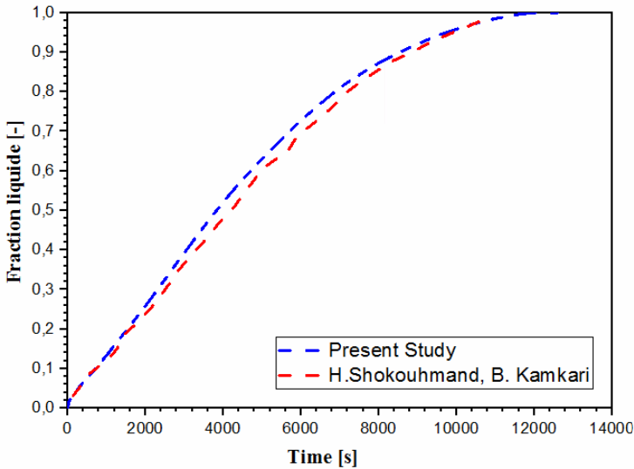
FIGURE 1. Validation of the numerical model by comparison with experimental data from H. Shokouhmand and B. Kamkari [11]
RESULTS
The main objective of this work is to conduct an in-depth analysis of the thermal charging process of phase change materials (PCMs) used in latent heat storage systems. The overall performance of these devices depends heavily not only on the intrinsic thermophysical properties of the PCM, but also on the morphology of the storage structure, which determines the efficiency of heat transfer.
With this in mind, two distinct geometric configurations were evaluated under identical boundary conditions (see Fig. 2). The study specifically focuses on the influence of fin geometry on the dynamics of the melting front progression and on the overall efficiency of heat exchange within the material.
Studied Configuration
The thermal storage unit studied in this work consists of a two-dimensional rectangular cavity, initially filled with phase change material (PCM) in its solid state. Eicosane was chosen as the storage fluid because of its melting properties, which are well-suited to latent storage applications. In order to improve the charging process, a hexagonal fin was integrated into the cavity; its geometry was modeled as a discrete solid using the SolidWorks design tool.
Two geometric configurations were then considered to analyse the evolution of PCM melting, as shown schematically in Fig. 2. The initial temperature of the material was set at 298 K, slightly below its melting temperature, in order to impose a zero liquid fraction at the start of the simulation.
Regarding the boundary conditions (Fig. 2), the vertical side walls (shown in red) were considered adiabatic, while the top wall was subjected to an imposed convection condition. The bottom wall, on the other hand, was heated by a constant heat flux.
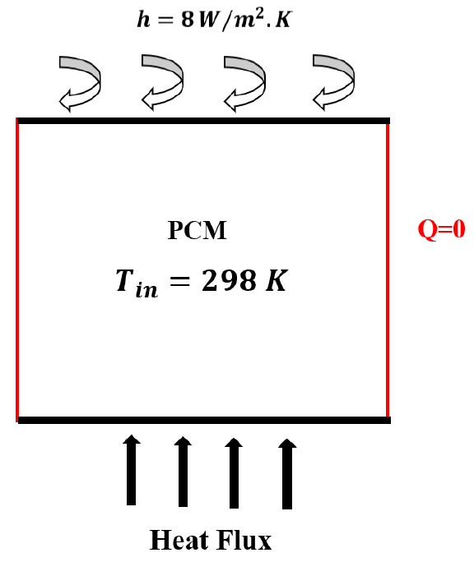 | 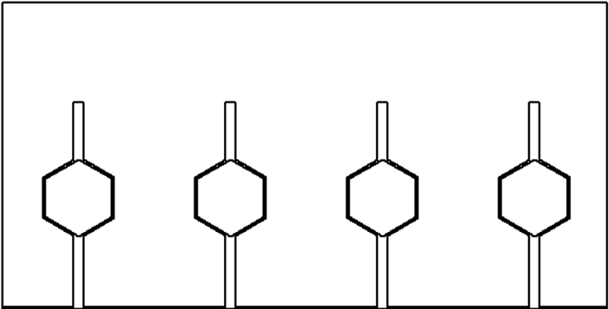
(a) | (b)
FIGURE 2. Description of the simulated system: (a) geometrical characteristics and boundary conditions of the computational domain; (b) physical arrangement of the rectangular cavity integrated with hexagonal-shaped fins.
In this work, aluminum fins were chosen. Table 1 presents the thermophysical properties of aluminum used in the numerical simulations, which were obtained from the material property database implemented in ANSYS Fluent.
TABLE 1. Relevant thermophysical parameters of aluminum are implemented in the present numerical model
Property | Units | Value
$$ρ$$ | $${kg}/{m^{3}}$$ | 2719
$$λ$$ | $$W/{m.K}$$ | 202.2
$$C_{p}$$ | $$J/{kg.K}$$ | 871

In this study, the phase change material (PCM) studied is Eicosane. Table 2 summarizes the main thermophysical properties included in the numerical simulation.

Table 2. Relevant thermophysical parameters of the phase change material incorporated in the present numerical analysis [12].
Property | Units | Value
$$ρ$$ | $${kg}/{m^{3}}$$ | 790
$$λ$$ | $$W/{m.K}$$ | 0.23
$$L$$ | $$J/{kg}$$ | 241000
$$C_{p}$$ | $$J/{kg.K}$$ | 2050
$$β$$ | $$1/K$$ | 0.0001
$$μ$$ | $${kg}/{m.s}$$ | 0.00355
$$T_{m}$$ | $$K$$ | 309.5
$$T_{s}$$ | $$K$$ | 308.5
$$T_{l}$$ | $$K$$ | 310.5

Evolution of The Phase Change Interface
From this figure, it is possible to accurately analyse the morphology and dynamics of the melt interface over time. The red and blue zones correspond respectively to the fully liquid (liquid fraction equal to 1) and fully solid (liquid fraction equal to 0) states. The melt interface, or transition zone, known as the mushy zone, corresponds to the intermediate region between these two states. For the reference configuration, i.e., the cavity containing only pure phase-change material (PCM), without fins between 0 and 1000 seconds, we observe the onset of melting progressing from the bottom wall to the top wall, parallel to the latter. This phenomenon is typical of heat transfer driven mainly by thermal conduction from the hot source at the bottom. However, the low intrinsic thermal conductivity of the PCM severely limits the propagation of heat flow, inducing significant thermal gradients and slowing down the fusion of areas far from the source. On the other hand, in the configuration with hexagonal fins, the melting front starts preferentially around the fins and spreads more evenly across the field. In the presence of these fins, the transfer regime is profoundly altered: the fins act as thermal bridges with high conductivity, promoting rapid redistribution of energy throughout the volume. This configuration reduces the effective thermal resistance of the system and attenuates temperature gradients, resulting in a more homogeneous and accelerated progression of the melting front. This hexagonal fin-optimized configuration thus has a significantly higher liquid fraction than the reference configuration for the same time.
The comparative analysis shows that after 4000 s, the finned configuration achieves almost total melting, unlike the reference configuration, where a solid fraction remains. This difference highlights the decisive role of internal conductive structures in improving melting kinetics.
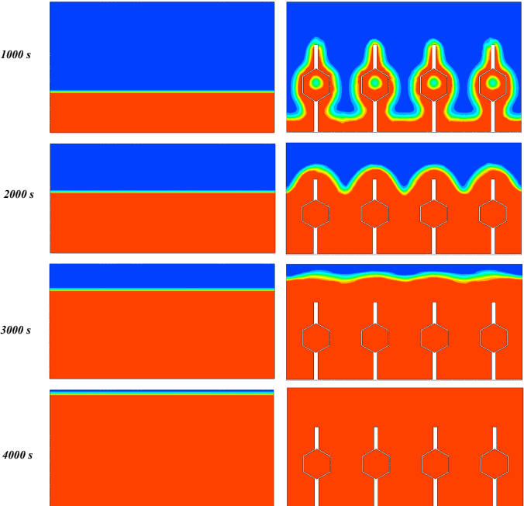
FIGURE 3. Spatial distribution of liquid mass fraction (1 = liquid, red; 0 = solid, blue)
Temporal Evolution of The Liquid Fraction
The liquid fraction is a dimensionless parameter widely used to characterize melting behavior in phase change thermal storage systems. Figure 4 illustrates its evolution for eicosane, which is contained in a rectangular cavity, with and without hexagonal fins. During the early stages of melting, the two configurations show a similar evolution, revealing a predominance of conduction transfer, with the heat flux still localized near the heated wall. Subsequently, the configuration incorporating hexagonal fins is distinguished by a significantly higher melting rate than that observed with pure PCM. This improvement is attributed to a reduction in effective thermal resistance and a more uniform distribution of heat flow throughout the volume.
This innovative geometry thus promotes more homogeneous and efficient melting, limiting the persistence of residual solid areas. In addition, the time required to achieve complete melting is reduced by 14.36% compared to the reference configuration, confirming the value of integrating optimized fins into the design of PCM-based thermal storage devices.
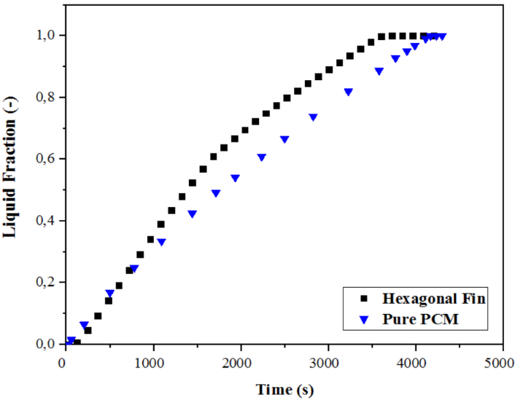
FIGURE 4. Evolution of the liquid fraction for both configurations
Evolution of Latent Heat Storage
This figure shows the evolution of stored latent heat as a function of time for the two configurations studied. Since latent heat is directly proportional to the amount of phase-change material (PCM) melted, the curves obtained follow a similar dynamic to that of the liquid fraction, reflecting the direct correlation between melting progress and storage capacity. It appears that the accumulation of latent heat is significantly faster in the configuration equipped with a hexagonal fin. By improving internal conduction and reducing thermal resistance, this geometry promotes a more homogeneous distribution of heat flow, which accelerates the melting process. As a result, the finned configuration reaches its maximum energy storage capacity more quickly than the pure PCM. This result highlights the contribution of internal conductive structures not only in increasing the rate of heat loading but also in improving the overall efficiency of PCM-based storage systems.
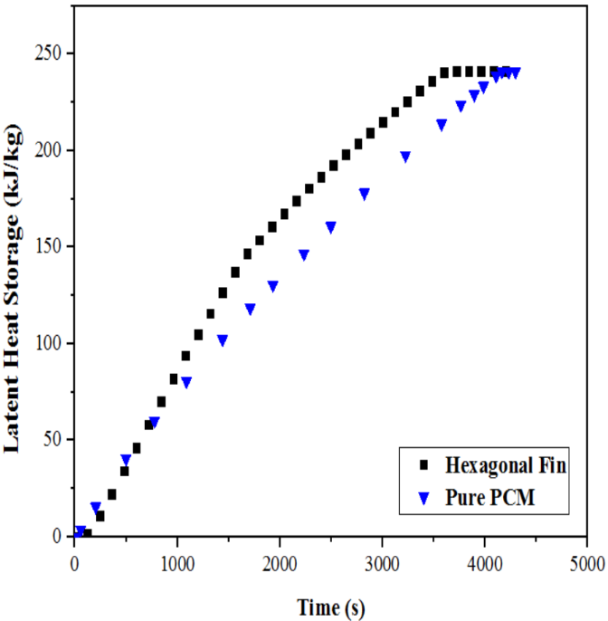
FIGURE 5. Evolution of the stored latent heat for both configurations
CONCLUSION
This study aims to deepen the understanding of heat transfer in phase change energy storage systems by analysing the effect of an innovative geometry of hexagonal fins inserted into a rectangular cavity filled with Eicosane. Numerical results from CFD simulations were used to compare the thermal performance of two configurations: a reference cavity containing only pure PCM, and a cavity incorporating a hexagonal fin structure.
Analyses have shown that, although the melting phase follows similar dynamics in both cases at the start of the process (dominated by conduction), the hexagonal fin configuration offers significant advantages as melting progresses. In particular, this structure enables more homogeneous heat propagation, a significant improvement in thermal distribution, and an acceleration of the melting front across the entire domain.
In terms of performance, the integration of hexagonal fins reduced the overall melting time by 14.36% and enabled the maximum energy storage capacity to be reached more quickly. These results confirm that this hybrid geometric approach combining the benefits of conventional fins and honeycomb structures is a promising solution for optimizing thermal storage devices based on phase-change materials.

References

[1] M. Hariss, A. Gounni, et M. El Alami, « A practical guide on numerical and experimental investigations of solid-liquid phase-change heat transfer using some heat transfer enhancement techniques: Case study in Morocco », J. Energy Storage, vol. 52, p. 105070, août 2022, doi: 10.1016/j.est.2022.105070.
[2] M. Hariss, A. Gounni, et M. El Alami, « Evaluation of charging process performance of phase change material enhanced with a partially filled metal matrix: A numerical study », Mater. Today Proc., p. S2214785324002438, avr. 2024, doi: 10.1016/j.matpr.2024.04.055.
[3] M. Hariss, A. Gounni, et M. El Alami, « Impact of innovative fin design on phase change material melting for thermal energy storage system », Appl. Therm. Eng., vol. 231, p. 120914, août 2023, doi: 10.1016/j.applthermaleng.2023.120914.
[4] A. P. Singh, S. Tiwari, H. Sinhmar, G. Pal, et A. K. Pandey, « Experimental study on PCM (OM-37) enhanced with nanoparticles for improved heat retention in solar ponds », J. Energy Storage, vol. 123, p. 116760, juill. 2025, doi: 10.1016/j.est.2025.116760.
[5] A. Chibani et al., « Simultaneous evaluation of PCM-metal foam (polyethylene glycol 1500-AlSi10Mg) composite with porous structures fabricated via additive manufacturing: The influence of porosity and pore size », Appl. Therm. Eng., vol. 277, p. 126988, oct. 2025, doi: 10.1016/j.applthermaleng.2025.126988.
[6] N. B. Khedher et al., « Maximizing charging/discharging capabilities of horizontal shell-and-tube latent heat storage systems with innovative curved fin inserts », Int. J. Heat Mass Transf., vol. 236, p. 126289, janv. 2025, doi: 10.1016/j.ijheatmasstransfer.2024.126289.
[7] X. Chen et al., « Performance study on cooling channel of PEMFC stack integrated with shrinkable honeycomb structure », Appl. Therm. Eng., vol. 262, p. 125267, mars 2025, doi: 10.1016/j.applthermaleng.2024.125267.
[8] F. Ren, Q. Li, et P. Wang, « Optimizing heat transfer in phase change thermal energy storage systems: A bionic method using alveolar vessel fins and nanofluids », Appl. Therm. Eng., vol. 266, p. 125668, mai 2025, doi: 10.1016/j.applthermaleng.2025.125668.
[9] C. Wang, S. Yao, X. Chen, et X. Yan, « Thermal performance analysis of new bionic “fishbone” fins in a triplex-tube latent heat storage system with single cycle process », Appl. Therm. Eng., vol. 259, p. 124902, janv. 2025, doi: 10.1016/j.applthermaleng.2024.124902.
[10] X. Shen, X. Zhang, M. Chen, et D. Chen, « Thermal management performance of spiderweb-like fins enhanced phase change material cooling system for lithium-ion batteries », J. Energy Storage, vol. 97, p. 112973, sept. 2024, doi: 10.1016/j.est.2024.112973.
[11] H. Shokouhmand et B. Kamkari, « Experimental investigation on melting heat transfer characteristics of lauric acid in a rectangular thermal storage unit », Exp. Therm. Fluid Sci., vol. 50, p. 201-212, oct. 2013, doi: 10.1016/j.expthermflusci.2013.06.010.
[12] A. Arshad, M. Jabbal, P. T. Sardari, M. A. Bashir, H. Faraji, et Y. Yan, « Transient simulation of finned heat sinks embedded with PCM for electronics cooling », Therm. Sci. Eng. Prog., vol. 18, p. 100520, août 2020, doi: 10.1016/j.tsep.2020.100520.

