Optimization of renewable processes for green fuel production and industrial decarbonization
Majd BARHDADI^{1, a)}, Mostapha BOUDI El^{1, b)}, Nizar EL HACHEMI^{2, c)}
¹Energetic team, Mechanical and Industrial Systems Lab, Mohammadia School of Engineers, Mohammed V University, Rabat, Morocco
²Modeling and Decision Support Systems Team, Mohammadia School of Engineers, Mohammed V University, Rabat, Morocco

Author Emails
^{a)} Corresponding author: majdbarhdadi@gmail.com
^{b)}elmostapha.boudi7@gmail.com
^{c)}nizar.elhachemi@gmail.com

Abstract. This study develops a comprehensive hybrid renewable energy system designed for the coastal region between Lagouira and Tarfaya in southern Morocco, an area with exceptional solar irradiance (2000 – 2200 kWh/m²/year) and consistent wind speeds (7 – 10 m/s). By integrating photovoltaic (PV) and wind resources, the system ensures continuous renewable electricity generation, overcoming the intermittency challenge commonly faced by single-source systems [1 - 3]. The generated electricity feeds a proton exchange membrane (PEM) electrolyzer, producing high-purity hydrogen (H₂) and oxygen (O₂) from ultrapure water supplied by multi-effect distillation (MED) of seawater. The hydrogen is subsequently reacted with industrial CO₂ via the exothermic Sabatier reaction to yield synthetic methane (CH₄), with residual heat recovered to drive desalination processes and enhance energy efficiency [10 – 13]. Brine produced during MED is treated through staged solar evaporation ponds, enabling the recovery of salts such as NaCl, KCl, and MgSO₄, while controlled discharge ensures minimal ecological impact [4 – 6, 10]. The novelty of this work lies in the integration of renewable generation, water desalination, CO₂ conversion, and resource valorization into a closed-loop system, addressing three critical challenges simultaneously: renewable energy intermittency, freshwater scarcity, and industrial decarbonization. The results demonstrate the technical feasibility of implementing such a system in Morocco, positioning the country as a potential regional leader in green hydrogen and synthetic fuel production [7 – 9, 11].

1. Introduction

The transition to low-carbon energy systems has become a global priority in order to mitigate greenhouse gas (GHG) emissions and address climate change. Morocco has positioned itself as a regional leader in this transition, with ambitious national targets aligned with the Paris Agreement to reduce GHG emissions by 45.5% by 2030 [8, 9]. Current estimates indicate that Moroccan industries emit approximately 60 million tonnes of CO₂ annually, representing about 20% of national emissions [11]. Key contributors include cement production (0.8 – 1.0 t CO₂ per tonne of cement), steel manufacturing (from coke and natural gas combustion), and agri-food industries, which generate relatively pure CO₂ as a fermentation by-product [12]. At the same time, Morocco faces severe water stress, with per capita renewable water resources below 600 m³/year, significantly under the 1,000 m³/year scarcity threshold [4, 5]. This constraint complicates the adoption of electrolysis-based hydrogen production, which requires high-purity water as feedstock. Seawater desalination, therefore, becomes a critical enabling technology for large-scale hydrogen projects [6, 10].
The southern Atlantic coastal corridor between Lagouira and Tarfaya provides a uniquely favorable environment for hybrid renewable energy systems. The region benefits from more than 3,000 hours of sunshine per year, with solar irradiation levels ranging from 2000 – 2200 kWh/m²/year, as well as consistent wind speeds averaging 7 – 10 m/s [1, 2, 7]. The complementarity of solar and wind resources ensures nearly continuous electricity generation, offering an effective solution to the intermittency problem that limits single-source renewable projects [3]. Recent advances in hybrid systems demonstrate the feasibility of coupling renewable generation with hydrogen production and carbon utilization [1, 2, 11]. Proton exchange membrane (PEM) electrolysis offers a dynamic, efficient route for producing high-purity hydrogen, while methanation through the Sabatier reaction enables the conversion of captured CO₂ into synthetic methane (CH₄), a storable and transportable fuel [12, 13]. Beyond energy, the valorization of by-products such as oxygen (O₂) and mineral salts from desalination aligns with the principles of circular economy and resource efficiency [4, 5, 10].
The novelty of this work lies in the integration of solar-wind hybrid generation, seawater desalination, PEM electrolysis, CO₂ methanation, and brine valorization into a single closed-loop system. This approach directly addresses three interconnected challenges: renewable energy intermittency, freshwater scarcity, and industrial CO₂ emissions. By situating the system in Morocco’s Lagouira-Tarfaya corridor, the study leverages one of the world’s richest renewable energy zones while tackling national decarbonization priorities.
The remainder of this paper is organized as follows: Section 2 presents the system description, detailing the main technological components. Section 3 outlines system operation and evaluates technical feasibility. Section 4 provides the conclusions and highlights perspectives for industrial deployment and policy integration.

2. System description
The proposed system integrates multiple renewable energy and advanced process technologies into a single, highly synergistic architecture designed to produce both green hydrogen and synthetic methane, while ensuring optimal resource utilization and minimal environmental footprint. The underlying concept is to capitalize on Morocco’s exceptional solar and wind potential to generate continuous renewable electricity, which is then coupled with water desalination, electrolysis, carbon capture, catalytic methanation, and brine valorization. This holistic configuration not only enhances overall energy conversion efficiency but also embodies the principles of industrial decarbonization, resource circularity, and sustainable coastal management [1 – 3].
At the heart of the system lies a hybrid renewable generation platform, combining large-scale photovoltaic (PV) arrays with onshore wind farms strategically deployed along the Lagouira-Tarfaya corridor. This region offers one of the highest complementarities between solar irradiation and wind regimes worldwide: solar output peaks during daylight hours, while wind resources are strongest and most stable overnight. This dual-source architecture significantly reduces intermittency and stabilizes the power supply, ensuring a more reliable and predictable flow of renewable electricity to downstream processes, thereby reducing the need for costly storage solutions [1, 2, 7].
The renewable electricity directly powers a proton exchange membrane (PEM) electrolyzer, a mature and flexible technology capable of producing high-purity hydrogen (H₂) and oxygen (O₂). The electrolyzer requires ultrapure water, supplied by a multi-effect distillation (MED) system designed to desalinate seawater. MED, known for its high thermal efficiency and robustness against saline fouling, is thermally integrated with the methanation unit, enabling the valorization of low-grade heat and reducing the overall energy intensity of water purification [4 – 6, 10].
In parallel, CO₂ captured from industrial point sources, such as cement plants or thermal power units, is directed to the methanation process. Within a fixed-bed reactor operating under controlled temperature and pressure conditions, hydrogen reacts with CO₂ in the presence of a nickel- or ruthenium-based catalyst according to the Sabatier reaction, yielding synthetic methane (CH₄) and water. This process is strongly exothermic, releasing substantial thermal energy. Instead of being wasted, this residual heat is recovered and redistributed to support desalination (MED), feedwater preheating, and other auxiliary needs, thereby maximizing energy recycling and minimizing external heat demand [11 – 13].
The brine management and valorization subsystem adds a crucial circular-economy dimension to the architecture. Concentrated brine from the MED process is first sent to solar evaporation ponds, where it undergoes sequential crystallization to extract commercially valuable salts such as sodium chloride (NaCl), potassium chloride (KCl), and magnesium sulfate (MgSO₄). These mineral by-products can be used in chemical, fertilizer, and industrial markets, creating additional revenue streams. The residual concentrated brine is then diluted with hot process water before controlled release into the Atlantic Ocean via submerged diffusers. Coupled with the strong dispersive capacity of the Canary Current, this strategy ensures compliance with marine environmental standards and minimizes ecological risks [5, 6, 10].
What makes the proposed system unique is its systemic integration:
- Renewable electricity powers the electrolyzer, producing hydrogen.
- Hydrogen feeds the methanation reactor, which generates synthetic methane and process heat.
- Heat is reused in the MED unit to desalinate seawater, supplying the ultrapure water needed for electrolysis.
- Oxygen from electrolysis and salts from brine valorization are recovered and utilized in industrial applications.
This closed loop, symbiotic configuration ensures that nearly all energy and material flows are internally recycled or externally valorized. The result is a resilient, scalable, and environmentally responsible production platform that positions Morocco as a future leader in green fuels and industrial decarbonization.
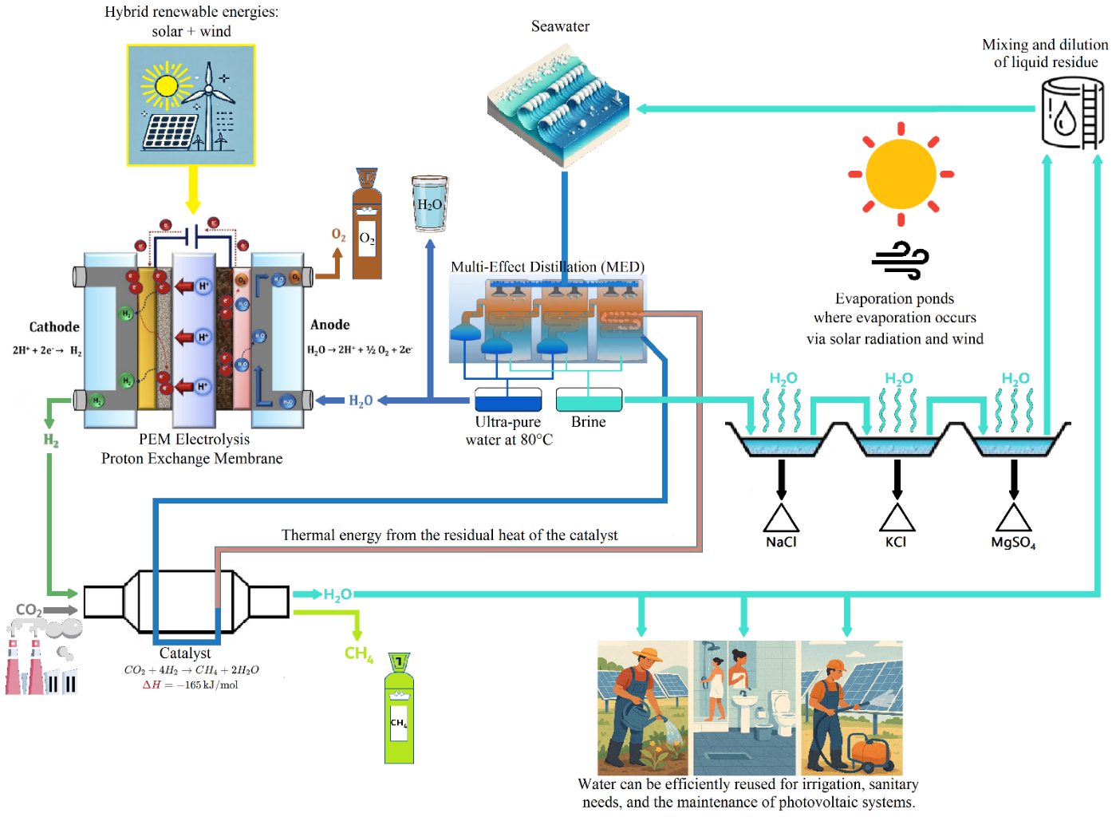
FIGURE 1. Schematic of a circular energy-water system coupling renewable energy with electrolysis, desalination, methanation, and salt recovery

3. System OPERATION
3.1. Step A: Energy Generation from Renewable Sources
The first stage of the system relies on the deployment of large-scale photovoltaic (PV) plants and wind farms strategically distributed along the coastal corridor from Lagouira to Tarfaya. This Atlantic region is particularly attractive because it benefits from one of the most favorable renewable energy endowments in North Africa. Solar irradiation levels range from 2000 – 2200 kWh/m²/year, placing it among the highest globally, while average wind speeds of 7 – 10 m/s are well above the threshold for profitable wind energy exploitation. Together, these conditions create an exceptional environment for hybrid renewable energy production [1, 7].
Photovoltaic installations in the region can achieve yields of 100 – 120 GWh per square kilometer annually, which corresponds to an installed capacity of approximately 12 MW/km² under optimized configurations. These figures highlight the scalability of PV plants in desert and semi-arid zones, where land availability is abundant and land-use conflicts are minimal. Wind farms, for their part, demonstrate equally strong performance. With capacity factors exceeding 40%, typical of high-quality coastal wind regimes, wind projects in this corridor are capable of producing 30 – 40 MW per square kilometer [2, 3]. The offshore like wind characteristics of this coastal belt not only ensure high annual generation but also enhance system stability by providing reliable nighttime production.
An important advantage of combining solar and wind resources in this context lies in their temporal complementarity. While solar generation naturally peaks during daytime and drops to zero at sunset, wind production tends to increase in the late afternoon, evening, and night. This offsetting behavior significantly reduces the risk of energy gaps and minimizes the intermittency challenges that typically affect single-source renewable systems. Consequently, hybrid PV-Wind integration allows for a more stable and predictable power supply, which is crucial for grid balancing and for enabling large-scale penetration of renewables.
Geospatial resource assessments further confirm the exceptional potential of the Lagouira-Tarfaya corridor. Figure 2 presents the geographical distribution of solar potential across Morocco, revealing particularly high irradiation zones in the southern provinces, while Figure 3 depicts wind resource availability concentrated along the Atlantic coastline. The overlap of these resource-rich zones underscores the region’s strategic value for hybrid generation projects.
In summary, the renewable energy potential of the corridor is not only vast but also uniquely complementary. By harnessing both solar and wind power at scale, the system achieves higher efficiency, reduced variability, and enhanced reliability, making it one of the most promising sites for renewable energy integration and export in Africa.

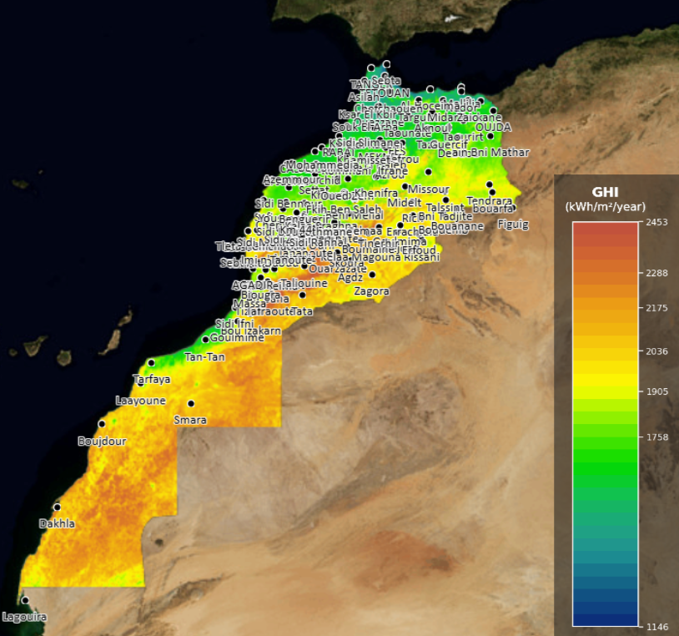
FIGURE 2. Geographical Distribution of Solar Potential in Morocco (in kWh/m²/year)
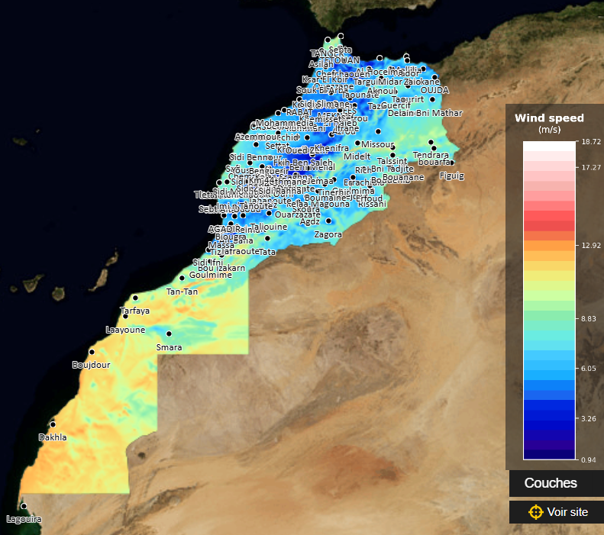
FIGURE 3. Wind potential map of Morocco:distribution of wind speeds
3.2. Step B: Seawater Desalination via Multi Effect Distillation (MED)
The second operational stage focuses on ensuring a continuous and reliable water supply for hydrogen production. Since proton exchange membrane (PEM) electrolysis requires ultrapure water to function efficiently and avoid electrode degradation, seawater from the Atlantic Ocean is desalinated using a multi-effect distillation (MED) process. MED operates through a sequence of evaporation-condensation chambers, where seawater is progressively heated and the resulting steam is condensed to produce fresh water. Each stage reuses the latent heat of condensation from the previous one, which makes MED a thermally efficient and mature technology for large-scale desalination. In the coastal areas of southern Morocco, where seawater is abundant and easily accessible, this method provides a sustainable source of high-quality water for the electrolyzers.
A distinctive feature of the proposed system lies in the integration between MED and the methanation unit. During the catalytic hydrogenation of CO₂ to produce synthetic methane, a considerable amount of low-grade residual heat is released. Instead of being wasted, this heat is recovered and directed to the MED process to drive evaporation. This synergistic coupling not only minimizes external energy demand but also increases the overall system efficiency, turning a potential energy loss into a valuable input [4 – 6, 10].
When compared to reverse osmosis (RO), the dominant desalination technology worldwide, MED presents several advantages in the context of this project. While RO relies heavily on high-pressure pumps and is sensitive to variations in feedwater salinity and turbidity, MED demonstrates greater robustness and resilience. It maintains stable performance even under challenging seawater conditions and requires less pre-treatment, which is particularly beneficial in industrial applications located in remote desert-coastal environments [5]. The freshwater obtained through MED is subsequently polished through deionization and filtration stages, ensuring that it fully complies with the stringent purity requirements of PEM electrolyzers. This guarantees long-term operational stability, reduces maintenance costs, and maximizes hydrogen production efficiency.
Finally, by sourcing water directly from the ocean and desalinating it onsite, the system significantly alleviates pressure on Morocco’s scarce freshwater reserves. This is a crucial consideration in a region already facing increasing water stress due to climate change, population growth, and agricultural demand. The deployment of seawater desalination for energy purposes therefore not only enables hydrogen production but also aligns with sustainable water management strategies in arid and semi-arid regions.
3.3. Step C: Hydrogen and Oxygen Production via PEM Electrolysis
The third stage of the system is dedicated to hydrogen generation through proton exchange membrane (PEM) electrolysis, which decomposes ultrapure water into hydrogen (H₂) and oxygen (O₂) using electricity supplied by the hybrid solar–wind platform. PEM electrolysis is particularly suited for integration with variable renewable energy because it offers fast response times (milliseconds to seconds), high current densities, and compact modular design. This flexibility allows it to efficiently track fluctuations in solar irradiation and wind output without compromising hydrogen purity or electrolyzer lifetime [11, 12].
Modern PEM electrolyzers achieve system efficiencies of 70 – 80% (based on higher heating value, HHV), with ongoing technological advancements targeting values above 85%. Their operating pressure can reach up to 30 – 60 bar directly, which reduces or even eliminates the need for downstream compression before storage or methanation. This feature significantly lowers balance-of-plant energy consumption compared to alkaline electrolysis systems, which typically require additional compression steps [11].
The electrochemical reactions occurring inside the PEM cell are as follows:
- Anode (oxidation): H₂O → 2H⁺ + ½ O₂ + 2e⁻
- Cathode (reduction): 2H⁺ + 2e⁻→ H₂
For every cubic meter of ultrapure water consumed, approximately 1.24 kg of hydrogen and 9.94 kg of oxygen are generated. In this system, hydrogen is directed to the methanation reactor, where it reacts with captured CO₂ to form synthetic methane. The oxygen, often treated as a low-value by-product in other projects, is here considered a strategic co-product. It can be utilized in various industries such as metallurgy (steelmaking and aluminum refining), chemical production (fertilizers, methanol), medical applications, and wastewater treatment. This valorization not only creates an additional revenue stream but also enhances the overall system’s economic viability [12]. A key innovation in this integrated design is the thermal coupling between PEM electrolysis and the multi-effect distillation (MED) unit. Preheating of the electrolyzer feedwater to approximately 70 – 80 °C using residual heat from methanation and MED significantly reduces the electrical energy demand for water splitting. This synergy exemplifies the closed-loop nature of the system: waste heat from one process is reused to improve the performance of another, thereby raising overall energy efficiency while lowering operational costs.
Compared to alternative technologies such as solid oxide electrolysis cells (SOECs), which can reach higher theoretical efficiencies but require operating temperatures above 700 °C, PEM electrolyzers offer superior durability, dynamic operation, and modular scalability under the conditions expected in Morocco’s renewable environment [11]. Their ability to operate flexibly in distributed configurations also makes them suitable for both centralized plants and smaller-scale demonstration projects along the coastal corridor.
In summary, PEM electrolysis forms the core enabling technology for green hydrogen production within this hybrid renewable architecture. By efficiently coupling renewable electricity, desalinated water, and waste heat integration, the system achieves sustainable hydrogen and oxygen generation, while ensuring adaptability to fluctuating renewable inputs and maximizing resource valorization.
3.4. Step D: CO₂ Capture and Conversion
The captured industrial CO₂ emissions originating from cement kilns, steel plants, or fermentation processes are converted into synthetic methane (CH₄) through the well-established Sabatier reaction:
CO₂ + 4H₂ → CH₄ + 2H₂O, ΔH = – 165 kJ/mol
This exothermic reaction is catalyzed by nickel- or ruthenium-based catalysts, which ensure high activity and selectivity under optimized conditions of 300 – 400 °C and 5 – 30 bar [11 – 13]. Catalyst choice is often application-specific: nickel is abundant and cost-effective, whereas ruthenium offers superior stability and tolerance to impurities such as sulfur or residual oxygenates. Under industrial operation, conversion efficiencies above 95% can be achieved, ensuring that nearly all of the captured CO₂ is valorized.
From a mass-balance perspective, the reaction is highly efficient: for every 1 tonne of CO₂ processed, approximately 227 kg of methane and 818 kg of water are produced. The methane generated can directly substitute for fossil-derived natural gas across multiple end-use sectors:
- Heating and industry: used as a drop-in fuel in boilers, furnaces, or combined heat and power systems.
- Electricity generation: combusted in gas turbines or engines for dispatchable power supply.
- Transportation: utilized in compressed natural gas (CNG) vehicles or liquefied as LNG for maritime and heavy-duty transport.
- Export: transported through existing gas pipelines or shipped as LNG to international markets.
Beyond its role as a fossil substitute, methanation acts as an energy storage solution. Surplus renewable electricity, which might otherwise be curtailed due to grid saturation, is transformed into a storable chemical energy carrier. Unlike batteries or hydrogen, methane benefits from existing large-scale infrastructure for storage and distribution, enabling seasonal storage and long-term energy security. This makes it particularly attractive for balancing intermittent PV and wind production in Morocco’s future high-renewable power system [7, 13].
A further benefit of the process is the recovery and reuse of by-product water. The water produced during CO₂ hydrogenation is integrated into the desalination loop, where it is employed to dilute the concentrated brine prior to marine discharge. This not only reduces the environmental impact of brine disposal but also strengthens the circularity of the system, closing material loops between energy, water, and carbon management.
In summary, the methanation stage provides a triple advantage:
- Carbon recycling: converting industrial emissions into a valuable energy carrier.
- Grid flexibility: transforming intermittent renewable electricity into dispatchable methane.
- Resource circularity: reusing by-product water and minimizing environmental discharge.
Together, these features position synthetic methane as a cornerstone of the integrated renewable-hydrogen-carbon system, supporting both domestic decarbonization and energy export strategies.
3.5. Step E: Recovery of Residual Heat
The methanation step is a highly exothermic process, releasing approximately 10 – 15% of methane’s lower heating value (LHV) as thermal energy. In conventional systems, this heat is often dissipated into the environment, representing a significant loss of usable energy. In the proposed integrated system, however, the released heat is systematically captured, valorized, and reinjected into complementary processes, thereby improving both energy efficiency and overall sustainability.
Two main applications of this recovered heat are identified:
- Thermal input for MED desalination
Multi-effect distillation (MED) requires a steady supply of low-grade thermal energy to drive seawater evaporation in its sequential chambers. Instead of relying on external heat sources such as boilers or electricity-powered heaters, the methanation unit provides waste heat at the appropriate temperature range (60 – 120 °C). This coupling minimizes the external energy demand for desalination, lowers operating costs, and transforms what would otherwise be a by-product into a valuable resource. In addition, it enhances the circularity of the water–energy nexus by directly linking carbon utilization with water supply.
- Preheating feedwater for PEM electrolysis
Proton exchange membrane (PEM) electrolyzers operate more efficiently and with reduced degradation when their feedwater is supplied at moderate temperatures (typically 50 – 80 °C). By preheating the desalinated water with recovered methanation heat, the system reduces the electricity demand of the electrolysis process. This not only improves overall hydrogen production efficiency but also extends the operational lifespan of the electrolyzers, as thermal stress and uneven temperature gradients are mitigated.
The integration of methanation heat into both desalination and electrolysis stages creates a closed-loop synergy, where the outputs of one process serve as inputs for another. This design substantially enhances the round-trip efficiency of the power-to-methane pathway, reduces reliance on external energy inputs, and brings the system closer to a self-sustaining energy-water cycle [10, 13]. Furthermore, this thermal integration has strategic implications for scaling up. In large-scale renewable-to-gas hubs, waste heat recovery can account for several hundred megawatts of thermal energy, enough to support extensive desalination capacity and large hydrogen plants. Such efficiency gains strengthen the economic viability of synthetic methane production and highlight the potential of Morocco’s coastal energy corridors to serve as global showcases for integrated renewable, water, and carbon systems.
3.6. Step F: Brine Management and Resource Valorization
The final operational stage addresses one of the most critical challenges of large-scale desalination: brine management. In conventional desalination plants, concentrated brine is typically discharged directly back into the sea, which can cause localized salinity spikes, oxygen depletion, and ecological stress in marine ecosystems. The proposed system adopts a more circular and value-oriented approach, transforming what is traditionally considered waste into a source of secondary resources.
First, the concentrated brine from the MED units is diverted into a network of solar evaporation ponds. In these ponds, sequential precipitation of salts occurs as water naturally evaporates under Morocco’s high solar irradiation. The precipitation sequence follows solubility thresholds:
- Sodium chloride (NaCl) crystallizes first, yielding a product widely used in the chemical industry, food processing, and de-icing applications.
- Potassium chloride (KCl) follows, representing a valuable input for the fertilizer industry, particularly as a component of potash.
- Magnesium sulfate (MgSO₄) precipitates last, with applications spanning pharmaceuticals, agriculture (soil conditioners), and specialty chemicals [5, 6, 10].
The commercial exploitation of these salts contributes to economic diversification, creating additional revenue streams that help offset system costs and promoting the concept of "desalination as co-production" rather than a single-output process. After salt recovery, the residual brine still contains elevated salinity. To minimize its environmental impact, it is blended with hot process water recovered from the methanation unit. This dilution step reduces the salinity gradient, bringing it closer to that of natural seawater, while also slightly increasing the buoyancy and dispersion potential of the discharge stream.
The diluted brine is then released through submerged multiport diffusers strategically placed in the Canary Current, a strong and persistent Atlantic upwelling system. The high turbulence and mixing intensity of this current ensure rapid dispersion and assimilation, preventing the formation of salinity plumes near the coast. This approach aligns with international marine discharge guidelines, including those of the World Health Organization (WHO) and the Barcelona Convention for the Protection of the Mediterranean Sea, adapted here to Atlantic conditions [10].
By combining salt recovery, thermal integration, and controlled marine discharge, the system achieves a triple benefit:
- Resource valorization, extracting marketable salts with industrial, agricultural, and pharmaceutical applications.
- Environmental protection – mitigating the ecological risks of concentrated brine disposal.
- System circularity, reusing waste heat from methanation to support dilution and aligning material flows across the water – energy – carbon nexus.
In conclusion, the brine management strategy transforms a potential liability into an economic and ecological opportunity, thereby closing the loop of the integrated system and reinforcing its sustainability at both local and global scales.

4. Conclusion
This work has presented a fully integrated hybrid renewable energy system for green fuel production and industrial decarbonization in southern Morocco. By combining photovoltaic and wind generation, seawater desalination, PEM electrolysis, CO₂ methanation, and brine valorization, the proposed design demonstrates the technical feasibility of producing green hydrogen and synthetic methane while simultaneously addressing freshwater scarcity and reducing greenhouse gas emissions [1 – 3, 7, 11 – 13].
The system stands out for its high degree of integration. Renewable electricity is converted into hydrogen, which is subsequently transformed into methane via CO₂ methanation. Waste heat from the methanation reaction drives seawater desalination, ensuring a sustainable water supply for electrolysis. By-products such as oxygen and mineral salts are valorized in industrial applications, while brine management strategies minimize ecological risks. This closed-loop design exemplifies circular economy principles, maximizing resource efficiency and minimizing waste [4 – 6, 10].
The case study of the Lagouira–Tarfaya corridor illustrates Morocco’s unique positioning to become a regional hub for green hydrogen and synthetic fuels. With its exceptional solar and wind resources, the country can not only decarbonize its domestic industries but also export green energy carriers such as hydrogen, ammonia, and synthetic methane to international markets, contributing to global climate goals [7 – 9].
Future work should extend this analysis with detailed techno-economic assessments, lifecycle analyses, and policy integration studies to evaluate scalability and competitiveness [11]. Beyond Morocco, the proposed system offers a replicable model for other regions with complementary renewable resources and urgent needs for industrial decarbonization.
In summary, the integrated approach developed here provides a roadmap for transforming renewable energy potential into a resilient, low-carbon, and resource-efficient energy system, aligning local development priorities with global sustainability objectives [1 – 3, 12, 13].

References
1. M. Danish, A. Tariq, U. Perwez, S. H. Iftikhar, B. A. Ahmed, A. S. Hakeem, and K. Askar, "A comprehensive review of green hydrogen-based hybrid energy systems: technologies, evaluation, and process safety" Energy Reviews, 4 (2025) 100154
2. W. Su, Q. Li, W. Zheng, Y. Han, Z. Yu and Z. Bai, "Enhancing wind-solar hybrid hydrogen production through multi-source integration" Renewable Energy 11, 1774-1786 (2024).
3. S. G. Nnabuife, E. Quainoo, H. Hamzat, E. Darko and S. Agyemang, "Innovative strategies for combining solar and wind energy with green hydrogen technologies" Appl. Sci. 14, 9771 (2024).
4. S. H. A. Salem, K. A. Abed, M. Moawed and M. A. Abdelrahman, "Hybrid renewable energy system for reverse osmosis desalination unit: a review" J. Int. Soc. for Sci. & Eng., Vol. 6, No. 1, pp. 7-17 (2024)
5. M. A. Alghassab, "A review of hybrid solar desalination systems: structure and performance" Water Sci. & Technol. 89(5), 1357–1381 (2024).
6. M. Al-Addous, M. Bdour, S. Rabaiah, A. Boubakri, N. Schweimanns, N. Barbana and J. Wellmann, "Innovations in solar-powered desalination: a comprehensive review of sustainable solutions for water scarcity in the Middle East and North Africa (MENA) region" Water 16, 1877 (2024).
7. K. Taroual, M. Nachtane, K. Adeli, A. Faik, A. Boulzehar, D. Saifaoui and M. Tarfaoui, "Hybrid marine energy and AI-driven optimization for hydrogen production in coastal regions" Int. J. Hydrogen Energy, 118, pp. 80-92 (2025)
8. A. Eljechtimi, "Morocco approves green hydrogen projects worth MAD 319 billion (USD 32.5 billion)" Reuters, 6 March 2025.
9. A. Hernandez, "Total Energies studies Moroccan project to export green ammonia to Europe" Reuters, 29 October 2024.
10. Y. R. Temsamani, "Renewable-powered seawater desalination technologies and brine management" EPJ Conferences 326, 04001 (2025), COFMER'05
11. I. Ourya, N. Nabil, S. Abderafi, N. Boutammachte and S. Rachidi, "Assessment of green hydrogen production in Morocco using hybrid renewable sources (PV and wind)" Int. J. Hydrogen Energy 48, 37428-37442 (2023).
12. S. Sebbahi, A. Assila, A. A. Belghiti and S. Laasri, "A comprehensive review of recent advances in alkaline water electrolysis for hydrogen production" Int. J. Hydrogen Energy 82, 583-599 (2024).
13. "Power-to-Gas" Wikipedia (online article), accessed September 8, 2025. Section on electrolysis-methanation integration, efficiency gains, and waste-heat reuse (efficiency benchmarks).

