Vector-Controlled Photovoltaic System Using Maximum Power Point Tracking Boost Converter and Three-Phase Inverter
Mohammed Azougagh¹, Tarik Lakhsim¹, Sadik Charadi^{2,3}, Adil Barra¹

Author Affiliations
¹Laboratory of Electrical and Industrial Engineering, Information Processing, Computing and Logistics, Hassan II University, Casablanca, Morocco
²SMARTiLab Laboratory, Moroccan School of Engineering Sciences (EMSI), Rabat, Morocco
³EEIS-Lab, ENSET Mohammedia, Hassan II University, Casablanca, Morocco

Author Emails
^{a)} Azougagh.ma@gmail.com
^{b)} Lakhsim@gmail.com
^{c)} Charadi.ssadik@gmail.com
^{d)} barraadil@gmail.com
Abstract: The performance of a grid-connected photovoltaic system is highly dependent on environmental conditions and grid electrical parameters. To enhance energy conversion efficiency, this work proposes the application of the Backstepping control algorithm for Maximum Power Point Tracking. The algorithm is assessed under various climatic scenarios to evaluate the overall stability and robustness of the system. Furthermore, a three-phase DC/AC inverter, governed by hysteresis-based Pulse Width Modulation, is employed to ensure accurate synchronization with the grid in terms of amplitude, frequency, and phase. This control technique offers both high dynamic response and ease of implementation while significantly improving the quality of the injected current. The combined use of the Backstepping Maximum Power Point Tracking strategy and hysteresis Pulse Width Modulation -controlled inverter results in a robust and efficient system, capable of delivering optimal power transfer and high-quality grid injection.
Keywords: Photovoltaic system, DC/DC converter, MPPT control, synchronization, inverter, hysteresis PWM, grid-connected.

INTRODUCTION
The global dependence on fossil fuels for energy generation in all its forms (electrical, mechanical, chemical etc), combined with the increase in energy demand, is accelerating the transition to renewable energy sources [1], [2]. Photovoltaic (PV) energy has emerged as an attractive solution due to its low maintenance costs and the development of power electronics, which have led to the expansion of grid-connected photovoltaic systems [3], [4].
This study presents an MPPT control strategy applied to a DC-DC boost converter, tested under various climatic conditions, as well as an optimized DC-AC conversion via a grid-synchronized inverter. The goal is to ensure a stable and high-quality energy injection.
MPPT techniques vary by application: AI-based methods offer flexibility but lack formal stability guarantees; linear controllers are easier to implement but limited by the system's nonlinearity. Nonlinear controllers offer better performance under dynamic conditions, but require accurate and practical models [5], [6], [7].
The proposed approach improves PV production by operating at the maximum power point and ensures compliance with grid stability and power quality standards [8], [9], [10].
This paper presents the modeling and simulation of a grid-connected photovoltaic (PV) system designed to improve energy efficiency and provide high-quality energy input into the grid. The proposed system combines a backstepping-based Maximum Power Point Tracking (MPPT) algorithm with a three-phase inverter controlled by hysteresis-based pulse-width modulation (PWM).
This study is divided into three sections. First, the photovoltaic array is modeled taking into account environmental influences such as irradiance and temperature. Second, the MPPT Backstepping algorithm is implemented and tested in various climate scenarios to assess its robustness and tracking performance. Third, a hysteresis-controlled inverter is developed to achieve precise synchronization with the grid in terms of amplitude, frequency, and phase. The simulation results are presented to evaluate the overall behavior of the system.
The results show that the proposed approach ensures fast and stable MPPT, high-quality current injection and compliance with grid standards. This integrated control strategy offers a promising solution for efficient and reliable grid-connected PV systems.

SYSTEM MODELING

This section discusses the main components of a grid-connected PV system, namely the PV panels, a DC/DC converter incorporating a MPPT algorithm [15], and a DC/AC inverter responsible for maintaining synchronization with the utility grid [4].

Modeling a PV Solar Field
The PV generator model is derived from the conversion of sunlight into electricity. The equivalent circuit of a PV cell is shown in Fig 1.
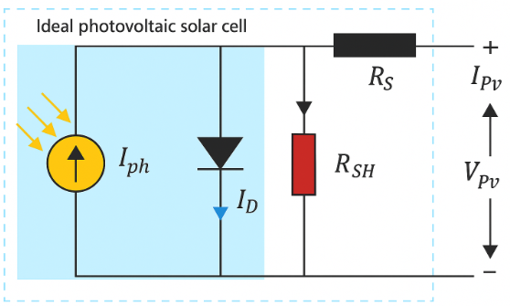
Fig. 1. PV cell circuit equivalent

The output current in this model is defined according to the expressions presented in (4)
$I_{pv}=I_{ph}-I_{0}-I_{sh}$ (1)
with $I_{0}=I_{s}\left[\exp^{\frac{q⋅\left( V+I⋅R_{s}\right)}{K⋅{ T}_{C}⋅ A}}-1\right]$ (2)
and $I_{sh}=\frac{V+I⋅R_{s}}{R_{sh}}$ (3)
Equations (1) can be deduced for N_{s} Cells series and N_{p} Parallel
$I_{pv}={ lteN}_{p}⋅I_{ph}-N_{p}⋅I_{s}\left[\exp{\frac{q⋅\left(\frac{v}{{ N}_{s}}+\frac{I⋅R_{s}}{N_{p}}\right)}{K⋅{ T}_{C}⋅ A}}-1\right] -\frac{\frac{N_{p}}{{ N}_{s}}+I⋅R_{s} }{R_{s}h}$ (4)
The power output of a PV cell is primarily influenced by solar irradiation: higher levels of irradiation result in increased current and power generation. However, this relationship is not strictly linear, as factors such as ambient temperature and the specific characteristics of the PV cell also play a significant role. To enhance overall performance particularly in conditions of variable sunlight efficient controllers and solar tracking systems are essential.

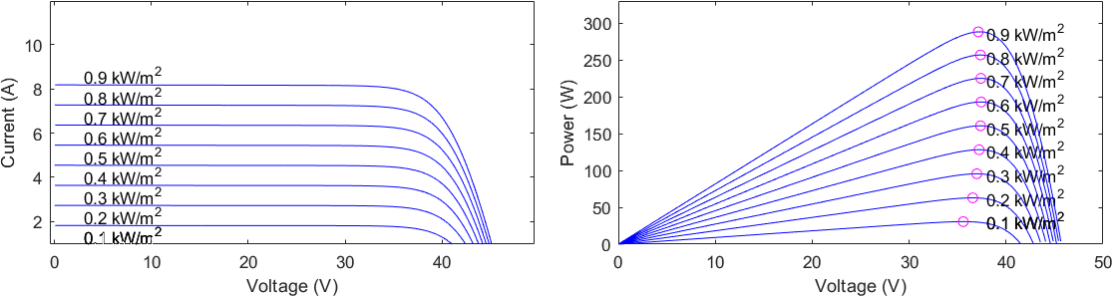

Fig. 2. Influence of solar irradiation on the I–V and P–V characteristics of PV panels

The power curves of a PV cell as a function of irradiation, shown in the fig 2, indicate that the maximum operating point is not stable under varying irradiation levels. This suggests that the system exhibits unstable behavior over time.
In photovoltaic systems, various control techniques are used to drive power converters (such as Boost converters and inverters) and ensure optimal tracking of the Maximum Power Point (MPPT).
These techniques are generally classified into two categories:
- Conventional methods: Backstepping, Sliding Mode Control (SMC), Perturb and Observe (P&O)
- Intelligent methods: Fuzzy Logic Control (FLC), Artificial Neural Networks (ANN)
The table 1 summarizes their comparison:

Table 1: Advantages and disadvantages of advanced control strategies

Technique | Advantages | Disadvantages | Références
Backstepping | Highly robust, good MPPT tracking | Complex design, requires an accurate model | [14][16][19]
SMC | Robust, fast response | Chattering effect, difficult to eliminate | [21]
P&O | Simple, low cost | Oscillations around MPP, less effective under dynamics | [20]
Fuzzy Logic | Adaptive, good balance between complexity and performance | Rule-dependent, less accurate in non-nominal conditions | [23]
ANN | Learns complex behaviors, adaptive to variations | Requires training data, high implementation complexity | [22]

Dynamic Model and Back-Stepping Control DC/DC Design

The role of the DC/DC converter is to adapt the DC current from the PV array to track the MPPT. Using high-frequency semiconductor switches, it responds swiftly to voltage changes through dynamic adjustment of the duty cycle [16].
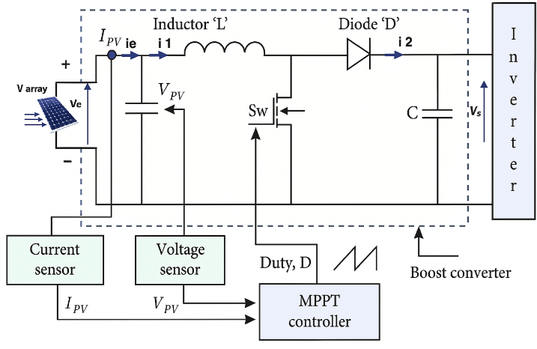

Fig. 3 Block diagram of a BOOST DC/DC converter
To reach the MPPT, the Boost converter elevates the voltage from the PV generator and forwards it to the inverter. System stability is ensured through a control approach grounded in Lyapunov functions, while Kirchhoff’s laws are used to establish the mathematical model of the system [16].
$\frac{dV_{pv}}{dt}=\frac{1}{C_{1}}\left(i_{pv}-i_{1}\right)$ (5)
$\frac{di_{1}}{dt}=\frac{1}{L}\left(V_{pv}-V_{s}\left(1-α\right)\right)$ (6)
$\frac{dv_{s}}{dt}=\frac{1}{c_{2}}\left(i_{1}\left(1-α\right)-i_{s}\right)$ (7)
The first step involves defining the tracking error as:
$e_{1}=V_{pv\text{ ref }}-V_{pv}$ ​ (8)
A control law based on Lyapunov theory is then applied to ensure the system’s stability and accurate tracking of the reference voltage $V_{pv\text{ ref }}$.The evolution of the error can be characterized by the following dynamic equation (8).
$\overset{˙}{e_{1}}={\overset{˙}{V}}_{e\text{ ref }}-{\overset{˙}{V}}_{pv}={\overset{˙}{V}}_{e\text{ ref }}-\frac{1}{c_{1}}\left(i_{pv}-i_{1}\right)=-K_{1}e_{1}$ (9)
To guarantee the stability of the control system in the first stage, the Lyapunov Candidate Function (LCF) is defined as follows:
$W_{1}=\frac{1}{2}e_{1}^{2}$ (10)
Then: ${\overset{˙}{W}}_{1}=e_{1}⋅{\overset{˙}{V}}_{e\text{ ref }}-\frac{1}{c_{1}}\left(i_{pv}-i_{1}\right)$ (11)we rest that ${\overset{˙}{ W}}_{1}=-K_{1}e_{1}^{2}<0 \left(i_{pv}-i_{1}\right)$ (12)
To ensure stability, equation (10) must hold, with $K_{1}$​ being a strictly positive constant
${\overset{˙}{ W}}_{1}=\overset{˙}{e_{1}e_{1}}=-K_{1}e_{1}^{2}<0$ (13)
In the first step, the virtual control input of the system is defined and set to the reference value $α_{\text{ref }}$
$-K_{1}e_{1}-V_{pvref}^{.}+\frac{i_{pv}}{c_{1}}=\frac{i_{1}}{c_{1}}=α_{ref}$ (14)
Second step: control of virtual variables
At this stage, we aim to ensure the stability of the virtual control tracking error, expressed as follows:
$e_{2}=α_{\text{ref }}-α$ (15)
Substituting α into equations (12) and (6) yields the following result
${\overset{˙}{e}}_{2}=\dot{α_{ref}}-\frac{1}{{LC}_{1}}\left(V_{pv}-V_{s}\left(1-α\right)\right)$ (16)
$\text{with }$ $α=\frac{i_{1}}{c_{1}}$ (17)
The second Lyapunov function is $W_{2}=\frac{1}{2}e_{1}^{2}+\frac{1}{2} e_{2}^{2}$ (18)
Then the derivative of W₂ is: ${\dot{W}}_{2}=e_{1}⋅{\overset{˙}{e}}_{1}+e_{2}⋅{\overset{˙}{e}}_{2}=-K_{1}e_{1}^{2}-e_{2}e_{1}+e_{2}⋅{\overset{˙}{e}}_{2}$ (19)
To obtain$\overset{˙}{e_{2}}=-K_{2}e_{2}+e_{1}$ where k₂ is a positive constant, it is necessary to have the following (20)
$-K_{2}e_{2}+e_{1}=\dot{α_{ref}}-\frac{1}{LC_{1}}\left(V_{pv}-V_{s}\left(-α\right)\right)$ (21)
The control strategy governing the converter's duty cycle is defined in $α$
$α= 1- \frac{{LC}_{1}}{V_{5}}\left(-K_{2}e_{2}+e_{1}-\dot{α_{ref}}\right)+\frac{v_{pv}}{V_{s}}$ (22)
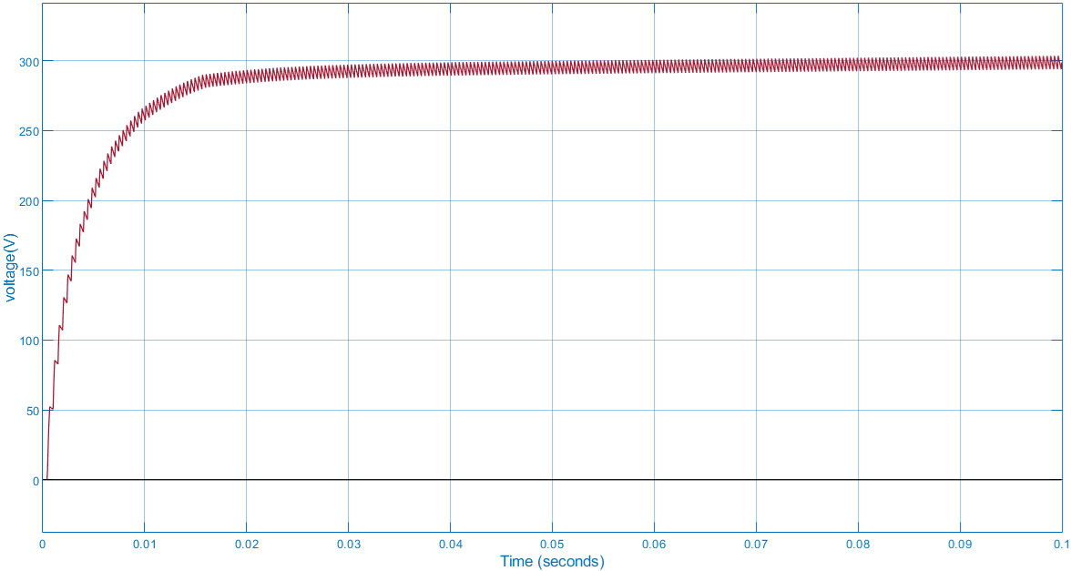

Fig. 4 The voltage of the Boost converter when using Backstepping

Table 2. DC-DC converter characteristics

Parameters | C1 | L | R | Vref | K1 | K2
Value | 0,00001 F | 0,001 H | 100 Ω | 300V | 1 | 100

The Boost DC-DC converter’s control system maintains a stable output voltage that closely tracks the reference set by the MPPT algorithm. Simulation results highlight its high performance, demonstrating excellent stability, accurate reference tracking, and rapid dynamic response with a settling time under 0.03 seconds. The values of the electrical components of the system are shown in Table 2.

Design Hysteresis Current Control of a Three-Phase Inverter
Inverters convert direct current (DC) into alternating current (AC) using PWM [13], [16], [17], [18], [19]. This study investigates a synchronization technique to align the inverter’s output with the grid current.
$U= {RI}_{ch}+\frac{L {d I}_{ch}}{dt}+e$ (23)
$U=\left\{\begin{matrix}U_{a} \\ U_{b} \\ U_{c}\end{matrix} \right.$, $i=\left\{\begin{matrix}i_{cha} \\ i_{chb} \\ i_{chc}\end{matrix} \right. , e\left\{\begin{matrix}e_{a} \\ e_{b} \\ e_{c}\end{matrix}\right.$ (24)

Reference voltages and currents are applied across the load and used to regulate the system's power flow $U_{\text{ref }}I_{\text{ref }}$
$U-U_{ref}=R_{ich}ε\left(t\right)+\frac{L_{d}ε\left(t\right)}{dt}$ (25)
Resistance can be neglected as it acts as an active load : $ε\left(t\right)=I_{ch}-I_{ch\text{ ref }}$ (26)
The error term ε(t) induces angular oscillations of the current through the load around its reference value [14].

SIMULATION AND RESULTS

The simulations, implemented in MATLAB/SIMULINK, model a PV system comprising a PV panel linked to the DC bus via a BOOST converter and a grid-tied inverter, facilitating energy transfer to the electrical grid.

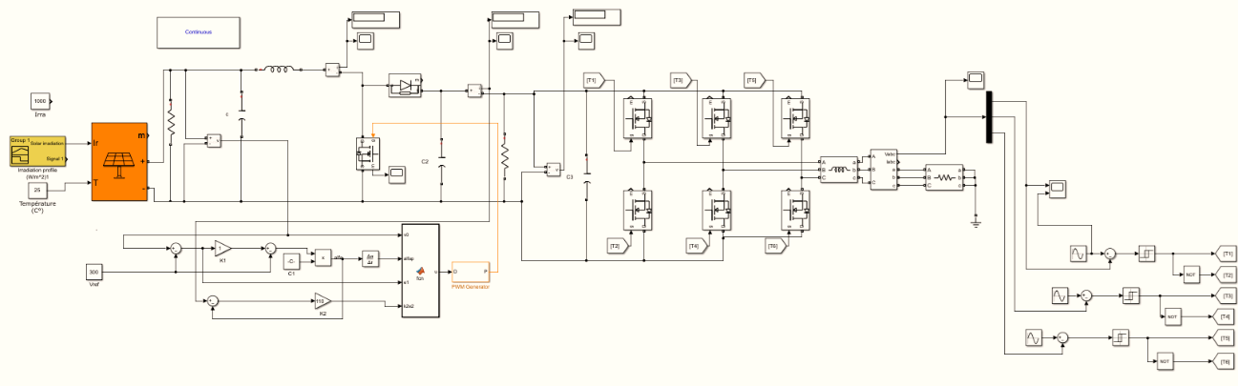
Fig. 5. Diagram of grouping a boost and a three-phase inverter

The system consists of PV modules, each providing a peak power of 319.92 W, with an open-circuit voltage of 44.5 V and a short-circuit current of 9.07 A. At the MPPT, each module operates at 37.2 V and 8.6 A.
The PV array is configured with 6 parallel strings, each composed of 2 modules in series. This setup results in an MPPT output voltage of 91.8 V (2 × 37.2 V) and a total power output of 3820 W (6 × 2 × 319.92 W).
The 91.8 V DC output from the PV array is supplied to a Boost converter, which steps up the voltage to 300 V DC, suitable for the input of a three-phase inverter.
The inverter then converts the 300VDC into a three-phase 380VAC output, synchronized and compatible with the local electrical grid
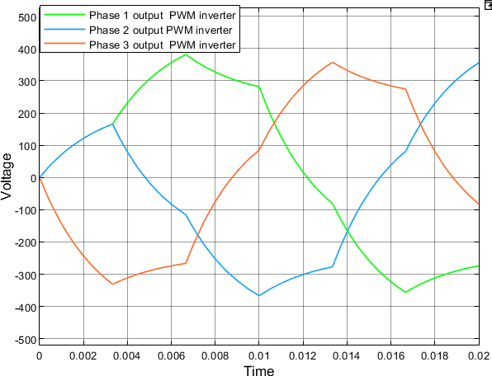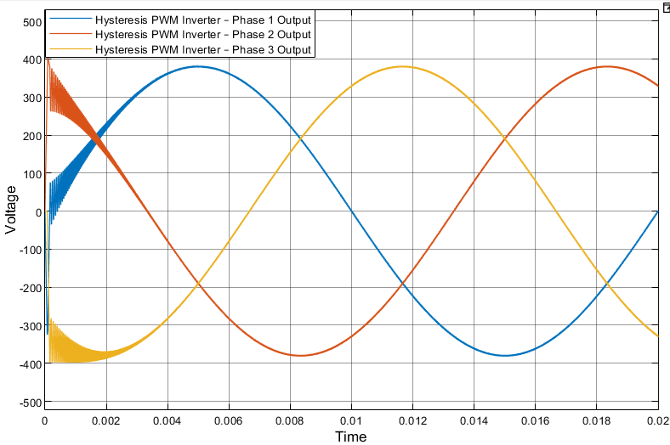
Fig 6: Three-phase voltage PWM control Fig 7: Three-phase voltage control PWM hysteresis

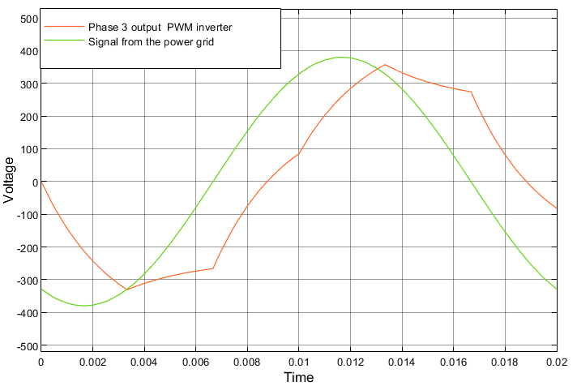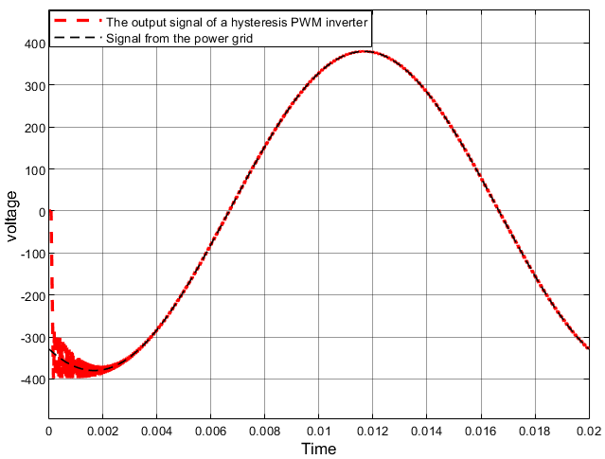

Fig 8: Phase shift between the PWM control s and the power grid signal Fig 9: voltage synchronization between the inverter PWM hysteresis output

Figures 6 and 8 present the simulation results based on conventional PWM, while Figures 7 and 9 illustrate the system’s performance using hysteresis-based PWM control.
The comparison clearly highlights a notable improvement in signal quality and better synchronization with the electrical grid when the hysteresis control method is applied.
Hysteresis PWM control is characterized by its simplicity, fast response time on the order of a few milliseconds, and high reliability. It ensures good system stability and is easy to implement. Its main tuning parameter is the hysteresis bandwidth, which defines the current tolerance around the reference value and directly affects the switching frequency. A narrower bandwidth results in more precise current tracking but increases the switching frequency.
To evaluate the quality of the current injected into the utility grid, a harmonic analysis was performed on the inverter output using the Fast Fourier Transform (FFT) method. The results indicate that the three-phase DC/AC inverter, operating under fixed-band hysteresis Pulse Width Modulation (PWM), achieves a Total Harmonic Distortion (THD) of 2.63% in the injected current. This value is well below the IEEE 519-2014 recommended limit of 5%, confirming the effectiveness of the control strategy in minimizing harmonic content. The FFT spectrum presented in Figure 10 illustrates the predominance of the fundamental component and the rapid attenuation of higher-order harmonics, demonstrating compliance with grid power quality requirements.

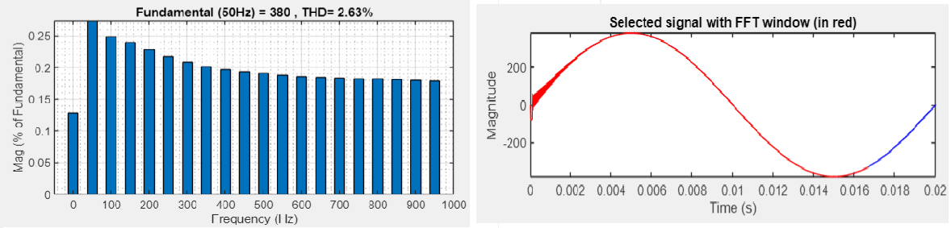
Fig 10: Harmonic Analysis of Injected Current under Fixed-Band Hysteresis PWM Control

DISCUSSION
The implementation of the Backstepping control strategy on the DC-DC Boost converter exhibits outstanding dynamic performance, characterized by a settling time of less than 30 milliseconds. This rapid transient response enables effective voltage step-up, even in low-power PV systems comprising as few as 2 to 10 modules connected in series. Consequently, the output voltage reaches levels compatible with subsequent DC/AC conversion, ensuring seamless integration with inverter stages.
In parallel, the three-phase DC/AC inverter controlled via fixed-band hysteresis Pulse Width Modulation (PWM) achieves high-precision synchronization with the utility grid. With a response time in the order of 100 microseconds, the inverter is capable of real-time tracking of grid voltage and frequency, leading to accurate current waveform generation and remarkably low Total Harmonic Distortion (THD) in the injected current.
The combined application of these advanced nonlinear and hysteresis-based control techniques results in a substantial improvement in overall system behavior. Notably, these methods enhance the robustness, efficiency, and power quality of the energy conversion process. Their capability to ensure stable operation under variable environmental and load conditions renders them particularly well-suited for emerging in applications such as grid-connected renewable energy systems, where fast dynamic response, minimal harmonic pollution, and high energy efficiency are imperative.
While the proposed hysteresis PWM-based control strategy demonstrates promising performance in terms of efficiency and harmonic distortion mitigation, certain limitations remain that should be acknowledged. First, the validation is mainly based on simulation models, which, despite their accuracy, may not fully capture the nonlinearities, parasitic effects, and uncertainties encountered in real-world PV systems. Second, the system’s performance is evaluated under typical irradiance and temperature profiles; however, more extreme environmental variations could impact the stability and effectiveness of the control approach. Third, the study focuses primarily on small-scale PV configurations, and scalability to larger, utility-scale systems requires further investigation.
Future research should therefore explore Hardware-in-the-Loop (HIL) and experimental validation to strengthen the practical applicability of the proposed strategy. Additionally, extending the framework to real-time embedded platforms would allow for assessing its computational efficiency under operational constraints. Investigating the adaptability of the method to hybrid renewable systems, including wind or energy storage integration, also represents a promising direction. Finally, the development of adaptive or predictive control schemes, possibly combined with artificial intelligence techniques, could enhance robustness against rapid environmental fluctuations and improve overall system resilience.

CONCLUSION

The backstepping control laws applied to the DC-DC Boost converter, combined with a hysteresis modulation strategy for the three-phase DC/AC inverter, demonstrated significantly superior performance. This approach allows for precise synchronization between output quantities and their references, while significantly improving the quality of the current injected, especially in terms of harmonic distortion reduction and dynamic stability. It thus confirms the relevance of advanced conventional control methods for the development of grid-connected photovoltaic systems, in particular for MPPT, DC/DC conversion and inverter control.
In addition, this control architecture constitutes a structuring foundation for the exploration of more advanced techniques, particularly those based on artificial intelligence. Real-time implementation via Hardware-in-the-Loop (HIL) and Software-in-the-Loop (SIL) platforms offers a rigorous framework for functional and temporal validation of control algorithms, making it possible to secure their industrial deployment.

REFERENCES

[1] S. Charadi, H. E. Chakir, A. Redouane, A. El Hasnaoui, and M. Et-taoussi, “Bi-objective optimal active and reactive power flow management in grid-connected AC/DC hybrid microgrids using metaheuristic–PSO,” Clean Energy, vol. 7, no. 6, pp. 1356–1380, 2023, doi: 10.1093/ce/zkad081.
[2] International Energy Agency, “CO2 emissions from fuel combustion,” IEA Stat., 2014.
[3] S. Charadi, H. E. Chakir, A. Redouane, A. El Hasnaoui, and B. El Bhiri, “A Novel Hybrid Imperialist Competitive Algorithm–Particle Swarm Optimization Metaheuristic Optimization Algorithm for Cost-Effective Energy Management in Multi-Source Residential Microgrids,” Energies, vol. 16, no. 19, 2023, doi: 10.3390/en16196896.
[4] S. Reshma Gopi, “Converter topologies in photovoltaic applications – A review,” Renewable and Sustainable Energy Reviews, vol. 94, pp. 1–14, Oct. 2018, doi: 10.1016/j.rser.2018.06.039.
El Fadili, A. Backstepping Control for Maximum Power Tracking in Single-Phase Photovoltaic Systems. ScienceDirect, 2013.
[5] Karthikkumar, S., & Sheela, A. Adaptive Hysteresis Current Controller in Grid-Tied Multilevel Converter with Battery Storage. Sci. Rep., 2025.
[6] Uswarman, R., Munawar, K., et al. Maximum Power Point Tracking in PV Systems Based on Global Sliding Mode Control with Adaptive Gain. Electronics, 2023.
[7] Wang, Y. Photovoltaic Maximum Power Point Tracking Technology Based on IP&O-Backstepping Algorithm. Electronics, 2024.
[8] Abed, J. K. Three-Phase Photovoltaic Grid-Tied Inverter Control Based on T-S Fuzzy and Hysteresis Current Control. IJPEDS, 2019.
[9] Motahhir, A., El Hammoumi, A., and El Ghzizal, A., “Photovoltaic system with quantitative comparison between an improved MPPT and existing INC and P&O methods under fast variations of solar irradiation,” Energy Reports, vol. 4, pp. 341–350, 2018..
[10] N. Mohan, T. M. Undeland, and W. P. Robbins, Power Electronics: Converters, Applications, and Design, 3rd ed., Hoboken, NJ, USA: Wiley, 2002.
[11] E.-T. Mehdi, “Management of a micro photovoltaic system controlled by a resonance converter,” 2019.
[12] S. Charadi, H. Eddine, A. Redouane, A. El, and B. El, “A novel hybrid ICA-PSO metaheuristic optimization algorithm for cost-effective energy management in multi-source residential microgrids”.
[13] T. I. F.-S. Kang, S.-J. Park, S. E. Cho, and C.-U. Kim, “Multilevel PWM inverters suitable for the use of stand-alone photovoltaic power systems,” IEEE Transactions on Energy Conversion, vol. 20, no. 4, pp. 906–915, Dec. 2005.
[14] C. A. O. Diouri, N. Es-Sbai, F. Errahimi, and A. Gaga, “Control of single-phase inverter using back-stepping in stand-alone mode,” in Proc. 2019 Int. Conf. Wireless Technol., Embedded and Intelligent Syst. (WITS), Fez, Morocco, 2019, pp. 1–6.
[15] T. Esram and P. L. Chapman, “Comparison of photovoltaic array maximum power point tracking techniques,” IEEE Transactions on Energy Conversion, vol. 22, no. 2, pp. 439–449, Jun. 2007.
[16] H. Mamur, “Nonlinear backstepping controller for DC–DC boost converters in photovoltaic applications,” Solar Energy, vol. 163, pp. 207–220, Mar. 2018
[17] Y. Zouggar, S. Ghouili, and D. Zidani, “Hysteresis current control of a three-phase inverter,” IEEE Transactions on Industrial Electronics, vol. 62, no. 3,Mar. 2015
[18] S. Ahmed et al., “Hysteresis PWM control method for three-phase grid-connected inverters,” Renewable Energy, vol. 64, Apr. 2014..
[19] A. J. M. Arsalan, R. Iftikhar, I. Ahmad, A. Hasan, and K. Sabahat, “MPPT for photovoltaic system using nonlinear backstepping controller with integral action,” Solar Energy, vol. 170, Oct. 2018.
[20] N.Femia, G.Petrone, G.Spagnuolo,and M.Vitelli,"Optimization of perturb and observe maximum power point tracking method,"IEEE Trans. Power Electron., vol. 20, no. 4, pp. 963–973, 2005
[21] M.Belkacem,M.S.Boucherit,andA.Cheriti,"Sliding mode control of a grid-connected photovoltaic system,"Energy Procedia, vol. 6, pp. 529–537, 2011
[22] M. Berriri, A. Cheriti, and A. Rekioua,"Artificial Neural Network-Based MPPT for Photovoltaic Systems,"Renew. Sustain. Energy Rev., vol. 41, pp. 243–252, 2015
[23] B. Bendib, F. Krim, H. Belmili, M. F. Almi, and S. Boulouma,"Advanced Fuzzy MPPT Controller for Standalone Photovoltaic System,"Energy Procedia, vol. 50, pp. 383–392, 2014

