Use of Graphene as an Interlayer to Optimize Flexible CTS Thin Film Properties: The Role of Sulfurization Temperature
Sevde ERKAN^{1,3 a)} , Yavuz Atasoy^{1,2, b)} ,M. Ali Olğar^{1,3,c)} Recep Zan^{1,3,d)}
¹ Niğde Ömer Halisdemir University, Nanotechnology Application and Research Center, Niğde, Turkey,
² Niğde Ömer Halisdemir University, Niğde Zübeyde Hanım Vocational School of Health Services, Niğde, Turkey
³ Niğde Ömer Halisdemir University, Department of Physics, Niğde, Turkey.

^{a)} Corresponding author: sevde1253@hotmail.com
^{b)} yavuzatasoy@ohu.edu.tr
^{c)} mehmetaliolgar@ohu.edu.tr
^{d)} recep.zan@ohu.edu.tr

Abstract. The integration of two-dimensional (2D) materials such as graphene into thin-film based solar cell layers holds great potential for enhancing both structural and optoelectronic properties. In this research, we examined into the impact of incorporating graphene on the characteristics of CTS thin films prepared via a two-step process. CTS precursors were coated onto flexible molybdenum (Mo) foils via the spin coating method, with and without an interlayer of chemical vapor deposition (CVD)-grown graphene and subsequently sulfurized at high temperatures. Energy-dispersive X-ray spectroscopy (EDX) indicated that all fabricated films exhibited a Cu-poor composition. Structural characterization by X-ray diffraction (XRD) revealed that all films crystallized in the monoclinic CTS phase at sulfurization temperatures of 475, 500, and 525 °C. The introduction of a graphene interlayer improved the microstructural quality of the films. Raman spectroscopy supported the XRD results, further identifying the vibrational modes characteristic of the CTS phase and confirming enhanced structural ordering in the graphene-containing samples. Optical spectroscopy measurements revealed that the introduction of a graphene interlayer reduced the optical band gap by approximately 0.05–0.08 eV across all investigated temperatures. This reduction, arising from suppressed band-tailing effects, enhanced optical absorption across a wider portion of the solar spectrum, thereby improving photon harvesting efficiency for photovoltaic applications. Overall, temperature-dependent analysis indicated that elevated processing temperatures (500 and 525 °C) induced additional structural defects and secondary phase (Sn₂S₃,CuS) formation in graphene-containing samples, whereas processing at 475 °C resulted in superior structural integrity and enhanced optical performance, highlighting it as the optimal condition.

INTRODUCTION
Cu₂ZnSn(S,Se)₄ (CZTSSe) kesterite compounds have attracted widespread interest and use in the field of thin-film solar cells because of their natural abundance and non-toxic nature [1],[2]. Cu₂SnS₃ (CTS) thin films exhibit p-type semiconductor properties with absorption coefficients higher than 10⁴ cm⁻¹, similar to Cu₂ZnSnS₄ (CZTS), and are considered alternative absorber layers in photovoltaic applications [3]. Moreover, research trends have focused on solar cell absorber materials composed of non-toxic and naturally abundant elements[4],[5]. In this context, CTS has emerged as a potential material for photovoltaic applications because of its environmentally friendly structure and favorable optoelectronic properties [6]. However, despite various optimizations, CTS absorber layers have yet to achieve the desired device performance. Thanks to its high optical transmittance, exceptional crystallinity, and atomic-scale thickness, single-layer graphene has been investigated and employed as an interlayer in thin-layer solar cell systems enhance charge carrier transport and promote better crystallographic compatibility at interfaces[7]. The use of flexible and highly conductive Mo foil as a substrate may provide integration and performance advantages for the production for achieving highly efficient thin-film solar cells by reducing production costs, thanks to its advantages such as high thermal stability, smooth surface structure and chemical inertness[8]. Mo flexible substrates are preferred due to their good conductivity and flexibility, which make them applicable in many areas. This structure provides compatibility with thin film absorber materials such as CTS. While the Mo layer serves as the ohmic contact required to collect holes (for p type CTS), it also helps prevent the thin film material from deteriorating during annealing thanks to its high adhesion strength, chemical stability and thermal expansion coefficient compatible with CTS [9]. Mo also exhibits relative resistance to sulfur atmosphere and can enhance charge carrier transfer through the formation of conductive secondary phases (e.g., MoS₂) within specific temperature ranges. [10]. For all these reasons, Mo is a preferred back contact material in many flexible solar cell designs. Peksu et al. reported the development of CZTS thin-film solar cells enhanced with graphene/ZnO nanorod (NR) composite overlayers[11]. Graphene consists of a single atomic layer of carbon atoms organized in a hexagonal lattice, possessing remarkable mechanical strength, electrical and thermal conductivity, and optical transparency, which makes it a highly promising nanomaterial for various advanced technological applications [12]. The incorporation of graphene as an interfacial layer in Cu-based kesterite materials has been shown to enhance performance by minimizing interface recombination and passivating defects, owing to its superior electrical conductivity and excellent carrier mobility[13]. In another study, the graphene interlayer provides a more uniform and dense structure by increasing the crystallinity of CZTSSe[14]. In line with the previous study by Olğar and colleagues on graphene interlayers in CZTS thin films, which aimed to reduce interface recombination and improve charge transport with graphene in the CZTS/Graphene/CdS configuration[15].
In this study, single-layer graphene layer grown by chemical vapor deposition technique (CVD) was transferred onto flexible Mo foil; subsequently, a CTS absorber layer was deposited onto this Mo/graphene stack. The samples were deposited onto graphene-transferred flexible Mo foil substrates using a spin coating method and then annealed at sulfurization temperatures of 475 °C, 500 °C, and 525 °C for 5 min. Unlike previous studies, graphene (Mo/Gr/CTS) and graphene-free (Mo/CTS) structures were comparatively evaluated. Accordingly, the effect of Mo/graphene interlayer impact on the structure, surface morphology, and optical–electronic features of CTS thin films coated on Mo was investigated using different annealing temperatures of 475, 500 and 525°C.

EXPERIMENTAL
CTS precursor layers were deposited onto flexible Mo foils (mounted on glass carriers) via spin coating in dynamic mode. Prior to deposition, the foils were cut to the desired dimensions and sequentially cleaned with acetone, isopropanol (IPA), and deionized water, followed by drying with nitrogen gas. The precursor solution was prepared by dissolving copper(II) chloride dihydrate (1.2 mmol.L⁻¹), tin(II) chloride dihydrate (0.6 mmol.L⁻¹), and thiourea (8 mmol.L⁻¹) in 5 mL of 2-methoxyethanol, according to the desired molar ratios. The mixture was kept under stirring at 50 °C for a specific duration 2 h until a clear, a homogeneous mixture was achieved. To enhance stability, monoethanolamine (MEA) was added dropwise (~3 drops using a micropipette), and the solution was further stirred for 6 h at room temperature in a sealed vial.The films were deposited using a two-step spin coating process: first at 500 rpm for 20 s, followed by 2500 rpm for 50 s. After each layer, the samples were dried on a hot plate at 250 °C for 10 min. This coating and drying cycle was repeated until the total film thickness reached approximately 1.3 μm. The coated CTS precursor films were heated in an RTP system with a temperature ramp rate of 1 °C.s⁻¹ to promote crystallization of CTS thin films. Before the annealing process, the quartz tube was purged twice, and then a mixed gas of Ar (95%) + N₂ (5%) was introduced to establish an inert atmosphere for the treatment. The final sulfurization step was performed into the sealed graphite box using 10 mg of powdered sulfur at . As shown in Figure 1, optimization of the CTS absorber layer was conducted by varying the sulfurization temperature. Sulfurization processes were carried out at 475 °C, 500 °C, and 525 °C for 5 min. Sample were coded according to the fabrication process and presented in Table 1.

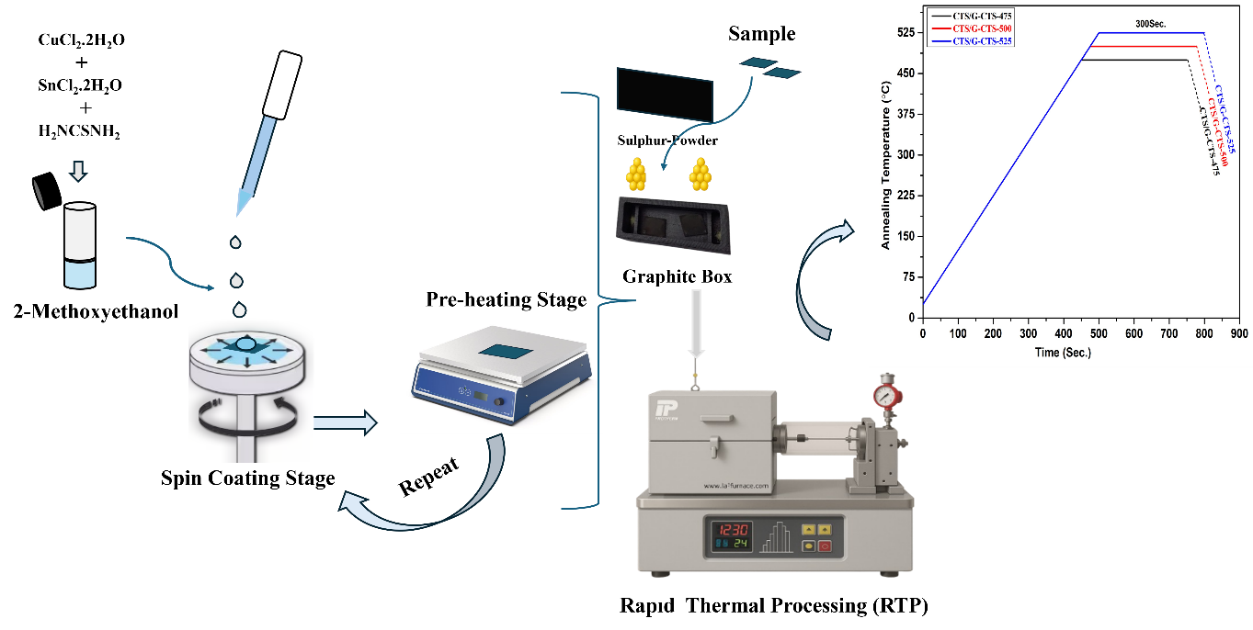

Figure 1. CTS Fabrication Processes

The obtained samples were deposited on graphene-coated flexible Mo-Foil substrate and graphene-free Mo substrate, and their structural, electrical a detailed investigation of the optical properties was carried out. The crystal structure was characterized using X-ray diffraction (XRD) with Cu Kα radiation (λ = 1.5406 Å), while Raman spectroscopy was employed for additional structural analysis. The surface morphology of the CTS films was investigated using a scanning electron microscope (SEM, HITACHI SU5000) to investigate the effects of solution type and the pre-annealing treatment on the morphological properties of the films. Analysis of the atomic composition reveals the elemental distribution within the CTS thin films, both with (G-CTS-475, G-CTS-500, G-CTS-525) and without graphene interlayers (CTS-475, CTS-500, CTS-525), the elemental composition was analyzed by energy-dispersive X-ray spectroscopy (EDX) operated at an accelerating voltage of 20 kV. The optical properties were determined by spectroscopic ellipsometry (J.A. Woollam V-VASE ellipsometer), while the basic electrical parameters such as resistivity and majority using a Keithley 2410 Source Meter, the Van der Pauw/Hall effect approach was used to determine the carrier concentration at a supply current of 0.1 mA and an estimated magnetic field strength of 0.57 T.

TABLE 1. Production of thin films of CTS with and without graphene using different sulfurization temperatures

Sample | Temperature (°C) | Heating rate (°C/s) | Dwell time (s)
CTS-475 | 475 | 1 | 300
CTS-500 | 500 | 1 | 300
CTS-525 | 525 | 1 | 300
G-CTS-475 | 475 | 1 | 300
G-CTS-500 | 500 | 1 | 300
G-CTS-525 | 525 | 1 | 300

RESULTS AND DISCUSSION

EDX Analysis
The atomic percentages and elemental Table 2 provides a summary of the ratios derived from CTS thin films that have been sulfurized at various temperatures. All sulfurized CTS samples were found to exhibit a Cu/Sn ratio of less than 2, indicating Cu deficiency (Cu-poor). Additionally, all the samples exhibited an S-to-metal ratio of less than 1, indicating sulfur deficiency. Such sulfur deficiency is consistent with the presence of Sn rich (Sn₂S₃), and Cu rich (CuS) phases detected by XRD. At high temperatures, sulfur becomes volatile and can be lost from the film. On the other hand, the close overlap of Mo Lα/Lβ and S Kα1 emission peaks in the EDX spectrum makes it difficult for the detector to accurately distinguish sulfur signals. As a result, the actual S/(Cu+Sn) ratio is likely higher than the values presented in the table. All films remain Cu-poor, which is the desired composition that supports higher open circuit voltage.

TABLE 2. The results of EDS analysis determining the elemental composition of CTS thin films with and without
graphene.
Sample | Cu |  | Sn S Mo |  |  |  |  | Cu/Sn | S/(Cu+Sn)
CTS-475 |  | 23.27 | 14.21 |  | 31.21 | 33.75 |  | 1.63 | 0.83
G-CTS-475 |  | 10.66 | 8.51 |  | 14.82 | 66.1 |  | 1.25 | 0.77
CTS-500 |  | 16.79 | 10.39 |  | 20.61 | 52.2 |  | 1.61 | 0.75
G-CTS-500 |  | 13.82 | 9.02 |  | 17.55 | 59.62 |  | 1.53 | 0.76
CTS-525 |  | 17.29 | 10.63 |  | 18.51 | 53.56 |  | 1.62 | 0.66
G-CTS-525 |  | 12.43 | 7 |  | 14.07 | 66.5 |  | 1.77 | 0.72

XRD Analysis

The XRD patterns of CTS and graphene-supported CTS (G-CTS) films at three different temperatures (475, 500 and 525°C) are shown comparatively in Figure 2. It was observed that at all three temperatures, the main peak belonging to the characteristic monoclinic phase of CTS occurred around 2θ= 28.40°, and other characteristic peaks occurred around 2θ=39.3°, 47.20°, 48.03° and 65.7° (JCPDS- 98-009-1762). Peaks corresponding to molybdenum were observed at 40.59°, 58.82°, and 73.69° in all samples (PDF 00-042-1120), while peaks at 31.70°, 46.52°, and 63.70° indicated the presence of the Sn₂S₃ phase in all samples (PDF 01-072-0031). At 475 and 500 °C, the peaks corresponding to the Sn₂S₃ phase are more pronounced in samples without graphene. In contrast, their intensity is generally lower in G-CTS films, suggesting that graphene suppresses the emergence of the Sn₂S₃ phase. Additionally, the diffraction peaks observed at 27.6°, 52.5°, 56.4°, and 63.7°, which correspond to the binary CuS phase (JCPDS card No. 85-0620), indicate that the secondary phase of CuS was present in all samples. Notably, in the graphene-containing samples, the intensity of the secondary phase peak at 27.6° was significantly reduced. In samples coated on graphene, it was observed that secondary phases decreased at low temperatures; in particular, at 475 °C these phases almost completely disappeared.

To determine the crystallite size of CTS samples according to the sulfurization temperature, the dominant peak of the monoclinic CTS structure computed using the Full Width at Half Maximum (FWHM) values​​ with the Debye-Scherrer formula at 2θ = 28.40°. Equations (1) and (2) were used to derive crystallite size and lattice strain, respectively. In addition to the crystallite size, the strain values ​​in the lattice were calculated[16,17].

$D=\frac{K.λ}{β.cosθ}$ (1)

$ε=\frac{β.cosθ}{4}$ (2)

Here D represents the crystallite size; λ is the wavelength of the X-ray ( Cu Kα, 1.5406 Å) ; K the Scherrer constant (~0.9) ; β is the FWHM (in radians) of the (131) peak of the CTS phase; θ is the Bragg angle., and ε is the strain in the lattice.

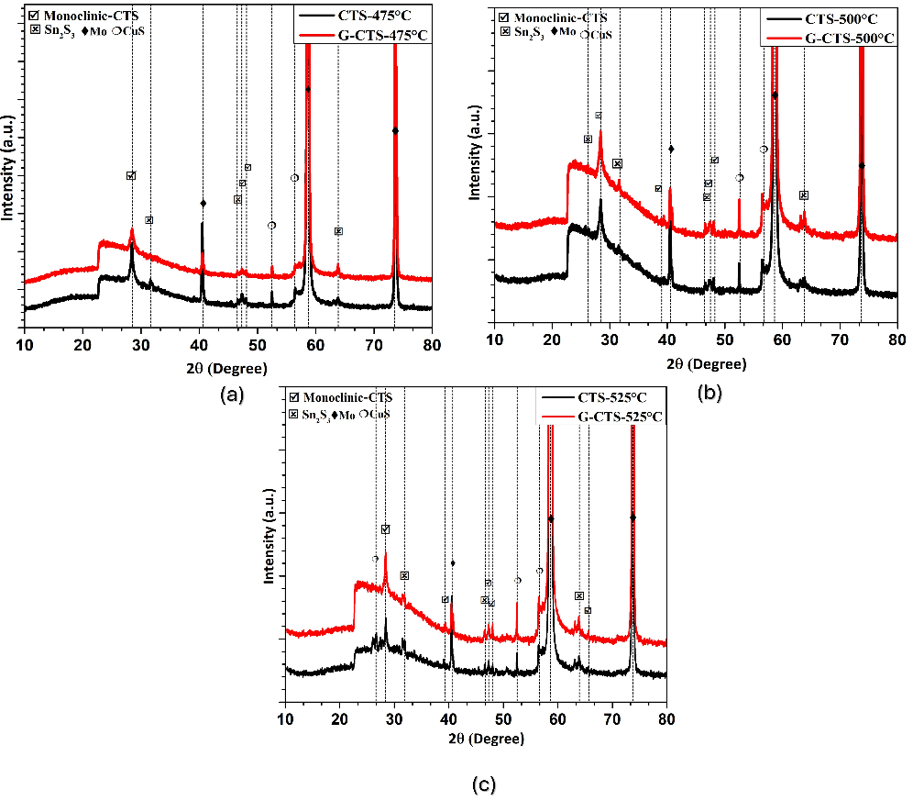
Figure 2. . XRD analysis of CTS films with and without graphene interlayer prepared at sulfurization temperatures of ; (a) 475°C
(b) 500°C and (c) 525 °C

The crystallite sizes of CTS and G-CTS films are presented in Table 3. It is observed that the full width at half maximum (FWHM) values are inversely related to the crystallite size, as per the Scherrer equation. The incorporation of graphene interlayers appears to facilitate crystal growth and enhance grain size especially higher temperatures, suggesting that graphene acts as a nucleation promoter during film formation. Furthermore, the graphene interlayer provides a thermodynamically favorable environment that supports recrystallization, as evidenced by SEM analyses. Notably, while high annealing temperatures tend to induce grain refinement in pristine CTS films, often associated with thermal degradation, the presence of graphene counteracts this effect and instead promotes grain coarsening, contributing to improved structural quality. Overall, as the sulfurization temperature is increased, secondary phases such as Sn₂S₃, CuS, and MoS₂ begin to emerge. The presence of these phases can detrimentally impact material performance by reducing the overall crystal purity. In particular, sulfur deficiency promotes the formation of structural defects and secondary phases, further degrading film quality. Graphene improves the quality of CTS thin films due to its outstanding electrical conductivity, large surface area, and strong chemical stability. As an interlayer, graphene facilitates better charge transport, reduces interfacial recombination, and promotes more uniform grain growth during film formation.

 | TABLE 3. Crystallite size values ​​of CTS films with and without graphene
Sample |  |  | 2θ | β(FWHM)
  D(nm)
CTS-475 |  | 28.42 |  |  | 0.30 |  | 28.52
CTS-500 |  | 28.43 |  |  | 0.40 |  | 21.39
CTS-525 |  | 28.42 |  |  | 0.43 |  | 19.90
G-CTS-475 |  | 28.41 |  |  | 0.40 |  | 21.39
G-CTS-500 |  | 28.43 |  |  | 0.33 |  | 25.93
G-CTS-525 |  | 28.43 |  |  | 0.31 |  | 27.60

Raman Spectroscopy
As a complementary analysis method, Raman spectroscopy analyses were performed to determine the crystal structure and the secondary phases present in the sulfurized CTS films at 475, 500 and 525 °C. Raman spectra of the films are presented in Figure 3.

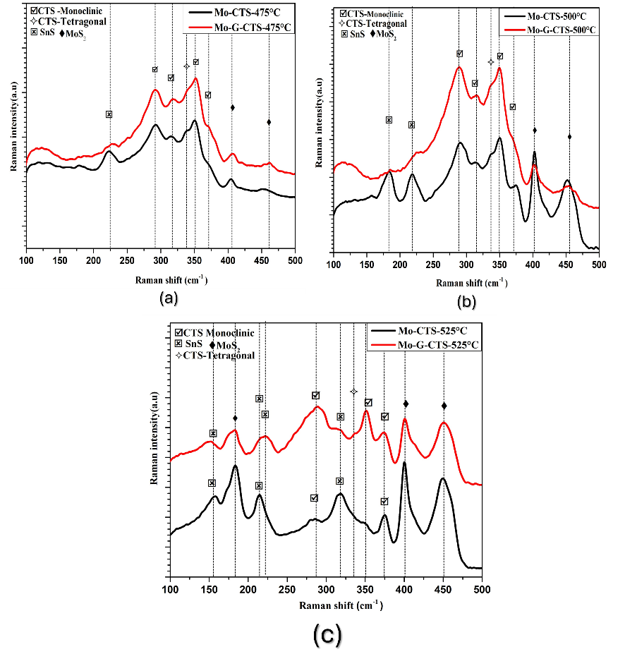
Figure 3. Raman spectra of CTS films with and without graphene produced at sulfurization temperatures of (a) 475 °C (b) 500 °C and (c) 525 °C.
The Raman spectra revealed that, independent of the sulfurization temperature, the prominent peaks corresponding to the monoclinic CTS structure appeared at approximately 292 cm⁻¹, 352 cm⁻¹ and 371 cm⁻¹[18]. However, peaks observed around 182 cm⁻¹ and 220-222 cm⁻¹ indicate the presence of SnS secondary phases [19,20]. Additionally, a weak peak observed around 336-338 cm⁻¹ may correspond to a tetragonal CTS phase. This peak becomes especially pronounced in samples processed at 475 °C and 500 °C; however, it is observed that the formation of this phase is suppressed with the use of graphene and the peaks in question become less pronounced [21]. The most notable observation is the formation of MoS₂ phases resulting from the interaction between molybdenum foils and sulfur at elevated temperatures. These phases are identified by characteristic peaks appearing in the range of 400–450 cm⁻¹. As the temperature increases, the intensity of these MoS₂-related peaks become more pronounced, and at 525 °C, their presence is so dominant that they nearly obscure the primary CTS peaks. However, in the samples incorporating a graphene interlayer, it is evident that graphene acts as an effective diffusion barrier on the molybdenum surface, significantly inhibiting the formation of MoS₂ phases [22].

SEM Analysis
Graphene clearly enhances CTS crystal growth and morphology, leading to larger grains and more defined structures. The effect of sulfurization temperature on the morphological properties of CTS thin films was confirmed by SEM surface analysis. Surface morphology of the films is shown in Figure 4. The SEM images of CTS samples are captured at 10 kX in one magnification. It is possible to say that a film structure consisting of grains of various sizes was formed in all samples, regardless of the sulfurization temperature. It was observed that sulfurization processes carried out at 475 °C contributed to obtaining a more homogeneous and compact thin film structure.
The morphological differences observed in the SEM images offer valuable insights into the impact of graphene incorporation on the microstructure of the films [23].

In graphene-free samples (CTS-475, CTS-500, and CTS-525), smaller surface features and irregularly shaped particles are evident, indicating non-uniform grain morphology. This suggests limited crystal growth and restricted grain coalescence. Notably, despite the relatively large crystallite size observed in the CTS-475 sample via XRD, surface smoothness remains suboptimal, suggesting that crystallite size alone does not ensure morphological uniformity. In contrast, graphene-containing samples exhibit more distinct, larger, and uniformly distributed grains. A particularly significant increase in lamellar or plate-like structures is observed in the G-CTS-475 sample, implying that graphene incorporation facilitates directional crystal growth and promotes a more ordered microstructure. These findings are consistent across other graphene- containing samples, reinforcing the conclusion that graphene plays a critical role in enhancing structural regularity and grain connectivity.

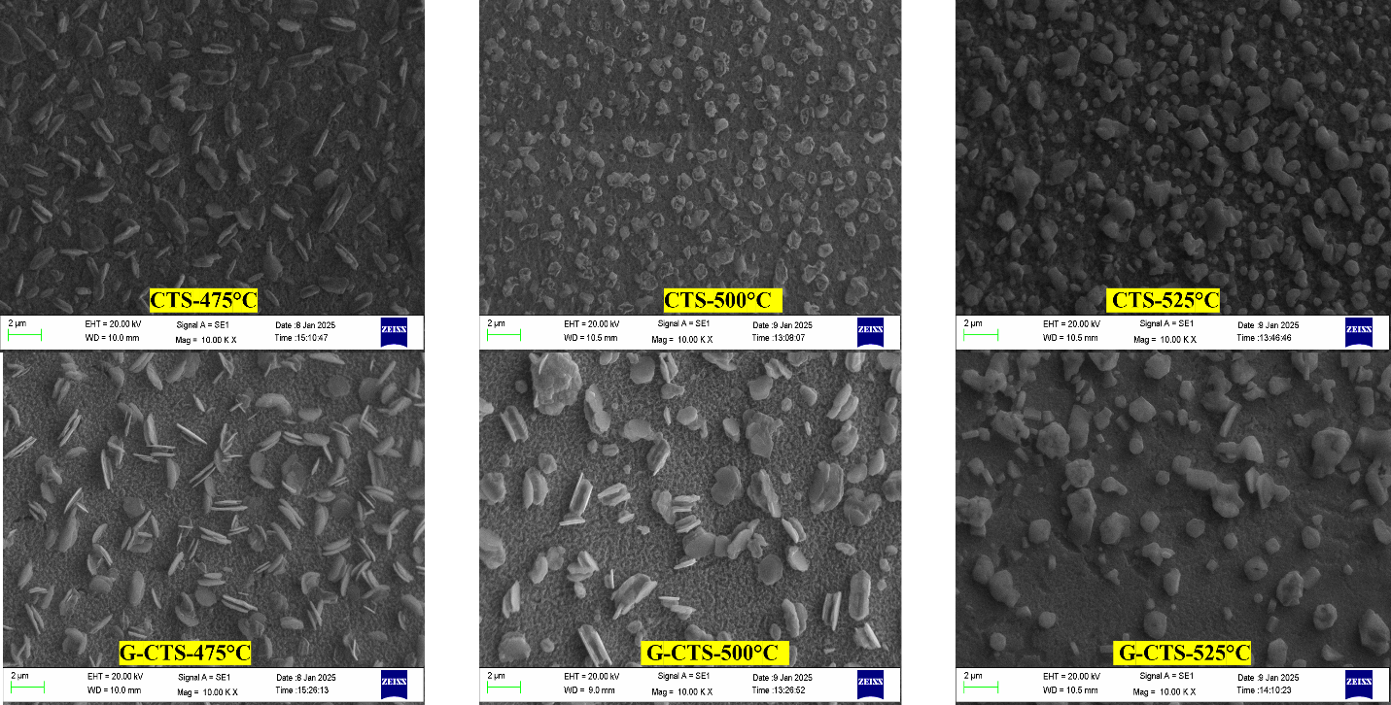
- (b) (c)
Figure 4. SEM images of graphene and graphene-free CTS films obtained at 10 kX magnifications (a) 475 °C (b) 500 °C and (c) 525 °C

Optical and Electrical Properties
The optical properties of CTS and graphene interfaced CTS (G-CTS) thin films were evaluated using Ellipsometer. All samples showed strong absorption in the near infrared (NIR)region, indicating that they are suitable for photovoltaic applications.

The optical properties of semiconductors, such as the absorption coefficient (α) and band gap energy (Eg) are very significant for developing absorber layers for thin film solar cells. Equation (3) is used to determine the absorption coefficient based on the transmittance spectra [24]. Using the transmittance spectrum, the absorption coefficient was calculated by

$α=\frac{1}{t}ln\frac{⁡1}{T}$ (3)

where t represents the thickness of the film and T denotes the transmittance. The optical band gap (Eg) of CTS thin films annealed at various temperatures was calculated using Tauc plots via the relation

$α.hν={A\left(hν - Eg\right)}^{1/2}$ (4)

where A is a material‑dependent constant and hν is the photon energy. The optical band gap values, ​​estimated from Tauc plots, were in the range of 0.99–1.03 eV, which agrees with the values ​​reported for monoclinic CTS. In particular, the inclusion of a graphene interlayer slightly lowers the apparent band gap energy. Overall, graphene incorporation yields CTS thin films with slightly narrower band gaps, which can enhance photon harvesting and thus the optoelectronic performance of prospective photovoltaic devices. The variations in the band gap are directly affected by the major factors that determine the crystalline structure and surface morphology of the thin film [25].

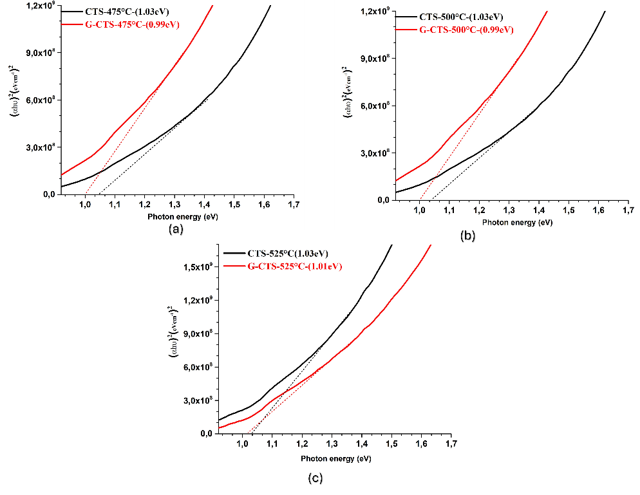
Figure 5. (αℎ𝑣)² vs (ℎ𝑣) plot of CTS films grown at sulfurization temperatures: (a) 475 °C (b) 500 °C and (c) 525 °C.

It was observed that in the graphene-free samples such as mobility, carrier density, and carrier type determined by the Van der Pauw method under a magnetic field intensity of approximately 0.57 T and a current of 0.1 mA are presented in Table 4. All thin films showed p-type conductivity. It has been reported that Sn₂S₃ thin films may exhibit either n-type or p-type electrical conductivity depending on their growth conditions [26]. The possible presence of n-type Sn₂S₃ is of particular concern, as it may reduce the concentration of majority carriers (holes) in the p-type absorber, thereby deteriorating charge transport and ultimately leading to a decline in photovoltaic performance. In contrast, the CuS secondary phase, which has also been detected in the structure, is generally considered to be a highly conductive phase and may contribute differently to the overall electrical response[27].
Table 4 also lists the mobility values of samples with and without graphene. It is evident that, particularly in low-temperature applications exhibiting superior structural characteristics, the incorporation of graphene leads to a partial increase in carrier concentration, whereas the carrier mobility correspondingly exhibits an inverse trend. However, at higher temperatures (>500°C), this effect may be reversed due to the possible thermal degradation or destabilization of the graphene structure.

TABLE 4. Carrier type, carrier concentration and mobility values of samples with and without graphene

Sample | Carrier type | Carrier concentration (N_{b}) | Mobility(µ-cm²/V_{s})
CTS-475 |  | 1.12×10¹⁹ | 0.26
G-CTS-475 |  | 2.81×10¹⁹ | 0.10
CTS-500 | p | 2.82×10¹⁸ | 0.65
G-CTS-500 |  | 7.31×10¹⁸ | 0.33
CTS-525 |  | 1.92×10¹⁸ | 0.24
G-CTS-525 |  | 4.61×10¹⁷ | 0.32

CONCLUSION
In conclusion, this study presents a comprehensive investigation into the fabrication and characterization of CTS thin films, with particular emphasis on the influence of a single-layer graphene interlayer and varying sulfurization temperatures on their structural, morphological, optical, and electrical properties. CTS and graphene interfaced (G-CTS) thin films annealed at different temperatures were systematically compared using XRD, Raman spectroscopy, SEM, electrical and optical analyses. XRD and Raman spectroscopy consistently confirmed the formation of monoclinic-phase CTS. The incorporation of graphene was observed to significantly enhance crystallinity and facilitate the development of larger, well-defined grains, particularly pronounced in samples annealed at 500 and 525°C, thereby supporting graphene's role as a nucleation promoter. Additionally, the formation of undesirable MoS₂ secondary phases particularly prominent at elevated sulfurization temperatures, was significantly mitigated by the graphene interlayer, which acts as a diffusion barrier at the Mo/CTS back interface. SEM analyses further supported these findings by revealing improved surface morphology in graphene-containing samples, characterized by larger, more homogeneously distributed, and plate-like grains. Optical measurements demonstrated that all samples exhibited strong absorption in the optical region, with absorption edges in the range of 0.99–1.03 eV. The G-CTS-475 sample, exhibiting p-type conductivity with the highest carrier concentration (2.81 × 10¹⁹ cm⁻³), was considered to have the most favorable electrical properties. Moreover, graphene incorporation improved light absorption, further supporting its beneficial role in film quality. Overall, the results indicate that graphene- interlayer CTS thin films exhibit superior structural integrity and optoelectronic performance, making them promising candidates for photovoltaic and other optoelectronic applications.

Acknowledgments
This study was supported by the project number 122F217 carried out by TÜBİTAK ARDEB and the BİÇABA "Birlikte Çalışıp Birlikte Başaracağız" Scholarship Program carried out by BİDEB.

References

- Y. Atasoy, Appl. Phys. A 128, 1030 (2022).
- F. Rehman, S. Yılmaz, İ. Polat, E. Bacaksız, R. Zan, and M. A. Olgar, Opt. Mater. 163, 117006 (2025).
- A. C. Lokhande, R. B. V. Chalapathy, M. He, E. Jo, M. Gang, S. A. Pawar, and J. H. Kim, Sol. Energy Mater. Sol. Cells 153, 84–107 (2016).
- D. Tiwari, T. K. Chaudhuri, T. Shripathi, U. Deshpande, and R. Rawat, Sol. Energy Mater. Sol. Cells 113, 165–170 (2013).
- Y. Atasoy, E. Bacaksız, A. Çiriş, M. A. Olğar, R. Zan, A. M. A. D. Ali, and B. M. Başol, Sol. Energy 267, 112247 (2024).
- E. Laghchim, A. Raidou, J. Zimou, J. Mhalla, A. El-Habib, K. Fareh, and M. Fahoume, Sol. Energy 290, 113341 (2025).
- Q. Han, R. Wang, Y. Xue, L. Camilli, G. Yu, and B. Luo, Corros. Rev. 43, 23–59 (2025).
- E. Jo, M. G. Gang, H. Shim, M. P. Suryawanshi, U. V. Ghorpade, and J. H. Kim, ACS Appl. Mater. Interfaces 11, 23118–23124 (2019).
- K. Chino, J. Koike, S. Eguchi, H. Araki, R. Nakamura, K. Jimbo, and H. Katagiri, Jpn. J. Appl. Phys. 51, 10NC35 (2012).
- X. Zhang, S. Xu, S. Jiang, J. Wang, J. Wei, S. Xu, and H. Li, Appl. Surf. Sci. 353, 63–70 (2015).
- E. Peksu, C. Yener, C. G. Unlu, and H. Karaagac, J. Alloys Compd. 976, 172979 (2024).
- X. Zhang, S. Cao, X. Wu, and L. Hu, Nanomaterials and Nanotechnology 2025, (2025).
- S. Erkan, A. Yagmyrov, A. Altuntepe, R. Zan, and M. A. Olgar, J. Alloys Compd. 920, 166041 (2022).
- Y. Ji, W. Yang, D. Yan, W. Luo, J. Li, S. Tang, and P. Mulvaney, arXiv:2408.15684 (2024).
- M. K. Gadha, T. V. Anitha, P. Punathil, and T. V. Vimalkumar, Mater. Sci. Eng. B 314, 118003 (2025).
- V. Dhiman, S. Kumar, M. Kaur, R. Sharma, T. Chandel, D. Bhardwaj, and D. Prasher, Inorg. Chem. Commun. 154, 110923 (2023).
- R. E. Agbenyeke, S. Song, H. Choi, B. K. Park, J. H. Yun, T. M. Chung, and J. H. Han, Chem. Mater. 33, 8112–8123 (2021).
- D. M. Berg, R. Djemour, L. Gütay, S. Siebentritt, P. J. Dale, X. Fontane, and A. Pérez-Rodriguez, Appl. Phys. Lett. 100, 191904 (2012).
- E. A. Lund, H. Du, O. O. Hlaing, G. Teeter, and M. A. Scarpulla, J. Appl. Phys. 115, 173504 (2014).
- A. Çiriş, Niğde Ömer Halisdemir Üniv. Müh. Bilim. Derg. 12, 3 (2023).
- P. A. Fernandes, P. M. P. Salomé, and A. F. Da Cunha, J. Phys. D: Appl. Phys. 43, 215403 (2010).
- A. Ashfaq, S. Tahir, U. ur Rehman, A. Ali, K. Mehmood, F. Ashfaq, and R. Saeed, Ceram. Int. 48, 18944–18948 (2022).
- Q. B. Zheng, M. M. Gudarzi, S. J. Wang, Y. Geng, Z. Li, and J. K. Kim, Carbon 49, 2905–2916 (2011).
- O. G. Abdullah, S. B. Aziz, K. M. Omer, and Y. M. Salih, J. Mater. Sci.: Mater. Electron. 26, 5303 (2015).
- S. Erkan, Y. Atasoy, M. A. Olğar, and R. Zan, Niğde Ömer Halisdemir Üniv. Müh. Bilim. Derg. 14, 1–1 (2025).
- T. S. Reddy, M. C. S. Kumar, and S. Shaji, Mater. Res. Express 4, 046404 (2017).
- T. S. Reddy and M. S. Kumar, RSC Adv,. 6, 95680 (2016).

