3D Numerical Analysis of the Performance of a Water- and Air-Cooled Photovoltaic-Thermal System
Yassine EL ALAMI^{1, a)}, Charaf Hajjaj^{1, b)}, Rehena Nasrin^{2,c)}, Alae Azouzoute^{3, d)}, Elhadi Baghaz^{1, e)}
¹Laboratory of Electronics, Instrumentation and Energetic FS, Chouaïb Doukkali University El Jadida, Morocco;
²Department of Mathematics, Bangladesh University of Engineering and Technology, Dhaka-1000, Bangladesh;
³Fluid Lechanics Team, Laboratory of Mechanics and Energetics, Faculty of Sciences, Mohammed First University Oujda;
^{a)} Corresponding author: yassineelalami97@gmail.com
^{b)}Hajjaj.c@ucd.ac.ma
^{c)} rehena@math.buet.ac.bd
^{d)} a.azouzoute@ump.ac.ma
^{e)} baghaz.e@ucd.ac.ma
Abstract. Photovoltaic panels (PV-Ps) often suffer from high operating temperatures, which significantly reduce their electrical efficiency and limit the long-term development of photovoltaic technology. Conventional cooling approaches remain insufficient to ensure optimal performance, highlighting the need for effective hybrid solutions. In this study, we propose and numerically investigate a new photovoltaic-thermal system (PV/T-S) designed to enhance both electrical and thermal performance by integrating dual cooling strategies: air and water. A three-dimensional numerical simulation was conducted in COMSOL Multiphysics using the finite element method (FEM). The numerical model was validated against previously reported computational and experimental results, confirming its reliability. The performance evaluation focused on system efficiencies and the effect of solar irradiance. Results reveal that water cooling considerably outperforms air cooling, with overall, thermal, and electrical efficiencies of 82.46%, 69.79%, and 12.66%, respectively, compared to 10.59%, 39.12%, and 49.71% for the air-cooled configuration. Moreover, higher solar irradiance causes a significant increase in cell temperature and electrical output, reaching 3.64°C and 75.93 W for the water-cooled system, compared to 32.52°C and 44.88 W for the air-cooled configuration.
Keywords: Three-dimensional model; Water cooling; Air cooling; Photovoltaic efficiency; Solar irradiance.

INTRODUCTION
Solar PVs are currently the most dynamic renewable energy source, with rapidly expanding production capacity worldwide and steadily increasing annual investment [1–3]. However, one of the main obstacles to the efficiency of PV systems is the overheating of solar cells. When the temperature of the cells rises, this causes a significant deterioration in their electrical performance. For every 1°C increase in temperature, the electrical efficiency (EE) of PV-P can fall between 0.3% and 0.5% [4]. This drop in efficiency is a critical problem, especially in regions with high solar irradiation, where temperatures can rise rapidly, limiting the overall energy potential of the systems. To attenuate this negative effect, various cooling methods have been explored to regulate the excessive heat generated on the surface of PV-Ps [5–9]. Among these solutions, air cooling is one of the simplest approaches, although it is often insufficient in high ambient temperature environments [10]. Water cooling, on the other hand, offers better heat dissipation capacity thanks to the higher conductivity of water compared with air, making it possible to maintain lower cell temperatures and stabilize electrical performance [11]. Attia et al. [12] compared two cooling configurations for PVT-Ss to minimize performance loss due to cell temperature rise. The first configuration includes longitudinal tubes placed under the panels, while the second configuration uses skeletal tubes integrated directly into the cells. Both configurations are cooled using air and water, with a flow rate (FR) of 0.0025 kg/s. The results show that configuration 2, equipped with skeletal tubes, performs better than configuration 1, improving thermal efficiency (TE) by 24.3% and EE by 0.16% when cooled by air, and by 7.27% and 3.98% respectively when cooled by water. Kazem et al. [13] compared the performance of three water-cooled PVT-Ss, each with a different flow channel design (sheet, direct, and spiral), against a conventional PV system. The PV/T-S with a spiral channel offered the best performance, recording a maximum power of 51.3 W. In terms of overall efficiency (OE), the conventional PV system achieved 7.8%, while the sheet, direct-flow, and spiral-flow systems achieved efficiencies of 18.5%, 28.0%, and 35.0% respectively. Tripty et al. [14] investigated an air-cooled PVT-S with aluminum fins to optimize TE and EE. The analysis focuses on a heat exchanger using 1 mm thick fins, where air flows in a waveform through the channels to facilitate heat transfer. Mass FR (0.015-0.535 kg/s) and inlet temperature (10-40°C) are the variables studied, and the results show that, although EE decreases with increasing temperature, OE increases by 0.33% for every 5°C increase. Majeed et al. [15] studied an air-cooled PV/T-S with a damper modifying the flow direction in a multi-flow channel. They analyzed the effect of different air mass FRs (0.04-0.08 kg/s) and irradiances (600-1000 W/m²) on PV cell temperature and system performance. At the highest tested FR of 0.08 kg/s combined with 1000 W/m² irradiance, EE reached 17.03 %, TE was 74.14 %, and total efficiency climbed to 90.4 %, resulting in a 28.44 % boost in power output.
Numerous studies have been carried out on PV/T-Ss using water and air as cooling fluids. However, despite the advances that have been made, these systems still have performance limitations that require further research to overcome. Improved performance could be achieved by introducing new PV/T-S designs and configurations. By proposing innovative systems, it would be possible to maximize energy yield, improve thermal and electrical efficiency, and make these technologies more suitable for a wide range of practical applications.
Numerous studies in the literature have compared water-cooled and air-cooled PV/T-Ss. However, these comparisons are often not entirely effective, as the majority of this research is based on a variety of operating conditions, making a direct assessment difficult. For example, the studies use different types of PV-Ps, different heat exchanger designs, and heterogeneous heat flows and fluid FRs. These variations directly influence electrical and thermal performance, making conclusions about the superiority of one system or another less reliable or consistent. For a more accurate comparison, it would be necessary to standardize operating parameters, such as panel type, heat exchanger structure, and environmental conditions, to better assess the relative merits of water-cooled and air-cooled systems.
This study introduces an original methodology to effectively report the drawbacks encountered in PV/T systems by investigating a new PV/T-S configuration under two cooling strategies: water cooling and air cooling. The main aim is to directly compare the performance of both systems under the same operating conditions while keeping the heat exchanger design unchanged. This comparison enables the identification of the most effective cooling fluid for the system and, more broadly, for similar PV/T-S applications. Additionally, the study evaluates how variations in solar irradiance affect system performance. The analysis was carried out using three-dimensional numerical simulations in COMSOL Multiphysics, based on the finite element method (FEM).

Methodology
This study focuses on the analysis of a PV/T-S composed of a heat exchanger and a PV-P, made up of different layers: ethylene vinyl acetate (EVA), Tedlar, glass, and the PV cell (Figure 1). The heat exchanger is composed of 176 channels, with a height of 30 mm for the manifolds that distribute the water through these channels. This technique’s comprehensive explanation can be found in reference [16]. The main objective is to analyze and compare the electrical and thermal performance of the system as a function of the cooling fluid used, i.e., water and air. The study aims to determine which fluid provides optimal cooling to maximize system efficiency and to identify the best option for wider use in PV/T-Ss. To carry out this analysis, numerical modeling was carried out using the FEM with COMSOL software. This approach addressed the equations of momentum, heat transport, and mass management. Using conjugate heat transport physics, we obtained and processed numerical results, which were then organized and visualized with Origin 2018 software for a comprehensive analysis. Finally, Tables 1 and 2 list the materials used in the system, together with their thermophysical properties, in addition to the specific design parameters adopted for this study.

Tedlar
Glass
EVA
EVA
Silicon
Connector
Alveolar plate
Collector
Openings
Fluid inlet
FIGURE 1. Illustration of the PV/T-S system configuration.
TABLE 1. Thermal criteria and materials used in the PV/T-S [16–18].
Materials | Thickness (mm) | ρ [Kg/m³] | C_{p} [J/kg.K] | k [W/m.K]
Silicon | 0.5 | 2329 | 700 | 148
Aluminum | 0.4 | 2700 | 900 | 237
Glass | 3 | 2500 | 500 | 1.8
Water | - | 998 | 4200 | 0.68
Tedlar | 0.1 | 1200 | 1250 | 0.15
Air | - | 1.164 | 1007 | 0.02588
EVA | 0.3 | 950 | 2090 | 0.311

TABLE 2. Main geometric, optical, and thermal input data for the PV/T-S model [16–20].
Description | Specification
Collector dimensions (L × W) | 1.960 m × 0.960 m
Solar cell absorptivity | 0.90
Overall heat loss coefficient from PVT surface (U_{t}) | 150 W/m²·K
Standard ambient/reference temperature | 25 °C
Glass cover transmissivity | 0.96
Glass cover emissivity | 0.04
Heat transfer coefficient from glass to ambient (U_{ga}) | 7.14 W/m²·K
Photovoltaic module reference efficiency | 13 %
Temperature coefficient of electrical efficiency (μ_{c}) | −0.0045 /°C
Cell packing factor (P_{c}) | 0.95

Governing equations
Inside the PV/T-S’s solid components, thermal energy may be transmitted solely through a conductive way, which can be described using the standard conduction equation [21]:
(1)
In this expression, the symbol ∇ stands for the vector differential operator, while T refers to the temperature variable.
Within the flow channels, heat transfer is governed by both conduction and convection mechanisms. The working fluid flow is treated as incompressible, Newtonian, and laminar. Based on these assumptions, the governing equations for the fluid region may be [21]:
(2)
(3)
(4)
The fluid density ρ (kg/m³) and specific heat capacitance C_{p}​ (J/kg·K) define its thermal properties, while the dynamic viscosity μ (m²/s) characterizes its flow resistance. The velocity field u (m/s) describes fluid motion, pressure P is measured in pascals (Pa), and thermal conductivity k (W/m·K) relates to heat transfer within the material.

Boundary conditions
- Received heat flux:
- Energy is lost from the system due to convection:
- Non-slip condition:
- Diffuse surface:, where is the Stefan-Boltzmann constant.
- Solid-fluid interaction area:
- Inlet and outlet specifications for the heat exchanger:
- At the input limit:
- At output:
- Insulation on all other surfaces:
The parameters used in the equations include the water inlet temperature, denoted as T_{in}​ (°C), and the ambient temperature, T_{amb​} (°C). The thermal conductivity of the solid material, k_{s​olid}, and that of the cooling water, k_{fluid}​, are expressed in watts per meter-kelvin (W·m⁻¹·K⁻¹). Fluid flow within the system is characterized by the velocity components u, v, and w, measured in meters per second (m·s⁻¹), while the overall flow velocity at the inlet is represented by U_{in}​ (m·s⁻¹). The temperatures at the surface and the glass cover are given by T_{s}​ and T_{g}​, respectively, both in degrees Celsius (°C). Finally, the vector normal to the surface, n, defines the orientation of the surfaces involved in the heat transfer processes.

Mathematical formulations
The overall energy absorbed by the PV/T-S system can be quantified using the following expression [16, 22]:
(5)
Calculating the cells’ temperature [16, 18]:
(6)
The collected thermal energy is calculated as follows [16, 23]:
(7)
The calculation of EE is based on the following formula [16, 23]:
(8)
Here, ƞ_{c} represents the reference efficiency of the cell, while μ_{c} denotes the thermal coefficient.
The equation below is used to calculate the TE [16]:
(9)
OE is determined by the following equation [23]:
(10)

Mesh generation
In this study, particular attention was paid to mesh accuracy for the numerical analysis. In order to guarantee reliable results, a suitable mesh was generated with the physics-based meshing arrangement available in COMSOL Multiphysics. As shown in Figure 2, the PV/T model mesh was produced using a combination of free triangular and tetrahedral meshes. Specifically, 1,138,516 triangular elements and 7,330,386 tetrahedral elements were used, ensuring optimum accuracy in the calculations.
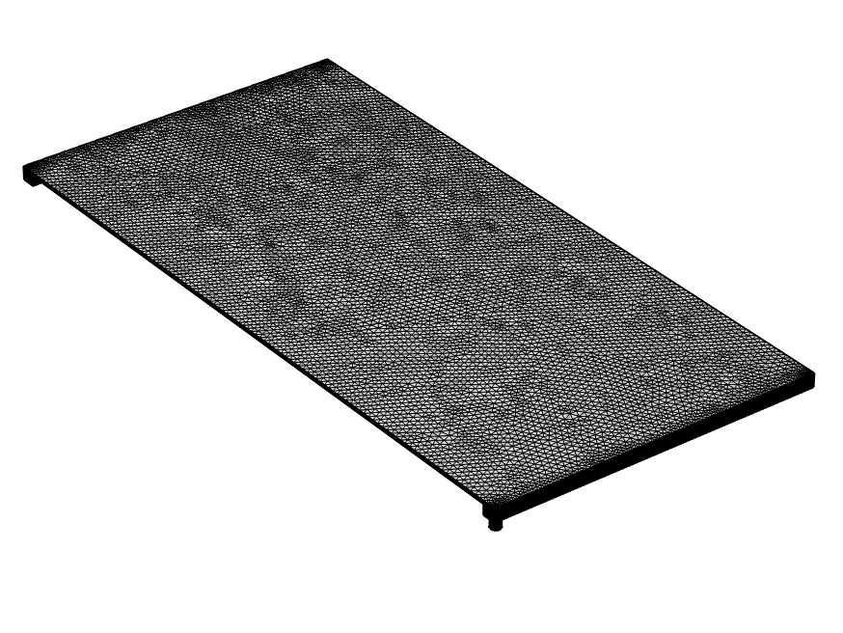
Tetrahedral finite element

Triangular finite element

FIGURE 2. PVT model mesh with triangular and tetrahedral elements for numerical simulation.

Confirmation of the model
A thorough validation was performed to confirm the reliability of the PVT-S numerical simulation. This process involved matching the 3D simulation outputs against published experimental and numerical results, thereby verifying the model’s accuracy. A detailed account of this validation procedure can be found in [16] and is not repeated here.

Results and discussion

This study evaluates the performance of a PVT-S, cooled once by water and once by air, using the same operating conditions to enable a direct comparison. The tests were carried out under three levels of solar irradiation (300, 500, and 700 W/m²), with a mass FR of 0.05 kg/s. The fluid inlet temperature and the ambient temperature were set at 28°C. This uniform approach makes it possible to effectively compare the thermal and electrical efficiency of the two systems, while highlighting the advantages and disadvantages of each cooling method.
Figure 3 presents the temperature contours of the water-cooled and air-cooled PV/T-Ss under an irradiance of 500 W/m². The water-cooled system reached an optimum 34.4°C temperature, demonstrating the high heat transfer effectiveness between the module surface and the coolant. Higher temperatures were observed at the outlet compared to the inlet, since the incoming water is cooler and progressively absorbs heat along the channel. This distribution indicates that water is capable of maintaining moderate thermal gradients across the system, effectively preventing excessive cell heating. In contrast, the air-cooled system recorded a peak temperature of 88.7°C, more than twice that of the water-cooled configuration. This significant difference is primarily due to the low thermal conductivity and heat capacity of air, which limit its ability to remove heat efficiently. As a result, heat accumulation occurs within the module, leading to elevated cell temperatures and a considerable reduction in electrical performance.
Overall, this analysis highlights the superiority of water cooling compared to air cooling in the studied PV/T-S. Moreover, the present results are consistent with the findings of El Alami et al. [23], who also reported that water cooling significantly reduces PV cell temperatures and enhances the overall performance of PV/T-Ss.
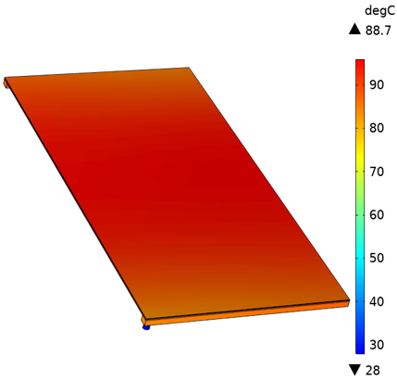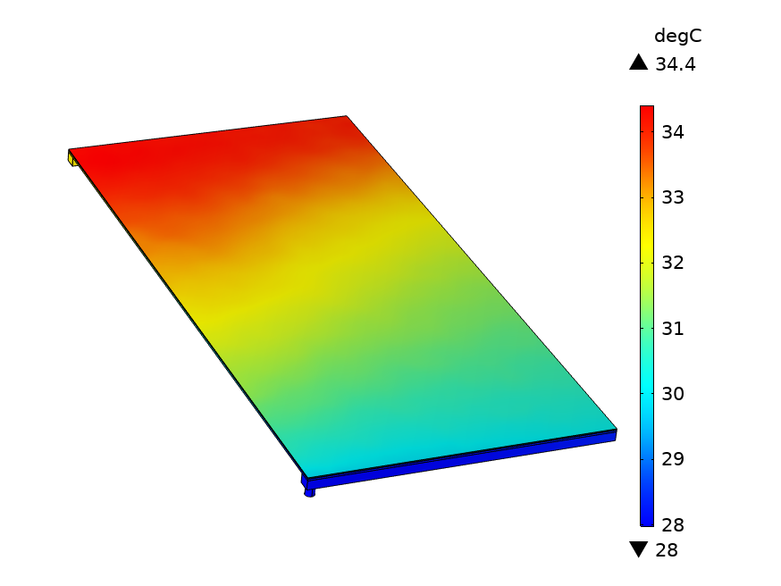
Air-PVT
Water-PVT
FIGURE 3. Temperature distribution for air- and water-cooled systems.
Figure 4 illustrates the variation of PV cell temperatures for both water-cooled and air-cooled systems as a function of solar irradiance. As expected, increasing solar irradiance leads to a rise in cell temperature for both configurations. For the water-cooled system, the cell temperature increases moderately from 30.74°C to 34.38°C, whereas for the air-cooled system, it rises sharply from 66.13°C to 98.65°C as irradiance increases from 300 to 700 W/m². This pronounced difference can be attributed to the higher heat capacity and thermal conductivity of water, which allow it to absorb and transport heat more effectively than air. Consequently, the water-cooled system maintains significantly lower cell temperatures across the irradiance range, reducing thermal-induced losses and enhancing electrical performance. These results clearly demonstrate the superior thermal management capability of water cooling, highlighting its advantage in maintaining PV efficiency under high irradiance conditions.
FIGURE 4. Cell temperatures in water- and air-cooled PV/T-Ss versus solar irradiance.
Figure 5 presents the electrical efficiencies of the water-cooled and air-cooled systems as a function of solar irradiance. As solar irradiance increases, EE decreases for both systems due to the corresponding rise in cell temperature, which reduces the voltage output and overall performance of the PV-Ps. For the water-cooled system, EE drops slightly from 12.66% to 12.45%, reflecting the system’s ability to maintain moderate cell temperatures even at higher irradiance levels. In contrast, the air-cooled system experiences a more pronounced decline, from 10.59% to 8.69%, due to insufficient heat removal and elevated cell temperatures that significantly impact its electrical performance. These results highlight the effectiveness of water cooling in limiting thermal losses and sustaining higher EE, particularly under high-irradiance conditions, emphasizing its superiority over air cooling in maintaining PV performance.
FIGURE 5. Electrical efficiencies of water- and air-cooled PVT-Ss against solar irradiance.
Figure 6 compares the electrical power output of the water-cooled and air-cooled PV/T-Ss as a function of solar irradiance. As expected, increasing solar irradiance leads to higher electrical power generation for both systems. Escalating irradiance (300-700 W/m²) enhances electrical power production of (58.67-134.60 W) and (49.06 -93.94 W) using the water- and air-cooled strategies, respectively. The superior performance of the water-cooled system is directly related to its ability to maintain lower cell temperatures, which minimizes thermal-induced losses and preserves higher voltage and current outputs. In contrast, the air-cooled system experiences a greater temperature rise, reducing its EE and limiting the increase in power output.
FIGURE 6. Electrical power of water- and air-cooled PV/T-Ss versus radiation.
Figure 7 presents the TEs of the water-cooled and air-cooled PV/T-Ss as a function of solar irradiance. As solar irradiance increases, TE decreases for both systems due to higher cell and fluid temperatures, which reduce the heat transfer gradient and slightly limit the system’s thermal extraction capability. For the water-cooled system, TE decreases moderately from 69.79% to 66.04% (a drop of 3.75%), reflecting the system’s capacity to maintain effective thermal management even under high irradiance. In contrast, the air-cooled system experiences a much larger reduction, from 39.12% to 29.34% (a decrease of 9.78%), due to the limited heat removal capability of air and the consequent increase in module temperature.
FIGURE 7. TEs of water- and air-cooled PV/T-Ss against radiation.
A comparison of the OE of water- and air-cooled PV/T-Ss as a function of solar irradiance is shown in Figure 8. The analysis shows that increasing solar irradiance reduces OE as higher irradiance levels lead to a reduction in both thermal and electrical efficiencies, thus negatively impacting OE. For the water-cooled system, OE fell from 82.46% to 78.49%, representing a drop of 3.97%. But the air-cooled system shows a more significant reduction, with OE dropping from 49.71% to 38.03%, corresponding to a reduction of 11.68%.
FIGURE 8. OE of water- and air-cooled PV/T-Ss versus radiation.
Table 3 summarizes the performance of air- and water-cooled PV/T-Ss, highlighting TE, EE, and electrical power for different solar irradiance levels.
TABLE 3. Comparative performance of air- and water-cooled PV/T-Ss with various radiations.
Radiation (W/m²) | Cooling Type | Electrical Power (W) | EE (%) | TE (%)
300 | Air | 49.06 | 10.59 | 39.12
300 | Water | 58.67 | 12.66 | 69.79
500 | Air | 73.66 | 9.54 | 34.55
500 | Water | 96.96 | 12.55 | 67.98
700 | Air | 93.94 | 8.69 | 29.34
700 | Water | 134.60 | 12.45 | 66.04

Table 4 presents a comparison of the current results with those available (literature) to validate their accuracy. This comparison shows that the system studied in this work demonstrates good performance, both for water- and air-cooling, compared to other studies.
TABLE 4. PV/T-S Performance compared with published results.
Reference | Working fluid | EE (%) | TE (%)
Khelifa et al.[24] | Air | 22.58 | 20.14
Abdallah et al. [25] | Water | 16 .5 | 40.9
Kumar and Rosen [26] | Air | 10.5 | 15.5
Alsharifi et al. [1] | Water | 11.9 | 58.0
Khelifa et al. [27] | Air | 22.26 | 35.07
Olmus et al. [28] | Water | 14.9 | 59.9
Present study | Air | 10.59 | 39.12
Present study | Water | 12.66 | 69.79

Conclusion
This study performed a 3D thermal-fluid dynamic of a PV/T-S system to compare the effects of water- and air-cooling, aiming to detect the most appropriate fluid for this system and PV/T-Ss in general, while also examining the impact of solar irradiance on system performance. The results show that water cooling is significantly more effective than air cooling due to the higher thermal conductivity of water, reducing the cell temperature by 53.57% at an irradiance of 700 W/m² compared to air cooling. The water-cooled system also demonstrates superior performance, with electrical, thermal, and overall efficiencies exceeding those of the air-cooled system by 30.20%, 55.57%, and 51.54%, respectively. Moreover, increasing solar irradiance leads to higher cell temperatures and electrical power, while reducing electrical, thermal, and overall efficiencies.
The main limitations of this study include the use of idealized boundary conditions and the lack of experimental validation. Future work should focus on experimental testing to confirm the numerical results, exploring alternative cooling fluids, optimizing system geometry, and investigating long-term performance under real operating conditions.

References
- T. Alsharifi, J.M. Mahdi, H. Togun, H.M. Taqi Al-Najjar, N. Ben Khedher, A. Cairns, P. Talebizadehsardari, Design and optimization of a household photovoltaic/thermal collector with serpentine tube: Energy and exergy analysis, Appl. Therm. Eng. 246 (2024) 122983. https://doi.org/10.1016/j.applthermaleng.2024.122983.
- Y. El Alami, E. Chetouani, H. Mokhliss, F. Ouerradi, M. Aoutoul, S. Bounouar, R. Bendaoud, A. Faize, R. Rmaily, Optimizing solar energy efficiency with an improved hill-climbing maximum power point tracking control approach: hardware implementation, Clean Energy 8 (2024) 167–176. https://doi.org/10.1093/ce/zkae061.
- Y.E. Alami, B. Zohal, R. Bendaoud, M. Rhiat, A. Rabhi, B. Benhala, K. Hirech, E. Baghaz, Comparative analysis of the performance of Shingle and Standard photovoltaic technologies in the environmental conditions of El Jadida, E3S Web Conf. 601 (2025) 00010. https://doi.org/10.1051/e3sconf/202560100010.
- S.A. Kalogirou, Y. Tripanagnostopoulos, Hybrid PV/T solar systems for domestic hot water and electricity production, Energy Convers. Manag. 47 (2006) 3368–3382. https://doi.org/10.1016/j.enconman.2006.01.012.
- A. Zarei, M. Liravi, M. Babaie Rabiee, M. Ghodrat, A Novel, eco-friendly combined solar cooling and heating system, powered by hybrid Photovoltaic thermal (PVT) collector for domestic application, Energy Convers. Manag. 222 (2020) 113198. https://doi.org/10.1016/j.enconman.2020.113198.
- Y. El Alami, E. Baghaz, R. Nasrin, M. Al-Damook, R. Bendaoud, T. Bouragba, M. Melhaoui, M. Benhmida, Up-to-Date Review on Flat-Plate Solar Hybrid Photovoltaic Thermal Systems: Absorber Designs and Fabrication Materials, Int. J. Energy Res. 2025 (2025) 5547555. https://doi.org/10.1155/er/5547555.
- Y. El Alami, E. Baghaz, R. Nasrin, F. Chanaa, R. Bendaoud, S. Padmanaban, M. Louzazni, Experimental-numerical comparative study of performance and cost-effectiveness of partially- and fully-cooled photovoltaic thermal systems, Case Stud. Therm. Eng. 73 (2025) 106660. https://doi.org/10.1016/j.csite.2025.106660.
- Y. El Alami, H.E. Achouby, E. Baghaz, C. Hajjaj, R. Nasrin, An innovative photovoltaic thermal system with direct water-cell contact: energy, exergy, and sustainability analysis, Sol. Energy 300 (2025) 113827. https://doi.org/10.1016/j.solener.2025.113827.
- Y.E. Alami, E. Baghaz, R. Nasrin, S. Padmanaban, M. Louzazni, Numerical Approach of An Advanced Hybrid Photovoltaic Thermal System Based on Exergy, Energy, Enviro-Economic, and Sustainability Factors, Results Eng. (2025) 106342. https://doi.org/10.1016/j.rineng.2025.106342.
- R. Sellami, M. Amirat, A. Mahrane, M.E.-A. Slimani, A. Arbane, R. Chekrouni, Experimental and numerical study of a PV/Thermal collector equipped with a PV-assisted air circulation system: Configuration suitable for building integration, Energy Build. 190 (2019) 216–234. https://doi.org/10.1016/j.enbuild.2019.03.007.
- J. Yazdanpanahi, F. Sarhaddi, M. Mahdavi Adeli, Experimental investigation of exergy efficiency of a solar photovoltaic thermal (PVT) water collector based on exergy losses, Sol. Energy 118 (2015) 197–208. https://doi.org/10.1016/j.solener.2015.04.038.
- M.E.H. Attia, A.E. Kabeel, A. Khelifa, M.M. Abdel-Aziz, Thermal and electrical analysis of the performance of a skeleton-shaped tubes via hybrid PVT cooling system, Appl. Therm. Eng. 248 (2024) 123277. https://doi.org/10.1016/j.applthermaleng.2024.123277.
- H.A. Kazem, A.H.A. Al-Waeli, M.T. Chaichan, K.H. Al-Waeli, A.B. Al-Aasam, K. Sopian, Evaluation and comparison of different flow configurations PVT systems in Oman: A numerical and experimental investigation, Sol. Energy 208 (2020) 58–88. https://doi.org/10.1016/j.solener.2020.07.078.
- T.A. Tripty, R. Nasrin, Efficiency upgrading of solar PVT finned hybrid system in Bangladesh: Flow rate and temperature influences, Heliyon 10 (2024) e28323. https://doi.org/10.1016/j.heliyon.2024.e28323.
- M.A. Majeed, S.M. Salih, Experimental and theoretical analysis of photovoltaic thermal collector performance with multi-flow channel, Al-Qadisiyah Journal for Engineering Sciences (2023).
- Y.E. Alami, A. Lamkaddem, R. Bendaoud, S. Talbi, M. Louzazni, E. Baghaz, Numerical study of a water-based photovoltaic-thermal (PVT) hybrid solar collector with a new heat exchanger, E-Prime - Adv. Electr. Eng. Electron. Energy (2024) 100693. https://doi.org/10.1016/j.prime.2024.100693.
- Y. Zhang, C. Shen, C. Zhang, G. Lv, C. Sun, D. Chwieduk, The study of heat control on PVT modules with a new leaf-like heat exchanger, J. Renew. Sustain. Energy 13 (2021) 023703. https://doi.org/10.1063/5.0030541.
- R. Nasrin, M. Hasanuzzaman, N.A. Rahim, Effect of high irradiation on photovoltaic power and energy, Int. J. Energy Res. 42 (2018) 1115–1131. https://doi.org/10.1002/er.3907.
- Y.E. Alami, H. Dahmani, F. Ouerradi, B. Zohal, R. Bendaoud, E. Baghaz, Impact of Heat Exchanger Materials on the Performance of Solar Hybrid Photovoltaic Thermal (PVT) Systems: 3D Analysis, in: B. Hajji, A. Gagliano, A. Mellit, A. Rabhi, M. Calì (Eds.), Proc. 4th Int. Conf. Electron. Eng. Renew. Energy Syst. - Vol. 2, Springer Nature, Singapore, 2025: pp. 609–619. https://doi.org/10.1007/978-981-97-9975-6_58.
- Y.E. Alami, F. Ouerradi, S. Bounouar, M. Benhmida, M. Rhiat, B. Benhala, K. Hirech, E. Baghaz, Comparative study of the performance of photovoltaic and photovoltaic thermal solar systems: Case study in El Jadida, E3S Web Conf. 601 (2025) 00011. https://doi.org/10.1051/e3sconf/202560100011.
- A. Nahar, M. Hasanuzzaman, N.A. Rahim, Numerical and experimental investigation on the performance of a photovoltaic thermal collector with parallel plate flow channel under different operating conditions in Malaysia, Sol. Energy 144 (2017) 517–528. https://doi.org/10.1016/j.solener.2017.01.041.
- Y. El Alami, E. Baghaz, R. Bendaoud, F. Chanaa, M. Benhmida, H. Ezzaki, R. Nasrin, Experimental-Numerical Investigation of the Photovoltaic Thermal System with Polypropylene Heat Exchanger: Case in Morocco, IET Renew. Power Gener. 19 (2025) e70041. https://doi.org/10.1049/rpg2.70041.
- Y. El Alami, B. Zohal, R. Nasrin, M. Benhmida, A. Faize, E. Baghaz, Solar thermal, photovoltaic, photovoltaic thermal, and photovoltaic thermal phase change material systems: A comprehensive reference guide, Int. Commun. Heat Mass Transf. 159 (2024) 108135. https://doi.org/10.1016/j.icheatmasstransfer.2024.108135.
- A. Khelifa, M. El Hadi Attia, K. Harby, A. Elnaby Kabeel, M.M. Abdel-Aziz, M. Abdelgaied, Experimental and economic evaluation on the performance improvement of a solar photovoltaic thermal system with skeleton-shaped fins, Appl. Therm. Eng. 248 (2024) 123180. https://doi.org/10.1016/j.applthermaleng.2024.123180.
- S.R. Abdallah, H. Saidani-Scott, O.E. Abdellatif, Performance analysis for hybrid PV/T system using low concentration MWCNT (water-based) nanofluid, Sol. Energy 181 (2019) 108–115. https://doi.org/10.1016/j.solener.2019.01.088.
- R. Kumar, M.A. Rosen, Performance evaluation of a double pass PV/T solar air heater with and without fins, Appl. Therm. Eng. 31 (2011) 1402–1410. https://doi.org/10.1016/j.applthermaleng.2010.12.037.
- A. Khelifa, M. Abdelgaied, K. Harby, M. El Hadi Attia, Performance improvement of photovoltaic/thermal collectors based on the optimized design of efficient innovative multiple-impinging slot jets, Sol. Energy 283 (2024) 112992. https://doi.org/10.1016/j.solener.2024.112992.
- U. Olmuş, Y.E. Güzelel, K.N. Çerçi, O. Büyükalaca, Numerical analysis and comparison of different serpentine-based photovoltaic-thermal collectors, Renew. Energy 241 (2025) 122196. https://doi.org/10.1016/j.renene.2024.122196.

