3D Numerical Study of the Effect of Partial and Total Cooling on the Performance of a Photovoltaic-Thermal System
Yassine El Alami^{1, a)}, Charaf Hajjaj^{1, b)}, Rehena Nasrin^{2, c)}, Alae Azouzoute^{3, d)}, Elhadi Baghaz^{1, e)}
¹Laboratory of Electronics, Instrumentation and Energetic FS, Chouaïb Doukkali University El Jadida, Morocco;
²Department of Mathematics, Bangladesh University of Engineering and Technology, Dhaka-1000, Bangladesh;
³Fluid Mechanics Team, Laboratory of Mechanics and Energetics, Faculty of Sciences, Mohammed First University Oujda;
^{a)} Corresponding author: yassineelalami97@gmail.com
^{b)}Hajjaj.c@ucd.ac.ma
^{c)} rehena@math.buet.ac.bd
^{d)} a.azouzoute@ump.ac.ma
^{d)} baghaz.e@ucd.ac.ma
Abstract. This study presents a three-dimensional numerical analysis to compare the performance of a fully cooled photovoltaic thermal collectors (PV/T-C) with that of a partially cooled system. The aim is to highlight the impact of temperature inhomogeneity on PV/T-C performance. The irradiation’s impact, between 700 and 1100 W/m², on the collector’s performance was also studied, representing operating conditions typical of hot climates and potential building-integrated PV/T applications. The numerical analysis is conducted utilizing COMSOL Multiphysics, which employs the finite element method (FEM), and results are verified with previously published data. The completely cooled system achieves electrical and thermal efficiencies of 13.37% and 65.40% respectively, while the partially cooled system achieves efficiencies of 12.43% and 52.91%. Furthermore, growing irradiance (700-1100 W/m²) leads to an increase in cell temperature and electrical output, with values of 13.45°C and 62.17 W for the partially cooled system, compared with 5.69°C and 76.25 W for the completely cooled system. These findings demonstrate the potential of complete cooling to improve PV/T performance under high-temperature operating conditions, although practical implementation must consider additional costs, design complexity, and installation constraints.
Keywords: PV/T collectors; Partial and total cooling; Temperature inhomogeneity; Solar irradiation; Three-dimensional simulation scheme.

INTRODUCTION
Faced with ever-increasing energy demand and the negative environmental impacts associated with the massive exploitation of fossil fuels, researchers are increasingly turning their attention to sustainable energy solutions [1]. Incorporating renewable energy sources into the overall energy mix represents a key solution to addressing these challenges. Among these solutions, solar energy stands out for its ability to provide abundant energy while limiting greenhouse gas emissions [2–4]. It can be converted into electricity or heat, offering energy versatility [5–7].
PV panels are a widely adopted method for producing electricity from solar energy. However, their efficiency remains limited: Only 11% to 24% of solar energy received is converted into electricity, with the remainder dissipating as heat [8–10]. As heat accumulates, the temperature of the photovoltaic cells rises, which negatively impacts their electrical performance [11]. In addition, a temperature rise of 1°C causes a decrease in conversion efficiency of around 0.4%, impacting the overall performance of the panels and reducing their lifespan due to thermal stress [12].
To overcome these limitations, photovoltaic thermal systems (PV/T-Ss) have been developed. These systems recover excess heat from PV panels and convert it into useful thermal energy for various applications [13]. PVT-Ss combine PV panels, which produce electricity, with thermal collectors that exploit the heat generated. By using air or water as a coolant, these systems reduce the temperature of the PV cells, thereby increasing their efficiency while producing heat [14]. This dual production of energy, both thermal and electrical, makes it possible to optimize the use of space, maximize energy efficiency, and reduce installation costs [15].
Since the introduction of PV/T-Ss in the 1970s, many studies, both experimental and numerical, have focused on enhancing their efficiency and overall performance. Mohammadi et al. [16] performed a numerical simulation to assess how tube flattening influences the cooling performance of a thermal PV system combined with phase change material. The study optimized four parameters: average panel temperature, material melt percentage, pressure drop, and temperature difference across the panel. The results indicate that increased flattening reduces the panel temperature and the temperature difference, but increases the pressure drop and decreases the melting percentage. An optimum flattening of 54.78% was found, providing a balance with an average temperature of 55.21 ˚C, a melt percentage of 42.54%, a pressure drop of 184.8 Pa, and a temperature difference of 33.42˚C. Umam et al. [17] evaluated the performance of PV/T-Ss with serpentine and spiral thermal collectors, without metal sheets, in both insulated and uninsulated configurations. Tests carried out in the Malaysian climate show that the addition of thermal collectors improves electrical efficiency by 0.53% and reduces module temperature by 5.60°C without insulation. With insulation, thermal efficiency increases by 18.26%, despite a drop in electrical efficiency. The study highlights the effectiveness of a single collector in increasing electrical performance and the positive impact of insulation on the thermal efficiency of PV/T-Ss. Kazem et al. [18] compared the performance of three water-cooled PV/T-Ss, each with a different flow channel design (sheet, direct, and spiral), to that of a conventional PV system. The PV/T-S with a spiral channel offered the best performance, recording a maximum power of 51.3 W. In terms of overall efficiency, the conventional PV system achieved 7.8%, while the sheet, direct flow, and spiral flow systems achieved efficiencies of 18.5%, 28.0% and 35.0% respectively. Attia et al. [19] compared two cooling configurations for PVT-Ss to minimize performance loss due to cell temperature rise. The first configuration includes longitudinal tubes placed under the panels, while the second configuration uses skeletal tubes integrated directly into the cells. Both configurations are cooled by air and water, with a flow rate of 0.0025 kg/s. The findings indicate that configuration 2, featuring skeletal tubes, achieves better performance than configuration 1, increasing thermal efficiency by 24.3% and electrical efficiency by 0.16% under air cooling, and by 7.27% and 3.98% respectively when water is used as the coolant.
Although PV/T-Ss have been the subject of intensive research, they still present a major problem: uneven temperature repartition over the surface of the PV panel, due to non-uniform cooling. This thermal inhomogeneity adversely affects the panel's performance and can shorten its lifespan. To overcome these limitations, it is crucial to carry out further studies and develop new heat exchanger configurations capable of guaranteeing uniform cooling over the entire surface, to improve the efficiency and durability of PV/T-Cs.
This study aims to evaluate and compare the performance of a completely cooled PV/T-C with that of a partially cooled system, to highlight the influence of thermal inhomogeneity on the efficiency of the system, and to underline the need for integral cooling of the PV panels. The study also examines the effect of solar irradiance, between 700 and 1100 W/m², on system performance. The analyses were conducted using COMSOL Multiphysics software, which employs the FEM.

Procedure
The main aim of this study is to analyze and compare the thermal and electrical performance of PV/T-C that are completely cooled and partially cooled (Fig.1), to assess the influence of temperature inhomogeneity on their performance. The PV/T-Cs studied consist of a heat exchanger and a PV panel, made up of several layers, including ethylene vinyl acetate (EVA), Tedlar, glass, and the PV cell (Fig. 2). The thermal exchanger is made of 165 pipes, with a height of 30 mm for the manifolds, which distribute the water through these channels. A detailed description of the heat exchanger can be found in the reference [11]. To carry out this study, numerical modeling was conducted using the FEM with COMSOL software [20]. This approach was used to solve the equations relating to momentum, heat transfer, and mass conservation. The convective-conductive thermal transfer physics was applied to generate and analyze numerical results. The numerical results were then organized and pictured via Origin 2018 software, facilitating a thorough examination of the outcomes. Tables 1 and 2 present the materials used in the system, along with thermophysical criteria and specific strategy constraints utilized in this study.
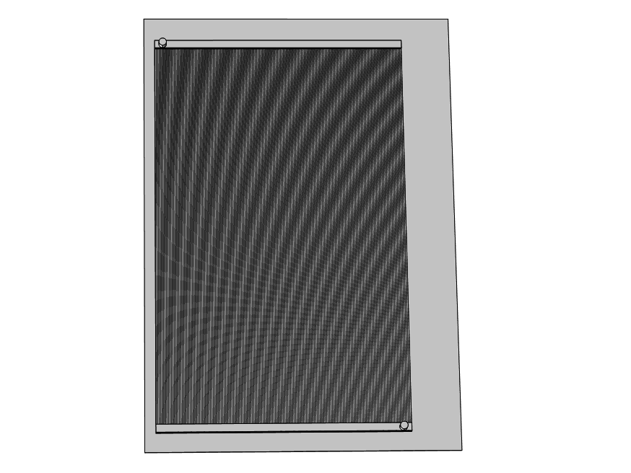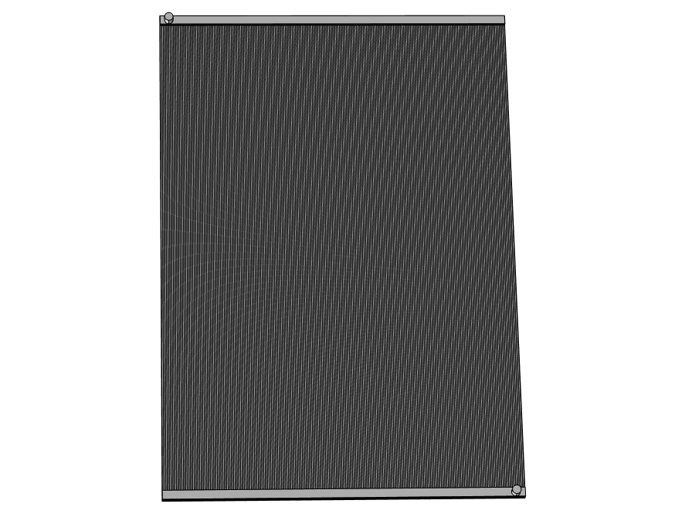
Partial cooling PVT-S
Total cooling PVT-S
FIGURE 1. Schematic representations of the PV/T-C analyzed.


Tedlar
Glass
EVA
EVA
Silicon
Connector
Alveolar plate
Collector
Openings
Fluid inlet
FIGURE 2. Schematic of the PV/T-C.

TABLE 1.Thermal properties and materials used in the PV/T-C [11, 21–23].
Materials | Thickness (mm) | C_{p} [J/kg.K] | ρ [Kg/m³] |  | k [W/m.K]
Mirror | 03.0 | 500.0 | 2500.0 | 1.80
EVA | 0.30 | 2090.0 | 950.0 | 0.3110
Silicon | 0.50 | 700.0 | 2329.0 | 148.0
Tedlar | 0.10 | 1250.0 | 1200.0 | 0.150
Aluminum | 0.40 | 900.0 | 2700.0 | 237.0
Water | - | 4200.0 | 998.0 | 0.680

TABLE 2. Main geometric, optical, and thermal input data for the PVT-S model [11, 21-22, 24].
Description | Specification
Collector dimensions (L × W) | 1.960 m × 0.960 m
Overall heat loss coefficient from PV/T surface (U_{t}) | 150 W/m²·K
Standard ambient/reference temperature | 25 °C
Glass cover transmissivity | 0.96
Glass cover emissivity | 0.04
Photovoltaic module reference efficiency | 14 %
Solar cell absorptivity | 0.90
Temperature coefficient of electrical efficiency (μ_{c}) | −0.0045 /°C
Cell packing factor (P_{c}) | 0.95
Heat transfer coefficient (glass-ambient) (U_{ga}) | 17.1 W/m²·K

Governing equations
In the solid components of the PV/T-C system, thermal energy is transmitted solely through conduction, which can be described using the standard conduction equation [25-26]:
(1)
In this expression, the symbol ∇ stands for the vector differential operator, while T refers to the temperature variable.
Within the flow channels, heat transfer is governed by both conduction and convection mechanisms. The working fluid flow is treated as incompressible, Newtonian, and laminar. Based on these assumptions, the governing equations for the fluid region are [25, 27]:
(2)
(3)
(4)
The fluid density ρ (kg/m³) and heat capacitance C_{p}​ (J/kg·K) define its thermal properties, while the dynamic viscosity μ (m²/s) characterizes its flow resistance. The velocity field u (m/s) describes fluid motion, pressure P is measured in pascals (Pa), and thermal conductivity k (W/m·K) relates to heat transfer within the material.

Boundary conditions
- Received heat flux:
- Convective energy loss:
- Non-slip criteria:
- Diffuse surface:, where Stefan-Boltzmann value $σ\left(=5,670367×{10}^{-8} Wm^{-2}K^{_4}\right)$.
- Solid-fluid interaction area:
- Inlet and outlet specifications for the heat exchanger:
- At the input limit:
- On the edge of the output:
- Insulation on all other PVT-S surfaces:
The parameters used in the equations include the water inlet temperature, denoted as T_{in}​ (°C), and the ambient temperature, T_{amb​} (°C). The thermal conductivity of the solid material, k_{s}​_{olid}, and that of the cooling water, k_{fluid}​, are expressed in watts per meter-kelvin (W·m⁻¹·K⁻¹). Fluid flow within the system is characterized by the velocity components u, v, and w, measured in meters per second (m·s⁻¹), while the overall flow velocity at the inlet is represented by U_{in}​ (m·s⁻¹). The temperatures at the surface and the glass cover are given by T_{s}​ and T_{g}​, respectively, both in degrees Celsius (°C). Finally, the vector normal to the surface, n, defines the orientation of the surfaces involved in the heat transfer processes.

Mathematical formulations
The overall energy absorbed by the PVT-C system can be quantified using the following expression [11, 28]:
(5)
Calculating cell’s temperature [11, 22, 29]:
(6)
The amount of thermal energy removed by the cooling water is calculated as follows [5, 11]:
(7)
The calculation of electrical efficiency is based on the following formula [5, 11, 30]:
(8)
Here, ƞ_{c} represents the reference efficiency of the cell, while μ_{c} denotes the thermal coefficient.
The equation below is used to calculate the thermal efficiency [11, 31]:
(9)
Overall efficiency is determined by the following equation [5]:
(10)

Mesh generation
The importance of mesh accuracy was highlighted in this study of the numerical simulation of the PV/T-C. To ensure reliable results, a suitable mesh was created using the physics-controlled mesh sequence in COMSOL Multiphysics. As shown in Fig. 3, the PV/T-C model mesh combines triangular and tetrahedral free meshes. In detail, 1,209,279 triangular and 5,045,304 tetrahedral elements have been integrated, ensuring optimum accuracy in the calculations.
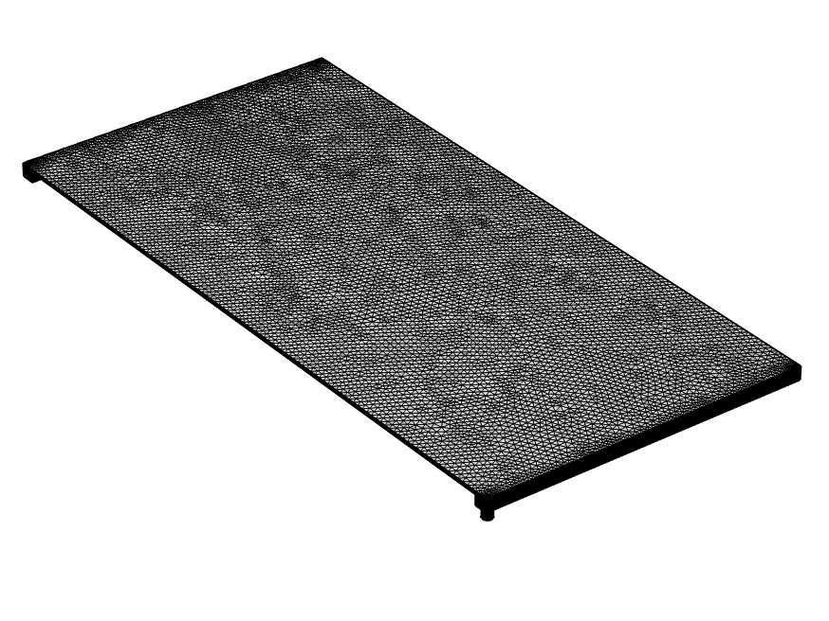
Tetrahedral finite element

Triangular finite element

FIGURE 3. Representation of the PV/T model mesh.
.

Confirmation of the model
To ensure the reliability of the numerical model developed for the PV/T-C, a rigorous validation phase was carried out. This involved comparing the results of the 3D numerical simulation with the available experimental and numerical data, thus confirming the accuracy of the model used. The details of this validation are presented in reference [11] and will not be repeated here.

Results and discussion

This study analyzes the performance of a completely cooled PV/T-C and a partially cooled system (covering 70% of the PV panel surface). Evaluations were conducted under solar irradiances ranging from 700 to 1100 W/m², with a mass flow rate of 0.05 kg/s. Fluid inlet and ambient temperatures were maintained at 26°C. The results are presented in the following sections.
Fig. 4 shows temperature profiles using completely- and partially-cooled PV/T-Cs under 900 W/m² radiation. For the completely cooled system, the maximum temperature recorded is 51.1°C. This system has a homogeneous thermal distribution, with higher temperatures near the outlet than the inlet, as the inlet fluid is colder than the outlet, a subsequent temperature gradient occurs along the freezing path. By contrast, in the case of the partially cooled system, the maximum temperature reaches 84°C, and this value is only observed at the edges of the PV panel, the uncooled zones. This uneven thermal distribution leads to local overheating, which degrades the performance of the PV panel. The comparison between these two systems highlights the importance of uniform cooling to guarantee optimum performance and extend the life of the PV panel.
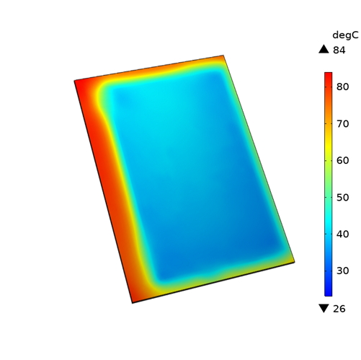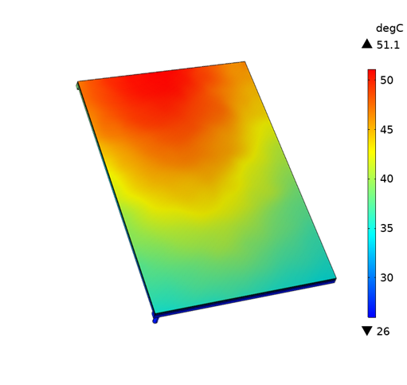
Partial cooling
Totale cooling
FIGURE 4. Temperature distribution for completely cooled and partially cooled systems.
Fig. 5 shows the cell temperatures obtained for the completely cooled and partially cooled systems versus irradiance. Augmenting irradiance (700-1100 W/m²) rises cell temperature (35.00- 40.69°C) and (49.91-63.36°C) for the completely- and partially-cooled PV/T-Cs, respectively. This comparison shows that the completely cooled system maintains lower temperatures, thereby improving the efficiency of the PV cells compared with the partially cooled system, which undergoes significant overheating.
FIGURE 5. Evolution of cell temperatures as a function of irradiance for completely and partially cooled systems.
Fig. 6 shows the electrical efficiencies obtained for the completely cooled system and the partially cooled system as a function of solar irradiance. It is observed that increasing solar irradiance leads to a decrease in electrical efficiency, as higher irradiance increases cell temperature, thus reducing cell efficiency. Using the completely-cooled PV/T-C, electrical efficiency drops (13.37-13.01%) due to enhanced irradiance (700-1100 W/m²). But for the partially cooled system, electrical efficiency falls more sharply, from 12.43% to 11.58% under the same irradiance conditions. This difference highlights the advantage of complete cooling in maintaining higher electrical performance.
FIGURE 6. Variation of electrical efficiencies due to radiation using completely and partially cooled systems.
Fig. 7 shows the evolution of electrical power as a function of solar irradiance for completely and partially cooled systems. As irradiance increases, electrical power rises for both systems. For the completely cooled system, electrical power rises from 144.11 W to 220.36 W when irradiance varies from 700 to 1100 W/m². In contrast, the partially cooled system sees its electrical power increase from 133.97 W to 196.14 W under the same conditions.
FIGURE 7. Electrical power as a function of irradiance for completely and partially cooled systems.
Figure 8 shows the fluid outlet temperatures for both the completely cooled and partially cooled systems as solar irradiance increases. Higher irradiance leads to higher fluid outlet temperatures because it raises cell temperatures, allowing more heat absorption by circulating water. The completely cooled system's fluid outlet temperature ranges from 31.99°C to 35.64°C as irradiance goes from 700 to 1100 W/m², while the partially cooled system ranges from 30.49°C to 33.8°C under the same conditions.
FIGURE 8. Fluid outlet temperatures as a function of irradiance for completely and partially cooled systems.
Fig. 9 shows thermal efficiencies for completely cooled and partially cooled PV/T-Cs as a function of solar irradiance. The analysis shows that increasing irradiance leads to improved thermal efficiencies. Applying the completely cooled collector, thermal efficiency rises (63.85-65.40%) as irradiance increases from 700 to 1100 W/m². But using the partially cooled collector, thermal efficiency falls from 47.86% to 52.91% under the same conditions.
FIGURE 9. Thermal efficiencies as a function of irradiance for completely and partially cooled systems.

Conclusion
This study led to a three-dimensional numerical analysis to evaluate the performance of a completely cooled PV/T-C compared to a partially cooled PV/T-C. The main objective was to explore the influence of temperature inhomogeneity on PVT-S performance. In parallel, the effect of solar irradiation on these performances was also examined. The results obtained highlight several key points, which are summarized below:
- The completely cooled PV/T-C offers excellent temperature homogeneity, resulting in a 55.7% reduction in cell temperature at an irradiance of 1100 W/m² compared with the partially cooled system.
- The completely cooled PV/T-C has electrical and thermal efficiencies that exceed those of the partially cooled system by 10.99% and 19.09% respectively.
- As solar irradiance increases, cell temperature rises, resulting in higher electrical power output and improved thermal efficiency, while electrical efficiency declines.
Despite these advantages, the study has certain limitations. The analysis is purely numerical, and real-world operating conditions such as varying wind speeds, dust accumulation, and long-term performance degradation were not considered. Additionally, the feasibility of full cooling is influenced by higher costs, greater system complexity, and specific installation requirements, which may limit its large-scale adoption.
Future research should therefore focus on experimental validation of the numerical model under different climatic conditions, optimization of cooling channel geometry to balance performance and cost, and life-cycle cost analysis for large-scale and building-integrated PV/T-Cs. Investigating hybrid cooling strategies or the use of advanced working fluids could also provide further performance improvements while addressing economic and practical constraints.

References
- M. Abdelgaied, M. Fathi Seleem, M. Mahgoub Bassuoni, A.M. Khaira, Performance of a solar hybrid desalination plant integrated with photovoltaic-thermal collectors for remote regions: Experimental and modeling investigation, Sol. Energy 264 (2023) 112082. https://doi.org/10.1016/j.solener.2023.112082.
- M. Abdelgaied, A.S. Abdullah, A.E. Kabeel, H.F. Abosheiasha, Assessment of an innovative hybrid system of PVT-driven RO desalination unit integrated with solar dish concentrator as preheating unit, Energy Convers. Manag. 258 (2022) 115558. https://doi.org/10.1016/j.enconman.2022.115558.
- M. Hosenuzzaman, N.A. Rahim, J. Selvaraj, M. Hasanuzzaman, A.B.M.A. Malek, A. Nahar, Global prospects, progress, policies, and environmental impact of solar photovoltaic power generation, Renew. Sustain. Energy Rev. 41 (2015) 284–297. https://doi.org/10.1016/j.rser.2014.08.046.
- Y.E. Alami, B. Zohal, R. Bendaoud, M. Rhiat, A. Rabhi, B. Benhala, K. Hirech, E. Baghaz, Comparative analysis of the performance of Shingle and Standard photovoltaic technologies in the environmental conditions of El Jadida, E3S Web Conf. 601 (2025) 00010. https://doi.org/10.1051/e3sconf/202560100010.
- Y. El Alami, B. Zohal, R. Nasrin, M. Benhmida, A. Faize, E. Baghaz, Solar thermal, photovoltaic, photovoltaic thermal, and photovoltaic thermal phase change material systems: A comprehensive reference guide, Int. Commun. Heat Mass Transf. 159 (2024) 108135. https://doi.org/10.1016/j.icheatmasstransfer.2024.108135.
- Y. El Alami, E. Baghaz, R. Nasrin, M. Al-Damook, R. Bendaoud, T. Bouragba, M. Melhaoui, M. Benhmida, Up-to-Date Review on Flat-Plate Solar Hybrid Photovoltaic Thermal Systems: Absorber Designs and Fabrication Materials, Int. J. Energy Res. 2025 (2025) 5547555. https://doi.org/10.1155/er/5547555.
- Y.E. Alami, F. Ouerradi, S. Bounouar, M. Benhmida, M. Rhiat, B. Benhala, K. Hirech, E. Baghaz, Comparative study of the performance of photovoltaic and photovoltaic thermal solar systems: Case study in El Jadida, E3S Web Conf. 601 (2025) 00011. https://doi.org/10.1051/e3sconf/202560100011.
- A. Khelifa, M. Abdelgaied, M.E.H. Attia, K. Harby, M. Arıcı, Development and optimization of dual-objective PVT modules for a smart residential building using inclined fins, J. Build. Eng. 97 (2024) 110893. https://doi.org/10.1016/j.jobe.2024.110893.
- Y. El Alami, E. Chetouani, H. Mokhliss, F. Ouerradi, M. Aoutoul, S. Bounouar, R. Bendaoud, A. Faize, R. Rmaily, Optimizing solar energy efficiency with an improved hill-climbing maximum power point tracking control approach: hardware implementation, Clean Energy 8 (2024) 167–176. https://doi.org/10.1093/ce/zkae061.
- Y. El Alami, A. Lamkaddem, H. Amiry, R. Bendaoud, F. Chanaa, S. Bounouar, S. Dlimi, K. Kassmi, E. Baghaz, R. Malek, S. Yadir, M. Benhmida, Design and realization of a descretized PV system with an improved MPPT control for a better exploitation of the PV energy, IJRER 14 (2024) 2. https://doi.org/10.20508/ijrer.v14i2.14354.g8884.
- Y.E. Alami, A. Lamkaddem, R. Bendaoud, S. Talbi, M. Louzazni, E. Baghaz, Numerical study of a water-based photovoltaic-thermal (PVT) hybrid solar collector with a new heat exchanger, E-Prime - Adv. Electr. Eng. Electron. Energy (2024) 100693. https://doi.org/10.1016/j.prime.2024.100693.
- S.-Y. Wu, C. Chen, L. Xiao, Heat transfer characteristics and performance evaluation of water-cooled PV/T system with cooling channel above PV panel, Renew. Energy 125 (2018) 936–946. https://doi.org/10.1016/j.renene.2018.03.023.
- T.A. Tripty, R. Nasrin, Efficiency upgrading of solar PVT finned hybrid system in Bangladesh: Flow rate and temperature influences, Heliyon 10 (2024) e28323. https://doi.org/10.1016/j.heliyon.2024.e28323.
- M.S. Hossain, A.K. Pandey, J. Selvaraj, N. Abd Rahim, A. Rivai, V.V. Tyagi, Thermal performance analysis of parallel serpentine flow based photovoltaic/thermal (PV/T) system under composite climate of Malaysia, Appl. Therm. Eng. 153 (2019) 861–871. https://doi.org/10.1016/j.applthermaleng.2019.01.007.
- A. Chauhan, V.V. Tyagi, S. Anand, Futuristic approach for thermal management in solar PV/thermal systems with possible applications, Energy Convers. Manag. 163 (2018) 314–354. https://doi.org/10.1016/j.enconman.2018.02.008.
- S. Mohammadi, M.H. Jahangir, F.R. Astaraei, Numerical modeling and optimization of tube flattening impacts on the cooling performance of the photovoltaic thermal system integrated with phase change material, Appl. Therm. Eng. 246 (2024) 122871. https://doi.org/10.1016/j.applthermaleng.2024.122871.
- M.F. Umam, M. Hasanuzzaman, N. Abd Rahim, Experimental investigation and performance evaluation of spiral and serpentine collectors based photovoltaic thermal system in Peninsular Malaysia, Sustain. Energy Technol. Assess. 58 (2023) 103373. https://doi.org/10.1016/j.seta.2023.103373.
- H.A. Kazem, A.H.A. Al-Waeli, M.T. Chaichan, K.H. Al-Waeli, A.B. Al-Aasam, K. Sopian, Evaluation and comparison of different flow configurations PVT systems in Oman: A numerical and experimental investigation, Sol. Energy 208 (2020) 58–88. https://doi.org/10.1016/j.solener.2020.07.078.
- M.E.H. Attia, A.E. Kabeel, A. Khelifa, M.M. Abdel-Aziz, Thermal and electrical analysis of the performance of a skeleton-shaped tubes via hybrid PVT cooling system, Appl. Therm. Eng. 248 (2024) 123277. https://doi.org/10.1016/j.applthermaleng.2024.123277.
- Y. El Alami, Y. Bannour, F. Ouerradi, H. Chetnouf, A. Ghennioui, B. Benhala, E. Baghaz, C. Hajjaj, Experimental and numerical evaluation of the performance of a photovoltaic panel in a semi-arid climate, in: 2025 5th Int. Conf. Innov. Res. Appl. Sci. Eng. Technol. IRASET, 2025: pp. 1–6. https://doi.org/10.1109/IRASET64571.2025.11008049.
- Y. Zhang, C. Shen, C. Zhang, G. Lv, C. Sun, D. Chwieduk, The study of heat control on PVT modules with a new leaf-like heat exchanger, J. Renew. Sustain. Energy 13 (2021) 023703. https://doi.org/10.1063/5.0030541.
- R. Nasrin, M. Hasanuzzaman, N.A. Rahim, Effect of high irradiation on photovoltaic power and energy, Int. J. Energy Res. 42 (2018) 1115–1131. https://doi.org/10.1002/er.3907.
- Y. El Alami, E. Baghaz, R. Nasrin, F. Chanaa, R. Bendaoud, S. Padmanaban, M. Louzazni, Experimental-numerical comparative study of performance and cost-effectiveness of partially- and fully-cooled photovoltaic thermal systems, Case Stud. Therm. Eng. 73 (2025) 106660. https://doi.org/10.1016/j.csite.2025.106660.
- Y. El Alami, H. El Achouby, F. Ouerradi, Y. Bannour, H. Chetnouf, B. Benhala, E. Baghaz, Numerical analysis of the influence of backsheet thickness on the performance of silicon photovoltaic modules, in: 2025 5th Int. Conf. Innov. Res. Appl. Sci. Eng. Technol. IRASET, 2025: pp. 1–6. https://doi.org/10.1109/IRASET64571.2025.11008016.
- A. Nahar, M. Hasanuzzaman, N.A. Rahim, Numerical and experimental investigation on the performance of a photovoltaic thermal collector with parallel plate flow channel under different operating conditions in Malaysia, Sol. Energy 144 (2017) 517–528. https://doi.org/10.1016/j.solener.2017.01.041.
- Y.E. Alami, E. Baghaz, R. Nasrin, S. Padmanaban, M. Louzazni, Numerical Approach of An Advanced Hybrid Photovoltaic Thermal System Based on Exergy, Energy, Enviro-Economic, and Sustainability Factors, Results Eng. (2025) 106342. https://doi.org/10.1016/j.rineng.2025.106342.
- Y. El Alami, H.E. Achouby, E. Baghaz, C. Hajjaj, R. Nasrin, An innovative photovoltaic thermal system with direct water-cell contact: energy, exergy, and sustainability analysis, Sol. Energy 300 (2025) 113827. https://doi.org/10.1016/j.solener.2025.113827.
- Y. El Alami, A. Ameur, M. Benhmida, A. Rabhi, E. Baghaz, Performance evaluation of different new channel box photovoltaic thermal systems, J. Clean. Prod. 478 (2024) 143953. https://doi.org/10.1016/j.jclepro.2024.143953.
- Y. El Alami, E. Baghaz, R. Bendaoud, F. Chanaa, M. Benhmida, H. Ezzaki, R. Nasrin, Experimental-Numerical Investigation of the Photovoltaic Thermal System with Polypropylene Heat Exchanger: Case in Morocco, IET Renew. Power Gener. 19 (2025) e70041. https://doi.org/10.1049/rpg2.70041.
- Y.E. Alami, H. Dahmani, F. Ouerradi, B. Zohal, R. Bendaoud, E. Baghaz, Impact of Heat Exchanger Materials on the Performance of Solar Hybrid Photovoltaic Thermal (PVT) Systems: 3D Analysis, in: B. Hajji, A. Gagliano, A. Mellit, A. Rabhi, M. Calì (Eds.), Proc. 4th Int. Conf. Electron. Eng. Renew. Energy Syst. - Vol. 2, Springer Nature, Singapore, 2025: pp. 609–619. https://doi.org/10.1007/978-981-97-9975-6_58.
- Y. El Alami, A. Lamkaddem, R. Nasrin, F. Ouerradi, N.E. Moussaoui, F. Chanaa, E. Baghaz, Optimizing the Performance of Hybrid Photovoltaic-Thermal Systems by Choosing the Input Temperature, in: C. Iwendi, Z. Boulouard, N. Kryvinska (Eds.), Proc. 4th Int. Conf. Adv. Commun. Technol. Comput. Eng. ICACTCE’24, Springer Nature Switzerland, Cham, 2025: pp. 442–452. https://doi.org/10.1007/978-3-031-94620-2_39.

