Performance Comparison of Floating and Ground-Based PV Systems: Effects of Water Cooling and Tilt Angle under Moroccan Conditions
El Mehdi BOUHNANE^{1, a)}, Bouchra LAARABI^{1, b)}, Salma ZAIM¹ and Abdelfettah BARHDADI¹
¹ Physics of Semiconductors and Solar Energy Research Team (PSES), Energy Research Center, ENS, Mohammed V University in Rabat, Morocco
^{a)} Corresponding authors: el.bouhnane@studenti.unime.it
^{b)} bouchra_laarabi@um5.ac.ma

Abstract. Floating photovoltaic (FPV) systems represent an innovative solar technology that enhances performance through water-based cooling while saving land. This study evaluates the performance of an FPV system installed at a 5° tilt on an agricultural reservoir in Sidi Slimane, Morocco, and compares it to ground-based photovoltaic (GPV) systems with tilt angles of 5° and the site-specific optimum of 34.2°. The FPV system demonstrated a 6.82% higher annual energy production than the GPV system at the same tilt, confirming the significant cooling effect of the water surface. When compared to the GPV system optimized at 34.2°, the annual total energy production is relatively close between the two systems: 644.02 MWh for FPV and 658.71 MWh for GPV, representing a difference of less than 3%. The FPV slightly outperforming GPV during summer months due to both thermal regulation and favorable low tilt for high solar angles, however, FPV performance was lower during winter due to reduced capture of low-angle sunlight. Simulations incorporating these factors indicate that optimizing FPV tilt could further enhance energy yield. These results highlight FPV’s strong potential in hot climates, especially for applications with high summer energy demand, while underscoring the need to carefully consider seasonal tilt and cooling effects in system design. In addition to performance, FPV also contributes to water preservation and offers land-use efficiency, making it a promising solution for sustainable energy generation in resource-constrained regions.

INTRODUCTION
Energy and water are fundamental pillars for economic development and global population growth, placing increasing pressure on natural resources. Dependence on conventional energy sources is unsustainable in the long term, hence the imperative to invest in renewable energies. At the same time, the increasing scarcity of water resources requires innovative solutions for their conservation. Traditional solar photovoltaic (PV) systems, while beneficial, require large areas of land, posing a major challenge for densely populated urban or island countries [1,2].
Faced with these challenges, floating photovoltaic (FPV) systems are emerging as a promising solution. These systems represent a rapidly growing segment of the PV industry, with a cumulative installed capacity of 7.7 GW worldwide by 2023. The majority of this capacity, nearly 90%, is located in Asia, with China alone accounting for close to 50%. Outside Asia, the Netherlands and France are the largest FPV markets [3]. FPV technology holds significant potential to contribute to climate targets, yet it still faces challenges such as regulatory barriers, cost competitiveness relative to GPV, and uncertainties regarding environmental impacts and system reliability. Currently, FPV installations are predominantly located on sheltered inland water bodies, including quarry lakes, irrigation ponds, and reservoirs [4]. The main components of an FPV system, as illustrated in Fig. 1, include: (a) the floating structure on which the plant is fixed, (b) mooring and anchoring system, (c) inverters, (d) underwater cabling, and (e) solar modules along with their support structures. The overall layout of an FPV plant is generally similar to that of a GPV system, although in some cases, the inverters may be installed on top of the floating platforms [2].
FPVs not only free up land for agriculture or housing, but also help reduce water evaporation, a crucial advantage in arid regions [5,6]. In addition, the high temperature of PV cells reduces their efficiency in converting light into energy. FPV technology mitigates this problem through the natural cooling effect of water, thereby improving the electrical performance of the panels [7,8]. This study presents a comparative performance analysis of two photovoltaic system configurations under Moroccan climatic conditions in the Sidi Slimane region: an FPV power plant installed on an agricultural reservoir and a GPV system. Specifically, the objectives are to quantify the energy gain attributable to the natural water cooling of the FPV system, to compare the overall performance of the FPV system with that of a GPV system optimized at the site-specific tilt angle of 34.2°, and to distinguish between performance improvements resulting from thermal regulation versus panel tilt. In addition, the land- and water-saving advantages of the FPV system are highlighted and assessed. To this end, the FPV system fixed at 5° tilt is directly compared with a GPV system of similar nominal capacity at both 5° and 34.2° tilt angles. Given the lack of an existing GPV plant matching the FPV technical characteristics in the region, the GPV configurations were simulated using PVSYST 7.2 software to ensure a consistent and controlled comparison.

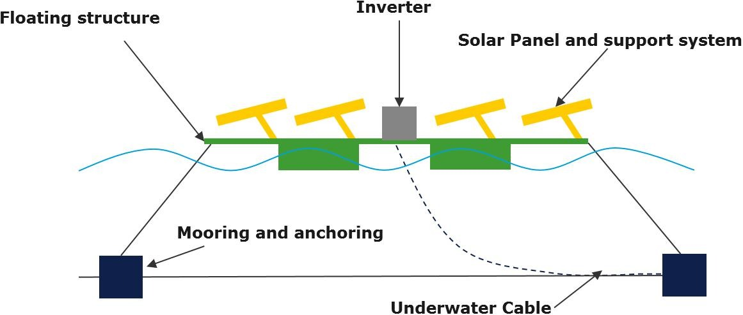
FIGURE 1. Key Components of an FPV System [2]

MATERIALS AND METHODS

Study Site and FPV System Configuration
Both systems were located in or referenced to Sidi Slimane, Morocco (Latitude: 34.24°, Longitude: -6.15°, Altitude: 60 m), a region characterized by high solar resource variability and distinct seasonal changes in irradiance (direct, diffuse, and reflected components) (Fig.2).
The FPV system (Fig.3) was installed on a 1-hectare agricultural reservoir with a depth of 5 meters. The floating structure, made of high-density polyethylene (HDPE), covered 0.6 hectares and was stabilized using a mooring and anchoring system fixed to the reservoir’s shore. system is fixed at a 5° tilt, oriented due south (azimuth 0°), and consists of the following components:
- Modules: 800 monocrystalline panels (Canadian Solar CS3W-450MS), each rated at 450 W, for a total installed capacity of 360 kW.
- Inverters: 5 units of HUAWEI SUN2000-60KTL-M0.
- Additional components: Integrated floating walkways were included to allow safe access for maintenance and inspection.
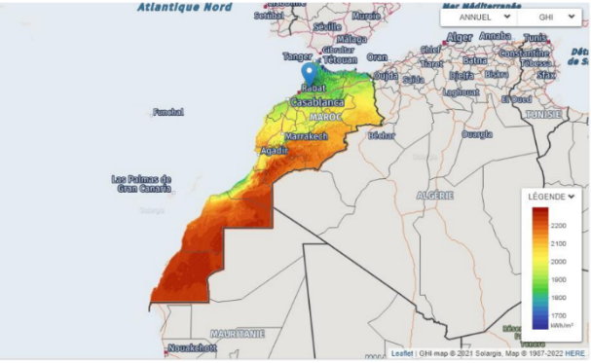 | 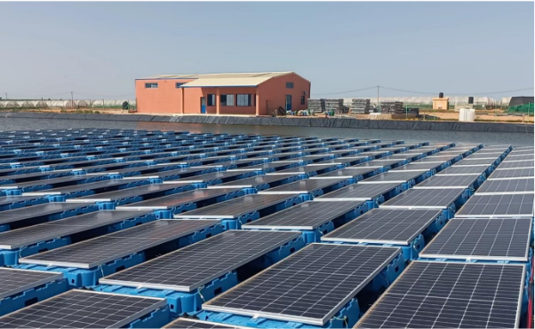
FIGURE 2. Irradiation map of Morocco [9] | FIGURE 3. The FPV power plant in Sidi Slimane.

GPV System Simulation
To ensure a controlled comparison, the GPV system was digitally simulated using PVSYST 7.2, a widely used software for photovoltaic system simulation. A grid-connected project was created within the software using (Fig. 4):
- The same geographic coordinates and meteorological conditions as the FPV site.
- Monthly climate data including solar irradiance, temperature, and wind speed specific to Sidi Slimane.
- The same PV modules and inverters as those installed on the FPV system to ensure consistency.
Two tilt configurations were simulated:
- A fixed 5° tilt, identical to the FPV setup.
- An optimized tilt of 34.2°, determined as the theoretical optimum for maximizing annual solar capture at the site.
Both configurations were oriented due south (azimuth 0°), and the simulation outputs included monthly and annual energy production for both GPV scenarios.

(a) | (b) | (c)
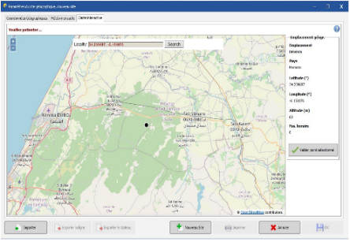 | 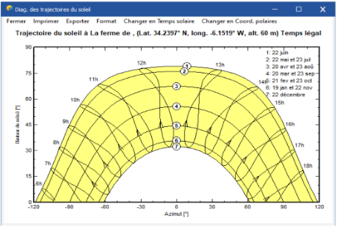 | 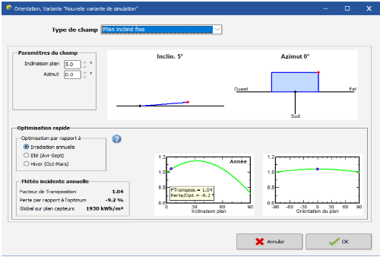
(d) | (e) | (f)
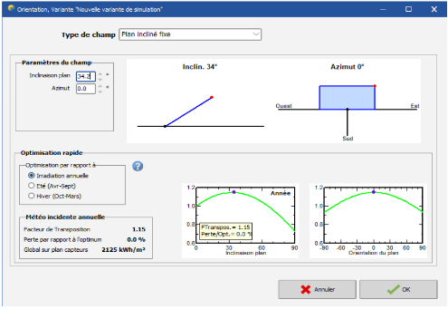 | 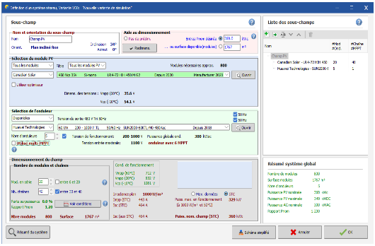 | 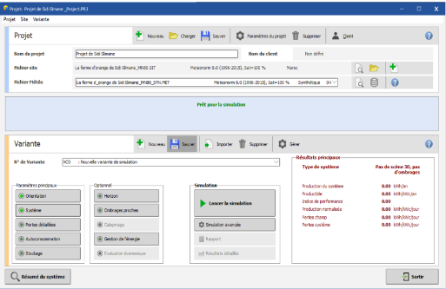

FIGURE 4. Simulation steps in PVSYST. (a) The geographical location of the GPV plant. (b) The sun's trajectory at the site throughout the year. (c) The orientation of 5° relative to south (Azimuth 0°). (d) The orientation of 34.2° relative to south (Azimuth 0°). (e) Choice of PV modules, inverters, and electrical design. (f) Execution of the simulation.

results and discussion
Figure 5 presents a comparative analysis of the monthly energy production (in MWh) between the FPV system and the GPV system, both installed at a fixed tilt angle of 5°. Both systems follow a similar seasonal trend, with energy production increasing from January, peaking between May and July, and subsequently declining towards December. This pattern corresponds closely to the annual variation in solar irradiance. The floating PV plant generates an annual total of 644 MWh, significantly outperforming the ground-based system, which produces 602.90 MWh under the same tilt conditions. This represents a notable gain of approximately 41.1 MWh, or a 6.82% increase in annual energy production for the FPV system. Throughout the year, the FPV system consistently delivers higher monthly energy output compared to the GPV system, although with varying margins. The performance advantage is most pronounced during the summer months (May to August), when the cooling effect of the underlying water body helps lower module temperatures, thereby enhancing efficiency [9,10]. The data can be divided into two distinct periods:
- Winter months (January, December): The difference between FPV and GPV is minimal, likely due to lower solar irradiance and reduced temperature-related performance disparities.
- Summer peak (May–July): FPV production reaches approximately 74 MWh per month, compared to about 69 MWh for the GPV system, underscoring the positive impact of water cooling on module performance.
Since the GPV system is simulated, a ±5% uncertainty margin is considered to reflect possible deviations from actual production [11]. Figure 6 illustrates the FPV production alongside the estimated range of GPV output accounting for this uncertainty. Even within this range, the FPV system continues to outperform the GPV counterpart, with a gain of ≥2%. Overall, the graph clearly demonstrates that floating PV systems benefit from a thermal regulation effect due to water cooling, which reduces heat-related energy losses. This characteristic makes FPV technology especially effective for maximizing energy yield in hot climates and regions where land availability is constrained.
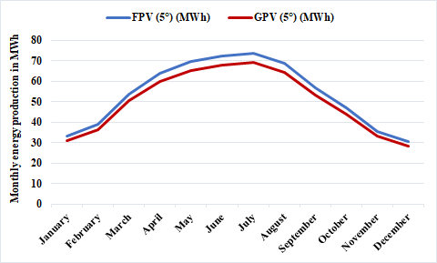 | 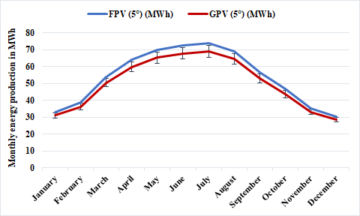
FIGURE 5. Comparison between the monthly energy production of the FPV and GPV systems (both tilted 5°). | FIGURE 6. Comparison between the monthly energy production of the FPV and GPV systems by considering the ±5% uncertainty of the simulation (both tilted 5°).
Normally, if a PV plant is installed on the ground, it is tilted at the site’s optimum angle—in this case, 34.2°, corresponding to the solar characteristics of Sidi Slimane. Figure 7 compares the monthly energy production (in MWh) of the FPV system fixed at 5° and the GPV system tilted at 34.2°. As expected, the GPV system generates more energy in most months, since its inclination is optimized to capture maximum solar irradiance throughout the year. However, the annual production of the two systems remains relatively close: 644.02 MWh for FPV versus 658.71 MWh for GPV, a difference of less than 3%. This suggests that, despite its suboptimal tilt, the FPV system compensates through advantages such as cooling, particularly during hotter periods. This conclusion remains valid even when accounting for potential uncertainties in the ground-based PV simulation, as illustrated in Fig. 8.
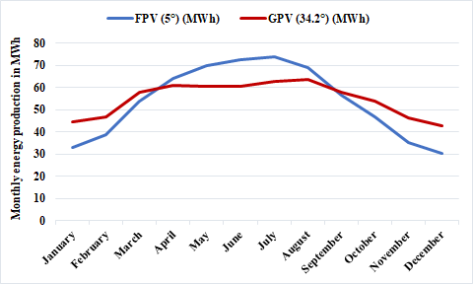 | 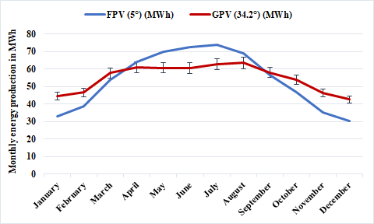
FIGURE 7. Comparison between the monthly energy production of the FPV (tilted 5°) and GPV systems (tilted 34.2°). | FIGURE 8. Comparison between the monthly energy production of the FPV (tilted 5°) and GPV systems (tilted 34.2°) by considering the ±5% uncertainty of the simulation.
From Fig. 5, 6, 7, and 8, it can be observed that when comparing FPV and GPV systems with the same tilt angle (5°), the difference in energy production remains relatively stable throughout the year, with a slight increase during the hotter months. However, when comparing an FPV system tilted at 5° with a GPV system tilted at the optimum angle of 34.2°, the behavior changes significantly. Generally, FPV systems are considered beneficial primarily due to the cooling effect of the water surface. However, it is important to distinguish this thermal benefit from the geometric effect of the tilt angle. To analyze this more accurately, the gain in monthly production due to FPV, cooling, and tilt angle was calculated and plotted in Fig. 9. The gain due to FPV is defined as the difference between the energy production of the FPV system and the GPV system tilted at 34.2° (E_{FPV(5°)}-E_{GPV(34.2°)}). The gain due to cooling corresponds to the difference between the FPV system and the GPV system tilted at 5° (E_{FPV(5°)} – E_{GPV(5°)}), while the gain due to tilt angle is the difference between the GPV tilted at 5° and the GPV tilted at 34.2° (E_{GPV(5°)} – E_{GPV(34.2°)}). From this figure, it can be observed that the FPV system underperforms compared to the GPV tilted at 34.2° from September to March, while the opposite occurs in the remaining months. This underperformance of the FPV system is mainly due to its low tilt angle, which does not align well with the lower solar trajectory during these months. Although some cooling effect is present, it was not sufficient to compensate for the losses caused by the low tilt angle. Between May and July, however, the low tilt angle becomes an advantage, as it aligns more effectively with the higher solar trajectory typical of hot months. This leads to the FPV system outperforming the GPV system tilted at 34.2°. In April and August, the FPV system also outperforms the GPV (34.2°), but in these cases the performance gain is primarily attributed to the cooling effect. The difference is that in August the low tilt angle further favors the FPV’s performance, whereas in April, it reduces it.
From these results, and aside from the land-use advantage of FPV, it can be deduced that at the studied site (Sidi Slimane), with an optimum tilt angle of 34.2°, and more generally across Morocco (where optimum tilt angles range from approximately 23.68° to 35.77°) [12], FPV systems—typically installed with tilt angles below 20° [4]—may not be highly beneficial in terms of energy yield from September to March. This reduces their usefulness for lighting applications, which are most needed during shorter days. From April to August, however, FPV systems become advantageous and are particularly suitable for applications such as water pumping, where demand is highest in summer due to reduced rainfall and higher temperatures.
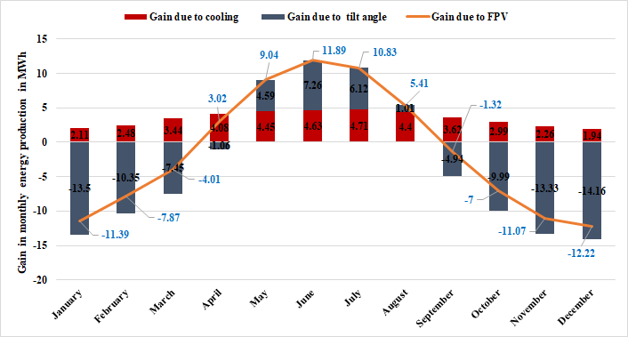
FIGURE 9. Comparison between the gain in monthly energy production due to FPV (E_{FPV(5°)}-E_{GPV(34.2°)}), due to cooling (E_{FPV(5°)} – E_{GPV(5°)}), and due to tilt angle (E_{GPV(5°)} – E_{GPV(34.2°)}).
Beyond total annual energy production, assessing the energy yield per unit area is an important metric, particularly for evaluating the efficiency of land or water use in regions where space is at a premium. This comparison provides valuable insight into the spatial footprint and productivity of different photovoltaic configurations. In the case of the studied FPV system, the power plant covers 0.6 hectares and produces 644.02 MWh annually, corresponding to an energy yield of approximately 107.34 kWh/m² of water surface occupied. For the GPV system, although the exact physical footprint was not explicitly detailed in the simulation, it can be estimated using industry standards. Ground-mounted solar systems typically require 5 to 8.75 m²/kW of installed capacity, accounting for row spacing to minimize self-shading, access paths for maintenance, and other infrastructure needs, especially in systems with higher tilt angles [13]. Using an average of 7 m²/kW for a 360 kW GPV system, the total estimated land requirement would be around 2520 m². With an annual production of 658.71 MWh at the optimal tilt angle of 34.2°, the GPV system achieves an energy yield of approximately 261.39 kWh/m².
This comparative analysis, though approximate, highlights an important insight: while FPV systems offer the clear advantage of freeing up valuable land for agriculture, housing, or other purposes by utilizing existing water bodies, their energy density per unit of occupied surface area is lower than that of optimally designed ground-based systems of equivalent capacity. Thus, the key advantage of FPVs lies not in maximizing energy output per unit area, but in their ability to exploit underutilized water surfaces and preserve scarce or high-value land resources.
Another major advantage of FPV systems is their ability to reduce water evaporation, which is particularly important given the water scarcity faced by many countries worldwide, including Morocco [14]. Assuming an evaporation reduction of 70%, as reported by the company in charge of this project, the volume of water saved V_{s} due to the FPV installation can be estimated using the following simple calculation:
$V_{s}=Evaporation rate × FPV area × Evaporation reduction$ (
For the evaporation rate, the open water evaporation of the Sebou basin (1390 mm/year) is used, given its proximity to the FPV reservoir and its climatic similarity to Sidi Slimane [15]. Since the FPV system covers an area of 0.6 hectares, the annual water savings are estimated to be approximately 5838 m³/year. As the reservoir is located on a farm for irrigation, this saved water can significantly support the farm’s water needs.
Apart from the above-mentioned advantages, soiling is one of the challenges these systems may face. Generally, FPV systems are considered to experience lower soiling rates than GPV systems installations [9,16]. This advantage is largely due to the cleaner microenvironment above water bodies, where dust concentrations are typically lower than in terrestrial settings. Nevertheless, FPV modules remain exposed to outdoor conditions and may accumulate dust, organic matter, and other environmental pollutants [10]. Moreover, the relatively low tilt angles commonly used in FPV systems, for example 5° in our studied FPV, are chosen for structural stability but can inadvertently encourage the accumulation of soiling particles on module surfaces [4]. Currently, there is limited publicly available information to establish the expected range of soiling rates for different FPV technologies across various climates. Moreover, since these systems are surrounded by water, cleaning can be challenging, making it essential to design FPV installations in a way that facilitates adequate operation and maintenance (O&M) activities [4].
In conclusion, although the GPV system benefits from an optimal tilt angle tailored to the site’s latitude, the FPV system’s performance remains competitive, particularly during hot months, making FPV an attractive option in locations with land constraints or available water bodies, even when the tilt angle is not optimized. Furthermore, in regions where the optimal tilt angle of GPV systems is close to that typically adopted in FPV systems, the cooling effect is expected to have a more significant impact than tilt angle. The preservation of precious water through reduced evaporation is also a key advantage that supports the wider adoption of FPV. However, challenges remain, particularly regarding system-specific soiling and cleaning requirements, which call for more targeted and dedicated studies.

CONCLUSION
This study investigated the energy performance of FPV systems compared to GPV systems under different tilt angles, using the Sidi Slimane region in Morocco as a case study. The main objective was to assess whether the cooling effect of water in FPV systems could offset the performance loss associated with their typically low tilt angles. Results showed that the FPV system tilted at 5° outperformed the GPV system with the same tilt by about 6.82% annually, thanks to the cooling effect that improves efficiency during hot months. When compared to a GPV system optimized at 34.2°, the FPV system produced only 2.2% less energy annually, showing that thermal benefits can significantly narrow the gap caused by suboptimal tilt. However, FPV systems showed reduced performance in winter due to their low tilt, limiting their usefulness for year-round applications like lighting. Still, their strong summer performance makes them highly suitable for water pumping and seasonal agricultural uses. The analysis also highlighted the importance of separating the effects of tilt angle and cooling when evaluating FPV performance.
Beyond energy output, assessing yield per unit area provided further insights into land and water use efficiency. The studied FPV system produced about 107 kWh/m² compared to 261 kWh/m² for an optimally tilted GPV system, underscoring that FPV’s main advantage lies not in maximizing energy density, but in utilizing underused water surfaces and preserving arable land. In addition, FPV installations can significantly reduce water evaporation; in this case, the system is estimated to save around 5838 m³ of water annually, enough to meaningfully support local irrigation needs. Nonetheless, challenges remain: soiling, though generally lower for FPV due to cleaner microenvironments above water, still occurs and may be exacerbated by the low tilt angles typically adopted. Cleaning can also be more complex given the water-based setting, making proper system design essential to ensure effective O&M.
Overall, FPV systems appear particularly promising for hot climates and regions with land and water constraints, as they provide competitive energy performance while contributing to water conservation. Nevertheless, their competitiveness must also be assessed in terms of cost. In addition, further research is required to better evaluate their durability under water-based conditions, as well as their long-term soiling behavior and maintenance needs across diverse climatic environments.

ACKNOWLEDGMENTS
The authors thank the Moroccan agricultural company Lady B for their considerable contribution and support to this work.

REFERENCES
1. Agrawal KK, Jha SK, Mittal RK, Vashishtha S. Assessment of floating solar PV (FSPV) potential and water conservation: Case study on Rajghat Dam in Uttar Pradesh, India. Energy for Sustainable Development [Internet]. 2022 Feb 1 [cited 2025 Aug 17]; 66:287–95. Available from: https://www.sciencedirect.com/science/article/abs/pii/S0973082621001514
2. Oliveira-Pinto S, Stokkermans J. Assessment of the potential of different floating solar technologies – Overview and analysis of different case studies. Energy Convers Manag [Internet]. 2020 May 1 [cited 2025 Aug 16]; 211:112747. Available from: https://www-sciencedirect-com.eressources.imist.ma/science/article/pii/S0196890420302855
3. Rodríguez-Gallegos CD, Gandhi O, Sun H, Paton C, Zhang J, Moideen Yacob Ali J, et al. Global floating PV status and potential. PrEne [Internet]. 2025 Jan 1 [cited 2025 Aug 16];7(1):015001. Available from: https://ui.adsabs.harvard.edu/abs/2025PrEne...7a5001R/abstract
4. IEA PVPS TCP. Floating Photovoltaic Power Plants: A Review of Energy Yield, Reliability, and Maintenance. Report IEA-PVPS T13-31:2025 [Internet]. 2025. Available from: www.iea-pvps.org
5. Kumar M, Mohammed Niyaz H, Gupta R. Challenges and opportunities towards the development of floating photovoltaic systems. Solar Energy Materials and Solar Cells [Internet]. 2021 Dec 1 [cited 2025 Aug 17]; 233:111408. Available from: https://www.sciencedirect.com/science/article/abs/pii/S0927024821004505
6. El Hammoumi A, Chalh A, Allouhi A, Motahhir S, El Ghzizal A, Derouich A. Design and construction of a test bench to investigate the potential of floating PV systems. J Clean Prod [Internet]. 2021 Jan 1 [cited 2025 Aug 17]; 278:123917. Available from: https://www.sciencedirect.com/science/article/abs/pii/S0959652620339627
7. Redón Santafé M, Torregrosa Soler JB, Sánchez Romero FJ, Ferrer Gisbert PS, Ferrán Gozálvez JJ, Ferrer Gisbert CM. Theoretical and experimental analysis of a floating photovoltaic cover for water irrigation reservoirs. Energy [Internet]. 2014 Apr 1 [cited 2025 Aug 17]; 67:246–55. Available from: https://www.sciencedirect.com/science/article/abs/pii/S0360544214001054
8. Cromratie Clemons SK, Salloum CR, Herdegen KG, Kamens RM, Gheewala SH. Life cycle assessment of a floating photovoltaic system and feasibility for application in Thailand. Renew Energy [Internet]. 2021 May 1 [cited 2025 Aug 17]; 168:448–62. Available from: https://www.sciencedirect.com/science/article/abs/pii/S096014812032022X
9. Gorjian S, Sharon H, Ebadi H, Kant K, Scavo FB, Tina GM. Recent technical advancements, economics and environmental impacts of floating photovoltaic solar energy conversion systems. J Clean Prod [Internet]. 2021 Jan 1 [cited 2025 Jun 22]; 278:124285. Available from: https://www.sciencedirect.com/science/article/abs/pii/S0959652620343304?via%3Dihub
10. Sathya RA, Ponraj C. Non-fluorinated, anti-reflective, self-cleaning and durable silane based superhydrophobic coating for floating solar cells. Mater Chem Phys [Internet]. 2025 Sep 1 [cited 2025 Jun 22]; 341:130880. Available from: https://www-sciencedirect-com.eressources.imist.ma/science/article/pii/S0254058425005267
11. Validations [Internet]. [cited 2025 Jun 22]. Available from: https://www.pvsyst.com/help-pvsyst7/validations.htm
12. Morocco latitude and longitude [Internet]. [cited 2025 Jun 22]. Available from: https://latitudelongitude.org/ma/
13. How Much Space Do You Need For Ground-Mount Solar? - Ground Mount Solar | Nuance Energy Group, Inc. [Internet]. [cited 2025 Aug 16]. Available from: https://nuanceenergy.com/solar-blog/how-much-space-do-you-need-for-ground-mount-solar
14. Verner D, Tréguer D, Redwood J, Christensen J, Mcdonnell R, Elbert C, et al. CLIMATE VARIABILITY, DROUGHT, AND DROUGHT MANAGEMENT IN MOROCCO’S AGRICULTURAL SECTOR.
15. Schyns JF, Hoekstra AY. THE WATER FOOTPRINT IN MOROCCO THE ADDED VALUE OF WATER FOOTPRINT ASSESSMENT FOR NATIONAL WATER POLICY VALUE OF WATER RESEARCH REPORT SERIES NO. 67. 2014.
16. Zahedi R, Ranjbaran P, Gharehpetian GB, Mohammadi F, Ahmadiahangar R. Cleaning of floating photovoltaic systems: A critical review on approaches from technical and economic perspectives. Vol. 14, Energies. MDPI AG; 2021.

