Thermal and Electrical Performance Evaluation of a Water-Based PVT Hybrid Solar Collector: Simulation and Experimental Analysis
Fatima Zahra KADDAR^{1, a)}, Bouchra LAARABI^{1, b)}, Hajar HAFS^{2,} and Abdelfettah BARHDADI¹
¹Physics of Semiconductors and Solar Energy Research Team (PSES), Energy Research Center, ENS, Mohammed V University in Rabat, Rabat, Morocco.
²Thermal and Energy Research Team (ERTE) ENSAM-Mohammed V University in Rabat, Morocco.
Corresponding authors: ^{a)} fatimazahrakaddar99@gmail.com
^{b)} bouchra_laarabi@um5.ac.ma
Abstract. During photovoltaic conversion in a photovoltaic module, a significant portion of incident solar radiation is not converted into electrical energy but instead transformed into heat, which raises the temperature of the photovoltaic cells and consequently reduces their efficiency. To address this issue, hybrid photovoltaic/thermal (PVT) solar collectors have gained increasing research attention due to their ability to extract excess heat from PV modules—thereby enhancing electrical performance while simultaneously supplying useful thermal energy. This study investigates the performance of a water-based PVT hybrid solar collector through both numerical simulation and experimental analysis. A thermal model of the system was developed using COMSOL Multiphysics software, and copper was identified as an effective material for the heat exchanger due to its high thermal conductivity. Experimental validation involved comparing the open-circuit voltage (Voc) of the developed PVT collector with that of a conventional PV module. The results showed a modest but consistent Voc improvement, with a maximum observed increase of 2.59%, under specific operating conditions. This suggests that hybrid systems can offer measurable efficiency gains, though their performance remains sensitive to environmental factors and system configuration.

Introduction
The electrical efficiency of a photovoltaic (PV) panel is highly dependent on its operating temperature. As the temperature increases, the electrical performance of the PV panel decreases. One of the key reasons for this increase in temperature is that not all of the solar radiation is used for generating electricity; a significant portion is converted into thermal energy [1]. This temperature is, in turn, depends on atmospheric variables such as solar irradiation, ambient temperature and wind speed [2]. In this context, a photovoltaic-thermal (PVT) hybrid system is proposed to reduce thermal stress on the PV panel by extracting excess heat and converting it into usable thermal energy [3].
In this study, a hybrid PVT solar collector using water as the heat transfer fluid is created. The first part focuses on a simulation using COMSOL Multiphysics to compare the effects of three different thermal systems based on different materials; copper, aluminum and iron on the temperature reduction of the PVT collector. The second part involves an experimental comparison of the electrical voltage output of the PVT collector with that of a conventional PV module. Furthermore, performance tests are carried out under two distinct flow rates to investigate their effect on the system’s overall efficiency.

MATERIALS AND METHODS

Simulation of The PVT Collector Using COMSOL Multiphysics
The simulation was conducted using COMSOL Multiphysics® 5.5 to compare the thermal performance of three systems based on different materials; copper, aluminum, and iron, integrated into a hybrid PVT solar collector. COMSOL Multiphysics is a finite element-based numerical simulation software that enables the modeling of a wide range of physical phenomena. One of its main strengths is its ability to handle coupled multiphysics problems within a unified framework [4]. A three-dimensional model was developed using the Conjugate Heat Transfer – Laminar Flow interface to capture the interaction between water flow and heat transfer (Fig. 1). A Time Dependent study was selected to simulate the transient thermal behavior of the collector. The geometry includes the typical layers of a PV module (glass, EVA, PV cell, Tedlar), a metal plate (copper, aluminum, or iron), and a serpentine copper tube for fluid circulation. Material properties were assigned using COMSOL’s material library or defined manually when needed. Initial and boundary conditions included a uniform ambient temperature and thermally insulated lateral and bottom surfaces. A refined mesh was generated to ensure numerical stability and accuracy. The simulation provided the temperature distribution over time within the PVT collector, allowing for a comparative analysis of the cooling performance of each material under dynamic environmental conditions.
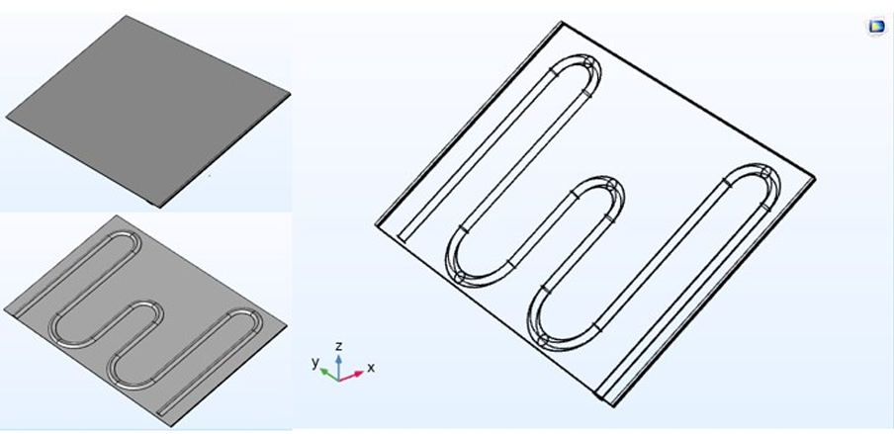
Figure 1. Three-dimensional representation of the modeled geometry in COMSOL

Experimental Study
In order to compare the performance of a conventional PV module with that of a hybrid PVT collector, a water-based PVT hybrid solar collector using copper as a thermal system material is designed. The system consists of a copper plate with a serpentine-shaped tube of the same material positioned beneath it, through which water flows (Table 1 and Fig. 2). Copper was selected for both the absorber plate and the tube due to its significantly higher thermal conductivity (~400 W/m·K at 25 °C) compared to other metals, which ensures efficient heat transfer and improved thermal performance [5,6]. Beyond these thermal advantages, economic and practical considerations may influence the suitability of copper in large-scale applications [6]. The relatively high cost of copper (≈ 6.6 USD/kg) and its market volatility can increase capital expenditures compared to alternatives such as aluminum [6,7]. While copper offers excellent durability and has long been used in commercial solar thermal collectors, it remains susceptible to corrosion depending on the working fluid chemistry, making it more suitable for operation with fluids of basic pH or when protective coatings are applied [6]. Moreover, its high density (8940 kg/m³) contributes to increased transport and installation costs at scale [8]. On the other hand, copper’s strong malleability and ductility allow simple manufacturing by brazing or welding, and its recyclability without loss of properties enhances its life-cycle value and sustainability [6,7]. Overall, while copper remains a technically attractive choice for PVT systems, its cost and corrosion concerns should be weighed against the scale of application and the potential of alternative or hybrid material solutions.
TABLE 1. The dimensions of the thermal system

Plate Length | 360 mm
Plate Width | 260 mm
Plate Thickness | 0.7 mm
Tube Diameter | 10 mm
Distance Between Two Tubes | 50 mm
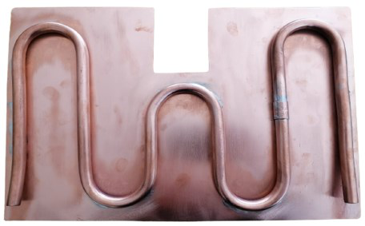
Figure 2. Image of the designed thermal system
In this study, two polycrystalline PV modules (Model TDC-P10-36) are used, with their technical specifications presented in Table 2.
TABLE 2. PV module specifications provided by the manufacturer
Maximum Power (P_{max}) | 10 W
Open Circuit Voltage (V_{OC}) | 21.2 V
Short Circuit Current (I_{SC}) | 0.64 A
Voltage at Maximum Power (V_{mp}) | 17.3 V
Current at Maximum Power (I_{mp}) | 0.58 A
Operating Temperature | -40°C to +85°C
After assembling the thermal system, it must be attached to the rear surface of the photovoltaic module. It is important to note that the front side of the absorber must be in direct contact with the back side of the PV module to ensure optimal heat absorption. For this purpose, silicone adhesive was used, as it is characterized by high thermal conductivity, low electrical conductivity, and a wide operating temperature range [9] (Fig. 3).
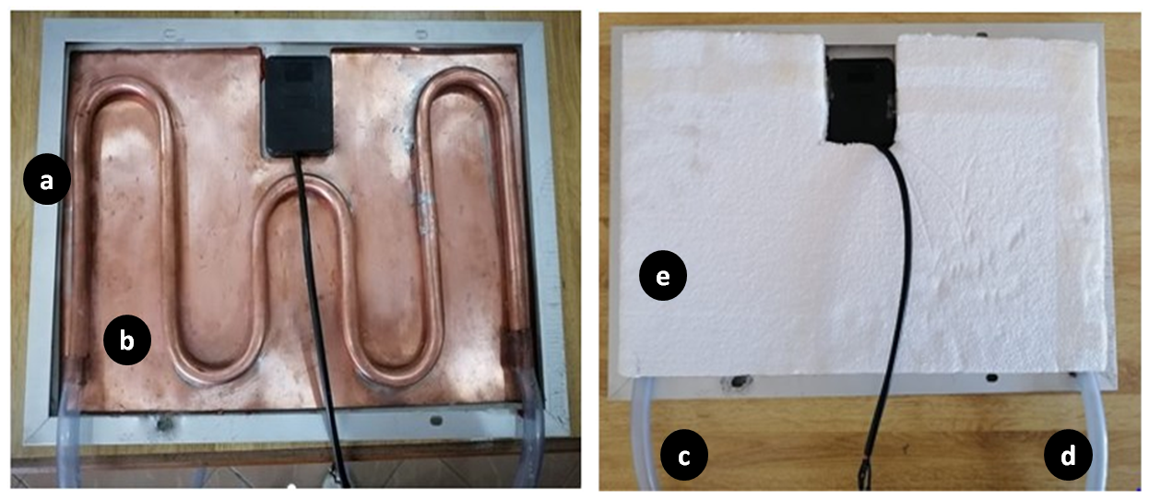
Figure 3. Photograph of the assembled hybrid PVT solar collector: (a) PV Module; (b) Thermal system; (c) Water inlet; (d) Water outlet; (e) Insulating layer (Polystyrene)
The two photovoltaic modules used in this study were mounted on a support structure with an inclination angle of 34°. One of the modules served as a reference, while the other was equipped with thermal system using water as the heat transfer fluid. The PVT hybrid collector is connected to an insulated water tank equipped with a pumping system and an adjustable valve. The volume of water used is 4.5 liters.
For this experiment, measurements were taken on two different days in August. On each day, a different mass flow rate was applied to evaluate its effect on the performance of the PVT system. On each day of the experiment, the water pump operated for seven and half hours, from 10:30 AM to 6:00 PM, while data were continuously recorded. The variation in open-circuit voltage (Voc) of both the PV and PVT modules was measured and compared, as voltage is considered the parameter most affected by temperature increases according to the literature[10]. Voltage variation was recorded every five minutes using a data logger, while changes in irradiance and water temperature were logged every thirty minutes. The schematic diagram of the experimental setup diagram is illustrated in Fig. 4 while its actual view is presented in Fig. 5.
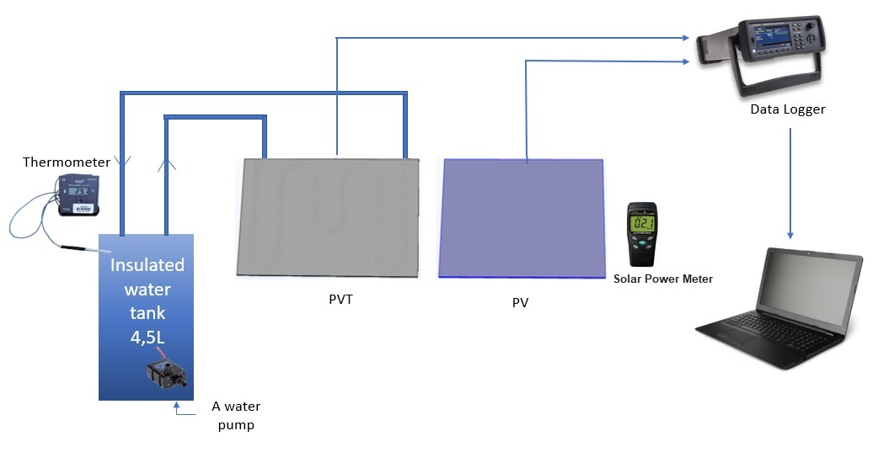
Figure 4. Schematic diagram of the experimental setup
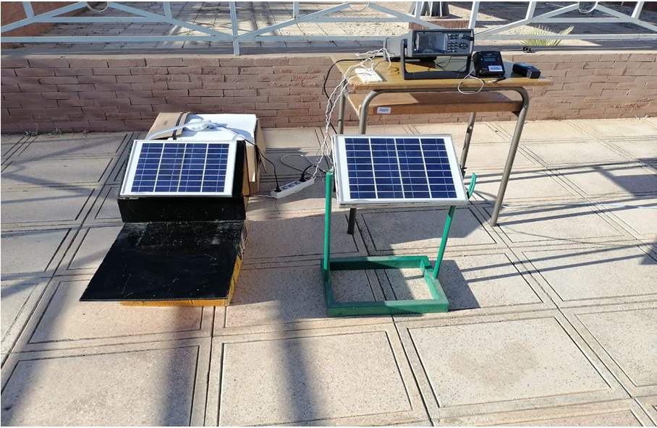
Figure 5. Actual image of the experimental setup

Results AND DISCUSSION

Experimental Results
The simulation conducted using COMSOL Multiphysics software confirmed that using a copper-based thermal system is the optimal choice (Fig. 6). The simulation of the hybrid PVT system reveals a temperature distribution ranging from about 27°C to 37°C across the collector surface, with the highest temperatures occurring directly above the copper serpentine tube (Fig. 7). Due to copper’s high thermal conductivity, heat gradually dissipates from the serpentine region to the surrounding areas, creating a smooth temperature gradient that indicates efficient heat conduction and uniform thermal management. The copper serpentine effectively removes heat from the photovoltaic cells, which helps lower module temperature and enhances cooling performance, potentially improving the system’s overall electrical efficiency [11].
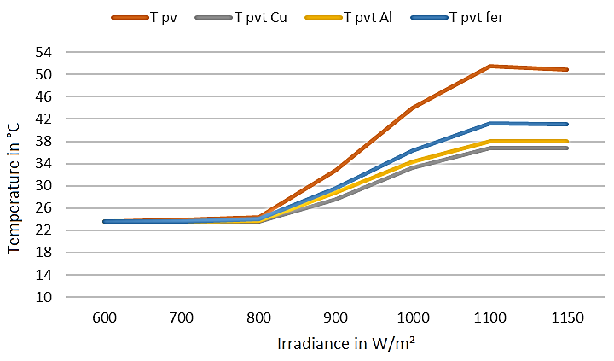 | 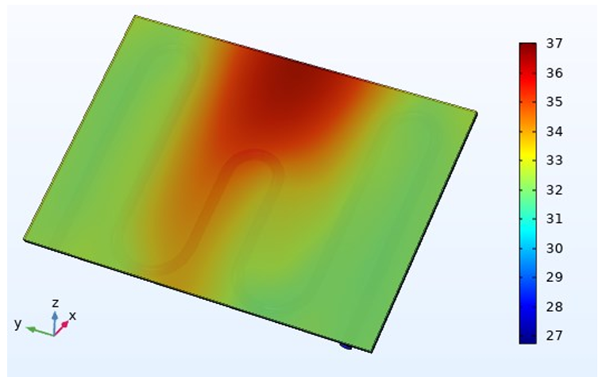
Figure 6. The Comparison of the effects of three thermal systems based on different materials using COMSOL Multiphysics | Figure 7. The image obtained after the simulation using Copper material

Experimental Results
On August 11, 2022, a first test was conducted with a mass flow rate of 0.0147 L/s. The results obtained, namely the variation in open-circuit voltage of the PV and PVT modules, and the variation in water temperature during pump operation, are presented in Fig. 8 and Fig. 9, respectively.

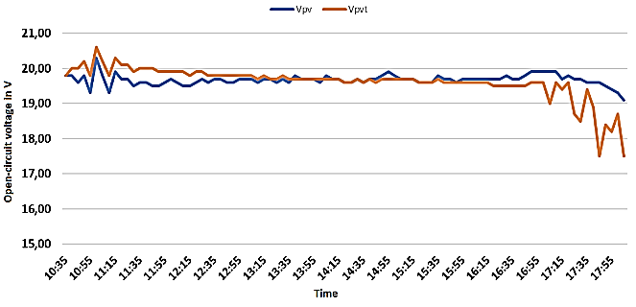 | 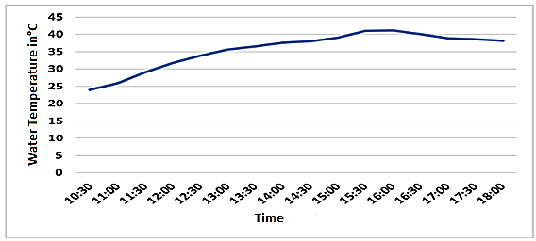
Figure 8. Open-circuit voltage variation of PV and PVT modules (August 11, 2022) | Figure 9. Water temperature variation during pump operation (August 11, 2022)
As shown in Fig. 8, the Voc of the created PVT hybrid collector is higher than that of the conventional PV module, with a noticeable difference of 2.59% observed between 10:30 A.M. and 4:00 P.M. This difference correlates with the rise in the temperature of the circulation water, which goes from 24°C to 40.1°C during the same time period, as illustrated in Fig. 9. After 4:00 P.M., it is observed that the Voc of the PVT collector becomes lower than that of the conventional PV module, coinciding with a decrease in water temperature. This decline can be interpreted by the fact that, from this time onward, the water temperature exceeds that of the PV module, causing the direction of heat transfer to reverse: from the water back to the module.
On August 15, 2022, a second test was conducted with a mass flow rate of 0.0625 L/s. The results obtained in particular, the variation in open-circuit voltage of the PV and PVT modules, and the variation in water temperature during pump operation, are presented in Fig. 10 and Fig. 11, respectively. In Fig. 10, it can be observed that increasing the mass flow rate did not produce a significantly different outcome, as the difference between the open-circuit voltage of the PV and PVT modules remained nearly the same as on the previous day. Furthermore, according to Fig. 11, the water temperature rose from 26°C to 40.1°C between 10:30 A.M. and 2:00 P.M., with the maximum temperature being reached in a shorter time. According to the literature, the applied mass flow rate influences electrical efficiency: the higher the flow rate, the greater the cooling effect, which can result in the PVT voltage exceeding that of the PV module [12]. However, this was not the case in our study. On the second day of the experiment (August 15, 2022), despite the mass flow rate being higher than on the first day, the voltage difference between the PV and PVT modules remained almost unchanged. Moreover, the Voc of the PVT collector dropped below that of the conventional PV module earlier in the day at (2:00 P.M.) compared to the first test (4:00 P.M.), coinciding with a reduction in water temperature.
In order to investigate the origin of these results, an analysis of the meteorological data for the two days was conducted. Fig. 12, Fig. 13, and Fig. 14 present the variation in wind speed, ambient temperature, and solar irradiance over the two days of the experiment. From these figures, a noticeable difference can be observed between the meteorological conditions of August 11 and August 15. On August 11, solar irradiance was lower (~800 W/m²), wind speed was higher (~5 m/s), and ambient temperature was lower (~23.5°C), whereas August 15 was characterized by higher solar irradiance (~1000 W/m²), lower wind speed (~3 m/s), and higher ambient temperature (~25°C). Based on these observations, it can be inferred that the amount of heat generated in the PVT collector on August 15 was significantly greater than on August 11. Consequently, even though the mass flow rate was increased, its cooling effect was not sufficient to counterbalance the higher heat input. In addition, the earlier occurrence of reversed heat transfer, at 4:00 P.M. on the first day and 2:00 P.M. on the second day, may also be attributed to the configuration of the water circuit. In a closed-loop system with a limited water volume, the cooling capacity can become insufficient over time. In contrast, an open-loop system or a circuit with a larger water volume would allow continuous contact with cooler, fresh water, enhancing the overall cooling effect.
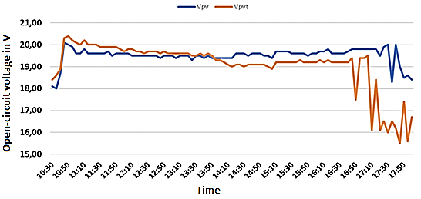 | 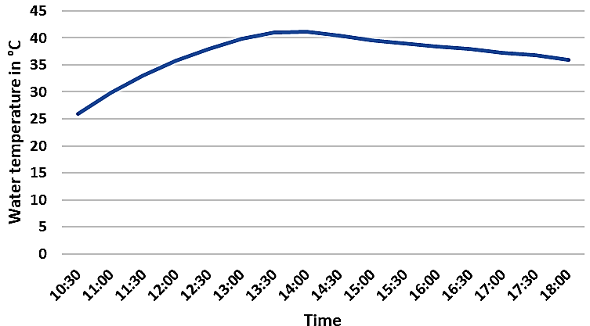
Figure 10. Open-circuit voltage variation of PV and PVT modules (August 15, 2022) | Figure 11. Water temperature variation during pump operation (August 15, 2022)
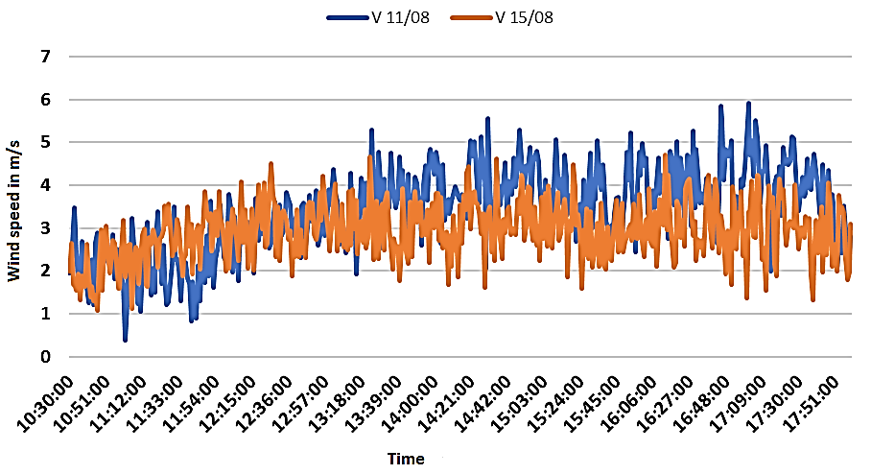 | 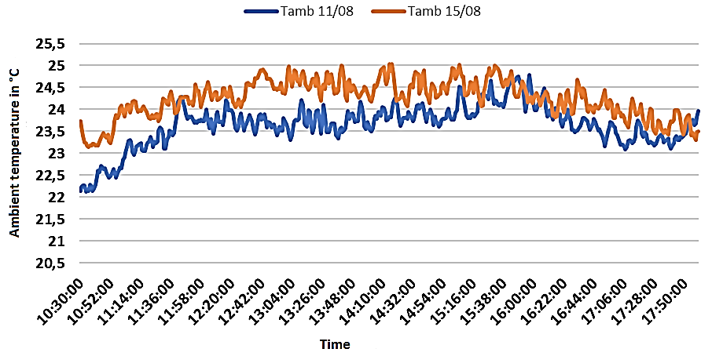
Figure 12. Wind speed variation | Figure 13. Ambient temperature variation
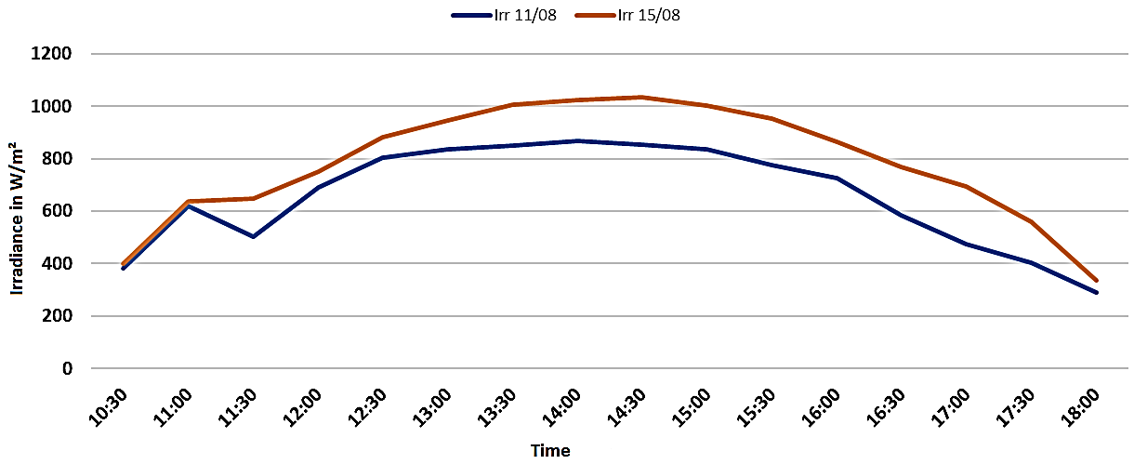
Figure 14. Solar irradiance variation
While this study demonstrated the PVT collector's ability to improve electrical voltage output and recover thermal energy, a precise quantification of the overall (combined electrical and thermal) efficiency was beyond the scope of the present experimental setup. A rigorous efficiency analysis requires simultaneous, high-frequency measurements of both thermal and electrical power output under controlled and steady-state conditions to accurately perform the necessary energy balance calculations. Future work should specifically be designed to facilitate this comprehensive analysis, employing longer monitoring periods and a controlled laboratory environment to minimize the influence of transient meteorological factors. Such an approach would yield more concrete conclusions regarding the total energy yield and economic viability of the system, providing a stronger basis for comparison with conventional PV modules and other solar technologies.

CONCLUSION
The present study investigated the thermal and electrical performance of a hybrid PVT (Photovoltaic/Thermal) system using both simulation and experimental approaches. The simulation results confirmed that copper is an effective material for the thermal system, owing to its high thermal conductivity, which enables efficient heat extraction and contributes to a more uniform temperature distribution across the collector surface. This thermal regulation is key to enhancing the cooling performance of the PV module and potentially improving its electrical efficiency. However, it is important to note that its relatively high cost and susceptibility to corrosion should be weighed against the scale of the application and the potential of alternative or hybrid material solutions.
Experimental tests conducted on two different days with varying mass flow rates revealed that the PVT collector consistently delivered a higher open-circuit voltage than a conventional PV module during the earlier part of the day, with a maximum improvement of 2.59%. However, despite increasing the mass flow rate on the second day, no significant enhancement in electrical performance was observed. In fact, reversed heat transfer occurred earlier, suggesting that external meteorological conditions, particularly solar irradiance, ambient temperature, and wind speed, played a dominant role in system performance.
The findings underscore the importance of not only optimizing the heat exchanger design but also carefully considering the configuration of the water circuit (open vs. closed loop) and the influence of environmental conditions to fully maximize the performance of PVT systems. To improve the accuracy and representativeness of future results, it is recommended to employ larger PV modules and extend the duration of experimental investigations. Moreover, further research should focus on developing dynamic control strategies capable of adapting to real-time weather variations, thereby maintaining effective thermal regulation and ensuring stable electrical output throughout the day.

References
1. Alami AH, Rabaia MKH, Sayed ET, Ramadan M, Abdelkareem MA, Alasad S, et al. Management of potential challenges of PV technology proliferation. Sustainable Energy Technologies and Assessments [Internet]. 2022 Jun 1 [cited 2025 Aug 19];51:101942. Available from: https://www.sciencedirect.com/science/article/abs/pii/S2213138821009565
2. Maleki A, Haghighi A, El Haj Assad M, Mahariq I, Alhuyi Nazari M. A review on the approaches employed for cooling PV cells. Solar Energy [Internet]. 2020 Oct 1 [cited 2025 Aug 19];209:170–85. Available from: https://www.sciencedirect.com/science/article/abs/pii/S0038092X20309245
3. Pathak SK, Sharma PO, Goel V, Bhattacharyya S, Aybar H, Meyer JP. A detailed review on the performance of photovoltaic/thermal system using various cooling methods. Sustainable Energy Technologies and Assessments [Internet]. 2022 Jun 1 [cited 2025 Aug 19];51:101844. Available from: https://www.sciencedirect.com/science/article/abs/pii/S2213138821008584
4. Introduction To COMSOL Multiphysics [Internet]. [cited 2025 Aug 19]. Available from: https://cdn.comsol.com/doc/5.5/IntroductionToCOMSOLMultiphysics.pdf
5. Tirupati Rao V, Raja Sekhar Y. Hybrid Photovoltaic/Thermal (PVT) Collector Systems With Different Absorber Configurations For Thermal Management – A Review. Energy and Environment. 2023 May 1;34(3):690–735.
6. Kalogirou SA. Solar thermal collectors and applications. Prog Energy Combust Sci [Internet]. 2004 Jan 1 [cited 2025 Aug 18];30(3):231–95. Available from: https://www-sciencedirect-com.eressources.imist.ma/science/article/pii/S0360128504000103
7. Efficient Copper Cooling Equipment Market – PW Consulting Chemical & Energy Research Center [Internet]. [cited 2025 Aug 18]. Available from: https://pmarketresearch.com/chemi/efficient-copper-cooling-equipment-market/?utm_source=chatgpt.com
8. Ellingsen DG, Horn N, Aaseth J. Copper. Handbook on the Toxicology of Metals [Internet]. 2007 Jan 1 [cited 2025 Aug 19];529–46. Available from: https://www.sciencedirect.com/science/article/abs/pii/B9780123694133500811
9. Xu P, Zhang X, Shen J, Wu Y, Connelly K, Yang T, et al. A review of thermal absorbers and their integration methods for the combined solar photovoltaic/thermal (PV/T) modules. Renewable and Sustainable Energy Reviews. 2017;75:839–54.
10. Hudișteanu VS, Cherecheș NC, Țurcanu FE, Hudișteanu I, Romila C. Impact of Temperature on the Efficiency of Monocrystalline and Polycrystalline Photovoltaic Panels: A Comprehensive Experimental Analysis for Sustainable Energy Solutions. Sustainability (Switzerland). 2024 Dec 1;16(23).
11. Brahim T, Jemni A. Economical assessment and applications of photovoltaic/thermal hybrid solar technology: A review. Solar Energy [Internet]. 2017 Sep 1 [cited 2025 Aug 19];153:540–61. Available from: https://www.sciencedirect.com/science/article/abs/pii/S0038092X17304887
12. Preet S. Water and phase change material based photovoltaic thermal management systems: A review. Renewable and Sustainable Energy Reviews [Internet]. 2018 Feb 1 [cited 2025 Aug 19];82:791–807. Available from: https://www.sciencedirect.com/science/article/abs/pii/S1364032117312571

